**Experiment 2**

Create a simple cloud software application for Flight Reservation System using any Cloud Service Provider to demonstrate SaaS

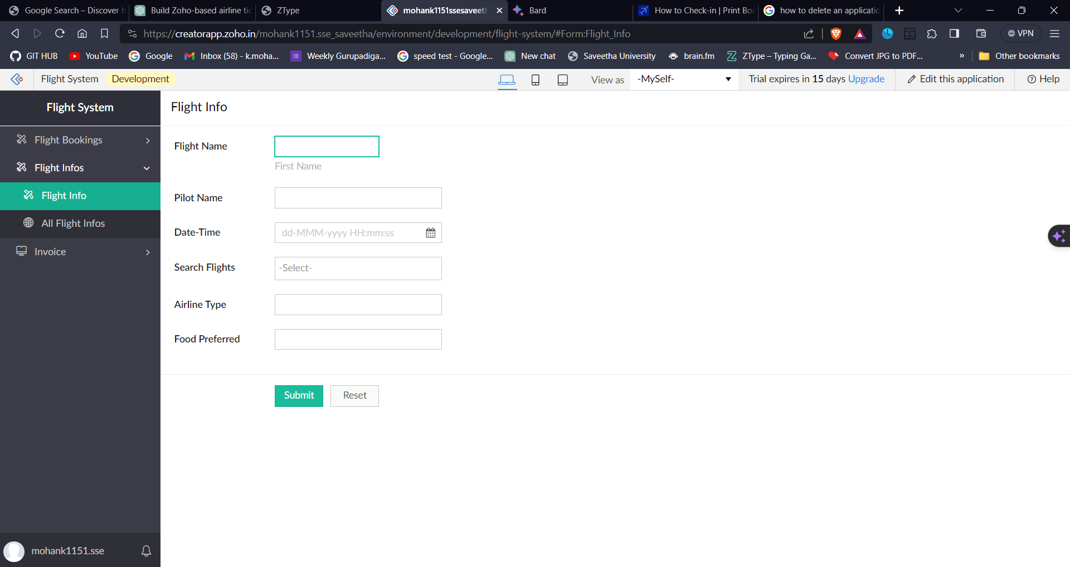

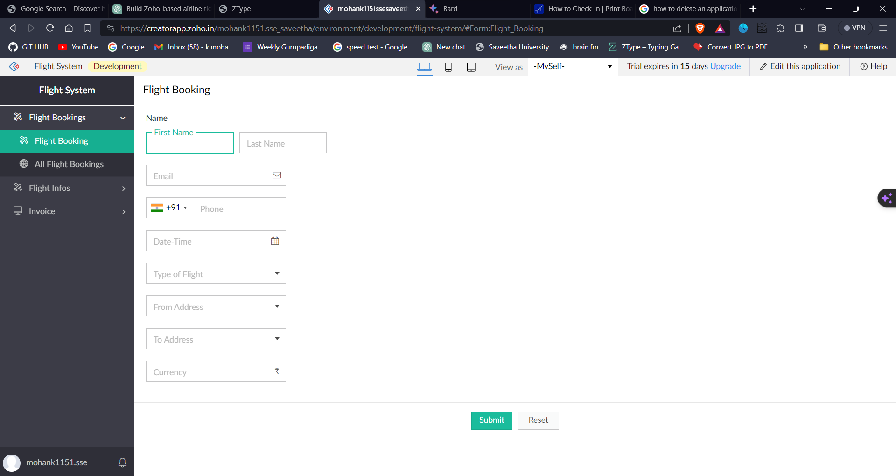**aS**

