**Step 1: Create a New Directory and Populate it with Script Files**

# Create a new directory

mkdir script-dir

# Move into the newly created directory

cd script-dir

# Create script files (you can create any number of scripts you want)

touch script1.py

touch script2.sh

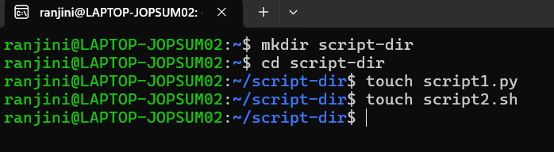

### Step 2: Initiate an Empty Repository on GitHub

**Initiate an Empty Repository on GitHub**:

* Go to GitHub and log in to your account.
* Click on the "+" icon in the top-right corner and select "New repository".
* Fill in the repository name, description, and choose other settings as needed.
* Make sure to leave the "Initialize this repository with a README" option unchecked since you want an empty repository.
* Click on "Create repository".

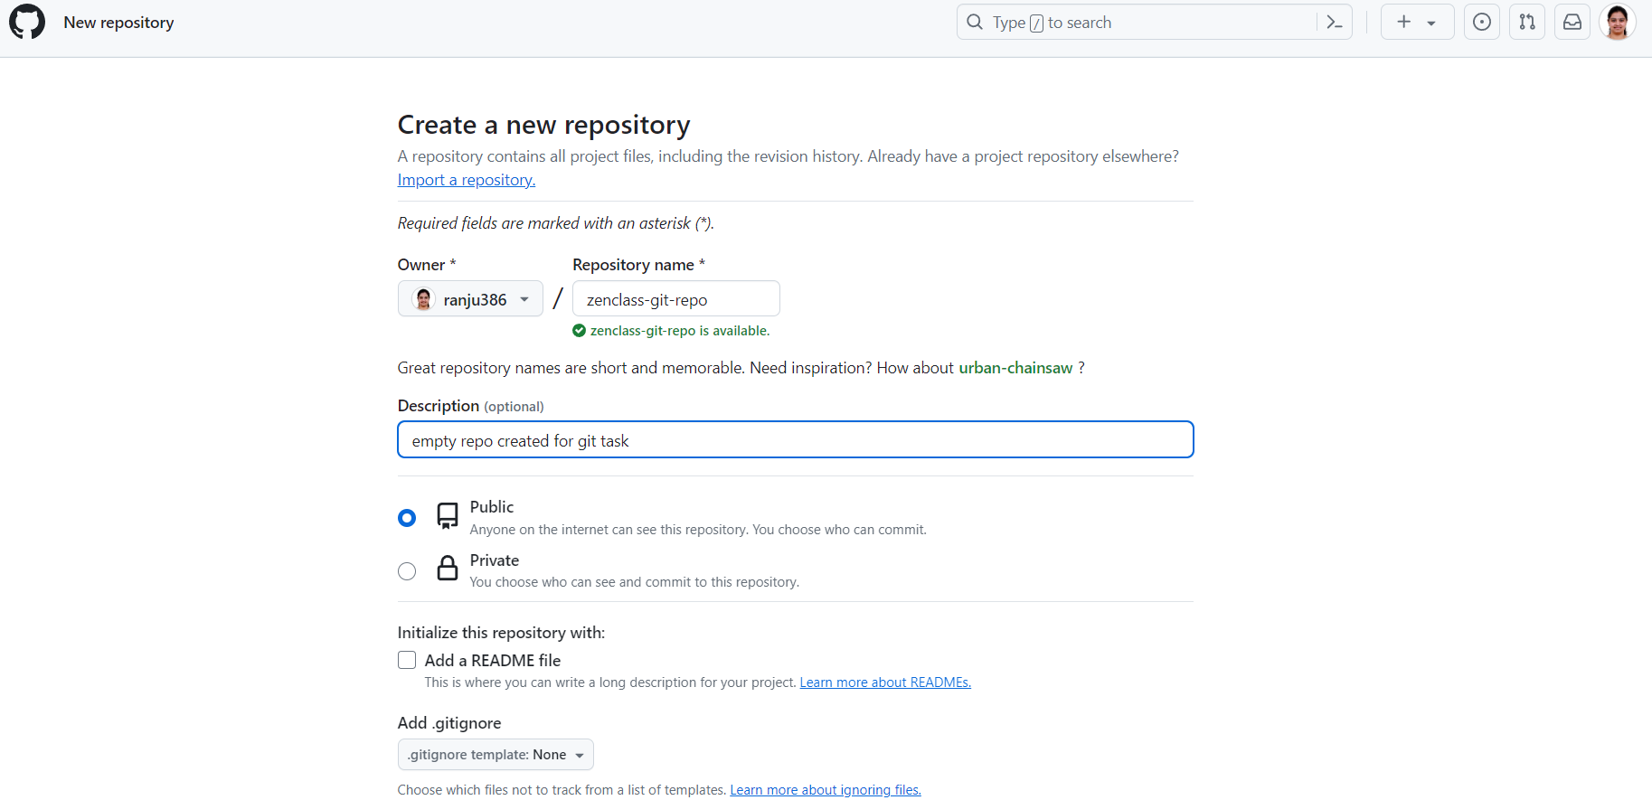

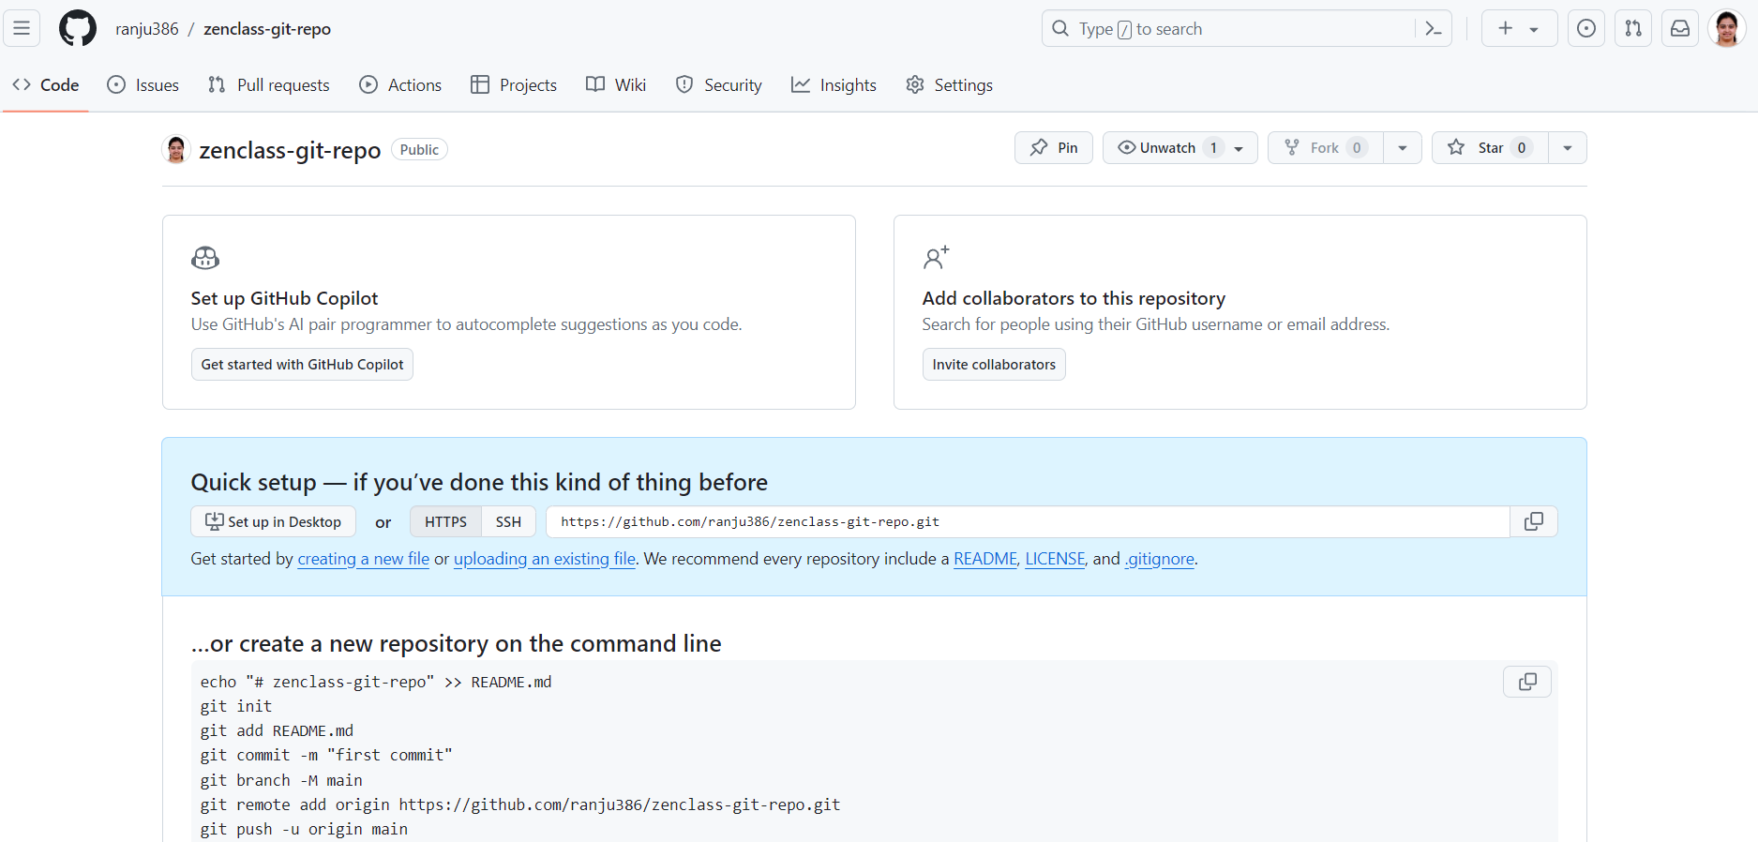

**Convert the Local Directory into a Git Repository and Link it to GitHub**

# Initialize a git repository in your local directory

git init

# Add all the script files to the staging area

git add .

# Commit the changes

git commit -m "Initial commit with script files"

# Add the GitHub repository as a remote and link it

git remote add origin https://github.com/ranju386/zenclass-git-repo.git

# Verify the remote repository

git remote -v

# Push the changes to GitHub

git push -u origin master

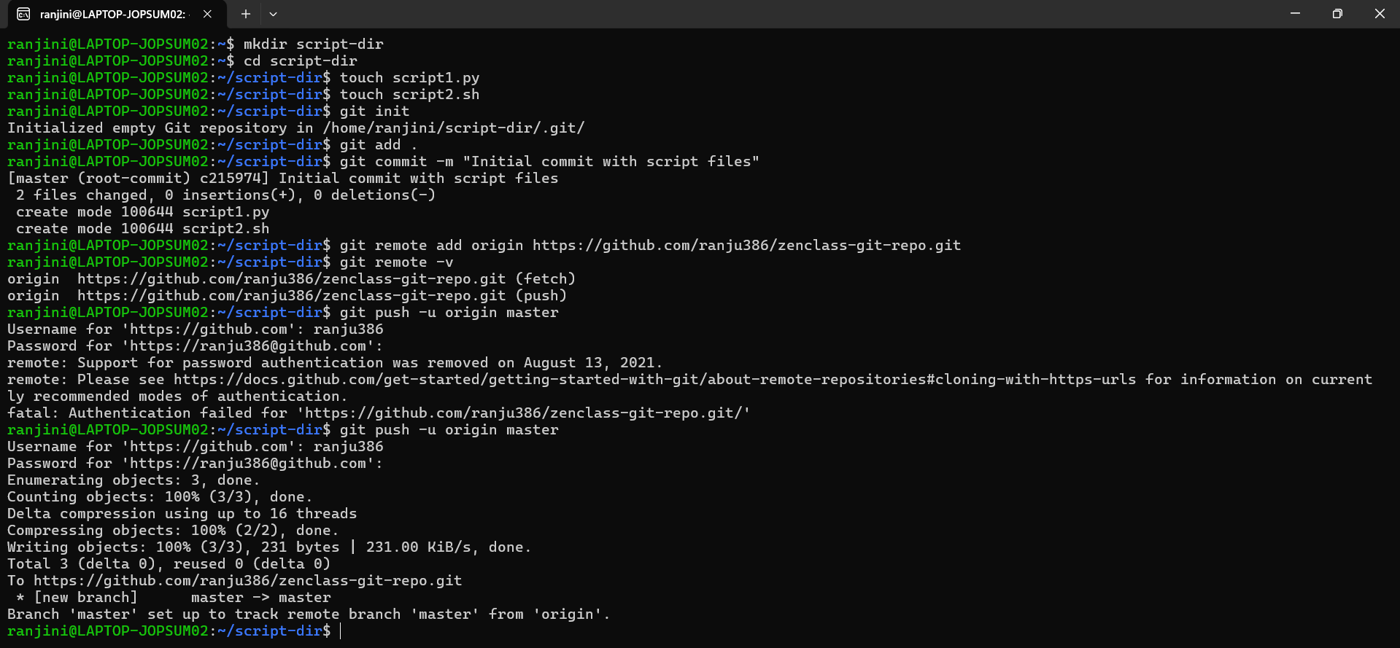

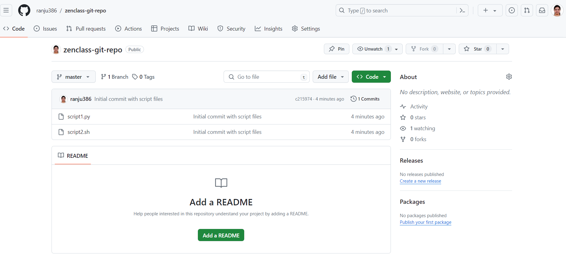

Now your local directory is connected to the GitHub repository, and your script files are pushed to it.