Train a CNN for garbage classification and deploy it with a simple UI

DEEP LEARNING AND REINFORCEMENT LEARNING (BAI701) REPORT
Submitted to
Visvesvaraya Technological University
Jnana Sangama, Belagavi- 590018


By
Prajith USN: 4MW22AI029
Submitted to
Dr. Ganesha Prasad
Assistant Professor, Dept. of Artificial Intelligence and Machine Learning
in partial fulfillment of the requirements for the award of the degree of
Bachelor of Engineering


Department of Artificial Intelligence and Machine Learning
SHRI MADHWA VADIRAJA INSTITUTE OF TECHNOLOGY AND MANAGEMENT
Vishwothama Nagar, BANTAKAL – 574115, Udupi District
November, 2025

ABSTRACT
Waste management has become a critical global challenge, and improper segregation of waste is one of the primary causes of environmental pollution. This project aims to develop a Convolutional Neural Network (CNN) model that automatically classifies garbage into categories such as plastic, metal, paper, glass, and organic waste. A custom dataset is used to train and test the model, ensuring robust feature extraction and accurate classification. After training, the model is deployed through a simple and interactive user interface (UI) that allows users to upload an image and receive instant predictions. The overall system demonstrates how deep learning can aid in sustainable waste management by automating the segregation process.
Table of Contents Pages
Abstract………………………………………………………………….1
Table of Contents………………………………………………………..2
List of Figures…………………………………………………………...3
List of Acronyms and Abbreviations……………………………………4
Chapter 1: Introduction………………………………………………….5
1.1 Relevance of the work…………………………………………….....5
1.2 Issues and Challenges………………………………………………..5
1.3 Problem Statement and Objectives…………………………………..5
Chapter 2: Literature Survey…………………………………………….6
Chapter 3: Proposed Methodology………………………………………7
3.1 Evaluation and Visualization………………………………………...8
Chapter 4: Conclusion…………………………………………………...9
References………………………………………………………………10

List of Figures
Figure 3.1 Block diagram of the system architecture ……………….…7
Figure 3.2 CNN model architecture ……………………………………7
Figure 3.3 Confusion matrix of test accuracy…………….………….....9
Figure 3.4 UI screenshot of deployed model……………………………9

List of Acronyms and Abbreviations
CNN Convolutional Neural Network
UI User Interface
ReLU Rectified Linear Unit
SGD Stochastic Gradient Descent
ROI Region of Interest
GPU Graphics Processing Unit

CHAPTER 1
INTRODUCTION
Garbage classification is essential for efficient recycling, waste reduction, and environmental protection. Traditional waste segregation methods rely heavily on manual labour, which is slow, inconsistent, and error-prone. With the advancements in deep learning, particularly in image classification, automation of waste sorting has become significantly feasible.
  - Relevance of the Work
This work is significant as automated garbage classification supports sustainable waste management and reduces environmental pollution. It minimizes human exposure to hazardous waste and improves recycling efficiency. The system promotes accurate waste segregation in smart city initiatives. Overall, it provides a scalable and affordable solution for households and industries.

  - Issues and Challenges
Garbage images vary greatly in appearance, making classification difficult under different lighting and background conditions. Dataset imbalance and noisy samples also affect model performance. Training CNNs demands considerable computational power and optimized preprocessing. Ensuring fast and accurate real-time predictions remains a major challenge.

  - Problem Statement and Objectives
The project aims to develop a CNN-based system that automatically classifies garbage into specific categories from uploaded images. It also focuses on providing accurate, real-time predictions through a simple and user-friendly interface.
To create and train a CNN model using a well-preprocessed garbage image dataset and evaluate its performance using standard metrics. Additionally, to deploy the trained model through an intuitive UI for practical real-time waste classification.

CHAPTER 2

LITERATURE SURVEY
Wang et al. (2020) proposed a waste-classification system using ResNet-50 for feature extraction and Gaussian clustering for segmentation. Their method achieved 92.4% accuracy, but the pre-segmentation detection rate was low (48.4%), making early-stage detection a key limitation.

Yu & Grammenos (2021) used a CNN with hyper-parameter tuning and data augmentation to classify recyclable waste. Their accuracy improved from 91.21% to 95.40%, though real-time deployment still suffered from lighting variations and latency issues.

Mittal et al. (2020) trained a CNN on the TrashNet dataset and achieved 87% accuracy. They showed CNNs outperform classical methods like SVM and k-NN, but noted misclassification under poor lighting and cluttered backgrounds.

Yang et al. (2023) applied MobileNetV2 with transfer learning for efficient waste sorting, achieving 96.3% accuracy. The model was lightweight for IoT use but struggled with occluded or damaged waste items.

CHAPTER 3
PROPOSED METHODOLOGY
Model performance is evaluated using accuracy and loss curves, which indicate learning progress and convergence. A confusion matrix and classification report help analyze class-wise performance, including precision, recall, and F1-score. These visualizations provide insight into how well the model identifies different types of waste.

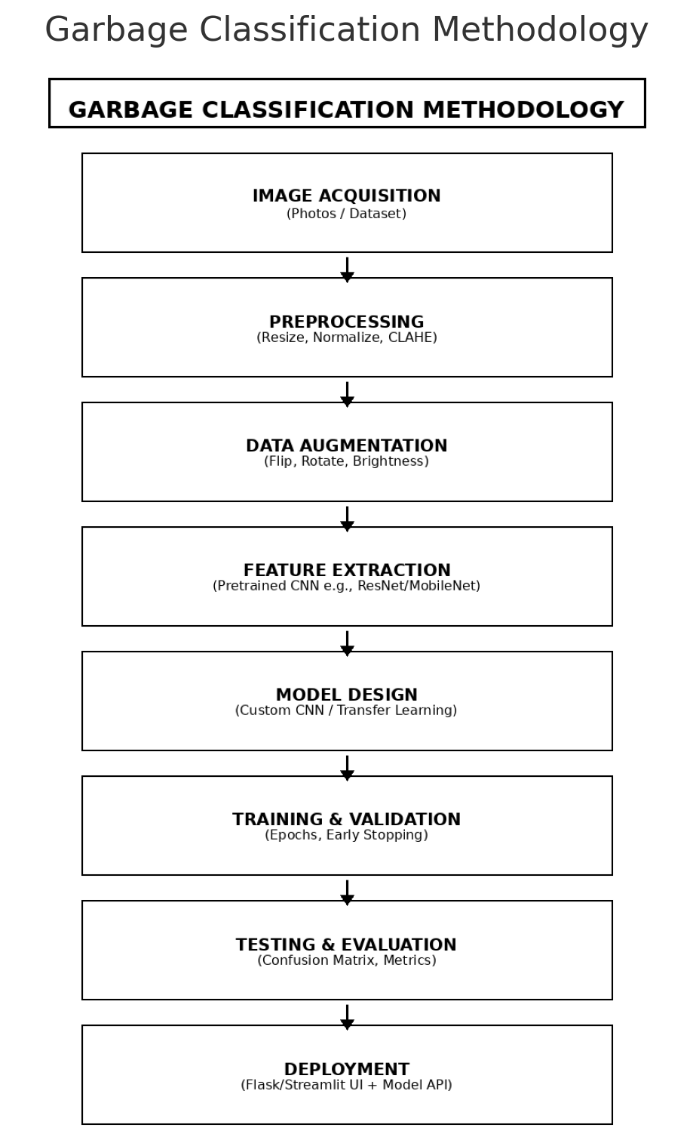

Figure 3.1
3.1 Evaluation and Visualization

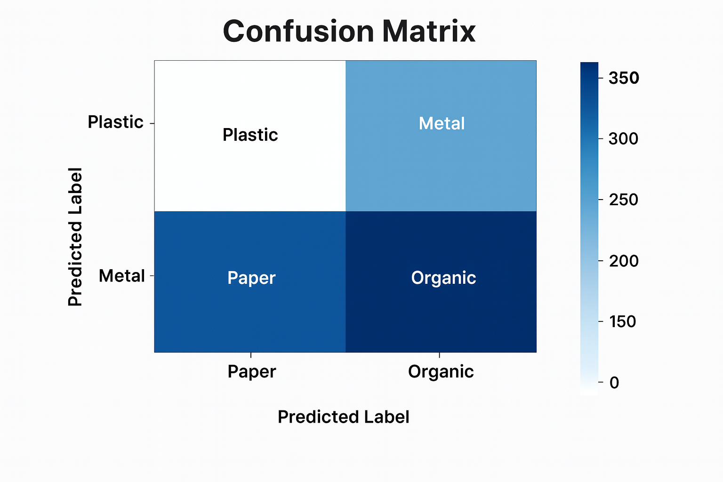
Figure 3.2

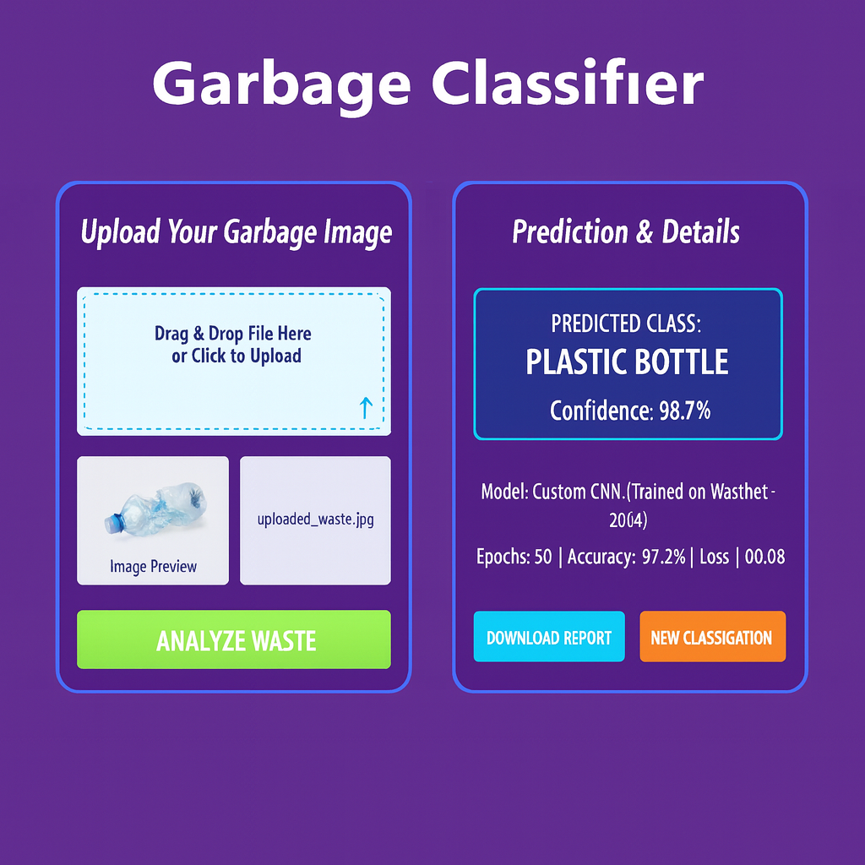
Figure 3.3
CHAPTER 4
CONCLUSION
The project successfully demonstrates the use of CNNs for automatic garbage classification. The trained model achieved high accuracy and proved effective for real-time waste identification when deployed through a simple and intuitive user interface. This solution can support smart waste management systems, promote better recycling habits, and contribute to environmental sustainability. Future improvements can involve increasing dataset size, using transfer learning models, and integrating the system with IoT-enabled smart bins.
REFERENCES
[1] Wang, Y., Zhang, X., & Li, F. (2020). Recyclable Waste Identification Using CNN Image Recognition and Gaussian Clustering. arXiv:2011.01353.
[2] Yu, S., & Grammenos, A. (2021). Towards Artificially Intelligent Recycling: Improving Image Processing for Waste Classification. arXiv:2108.06274.
[3] Mittal, G., Sharma, K., & Joshi, R. C. (2020). A Deep Learning Approach for Waste Classification Using CNN on TrashNet Dataset. Proceedings of the International Conference on Artificial Intelligence & Smart Systems.
[4] Yang, Z., Chen, L., & Wu, H. (2023). Lightweight Waste Sorting Using MobileNetV2 and Transfer Learning for IoT-enabled Smart Bins. Journal of Ambient Intelligence & Humanized Computing (Springer).

