## **Roadrunner Casino**

## By: Kanayo E., Doug R., Ray A., Daniel Q.

## CMPS 3350

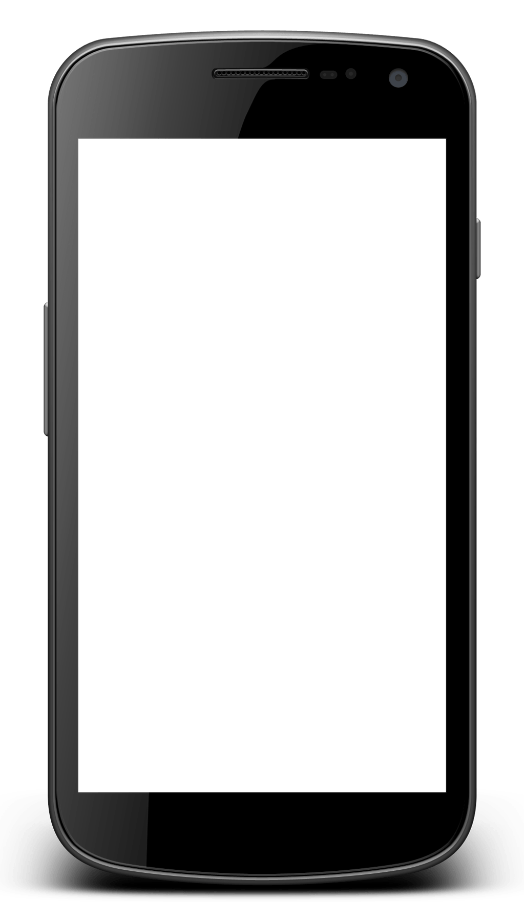

PLAY

HELP

SETTINGS

**Roadrunner**

**Casino**

**Overview:**

With luck not on your side and loan sharks circling in you’re in trouble! Play hands in Blackjack or Poker and try and turn it around. Amass enough cash to pay the loan sharks back and get a one-way ticket home. Starting off with a measly $1,000, you will need to find another $25,000 to get home. Test your skill and turn that luck around!

**Software and Development:**

* Primary language done in Java, as well as some coding in HTML.
* We will be using the Android Studio IDE.
* Inputs will be purely touch.
  + Different on-screen prompts will allow navigation and control throughout the app.

**Product Summary:**

First launching the app, the player is introduced to their situation. After a brief summary they will be able to choose what table to sit at, either Blackjack or Poker. The onscreen UI will allow the player to change their bet before starting the hand. Once the hand is started, they will be able to pick either to hit or stay, Blackjack; or raise, go all-in, fold for Poker. The playing cards will be displayed on screen and use standard playing card formatting and units. The player would also be able to pick between different styles of cards. The deck will simulate a realistic casino shoe and be comprised of multiple decks. Shuffling will occur at certain intervals.