Biochemistry Testing
HUMAN HEALTH SOCIAL

Dear John Smith
Ultimately, the entire body's electro-chemistry depends on the body's
ability to digest and convert food, water, and air into energy. By building
and maintaining the appropriate balance of chemistry within the body we
are able to create the most efficient energy available to us. This energy is
used for healing, recovery, physical performance, mental robustness and
the elimination of toxins
John’s overall ENERGY SCORE : 72/100

Ideal or perfect numbers are expressed as
1.5 6.4/6.4 0.04 7 3/3
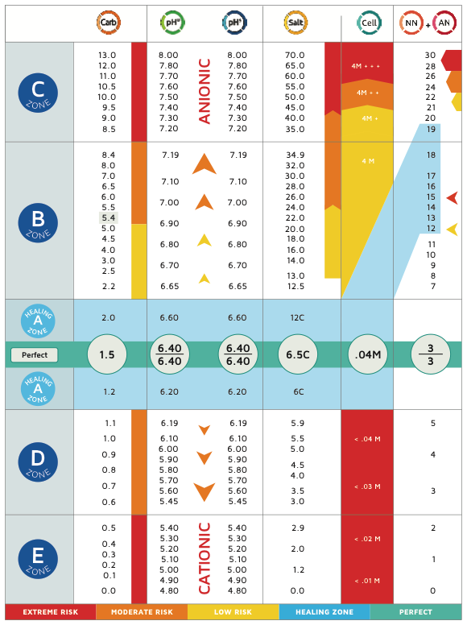
Where:
1.5 is the level of carbohydrate in the urine sample
6.4 is the pH of the urine sample
6.4 is the pH of the saliva sample
0.04 is the amount of cell debris in the urine sample
7 is the measurement of salts and toxins in the urine sample

Further testing will reveal undigested protein and waste in the body.
3 is the measurement of nitrogenous wastes in the urine samples
3 is the measurement of ammoniacal wastes in the urine sample chemical testing will indicate

Any deviations from these numbers would enable a trained practitioner
to know what is needed to be done with detoxing, diet, counselling and
supplements to return a client to ideal health. It is important to note that
no number is ideal when any of the numbers are out of the ideal range.
All other numbers then become compensations.

(LOGO HIGH SUGAR RESULT)

YOUR BIOCHEMISTRY RESULTS

CARBOHYDRATES. (All sugars or total sugars)

JOHN, At the time of the test, Your Carbohydrates are
(…5.2% …) TOO HIGH
SCORE 63/100

Target Healing zone of total carbohydrates is 1.5 to 2.0 or over 92/100

(BLURB..page1?)
The carbohydrate will be too high or too low and indicates:
- Available oxygen
- Potential energy
- Physical, mental and emotional issues
- Seizure potential
- Hyper or Hypoglycaemia
- Possible Pre-Diabetic states
Carbohydrates provide energy in the form of glucose, or blood sugar. Glucose is necessary to support your body's everyday needs and performance. However, if the level is too low or too high then the body ability to create energy is compromised. Some Carbs last longer than others. Some carbs come form processed sugar and others from food and fluids.
Carbs provide your body with energy. One of the primary functions of carbohydrates is to provide your body and brain with energy to sustain life.
When taken with the other numbers suggest imbalanced sugars with hyperglycaemic (high sugar) tendencies. This will lead to the oxygen and glucose in the blood at times becoming unavailable because of thick congested viscous blood.
Difficult for nutrients to get to outer extremities, because of the high sugar energy levels
Wasted energy like a rich fuel mix for a lawnmower,

HIGH SUGAR ONLY
Carb results 5.5 and above will reflect on and/or may cause;
- Skin Health
- Heart health
- Feeling too hot or too cold
- Restless legs
- Hyper-glycaemic
- (pre)- Diabetes
MAY include: Adrenal fatigue, low energy, mood swings or just feeling real highs then real lows. Depression, skin irritations, headaches ,stress and uncontrolled emotional outbursts.

SOLUTIONS…ANSWERS ….WHAT TO DO
Reduce or eliminate added sugars and simple carbohydrate foods
Eat more low GI foods such as cooked vegetables and healthy salads
Less alcohol, sweets or grains.
Try extended deep breathing
Look for all the places that are stressful in your life and reduce the points of stress.
Drink the correct amount of water
Eat small frequent meals
Always go by the numbers.
NEXT STEP. WEBSITE LINKS VIDEOS………………
CONATCT DETAILS. ………………………………….

High Sugars
making blood thick and heavy, which is harder
for the heart to push around your body. Therefore, the heart has to work
harder and you become more tired and can lack motivation and energy.
Energy and thinking can become erratic. This is known as the zone of
misery as the bodies biochemistry can change rapidly affecting moods and
energy.

Symptoms TOO HIGH SUGAR READING
Some of the more common symptoms that you may experience
with this pattern at times: are muscle and joint pain, nervousness, anxiety,
irritability, exhaustion, faintness, dizziness, tremor, cold sweats, weak spells,
depression, drowsiness, headaches, digestive disturbances, forgetfulness,
skin irritations, sugar cravings, carbohydrate cravings, alcohol addiction,
worrying and insomnia.

