Biochemistry Testing
HUMAN HEALTH SOCIAL

Dear John Smith
Ultimately, the entire body's electro-chemistry depends on the body's
ability to digest and convert food, water, and air into energy. By building
and maintaining the appropriate balance of chemistry within the body we
are able to create the most efficient energy available to us. This energy is
used for healing, recovery, physical performance, mental robustness and
the elimination of toxins
John’s overall ENERGY SCORE : 72/100

Ideal or perfect numbers are expressed as
1.5 6.4/6.4 0.04 7 3/3
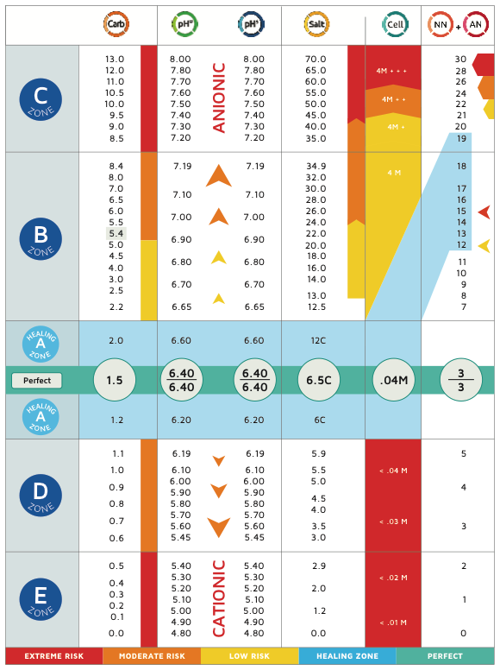
Where:
1.5 is the level of carbohydrate in the urine sample
6.4 is the pH of the urine sample
6.4 is the pH of the saliva sample
0.04 is the amount of cell debris in the urine sample
7 is the measurement of salts and toxins in the urine sample

Further testing will reveal undigest protein and waste in the body.
3 is the measurement of nitrogenous wastes in the urine samples
3 is the measurement of ammoniacal wastes in the urine sample chemical testing will indicate

Any deviations from these numbers would enable a trained practitioner
to know what is needed to be done with detoxing, diet, counselling and
supplements to return a client to ideal health. It is important to note that
no number is ideal when any of the numbers are out of the ideal range.
All other numbers then become compensations.

(LOGO)

YOUR BIOCHEMISTRY RESULTS

CARBOHYDRATES. (All sugars or total sugars)

JOHN, At the time of the test, Your Carbohydrates are(…0.9% …) TOO LOW

SCORE 54/100
Healing zone of total carbohydrates is 1.5 to 2.0 over 92%

When taken with the other numbers suggest imbalanced sugars with hypoglycaemic (low sugar) tendencies. This will lead to the oxygen and glucose in the blood at times becoming unavailable
to the cells and the brain, because of the low sugar energy levels not enough to go around.
NOT enough energy for the things you like and need to do.

Symptoms or Indicators
MAY include: Adrenal fatigue, low energy, mood swings or just feeling low. Depression, skin irritatio s, headaches ,forgetfulness anxiety and worrying.

SOLUTIONS…ANSWERS ….WHAT TO DO
Eat small frequent meals
Balance your intake of protein, fats and carbohydrates
Reduce or eliminate added sugars and simple carbohydrate foods
Eat more low GI foods such as cooked vegetables and healthy salads
Less alcohol, sweets or grains.
Check with an experienced kinesiologist for any food sensitivities or
Intolerances. Support liver and pancreas function and appropriate supplements including digestive enzymes
Always go by the numbers.
NEXT STEP. WEBSITE LINKS VIDEOS………………
CONATCT DETAILS. ………………………………….

