Physics Problem Set: Mechanics
  - Questions, answers and fully worked solutions (from Sheets 1-3)
Each problem is given in the order Question → Answer → Solution. The source sheet and original question number are shown under each heading.

Question 1
Source: Sheet 1, Q.3
A tour boat leaves Siófok and travels at a constant speed of $18 \text{km/h}$. It first moves north for a quarter of an hour, then turns and travels west for another quarter of an hour, then turns again and travels south for a quarter of an hour, and finally travels east for a quarter of an hour.
- Taking the curvature of the Earth into account, estimate how far the boat will be from its starting point at the end of the tour.
- The mass of the boat is 500 tonnes. By how much is the weight of the boat smaller while it travels east than while it travels west?
Answer:
(a) about $3.4 \text{m}$ (the boat ends up west of the starting point)
(b) $ΔG=4mωvcosφ≈500 \text{N}$
Solution:
(a) Each leg is
$$s=vt=18 \text{km/h}⋅0.25 \text{h}=4.5 \text{km}.$$
The north and south legs are along meridians and cancel exactly. The east and west legs, however, are along circles of latitude of different radii. Siófok lies at latitude $φ≈46.9°$. Going north by $s$ changes the latitude by $δ=s/R$ ($R=6371 \text{km}$). The westward leg is at latitude $φ+δ$, where the circle of latitude has the smaller radius $Rcos(φ+δ)$, so it covers a larger change of longitude than the eastward leg at latitude $φ$:
$$Δλ=\frac{s}{Rcos(φ+δ)}−\frac{s}{Rcosφ}.$$
At the starting latitude this longitude difference corresponds to the distance
$$d=Rcosφ Δλ=s\left(\frac{cosφ}{cos(φ+δ)}−1\right)≈s δtanφ=\frac{s^{2}tanφ}{R}.$$
$$d≈\frac{(4500 \text{m})^{2}⋅tan46.9°}{6.371×{10}^{6} \text{m}}≈3.4 \text{m}.$$
The boat finishes about $3.4 \text{m}$ west of where it started.
(b) In the rotating frame of the Earth a moving body feels the Coriolis force $−2m\vec{ω}×\vec{v}$. For horizontal east–west motion its vertical component is $2mωvcosφ$, directed upward for eastward motion and downward for westward motion (Eötvös effect). The centrifugal-type terms proportional to $v^{2}/R$ are the same for both directions and cancel in the difference. Hence
$$ΔG=G_{\text{west}}−G_{\text{east}}=4mωvcosφ,$$
with $m=5×{10}^{5} \text{kg}$, $ω=7.29×{10}^{−5} {\text{s}}^{−1}$, $v=5 \text{m/s}$:
$$ΔG=4⋅5×{10}^{5} \text{kg}⋅7.29×{10}^{−5} {\text{s}}^{−1}⋅5 \text{m/s}⋅cos46.9°≈5.0×{10}^{2} \text{N}.$$
The weight is about $500 \text{N}$ smaller when travelling east — roughly ${10}^{−4}$ of the weight $mg≈4.9×{10}^{6} \text{N}$.
Note: the original sheet gives the correct formula but states $≈50 \text{N}$; evaluating it gives about $500 \text{N}$.

Question 2
Source: Sheet 1, Q.4
The two ends of an $8 \text{m}$ long weightless thread are fixed at the same height, $4 \text{m}$ apart. An object of mass $10 \text{kg}$ is hung on the thread so that it can slide along it without friction.
- What horizontal force must be exerted on the object to keep it at rest on the thread exactly below one of the endpoints?
- If the object is released from this position, what maximum speed does it reach?
Answer:
(a) $F=mg/2≈49 \text{N}$
(b) $v_{max}≈3.0 \text{m/s}$
Solution:
(a) Let the object hang directly below endpoint $A$. Call the length of the vertical piece $a$ and the slanted piece (to endpoint $B$) $b$. Then $a+b=8 \text{m}$ and, by Pythagoras, $b^{2}=a^{2}+(4 \text{m})^{2}$:
$$(8−a)^{2}=a^{2}+16⇒a=3 \text{m}, b=5 \text{m}.$$
Because the object slides without friction, the tension $T$ is the same in both pieces. The slanted piece makes an angle with $cosβ=3/5$ with the vertical and $sinβ=4/5$. Equilibrium:
$$T+T⋅\frac{3}{5}=mg⇒T=\frac{5}{8}mg,$$
$$F=T⋅\frac{4}{5}=\frac{mg}{2}=\frac{10 \text{kg}⋅9.81 {\text{m/s}}^{2}}{2}≈49 \text{N}.$$
The force must point away from $B$ (it balances the horizontal pull of the slanted thread).
(b) Since the sum of the distances from $A$ and $B$ is constant, the object moves along an ellipse with foci $A$ and $B$. No work is done by the tension (it is perpendicular to the path), so mechanical energy is conserved and the speed is greatest at the lowest point, which by symmetry is midway between the endpoints. There each half of the thread is $4 \text{m}$ long and the depth below the endpoints is
$$h_{\text{low}}=\sqrt{(4 \text{m})^{2}−(2 \text{m})^{2}}=\sqrt{12} \text{m}≈3.464 \text{m}.$$
The starting depth was $3 \text{m}$, so the object drops by $Δh=0.464 \text{m}$:
$$v_{max}=\sqrt{2g Δh}=\sqrt{2⋅9.81 {\text{m/s}}^{2}⋅0.464 \text{m}}≈3.0 \text{m/s}.$$

Question 3
Source: Sheet 1, Q.5
A uniform solid disc of mass $m=5 \text{kg}$ and radius $R=10 \text{cm}$ is set spinning at angular speed $ω_{0}=120 {\text{s}}^{−1}$ about its symmetry axis, which is horizontal. It is then carefully placed on the horizontal ground with no initial translational velocity. The coefficient of friction between the disc and the ground is $μ=0.4$.
Determine the work done by the friction force on the disc while the disc covers a distance of $s=5 \text{m}$. Show that the result is the same whether the work–kinetic energy theorem is used or the product of the force and the displacement is calculated.
Answer: $W_{\text{friction}}=−120 \text{J}$ (the kinetic energy decreases from $180 \text{J}$ to $60 \text{J}$; friction acts only during the first $2.04 \text{m}$)
Solution:
Motion. At first the disc slips: the bottom point moves backward, so kinetic friction $S=μmg$ acts forward. It accelerates the centre and decelerates the rotation:
$$a=μg=3.92 {\text{m/s}}^{2}, β=\frac{SR}{\frac{1}{2}mR^{2}}=\frac{2μg}{R}.$$
Slipping stops when $v=ωR$. The angular momentum about the contact point is conserved (friction passes through it, gravity and normal force cancel):
$$\frac{1}{2}mR^{2}ω_{0}=\frac{1}{2}mR^{2}ω+mvR⇒v=\frac{ω_{0}R}{3}=4 \text{m/s}.$$
This takes $t_{1}=v/(μg)=1.02 \text{s}$ and a distance $s_{1}=v^{2}/(2μg)=2.04 \text{m}<5 \text{m}$. Afterwards the disc rolls without slipping at constant speed and no friction is needed, so friction does work only during the first $2.04 \text{m}$.
Work–kinetic energy theorem.
$$E_{0}=\frac{1}{2}⋅\frac{1}{2}mR^{2}ω_{0}^{2}=\frac{1}{4}⋅5 \text{kg}⋅(0.1 \text{m})^{2}⋅(120 {\text{s}}^{−1})^{2}=180 \text{J},$$
$$E_{1}=\frac{1}{2}mv^{2}+\frac{1}{2}⋅\frac{1}{2}mR^{2}ω^{2}=\frac{3}{4}mv^{2}=\frac{3}{4}⋅5 \text{kg}⋅(4 \text{m/s})^{2}=60 \text{J},$$
$$W=E_{1}−E_{0}=−120 \text{J}.$$
Force times displacement. The work of a force equals the force times the displacement of the material point where it acts. Here the friction force acts on the bottom point of the disc, whose velocity relative to the ground is $u=ωR−v$ (backward). Its rate of change is
$$\frac{du}{dt}=−βR−a=−3μg,$$
so $u$ decreases uniformly from $12 \text{m/s}$ to zero in $t_{1}=12/(3μg)=1.02 \text{s}$. The slip distance is
$$s_{\text{rel}}=\frac{12 \text{m/s}}{2}⋅1.02 \text{s}=6.12 \text{m}.$$
The force ($μmg=19.6 \text{N}$, forward) is opposite to this displacement (backward):
$$W=−μmg s_{\text{rel}}=−19.62 \text{N}⋅6.12 \text{m}≈−120 \text{J}.$$
(Equivalently: translational work $+μmg s_{1}=+40 \text{J}$ plus rotational work $−μmgR Δφ=−160 \text{J}$.) Both methods give $−120 \text{J}$, which is dissipated as heat.

Question 4
Source: Sheet 1, Q.9
A soap film of surface tension $σ$ is formed in the circular frame shown in the figure; the diameter of the frame is $l$. An unstretched hair of length $l$, Young’s modulus $E$ (and cross-sectional area $A$) joins the points $P$ and $Q$. By how much is the hair elongated if the film on the right-hand side is pricked with a hot pin? (The endpoints of the hair are fixed and its weight is negligible. For small angles use the approximation $sinα≈α−α^{3}/6$.)
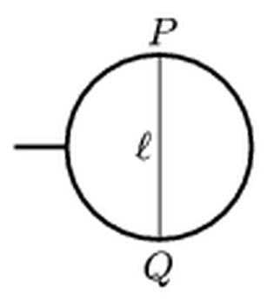
Figure: circular frame with a hair PQ along a diameter
Answer: $Δl=\frac{l}{6}{\left(\frac{6lσ}{EA}\right)}^{2/3}$
Solution:
After the right-hand film is destroyed, the left-hand film pulls the hair to the left. A soap film has two surfaces, so it pulls on every unit length of the hair with the force $2σ$, perpendicular to the hair. A string under a uniform perpendicular load per unit length $q$ takes the shape of a circular arc, with tension
$$T=qρ=2σρ,$$
where $ρ$ is the radius of curvature. Let the arc subtend the half-angle $α$ at its centre. The chord is fixed:
$$l=2ρsinα,$$
and the arc is the stretched hair:
$$l+Δl=2ρα.$$
Subtracting and using $sinα≈α−α^{3}/6$:
$$Δl=2ρ(α−sinα)≈\frac{ρα^{3}}{3}.$$
To lowest order $ρ≈l/(2α)$, so
$$Δl≈\frac{lα^{2}}{6}.$$
Hooke’s law for the hair gives the tension:
$$T=EA\frac{Δl}{l}=\frac{EAα^{2}}{6}.$$
Setting this equal to $T=2σρ=σl/α$:
$$\frac{EAα^{2}}{6}=\frac{σl}{α}⇒α={\left(\frac{6lσ}{EA}\right)}^{1/3}.$$
Therefore the elongation is
$$Δl=\frac{l}{6}{\left(\frac{6lσ}{EA}\right)}^{2/3}.$$

Question 5
Source: Sheet 1, Q.11
A 20-litre plastic can contains petrol. The can floats on the water of a lake with one third of its volume above the water. The mass of the empty can is $0.78 \text{kg}$, the density of petrol is $720 {\text{kg/m}}^{3}$ and the density of the plastic is $1300 {\text{kg/m}}^{3}$. Approximately how many litres of petrol are in the can?
Answer: about $18$ litres
Solution:
The 20 litres is the internal capacity; the plastic wall adds its own volume:
$$V_{\text{plastic}}=\frac{0.78 \text{kg}}{1300 {\text{kg/m}}^{3}}=6.0×{10}^{−4} {\text{m}}^{3}=0.6 \text{L}.$$
The total external volume of the can is $V=20.6 \text{L}$, and two thirds of it is under water:
$$V_{\text{sub}}=\frac{2}{3}⋅20.6 \text{L}=13.73 \text{L}.$$
Archimedes’ principle (floating equilibrium): the weight of the can plus petrol equals the weight of displaced water (the air in the can is negligible):
$$m_{\text{can}}+m_{\text{petrol}}=ρ_{w}V_{\text{sub}}=1000 {\text{kg/m}}^{3}⋅13.73×{10}^{−3} {\text{m}}^{3}=13.73 \text{kg},$$
$$m_{\text{petrol}}=13.73 \text{kg}−0.78 \text{kg}=12.95 \text{kg},$$
$$V_{\text{petrol}}=\frac{12.95 \text{kg}}{720 {\text{kg/m}}^{3}}≈0.018 {\text{m}}^{3}=18 \text{L}.$$
(If the wall volume were ignored, one would get about $17.4 \text{L}$, so the answer is approximately 18 litres either way.)

Question 6
Source: Sheet 1, Q.12
A small object is fixed to the rim of a hoop of radius $r$; the object and the hoop have equal masses. The hoop is placed in a fixed, rough semi-cylindrical trough of radius $R$ so that the small object is at the top. Find the smallest ratio $r/R$ for which the equilibrium of the hoop is stable.
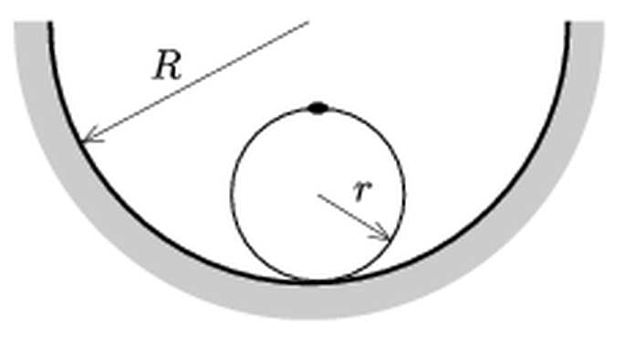
Figure: hoop with a small mass on top, resting in a semi-cylindrical trough
Answer: the equilibrium is stable if $r/R>1/3$
Solution:
Since the trough is rough, the hoop rolls without slipping. Equilibrium is stable if the potential energy (the height of the common centre of mass) has a minimum.
The centre of mass of the system (hoop of mass $m$ with centre $C$, point mass $m$ on its rim) lies halfway between $C$ and the small object, i.e. at distance $r/2$ from $C$, initially directly above $C$.
Let the line from the trough’s axis $O$ to $C$ turn by a small angle $φ$ from the vertical. $C$ moves on a circle of radius $R−r$, so its height is
$$y_{C}=−(R−r)cosφ.$$
Rolling without slipping ($Rφ$ arc on the trough equals the arc on the hoop) means that the hoop rotates in the opposite sense by the angle
$$θ=\frac{(R−r)φ}{r}.$$
Hence the height of the centre of mass is
$$y=−(R−r)cosφ+\frac{r}{2}cosθ.$$
For small angles, $cosx≈1−x^{2}/2$:
$$y≈\text{const}+\frac{(R−r)φ^{2}}{2}\left(1−\frac{R−r}{2r}\right).$$
The equilibrium is stable if the coefficient of $φ^{2}$ is positive:
$$1−\frac{R−r}{2r}>0⇒3r>R⇒\frac{r}{R}>\frac{1}{3}.$$
So the smallest ratio is $r/R=1/3$; for any hoop with $R/3<r<R$ the equilibrium is stable.

Question 7
Source: Sheet 1, Q.13
On a smooth horizontal table a spring lies with one end fixed; at its other end a ball of mass $M=1.15 \text{kg}$ is at rest. Another ball of mass $m=1.00 \text{kg}$ hangs on a vertical thread of length $l=0.30 \text{m}$ and touches the first ball. The hanging ball is pulled aside until the thread is horizontal and released from rest. At the moment of impact its velocity is parallel to the axis of the spring. The collision is perfectly elastic. (Friction and the mass of the spring are negligible.)
- What should the spring constant be so that the second collision of the balls occurs at the same place as the first?
- How much time elapses between the two collisions?
- After the first collision, what is the maximum distance between the two balls?
Answer:
(a) $k=Mg/l≈37.6 \text{N/m}$
(b) $t=π\sqrt{l/g}≈0.55 \text{s}$
(c) $d_{max}=\sqrt{2} l≈0.42 \text{m}$
Solution:
Speed before the collision (energy conservation for the pendulum):
$$v=\sqrt{2gl}=\sqrt{2⋅9.81 {\text{m/s}}^{2}⋅0.30 \text{m}}=2.43 \text{m/s}.$$
Elastic collision (target at rest):
$$u_{m}=\frac{m−M}{m+M}v=−0.169 \text{m/s}, u_{M}=\frac{2m}{m+M}v=2.26 \text{m/s}.$$
The pendulum ball bounces back slowly; the ball $M$ starts a harmonic oscillation on the spring.
(a) After the collision both balls perform harmonic oscillations starting from the collision point (their equilibrium positions). Each returns to that point after half of its own period. The pendulum ball swings with a tiny amplitude ($0.169/5.72≈3 \text{cm}$), so its motion is simple harmonic with $T_{p}=2π\sqrt{l/g}$. The ball on the spring has $T_{s}=2π\sqrt{M/k}$. For them to meet again at the same point (each at its equilibrium position after half a period), the periods must be equal:
$$\sqrt{\frac{M}{k}}=\sqrt{\frac{l}{g}}⇒k=\frac{Mg}{l}=\frac{1.15 \text{kg}⋅9.81 {\text{m/s}}^{2}}{0.30 \text{m}}≈37.6 \text{N/m}.$$
(b) The time between the collisions is half a period:
$$t=π\sqrt{\frac{l}{g}}=π\sqrt{\frac{0.30 \text{m}}{9.81 {\text{m/s}}^{2}}}≈0.55 \text{s}.$$
(c) With the common angular frequency $ω=\sqrt{g/l}=5.72 {\text{s}}^{−1}$, the two balls move in opposite directions:
$$x_{M}=\frac{u_{M}}{ω}sinωt, x_{m}=−\frac{\left|u_{m}\right|}{ω}sinωt.$$
Their separation is $(u_{M}+\left|u_{m}\right|)sin(ωt)/ω$, which is greatest at $ωt=π/2$. Since $u_{M}+\left|u_{m}\right|=v$ (relative speed is unchanged in an elastic collision),
$$d_{max}=\frac{v}{ω}=\sqrt{2gl}\sqrt{\frac{l}{g}}=\sqrt{2} l≈0.42 \text{m}.$$
Note: the original sheet gives “approximately 43 cm”; the exact value is $\sqrt{2}⋅30 \text{cm}=42.4 \text{cm}$.

Question 8
Source: Sheet 1, Q.14
An iron rod of length $L$ is suspended from a single point by two threads of length $l$ attached to its two ends. The rod is displaced slightly in the plane of the threads. For what thread length is the period of the swinging smallest, and what is this period?
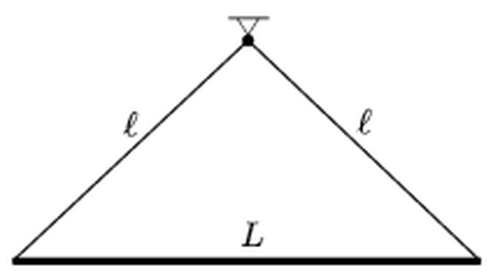
Figure: rod of length L hung from a point by two threads of length l
Answer: $l=L/\sqrt{3}≈0.58L$; $T_{min}=2π\sqrt{\frac{L}{\sqrt{3} g}}$
Solution:
The threads and rod form a rigid triangle, so the rod swings as a physical pendulum about the suspension point. The distance of the rod’s centre (its centre of mass) from the pivot is
$$d=\sqrt{l^{2}−\frac{L^{2}}{4}}.$$
The moment of inertia about the pivot (Steiner’s theorem):
$$Θ=\frac{1}{12}mL^{2}+md^{2}.$$
The period of a physical pendulum is
$$T=2π\sqrt{\frac{Θ}{mgd}}=2π\sqrt{\frac{1}{g}\left(\frac{L^{2}}{12d}+d\right)}.$$
The expression in the bracket has the form $a/d+d$, which is minimal when $d=\sqrt{a}$ (AM–GM inequality, or set the derivative to zero):
$$d=\frac{L}{\sqrt{12}}=\frac{L}{2\sqrt{3}}.$$
The corresponding thread length:
$$l^{2}=d^{2}+\frac{L^{2}}{4}=\frac{L^{2}}{12}+\frac{3L^{2}}{12}=\frac{L^{2}}{3}⇒l=\frac{L}{\sqrt{3}}.$$
(The threads then meet at an angle of $120°$.) The minimal period, with $L^{2}/(12d)+d=2d=L/\sqrt{3}$:
$$T_{min}=2π\sqrt{\frac{L}{\sqrt{3} g}}.$$

Question 9
Source: Sheet 1, Q.21
Every morning two runners run around the track of a stadium at constant speeds. If they run in the same direction, the time between two consecutive meetings is 11 times longer than when they run in opposite directions. What is the ratio of their speeds?
Answer: $v_{1}:v_{2}=6:5=1.2$
Solution:
Let the track length be $C$ and the speeds $v_{1}>v_{2}$.
Running in the same direction, the faster runner must gain a full lap on the slower one between meetings:
$$t_{\text{same}}=\frac{C}{v_{1}−v_{2}}.$$
Running in opposite directions, together they cover one full lap between meetings:
$$t_{\text{opp}}=\frac{C}{v_{1}+v_{2}}.$$
The condition $t_{\text{same}}=11 t_{\text{opp}}$ gives
$$v_{1}+v_{2}=11(v_{1}−v_{2})⇒12v_{2}=10v_{1}⇒\frac{v_{1}}{v_{2}}=\frac{6}{5}=1.2.$$

Question 10
Source: Sheet 1, Q.22
Is it true that the gravitational force exerted by the Earth on the Moon is smaller than that exerted by the Sun on the Moon? If so, why does the Moon orbit the Earth rather than the Sun?
Answer: Yes: the Sun’s pull on the Moon is about 2.2 times the Earth’s ($5.9×{10}^{−3}$ versus $2.7×{10}^{−3} {\text{m/s}}^{2}$). The Moon does orbit the Sun — together with the Earth. The Sun gives the Earth and the Moon almost the same acceleration, so relative to the Earth only the tiny difference (the tidal acceleration, about $3×{10}^{−5} {\text{m/s}}^{2}$) counts, and the Earth’s pull dominates the relative motion.
Solution:
Comparing the forces. The gravitational field strength $g=GM/r^{2}$ at the Moon’s position due to each body:
$$g_{E}=\frac{GM_{E}}{r_{EM}^{2}}=\frac{3.99×{10}^{14} {\text{m}}^{3}/{\text{s}}^{2}}{(3.84×{10}^{8} \text{m})^{2}}≈2.7×{10}^{−3} {\text{m/s}}^{2},$$
$$g_{S}=\frac{GM_{S}}{r_{SM}^{2}}=\frac{1.33×{10}^{20} {\text{m}}^{3}/{\text{s}}^{2}}{(1.50×{10}^{11} \text{m})^{2}}≈5.9×{10}^{−3} {\text{m/s}}^{2}.$$
So the Sun pulls the Moon about 2.2 times more strongly than the Earth does — the statement is true.
Why the Moon still circles the Earth. The Moon actually does orbit the Sun: the Earth–Moon system as a whole travels around the Sun once a year, and the Sun’s attraction provides the centripetal acceleration of this annual motion. In fact the Moon’s path around the Sun is everywhere curved toward the Sun.
The Earth, however, is accelerated by the Sun in practically the same way as the Moon, since both are at nearly the same distance from it. When we describe the Moon’s motion relative to the Earth, the common acceleration drops out; only the difference between the Sun’s pull on the Moon and on the Earth (the tidal acceleration) remains:
$$Δg≈\frac{2GM_{S} r_{EM}}{r_{SM}^{3}}≈3×{10}^{−5} {\text{m/s}}^{2}.$$
This is about a hundred times smaller than $g_{E}$. Therefore, in the frame moving with the Earth, the Earth’s attraction governs the motion and the Moon circles the Earth, while the Sun only slightly perturbs this orbit.

Question 11
Source: Sheet 1, Q.24
A train travelling at speed $v_{0}$ decelerates uniformly over a time $T$ until it stops. A small object lies on the floor of one of the wagons; the coefficient of friction between it and the floor is $μ$. How far does the object slide along the floor, and for how long does it move?
Answer: If $v_{0}/T≤μg$ the object does not slide at all. If $v_{0}/T>μg$ (and the wagon is long enough), it slides for $t=v_{0}/(μg)$ and covers $s=\frac{v_{0}^{2}}{2μg}−\frac{v_{0}T}{2}$ along the floor.
Solution:
The train’s deceleration is
$$a_{0}=\frac{v_{0}}{T}.$$
Friction can give the object a deceleration of at most $μg$ (taking static and kinetic coefficients equal).
Case 1: $a_{0}≤μg$. Static friction can decelerate the object together with the wagon, so the object stays at rest relative to the floor: $s=0$.
Case 2: $a_{0}>μg$. The object slides forward relative to the floor from the very beginning. In the ground frame it decelerates uniformly at $μg$ (kinetic friction backward), so it stops (relative to the ground) after
$$t=\frac{v_{0}}{μg}.$$
This is longer than $T$, so the train is already at rest when the object stops; from then on the object is at rest relative to the floor too. Hence the object moves for $t=v_{0}/(μg)$.
Distances relative to the ground:
$$s_{\text{object}}=\frac{v_{0}^{2}}{2μg}, s_{\text{train}}=\frac{v_{0}T}{2}.$$
The distance covered along the floor is their difference:
$$s=\frac{v_{0}^{2}}{2μg}−\frac{v_{0}T}{2}=\frac{v_{0}}{2}\left(\frac{v_{0}}{μg}−T\right).$$
This is positive exactly when $v_{0}/T>μg$, as expected. The result assumes the wagon is long enough so that the object does not hit the front wall.

Question 12
Source: Sheet 2, Q.1
A small object of mass $m=0.4 \text{kg}$ is threaded on a vertical ring of radius $r=30 \text{cm}$ with centre $O$, along which it can move without friction. One end of a spring of spring constant $D=16 \text{N/m}$ and natural length $30 \text{cm}$ is attached to the object; the other end is fixed at point $A$, the right end of the horizontal diameter. The object is released from rest at point $B$ (the left end of the horizontal diameter). Find its speed when it passes the lowest point $C$. What force does the object exert on the ring there, and what is the direction of its acceleration at $C$?
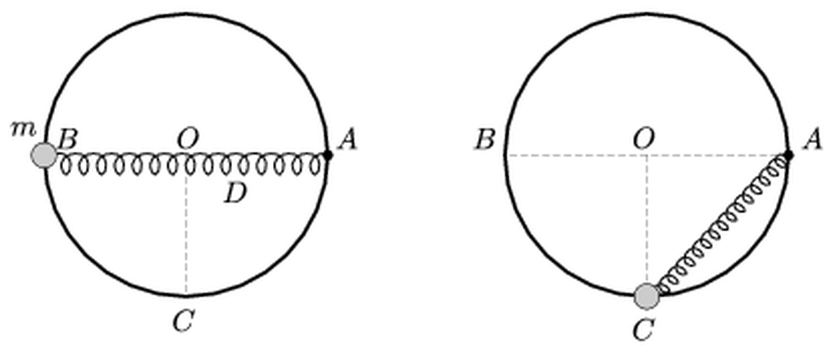
Figure: ring with spring from A to the object, initially at B, then at C
Answer: $v_{C}=\sqrt{2gr+2\frac{D}{m}r^{2}(\sqrt{2}−1)}≈2.98 \text{m/s}$; the object presses on the ring with $N=3mg+Dr\left(\frac{5}{\sqrt{2}}−3\right)≈14.3 \text{N}$, vertically downward; its acceleration points upward, tilted about $6.8°$ from the vertical toward $A$.
Solution:
Spring extensions. At $B$ the spring length is $AB=2r=0.6 \text{m}$, extension $Δl_{B}=r=0.3 \text{m}$. At $C$ the length is $AC=\sqrt{2} r=0.424 \text{m}$, extension
$$Δl_{C}=(\sqrt{2}−1)r=0.124 \text{m}.$$
Speed at C (energy conservation; the ring’s normal force does no work):
$$mgr+\frac{1}{2}Dr^{2}=\frac{1}{2}mv_{C}^{2}+\frac{1}{2}D(\sqrt{2}−1)^{2}r^{2}.$$
Since $1−(\sqrt{2}−1)^{2}=2\sqrt{2}−2$:
$$v_{C}^{2}=2gr+\frac{2Dr^{2}(\sqrt{2}−1)}{m}=5.886+2.982=8.87 {\text{m}}^{2}/{\text{s}}^{2},$$
$$v_{C}≈2.98 \text{m/s}.$$
Force on the ring. At $C$ the spring force has magnitude
$$F_{s}=D(\sqrt{2}−1)r=1.99 \text{N},$$
directed along $CA$, i.e. at $45°$ upward toward $A$. Its components are $F_{s}/\sqrt{2}=1.41 \text{N}$ upward and $1.41 \text{N}$ horizontally toward $A$. The ring (frictionless) can push only radially, i.e. vertically at $C$. Newton’s second law in the radial (upward) direction:
$$N+\frac{F_{s}}{\sqrt{2}}−mg=\frac{mv_{C}^{2}}{r}.$$
$$N=mg+\frac{mv_{C}^{2}}{r}−\frac{F_{s}}{\sqrt{2}}=3.92+11.82−1.41≈14.3 \text{N}.$$
Algebraically this is $N=3mg+Dr(5/\sqrt{2}−3)$. By Newton’s third law the object presses on the ring with $14.3 \text{N}$, vertically downward.
Direction of the acceleration. Centripetal component (upward):
$$a_{cp}=\frac{v_{C}^{2}}{r}=29.6 {\text{m/s}}^{2}.$$
Tangential component (horizontal, toward $A$), produced only by the horizontal part of the spring force:
$$a_{t}=\frac{F_{s}}{\sqrt{2} m}=3.51 {\text{m/s}}^{2}.$$
$$θ=arctan\frac{a_{t}}{a_{cp}}=arctan\frac{3.51}{29.6}≈6.8°.$$
The acceleration points upward, tilted $6.8°$ from the vertical toward the side of $A$.

Question 13
Source: Sheet 2, Q.2
A stationary sound source emits a tone of frequency $f_{0}=250 \text{Hz}$ for some time. The driver of a car moving toward the source at speed $v$ along a straight line hears the tone at frequency $f^{′}=263 \text{Hz}$, and he hears it for exactly as long as it takes him to cover a distance of $s=82 \text{m}$.
- What is the speed of the car?
- For how long did the source emit the sound?
Answer:
(a) $v≈17.7 \text{m/s}≈64 \text{km/h}$
(b) $τ≈4.9 \text{s}$
Solution:
Take the speed of sound as $c=340 \text{m/s}$.
(a) For an observer moving toward a stationary source (Doppler effect):
$$f^{′}=f_{0}\left(1+\frac{v}{c}\right)⇒v=c\left(\frac{f^{′}}{f_{0}}−1\right)=340 \text{m/s}⋅\frac{13}{250}=17.7 \text{m/s}≈64 \text{km/h}.$$
(b) The driver hears the sound for
$$t^{′}=\frac{s}{v}=\frac{82 \text{m}}{17.68 \text{m/s}}=4.64 \text{s}.$$
The emitted sound forms a wave train of length $cτ$ in the air, travelling toward the car. The car approaches the wave train with relative speed $c+v$, so it is inside the train for
$$t^{′}=\frac{cτ}{c+v}.$$
$$τ=t^{′}\frac{c+v}{c}=t^{′}\frac{f^{′}}{f_{0}}=4.64 \text{s}⋅\frac{263}{250}≈4.9 \text{s}.$$
(Check: the number of oscillations is the same for source and listener, $f_{0}τ=f^{′}t^{′}$.)

Question 14
Source: Sheet 2, Q.5
A floating wooden cube of density $600 {\text{kg/m}}^{3}$ and edge $10 \text{cm}$ is pushed down very slowly until its top is just below the water surface,
- in a lake;
- in a vessel whose base area is $3 {\text{dm}}^{2}$.
Plot the force as a function of the displacement of the cube, and calculate the work done in both cases.
Answer:
(a) $F=ρ_{w}ga^{2}x$ up to $x=4 \text{cm}$, $F_{max}=3.92 \text{N}$; $W≈0.08 \text{J}$
(b) $F=1.5ρ_{w}ga^{2}x$ up to $x=2.67 \text{cm}$, $F_{max}=3.92 \text{N}$; $W≈0.05 \text{J}$
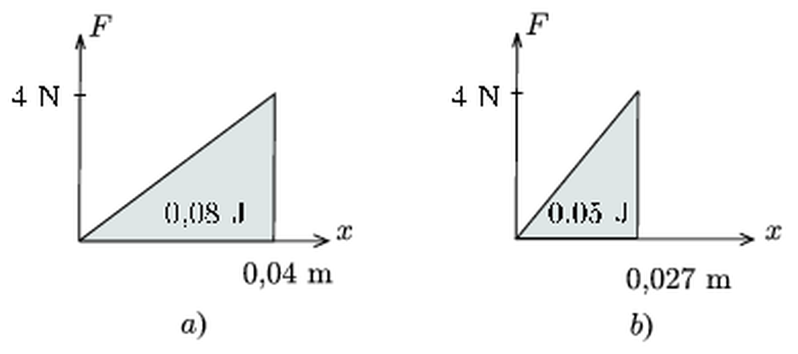
Figure: force–displacement graphs from the original answer
Solution:
Floating equilibrium. With $a=0.1 \text{m}$, the immersed depth $d_{0}$ satisfies $ρ_{w}a^{2}d_{0}=ρa^{3}$:
$$d_{0}=\frac{ρ}{ρ_{w}}a=0.6⋅10 \text{cm}=6 \text{cm},$$
so $4 \text{cm}$ of the cube sticks out. Since it is pushed slowly, the pushing force always equals the extra buoyancy:
$$F=ρ_{w}ga^{2} Δd,$$
where $Δd$ is the extra immersion depth. The cube is fully submerged when $Δd=4 \text{cm}$, so in both cases
$$F_{max}=1000 {\text{kg/m}}^{3}⋅9.81 {\text{m/s}}^{2}⋅0.01 {\text{m}}^{2}⋅0.04 \text{m}=3.92 \text{N}.$$
(a) Lake. The water level does not change, so $Δd=x$ and the force grows linearly, $F=(98.1 \text{N/m}) x$, up to $x=4 \text{cm}$. The work is the area under the graph:
$$W_{a}=\frac{1}{2}F_{max}x_{max}=\frac{1}{2}⋅3.92 \text{N}⋅0.04 \text{m}≈0.078 \text{J}.$$
(b) Vessel. Now the water level rises by $y$ when the cube moves down by $x$. The water volume is constant, so the extra submerged cube volume equals the volume of water raised around the cube:
$$a^{2}x=(A−a^{2}) y⇒y=\frac{0.01}{0.03−0.01}x=\frac{x}{2}.$$
The extra immersion depth is $Δd=x+y=1.5x$, so
$$F=1.5ρ_{w}ga^{2}x=(147 \text{N/m}) x.$$
Full submersion requires $1.5x=4 \text{cm}$, i.e. $x_{max}=2.67 \text{cm}$:
$$W_{b}=\frac{1}{2}⋅3.92 \text{N}⋅0.0267 \text{m}≈0.052 \text{J}.$$
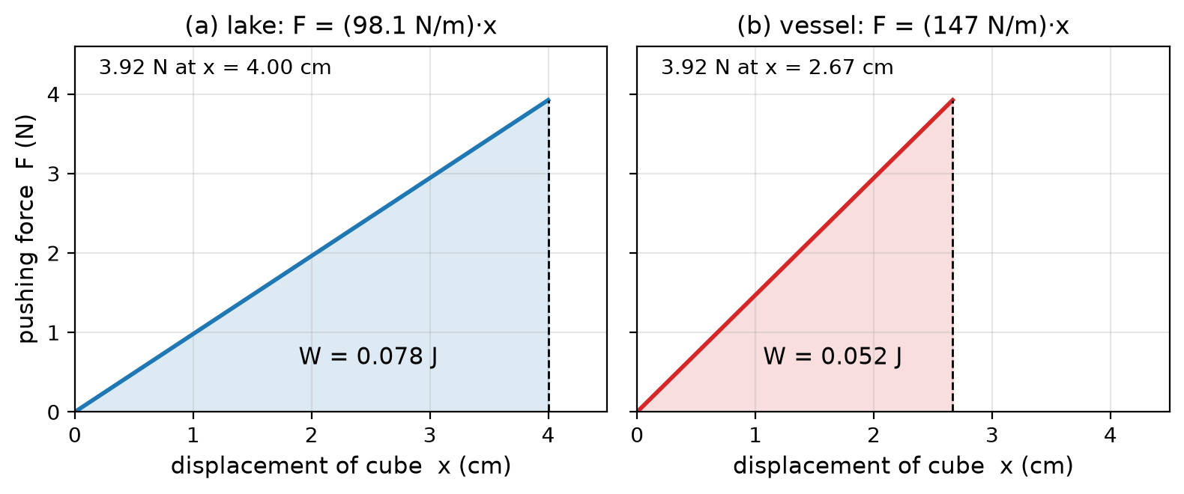
Figure: pushing force versus displacement of the cube, (a) in a lake and (b) in the vessel
The work is smaller in the vessel because the rising water level does part of the job: less displacement of the cube is needed to submerge it, while the maximum force is the same.

Question 15
Source: Sheet 2, Q.14
At the 1984 Olympic Games the British athlete Daley Thompson won the decathlon gold medal (he had also won it in 1980). His results included $10.45 \text{s}$ in the 100 metres and $5 \text{m}$ in the pole vault. In which event did he have more mechanical energy?
Answer: In the sprint: near the finish his kinetic energy is about $50\text{–}60 \text{J/kg}$, while at the top of the pole vault his mechanical energy (relative to standing) is only about $40 \text{J/kg}$.
Solution:
It is convenient to compare mechanical energy per unit mass, measured relative to the athlete standing at rest.
Sprint. The average speed is
$$\overset{‾}{v}=\frac{100 \text{m}}{10.45 \text{s}}=9.57 \text{m/s}.$$
Since the start is slow, the speed near the finish is higher, about $10\text{–}11 \text{m/s}$. The kinetic energy per unit mass is then
$$\frac{E}{m}=\frac{v^{2}}{2}≈\frac{(10.5 \text{m/s})^{2}}{2}≈55 \text{J/kg},$$
and certainly more than ${\overset{‾}{v}}^{2}/2≈46 \text{J/kg}$, i.e. about $50 \text{J/kg}$ or more.
Pole vault. The centre of mass of a standing athlete is at about $1 \text{m}$ height; when clearing a $5 \text{m}$ bar it is roughly at the bar height, so it is raised by only about $4 \text{m}$:
$$\frac{E_{\text{pot}}}{m}=g Δh≈10 {\text{m/s}}^{2}⋅4 \text{m}=40 \text{J/kg}.$$
Above the bar the athlete moves slowly, about $1 \text{m/s}$, adding only $v^{2}/2≈0.5 \text{J/kg}$. The total is about $40 \text{J/kg}$.
Conclusion. The mechanical energy is larger in the sprint. This is consistent with physics: the vaulter’s energy comes from his run-up kinetic energy (which is at most his sprinting energy), and part of it is lost in the pole and in the take-off.

Question 16
Source: Sheet 2, Q.15
A semi-cylindrical hollow of radius $R$ is cut out of a block, and the block stands on a horizontal surface. A small body of mass $m$ is released from rest at the top edge of the hollow. (Friction is negligible.)
- If the block is fixed, what force does the small body exert on the block at the lowest point of its path?
- If the block can slide without friction on the horizontal surface, the force exerted on the block by the small body at the lowest point is $3.5mg$. How many times greater is the mass of the block than that of the small body?
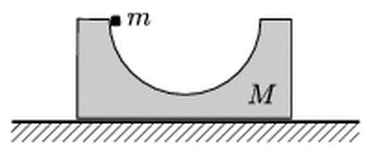
Figure: block with a semi-cylindrical hollow, small body at its top edge
Answer:
(a) $N=3mg$
(b) $M=4m$ (the block is four times as heavy as the small body)
Solution:
(a) Energy conservation from the rim to the bottom:
$$v^{2}=2gR.$$
At the bottom the net upward force provides the centripetal acceleration:
$$N−mg=\frac{mv^{2}}{R}⇒N=mg+2mg=3mg.$$
By Newton’s third law the body presses on the block with $3mg$, vertically downward.
(b) Now the block recoils. Let the body have speed $v$ and the block speed $V$ (opposite directions) at the lowest point. Horizontal momentum is conserved (it was zero initially):
$$mv=MV.$$
Mechanical energy is conserved:
$$mgR=\frac{1}{2}mv^{2}+\frac{1}{2}MV^{2}.$$
Substituting $v=MV/m$:
$$mgR=\frac{1}{2}MV^{2} \frac{M+m}{m}⇒V^{2}=\frac{2m^{2}gR}{M(M+m)}.$$
At the lowest point the force between body and block is vertical, so the block has no acceleration at that instant: its frame is momentarily inertial. Relative to the block, the body moves on a circle of radius $R$ with relative speed
$$u=v+V=V\frac{M+m}{m},$$
$$u^{2}=\frac{2gR(M+m)}{M}.$$
Newton’s second law in the block’s frame:
$$N=mg+\frac{mu^{2}}{R}=mg\left(3+\frac{2m}{M}\right).$$
With $N=3.5mg$:
$$\frac{2m}{M}=0.5⇒M=4m.$$
The block’s mass is four times the mass of the small body (i.e. three times greater than it).

Question 17
Source: Sheet 2, Q.22
A tall tower is built from identical thin-walled tubes and rectangular sheets whose mass is negligible compared with that of the tubes, as shown in the figure (sheet width $20 \text{cm}$, distance between the axes of the two tube columns $5 \text{cm}$). What happens if one of the sheets near the bottom is suddenly pulled out horizontally, perpendicular to the tubes,
- by $2 \text{cm}$;
- by $6 \text{cm}$?
(Static friction is large enough that the tubes do not slip.)
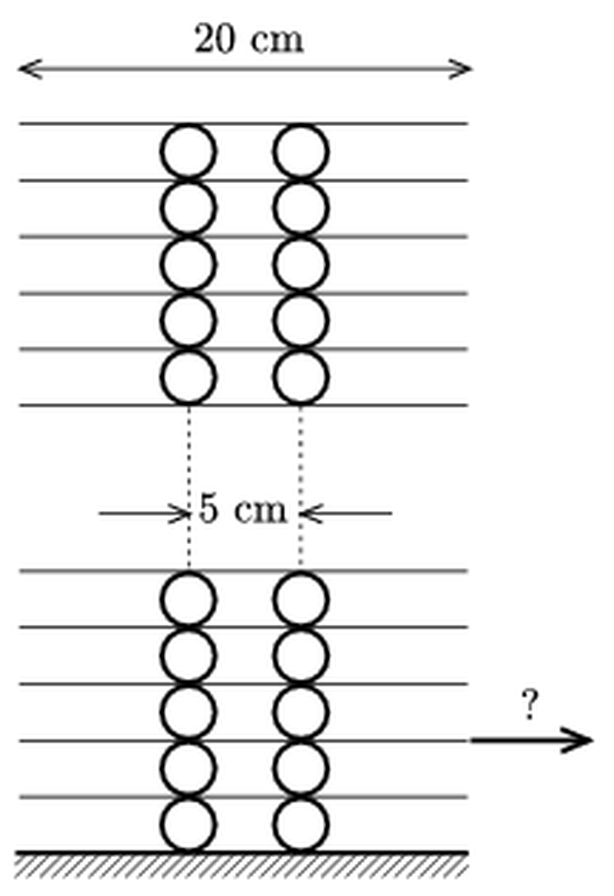
Figure: tower of sheets and pairs of tubes; one lower sheet is pulled sideways
Answer:
(a) Only the tubes directly above and below the pulled sheet roll, by $1 \text{cm}$; the tower remains standing.
(b) These tubes roll by $3 \text{cm}$; the supports of the upper part of the tower move to $0.5 \text{cm}$ and $5.5 \text{cm}$ from its centre line, its centre of gravity is no longer above the support, and the upper part of the tower topples.
Solution:
Which parts move. The pull is sudden, and the upper part of the tower is heavy, so by inertia it stays in place, as do the lower tubes and sheets. Only the light, pulled sheet moves by $d$, and the tubes directly in contact with it (the pair above and the pair below) roll between the moving sheet and a stationary sheet.
Rolling between two surfaces. A tube rolling without slipping between a fixed surface and a surface displaced by $d$ has its centre displaced by $d/2$ (the centre moves at the average of the velocities of the top and bottom contact points). So these tubes move by $d/2$, and the line along which each of them supports the stationary sheet above them also moves by $d/2$.
Stability of the upper part. The upper part of the tower is symmetric, so its centre of gravity lies on the centre line, midway between the tube columns. Originally it is supported along two lines at $±2.5 \text{cm}$ from the centre line. After the shift the support lines are at
$$−2.5 \text{cm}+\frac{d}{2} \text{and} +2.5 \text{cm}+\frac{d}{2}.$$
The upper part remains stable as long as its centre of gravity (at $0$) lies between them, i.e. $d/2<2.5 \text{cm}$, $d<5 \text{cm}$.
(a) $d=2 \text{cm}$: the tubes roll by $1 \text{cm}$; the supports are at $−1.5 \text{cm}$ and $+3.5 \text{cm}$, the centre of gravity is between them, so the tower stays standing (slightly offset).
(b) $d=6 \text{cm}$: the tubes roll by $3 \text{cm}$; the supports are at $+0.5 \text{cm}$ and $+5.5 \text{cm}$. The centre of gravity of the upper part is now outside the base of support, so the weight produces an unbalanced torque and the upper part of the tower topples (toward the side opposite to the pull). The $20 \text{cm}$ wide sheet is still under the tubes, so the collapse is due to tipping, not to the sheet slipping out.

Question 18
Source: Sheet 2, Q.24
The homogeneous rectangular block of mass $M$ shown in the figure (height $h$, base length $l$) stands on the ice of a skating rink. A horizontal force $F$ is applied at height $\frac{3}{4}h$. What is the greatest force with which it can be moved so that it does not tip up? (Friction is negligible.)
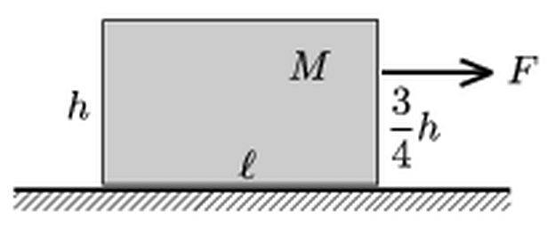
Figure: block of height h and base l on ice, pulled horizontally at height 3h/4
Answer: $F≤\frac{2l}{h}Mg$
Solution:
On frictionless ice the force accelerates the block horizontally:
$$a=\frac{F}{M}.$$
The block does not tip as long as it does not rotate, i.e. the net torque about its centre of mass $S$ is zero, with both edges of the base in contact. Let $N_{1}$ be the normal force at the rear edge and $N_{2}$ at the front edge (each at horizontal distance $l/2$ from $S$). Vertical equilibrium:
$$N_{1}+N_{2}=Mg.$$
The line of action of $F$ is $\frac{3}{4}h−\frac{1}{2}h=\frac{h}{4}$ above $S$. It tends to rotate the block forward (lifting the rear edge). Torques about $S$ (the frictionless ice exerts no horizontal force):
$$(N_{2}−N_{1})\frac{l}{2}=F\frac{h}{4}.$$
Solving for the rear normal force:
$$N_{1}=\frac{Mg}{2}−\frac{Fh}{4l}.$$
The rear edge lifts when $N_{1}$ would become negative. The condition $N_{1}≥0$ gives
$$F≤\frac{2l}{h}Mg.$$
(For the block in the figure, roughly $l≈1.6h$, this is about $3Mg$.)

Question 19
Source: Sheet 2, Q.25
The bob of a $2 \text{m}$ long pendulum moves in a horizontal circle (conical pendulum). What is the longest time it can take to complete one circle?
Answer: $T<2π\sqrt{l/g}≈2.84 \text{s}$
Solution:
Let the string make an angle $θ$ with the vertical. The bob moves on a circle of radius $ρ=lsinθ$. The vertical component of the tension balances gravity, the horizontal component provides the centripetal force:
$$Kcosθ=mg,$$
$$Ksinθ=mω^{2}lsinθ.$$
Dividing:
$$ω^{2}=\frac{g}{lcosθ}⇒T=2π\sqrt{\frac{lcosθ}{g}}.$$
The period increases as $θ$ decreases, and approaches its upper limit as $θ→0$ ($cosθ→1$):
$$T_{max}=2π\sqrt{\frac{l}{g}}=2π\sqrt{\frac{2 \text{m}}{9.81 {\text{m/s}}^{2}}}≈2.84 \text{s}.$$
This is the period of small oscillations of the same pendulum; a real circular motion always takes slightly less time.
Note: the original sheet gives $2.83 \text{s}$; with $g=9.81 {\text{m/s}}^{2}$ the value is $2.84 \text{s}$ (rounding difference).

Question 20
Source: Sheet 2, Q.26
A sonic boom is heard when sound emitted by an aircraft over a short period of time reaches the observer at a single instant.
- How can this happen? At what speed must the plane fly?
- In November 2008 the Space Shuttle Endeavour had to land in California because of bad weather. Interestingly, observers heard two sonic booms. How could this happen?
Answer:
(a) Sound emitted at different times arrives together if the plane approaches the observer at exactly the speed of sound, i.e. the component of its velocity toward the observer equals $c$ (Mach condition). This is possible only if the plane flies faster than sound, $v>c$.
(b) The Mach condition was fulfilled for the same observer at two different parts of the shuttle’s path (it flew a curved, decelerating trajectory); in addition, a long supersonic body produces a separate shock wave from its nose and from its tail, which are heard as two bangs.
Solution:
(a) A sound emitted at time $t$ from a point at distance $r(t)$ from the observer arrives at time
$$t_{\text{arr}}=t+\frac{r(t)}{c}.$$
Sounds emitted during a short interval arrive at the same instant if $t_{\text{arr}}$ does not change with $t$:
$$\frac{dt_{\text{arr}}}{dt}=1+\frac{1}{c}\frac{dr}{dt}=0⇒\frac{dr}{dt}=−c.$$
So the plane must approach the observer with a velocity component $vcosβ=c$ along the line of sight ($β$ is the angle between the velocity and the direction toward the observer). This requires $v≥c$: the plane must be supersonic. Then the sound emitted around that point of the path piles up and arrives as a sudden bang. Geometrically, this is the condition that the observer lies on the Mach cone, whose half-angle $α$ satisfies $sinα=c/v$.
(b) The returning shuttle does not fly in a straight line at constant speed: it decelerates from hypersonic speed and performs large banking turns before landing. Along such a curved path the Mach condition $vcosβ=c$ can be satisfied for the same observer at two separate points of the trajectory, so two bursts of sound arrive at two different times.
A second effect also contributes: a supersonic body produces a shock wave both at its nose and at its tail. For a large body like the shuttle these two shocks reach the ground a fraction of a second apart and are heard as the characteristic “double boom”.

Question 21
Source: Sheet 2, Q.27
A small ball of mass $m=0.1 \text{kg}$ hangs at rest on a thread of length $l=1 \text{m}$ from a horizontal peg. The peg is at height $2l$ above the ground. Another small ball of mass $M=0.2 \text{kg}$ is projected from the ground and collides with the hanging ball. The collision is perfectly elastic and head-on, and after it the ball on the thread completes a full circle around the peg.
- What is the smallest possible value of the distance $x$ shown in the figure?
- What is the initial velocity (speed and direction) of the projected ball?
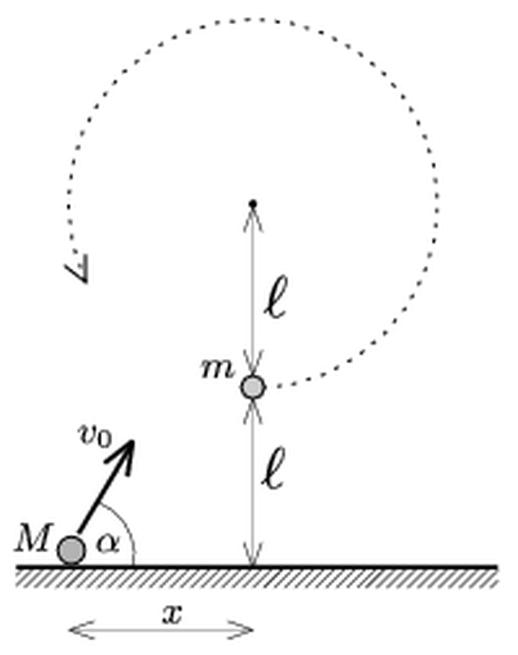
Figure: ball m hanging at height l below the peg; ball M launched from the ground at distance x
Answer:
(a) $x_{min}≈2.37 \text{m}$
(b) $v_{0}≈6.87 \text{m/s}$ at $α≈40.1°$ above the horizontal
Solution:
Condition for the full circle. The hanging ball can move only perpendicular to the thread, so it must receive a horizontal velocity $u$. To go around the full circle with a taut thread, the speed at the top must be at least $\sqrt{gl}$; with energy conservation this gives
$$u^{2}=gl+4gl⇒u≥\sqrt{5gl}=7.00 \text{m/s}.$$
Collision. The collision is head-on and gives $m$ a horizontal velocity, so $M$ must be moving horizontally at impact: it is at the top of its trajectory, at height $l$. For an elastic collision with a target at rest:
$$u=\frac{2M}{M+m}V=\frac{4}{3}V⇒V≥\frac{3}{4}\sqrt{5gl}=5.25 \text{m/s},$$
where $V$ is the (horizontal) velocity of $M$ just before the collision.
(a) The projectile reaches the height $l$ at its apex, so its vertical launch speed and rise time are
$$v_{y}=\sqrt{2gl}=4.43 \text{m/s}, t=\frac{v_{y}}{g}=0.452 \text{s}.$$
The horizontal distance covered is
$$x=Vt≥5.25 \text{m/s}⋅0.452 \text{s}≈2.37 \text{m}.$$
(b) For the minimal case, the horizontal launch component is $V=5.25 \text{m/s}$ and the vertical one is $4.43 \text{m/s}$:
$$v_{0}=\sqrt{V^{2}+v_{y}^{2}}=\sqrt{27.6+19.6} \text{m/s}≈6.87 \text{m/s},$$
$$α=arctan\frac{v_{y}}{V}=arctan\frac{4.43}{5.25}≈40.1°.$$
(A larger $x$ also works, with a larger horizontal component and a correspondingly flatter launch.)
Note: the original sheet gives $α=40.2°$; the computed value is $40.1°$ (rounding difference).

Question 22
Source: Sheet 2, Q.23
What is the minimum mass of the Earth’s atmosphere, if the mean radius of the Earth is $6370 \text{km}$ and the average air pressure at the Earth’s surface is $100 \text{kPa}$?
Answer: $m≥\frac{4πR^{2}p_{0}}{g}≈5.2×{10}^{18} \text{kg}$
Solution:
Principle. Atmospheric pressure at the ground is caused by the weight of the air above it. The total pressure force on the whole surface of the Earth therefore balances the weight of the atmosphere.
The pressure force acting on the whole surface of the sphere is
$$F=p_{0}⋅4πR^{2}.$$
If all the air were at the surface, where the gravitational acceleration is $g$, its weight would be $mg$, and $mg=F$. In reality the air extends to some height. Higher up, $g$ is slightly smaller. Also, the shells of air higher up have a larger area than the ground, so the weight of the air above a unit of ground area is spread over more area. Both effects mean the true mass is a little larger than the value found from the surface formula. This value is therefore a lower bound:
$$m≥\frac{4πR^{2}p_{0}}{g}$$
Numbers. With $R=6.37×{10}^{6} \text{m}$, $p_{0}=1.0×{10}^{5} \text{Pa}$ and $g=9.81 {\text{m/s}}^{2}$:
$$m≥\frac{4π (6.37×{10}^{6} \text{m})^{2}⋅1.0×{10}^{5} \text{Pa}}{9.81 {\text{m/s}}^{2}}≈5.2×{10}^{18} \text{kg}$$
The atmosphere is only about $100 \text{km}$ thick, much less than $R$, so the true mass is only slightly larger than this.

Question 23
Source: Sheet 2, Q.34
A plane covers a distance of $2 \text{km}$ in $15 \text{s}$ when it flies downwind, and in $20 \text{s}$ when it flies into the wind. Calculate the speed of the plane relative to the air and the speed of the wind, in $\text{km/h}$.
Answer: plane: $420 \text{km/h}$; wind: $60 \text{km/h}$
Solution:
Principle. Velocities add (Galilean relativity). Let $v$ be the speed of the plane relative to the air and $w$ the speed of the wind. The ground speed is $v+w$ downwind and $v−w$ into the wind.
Ground speeds:
$$v+w=\frac{2 \text{km}}{15 \text{s}}=\frac{2 \text{km}}{\frac{15}{3600} \text{h}}=480 \text{km/h}$$
$$v−w=\frac{2 \text{km}}{20 \text{s}}=\frac{2 \text{km}}{\frac{20}{3600} \text{h}}=360 \text{km/h}$$
Adding and subtracting the two equations:
$$v=\frac{480+360}{2} \text{km/h}=420 \text{km/h}$$
$$w=\frac{480−360}{2} \text{km/h}=60 \text{km/h}$$
So the plane flies at $420 \text{km/h}$ (about $117 \text{m/s}$) relative to the air, and the wind blows at $60 \text{km/h}$ (about $16.7 \text{m/s}$).

Question 24
Source: Sheet 2, Q.35
A pebble is shot vertically upward from a slingshot with an initial speed of $50 \text{m/s}$. Neglecting air drag:
- where would the pebble be after $7 \text{s}$?
- what would its speed be at that moment?
- what distance would it cover in those $7 \text{s}$?
(a) about $109.7 \text{m}$ above the launch point
(b) $18.7 \text{m/s}$, moving downward
(c) about $145 \text{m}$ ($127.4 \text{m}$ up and $17.8 \text{m}$ down)
Solution:
Principle. Vertical throw with constant acceleration $g=9.81 {\text{m/s}}^{2}$ directed downward. Take upward as positive, with $v_{0}=50 \text{m/s}$ and $t=7 \text{s}$.
(a) Position
$$y=v_{0}t−\frac{1}{2}gt^{2}=50⋅7 \text{m}−\frac{1}{2}⋅9.81⋅49 \text{m}=350 \text{m}−240.3 \text{m}≈109.7 \text{m}$$
The pebble is about $110 \text{m}$ above the point of launch.
(b) Velocity
$$v=v_{0}−gt=50 \text{m/s}−9.81⋅7 \text{m/s}=−18.7 \text{m/s}$$
The negative sign means the pebble is already falling, with a speed of $18.7 \text{m/s}$.
(c) Distance travelled. The pebble turns back at the top, so the distance is the sum of the climb and the fall. The climb lasts $t_{1}=v_{0}/g=5.10 \text{s}$ and reaches
$$H=\frac{v_{0}^{2}}{2g}=\frac{(50 \text{m/s})^{2}}{2⋅9.81 {\text{m/s}}^{2}}≈127.4 \text{m}$$
In the remaining time it falls $H−y=127.4 \text{m}−109.7 \text{m}=17.8 \text{m}$. The total distance is
$$s=H+(H−y)=127.4 \text{m}+17.8 \text{m}≈145 \text{m}$$
Note: the original sheet gives 109.3 m for (a). With $g=9.81 {\text{m/s}}^{2}$ the value is 109.7 m. The answers to (b) and (c) agree.

Question 25
Source: Sheet 2, Q.36
Two trolleys, each of mass $2 \text{kg}$, stand at rest along a line on a horizontal tabletop. A spring is mounted on one of them, as shown in the figure. The trolley on the left is given an initial speed of $5 \text{m/s}$ and collides with the one on the right. How much energy is stored in the spring when it is at its shortest?
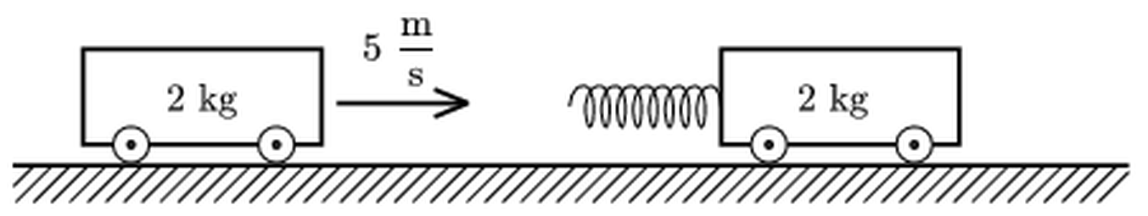
Figure: two 2 kg trolleys, the left one moving at 5 m/s toward the spring on the right one
Answer: $E_{\text{spring}}=12.5 \text{J}$
Solution:
Principle. Momentum is conserved during the interaction, because the horizontal external force is zero. Mechanical energy is also conserved, because the spring is ideal and there is no friction. The spring is shortest when the two trolleys are not moving relative to each other, that is, when they have a common velocity $u$.
Common velocity. With $m=2 \text{kg}$ and $v_{0}=5 \text{m/s}$:
$$mv_{0}=2mu$$
$$u=\frac{v_{0}}{2}=2.5 \text{m/s}$$
Energy balance. The initial kinetic energy is
$$E_{0}=\frac{1}{2}mv_{0}^{2}=\frac{1}{2}⋅2 \text{kg}⋅(5 \text{m/s})^{2}=25 \text{J}$$
At maximum compression the kinetic energy is
$$E_{1}=\frac{1}{2}(2m)u^{2}=\frac{1}{2}⋅4 \text{kg}⋅(2.5 \text{m/s})^{2}=12.5 \text{J}$$
The difference is stored in the spring:
$$E_{\text{spring}}=E_{0}−E_{1}=25 \text{J}−12.5 \text{J}=12.5 \text{J}$$
For equal masses, exactly half of the initial kinetic energy is stored. The other half is the kinetic energy of the centre-of-mass motion, which cannot be changed by internal forces.

Question 26
Source: Sheet 2, Q.37
Two bodies, each of mass $m=0.5 \text{kg}$, rest on a horizontal frictionless tabletop. They are connected by an unstretched spring of length $L=20 \text{cm}$ and spring constant $D=16 \text{N/m}$. The mass of the spring is negligible. At a certain moment both bodies are given an initial speed $v_{0}=0.36 \text{m/s}$ toward the wall on the right. The body on the right collides with the wall perfectly elastically.
- What is the greatest compression of the spring during the motion?
- After the collision with the wall, how much time passes until the bodies are closest to each other?
- Will there be any further collision with the wall? How will the system move after a long time?
- What is the change in the linear momentum of the system after all the collisions have occurred?
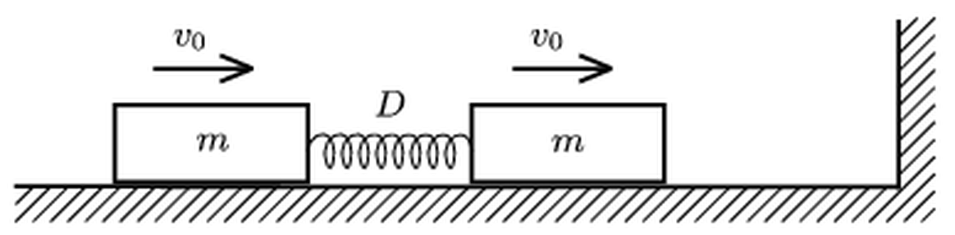
Figure: two bodies of mass m joined by a spring, both moving with v0 toward a wall on the right
(a) $Δl_{max}=9 \text{cm}$
(b) $t=\frac{T}{4}=\frac{π}{16} \text{s}≈0.20 \text{s}$
(c) yes, the right-hand body hits the wall once more; afterwards both bodies move to the left with speed $v_{0}$ and the spring stays unstretched
(d) $Δp=0.72 \text{kg m/s}$, directed to the left (away from the wall)
Solution:
Before the collision the two bodies move together with $v_{0}$ and the spring is unstretched. In an elastic collision with the wall, the velocity of the right-hand body reverses instantly to $−v_{0}$. The left-hand body still moves with $+v_{0}$.
(a) Greatest compression. After the collision the total momentum is $mv_{0}−mv_{0}=0$. The centre of mass is therefore at rest, and at maximum compression both bodies are momentarily at rest. All the kinetic energy is then stored in the spring:
$$2⋅\frac{1}{2}mv_{0}^{2}=\frac{1}{2}D(Δl)^{2}$$
$$Δl=v_{0}\sqrt{\frac{2m}{D}}=0.36 \text{m/s}⋅\sqrt{\frac{1 \text{kg}}{16 \text{N/m}}}=0.09 \text{m}=9 \text{cm}$$
(b) Time to closest approach. With the centre of mass at rest, each body oscillates harmonically about it. Each body is attached to the fixed centre of mass by half of the spring, whose stiffness is $2D$. The angular frequency is
$$ω=\sqrt{\frac{2D}{m}}=\sqrt{\frac{32 \text{N/m}}{0.5 \text{kg}}}=8 {\text{s}}^{−1}$$
The period is $T=2π/ω=π/4 \text{s}≈0.785 \text{s}$. Each body starts from the equilibrium position with maximum speed, so it comes to rest (maximum compression) after a quarter period:
$$t=\frac{T}{4}=\frac{π}{16} \text{s}≈0.20 \text{s}$$
(c) Later motion. Each body has amplitude $4.5 \text{cm}$ about the fixed centre of mass. After half a period ($t=T/2$) both are back at their starting positions with their velocities reversed. The right-hand body is at the wall again, moving toward it with $+v_{0}$, and the spring is unstretched. It collides with the wall a second time and bounces back with $−v_{0}$. Now both bodies move to the left with $v_{0}$ and the spring is unstretched. There are no more collisions, and the system moves away from the wall uniformly as a rigid unit with speed $v_{0}$.
(d) Change of momentum. Initially $p_{1}=2mv_{0}$ to the right. Finally $p_{2}=2mv_{0}$ to the left. Taking right as positive:
$$Δp=−2mv_{0}−2mv_{0}=−4mv_{0}=−4⋅0.5 \text{kg}⋅0.36 \text{m/s}=−0.72 \text{kg m/s}$$
The wall gives the system a total impulse of $0.72 \text{kg m/s}$, directed away from the wall, in its two collisions. Each collision delivers $2mv_{0}=0.36 \text{kg m/s}$.
Note: the sheet’s answer for (b) is garbled (“T/40”). The correct time is a quarter period, about 0.20 s.

Question 27
Source: Sheet 2, Q.38
A spherical sprinkler is used at the end of a garden hose. Water leaves it with the same speed in every direction. The jet directed vertically upward reaches a height $h$. In one case the sprinkler is placed on the ground, and in another case at a height $h$ above the ground. By what factor is the watered area greater in the second case? (Neglect air resistance and assume the pressure in the sprinkler is constant.)
Answer: the watered area is twice as large: $A_{2}:A_{1}=2:1$
Solution:
Principle. Projectile motion. Water leaves in every direction, so it lands on a full disc whose radius equals the maximum horizontal range. The outflow speed $v$ follows from the height of the vertical jet:
$$v^{2}=2gh$$
Case 1: sprinkler on the ground. The maximum range (launch at $45°$) is
$$R_{1}=\frac{v^{2}}{g}=2h$$
$$A_{1}=πR_{1}^{2}=4πh^{2}$$
Case 2: sprinkler at height h. For a launch from height $H$ with speed $v$, the largest horizontal range (at the optimum angle) is
$$R_{max}=\frac{v}{g}\sqrt{v^{2}+2gH}$$
This follows from the condition that the landing velocity is perpendicular to the launch velocity. Here $H=h$ and $v^{2}=2gh$:
$$R_{2}=\frac{v^{2}}{g}\sqrt{1+\frac{2gh}{v^{2}}}=2h\sqrt{2}=2\sqrt{2} h$$
$$A_{2}=πR_{2}^{2}=8πh^{2}$$
Ratio
$$\frac{A_{2}}{A_{1}}=\frac{8πh^{2}}{4πh^{2}}=2$$
Raising the sprinkler to the height $h$ doubles the watered area, and the range grows by a factor of $\sqrt{2}$.

Question 28
Source: Sheet 2, Q.43
The figure shows the velocity-time graph of a lift in a mine. To what depth does the lift go down?
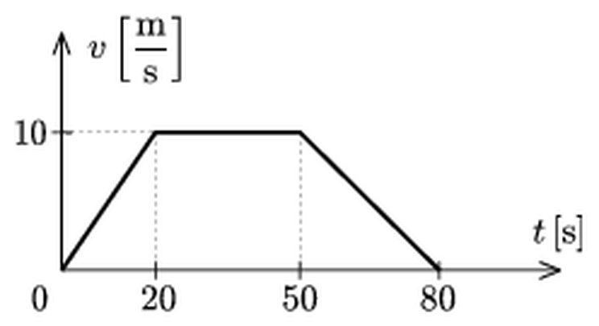
Figure: v-t graph of the lift: rises to 10 m/s at 20 s, constant until 50 s, falls to 0 at 80 s
Answer: $d=550 \text{m}$
Solution:
Principle. On a velocity-time graph, the displacement equals the area under the curve. The graph is a trapezium made of three parts.
Accelerating phase ($0$ to $20 \text{s}$), uniformly from $0$ to $10 \text{m/s}$:
$$s_{1}=\frac{1}{2}⋅20 \text{s}⋅10 \text{m/s}=100 \text{m}$$
Uniform phase ($20$ to $50 \text{s}$):
$$s_{2}=30 \text{s}⋅10 \text{m/s}=300 \text{m}$$
Braking phase ($50$ to $80 \text{s}$), uniformly from $10 \text{m/s}$ to $0$:
$$s_{3}=\frac{1}{2}⋅30 \text{s}⋅10 \text{m/s}=150 \text{m}$$
Total depth
$$d=s_{1}+s_{2}+s_{3}=100 \text{m}+300 \text{m}+150 \text{m}=550 \text{m}$$
As a check, the trapezium formula gives $d=\frac{1}{2}(80 \text{s}+30 \text{s})⋅10 \text{m/s}=550 \text{m}$.

Question 29
Source: Sheet 2, Q.44
A car was travelling at $45 \text{km/h}$ when a pedestrian stepped off the pavement. The driver braked suddenly and the accident was avoided. The braking distance was $6.25 \text{m}$.
- A car in the next lane could only stop in a distance of $9 \text{m}$. What was the speed of this car, if the decelerations of the two cars were the same?
- What were the braking times of the two cars?
- What is the ratio of their initial kinetic energies, if their masses are the same?
(a) $v_{2}=15 \text{m/s}=54 \text{km/h}$
(b) $t_{1}=1.0 \text{s}$, $t_{2}=1.2 \text{s}$
(c) $E_{2}/E_{1}=1.44$
Solution:
Principle. Uniform deceleration to rest: $v^{2}=2as$ and $v=at$.
Deceleration of the first car. $v_{1}=45 \text{km/h}=12.5 \text{m/s}$ and $s_{1}=6.25 \text{m}$:
$$a=\frac{v_{1}^{2}}{2s_{1}}=\frac{(12.5 \text{m/s})^{2}}{2⋅6.25 \text{m}}=12.5 {\text{m/s}}^{2}$$
(a) Speed of the second car. It has the same deceleration and $s_{2}=9 \text{m}$:
$$v_{2}=\sqrt{2as_{2}}=\sqrt{2⋅12.5 {\text{m/s}}^{2}⋅9 \text{m}}=15 \text{m/s}=54 \text{km/h}$$
The same result follows without $a$: $v_{2}=v_{1}\sqrt{s_{2}/s_{1}}=12.5 \text{m/s}⋅1.2=15 \text{m/s}$.
(b) Braking times
$$t_{1}=\frac{v_{1}}{a}=\frac{12.5 \text{m/s}}{12.5 {\text{m/s}}^{2}}=1.0 \text{s}$$
$$t_{2}=\frac{v_{2}}{a}=\frac{15 \text{m/s}}{12.5 {\text{m/s}}^{2}}=1.2 \text{s}$$
(c) Ratio of kinetic energies. For equal masses:
$$\frac{E_{2}}{E_{1}}=\frac{v_{2}^{2}}{v_{1}^{2}}={\left(\frac{15}{12.5}\right)}^{2}=1.44$$
This equals the ratio of the braking distances, $9/6.25=1.44$. This is expected, because the work done by the same braking force, $Fs$, removes all the kinetic energy.

Question 30
Source: Sheet 2, Q.45
$10 \text{cm}$ below a tap, the diameter of the thin stream of water flowing from it is $2 \text{mm}$. How long does it take to fill a half-litre mug?
Answer: $t≈114 \text{s}≈1.9 \text{min}$
Solution:
Principles. (1) Water leaving the tap falls freely. Assume the outflow speed at the tap is negligible compared with the speed gained in the fall, which is reasonable for a thin trickle. (2) Continuity: the volume flow rate $Q=Av$ is the same at every cross-section of the stream.
Speed $10 \text{cm}$ below the tap. Free fall through $h=0.10 \text{m}$ gives
$$v=\sqrt{2gh}=\sqrt{2⋅9.81 {\text{m/s}}^{2}⋅0.10 \text{m}}≈1.40 \text{m/s}$$
Flow rate. At that point the radius is $r=1 \text{mm}=1×{10}^{−3} \text{m}$:
$$Q=πr^{2}v=π (1×{10}^{−3} \text{m})^{2}⋅1.40 \text{m/s}≈4.4×{10}^{−6} {\text{m}}^{3}\text{/s}$$
Filling time. For $V=0.5 \text{L}=5×{10}^{−4} {\text{m}}^{3}$:
$$t=\frac{V}{Q}=\frac{5×{10}^{−4} {\text{m}}^{3}}{4.4×{10}^{−6} {\text{m}}^{3}\text{/s}}≈114 \text{s}≈1.9 \text{min}$$
If the water left the tap with a non-negligible speed, the speed $10 \text{cm}$ lower would be larger. The flow rate would then be larger and the filling time a little shorter.

Question 31
Source: Sheet 3, Q.51
Two balls of masses $m_{1}=0.173 \text{kg}$ and $m_{2}=0.2 \text{kg}$ move in directions perpendicular to each other, with speeds $v_{1}=10 \text{m/s}$ and $v_{2}=5 \text{m/s}$ respectively. After the collision the ball of mass $m_{1}$ stops. What is the speed of the ball of mass $m_{2}$ after the collision?
Answer: $v_{2}^{′}=\sqrt{{\left(\frac{m_{1}}{m_{2}}\right)}^{2}v_{1}^{2}+v_{2}^{2}}≈10 \text{m/s}$, at about $60°$ to its original direction
Solution:
Principle. During the collision only internal forces act, so the total momentum (a vector) is conserved.
Choose the $x$ axis along the velocity of ball 1 and the $y$ axis along the velocity of ball 2. The momenta before the collision are
$$p_{x}=m_{1}v_{1}=0.173 \text{kg}⋅10 \text{m/s}=1.73 \text{kg m/s}$$
$$p_{y}=m_{2}v_{2}=0.2 \text{kg}⋅5 \text{m/s}=1.0 \text{kg m/s}$$
After the collision ball 1 is at rest, so ball 2 carries all the momentum:
$$m_{2}v_{2}^{′}=\sqrt{p_{x}^{2}+p_{y}^{2}}=\sqrt{{1.73}^{2}+{1.0}^{2}} \text{kg m/s}≈2.0 \text{kg m/s}$$
$$v_{2}^{′}=\frac{2.0 \text{kg m/s}}{0.2 \text{kg}}≈10 \text{m/s}$$
Direction. The angle $φ$ between the new velocity and the original velocity of ball 2 satisfies
$$tanφ=\frac{p_{x}}{p_{y}}=1.73$$
so $φ≈60°$.
Energy check. The kinetic energy before is $\frac{1}{2}(0.173)({10}^{2})+\frac{1}{2}(0.2)(5^{2})=11.15 \text{J}$, and after it is $\frac{1}{2}(0.2)({10}^{2})≈10.0 \text{J}$. The kinetic energy decreases slightly, so the collision is possible (partly inelastic).

Question 32
Source: Sheet 3, Q.53
A skewer (a thin uniform rod) of mass $m=1 \text{g}$ hangs from a fixed point $P$ by a short thread tied to its upper end. A long thread is tied to its lower end and is pulled with a horizontal force, which keeps the skewer in equilibrium. In this position the skewer makes an angle $α$ with the vertical.
- Find the angle between the short thread and the vertical.
- Find the tension in the short thread if $α=45°$.
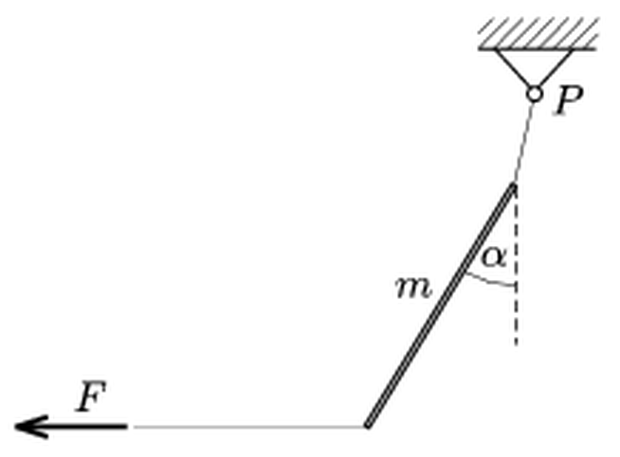
Figure: skewer hanging from P on a short thread, pulled sideways at its lower end by a horizontal force F
(a) $tanβ=\frac{1}{2}tanα$
(b) $T=\frac{\sqrt{5}}{2}mg≈11 \text{mN}$ (at $β≈26.6°$)
Solution:
Principle. Three forces act on the skewer: its weight $mg$ at the midpoint, the horizontal pull $F$ at the lower end, and the tension $T$ of the short thread at the upper end. For equilibrium the net force and the net torque must be zero.
Let the skewer have length $l$.
(a) Torque about the upper end. The lever arm of $F$ is the vertical extent of the skewer, $lcosα$. The lever arm of the weight is the horizontal distance of the midpoint, $\frac{l}{2}sinα$:
$$Flcosα=mg\frac{l}{2}sinα$$
$$F=\frac{1}{2}mgtanα$$
Force balance. The thread tension balances the other two forces:
$$T_{x}=F$$
$$T_{y}=mg$$
The angle $β$ of the short thread with the vertical is therefore
$$tanβ=\frac{T_{x}}{T_{y}}=\frac{F}{mg}=\frac{1}{2}tanα$$
The same result follows geometrically: three non-parallel forces in equilibrium must meet in one point. The line of the weight and the line of $F$ meet at the point vertically below the midpoint, at the level of the lower end. The thread must point at that point too. Its horizontal distance from the top is half that of the bottom end, so the thread is less steep than the skewer.
(b) Tension for alpha = 45 degrees. Here $tanβ=\frac{1}{2}$, so $β≈26.6°$, and
$$T=\sqrt{F^{2}+(mg)^{2}}=mg\sqrt{1+\frac{1}{4}}=\frac{\sqrt{5}}{2}mg$$
$$T=1.118⋅1×{10}^{−3} \text{kg}⋅9.81 {\text{m/s}}^{2}≈1.1×{10}^{−2} \text{N}=11 \text{mN}$$

Question 33
Source: Sheet 3, Q.54
In a soap-film experiment, a thread of length $L$ that bounds the film originally takes the shape of a semicircle. When a force $F$ is applied at the middle of the thread, the thread can be pulled into the shape of two semicircles (see figure). Calculate the surface tension of the soap solution.
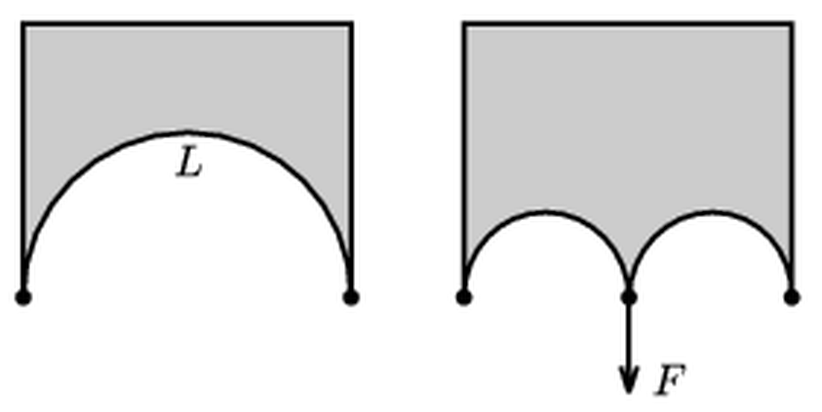
Figure: thread bounding a soap film: one semicircle of length L (left); two semicircles when the midpoint is pulled down with force F (right)
Answer: $σ=\frac{πF}{2L}$ (the film has two surfaces)
Solution:
Principle. A soap film has two surfaces. Each pulls on its boundary with a force $σ$ per unit length, so a thread bounding the film feels an outward pull of $2σ$ per unit length, perpendicular to the thread. A flexible thread under such a uniform sideways load takes the shape of a circular arc. The tension $T$ in it is related to the radius $r$ by
$$T=2σr$$
This follows by cutting a semicircle off along its diameter. The film pulls on the semicircle with a resultant $2σ⋅2r$, which is balanced by the tensions $2T$ at its two ends.
Right-hand configuration. Each of the two semicircles has length $L/2$, so its radius is
$$r=\frac{L/2}{π}=\frac{L}{2π}$$
The tension in the thread is
$$T=2σr=\frac{σL}{π}$$
Equilibrium of the midpoint. At the middle point both semicircles meet the line of the fixed ends vertically. Each of the two thread pieces therefore pulls the midpoint upward (into the film) with force $T$. The applied force $F$ balances them:
$$F=2T=\frac{2σL}{π}$$
$$σ=\frac{πF}{2L}$$
The left-hand figure is only needed to show that the total length of the thread is $L$. It does not change during the deformation.
Note: the original sheet gives $πF/L$. That result counts only one surface of the film. Because a soap film has two surfaces, the surface tension is half of that, $πF/(2L)$.

Question 34
Source: Sheet 3, Q.60
It is well known that with a bicycle it is easier to reach a given speed with a tailwind and harder with a headwind than in calm weather. What happens when the wind blows perpendicular to the direction of motion?
Answer: riding is harder than in calm weather. The drag component opposing the motion is larger than without wind.
Solution:
Principle. At cycling speeds the air drag is proportional to the square of the speed of the air relative to the rider, and it acts along that relative velocity:
$$\vec{F}=−k \left|\vec{u}\right| \vec{u}$$
Here $\vec{u}$ is the velocity of the bicycle relative to the air.
Calm weather. $\vec{u}$ is just the riding velocity $v$, so the retarding force is
$$F_{0}=kv^{2}$$
Crosswind of speed w. Relative to the air, the bicycle moves with velocity $v$ forward and $w$ sideways, so
$$\left|\vec{u}\right|=\sqrt{v^{2}+w^{2}}$$
The drag points opposite to $\vec{u}$. Its component along the direction of travel, which the rider must overcome, is
$$F_{∥}=k\sqrt{v^{2}+w^{2}}⋅v$$
Since $\sqrt{v^{2}+w^{2}}>v$, we get $F_{∥}>kv^{2}=F_{0}$.
Conclusion. The wind does not push against the rider directly, but it increases the relative air speed. Because the drag depends on the square of that speed, the backward component grows. Keeping the same speed takes more power than in calm weather, so riding is harder. In addition, the sideways component $k\sqrt{v^{2}+w^{2}} w$ has to be balanced by leaning and steering. If the drag were proportional to the speed (linear drag), a crosswind would have no effect on the forward force.

Question 35
Source: Sheet 3, Q.61
The bottom end of a smooth inclined plane is joined, without a break, to a curved track whose cross-section is a semicircle of radius $R=0.5 \text{m}$. The plane has an angle of elevation $α=60°$ and length $3R$. A point-like object of mass $m=0.2 \text{kg}$ slides down from the top of the plane, starting from rest. It travels round the semicircular track and leaves it.
- What is the kinetic energy of the object at the highest point of its curved path after it leaves the track?
- Where does the object hit the inclined plane? (Friction and air drag are negligible.)
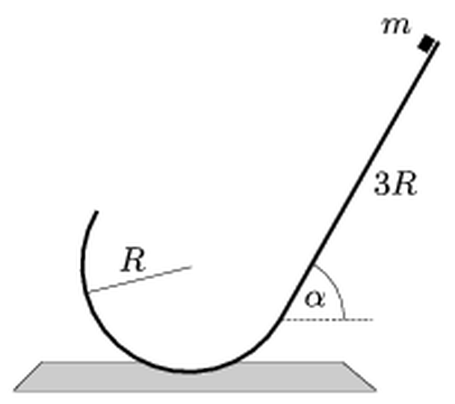
Figure: incline of length 3R at angle alpha, joining tangentially a semicircular track of radius R
(a) $E=\cos^{2}α (3sinα−2cosα) mgR=\frac{3\sqrt{3}−2}{8}mgR≈0.39 \text{J}$
(b) at a distance $l=2\left(\sqrt{6tanα−4}−tanα\right)R≈0.80 \text{m}$ from the bottom end of the incline
Solution:
Geometry. Let $O$ be the centre of the semicircle. The incline touches the circle at its lower end $B$, where the radius $OB$ makes an angle $α$ with the downward vertical. The semicircle covers $180°$, so it ends at the point $E$ diametrically opposite $B$. That point is on the far side, at height $Rcosα$ above $O$. At $E$ the tangent of the circle is parallel to the incline, so the object leaves the track with velocity $v_{E}$ directed parallel to the inclined plane, at angle $α$ above the horizontal.
Speed at E (energy conservation). The top of the incline is at height $3Rsinα−Rcosα$ above $O$, and $E$ is at height $Rcosα$. Their difference is $R(3sinα−2cosα)$:
$$\frac{1}{2}mv_{E}^{2}=mgR (3sinα−2cosα)=mgR\left(\frac{3\sqrt{3}}{2}−1\right)≈1.60 mgR$$
The object does stay on the track up to $E$. There it needs a centripetal acceleration of only $gcosα=0.5g$ from gravity, while $v_{E}^{2}/R≈3.2g$.
(a) Highest point of the flight. After leaving the track the object is a projectile. At the top of its parabola only the horizontal velocity component $v_{E}cosα$ remains:
$$E=\frac{1}{2}mv_{E}^{2}\cos^{2}α=\cos^{2}α (3sinα−2cosα) mgR=\frac{3\sqrt{3}−2}{8} mgR$$
$$E=0.400⋅0.2 \text{kg}⋅9.81 {\text{m/s}}^{2}⋅0.5 \text{m}≈0.39 \text{J}$$
(b) Where it lands. Use axes along the incline ($s$, measured from $B$ up the slope) and perpendicular to it ($n$). The point $E$ lies exactly “above” $B$ at perpendicular distance $n_{0}=2R$, because $BE$ is a diameter perpendicular to the incline. Its initial velocity $v_{E}$ points along $s$. Gravity has components $−gsinα$ along $s$ and $−gcosα$ along $n$:
$$n(t)=2R−\frac{1}{2}gcosα t^{2}$$
$$s(t)=v_{E}t−\frac{1}{2}gsinα t^{2}$$
The object reaches the plane when $n=0$:
$$t^{2}=\frac{4R}{gcosα}$$
Substituting into $s(t)$, with $v_{E}^{2}=2gR(3sinα−2cosα)$:
$$l=v_{E}t−2Rtanα=2R\left(\sqrt{6tanα−4}−tanα\right)$$
With $tanα=\sqrt{3}$:
$$l=2⋅0.5 \text{m}⋅\left(\sqrt{6\sqrt{3}−4}−\sqrt{3}\right)=1 \text{m}⋅(2.528−1.732)≈0.80 \text{m}$$
The object lands on the incline about $0.8 \text{m}$ above its lower end $B$, measured along the slope. This is within the $1.5 \text{m}$ length of the plane. The result does not depend on $g$ or $m$.

Question 36
Source: Sheet 3, Q.62
A container with some water stands on a table. Its bottom is connected by a tube to the inside of a black box beside the table, which is as large as a cupboard. If a little more water is poured into the container, the water level in it drops. If some water is taken out, the level rises. What could be in the black box?
Answer: for example, a vessel (bucket) hanging on a soft spring and connected to the container by a flexible tube, or a vessel on one pan of a balance. Extra water makes the hanging vessel sink, and the common water level falls.
Solution:
Principle. The container and the vessel in the box form communicating vessels: the free water surfaces in both are always at the same height. The level in the container can fall when water is added only if the other vessel moves downward when it gets heavier, and moves down more than the extra water raises the level.
Possible arrangement 1: bucket on a spring. Inside the box a bucket hangs from the top on a soft spring. A flexible hose joins its bottom to the bottom of the container on the table.
- Pour water into the container. The water spreads into both vessels and the bucket becomes heavier.
- The spring stretches and the bucket sinks. The common water surface moves down with the bucket.
- If the spring is soft enough, the bucket goes down by more than the water rises inside it. The water surface then ends up lower relative to the table, so the level in the container drops.
- Taking water out works the other way: the bucket gets lighter, the spring pulls it up, and the level in the container rises.
Possible arrangement 2: a balance. The box holds a two-pan balance, initially in equilibrium. On one pan there is a vessel connected to the container by a flexible tube, and on the other pan a counterweight. Extra water makes the vessel’s pan go down. The vessel sinks, and with it the common water level. Removing water lifts the pan and the level rises.
In both cases the essential feature is a vessel whose height depends on the weight of water in it, and which is soft enough that its sinking outweighs the rise of the water inside it.

Question 37
Source: Sheet 3, Q.67
Two point-like elastic balls of equal mass are projected vertically upward with the same initial speed. The second ball is launched $4 \text{s}$ after the first one. Air drag can be neglected.
- What are the velocities of the two balls just before and just after their first collision?
- Determine and graph the height of the first collision above the ground as a function of the initial speed.
(a) before: ball 1 moves down at $19.6 \text{m/s}$ and ball 2 moves up at $19.6 \text{m/s}$; after: ball 1 moves up at $19.6 \text{m/s}$ and ball 2 moves down at $19.6 \text{m/s}$ (independent of $v_{0}$)
(b) $h=\frac{v_{0}^{2}}{2g}−2g⋅(1 {\text{s}}^{2})=\frac{v_{0}^{2}}{2g}−19.6 \text{m}$, for $v_{0}>19.6 \text{m/s}$
Solution:
Principle. Both balls move with the same constant acceleration $g$. In a head-on elastic collision of equal masses, the two balls exchange velocities.
Let $τ=4 \text{s}$ be the delay and $t$ the time measured from the launch of the first ball. Taking upward as positive:
$$y_{1}=v_{0}t−\frac{1}{2}gt^{2}$$
$$y_{2}=v_{0}(t−τ)−\frac{1}{2}g(t−τ)^{2}$$
Time of the collision. Setting $y_{1}=y_{2}$, the $t^{2}$ terms cancel:
$$0=−v_{0}τ+gtτ−\frac{1}{2}gτ^{2}$$
$$t_{c}=\frac{v_{0}}{g}+\frac{τ}{2}$$
The balls meet $τ/2=2 \text{s}$ after the first ball has reached its highest point. By symmetry, this is also $2 \text{s}$ before the second ball reaches its own highest point.
(a) Velocities
$$v_{1}=v_{0}−gt_{c}=−\frac{gτ}{2}=−19.6 \text{m/s}$$
$$v_{2}=v_{0}−g(t_{c}−τ)=+\frac{gτ}{2}=+19.6 \text{m/s}$$
Just before the collision ball 1 moves down at $19.6 \text{m/s}$ and ball 2 moves up at $19.6 \text{m/s}$, whatever the value of $v_{0}$. In the elastic collision of equal masses the velocities are exchanged. Just afterwards ball 1 moves up at $19.6 \text{m/s}$ and ball 2 moves down at $19.6 \text{m/s}$.
(b) Height of the collision
$$h=v_{0}t_{c}−\frac{1}{2}gt_{c}^{2}=\frac{v_{0}^{2}}{2g}−\frac{gτ^{2}}{8}$$
With $τ=4 \text{s}$ and $g=9.81 {\text{m/s}}^{2}$, $\frac{gτ^{2}}{8}=19.6 \text{m}$:
$$h=\frac{v_{0}^{2}}{2g}−19.6 \text{m}$$
The collision happens in the air only if $h>0$, that is, if
$$v_{0}>\frac{gτ}{2}=19.6 \text{m/s}$$
For smaller speeds the first ball is back on the ground ($2v_{0}/g≤4 \text{s}$) before the second one is launched, so there is no collision in the air. Above this threshold, $h$ grows quadratically with $v_{0}$ (a parabola starting at $v_{0}=19.6 \text{m/s}$). For example, $h≈26 \text{m}$ at $v_{0}=30 \text{m/s}$ and $h≈108 \text{m}$ at $v_{0}=50 \text{m/s}$.
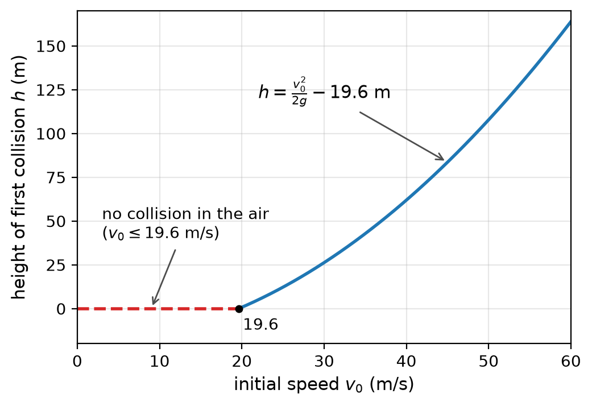
Figure: height of the first collision as a function of the initial speed
Note: the original sheet gives only the value 19.6 m/s for (a) and no answer for (b).

Question 38
Source: Sheet 3, Q.68
A uniform ruler is supported from below at $15 \text{cm}$ from one of its ends. It can then be balanced with two identical coins placed $5 \text{cm}$ from that end. When the support is moved to $1 \text{cm}$ from the same end, it can be balanced with six identical coins at the same position. How long is the ruler?
(The “1 cm” in the sheet must be a misprint for 10 cm: with the support at 1 cm the coins and the ruler’s centre would be on the same side of the support, so no balance would be possible. The solution uses 10 cm, which reproduces the sheet’s answer.)
Answer: $L=50 \text{cm}$ (the ruler’s mass equals that of 2 coins)
Solution:
Principle. For a body balanced on a support, the torques about the support are equal. The weight of the uniform ruler acts at its midpoint, $L/2$ from the end. Let $M$ be the mass of the ruler and $m$ that of one coin. All distances are measured from the chosen end, in centimetres.
Support at 15 cm, two coins at 5 cm
$$2m (15−5)=M\left(\frac{L}{2}−15\right)$$
Support at 10 cm, six coins at 5 cm
$$6m (10−5)=M\left(\frac{L}{2}−10\right)$$
So the two conditions are
$$20m=M\left(\frac{L}{2}−15\right)$$
$$30m=M\left(\frac{L}{2}−10\right)$$
Subtracting the first from the second gives $10m=5M$, so $M=2m$. Substituting into the first:
$$20m=2m\left(\frac{L}{2}−15\right)$$
$$\frac{L}{2}=25 \text{cm}$$
$$L=50 \text{cm}$$
Note: the original sheet text says the second support is “1 cm” from the end. That is impossible, because the coins (at 5 cm) and the ruler’s centre would then be on the same side of the support. The sheet’s answer of 50 cm corresponds to a support at 10 cm, which is used here.

Question 39
Source: Sheet 3, Q.69
With what speed must a pebble be thrown from a height $h$, at an angle of $30°$ to the horizontal, if it is to hit the ground at an angle of $45°$? (Air drag can be neglected.)
Answer: $v_{0}=2\sqrt{gh}=\sqrt{4gh}$, for both an upward and a downward throw at $30°$
Solution:
Principles. (1) In projectile motion the horizontal velocity component is constant. (2) Energy conservation gives the speed at the ground.
Condition for 45 degrees. The horizontal component stays $v_{0}cos30°$. The pebble hits the ground at $45°$ if its vertical component there has the same magnitude. The final speed is then
$$v^{2}=2 (v_{0}cos30°)^{2}=2v_{0}^{2}⋅\frac{3}{4}=\frac{3}{2}v_{0}^{2}$$
Energy conservation. Falling through the height $h$:
$$v^{2}=v_{0}^{2}+2gh$$
Combining the two:
$$\frac{3}{2}v_{0}^{2}=v_{0}^{2}+2gh$$
$$\frac{1}{2}v_{0}^{2}=2gh$$
$$v_{0}=2\sqrt{gh}$$
Neither step uses the sign of the initial vertical velocity. The result is the same whether the pebble is thrown at $30°$ above or below the horizontal. In the upward case it simply spends longer in the air.

Question 40
Source: Sheet 3, Q.70
A carpet runner is laid on a long, straight inclined plane along the line of steepest slope, from the bottom of the slope to its top. The carpet is thin and flexible. Friction keeps it from sliding down, but it can easily be lifted because it does not stick to the plane. The top end of the carpet is rolled up a little and this roll is released. The roll rolls down the slope faster and faster while its diameter grows, and it reaches the bottom of the slope in a time $t_{1}$. A solid cylinder released at the top of the slope reaches the bottom in a time $t_{2}$.
- Which motion takes longer, that of the carpet or that of the cylinder?
- Calculate the ratio $t_{1}/t_{2}$.
(a) the carpet roll takes longer
(b) $t_{1}/t_{2}=\sqrt{2}≈1.41$
Solution:
Let the slope have angle $θ$ and length $ℓ$, and let $λ$ be the mass of the carpet per unit length. Neglect the small initial roll.
Principle. Mechanical energy is conserved for both bodies. Both roll without slipping, so static friction does no work. The carpet is picked up at the contact point, which is momentarily at rest, so no velocity jump and no dissipation occur.
Solid cylinder. For a solid cylinder rolling without slipping, $E_{\text{kin}}=\frac{1}{2}mv^{2}+\frac{1}{2}⋅\frac{1}{2}mr^{2}ω^{2}=\frac{3}{4}mv^{2}$. After it has moved a distance $x$:
$$\frac{3}{4}mv^{2}=mgxsinθ$$
$$v^{2}=\frac{4}{3}gsinθ⋅x$$
This means a uniform acceleration $a_{2}=\frac{2}{3}gsinθ$, since $v^{2}=2ax$.
Carpet roll. After the roll has moved a distance $x$, it contains the piece of carpet of length $x$ and has mass $λx$. It is still very nearly a solid cylinder, so its kinetic energy is $\frac{3}{4}λxv^{2}$. That piece of carpet originally lay with its centre of mass at $x/2$ from the top. Now its centre of mass is at $x$, so it has descended $\frac{x}{2}sinθ$:
$$\frac{3}{4}λx v^{2}=λx g\frac{x}{2}sinθ$$
$$v^{2}=\frac{2}{3}gsinθ⋅x$$
Again $v^{2}∝x$, so the motion is uniformly accelerated, with half the acceleration of the cylinder:
$$a_{1}=\frac{1}{3}gsinθ=\frac{a_{2}}{2}$$
(a) The carpet roll’s acceleration is smaller, so the carpet takes longer. Only half of the carpet’s potential-energy loss per unit length is available. The picked-up carpet starts from rest and descends only on average half as far as the roll.
(b) For uniform acceleration from rest over the same length, $t=\sqrt{2ℓ/a}$:
$$\frac{t_{1}}{t_{2}}=\sqrt{\frac{a_{2}}{a_{1}}}=\sqrt{2}≈1.41$$

Question 41
Source: Sheet 3, Q.72
After leaving the runway, a supersonic fighter climbs along a straight line at an angle of elevation of $30°$. Because of the sharp sound (shock) wave, the grass in the fields around the runway is flattened over a region with a parabolic boundary. What is the speed of the fighter?
Answer: $v=2c≈680 \text{m/s}$ (Mach 2, about $2400 \text{km/h}$)
Solution:
Principle. A body moving faster than sound produces a conical shock front (the Mach cone). Its apex is at the aircraft and its axis lies along the flight path. Its half-angle $μ$ is given by
$$sinμ=\frac{c}{v}$$
Conic section. The flattened grass marks where the cone meets the horizontal ground. A plane cuts a cone in a parabola exactly when it is parallel to one of the cone’s generators. Here the cone’s axis is tilted $30°$ above the horizontal and trails behind and below the aircraft. Its lowest generator is horizontal, and so parallel to the ground, when the half-angle equals the angle of climb:
$$μ=30°$$
If $μ>30°$ the section would be a hyperbola, and if $μ<30°$ it would be an ellipse.
Speed
$$v=\frac{c}{sin30°}=2c≈2⋅340 \text{m/s}=680 \text{m/s}$$
The fighter flies at Mach 2, about $2400 \text{km/h}$.

Question 42
Source: Sheet 3, Q.73
A thin ring of mass $M$ and radius $R$ floats in space.
- At which point of the line through the centre of the ring, perpendicular to its plane, is the gravitational force on a small point-like object greatest? (Where is the gravitational field strength greatest?)
- A point-like object of mass $m$ ($m≪M$) is released from rest at that point. With what relative speed does it pass through the ring?
(a) at a distance $z=\frac{R}{\sqrt{2}}$ from the centre, on either side; there $g_{max}=\frac{2γM}{3\sqrt{3} R^{2}}$
(b) $v=\sqrt{\left(2−\sqrt{\frac{8}{3}}\right)\frac{γM}{R}}≈0.606\sqrt{\frac{γM}{R}}$
Solution:
(a) Field on the axis. Every element $dM$ of the ring is at distance $\sqrt{R^{2}+z^{2}}$ from a point at height $z$ on the axis. By symmetry, the components perpendicular to the axis cancel. Only the axial components, a fraction $z/\sqrt{R^{2}+z^{2}}$ of each, add up:
$$g(z)=\frac{γMz}{(R^{2}+z^{2})^{3/2}}$$
It is zero at the centre and tends to zero far away, so it has a maximum in between. Setting the derivative to zero:
$$\frac{dg}{dz}=γM\frac{(R^{2}+z^{2})−3z^{2}}{(R^{2}+z^{2})^{5/2}}=0$$
$$z=\frac{R}{\sqrt{2}}$$
At this distance (on either side of the ring) the field strength is greatest:
$$g_{max}=\frac{γM\frac{R}{\sqrt{2}}}{{\left(\frac{3}{2}R^{2}\right)}^{3/2}}=\frac{2γM}{3\sqrt{3} R^{2}}≈0.385 \frac{γM}{R^{2}}$$
(b) Speed at the centre. Since $m≪M$, the ring stays practically at rest, so the speed of the object is also the relative speed. The potential on the axis is
$$V(z)=−\frac{γM}{\sqrt{R^{2}+z^{2}}}$$
Energy conservation between $z_{0}=R/\sqrt{2}$, where $\sqrt{R^{2}+z_{0}^{2}}=R\sqrt{3/2}$, and the centre $z=0$:
$$\frac{1}{2}mv^{2}=γMm\left(\frac{1}{R}−\frac{1}{R\sqrt{3/2}}\right)=\frac{γMm}{R}\left(1−\sqrt{\frac{2}{3}}\right)$$
$$v=\sqrt{2\left(1−\sqrt{\frac{2}{3}}\right)\frac{γM}{R}}=\sqrt{\left(2−\sqrt{\frac{8}{3}}\right)\frac{γM}{R}}≈0.606\sqrt{\frac{γM}{R}}$$
The object then passes through the ring, slows down, stops at $z=−R/\sqrt{2}$ and oscillates back and forth through the ring.

Question 43
Source: Sheet 3, Q.76
A man carries a beam on his shoulder. The centre of mass of the beam is not above his shoulder, so he places his arm on the beam to balance it. Someone states that the force exerted on his shoulder is greater than the weight of the beam. Is he right?
Answer: It depends on where the centre of mass is. If the centre of mass lies on the side of the shoulder opposite to the hand (the hand must press the beam down), the shoulder force is greater than the weight: $N=W+F$. If the centre of mass lies on the same side as the hand (the hand must hold the beam up), the shoulder force is smaller: $N=W−F$.
Solution:
The beam is in equilibrium, so both the net force and the net torque on it must be zero. Three forces act on the beam: its weight $W$ at the centre of mass, the upward supporting force $N$ of the shoulder, and the force $F$ of the hand (vertical, for simplicity).
Torque condition. Take torques about the shoulder. Because the centre of mass is not above the shoulder, the weight has a non-zero torque $Wd$ about the shoulder, where $d$ is the horizontal distance of the centre of mass from the shoulder. The hand, at distance $k$ from the shoulder, must provide an equal and opposite torque:
$$Fk=Wd$$
Force condition. Now the direction of $F$ matters.
- Centre of mass on the far side (e.g. behind the shoulder, while the hand grips the beam in front). The weight tends to tip the front end up, so the hand must push down. Vertical balance gives
$$N=W+F=W\left(1+\frac{d}{k}\right)>W$$
- Centre of mass on the hand’s side (in front of the shoulder, with the hand further out or nearer). The weight tends to tip the front end down, so the hand must lift up. Then
$$N=W−F<W$$
So the statement is correct only in the first case: when the man has to press the beam down with his hand, his shoulder carries more than the whole weight of the beam (it also carries the extra force of his own hand). When he lifts the beam with his hand, his shoulder carries less than the weight.

Question 44
Source: Sheet 3, Q.78
Waves are generated by a wave source (the phase angle is zero when they are started) and they travel along a straight line at a speed of $1 \text{m/s}$. When a point of the wave has zero displacement, the closest point that has maximum displacement is at a distance of $1 \text{m}$.
- Find the wavelength and the frequency.
- What is the distance between points whose phase difference is $270°$?
- Measured from the start of the waves, when will the phase of the point $5 \text{m}$ from the source first be $180°$?
Answer:
(a) $λ=4 \text{m}$, $f=0.25 \text{Hz}$
(b) $3 \text{m}$ (in general $3 \text{m}+n⋅4 \text{m}$)
(c) $t=7 \text{s}$
Solution:
(a) In a sinusoidal wave, a point of zero displacement and the nearest point of maximum displacement are a quarter wavelength apart:
$$\frac{λ}{4}=1 \text{m}⇒λ=4 \text{m}$$
From $c=λf$:
$$f=\frac{c}{λ}=\frac{1 \text{m/s}}{4 \text{m}}=0.25 \text{Hz}, T=4 \text{s}$$
(b) A phase difference of $360°$ corresponds to a distance of one wavelength, so
$$Δx=\frac{270°}{360°}λ=\frac{3}{4}⋅4 \text{m}=3 \text{m}$$
(Points $3 \text{m}+nλ$ apart have the same phase difference modulo $360°$.)
(c) The wave front needs $x/c=5 \text{s}$ to reach the point at $x=5 \text{m}$; before that the point is at rest. Its phase is
$$φ=2π\left(\frac{t}{T}−\frac{x}{λ}\right)=2π \frac{t−x/c}{T}$$
The phase $180°$ (half a period) is reached half a period after the wave arrives:
$$t=\frac{x}{c}+\frac{T}{2}=5 \text{s}+2 \text{s}=7 \text{s}$$

Question 45
Source: Sheet 3, Q.79
An object moving along a circular path with uniform deceleration loses two-thirds of its speed while it covers a half circle. From this point on, what fraction of the whole circle does it cover until it stops, and how long does this take?
Answer: It covers $\frac{1}{16}$ of the circle, in a time $t=\frac{3πR}{4v_{0}}=\frac{3}{8}T$, where $v_{0}$ is the initial speed and $T=2πR/v_{0}$ is the period of uniform circular motion at the initial speed.
Solution:
“Uniform deceleration” along the path means the tangential deceleration $a$ is constant, so the kinematic relations of uniformly decelerated motion hold along the arc length $s$. Let the radius be $R$ and the initial speed $v_{0}$.
First stage (half circle, $s_{1}=πR$). The speed drops from $v_{0}$ to $v_{0}/3$:
$$v_{0}^{2}−{\left(\frac{v_{0}}{3}\right)}^{2}=2aπR⇒a=\frac{8v_{0}^{2}}{18πR}=\frac{4v_{0}^{2}}{9πR}$$
Second stage (until stop). The remaining arc length is
$$s_{2}=\frac{(v_{0}/3)^{2}}{2a}=\frac{v_{0}^{2}}{9}⋅\frac{9πR}{8v_{0}^{2}}=\frac{πR}{8}$$
As a fraction of the full circumference:
$$\frac{s_{2}}{2πR}=\frac{1}{16}$$
(Equivalently: the “stopping distance” is proportional to $v^{2}$; from $v_{0}/3$ it is $1/9$ of that from $v_{0}$, i.e. $\frac{1}{8}$ of the half circle already covered.)
The time of the second stage is
$$t_{2}=\frac{v_{0}/3}{a}=\frac{v_{0}}{3}⋅\frac{9πR}{4v_{0}^{2}}=\frac{3πR}{4v_{0}}$$
Expressed with the period $T=2πR/v_{0}$ of uniform motion at the initial speed:
$$t_{2}=\frac{3}{8}T$$

Question 46
Source: Sheet 3, Q.81
An ice floe floats in the sea. The part above the water is a prism of height $0.5 \text{m}$. A $200 \text{kg}$ seal climbs onto the floe, which then sinks $5 \text{cm}$ deeper into the water. How many seals of the same mass can the floe hold without sinking completely under water? What is the volume of the ice floe?
Answer: 10 seals (with the tenth seal the top of the floe just reaches the water surface); $V≈25 {\text{m}}^{3}$ (with $ρ_{\text{water}}=1000 {\text{kg/m}}^{3}$, $ρ_{\text{ice}}=920 {\text{kg/m}}^{3}$).
Solution:
Number of seals. The part above water is a prism of cross-sectional area $A$, so every additional centimetre of sinking displaces the same extra volume of water. One seal ($m=200 \text{kg}$) causes $Δh=5 \text{cm}$ extra sinking (Archimedes’ principle):
$$ρ_{w}AΔh=m$$
The floe sinks completely when it has sunk the whole $h=0.5 \text{m}$, which needs
$$n=\frac{h}{Δh}=\frac{0.5 \text{m}}{0.05 \text{m}}=10$$
seals. With 10 seals the top of the floe is just level with the water; the floe can therefore carry at most 10 seals (an eleventh would sink it).
Cross-section. From the first equation:
$$A=\frac{m}{ρ_{w}Δh}=\frac{200 \text{kg}}{1000 {\text{kg/m}}^{3}⋅0.05 \text{m}}=4 {\text{m}}^{2}$$
Volume. For the floe alone, its weight equals the buoyant force on the submerged part, whose volume is $V−Ah$:
$$ρ_{i}V=ρ_{w}(V−Ah)$$
$$V=\frac{ρ_{w}Ah}{ρ_{w}−ρ_{i}}=\frac{nm}{ρ_{w}−ρ_{i}}=\frac{2000 \text{kg}}{(1000−920) {\text{kg/m}}^{3}}=25 {\text{m}}^{3}$$
The result is very sensitive to the densities: with sea water $ρ_{w}=1025 {\text{kg/m}}^{3}$ and $ρ_{i}=917 {\text{kg/m}}^{3}$ one gets $V=2000/108≈19 {\text{m}}^{3}$. The order of magnitude, about $20$–$25 {\text{m}}^{3}$, is reliable.

Question 47
Source: Sheet 3, Q.82
A thin, strong steel cable is stretched horizontally with a large force above a street. A tightrope walker walks along the cable. When she has covered one quarter of the length of the cable (she is at point $N$), the point of the cable at one third of its length ($H$) is $10 \text{cm}$ below its original position. How far will point $N$ descend when the walker is at point $H$? (The mass of the cable is negligible, the deflection is very small compared with the length of the cable, and the tension in the cable can be considered constant.)
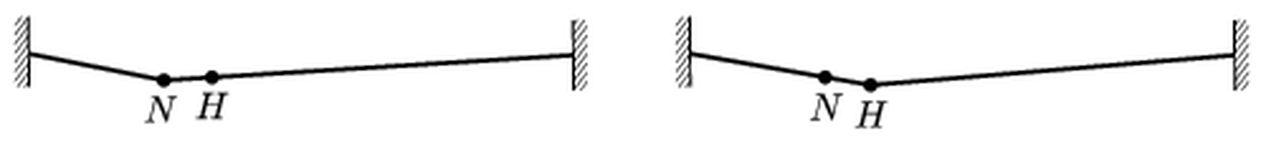
Figure: the cable with the walker at N (left) and at H (right)
Answer: Point $N$ descends by exactly $10 \text{cm}$.
Solution:
Let the cable have length $L$ and constant tension $T$, and let the walker’s weight be $G$. Under a point load the cable forms two straight segments. If the load is at distance $x$ from the left end and the depression there is $δ$, then for small angles the vertical components of tension give
$$G=T\left(\frac{δ}{x}+\frac{δ}{L−x}\right)⇒δ=\frac{Gx(L−x)}{TL}$$
A point at distance $s$ lies on one of the straight segments, so its depression is obtained by linear interpolation:
$$y(s)=\frac{G s(L−x)}{TL} (s≤x)$$
$$y(s)=\frac{G x(L−s)}{TL} (s≥x)$$
Walker at N ($x=L/4$), depression of H ($s=L/3≥x$):
$$y_{H}=\frac{G}{TL}⋅\frac{L}{4}⋅\frac{2L}{3}=\frac{GL}{6T}=10 \text{cm}$$
Walker at H ($x=L/3$), depression of N ($s=L/4≤x$):
$$y_{N}=\frac{G}{TL}⋅\frac{L}{4}⋅\frac{2L}{3}=\frac{GL}{6T}$$
The two expressions are identical, so $y_{N}=10 \text{cm}$.
This is not a coincidence: the formula is symmetric in $s$ and $x$ (the product of the distance of the nearer point from its end and of the farther point from the other end). For any two points $P$ and $Q$ of the cable, the depression of $Q$ caused by the load at $P$ equals the depression of $P$ caused by the same load at $Q$ (Maxwell’s reciprocity theorem).

Question 48
Source: Sheet 3, Q.83
Two soap bubbles stick together. One part of the resulting shape is a sphere segment of radius $R=6 \text{cm}$, the other has radius $r=2 \text{cm}$.
- What is the radius $ρ$ of the spherical cap that separates the two parts?
- What is the pressure difference between the two parts? The surface tension of the soap solution is $α=0.029 \text{N/m}$.
- In another pair of bubbles stuck together, the radius of the separating cap equals $R$. By what factor is $R$ greater than $r$ in that case?
Answer:
(a) $ρ=\frac{Rr}{R−r}=3 \text{cm}$
(b) $Δp=\frac{4α}{ρ}≈3.9 \text{Pa}$
(c) $R=2r$
Solution:
A soap film has two surfaces, so the pressure jump across a spherical film of radius $ρ$ is $4α/ρ$ (higher pressure on the concave side).
The pressures inside the large and the small bubble (outer pressure $p_{0}$):
$$p_{R}=p_{0}+\frac{4α}{R}$$
$$p_{r}=p_{0}+\frac{4α}{r}$$
(a) The separating film is also a double-surface film; the pressure jump across it equals the difference of the two inner pressures, and it bulges into the larger bubble:
$$\frac{4α}{ρ}=p_{r}−p_{R}=4α\left(\frac{1}{r}−\frac{1}{R}\right)$$
$$ρ=\frac{Rr}{R−r}=\frac{6⋅2}{6−2} \text{cm}=3 \text{cm}$$
(b)
$$Δp=\frac{4α}{ρ}=\frac{4⋅0.029 \text{N/m}}{0.03 \text{m}}≈3.9 \text{Pa}$$
(c) Put $ρ=R$ in the relation of part (a):
$$\frac{1}{R}=\frac{1}{r}−\frac{1}{R}⇒\frac{2}{R}=\frac{1}{r}⇒R=2r$$
So $R$ is twice $r$.
Note: the original sheet gives $Δp=4 \text{Pa}$, which is the rounded value of $3.87 \text{Pa}$.

Question 49
Source: Sheet 3, Q.84
The blood pressure of a healthy person is $120/80 \text{mmHg}$. In intravenous (IV) therapy a solution is fed directly into a vein. From what height would the solution have to be given in order to make it flow into an artery? What is the blood pressure in the vein if the IV solution starts to flow back when the solution bag is lower than $40 \text{cm}$?
Answer: To flow into an artery the bag would have to be about $1.6 \text{m}$ (a $163 \text{cm}$ water column, equivalent to $120 \text{mmHg}$) above the puncture point. The venous pressure is about $3.9 \text{kPa}≈29 \text{mmHg}$ (equal to a $40 \text{cm}$ water column).
Solution:
The IV solution is essentially water ($ρ≈1000 {\text{kg/m}}^{3}$); mercury has $ρ_{\text{Hg}}=13 600 {\text{kg/m}}^{3}$. Blood pressure values are gauge pressures (above atmospheric). The fluid flows into the vessel only if the hydrostatic pressure of the column in the tube, $ρgh$, exceeds the blood pressure in the vessel.
Into an artery. The pressure must exceed even the systolic (maximum) value of $120 \text{mmHg}$. Equal pressures mean $ρgh=ρ_{\text{Hg}}gh_{\text{Hg}}$:
$$h=\frac{ρ_{\text{Hg}}}{ρ}h_{\text{Hg}}=13.6⋅0.12 \text{m}≈1.63 \text{m}$$
So the bag would have to hang about $1.6 \text{m}$ above the arm. (This is why infusions are given into veins, where the pressure is much smaller.)
Venous pressure. Back-flow starts when the column height falls below $40 \text{cm}$, so the venous pressure equals the pressure of a $40 \text{cm}$ water column:
$$p_{v}=ρgh=1000 {\text{kg/m}}^{3}⋅9.81 {\text{m/s}}^{2}⋅0.40 \text{m}≈3.9 \text{kPa}$$
In mercury units:
$$h_{\text{Hg}}=\frac{0.40 \text{m}}{13.6}≈29 \text{mm}⇒p_{v}≈29 \text{mmHg}$$
Note: the original (garbled) answer quotes “40 mmHg” and “30 cm of water column”; a 40 cm water column corresponds to about 29 mmHg.

Question 50
Source: Sheet 3, Q.91
A U-shaped communicating vessel made of a bent glass tube contains water. The part of the tube filled with water is $30 \text{cm}$ long. When the vessel is in a uniformly accelerating vehicle, the difference between the water levels in the two arms is $1 \text{cm}$.
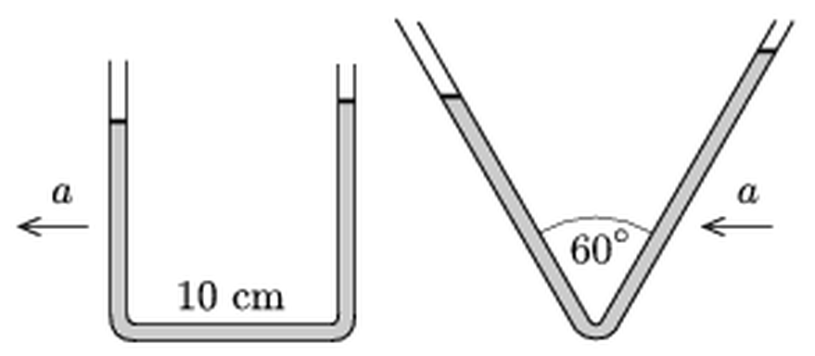
Figure: U-tube with a 10 cm horizontal part, and a V-tube with a 60 degree apex angle, both accelerating
What is the acceleration of the vehicle if the length of the horizontal part of the tube is $10 \text{cm}$? What would the difference between the lengths of the water columns have been if a V-shaped vessel (apex angle $60°$) had been used, in which the total length of the water-filled tube is also $30 \text{cm}$?
Answer: $a=\frac{g}{10}≈0.98 {\text{m/s}}^{2}≈1 {\text{m/s}}^{2}$. In the V-tube the two water columns would differ in length by $Δl=\frac{30 \text{cm}}{10\sqrt{3}}≈1.7 \text{cm}$ (a level difference of $1.5 \text{cm}$).
Solution:
U-tube. The water in the vertical arms is accelerated horizontally by the side walls; it is the water in the horizontal part (length $l=10 \text{cm}$, cross-section $A$, mass $ρAl$) that has to be accelerated by a pressure difference. The pressure difference between the two ends of the horizontal part is produced by the level difference $Δh$:
$$ρgΔh⋅A=ρAl⋅a$$
$$a=g\frac{Δh}{l}=9.81 {\text{m/s}}^{2}⋅\frac{1 \text{cm}}{10 \text{cm}}≈0.98 {\text{m/s}}^{2}$$
The water rises in the rear arm (opposite to the direction of acceleration).
V-tube. In the frame of the vehicle the water is in equilibrium in an effective field: gravity $g$ downward plus the inertial acceleration $a$ opposite to the acceleration. The two free surfaces must lie at the same “potential” of this field:
$$gy_{1}−ax_{1}=gy_{2}−ax_{2}$$
where $x$ is measured in the direction of the inertial force (opposite to $\vec{a}$). Each arm makes $30°$ with the vertical. A column of length $l_{1}$ in the front arm ends at $x_{1}=−l_{1}/2$, $y_{1}=l_{1}\sqrt{3}/2$; a column of length $l_{2}$ in the rear arm ends at $x_{2}=l_{2}/2$, $y_{2}=l_{2}\sqrt{3}/2$. Substituting:
$$l_{1}\left(g\sqrt{3}+a\right)=l_{2}\left(g\sqrt{3}−a\right)$$
Rearranging, $(l_{2}−l_{1})g\sqrt{3}=(l_{1}+l_{2})a$, so with $l_{1}+l_{2}=30 \text{cm}$ and $a=g/10$:
$$Δl=l_{2}−l_{1}=\frac{(l_{1}+l_{2})a}{\sqrt{3}g}=\frac{30 \text{cm}}{10\sqrt{3}}≈1.73 \text{cm}$$
The columns are about $14.1 \text{cm}$ and $15.9 \text{cm}$ long. The corresponding difference in level height is $Δlcos30°=1.5 \text{cm}$.

Question 51
Source: Sheet 3, Q.92
A rubber ball is dropped from a height of $2 \text{m}$ in a lift at rest, and after the first bounce it rises to a height of $162 \text{cm}$. How much time elapses between the first and the second bounce? The experiment is then repeated while the lift accelerates upward with a constant acceleration of $1 {\text{m/s}}^{2}$. Do the rebound heights and the time between two consecutive bounces change? If so, how?
Answer: $t=1.15 \text{s}$ in the lift at rest. In the accelerating lift the rebound heights (relative to the floor) do not change; the times become shorter by the factor $\sqrt{g/(g+a)}=0.953$, i.e. about $5\%$ shorter (about $1.09 \text{s}$ between the first and second bounces).
Solution:
Lift at rest. After the first bounce the ball leaves the floor with speed $v_{1}$ and rises to $h_{1}=1.62 \text{m}$. The flight up and down is symmetric, so the time between the first and the second bounce is
$$t_{1}=2\sqrt{\frac{2h_{1}}{g}}=2\sqrt{\frac{2⋅1.62 \text{m}}{9.81 {\text{m/s}}^{2}}}≈1.15 \text{s}$$
(The ratio $h_{1}/h_{0}=0.81$ means the coefficient of restitution is $e=\sqrt{0.81}=0.9$.)
Accelerating lift. In the frame of the lift, which accelerates upward with $a$, the ball feels an inertial force $ma$ downward in addition to gravity. All motion relative to the lift therefore happens as in a lift at rest with an effective gravitational acceleration
$$g^{′}=g+a=10.81 {\text{m/s}}^{2}$$
Heights. The ball is released from rest relative to the lift at $2 \text{m}$. The speed at impact is $\sqrt{2g^{′}h_{0}}$, the rebound speed is $e$ times this, and the rebound height is $e^{2}h_{0}$, independent of $g^{′}$. Assuming the same coefficient of restitution, the heights are unchanged: $1.62 \text{m}$, $1.31 \text{m}$, and so on.
Times. Every flight time scales as $1/\sqrt{g^{′}}$:
$$\frac{t^{′}}{t}=\sqrt{\frac{g}{g+a}}=\sqrt{\frac{9.81}{10.81}}≈0.953$$
$$t_{1}^{′}=0.953⋅1.15 \text{s}≈1.09 \text{s}$$
So the time between bounces decreases by about $5\%$.
Note: the original sheet gives $1.14 \text{s}$ for the lift at rest; with $g=9.81 {\text{m/s}}^{2}$ the value is $1.149 \text{s}≈1.15 \text{s}$.

Question 52
Source: Sheet 3, Q.93
An object is projected horizontally from a tower and hits the ground $40 \text{m}$ from the foot of the tower at an angle of $45°$. (Air drag is negligible.)
- From what height is the object projected?
- From what height should the object be projected with the same initial horizontal speed so that the ratio of the horizontal and vertical displacements is the reciprocal of the previous ratio?
Answer:
(a) $h=20 \text{m}$ (initial speed $v_{0}≈20 \text{m/s}$)
(b) $h^{′}=320 \text{m}$ (the object then lands $160 \text{m}$ from the tower after about $8 \text{s}$)
Solution:
In horizontal projection the horizontal motion is uniform ($x=v_{0}t$) and the vertical motion is free fall from rest ($y=gt^{2}/2$, $v_{y}=gt$).
(a) Hitting the ground at $45°$ means $v_{y}=v_{0}$ at impact. The average vertical speed during the fall is $v_{y}/2=v_{0}/2$, so
$$y=\frac{v_{y}}{2}t=\frac{v_{0}t}{2}=\frac{x}{2}=\frac{40 \text{m}}{2}=20 \text{m}$$
The initial speed:
$$v_{0}=v_{y}=\sqrt{2gy}=\sqrt{2⋅9.81⋅20} \text{m/s}≈19.8 \text{m/s}≈20 \text{m/s}$$
(b) In case (a) the ratio was $x:y=2:1$; now we require $x^{′}:y^{′}=1:2$ with the same $v_{0}$:
$$\frac{x^{′}}{y^{′}}=\frac{v_{0}t^{′}}{gt^{′}​^{2}/2}=\frac{2v_{0}}{gt^{′}}=\frac{1}{2}⇒t^{′}=\frac{4v_{0}}{g}$$
The height of the tower:
$$y^{′}=\frac{gt^{′}​^{2}}{2}=\frac{8v_{0}^{2}}{g}=\frac{8⋅2g⋅20 \text{m}}{g}=320 \text{m}$$
using $v_{0}^{2}=2g⋅20 \text{m}$ from part (a); the result does not depend on the value of $g$. The flight time is $t^{′}=4v_{0}/g≈8 \text{s}$ and the horizontal range is $x^{′}=y^{′}/2=160 \text{m}$.

Question 53
Source: Sheet 3, Q.97
By what percentage would the gravitational acceleration at the North Pole change if the radius of the Earth increased by $1\%$ while its mass remained the same?
Answer: It would decrease by about $2\%$ (more precisely by $1.97\%$).
Solution:
At the pole there is no centrifugal effect from the Earth’s rotation, so the gravitational acceleration is given purely by Newton’s law of gravitation:
$$g=\frac{GM}{R^{2}}$$
With the same mass and the radius increased to $R^{′}=1.01R$:
$$\frac{g^{′}}{g}={\left(\frac{R}{R^{′}}\right)}^{2}=\frac{1}{{1.01}^{2}}=0.9803$$
So $g$ decreases by
$$1−0.9803=0.0197≈2\%$$
This agrees with the quick estimate for small changes: since $g∝R^{−2}$, the relative change is $Δg/g≈−2 ΔR/R=−2\%$.

Question 54
Source: Sheet 3, Q.98
A $200 \text{m}$ long convoy of cars travels at a speed of $10 \text{m/s}$. A motorbike starts from the end of the convoy towards its front at a speed of $20 \text{m/s}$.
- How long does it take to reach the front of the convoy?
- How long does it take to get back?
Answer:
(a) $20 \text{s}$
(b) $6.7 \text{s}$
Solution:
Work in the frame of the convoy, in which the convoy is at rest and has length $L=200 \text{m}$. The motorbike’s speed (relative to the road) is $20 \text{m/s}$ in both directions.
(a) Moving forward, the relative speed is the difference of the speeds:
$$t_{1}=\frac{L}{v_{m}−v_{c}}=\frac{200 \text{m}}{(20−10) \text{m/s}}=20 \text{s}$$
(In the road frame the motorbike covers $400 \text{m}$ while the front of the convoy moves $200 \text{m}$.)
(b) Moving back, the motorbike and the end of the convoy approach each other, so the relative speed is the sum:
$$t_{2}=\frac{L}{v_{m}+v_{c}}=\frac{200 \text{m}}{(20+10) \text{m/s}}≈6.7 \text{s}$$

Question 55
Source: Sheet 3, Q.100
The natural length of a spring is $25 \text{cm}$, and it extends by $2 \text{cm}$ when a force of $1 \text{N}$ acts on it. A container is filled with water, and one end of the spring is fixed $30 \text{cm}$ above the water surface. A wooden block of mass $32 \text{g}$, density $0.4 {\text{g/cm}}^{3}$ and height $5 \text{cm}$ hangs on the other end of the spring. To what depth is the block immersed in the water?
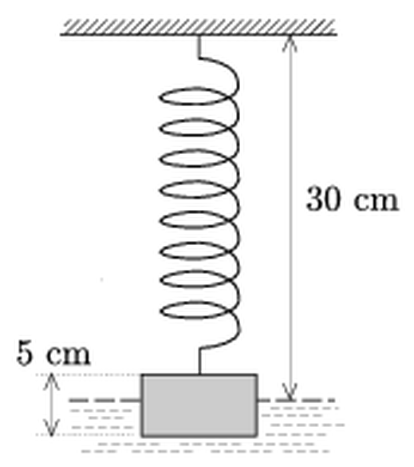
Figure: block hanging on a spring above water
Answer: $d≈0.48 \text{cm}≈0.5 \text{cm}$
Solution:
Data. Spring constant:
$$k=\frac{1 \text{N}}{0.02 \text{m}}=50 \text{N/m}$$
Volume and base area of the block:
$$V=\frac{m}{ρ_{b}}=\frac{32 \text{g}}{0.4 {\text{g/cm}}^{3}}=80 {\text{cm}}^{3}, A=\frac{V}{5 \text{cm}}=16 {\text{cm}}^{2}$$
Geometry. If the spring has length $25 \text{cm}+x$ (extension $x$), the bottom of the block is $25 \text{cm}+x+5 \text{cm}=30 \text{cm}+x$ below the fixed point. The water surface is $30 \text{cm}$ below it, so the immersion depth equals the extension:
$$d=x$$
(Without the spring stretching, the bottom of the block would just touch the water.)
Equilibrium. The spring force and the buoyant force together support the weight:
$$kd+ρ_{w}gAd=mg$$
$$d=\frac{mg}{k+ρ_{w}gA}$$
Here $ρ_{w}gA=1000⋅9.81⋅16×{10}^{−4} \text{N/m}=15.7 \text{N/m}$ and $mg=0.314 \text{N}$:
$$d=\frac{0.314 \text{N}}{(50+15.7) \text{N/m}}≈4.8×{10}^{−3} \text{m}≈0.48 \text{cm}$$
The block is immersed about $0.5 \text{cm}$ deep. Since the block (density $0.4 {\text{g/cm}}^{3}$) would float freely immersed $2 \text{cm}$ deep, the spring still carries most of its weight: $kd≈0.24 \text{N}$, while buoyancy gives about $0.075 \text{N}$.

Question 56
Source: Sheet 3, Q.101
A physics teacher often went skating on a nearby frozen lake. Once, while skidding, he reduced his speed to one third of its original value over $16 \text{m}$, and then it took him $1$ more second to stop. What distance did he cover during the braking? On another day, with the same initial speed, he suddenly noticed a crack in the ice $20 \text{m}$ in front of him. How far from the crack could he stop if his reaction time is $0.1 \text{s}$ and he used his usual braking technique?
Answer: The braking distance is $18 \text{m}$ (initial speed $12 \text{m/s}$, deceleration $4 {\text{m/s}}^{2}$). On the other day he stops $0.8 \text{m}$ before the crack.
Solution:
Assume uniform deceleration $a$ and initial speed $v_{0}$.
Second stage. From $v_{0}/3$ to rest in $t=1 \text{s}$:
$$\frac{v_{0}}{3}=a⋅1 \text{s}⇒v_{0}=3a⋅(1 \text{s})$$
First stage. From $v_{0}$ to $v_{0}/3$ over $s_{1}=16 \text{m}$:
$$v_{0}^{2}−\frac{v_{0}^{2}}{9}=2as_{1}⇒\frac{8}{9}v_{0}^{2}=32 \text{m}⋅a$$
Substituting $v_{0}=3a$ (in SI units): $8a^{2}=32a$, so
$$a=4 {\text{m/s}}^{2}, v_{0}=12 \text{m/s}$$
Total braking distance. The second stage:
$$s_{2}=\frac{(v_{0}/3)^{2}}{2a}=\frac{(4 \text{m/s})^{2}}{8 {\text{m/s}}^{2}}=2 \text{m}$$
$$s=s_{1}+s_{2}=16 \text{m}+2 \text{m}=18 \text{m}$$
(Check: $v_{0}^{2}/(2a)=144/8 \text{m}=18 \text{m}$.)
The crack. During the reaction time he still glides at full speed:
$$s_{r}=v_{0}t_{r}=12 \text{m/s}⋅0.1 \text{s}=1.2 \text{m}$$
The total stopping distance is $1.2 \text{m}+18 \text{m}=19.2 \text{m}$, so he stops
$$20 \text{m}−19.2 \text{m}=0.8 \text{m}$$
in front of the crack.

Question 57
Source: Sheet 3, Q.106
A group of amateur astronomers observes a newly discovered binary star. The two stars look like a pair of bright points moving along the ellipse shown in the figure. Ester, the most enthusiastic member of the group, has recently learned Kepler’s laws at school. She knows that celestial bodies move along elliptical paths, but that the centre of attraction is not at the centre $O$ of the ellipse but at one of its foci. She suspects that the two stars revolve around an invisible black hole, much more massive than the stars, located at a focus of the ellipse. Can Ester be right? How would you explain the observation?
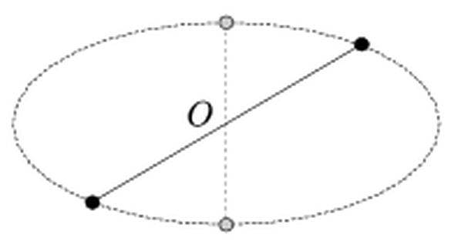
Figure: two stars on an ellipse, always on a line through its centre O
Answer: No. The two stars are always seen at opposite ends of a chord through the centre $O$, which is impossible for Kepler motion around a focus. The two stars (of equal mass) move around their common centre of mass on a circle; the plane of the orbit is tilted with respect to the line of sight, so the circle is seen as an ellipse whose centre $O$ is the projection of the centre of mass.
Solution:
Why the black-hole picture fails. If a dominant mass sat at a focus $F$, each star would obey Kepler’s second law with respect to $F$: equal areas swept about the focus in equal times. A star would move fast near the pericentre (the vertex nearer to $F$) and slowly near the apocentre. Two stars on the same orbit would therefore bunch up near the apocentre and spread apart near the pericentre. They could not stay at the two ends of a chord through the centre $O$, because that symmetric arrangement requires the motion to be symmetric about $O$, whereas Kepler motion around a focus is not. The observed symmetry about $O$ thus contradicts Ester’s hypothesis.
Correct explanation. In a binary system the two stars attract each other and both orbit their common centre of mass $C$, which always lies on the line joining them. Being always diametrically opposite with respect to $O$ means:
- the centre of mass is at $O$ and divides the separation in half, so the two stars have equal masses;
- since both stars lie on the same curve, symmetric about $O$, the simplest consistent orbit is a circle around $C$, traversed uniformly.
We see a circle as an ellipse when its plane is inclined to our line of sight. A circle of radius $a$ whose plane is tilted by angle $i$ (between the orbit’s normal and the line of sight) projects into an ellipse with semi-axes $a$ and $b=acosi$, and its centre projects onto the centre $O$ of the ellipse, not onto a focus. Uniform circular motion projects into motion in which the two points are always symmetric about $O$, exactly as observed.
From the measured axis ratio the inclination follows as $cosi=b/a$. In addition, measuring the period and (with a known distance) the true size of the orbit gives the masses of the stars from Kepler’s third law.

Question 58
Source: Sheet 3, Q.107
What are the direction and the magnitude of the smallest force that can move a small object of mass $m$ resting on a horizontal table? The coefficients of static and kinetic friction are equal, $μ$.
Answer: $F_{\text{min}}=\frac{μmg}{\sqrt{1+μ^{2}}}$, directed upward at an angle $θ=arctanμ$ above the horizontal (equal to the angle of friction).
Solution:
Let the force $F$ act at an angle $θ$ above the horizontal. The forces on the object are its weight $mg$, the normal force $N$, the friction force $S≤μN$ and $F$.
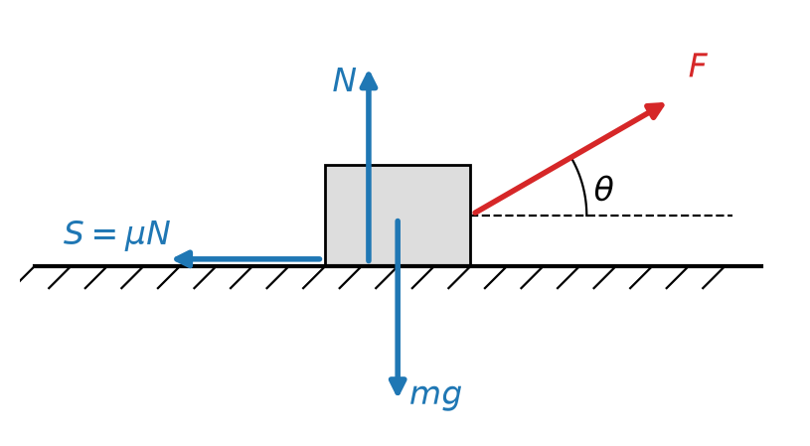
Figure: forces on the object pulled at angle theta
Pulling upward reduces the normal force:
$$N=mg−Fsinθ$$
The object just starts to move when the horizontal component of $F$ equals the maximum static friction:
$$Fcosθ=μ\left(mg−Fsinθ\right)$$
$$F(θ)=\frac{μmg}{cosθ+μsinθ}$$
$F$ is smallest when the denominator is largest. Write $μ=tanφ$ ($φ$ is the angle of friction):
$$cosθ+μsinθ=\frac{cos(θ−φ)}{cosφ}$$
This is maximal for $θ=φ$, where it equals $1/cosφ=\sqrt{1+μ^{2}}$. Hence
$$F_{\text{min}}=\frac{μmg}{\sqrt{1+μ^{2}}}=mgsinφ, tanθ=μ$$
Geometric interpretation. At the point of slipping the normal force and the maximum friction combine into a total contact force tilted by $φ$ from the vertical. The three forces $mg$, the contact force and $F$ must form a closed triangle; $F$ is shortest when it is perpendicular to the contact force, i.e. tilted by $φ$ above the horizontal, and then $F=mgsinφ$.
For comparison, a horizontal pull would need $μmg$, which is larger by the factor $\sqrt{1+μ^{2}}$.

Question 59
Source: Sheet 3, Q.108
A rubber cord is stretched between two walls. A force $F$ along the direction of the cord acts at point $C$ of the cord.
- What is the displacement of point $C$ if the whole cord can be characterised by the spring constant $D$?
- At which point of the cord must the force $F$ act for the displacement of the point of application to be largest?
Data: $F=5 \text{N}$, $a=40 \text{cm}$, $b=10 \text{cm}$, $D=1 \text{N/cm}$.
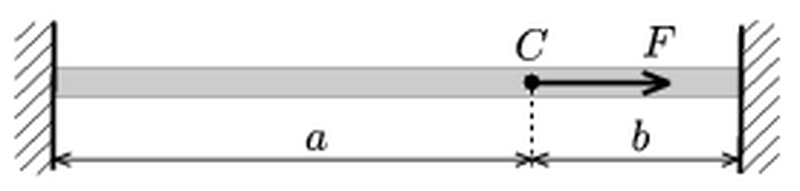
Figure: cord between two walls with force F at point C, distances a and b
Answer:
(a) $Δl=\frac{ab}{(a+b)^{2}}⋅\frac{F}{D}=0.8 \text{cm}$
(b) At the midpoint ($a=b$), where $Δl_{\text{max}}=\frac{F}{4D}=1.25 \text{cm}$ (provided the cord stays taut).
Solution:
(a) The spring constant of a uniform elastic cord is inversely proportional to its length. The whole cord of length $a+b$ has constant $D$, so the two pieces have
$$D_{a}=D \frac{a+b}{a}$$
$$D_{b}=D \frac{a+b}{b}$$
When $C$ moves by $Δl$ towards the wall at $b$, piece $a$ lengthens and piece $b$ shortens by $Δl$. The tension in $a$ increases by $D_{a}Δl$, the tension in $b$ decreases by $D_{b}Δl$, and both changes oppose the displacement. The two pieces act like springs in parallel:
$$F=(D_{a}+D_{b}) Δl=D \frac{(a+b)^{2}}{ab} Δl$$
$$Δl=\frac{ab}{(a+b)^{2}}⋅\frac{F}{D}$$
Numerically:
$$Δl=\frac{40⋅10}{{50}^{2}}⋅\frac{5 \text{N}}{1 \text{N/cm}}=0.16⋅5 \text{cm}=0.8 \text{cm}$$
(b) With $a+b$ fixed, $Δl$ is largest when the product $ab$ is largest. Of all rectangles with a given perimeter the square has the largest area, so the maximum is at $a=b$, i.e. at the midpoint of the cord:
$$Δl_{\text{max}}=\frac{1}{4}⋅\frac{F}{D}=\frac{5 \text{N}}{4 \text{N/cm}}=1.25 \text{cm}$$
This holds only if the cord remains taut, i.e. the original tension is larger than the decrease $D_{b}Δl$ in the shortened piece; otherwise that piece goes slack and only the other piece resists.

Question 60
Source: Sheet 3, Q.110
Three rods, any two of which are perpendicular to each other, stand on a rough horizontal surface and form a pyramid. The vertex of the pyramid supports a weight $Q$. What forces do the rods exert if they have equal lengths, and if they have different lengths? (The weight of the rods is negligible compared with $Q$.)
Answer: Equal lengths: each rod is compressed by $F=\frac{Q}{\sqrt{3}}≈0.577 Q$. Lengths $a$, $b$, $c$: the forces are inversely proportional to the lengths,
$$F_{a}=\frac{Q/a}{\sqrt{\frac{1}{a^{2}}+\frac{1}{b^{2}}+\frac{1}{c^{2}}}}$$
and similarly for $F_{b}$ and $F_{c}$.
Solution:
The rods are weightless and are loaded only at their ends, so each rod is a two-force member: the force it exerts on the vertex acts along the rod (compression). The rough ground holds the feet in place.
Equilibrium of the vertex. Let ${\vec{e}}_{1}$, ${\vec{e}}_{2}$, ${\vec{e}}_{3}$ be unit vectors along the rods, pointing from the vertex towards the feet. They are mutually perpendicular, so they form an orthonormal basis. Let $γ_{i}$ be the angle between rod $i$ and the vertical. The rod forces on the vertex are $−F_{i}{\vec{e}}_{i}$, and they must balance the load $Q$ pointing downward. Decomposing the downward unit vector $\vec{k}$ in this basis, $\vec{k}=∑(\vec{k}⋅{\vec{e}}_{i}) {\vec{e}}_{i}$, gives
$$F_{i}=Q (\vec{k}⋅{\vec{e}}_{i})=Qcosγ_{i}$$
Because the basis is orthonormal, the direction cosines satisfy
$$\cos^{2}γ_{1}+\cos^{2}γ_{2}+\cos^{2}γ_{3}=1$$
Equal rods. By symmetry all three angles are equal, so $cosγ=1/\sqrt{3}$ and
$$F=\frac{Q}{\sqrt{3}}≈0.577 Q$$
Rods of lengths $a$, $b$, $c$. All feet are on the same horizontal plane, so the height $h$ of the vertex is
$$h=acosγ_{a}=bcosγ_{b}=ccosγ_{c}$$
Substituting $cosγ_{i}=h/l_{i}$ into the sum of squared cosines:
$$h^{2}\left(\frac{1}{a^{2}}+\frac{1}{b^{2}}+\frac{1}{c^{2}}\right)=1$$
Therefore $F_{a}=Qh/a$, i.e.
$$F_{a}=\frac{Q/a}{\sqrt{\frac{1}{a^{2}}+\frac{1}{b^{2}}+\frac{1}{c^{2}}}}$$
and analogously for $F_{b}$ and $F_{c}$. The forces are inversely proportional to the rod lengths: the shortest rod, which stands most steeply, carries the largest load. Check: for $a=b=c$ this gives $Q/\sqrt{3}$, and $F_{a}^{2}+F_{b}^{2}+F_{c}^{2}=Q^{2}$, as required for three perpendicular components of the force $Q$.

Question 61
Source: Sheet 3, Q.111
An object of mass $m$ can move without friction along the horizontal $X$ axis. Another object of mass $m$ is connected to it by a thread of length $L$; this second object can move only along the vertical $Y$ axis. Initially the second object is at the origin and the first one is on the $X$ axis at distance $L$ from it. Then the objects are released. What maximum speeds do the objects reach due to gravity? What kind of motion do they perform?
Answer: The object on the $X$ axis reaches $v_{1,\text{max}}=\sqrt{2gL}$ when it passes the origin (thread vertical). The object on the $Y$ axis reaches $v_{2,\text{max}}=\sqrt{\frac{4gL}{3\sqrt{3}}}≈0.88\sqrt{gL}$ when the thread makes the angle $θ=arcsin\frac{1}{\sqrt{3}}≈35.3°$ with the horizontal. Both objects oscillate periodically, but not harmonically (the motion is that of a simple pendulum of length $L$ released from the horizontal).
Solution:
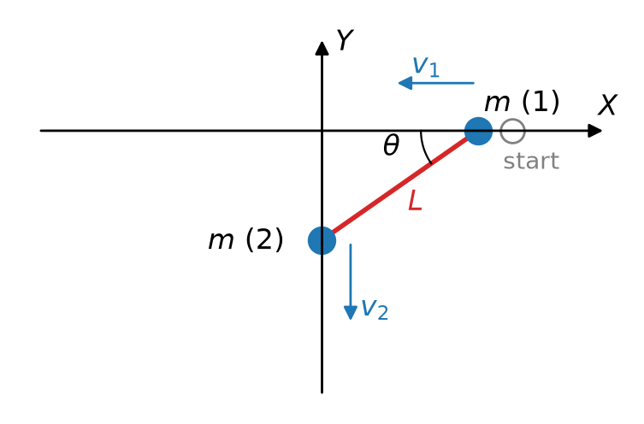
Figure: the two objects on the X and Y axes connected by the thread
Let $θ$ be the angle between the thread and the $X$ axis. Then object 1 is at $x=Lcosθ$ and object 2 at $y=−Lsinθ$. Differentiating, the speeds are
$$v_{1}=Lsinθ \dot{θ}, v_{2}=Lcosθ \dot{θ}$$
Energy conservation (no friction; the thread does no net work). Object 2 has fallen by $Lsinθ$:
$$\frac{1}{2}mv_{1}^{2}+\frac{1}{2}mv_{2}^{2}=mgLsinθ$$
Since $v_{1}^{2}+v_{2}^{2}=L^{2}{\dot{θ}}^{2}$:
$$L^{2}{\dot{θ}}^{2}=2gLsinθ$$
This is exactly the energy equation of a simple pendulum of length $L$ released from the horizontal position, with $θ$ measured from the horizontal. The thread stays taut throughout: from Newton’s law for object 1 the tension is $T=3mgsinθ≥0$.
Maximum speed of object 1.
$$v_{1}^{2}=2gL\sin^{3}θ$$
This is largest at $θ=90°$, when object 1 passes through the origin and object 2 is momentarily at rest at its lowest point:
$$v_{1,\text{max}}=\sqrt{2gL}$$
Maximum speed of object 2.
$$v_{2}^{2}=2gL\cos^{2}θsinθ=2gL\left(sinθ−\sin^{3}θ\right)$$
Setting the derivative with respect to $sinθ$ to zero gives $1−3\sin^{2}θ=0$, so $sinθ=1/\sqrt{3}$ ($θ≈35.3°$) and
$$v_{2,\text{max}}=\sqrt{2gL⋅\frac{2}{3}⋅\frac{1}{\sqrt{3}}}=\sqrt{\frac{4gL}{3\sqrt{3}}}≈0.88\sqrt{gL}$$
Type of motion. Like the equivalent pendulum, $θ$ swings between $0°$ and $180°$. Object 1 oscillates along the $X$ axis between $x=L$ and $x=−L$; object 2 moves down to $y=−L$ and back up to the origin twice during each full oscillation of object 1. The motion is periodic but not harmonic, because the amplitude is large ($90°$ for the equivalent pendulum). Its period is that of a pendulum released from the horizontal, about $7.42\sqrt{L/g}$, compared with $2π\sqrt{L/g}$ for small swings.

Question 62
Source: Sheet 3, Q.116
Why do we shorten our steps in winter when the pavement is slippery?
Answer: With short steps the leg stays closer to vertical, so the force between foot and ground is nearly vertical and needs only a small horizontal (friction) component. On a slippery surface the maximum friction is small, so a long step, with a slanted leg, would need more friction than is available and the foot would slip.
Solution:
Force on the foot. When walking, the body hardly rotates, so to a good approximation the total torque about the centre of mass is zero. The resultant force exerted by the ground on the foot (normal force plus friction) must therefore pass approximately through the centre of mass of the body, i.e. it points roughly along the leg.
Friction condition. If the leg makes an angle $β$ with the vertical, this resultant has a horizontal component $S$ and a vertical component $N$ with
$$\frac{S}{N}≈tanβ$$
The foot does not slip only if $S≤μN$, so
$$tanβ≤μ$$
In other words, the contact force must stay inside the friction cone, whose half-angle $φ$ satisfies $tanφ=μ$.
Effect of step length. With leg length $l$ and step length $d$, the leg makes an angle of roughly $sinβ≈d/(2l)$ with the vertical at the moment of heel strike and push-off. Long steps mean slanted legs and a large required friction ratio. On dry pavement $μ$ is about $0.6$–$0.8$ ($φ$ about $30°$–$40°$), which easily allows normal steps. On ice $μ$ may be only $0.05$–$0.1$ ($φ$ about $3°$–$6°$), so the leg angle must be kept very small.
By shortening our steps (and placing the feet more directly under the body), we keep the contact force nearly vertical and inside the narrow friction cone, so the foot does not slide forward on landing or backward on push-off. Walking slowly helps for the same reason: it also reduces the horizontal forces needed to change the body’s velocity.

Question 63
Source: Sheet 3, Q.117
An air-gun bullet of mass $0.5 \text{g}$ is fired horizontally through the middle of a Plasticine sphere of mass $5 \text{dkg}=50 \text{g}$, which is initially at rest on the edge of a table of height $80 \text{cm}$. The Plasticine sphere and the bullet land on the ground $8.2 \text{m}$ apart. In a second experiment the Plasticine sphere has three times the diameter; now the bullet does not get through the sphere but stops just at its far surface. Find the initial speed of the bullet, assuming that it decelerates uniformly inside the Plasticine in both cases.
Answer: $v_{0}≈25 \text{m/s}$ (more precisely $24.9 \text{m/s}$)
Solution:
Principles. Both bodies leave the table edge horizontally and fall the same height, so the separation on the ground comes only from the difference of their horizontal velocities. Inside the Plasticine the bullet and the sphere push on each other with a constant force $F$ (uniform deceleration), so their relative motion is uniformly decelerated.
Time of fall and relative velocity. With $h=0.80 \text{m}$:
$$t=\sqrt{\frac{2h}{g}}=\sqrt{\frac{2⋅0.80}{9.81}} \text{s}=0.404 \text{s}$$
$$u=v_{\text{bullet}}−v_{\text{sphere}}=\frac{8.2 \text{m}}{0.404 \text{s}}=20.3 \text{m/s}$$
Relative motion. Let $m=0.5 \text{g}$, $M=50 \text{g}$, and $D$ the diameter of the first sphere. The relative deceleration is
$$a_{\text{rel}}=F\left(\frac{1}{m}+\frac{1}{M}\right)$$
First experiment (relative path $D$, final relative speed $u$):
$$v_{0}^{2}−u^{2}=2F\left(\frac{1}{m}+\frac{1}{M}\right)D$$
Second experiment: the diameter is $3D$, so the mass is $27M$, and the relative speed falls to zero over the relative path $3D$:
$$v_{0}^{2}=2F\left(\frac{1}{m}+\frac{1}{27M}\right)3D$$
Dividing the two equations:
$$\frac{v_{0}^{2}}{v_{0}^{2}−u^{2}}=\frac{3\left(\frac{1}{m}+\frac{1}{27M}\right)}{\frac{1}{m}+\frac{1}{M}}=\frac{3⋅2.00074}{2.02}=2.971$$
Hence
$$v_{0}=u\sqrt{\frac{2.971}{1.971}}=1.228⋅20.3 \text{m/s}≈24.9 \text{m/s}$$
Because the sphere is 100 times heavier than the bullet, its recoil hardly matters. Neglecting it entirely gives $v_{0}=u\sqrt{3/2}≈24.9 \text{m/s}$ as well.
Note: the original sheet states $v_{0}=25.4 \text{m/s}$; with the given data and $g=9.81 {\text{m/s}}^{2}$ the result is $24.9 \text{m/s}≈25 \text{m/s}$.

Question 64
Source: Sheet 3, Q.119
In calm weather the rope attached to a helium-filled spherical balloon hangs vertically and is taut. In wind, the rope makes an angle of $20°$ with the vertical in one case and $55°$ in another. Find the ratio of the wind speeds in the two cases, given that the air drag is proportional to the square of the wind speed.
Answer: $\frac{v_{2}}{v_{1}}=\sqrt{\frac{tan55°}{tan20°}}≈1.98≈2.0$
Solution:
Forces on the balloon. Three forces act on the balloon:
- the net vertical lift $L$ (buoyancy minus weight), the same in both cases;
- the horizontal drag $F=kv^{2}$;
- the rope tension $T$, which acts along the rope.
In equilibrium the rope must point opposite to the resultant of $L$ and $F$, so the angle $φ$ of the rope with the vertical satisfies
$$tanφ=\frac{F}{L}=\frac{kv^{2}}{L}$$
Ratio. $L$ and $k$ are the same in both cases, so
$$\frac{tanφ_{2}}{tanφ_{1}}=\frac{v_{2}^{2}}{v_{1}^{2}}$$
$$\frac{v_{2}}{v_{1}}=\sqrt{\frac{tan55°}{tan20°}}=\sqrt{\frac{1.428}{0.364}}=\sqrt{3.92}≈1.98$$
The wind in the second case is about twice as fast as in the first case.

Question 65
Source: Sheet 3, Q.120
The two ends of a flexible rope of uniform density are fixed at the same height, as shown in the figure. Starting each time from the equilibrium position, we perform two experiments:
I. We pull the midpoint of the rope down to point $A$. (The rope is then almost V-shaped.)
- We pull the midpoint of the rope up to point $B$. (The rope then has the shape of an upside-down V.)
The total work done in the two processes is $W$. How much work is needed to lift the midpoint of the rope to point $C$, which lies on the line joining the two ends?
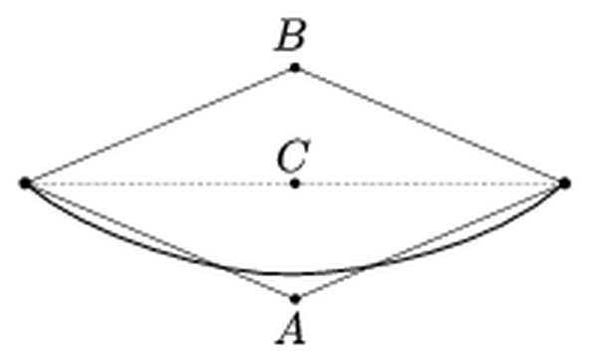
Figure: rope fixed at both ends; points A below, C on the line, B above
Answer: $W_{C}=\frac{W}{4}$
Solution:
Principle. The rope is moved slowly, so the work done equals the increase of its gravitational potential energy, $mg Δy_{\text{CM}}$, where $y_{\text{CM}}$ is the height of the centre of mass. Measure heights from the line of the suspension points. In equilibrium the rope hangs as a catenary whose centre of mass is at depth $y_{0}$ below this line.
Experiments I and II. The rope is inextensible, so in both V-shapes the two straight halves have the same length. Therefore $A$ and $B$ are at the same distance $d$ below and above the line. Each straight half has its centre of mass at its own midpoint, so the centre of mass is at $−d/2$ (case I) or $+d/2$ (case II):
$$W_{\text{I}}=mg\left(y_{0}−\frac{d}{2}\right)$$
$$W_{\text{II}}=mg\left(y_{0}+\frac{d}{2}\right)$$
$$W=W_{\text{I}}+W_{\text{II}}=2mg y_{0}$$
Midpoint at C. With the midpoint held at $C$, each half of the rope hangs freely between a fixed end and $C$. Each half has half the length and spans half the distance of the original rope, so it hangs as a catenary geometrically similar to the original one, scaled down by a factor of 2. Its centre of mass is therefore at depth $y_{0}/2$, and so is the centre of mass of the whole rope:
$$W_{C}=mg\left(y_{0}−\frac{y_{0}}{2}\right)=\frac{mg y_{0}}{2}=\frac{W}{4}$$

Question 66
Source: Sheet 3, Q.125
A cyclist rides at $16 \text{km/h}$ on level road, $12 \text{km/h}$ uphill and $24 \text{km/h}$ downhill. Once he rode from the village to the town and back, and the round trip took $3$ hours. How far is the town from the village?
Answer: $s=24 \text{km}$
Solution:
Setting up. Going from the village to the town, let the route contain $x$ km uphill, $y$ km downhill and $z$ km of level road. On the way back the uphill and downhill sections swap, while the level sections stay the same.
Total time.
$$t=\frac{2z}{16}+x\left(\frac{1}{12}+\frac{1}{24}\right)+y\left(\frac{1}{24}+\frac{1}{12}\right)$$
Since $\frac{1}{12}+\frac{1}{24}=\frac{3}{24}=\frac{1}{8}$ and $\frac{2}{16}=\frac{1}{8}$:
$$t=\frac{x+y+z}{8 \text{km/h}}=\frac{s}{8 \text{km/h}}$$
On every section, one kilometre ridden there and back takes the same time as two kilometres on level road. The distance follows without knowing the profile of the route:
$$s=8 \text{km/h}⋅3 \text{h}=24 \text{km}$$

Question 67
Source: Sheet 3, Q.126
In a long line of moving cars the gap between cars is $15 \text{m}$ and the average length of a car is $5 \text{m}$. The line moves at $72 \text{km/h}$. After an accident, how long does it take for a $10 \text{km}$ long queue of standing cars to form, if the gap between the standing cars is $3 \text{m}$?
Answer: $t=750 \text{s}=12.5 \text{min}$
Solution:
Number of cars in the jam. In the standing queue each car takes up $5+3=8 \text{m}$:
$$N=\frac{10 000 \text{m}}{8 \text{m}}=1250$$
Where the last car came from. In the moving line each car takes up $5+15=20 \text{m}$. At the moment of the accident, the last of these 1250 cars was $1250⋅20 \text{m}=25 \text{km}$ behind the accident site. It stops at the tail of the jam, $10 \text{km}$ from the site, so it still travels $15 \text{km}$ at $v=72 \text{km/h}=20 \text{m/s}$:
$$t=\frac{15 000 \text{m}}{20 \text{m/s}}=750 \text{s}=12.5 \text{min}$$
Check: speed of the tail. The tail of the jam moves backwards at speed $u$. Cars reach it at the rate $(20+u)/20$ per second, and each adds $8 \text{m}$:
$$u=\frac{8(20+u)}{20}$$
This gives $u=13.3 \text{m/s}$, and $10 000/13.3=750 \text{s}$, the same result.

Question 68
Source: Sheet 3, Q.127
A vertical rod of mass $4 \text{kg}$ hangs on a rope, and a $3 \text{kg}$ cat is holding on to the bottom end of the rod. The rope is cut, and the frightened cat runs up the rod so that it stays at the same height above the ground while the rod falls vertically. Calculate the acceleration of the rod.
Answer: $a=\frac{7}{4}g≈17.2 {\text{m/s}}^{2}$ (downward)
Solution:
The cat. The cat stays at rest relative to the ground, so the net force on it is zero. The upward friction force from the rod must balance its weight:
$$F=m_{\text{cat}} g=3 \text{kg}⋅9.81 {\text{m/s}}^{2}=29.4 \text{N}$$
The rod. By Newton’s third law the cat pushes the rod downward with the same force $F$. Newton’s second law for the rod ($M=4 \text{kg}$) gives:
$$Ma=Mg+m_{\text{cat}} g$$
$$a=\frac{M+m_{\text{cat}}}{M} g=\frac{7}{4}g=17.2 {\text{m/s}}^{2}$$
The rod accelerates downward faster than free fall, because the cat pushes it down.

Question 69
Source: Sheet 3, Q.128
A track is made for a uniform cube of mass $m$ and edge $a$ such that, when the cube rolls along it without slipping, its centre moves along a horizontal straight line (a “square wheel”). At the “top” of the track the centre of the cube is given a horizontal velocity $v_{0}$. Static friction is large enough that the cube never slips. What is the speed of the centre of mass when the cube touches the lowest point of the track? (The moment of inertia of the cube about its centre of mass is $\frac{1}{6}ma^{2}$.)
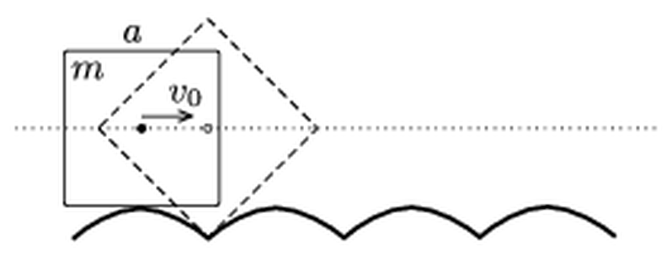
Figure: square wheel rolling on a track of arches
Answer: $v=\frac{\sqrt{5}}{2}v_{0}≈1.12 v_{0}$
Solution:
Principles. The cube rolls without slipping, so the contact point $P$ is the instantaneous axis of rotation. The centre moves horizontally, so its velocity is perpendicular to $CP$, and therefore $P$ is always vertically below the centre $C$. Let $d=CP$. Then
$$v=ωd$$
The centre stays at constant height, so the potential energy does not change. Static friction does no work, so the kinetic energy is conserved.
Kinetic energy. Rotation about $P$, using the parallel-axis theorem:
$$E=\frac{1}{2}\left(\frac{1}{6}ma^{2}+md^{2}\right)ω^{2}=\frac{1}{2}mv^{2}\left(1+\frac{a^{2}}{6d^{2}}\right)$$
At the top of the track the cube rests on the middle of a face, so $d=a/2$:
$$E=\frac{1}{2}mv_{0}^{2}\left(1+\frac{2}{3}\right)=\frac{5}{6}mv_{0}^{2}$$
At the lowest point the contact is at a corner of the cube, so $d=a/\sqrt{2}$:
$$E=\frac{1}{2}mv^{2}\left(1+\frac{1}{3}\right)=\frac{2}{3}mv^{2}$$
Energy conservation.
$$\frac{2}{3}mv^{2}=\frac{5}{6}mv_{0}^{2}$$
$$v=\sqrt{\frac{5}{4}} v_{0}=\frac{\sqrt{5}}{2}v_{0}≈1.12 v_{0}$$

Question 70
Source: Sheet 3, Q.129
A thin-walled Plexiglas cylinder of mass $M$ and radius $R$ can rotate freely, without friction, about its horizontal axis. Inside it is a solid rubber cylinder of mass $m$ and radius $r$. What is the period of the motion of the system when the rubber cylinder is displaced slightly from its equilibrium position? Assume that the rubber cylinder rolls without slipping inside the Plexiglas one.
Answer: $T=2π\sqrt{\frac{3M+m}{2M+m}⋅\frac{R−r}{g}}$
Solution:
Coordinates. Let $θ$ be the angle between the vertical and the line from the axis to the centre of the rubber cylinder. Let $ψ$ be the rotation angle of the outer cylinder and $φ$ that of the rubber cylinder, measured in the same sense. The centre of the rubber cylinder moves with speed $u=(R−r)\dot{θ}$.
Rolling condition. At the contact point the two surfaces have equal velocities:
$$R\dot{ψ}=(R−r)\dot{θ}+r\dot{φ}$$
Angular momentum of the outer cylinder. The only torque on the outer cylinder about its axis comes from the friction force $f$ at the contact. The same force, reversed, gives the rubber cylinder a torque about its own centre. Hence
$$\frac{d}{dt}\left(MR^{2}\dot{ψ}\right)=fR$$
$$\frac{d}{dt}\left(\frac{1}{2}mr^{2}\dot{φ}\right)=−fr$$
Eliminating $f$ and starting from rest:
$$MR\dot{ψ}=−\frac{1}{2}mr\dot{φ}$$
Combining this with the rolling condition gives
$$R\dot{ψ}=\frac{m}{2M+m}u$$
$$r\dot{φ}=−\frac{2M}{2M+m}u$$
Kinetic energy.
$$E_{k}=\frac{1}{2}M(R\dot{ψ})^{2}+\frac{1}{2}mu^{2}+\frac{1}{4}m(r\dot{φ})^{2}=\frac{1}{2}mu^{2} \frac{3M+m}{2M+m}$$
So the system behaves like a point mass with effective (inertial) mass $m_{\text{eff}}=m\frac{3M+m}{2M+m}$ moving on a circle of radius $R−r$.
Potential energy. For small angles:
$$E_{p}=mg(R−r)(1−cosθ)≈\frac{1}{2}mg(R−r)θ^{2}$$
Period. Energy conservation gives simple harmonic motion with
$$ω^{2}=\frac{mg(R−r)}{m_{\text{eff}}(R−r)^{2}}=\frac{2M+m}{3M+m}⋅\frac{g}{R−r}$$
$$T=2π\sqrt{\frac{3M+m}{2M+m}⋅\frac{R−r}{g}}$$
Checks. For $M→∞$ (fixed outer cylinder) this gives $T=2π\sqrt{\frac{3(R−r)}{2g}}$, the familiar result for a cylinder rolling in a fixed trough. For $M→0$ the rubber cylinder does not rotate, and the result is the pendulum value $2π\sqrt{(R−r)/g}$.

Question 71
Source: Sheet 3, Q.130
A man in a small dinghy approaches from far away a breakwater that has two openings $8 \text{m}$ apart. Waves of wavelength $λ=6 \text{m}$ hit the other side of the breakwater. Along what path should the dinghy travel so that it is rocked as little as possible?
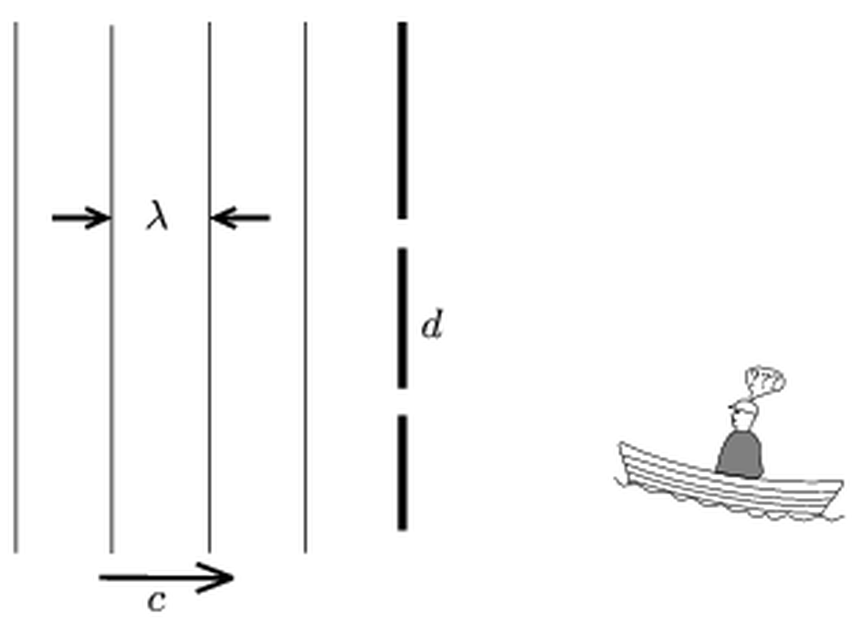
Figure: plane waves hitting a breakwater with two openings d apart; dinghy on the far side
Answer: along a line of destructive interference: a straight line through the midpoint of the openings at about $22.0°$ to the normal of the breakwater (on either side), which near the breakwater becomes the hyperbola $\left|r_{1}−r_{2}\right|=3 \text{m}$.
Solution:
Principle. The waves reach the two openings in phase, so the openings act as two coherent point sources at distance $d=8 \text{m}$ apart. Behind the breakwater the two circular waves interfere. The dinghy rocks least where they cancel, that is, where the path difference is an odd multiple of half a wavelength:
$$\left|r_{1}−r_{2}\right|=\left(k+\frac{1}{2}\right)λ$$
Far from the breakwater. The path difference is $dsinθ$, where $θ$ is measured from the normal of the breakwater:
$$dsinθ=\left(k+\frac{1}{2}\right)λ$$
For $k=0$:
$$sinθ=\frac{λ}{2d}=\frac{6}{16}=0.375$$
$$θ=22.0°$$
For $k=1$ we would need $sinθ=9/8>1$, which is impossible. So there are only two nodal lines, symmetric about the normal.
The path. The dinghy should come in along the straight line through the midpoint of the two openings that makes $22.0°$ with the normal of the breakwater (either side). Closer to the breakwater this nodal line curves into the hyperbola $\left|r_{1}−r_{2}\right|=λ/2=3 \text{m}$, whose foci are the two openings. The dinghy should follow this hyperbola.

Question 72
Source: Sheet 3, Q.134
A freight train moving uniformly passes a signal beside the track in $4$ seconds. Then it passes a $40 \text{m}$ long train that moves at the same speed in the opposite direction, again in $4$ seconds. What is the speed of the freight train in km/h?
Answer: $v=10 \text{m/s}=36 \text{km/h}$ (the freight train is also $40 \text{m}$ long)
Solution:
Let $L$ be the length of the freight train and $v$ its speed.
Passing the signal. The train covers its own length:
$$L=v⋅4 \text{s}$$
Passing the other train. The relative speed is $2v$. To pass completely, the trains must move past each other by the sum of their lengths:
$$L+40 \text{m}=2v⋅4 \text{s}$$
Solving. Substituting $L=4v$:
$$4v+40 \text{m}=8v$$
$$v=10 \text{m/s}=36 \text{km/h}$$
The freight train’s length is $L=40 \text{m}$.

Question 73
Source: Sheet 3, Q.135
A body is attached to a soft spring hanging vertically. The body is released (with the spring unstretched), and the time it takes to reach the lowest point of its path is measured. How many times longer is this than the time a body falling freely from rest takes to cover the same distance?
Answer: $\frac{t_{1}}{t_{2}}=\frac{π}{2}≈1.57$
Solution:
Oscillation on the spring. Let the spring constant be $k$ and the body’s mass $m$; the spring’s own mass is negligible. The body performs simple harmonic motion about the equilibrium position, which is $x_{0}=mg/k$ below the release point. It is released from rest, so the amplitude is $A=mg/k$. The lowest point is reached after half a period:
$$t_{1}=\frac{T}{2}=π\sqrt{\frac{m}{k}}$$
The distance covered is
$$s=2A=\frac{2mg}{k}$$
Free fall over the same distance.
$$t_{2}=\sqrt{\frac{2s}{g}}=\sqrt{\frac{4m}{k}}=2\sqrt{\frac{m}{k}}$$
Ratio.
$$\frac{t_{1}}{t_{2}}=\frac{π}{2}≈1.57$$
The ratio does not depend on $m$ or $k$.

Question 74
Source: Sheet 3, Q.146
The newest Indian nuclear submarine is $112 \text{m}$ long, has a mass of $6000$ tonnes, a maximum speed of $44 \text{km/h}$ and a maximum power of $85 \text{MW}$. Using these data (and other data you need), estimate
- the maximum thrust of the submarine;
- the diameter of the submarine’s hull.
Answer: (a) $F_{max}≈7×{10}^{6} \text{N}$; (b) $D≈8 \text{m}$
Solution:
The table mentioned in the original question is not available. We assume a seawater density of $ρ=1025 {\text{kg/m}}^{3}$, model the hull as a cylinder of length $112 \text{m}$, and assume that the whole maximum power drives the submarine forward.
(a) At constant maximum speed the thrust balances the drag, and the power is $P=Fv$. With $v=44 \text{km/h}=12.2 \text{m/s}$:
$$F_{max}=\frac{P}{v}=\frac{85×{10}^{6} \text{W}}{12.2 \text{m/s}}≈7.0×{10}^{6} \text{N}$$
(b) A submerged submarine floats, so its weight equals the buoyant force. Its volume is therefore
$$V=\frac{m}{ρ}=\frac{6.0×{10}^{6} \text{kg}}{1025 {\text{kg/m}}^{3}}≈5.9×{10}^{3} {\text{m}}^{3}$$
Treating the hull as a cylinder of length $l=112 \text{m}$:
$$A=\frac{V}{l}=\frac{5850 {\text{m}}^{3}}{112 \text{m}}≈52 {\text{m}}^{2}$$
$$D=\sqrt{\frac{4A}{π}}=\sqrt{\frac{4⋅52}{π}} \text{m}≈8 \text{m}$$
The real hull is tapered at both ends, so the diameter in the middle is somewhat larger, but the order of magnitude is about $8 \text{m}$.

Question 75
Source: Sheet 3, Q.147
Two tennis balls of mass $60 \text{g}$ are joined by a massless rubber thread and held vertically, as shown in the figure, with the lower ball on the ground. In this position the rubber thread is unstretched and $40 \text{cm}$ long. The upper ball is raised slowly, vertically upward, until the lower ball just stops pressing on the ground. At this moment the thread is $1 \text{m}$ long. The force exerted by the rubber thread is proportional to its extension.
- How much work is done while raising the upper ball?
- If the upper ball is then released, with what speed does it hit the lower ball?
- How much time passes between releasing the upper ball and the collision?
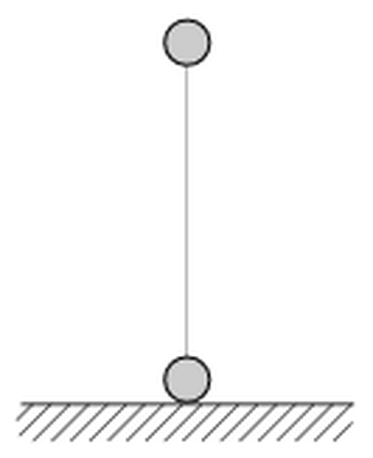
Figure: two balls joined vertically by a rubber thread, lower ball on the ground
Answer: (a) $W≈0.53 \text{J}$; (b) $v≈5.1 \text{m/s}$; (c) $t≈0.35 \text{s}$
Solution:
Spring constant. When the lower ball just lifts off, the thread pulls it up with force $mg$, at an extension $x=1.0−0.4=0.6 \text{m}$:
$$k=\frac{mg}{x}=\frac{0.06⋅9.81 \text{N}}{0.6 \text{m}}=0.981 \text{N/m}$$
(a) The ball is raised slowly, so the work done equals the gain in gravitational and elastic energy. The upper ball rises $0.6 \text{m}$:
$$W=mgx+\frac{1}{2}kx^{2}=0.353 \text{J}+0.177 \text{J}≈0.53 \text{J}$$
(b) After release, the tension pulling the lower ball up decreases, so the lower ball stays on the ground. The thread is attached to the surfaces of the balls, so the upper ball hits the lower one after falling a total of $1.0 \text{m}$, and the full elastic energy is released. Energy conservation gives
$$\frac{1}{2}mv^{2}=mg⋅1.0 \text{m}+\frac{1}{2}kx^{2}=0.589 \text{J}+0.177 \text{J}=0.765 \text{J}$$
$$v=\sqrt{\frac{2⋅0.765}{0.06}} \text{m/s}≈5.05 \text{m/s}≈5.1 \text{m/s}$$
(c) Phase 1 (thread stretched). With $x$ the extension, the equation of motion is $m\ddot{x}=−kx−mg$. This is simple harmonic motion about $x_{c}=−mg/k=−0.6 \text{m}$, with
$$ω=\sqrt{\frac{k}{m}}=\sqrt{\frac{0.981}{0.06}} {\text{s}}^{−1}=4.04 {\text{s}}^{−1}$$
The motion starts at rest at $x=0.6 \text{m}$, so the amplitude is $1.2 \text{m}$. The thread becomes slack ($x=0$) when the displacement from the centre has dropped to half the amplitude, that is, when $cosωt_{1}=\frac{1}{2}$:
$$t_{1}=\frac{π}{3ω}=0.259 \text{s}$$
$$v_{1}=ω\sqrt{{1.2}^{2}−{0.6}^{2}} \text{m}=4.20 \text{m/s}$$
Phase 2 (free fall through $0.4 \text{m}$). The ball reaches $v=5.05 \text{m/s}$ from (b):
$$t_{2}=\frac{v−v_{1}}{g}=\frac{5.05−4.20}{9.81} \text{s}=0.086 \text{s}$$
$$t=t_{1}+t_{2}≈0.35 \text{s}$$
Note: the original sheet gives 0.34 s; the more precise value is 0.345 s.

Question 76
Source: Sheet 3, Q.148
Three beads of masses $4m$, $m$ and $3m$ can slide without friction along a horizontal rod (the beads have holes through them). At a certain moment the middle bead is given an initial speed $v_{0}=5 \text{m/s}$ to the right. After all the (perfectly elastic) collisions, find
- the velocities of the beads;
- the ratio of the kinetic energies of the beads.
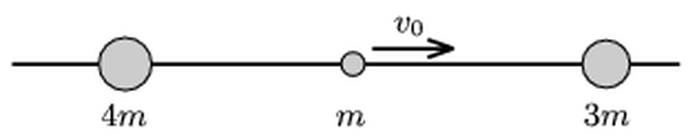
Figure: beads 4m, m, 3m on a rod; the middle one moves right with v0
Answer: (a) $4m$: $1 \text{m/s}$ to the left; $m$: $1.5 \text{m/s}$ to the right; $3m$: $2.5 \text{m/s}$ to the right
- $E_{4m}:E_{m}:E_{3m}=16:9:75$
Solution:
Principle. In a one-dimensional elastic collision between $m_{1}$ (velocity $u_{1}$) and $m_{2}$ initially at rest, the final velocities are
$$v_{1}=\frac{m_{1}−m_{2}}{m_{1}+m_{2}}u_{1}$$
$$v_{2}=\frac{2m_{1}}{m_{1}+m_{2}}u_{1}$$
(a) First collision ($m$ hits $3m$):
$$v_{m}=\frac{m−3m}{4m}v_{0}=−\frac{v_{0}}{2}=−2.5 \text{m/s}$$
$$v_{3m}=\frac{2m}{4m}v_{0}=2.5 \text{m/s}$$
Second collision ($m$, moving left at $2.5 \text{m/s}$, hits $4m$):
$$v_{m}^{′}=\frac{m−4m}{5m}(−2.5 \text{m/s})=+1.5 \text{m/s}$$
$$v_{4m}=\frac{2m}{5m}(−2.5 \text{m/s})=−1 \text{m/s}$$
Now the middle bead ($1.5 \text{m/s}$) is slower than the $3m$ bead ($2.5 \text{m/s}$) and moves away from the $4m$ bead, so there are no more collisions. The $4m$ bead moves left at $1 \text{m/s}$, the middle bead right at $1.5 \text{m/s}$, and the $3m$ bead right at $2.5 \text{m/s}$. Check of momentum: $−4+1.5+7.5=5=1⋅v_{0}$ (in units of $m⋅\text{m/s}$).
(b)
$$E_{4m}=\frac{1}{2}(4m)(1)^{2}=2m$$
$$E_{m}=\frac{1}{2}m(1.5)^{2}=1.125m$$
$$E_{3m}=\frac{1}{2}(3m)(2.5)^{2}=9.375m$$
$$E_{4m}:E_{m}:E_{3m}=2:1.125:9.375=16:9:75$$
The sum, $12.5m=\frac{1}{2}mv_{0}^{2}$, equals the initial kinetic energy, as it should.
Note: the original sheet states the ratio 14 : 9 : 75; the correct ratio is 16 : 9 : 75.

Question 77
Source: Sheet 3, Q.156
A hard plate inclined at $45°$ to the horizontal is placed below a falling marble. The marble falls from a height of $2 \text{m}$ and collides perfectly elastically with the plate. At what height must the plate be placed to make
- the horizontal distance covered by the marble before it hits the ground as large as possible;
- the time until the marble hits the ground as long as possible?
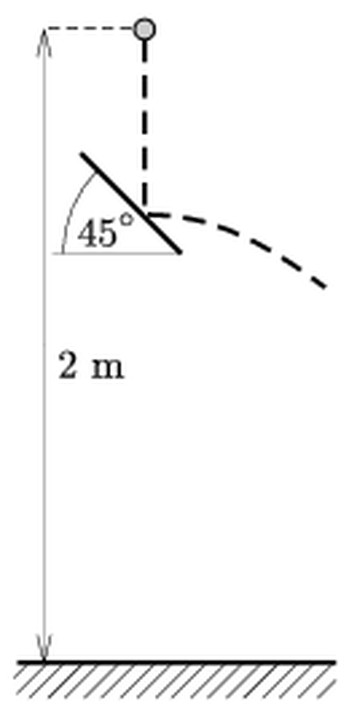
Figure: marble falling from 2 m onto a 45 degree plate, then moving horizontally
Answer: (a) at $h=1 \text{m}$ (range $2 \text{m}$); (b) at $h=1 \text{m}$ (time $0.90 \text{s}$)
Solution:
Collision. Let $H=2 \text{m}$ and let the plate be at height $h$. The marble hits it with speed
$$v=\sqrt{2g(H−h)}$$
In a perfectly elastic collision with a $45°$ plate, the speed is unchanged and the direction turns through $90°$. The marble leaves the plate horizontally with speed $v$, as a horizontal projectile from height $h$.
(a) The time of fall from the plate is $\sqrt{2h/g}$, so the range is
$$x=\sqrt{2g(H−h)}⋅\sqrt{\frac{2h}{g}}=2\sqrt{h(H−h)}$$
For fixed sum $h+(H−h)=H$, the product $h(H−h)$ is largest when the two factors are equal:
$$h=\frac{H}{2}=1 \text{m}$$
$$x_{max}=H=2 \text{m}$$
(b) The total time is the fall to the plate plus the fall from the plate:
$$t=\sqrt{\frac{2(H−h)}{g}}+\sqrt{\frac{2h}{g}}=\sqrt{\frac{2}{g}}\left(\sqrt{H−h}+\sqrt{h}\right)$$
Since ${\left(\sqrt{H−h}+\sqrt{h}\right)}^{2}=H+2\sqrt{h(H−h)}$, the time is again longest for $h=H/2=1 \text{m}$:
$$t_{max}=2\sqrt{\frac{2⋅1}{9.81}} \text{s}=0.90 \text{s}$$
Without the plate, the fall would take only $0.64 \text{s}$.

Question 78
Source: Sheet 3, Q.158
A small block of mass $m=1 \text{kg}$ is placed on a plank that can move on a horizontal frictionless surface, as shown in the figure. The plank has mass $M=4 \text{kg}$ and length $L=0.8 \text{m}$. The coefficient of friction between the plank and the block is $μ=0.4$.
- What is the smallest constant force $F_{0}$ with which the plank must be pulled to make the block slide off it?
- How long does it take the block to slide off if the pulling force is $F_{1}=3mg$?
- Up to the moment the block falls off the plank, what percentage of the work done by $F_{1}$ is converted into internal energy (heat)?
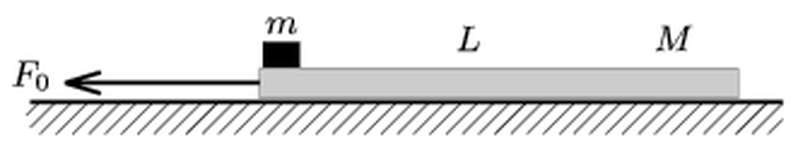
Figure: block m at the left end of plank M of length L, plank pulled left by F0
Answer: (a) $F_{0}>μ(m+M)g=19.6 \text{N}$; (b) $t≈0.81 \text{s}$; (c) about $5\%$ (5.1%)
Solution:
(a) The block is accelerated only by friction, so its acceleration is at most $a_{max}=μg=3.92 {\text{m/s}}^{2}$. If the two bodies move together, the force needed is $(m+M)a$. The block starts to slide when this would require more than the maximum static friction:
$$F_{0}>μ(m+M)g=0.4⋅5 \text{kg}⋅9.81 {\text{m/s}}^{2}=19.6 \text{N}$$
(b) With $F_{1}=3mg=29.4 \text{N}$ the block slides, and kinetic friction $μmg=3.92 \text{N}$ acts on both bodies:
$$a_{m}=μg=3.92 {\text{m/s}}^{2}$$
$$a_{M}=\frac{F_{1}−μmg}{M}=\frac{29.43−3.92}{4} {\text{m/s}}^{2}=6.38 {\text{m/s}}^{2}$$
The block starts at the front (left) end and slides back relative to the plank with relative acceleration
$$a_{\text{rel}}=a_{M}−a_{m}=\frac{F_{1}−μg(m+M)}{M}=2.45 {\text{m/s}}^{2}$$
It falls off after a relative displacement $L$:
$$t=\sqrt{\frac{2L}{a_{\text{rel}}}}=\sqrt{\frac{2LM}{F_{1}−μg(m+M)}}=\sqrt{\frac{1.6}{2.45}} \text{s}≈0.81 \text{s}$$
(c) During this time the plank moves
$$s_{M}=\frac{1}{2}a_{M}t^{2}=\frac{1}{2}⋅6.38⋅0.652 \text{m}=2.08 \text{m}$$
so the work done by $F_{1}$ is
$$W=F_{1}s_{M}=29.4 \text{N}⋅2.08 \text{m}=61.2 \text{J}$$
The heat produced is the friction force times the relative sliding distance:
$$Q=μmgL=3.92 \text{N}⋅0.8 \text{m}=3.14 \text{J}$$
$$\frac{Q}{W}=\frac{3.14}{61.2}≈0.051=5.1\%$$

Question 79
Source: Sheet 3, Q.162
A bird can fly through the air at a constant speed $v$. A wind of speed $v_{1}$ is blowing from the north. In which direction should the bird fly so that it moves along the east–west direction? What is its speed relative to the ground? Data: $v=40 \text{km/h}$, $v_{1}=10 \text{m/s}$.
Answer: heading $25.8°$ from north towards the west (or east), i.e. $64.2°$ north of the west (east) line; ground speed $≈17.4 \text{km/h}$
Solution:
Velocity addition. Relative to the ground, the bird’s velocity is its velocity relative to the air plus the wind velocity:
$${\vec{v}}_{\text{ground}}=\vec{v}+{\vec{v}}_{1}$$
The wind blows from the north, so ${\vec{v}}_{1}$ points south with magnitude $v_{1}=10 \text{m/s}=36 \text{km/h}$. For the ground velocity to point east or west, the bird’s air velocity must have a northward component that exactly cancels the wind.
Direction. Let $β$ be the angle between the bird’s heading and north:
$$vcosβ=v_{1}$$
$$cosβ=\frac{36}{40}=0.9$$
$$β=25.8°$$
The bird must head $25.8°$ west of north to travel west, or $25.8°$ east of north to travel east. Its heading makes $64.2°$ with the east–west line.
Ground speed. Only the east–west component remains:
$$v_{\text{ground}}=\sqrt{v^{2}−v_{1}^{2}}=\sqrt{{40}^{2}−{36}^{2}} \text{km/h}=\sqrt{304} \text{km/h}≈17.4 \text{km/h}$$
Note: the wind speed in the sheet is given without a unit. The sheet’s answer ($25.8°$, $17.4 \text{km/h}$) corresponds to $v_{1}=10 \text{m/s}$. If $v_{1}=10 \text{km/h}$ were meant, the bird would head $14.5°$ north of the east–west line, with a ground speed of $38.7 \text{km/h}$.

Question 80
Source: Sheet 3, Q.163
When an underground train starts to move, is it easier to walk towards the front (towards the engine) or towards the rear of the train? Why?
Answer: It is easier to walk towards the rear. While the train accelerates forward, in the train’s frame an inertial force $−ma$ acts backwards on the passenger and helps motion towards the rear.
Solution:
Ground frame. While the train starts, it accelerates forward with acceleration $a$. To walk forward relative to the car, the passenger must accelerate forward more than the car. To do this, his feet have to push backwards on the floor with a larger force than usual, and the friction from the floor must supply both his acceleration relative to the car and the car’s acceleration $a$. To walk backwards relative to the car, he only needs to accelerate forward less than the car, so the floor has less to do.
Train frame. In the accelerating car an inertial force of magnitude $ma$ acts on every passenger, pointing towards the rear. Everyone feels “pushed back” when the train starts.
- Walking towards the engine, the passenger works against this force, as if walking uphill on a slope of angle $arctan(a/g)$.
- Walking towards the rear, the force helps him, as if walking downhill.
So when the train is starting, walking towards the rear is easier. (When the train brakes, the opposite is true.)

Question 81
Source: Sheet 3, Q.169
If the pages of two exercise books are interleaved (shuffled into each other alternately) and the books are then pressed together with two fingers, even an adult cannot pull them apart. What is the reason?
Answer: Friction acts on every one of the many page interfaces, so the total friction is the sum over very many surfaces. Pulling also tilts the fanned pages and presses them together harder, so the friction grows with the pull (self-locking).
Solution:
Many friction surfaces. If each book has about $n$ interleaved pages, there are about $2n$ contact surfaces between pages of the two books. Every page is squeezed between its neighbours by the normal force $N$ from the fingers. The maximum static friction on each surface is $μN$, so the total friction that must be overcome is roughly
$$F≈2nμN$$
With $n≈50$ and $μ≈0.5$, this is about $50$ times the pressing force.
Self-reinforcement. The pages fan out from the spines, so they are not exactly parallel to the direction of pulling. When the books are pulled apart, the tension in each page has a small component perpendicular to the stack. This presses the pages together even more, so the normal forces, and with them the friction, increase as the pull increases. Pulling harder only locks the books more tightly, like a wedge or a Chinese finger trap. In the classic demonstration, two interleaved telephone books cannot be pulled apart even by cars.
Separating them. The books can be separated by lifting the pages one by one, reducing the pressure. Then only a few surfaces carry a small normal force at any time.

Question 82
Source: Sheet 3, Q.171
A child sitting on a sled slides down a slope inclined at $10°$ to the horizontal. A light wind exerts a force of $10.5 \text{N}$ on the child in the direction of motion. The total mass of the child and the sled is $65 \text{kg}$, and the coefficient of kinetic friction between the sled and the snow is $0.15$.
- If the sled starts from rest, what is its speed at the end of the $125 \text{m}$ long slope?
- How long does it take the sled to reach the bottom of the slope?
Answer: (a) $v≈10 \text{m/s}$ ($10.2 \text{m/s}$); (b) $t≈25 \text{s}$ ($24.5 \text{s}$)
Solution:
Forces along the slope (positive downhill):
- component of gravity: $mgsin10°$;
- wind force: $F_{w}=10.5 \text{N}$;
- kinetic friction: $−μmgcos10°$.
Newton’s second law gives the constant acceleration:
$$a=gsin10°−μgcos10°+\frac{F_{w}}{m}$$
$$a=(1.704−1.449+0.162) {\text{m/s}}^{2}=0.416 {\text{m/s}}^{2}$$
(a) Uniform acceleration from rest over $s=125 \text{m}$:
$$v=\sqrt{2as}=\sqrt{2⋅0.416⋅125} \text{m/s}≈10.2 \text{m/s}$$
(b)
$$t=\frac{v}{a}=\frac{10.2 \text{m/s}}{0.416 {\text{m/s}}^{2}}≈24.5 \text{s}$$

Question 83
Source: Sheet 3, Q.172
A piece of chocolate is dropped into a glass of soda water. The density of the chocolate is $1.2 {\text{g/cm}}^{3}$ and its volume is $2 {\text{cm}}^{3}$. Carbon dioxide bubbles start to stick to the surface of the chocolate. What is the smallest total volume of the bubbles at which the chocolate starts to rise?
Answer: $V_{b}=0.4 {\text{cm}}^{3}$
Solution:
Principle. The chocolate and its bubbles form one floating body. It starts to rise when the buoyant force on the whole body reaches its weight (Archimedes’ principle). The mass of the ${\text{CO}}_{2}$ gas is negligible, and the soda water’s density is taken as $ρ_{w}=1.0 {\text{g/cm}}^{3}$.
Mass of the chocolate.
$$m=ρ_{c}V=1.2 {\text{g/cm}}^{3}⋅2 {\text{cm}}^{3}=2.4 \text{g}$$
Condition for rising.
$$ρ_{w}(V+V_{b})g≥mg$$
$$V+V_{b}≥\frac{m}{ρ_{w}}=2.4 {\text{cm}}^{3}$$
$$V_{b}≥0.4 {\text{cm}}^{3}$$
So the bubbles must have a total volume of at least $0.4 {\text{cm}}^{3}$.

