Physics Problem Set: Electrodynamics
  - Questions, answers and fully worked solutions (from Sheets 1-3)
Each problem is given in the order Question → Answer → Solution. The source sheet and original question number are shown under each heading.

Question 1
Source: Sheet 1, Q.7
A hemispherical insulating shell carries a uniformly distributed positive charge and is held fixed. A small, negatively charged bead is released from rest at a point on the symmetry axis whose distance from the centre $O$ of the hemisphere equals the radius $R$ (on the open side of the shell, see figure). The bead reaches the centre $O$ with speed $v_{0}$. What is the speed of the bead when it reaches the shell? (Neglect gravity.)
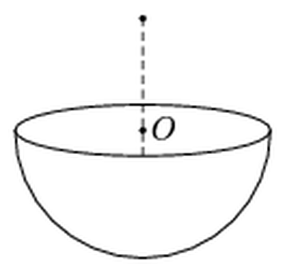
Figure: charged hemispherical shell, bead released on the axis at distance R from the centre O
Answer: $v=\sqrt{2} v_{0}≈1.41 v_{0}$
Solution:
Only the electrostatic force does work, so the work–energy theorem gives, for a bead of charge $−q$ moving from point $X$ to point $Y$:
$$\frac{1}{2}mv_{Y}^{2}−\frac{1}{2}mv_{X}^{2}=q\left(V_{Y}−V_{X}\right)$$
Let $P$ be the release point (distance $R$ above $O$), and $S$ the lowest point of the shell (distance $R$ below $O$), which is where the bead hits the shell. Denote the potential of the given (lower) hemisphere by $V_{L}$.
Trick: complete the sphere. Imagine a second, identical hemisphere with the same charge placed on top, forming a full uniformly charged sphere of charge $2Q$. Its potential on the surface (and inside) is
$$V_{0}=\frac{k⋅2Q}{R}$$
At the bottom pole $S$ this is the sum of the contributions of the lower and upper hemispheres: $V_{0}=V_{L}(S)+V_{U}(S)$. By mirror symmetry, the upper hemisphere at $S$ produces the same potential as the lower hemisphere at the top pole $P$: $V_{U}(S)=V_{L}(P)$. Hence
$$V_{L}(P)=V_{0}−V_{L}(S)$$
At the centre every charge of the hemisphere is at distance $R$, so
$$V_{L}(O)=\frac{kQ}{R}=\frac{V_{0}}{2}$$
Energy balance. From $P$ to $O$ (starting from rest):
$$\frac{1}{2}mv_{0}^{2}=q\left(V_{L}(O)−V_{L}(P)\right)=q\left(V_{L}(S)−\frac{V_{0}}{2}\right)$$
From $P$ to $S$:
$$\frac{1}{2}mv^{2}=q\left(V_{L}(S)−V_{L}(P)\right)=q\left(2V_{L}(S)−V_{0}\right)=2⋅q\left(V_{L}(S)−\frac{V_{0}}{2}\right)$$
Therefore $\frac{1}{2}mv^{2}=2⋅\frac{1}{2}mv_{0}^{2}$, i.e.
$$v=\sqrt{2} v_{0}≈1.41 v_{0}$$
Remark: if gravity acted along the axis, it would do work $mgR$ on both halves of the path, so the kinetic energy at $S$ would still be twice that at $O$ and the result would not change.

Question 2
Source: Sheet 1, Q.8
How much charge flows through the wire $AB$ shown in the figure when the switch is closed and a long enough time has elapsed?
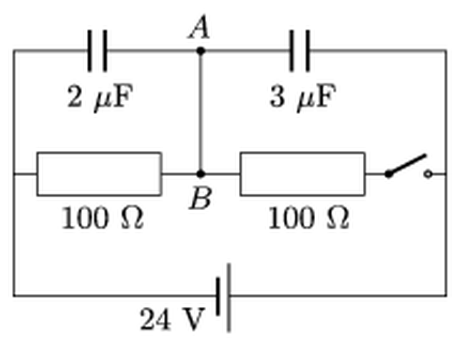
Figure: two capacitors (2 μF and 3 μF) and two 100 Ω resistors connected to a 24 V battery; wire AB joins their midpoints
Answer: $ΔQ=6×{10}^{−5} \text{C}=60 μ\text{C}$
Solution:
We assume the circuit had been connected to the battery with the switch open for a long time, so the capacitors were already in a steady state before the switch was closed. In steady state no current flows through the capacitors.
Take the left terminal of the battery as $0 \text{V}$ and the right one as $24 \text{V}$ (the sign convention does not affect the magnitude). The node $A$–$B$ is one conductor; the charge it holds is the sum of the charges on the capacitor plates connected to $A$:
$$Q_{A}=C_{1}\left(V_{A}−0\right)+C_{2}\left(V_{A}−24 \text{V}\right)$$
with $C_{1}=2 μ\text{F}$ and $C_{2}=3 μ\text{F}$. This charge can change only by flowing through the wire $AB$ (plates connected to $A$ have no other connection).
Switch open. The right resistor carries no current, and no current flows through the left one either, so $B$ (and hence $A$) is at the potential of the left terminal: $V_{A}=0$.
$$Q_{A}=3 μ\text{F}⋅(0−24 \text{V})=−72 μ\text{C}$$
(The $2 μ\text{F}$ capacitor is uncharged, the $3 μ\text{F}$ one has $24 \text{V}$ across it.)
Switch closed. A current flows through the two equal $100 Ω$ resistors, so $B$ is at the midpoint potential $V_{A}=12 \text{V}$:
$$Q_{A}^{′}=2 μ\text{F}⋅12 \text{V}+3 μ\text{F}⋅(12 \text{V}−24 \text{V})=24 μ\text{C}−36 μ\text{C}=−12 μ\text{C}$$
Charge through AB:
$$ΔQ=Q_{A}^{′}−Q_{A}=−12 μ\text{C}−(−72 μ\text{C})=60 μ\text{C}=6×{10}^{−5} \text{C}$$

Question 3
Source: Sheet 1, Q.10
Can the energy of a charged capacitor be increased without giving more charge to it?
Answer: Yes. Disconnect it (keeping $Q$ constant) and decrease its capacitance, e.g. pull the plates further apart or remove the dielectric; the energy $Q^{2}/(2C)$ grows by the mechanical work done.
Solution:
The energy stored in a capacitor of charge $Q$ and capacitance $C$ is
$$W=\frac{Q^{2}}{2C}$$
If the capacitor is isolated (disconnected from the source), its charge cannot change. The energy can still be increased by decreasing the capacitance. For a parallel-plate capacitor
$$C=\frac{ε_{0}ε_{r}A}{d}$$
so $C$ decreases if
- the plates are pulled further apart (larger $d$),
- the dielectric is pulled out from between the plates (smaller $ε_{r}$),
- the plates are slid sideways so that their overlapping area $A$ decreases.
For example, doubling the plate separation halves $C$ and doubles the stored energy (the voltage $U=Q/C$ also doubles).
The energy does not come from nowhere: the oppositely charged plates attract each other (and the dielectric is pulled into the field), so we must do mechanical work against the electric forces. This work is exactly the increase of the stored energy:
$$W_{\text{mech}}=ΔW=\frac{Q^{2}}{2}\left(\frac{1}{C_{2}}−\frac{1}{C_{1}}\right)>0$$

Question 4
Source: Sheet 1, Q.17
In the circuit shown, $R=1 \text{k}Ω$ and $C=10 \text{mF}$. What is the terminal voltage of the battery if, after charging, the capacitor stores $4.5 \text{J}$ of energy?
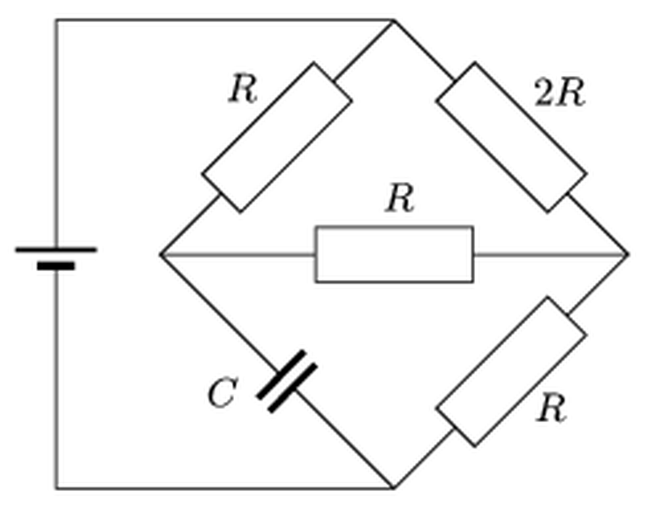
Figure: bridge circuit with resistors R, 2R, R, R and a capacitor C, fed by a battery
Answer: $U=40 \text{V}$
Solution:
Label the nodes: $T$ (top, + terminal of battery), $D$ (bottom, $−$ terminal), $L$ (left corner of the bridge) and $M$ (right corner). The branches are: $T$–$L$: $R$; $T$–$M$: $2R$; $L$–$M$: $R$ (middle); $L$–$D$: $C$; $M$–$D$: $R$.
Capacitor voltage. From the stored energy:
$$W=\frac{1}{2}CU_{C}^{2}⇒U_{C}=\sqrt{\frac{2W}{C}}=\sqrt{\frac{2⋅4.5 \text{J}}{{10}^{−2} \text{F}}}=30 \text{V}$$
Steady state. When the capacitor is fully charged, no current flows through it. Let $V_{D}=0$, $V_{T}=U$, and let $V_{L}$, $V_{M}$ be the unknown node potentials. Note that $U_{C}=V_{L}$.
Kirchhoff’s current law at $L$ (current in through $R$ from $T$ = current out through the middle $R$):
$$\frac{U−V_{L}}{R}=\frac{V_{L}−V_{M}}{R}⇒V_{M}=2V_{L}−U$$
Kirchhoff’s current law at $M$:
$$\frac{U−V_{M}}{2R}+\frac{V_{L}−V_{M}}{R}=\frac{V_{M}}{R}$$
Multiplying by $2R$: $U+2V_{L}=5V_{M}$. Substituting $V_{M}=2V_{L}−U$:
$$U+2V_{L}=10V_{L}−5U⇒V_{L}=\frac{3}{4}U$$
Battery voltage. Since $V_{L}=U_{C}=30 \text{V}$:
$$U=\frac{4}{3}⋅30 \text{V}=40 \text{V}$$
This is the voltage across the battery terminals (its internal resistance, if any, is already included in this terminal voltage). Check: $V_{M}=20 \text{V}$; the currents are $10 \text{mA}$ ($T→L$), $10 \text{mA}$ ($L→M$), $10 \text{mA}$ ($T→M$) and $20 \text{mA}$ ($M→D$), which balance.

Question 5
Source: Sheet 1, Q.18
One side of an old gramophone record was thoroughly wiped, so that this side became evenly charged with a charge of $Q=1 μ\text{C}$. The record of diameter $d=300 \text{mm}$ was rotated by the turntable at $f=78$ revolutions per minute. What is the magnetic induction at the centre of the record? Compare its order of magnitude with that of the Earth’s magnetic field.
Answer: $B≈1.1×{10}^{−11} \text{T}$, about ${10}^{−11} \text{T}$; this is roughly 5 million times smaller than the Earth’s field ($≈5×{10}^{−5} \text{T}$).
Solution:
A rotating charged disc is equivalent to a set of concentric circular currents. Let $a=d/2=0.15 \text{m}$ be the radius, $σ=Q/(πa^{2})$ the surface charge density and $ω=2πf$ the angular velocity:
$$ω=2π⋅\frac{78}{60 \text{s}}=8.17 {\text{s}}^{−1}$$
A thin ring of radius $r$ and width $\text{d}r$ carries charge $\text{d}q=σ⋅2πr \text{d}r$, which passes any point $ω/(2π)$ times per second, so it represents the current
$$\text{d}I=\text{d}q⋅\frac{ω}{2π}=σωr \text{d}r$$
The field of a circular current loop at its centre is $μ_{0}I/(2r)$, so
$$\text{d}B=\frac{μ_{0} \text{d}I}{2r}=\frac{μ_{0}σω}{2} \text{d}r$$
Integrating from $0$ to $a$:
$$B=\frac{μ_{0}σωa}{2}=\frac{μ_{0}Qω}{2πa}$$
Numerically:
$$B=\frac{4π×{10}^{−7} \text{T m/A}⋅{10}^{−6} \text{C}⋅8.17 {\text{s}}^{−1}}{2π⋅0.15 \text{m}}≈1.1×{10}^{−11} \text{T}$$
Comparison. The Earth’s magnetic induction is about $5×{10}^{−5} \text{T}$, so
$$\frac{B_{\text{Earth}}}{B}≈\frac{5×{10}^{−5}}{1.1×{10}^{−11}}≈5×{10}^{6}$$
The field of the rotating record is several million times weaker than the Earth’s field and is completely negligible.
Note: the original sheet gives about $2×{10}^{−12} \text{T}$, which results from using $f$ instead of $ω=2πf$; the correct value is $1.1×{10}^{−11} \text{T}$. The conclusion (millions of times smaller than the Earth’s field) is unchanged.

Question 6
Source: Sheet 1, Q.27
A beam of electrons with speed $v_{0}$ enters a region of uniform magnetic field of induction $B$, perpendicular to the field, as shown in the figure. The field region has a circular cross-section of radius $R$. After passing through the field, what is the largest angle by which electrons of the beam are deflected from their original direction? (Assume the magnetic field is weak.)
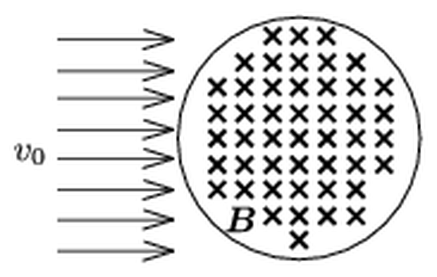
Figure: parallel electron beam entering a circular region of magnetic field directed into the page
Answer: $ϑ_{max}=2arcsin\frac{eBR}{mv_{0}}$, valid for $B<\frac{mv_{0}}{eR}$
Solution:
Path in the field. The Lorentz force $evB$ is perpendicular to the velocity, so the speed stays $v_{0}$ and each electron moves along a circular arc of radius
$$r=\frac{mv_{0}}{eB}$$
“Weak field” means $r>R$, i.e. $B<mv_{0}/(eR)$: every electron leaves the field region after turning through less than a half-turn.
Deflection angle and chord. An electron enters at $P$ and leaves at $Q$. The velocity turns by the same angle $ϑ$ as the radius of curvature, i.e. $ϑ$ is the central angle of the arc $PQ$ of radius $r$. The chord of this arc is
$$\overline{PQ}=2rsin\frac{ϑ}{2}$$
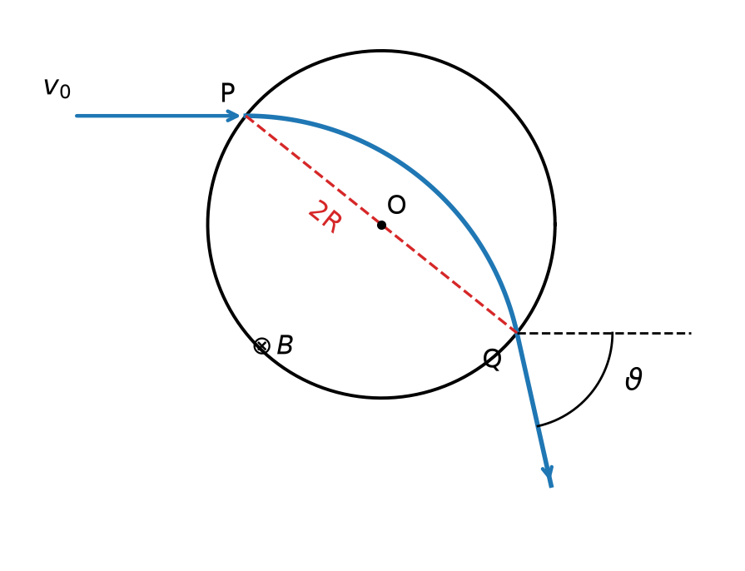
Figure: electron path of maximum deflection, whose chord PQ is a diameter of the field region
Maximum. Since all electrons have the same $r$, the deflection is larger when the chord is longer ($sin(ϑ/2)$ grows with the chord for $ϑ<180°$). Both $P$ and $Q$ lie on the boundary circle of radius $R$, so the longest possible chord is a diameter, $\overline{PQ}=2R$. For the electron whose entry and exit points are endpoints of a diameter:
$$2R=2rsin\frac{ϑ_{max}}{2}$$
$$ϑ_{max}=2arcsin\frac{R}{r}=2arcsin\frac{eBR}{mv_{0}}$$
All other electrons of the beam are deflected by smaller angles. (If the field were strong, $r≤R$, some electrons could be turned through $180°$; that case is excluded by the assumption.) For a very weak field, $ϑ_{max}≈2eBR/(mv_{0})$.

Question 7
Source: Sheet 1, Q.28
The r.m.s. voltage of the $50 \text{Hz}$ mains is $230 \text{V}$. In a series RLC circuit connected to it, the r.m.s. voltage across the capacitor is $100 \text{V}$ and that across the ohmic resistor is $200 \text{V}$. The r.m.s. current is $200 \text{mA}$. What is the relative permeability of the iron core of the coil, if the coil is $8 \text{cm}$ long, its cross-section is $4 {\text{cm}}^{2}$ and it has 300 turns?
Answer: $μ_{r}≈6000$
Solution:
We treat the coil as an ideal inductor (all resistance is in the resistor).
Voltage across the coil. In a series RLC circuit the voltages add as phasors: $U_{R}$ is in phase with the current, $U_{L}$ and $U_{C}$ are $90°$ ahead and behind it. Hence
$$U^{2}=U_{R}^{2}+{\left(U_{L}−U_{C}\right)}^{2}$$
$$\left|U_{L}−U_{C}\right|=\sqrt{{230}^{2}−{200}^{2}} \text{V}=\sqrt{12 900} \text{V}=113.6 \text{V}$$
$U_{L}=100 \text{V}−113.6 \text{V}$ would be negative, so
$$U_{L}=100 \text{V}+113.6 \text{V}=213.6 \text{V}$$
Inductance. The inductive reactance and inductance are
$$X_{L}=\frac{U_{L}}{I}=\frac{213.6 \text{V}}{0.2 \text{A}}=1068 Ω$$
$$L=\frac{X_{L}}{2πf}=\frac{1068 Ω}{2π⋅50 \text{Hz}}=3.40 \text{H}$$
Permeability. For a long solenoid with an iron core
$$L=μ_{0}μ_{r}\frac{N^{2}A}{l}$$
$$μ_{r}=\frac{Ll}{μ_{0}N^{2}A}=\frac{3.40 \text{H}⋅0.08 \text{m}}{4π×{10}^{−7} \text{V s/(A m)}⋅{300}^{2}⋅4×{10}^{−4} {\text{m}}^{2}}≈6.0×{10}^{3}$$
The relative permeability of the core is about 6000.

Question 8
Source: Sheet 2, Q.3
We have 8 Christmas-tree bulbs rated at $14 \text{V}$, $3 \text{W}$, and among some old junk we find bulbs rated at $110 \text{V}$ with powers of $10 \text{W}$, $24 \text{W}$, $40 \text{W}$ and $60 \text{W}$. Which one should be connected in series with the 8 Christmas-tree bulbs (which are also connected in series) so that all nine bulbs operate properly when connected to a $220 \text{V}$ supply?
Answer: The $110 \text{V}$, $24 \text{W}$ bulb.
Solution:
In a series connection every bulb carries the same current, so all of them work properly only if this current equals the rated current of the Christmas-tree bulbs:
$$I=\frac{P}{U}=\frac{3 \text{W}}{14 \text{V}}=0.214 \text{A}$$
The 8 small bulbs take
$$8⋅14 \text{V}=112 \text{V}$$
so the ninth bulb must take the rest:
$$U_{9}=220 \text{V}−112 \text{V}=108 \text{V}≈110 \text{V}$$
Its operating power is therefore
$$P_{9}=U_{9}I=108 \text{V}⋅0.214 \text{A}≈23 \text{W}$$
Check with resistances: the required resistance is $R=108 \text{V}/0.214 \text{A}=504 Ω$, while the hot resistance of the $110 \text{V}$, $24 \text{W}$ bulb is
$$R_{24}=\frac{U^{2}}{P}=\frac{(110 \text{V})^{2}}{24 \text{W}}=504 Ω$$
an essentially perfect match. (The $10 \text{W}$ bulb would have $1210 Ω$ and the current would be far too small; the $40 \text{W}$ and $60 \text{W}$ bulbs would let too much current flow and burn out the small bulbs.) So the 24 W bulb must be used.

Question 9
Source: Sheet 2, Q.4
Three scout troops are camping at three different places, each $1 \text{km}$ from the other two. Electric bells are to be installed so that any troop can signal to any other troop. Draw the circuit diagram. How much wire is needed if
- at each location there is a battery, a bell and two push-buttons;
- instead of three batteries only one is available?
Answer: (a) about $7.7 \text{km}$ (sheet: approx. $7.8 \text{km}$); (b) about $9.5 \text{km}$ of wire (with the circuits shown; any other working circuit is acceptable).
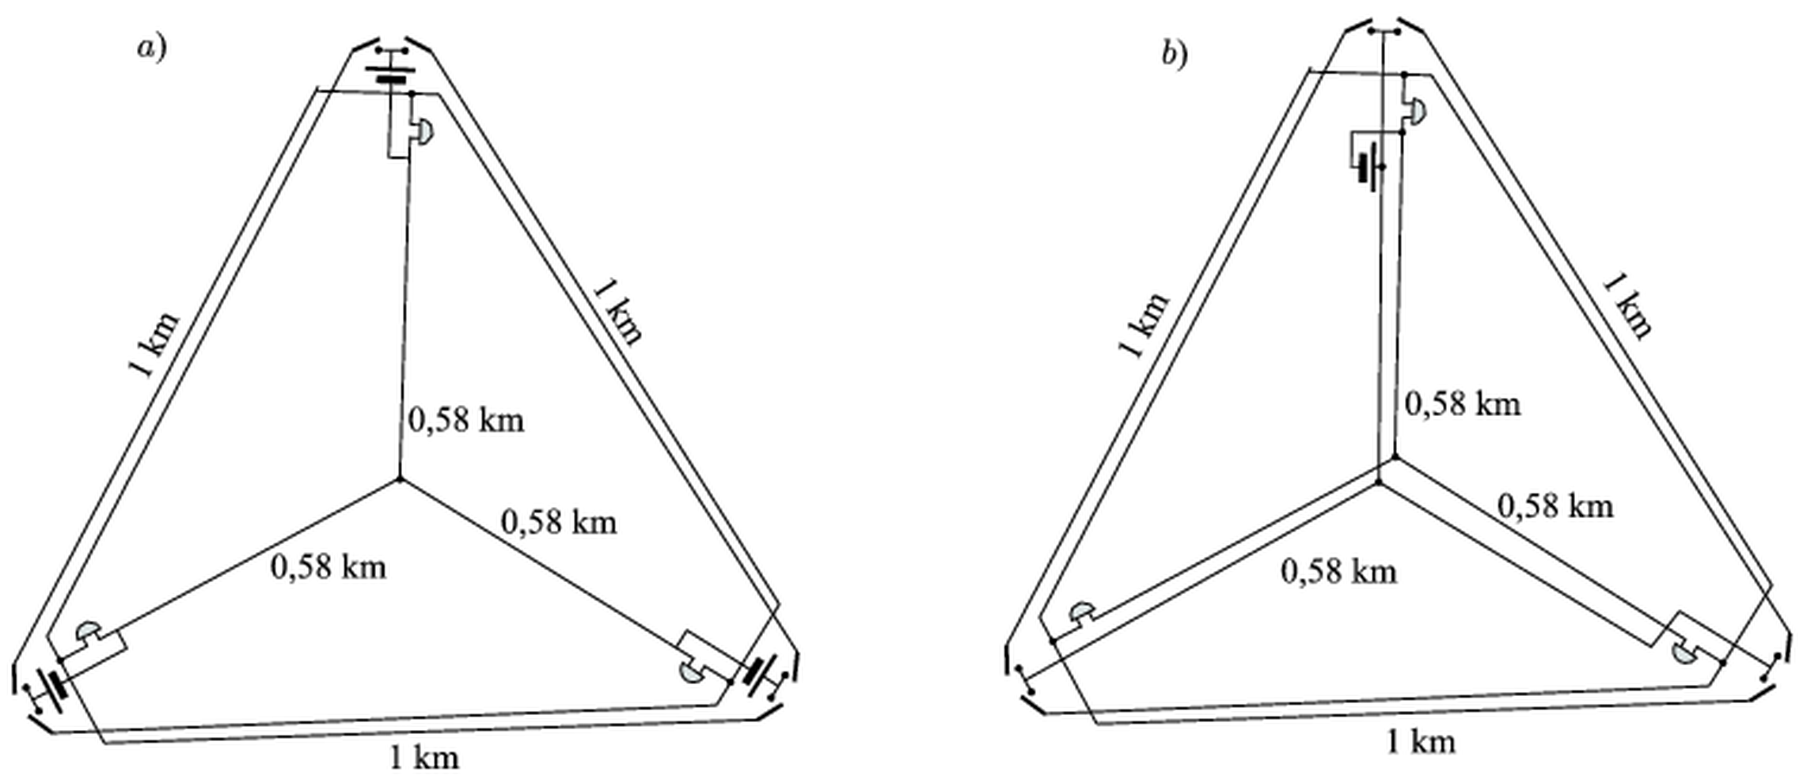
Figure: original solution, wiring laid out on the triangle of the three camps
Solution:
The places $X$, $Y$, $Z$ form an equilateral triangle of side $a=1 \text{km}$. Its centre is at distance
$$\frac{a}{\sqrt{3}}=0.577 \text{km}≈0.58 \text{km}$$
from each corner.
Principle of the circuit. Every bell is connected between its own signal line and a common return wire. Pressing a button connects the + pole of a battery (whose $−$ pole is on the common wire) to the signal line of the bell that should ring. The common wire is laid as a star from the three places to the centre of the triangle, which is the shortest way of connecting all three ($3⋅0.577 \text{km}=1.73 \text{km}$).
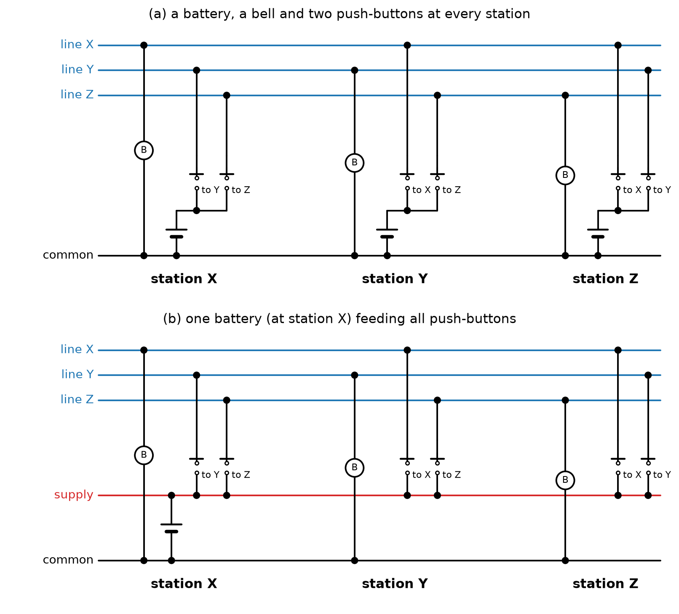
Figure: circuit diagrams for cases (a) and (b); “B” denotes a bell
(a) Each place has its own battery with two buttons. The signal line of each bell must reach the two other places (where its buttons are), i.e. $2 \text{km}$ of wire per bell along the sides of the triangle, $6 \text{km}$ in total. Together with the common star wire:
$$l_{a}=6⋅1 \text{km}+3⋅0.577 \text{km}=7.73 \text{km}≈7.7 \text{km}$$
(b) Now there is a single battery (say at $X$). Its + pole has to be taken to the buttons at the other two places as well, by an extra supply wire. Laying it, like the common wire, as a star through the centre requires another $3⋅0.577 \text{km}$:
$$l_{b}=6⋅1 \text{km}+6⋅0.577 \text{km}=9.46 \text{km}≈9.5 \text{km}$$
The quoted lengths belong to these particular arrangements; other working circuits (with different wire lengths) are equally acceptable.
Note: the original sheet gives approx. $7.8 \text{km}$ for (a); the exact length of the shown arrangement is $7.73 \text{km}$.

Question 10
Source: Sheet 2, Q.6
In district-heating pipes two metal wires are embedded in the insulating foam surrounding the pipe. The wires run parallel to the axis of the pipe. What is the purpose of these wires, and when are they needed?
Answer: They are a leak-detection and leak-location system. If the pipe or its casing is damaged, the foam gets wet and starts to conduct between the wires. From resistance measurements at the ends the distance of the fault is $l=\frac{R_{0}+R_{1}−R_{2}}{2R_{0}}L$.
Solution:
Purpose. Dry polyurethane foam is an excellent insulator, so normally the two wires are electrically insulated from each other. If the steel pipe springs a leak, or ground water enters through a damaged outer casing, the foam becomes wet. Wet foam conducts, so at the place of the fault a (unknown) resistance $R_{x}$ appears between the two wires. Monitoring the resistance between the wires therefore signals a leak immediately, and, more importantly, the place of the leak can be calculated without digging up the whole line. The wires are needed when the pipe is damaged (leakage, corrosion, moisture ingress).
Locating the fault. Let the pipeline have length $L$, and let each wire have resistance $r$ per unit length. Suppose the fault (resistance $R_{x}$) is at distance $l$ from end 1.
- The loop resistance of the two wires, measured at end 1 with the wires short-circuited at end 2 (on the healthy line, or calculated from the wire data), is $R_{0}=2rL$.
- Measure between the wires at end 1 (end 2 open): $R_{1}=2rl+R_{x}$.
- Measure between the wires at end 2 (end 1 open): $R_{2}=2r(L−l)+R_{x}$.
Subtracting eliminates the unknown $R_{x}$:
$$R_{1}−R_{2}=2r(2l−L)=\frac{R_{0}}{L}(2l−L)$$
Solving for $l$:
$$l=\frac{R_{0}+R_{1}−R_{2}}{2R_{0}} L$$
So with three simple resistance measurements the leak can be located, and only that short section of the pipeline has to be excavated and repaired.

Question 11
Source: Sheet 2, Q.8
The capacitor of capacitance $C=12.5 μ\text{F}$ in an ideal resonant (LC) circuit is charged to $U_{1}=400 \text{V}$, and then the circuit is closed. The inductance of the coil is $0.5 \text{H}$.
- Give the current as a function of time.
- At what time intervals is the energy of the capacitor maximal?
Answer: (a) $I(t)=2 \text{A}⋅sin\left(400 {\text{s}}^{−1}⋅t\right)$; (b) every half-period, i.e. every $7.85 \text{ms}$.
Solution:
(a) In an ideal LC circuit the charge oscillates harmonically with angular frequency
$$ω=\frac{1}{\sqrt{LC}}=\frac{1}{\sqrt{0.5 \text{H}⋅12.5×{10}^{−6} \text{F}}}=400 {\text{s}}^{−1}$$
At $t=0$ the capacitor is fully charged and the current is zero, so
$$q(t)=CU_{1}cosωt$$
and the current is $I=−\text{d}q/\text{d}t=CU_{1}ωsinωt$. Its amplitude follows from $I_{0}=CU_{1}ω$, or from energy conservation $\frac{1}{2}CU_{1}^{2}=\frac{1}{2}LI_{0}^{2}$:
$$I_{0}=U_{1}\sqrt{\frac{C}{L}}=400 \text{V}⋅\sqrt{\frac{12.5×{10}^{−6} \text{F}}{0.5 \text{H}}}=2 \text{A}$$
Hence
$$I(t)=2 \text{A}⋅sin\left(400 {\text{s}}^{−1}⋅t\right)$$
(b) The capacitor energy $\frac{q^{2}}{2C}∝\cos^{2}ωt$ is maximal whenever $\left|q\right|$ is maximal (and $I=0$), i.e. at $ωt=0,π,2π,…$ — twice in every period (with opposite polarity). The period is
$$T=\frac{2π}{ω}=\frac{2π}{400 {\text{s}}^{−1}}=15.7 \text{ms}$$
so the energy of the capacitor is maximal every
$$\frac{T}{2}=7.85 \text{ms}≈7.8 \text{ms}$$
Note: the original sheet gives no answer for part (a).

Question 12
Source: Sheet 2, Q.13
A long vertical copper tube hangs on a spring balance. A small bar magnet is dropped into the tube and falls through it without touching the wall. Does the reading of the spring balance change?
Answer: Yes. While the magnet falls inside the tube at its (quickly reached) constant terminal speed, the balance shows the weight of the tube plus the weight of the magnet; before the magnet enters and after it leaves, it shows the weight of the tube only.
Solution:
Eddy currents. As the magnet falls, the magnetic flux through each ring-shaped section of the copper tube changes, so currents are induced in the wall (eddy currents). By Lenz’s law these currents oppose the motion that produces them: they exert an upward braking force $F$ on the magnet. By Newton’s third law, the magnet exerts an equal, downward force $F$ on the tube.
Terminal velocity. The braking force grows with the speed of the magnet. Because copper is a very good conductor, the magnet very soon reaches a constant (terminal) speed at which the braking force balances its weight:
$$F=mg$$
From then on the magnet is not accelerating, so the tube is pushed down by a force equal to the magnet’s weight.
Reading of the balance. The balance holds the tube, so
$$F_{\text{balance}}=M_{\text{tube}}g+F$$
- Before the magnet enters the tube: $F=0$, the reading is $M_{\text{tube}}g$.
- Just after entering, while the magnet is still speeding up: $0<F<mg$, the reading gradually increases.
- During the steady fall: $F=mg$, the reading is $(M_{\text{tube}}+m)g$, exactly as if the magnet were resting in the tube.
- After the magnet leaves the bottom: the reading returns to $M_{\text{tube}}g$.
Another way to see the middle case: the system “tube + magnet” has no acceleration, so the balance must carry the total weight. The gravitational energy lost by the magnet is converted into heat in the tube by the eddy currents.

Question 13
Source: Sheet 2, Q.17
We have $n$ voltaic cells, each with electromotive force $U_{0}$ and internal resistance $R_{b}$. Find the largest power that can be drawn from the cells if they are
- connected in series;
- connected in parallel.
Answer: In both cases $P_{max}=\frac{nU_{0}^{2}}{4R_{b}}$.
Solution:
Maximum power of a source. A source of e.m.f. $E$ and internal resistance $r$ delivers to an external resistor $R$ the power
$$P=I^{2}R=\frac{E^{2}R}{(R+r)^{2}}$$
This is maximal for $R=r$ (matched load), when
$$P_{max}=\frac{E^{2}}{4r}$$
(a) Series connection. The e.m.f.s and the internal resistances add: $E=nU_{0}$, $r=nR_{b}$. With a load $R=nR_{b}$:
$$P_{max}=\frac{(nU_{0})^{2}}{4nR_{b}}=\frac{nU_{0}^{2}}{4R_{b}}$$
(b) Parallel connection. The e.m.f. is that of one cell, $E=U_{0}$, and the internal resistances are in parallel: $r=R_{b}/n$. With a load $R=R_{b}/n$:
$$P_{max}=\frac{U_{0}^{2}}{4R_{b}/n}=\frac{nU_{0}^{2}}{4R_{b}}$$
The maximum available power is the same in both cases: it is $n$ times the maximum power of a single cell, $U_{0}^{2}/(4R_{b})$, as expected since in the matched case each cell works under identical conditions. Only the load resistance needed differs ($nR_{b}$ versus $R_{b}/n$).

Question 14
Source: Sheet 2, Q.18
News in the dog days: “In summer the transmission lines get longer, so the electrical energy that can be transmitted through them decreases.” Examine how much truth this news contains.
Answer: Partly true. The lines really do get longer (and sag), and their transmission capacity really does decrease in hot weather, but not because of the lengthening: thermal expansion alone would even reduce the resistance slightly. The main reason is the increase of the resistivity with temperature (plus poorer cooling and the sag limit).
Solution:
The resistance of a wire is
$$R=ρ\frac{l}{A}$$
Effect of thermal expansion. With the linear expansion coefficient $α$, a temperature rise $ΔT$ increases the length by a factor $(1+αΔT)$ but the cross-section by $(1+2αΔT)$. Therefore the geometric factor changes as
$$\frac{l}{A}→\frac{l}{A}⋅\frac{1+αΔT}{1+2αΔT}≈\frac{l}{A}\left(1−αΔT\right)$$
So the expansion by itself would decrease the resistance, and only very slightly: for aluminium $α≈2.3×{10}^{−5} {\text{K}}^{−1}$, giving about $0.07 \%$ for $ΔT=30 \text{K}$.
Effect of the resistivity. The resistivity of metals increases with temperature,
$$ρ=ρ_{0}\left(1+βΔT\right)$$
with $β≈4×{10}^{−3} {\text{K}}^{−1}$ for copper and aluminium, about 200 times larger than $α$. For $ΔT=30 \text{K}$ the resistance grows by about $12 \%$. This dominates completely.
Consequences. At a given transmitted current the Joule loss $I^{2}R$ is larger in summer. Moreover, the allowed current of a line is limited by the temperature of the conductor: in hot weather the conductor is cooled less effectively by the air, and the lengthened (expanded) wires sag more, so the ground clearance limit is reached at a lower current. Hence the transmittable power really is smaller in summer.
Conclusion: the statement is right that the lines get longer and that their capacity decreases, but the causal link is wrong — the decrease is due mainly to the temperature dependence of the resistivity (and cooling/sag limits), not to the increase in length.

Question 15
Source: Sheet 2, Q.19
A coil of self-inductance $36 \text{mH}$ and an unknown coil wound in the opposite sense are connected in series. The coupling coefficient between the coils is $k=\frac{M}{\sqrt{L_{1}L_{2}}}=0.75$. Find the self-inductance of the unknown coil for which the current in the (AC) circuit is maximal.
Answer: $L_{2}=k^{2}L_{1}≈20 \text{mH}$ ($20.25 \text{mH}$); the total inductance is then minimal, $L_{min}=(1−k^{2})L_{1}≈15.8 \text{mH}$.
Solution:
Total inductance. For two magnetically coupled coils in series, wound in opposite senses (fluxes opposing each other), the mutual inductance reduces the total inductance:
$$L=L_{1}+L_{2}−2M=L_{1}+L_{2}−2k\sqrt{L_{1}L_{2}}$$
Condition for maximum current. With a given AC voltage (and given resistance), the current is largest when the impedance, i.e. the total inductance $L$, is smallest. Write $x=\sqrt{L_{2}}$:
$$L(x)=x^{2}−2k\sqrt{L_{1}} x+L_{1}={\left(x−k\sqrt{L_{1}}\right)}^{2}+\left(1−k^{2}\right)L_{1}$$
This is minimal when $x=k\sqrt{L_{1}}$, i.e.
$$L_{2}=k^{2}L_{1}={0.75}^{2}⋅36 \text{mH}=20.25 \text{mH}≈20 \text{mH}$$
The smallest total inductance is
$$L_{min}=\left(1−k^{2}\right)L_{1}=0.4375⋅36 \text{mH}=15.75 \text{mH}$$
compared with $36 \text{mH}$ for the first coil alone. (Then $M=k\sqrt{L_{1}L_{2}}=20.25 \text{mH}=L_{2}$.)
Why not a minimum current? Note that $L$ has no maximum: as $L_{2}→∞$, $L→∞$ and the current tends to zero without reaching a minimum. So the problem is meaningful only when it asks for the maximum current, which corresponds to the minimum total inductance found above.
Note: the original sheet’s answer is garbled (it states that the question should ask for a minimum instead of a maximum, and gives no value). The only well-posed reading is maximum current = minimum total inductance, giving $L_{2}=20.25 \text{mH}$.

Question 16
Source: Sheet 2, Q.30
A triangle is made of thin insulating rods of different lengths, and the rods are charged uniformly, all with the same linear charge density. Where is the electric field strength zero?
Answer: At the centre of the inscribed circle of the triangle (the incentre, the intersection of the angle bisectors).
Solution:
Field of a straight rod. Consider a uniformly charged rod (linear density $λ$) and a point $P$ at perpendicular distance $d$ from the line of the rod. Measure the position of a rod element by the angle $φ$ between the perpendicular from $P$ and the line joining $P$ to the element: $x=dtanφ$, so $\text{d}x=\frac{d}{\cos^{2}φ}\text{d}φ$ and the distance is $\frac{d}{cosφ}$. The element produces
$$\text{d}E=\frac{kλ \text{d}x}{{\left(d/cosφ\right)}^{2}}=\frac{kλ}{d} \text{d}φ$$
A circular arc of radius $d$ centred at $P$ with the same $λ$ gives exactly the same field element, $\frac{kλ (d \text{d}φ)}{d^{2}}=\frac{kλ}{d}\text{d}φ$, in the same direction. Therefore:
The field of a straight charged rod at $P$ equals the field of the arc of the circle of radius $d$ (centred at $P$, touching the rod’s line) seen from $P$ under the same angle, with the same linear charge density.
Applying it at the incentre. The incentre $I$ is the only point inside the triangle at the same distance $r$ (the inradius) from all three sides. The three sides subtend angles at $I$ that together make up the full angle $360°$. Replacing each rod by its equivalent arc of radius $r$, the three arcs join to form a complete circle of radius $r$ centred at $I$, with uniform charge density $λ$. By symmetry, the field of a uniformly charged ring at its centre is zero, so
$$\vec{E}(I)=0$$
At any other point the distances to the sides differ, the equivalent arcs have different radii, and the fields do not cancel. So the field vanishes at the centre of the inscribed circle. (For a scalene triangle this point differs from the centroid, so “centre” must be understood as the incentre.)

Question 17
Source: Sheet 2, Q.31
The resistances $R_{1}$ and $R_{2}$ of the resistors are given. Choose the resistance $R$ so that the equivalent resistance of the circuit shown in the figure
- is also $R$;
- is a given value $R_{0}$. (What values can $R_{0}$ take?)
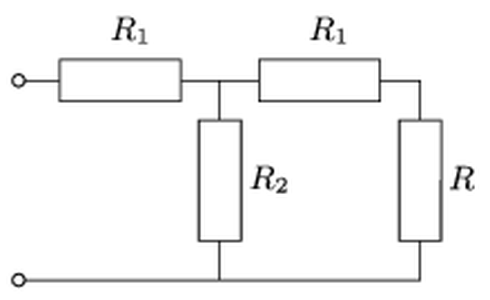
Figure: ladder network: R1 in series, then R2 to ground in parallel with R1 in series with R
Answer:
(a) $R=\sqrt{R_{1}\left(R_{1}+2R_{2}\right)}$
(b) $R=\frac{R_{0}\left(R_{1}+R_{2}\right)−R_{1}\left(R_{1}+2R_{2}\right)}{R_{1}+R_{2}−R_{0}}$, possible for $R_{1}+\frac{R_{1}R_{2}}{R_{1}+R_{2}}≤R_{0}<R_{1}+R_{2}$
Solution:
Equivalent resistance. The right-hand $R_{1}$ and $R$ are in series; this combination is parallel with $R_{2}$; and the whole is in series with the left-hand $R_{1}$:
$$R_{e}=R_{1}+\frac{R_{2}\left(R_{1}+R\right)}{R_{1}+R_{2}+R}$$
(a) Setting $R_{e}=R$:
$$\left(R−R_{1}\right)\left(R+R_{1}+R_{2}\right)=R_{2}\left(R_{1}+R\right)$$
Expanding: $R^{2}+RR_{2}−R_{1}^{2}−R_{1}R_{2}=R_{1}R_{2}+RR_{2}$, hence
$$R^{2}=R_{1}^{2}+2R_{1}R_{2}$$
$$R=\sqrt{R_{1}\left(R_{1}+2R_{2}\right)}$$
(This is the “characteristic resistance” of the ladder: terminating it with this $R$ leaves the input resistance unchanged.)
(b) Setting $R_{e}=R_{0}$:
$$\left(R_{0}−R_{1}\right)\left(R_{1}+R_{2}+R\right)=R_{2}\left(R_{1}+R\right)$$
Collecting the terms containing $R$:
$$R\left(R_{1}+R_{2}−R_{0}\right)=\left(R_{0}−R_{1}\right)\left(R_{1}+R_{2}\right)−R_{1}R_{2}$$
$$R=\frac{R_{0}\left(R_{1}+R_{2}\right)−R_{1}\left(R_{1}+2R_{2}\right)}{R_{1}+R_{2}−R_{0}}$$
Allowed values of R0. $R_{e}$ increases monotonically with $R$. For $R=0$ (short circuit) it is smallest, for $R→∞$ (open circuit) it is largest:
$$R_{e}(0)=R_{1}+\frac{R_{1}R_{2}}{R_{1}+R_{2}}$$
$$R_{e}(∞)=R_{1}+R_{2}$$
So a non-negative finite $R$ exists only if
$$R_{1}+\frac{R_{1}R_{2}}{R_{1}+R_{2}}≤R_{0}<R_{1}+R_{2}$$
($R_{0}=R_{1}+R_{2}$ can be reached only with the branch left open, $R→∞$.)

Question 18
Source: Sheet 2, Q.32
A flat coil of 200 turns is made by winding wire of negligible resistance on a rectangular frame of area $50 {\text{cm}}^{2}$. The frame rotates about one of the symmetry axes of the rectangle lying in its plane, in a magnetic field of induction $0.1 \text{T}$ perpendicular to the axis of rotation. A bulb rated $6.3 \text{V}$, $3 \text{W}$ and a coil of resistance $10 Ω$ and inductance $50 \text{mH}$ are connected in series to the ends of the rotating coil.
- At what rate (revolutions per second) should the coil rotate so that the voltage across the bulb is $6.3 \text{V}$?
- By what phase angle does the current lag behind the voltage across the $50 \text{mH}$ coil?
Answer: (a) $n≈26 {\text{s}}^{−1}$ ($ω=166 {\text{s}}^{−1}$); (b) $φ≈39.7°$
Solution:
(a) The rotating coil is an AC generator with peak e.m.f. $E_{0}=NBAω$, so its r.m.s. e.m.f. is
$$E=\frac{NBAω}{\sqrt{2}}$$
where $NBA=200⋅0.1 \text{T}⋅5×{10}^{−3} {\text{m}}^{2}=0.1 \text{V s}$. (The resistance and self-inductance of the generator coil are neglected.)
The bulb works properly with current and resistance
$$I=\frac{P}{U}=\frac{3 \text{W}}{6.3 \text{V}}=0.476 \text{A}$$
$$R_{b}=\frac{U^{2}}{P}=\frac{(6.3 \text{V})^{2}}{3 \text{W}}=13.23 Ω$$
The total resistance of the circuit is $R=13.23 Ω+10 Ω=23.23 Ω$, and the reactance is $ωL$. Ohm’s law for the AC circuit:
$$\frac{NBAω}{\sqrt{2}}=I\sqrt{R^{2}+ω^{2}L^{2}}$$
Squaring and solving for $ω$:
$$ω^{2}=\frac{I^{2}R^{2}}{\frac{(NBA)^{2}}{2}−I^{2}L^{2}}=\frac{(0.476⋅23.23)^{2}}{0.005−{0.476}^{2}⋅{0.05}^{2}} {\text{s}}^{−2}≈2.76×{10}^{4} {\text{s}}^{−2}$$
$$ω≈166 {\text{s}}^{−1}$$
$$n=\frac{ω}{2π}≈26.4 {\text{s}}^{−1}≈26 \text{Hz}$$
(Check: $E=0.1⋅166/\sqrt{2} \text{V}=11.7 \text{V}$.)
(b) The $50 \text{mH}$ coil is a real coil with resistance $r=10 Ω$. Across it, the resistive voltage $Ir$ is in phase with the current and the inductive voltage $IωL$ leads by $90°$. So the current lags behind the coil voltage by $φ$ with
$$tanφ=\frac{ωL}{r}=\frac{166 {\text{s}}^{−1}⋅0.05 \text{H}}{10 Ω}=0.831$$
$$φ≈39.7°$$

Question 19
Source: Sheet 2, Q.40
Two capacitors of capacitances $C_{1}=180 \text{pF}$ and $C_{2}=20 \text{pF}$ (with air between the plates) are connected in series, and the free terminals are connected to a rechargeable battery of constant e.m.f. $U_{0}=24 \text{V}$. Some energy is thus stored in both capacitors. Later the energies stored in the capacitors were increased, both by the same amount. This was done by completely filling the space between the plates of capacitor $C_{2}$ with glass of relative permittivity $ε_{r}$. The connections and the capacitor $C_{1}$ were not changed.
- What was the relative permittivity $ε_{r}$ of the glass?
- By how much did the energy of the capacitors increase? (The relative permittivity of air is 1.)
Answer: (a) $ε_{r}=6$; (b) each capacitor’s energy increased by $ΔW≈7.8×{10}^{−9} \text{J}≈8 \text{nJ}$ (together $1.56×{10}^{−8} \text{J}$).
Solution:
Initial state. Capacitors in series carry the same charge:
$$Q=\frac{C_{1}C_{2}}{C_{1}+C_{2}}U_{0}=18 \text{pF}⋅24 \text{V}=432 \text{pC}$$
The energies are $W_{1}=\frac{Q^{2}}{2C_{1}}$, $W_{2}=\frac{Q^{2}}{2C_{2}}$. Note $C_{1}=9C_{2}$.
After inserting the glass, $C_{2}^{′}=ε_{r}C_{2}$ and the battery supplies more charge:
$$Q^{′}=\frac{C_{1}ε_{r}C_{2}}{C_{1}+ε_{r}C_{2}}U_{0}$$
The ratio of charges is
$$q=\frac{Q^{′}}{Q}=\frac{ε_{r}\left(C_{1}+C_{2}\right)}{C_{1}+ε_{r}C_{2}}=\frac{10ε_{r}}{9+ε_{r}}$$
(a) Equal energy increases:
$$\frac{Q^{′}​^{2}−Q^{2}}{2C_{1}}=\frac{Q^{′}​^{2}}{2ε_{r}C_{2}}−\frac{Q^{2}}{2C_{2}}$$
Dividing by $Q^{2}/(2C_{2})$ and using $C_{1}=9C_{2}$:
$$\frac{q^{2}−1}{9}=\frac{q^{2}}{ε_{r}}−1⇒q^{2}\left(9−ε_{r}\right)=8ε_{r}$$
Substituting $q^{2}=\frac{100ε_{r}^{2}}{(9+ε_{r})^{2}}$:
$$25ε_{r}\left(9−ε_{r}\right)=2{\left(9+ε_{r}\right)}^{2}$$
$$27ε_{r}^{2}−189ε_{r}+162=0⇒ε_{r}^{2}−7ε_{r}+6=0$$
The roots are $ε_{r}=1$ (no change, trivial) and
$$ε_{r}=6$$
(b) With $ε_{r}=6$: $q=60/15=4$, so $Q^{′}=4Q=1728 \text{pC}$. The initial energy of $C_{1}$ is
$$W_{1}=\frac{Q^{2}}{2C_{1}}=\frac{(4.32×{10}^{−10} \text{C})^{2}}{2⋅1.8×{10}^{−10} \text{F}}=5.18×{10}^{−10} \text{J}$$
Its energy grows by the factor $q^{2}=16$:
$$ΔW_{1}=\left(16−1\right)W_{1}=7.78×{10}^{−9} \text{J}$$
Check for $C_{2}$: $W_{2}=4.67×{10}^{−9} \text{J}$ and $W_{2}^{′}=\frac{16Q^{2}}{2⋅6C_{2}}=1.24×{10}^{−8} \text{J}$, so $ΔW_{2}=7.78×{10}^{−9} \text{J}$ as required.
So each capacitor gained about $7.8 \text{nJ}≈8 \text{nJ}$, and the total stored energy increased by about $1.56×{10}^{−8} \text{J}$.

Question 20
Source: Sheet 2, Q.41
A real coil is connected in series with an ohmic resistor of $600 Ω$. The r.m.s. voltages across the coil and the resistor are $200 \text{V}$ and $100 \text{V}$, respectively. What are the inductance and the resistance of the coil if the r.m.s. supply voltage is $230 \text{V}$ and its frequency is $50 \text{Hz}$?
Answer: $L≈3.8 \text{H}$, $r=87 Ω$
Solution:
Current. From the resistor:
$$I=\frac{U_{R}}{R}=\frac{100 \text{V}}{600 Ω}=\frac{1}{6} \text{A}=0.167 \text{A}$$
Phasor relations. The coil voltage has a resistive component $U_{r}=Ir$ (in phase with the current) and an inductive component $U_{L}=IωL$ (leading by $90°$):
$$U_{\text{coil}}^{2}=U_{r}^{2}+U_{L}^{2}$$
For the whole circuit, the in-phase components $U_{R}+U_{r}$ add:
$$U^{2}={\left(U_{R}+U_{r}\right)}^{2}+U_{L}^{2}$$
Subtracting the two equations eliminates $U_{L}$:
$$U^{2}−U_{\text{coil}}^{2}=U_{R}^{2}+2U_{R}U_{r}$$
$$U_{r}=\frac{{230}^{2}−{200}^{2}−{100}^{2}}{2⋅100} \text{V}=\frac{2900}{200} \text{V}=14.5 \text{V}$$
Resistance of the coil:
$$r=\frac{U_{r}}{I}=\frac{14.5 \text{V}}{1/6 \text{A}}=87 Ω$$
Inductance:
$$U_{L}=\sqrt{{200}^{2}−{14.5}^{2}} \text{V}=199.5 \text{V}$$
$$X_{L}=\frac{U_{L}}{I}=1197 Ω$$
$$L=\frac{X_{L}}{2πf}=\frac{1197 Ω}{2π⋅50 \text{Hz}}≈3.8 \text{H}$$

Question 21
Source: Sheet 2, Q.50
Two resistors of $1 \text{k}Ω$ and $4 \text{k}Ω$ are connected in series to a $220 \text{V}$ supply of negligible internal resistance. A moving-coil voltmeter connected across the $4 \text{k}Ω$ resistor reads $147 \text{V}$. What would this voltmeter read if it were connected across the other resistor?
Answer: about $37 \text{V}$ ($36.7 \text{V}$); the voltmeter’s resistance is about $4 \text{k}Ω$.
Solution:
Without the meter, the voltages would be $176 \text{V}$ and $44 \text{V}$. The meter reads only $147 \text{V}$ because its own resistance $R_{V}$ is comparable to the resistors: it is connected in parallel and lowers the resistance of that section.
Resistance of the voltmeter. The current through the $1 \text{k}Ω$ resistor is
$$I=\frac{220 \text{V}−147 \text{V}}{1 \text{k}Ω}=73 \text{mA}$$
so the parallel combination of $4 \text{k}Ω$ and $R_{V}$ is
$$R_{p}=\frac{147 \text{V}}{73 \text{mA}}=2.01 \text{k}Ω$$
$$\frac{1}{R_{V}}=\frac{1}{R_{p}}−\frac{1}{4 \text{k}Ω}⇒R_{V}≈4.06 \text{k}Ω≈4 \text{k}Ω$$
(With exactly $R_{V}=4 \text{k}Ω$: $R_{p}=2 \text{k}Ω$ and the reading is $220⋅2/3=146.7 \text{V}≈147 \text{V}$, so the meter’s resistance is $4 \text{k}Ω$.)
Meter across the 1 kΩ resistor. Now $1 \text{k}Ω$ is in parallel with $R_{V}=4 \text{k}Ω$:
$$R_{p}^{′}=\frac{1⋅4}{1+4} \text{k}Ω=0.8 \text{k}Ω$$
Voltage division:
$$U^{′}=220 \text{V}⋅\frac{0.8 \text{k}Ω}{0.8 \text{k}Ω+4 \text{k}Ω}=36.7 \text{V}≈37 \text{V}$$
(Using $R_{V}=4.06 \text{k}Ω$ gives $36.75 \text{V}$.) Note that the two readings add up to only $147+37=184 \text{V}<220 \text{V}$, a typical effect of a voltmeter with finite resistance.
Note: the original sheet gives no answer for this question.

Question 22
Source: Sheet 3, Q.52
Two filament bulbs, rated $6 \text{V}; 0.5 \text{A}$ and $4 \text{V}; 0.4 \text{A}$, are to be operated from a $12 \text{V}$ rechargeable battery. Both bulbs must operate at their ratings.
Plan a possible circuit using suitable resistors. How much energy is lost?
Answer: Circuit 1: each bulb with its own series resistor ($12 Ω$ and $20 Ω$), with the two branches in parallel across the battery. The loss is $6.2 \text{W}$, i.e. $57.4 \%$ of the energy taken from the battery.
Circuit 2 (better): a $40 Ω$ shunt across the $4 \text{V}$ bulb, and this pair in series with the $6 \text{V}$ bulb and a $4 Ω$ resistor. The loss is $1.4 \text{W}$, i.e. $23.3 \%$.
Solution:
The bulbs need $U_{1}=6 \text{V}$, $I_{1}=0.5 \text{A}$ (power $P_{1}=3 \text{W}$) and $U_{2}=4 \text{V}$, $I_{2}=0.4 \text{A}$ ($P_{2}=1.6 \text{W}$). The useful power is therefore
$$P_{\text{useful}}=P_{1}+P_{2}=4.6 \text{W}$$
The battery voltage is too high, and the two bulbs need different currents, so resistors have to take up the voltage or current that is left over.
Circuit 1: two parallel branches. Each bulb gets a series resistor that drops the remaining voltage at the bulb’s rated current:
$$R_{a}=\frac{12 \text{V}−6 \text{V}}{0.5 \text{A}}=12 Ω$$
$$R_{b}=\frac{12 \text{V}−4 \text{V}}{0.4 \text{A}}=20 Ω$$
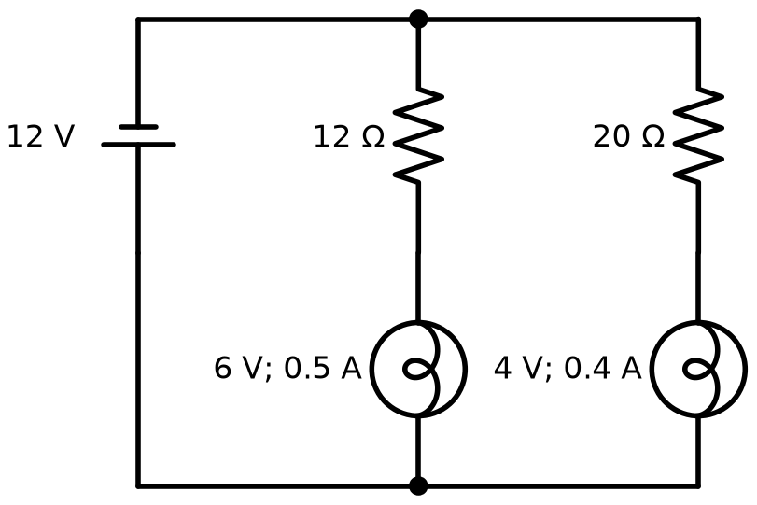
Figure: circuit 1, each bulb with its own series resistor
The battery supplies $I=0.9 \text{A}$, so $P=12 \text{V}⋅0.9 \text{A}=10.8 \text{W}$. The resistors turn into heat
$$P_{\text{lost}}=10.8 \text{W}−4.6 \text{W}=6.2 \text{W}$$
which is $6.2/10.8=57.4 \%$ of the energy taken from the battery.
Circuit 2: bulbs in series. If the bulbs are in series, the current must be $0.5 \text{A}$ for the larger bulb. The surplus $0.1 \text{A}$ is led past the $4 \text{V}$ bulb through a parallel (shunt) resistor:
$$R_{p}=\frac{4 \text{V}}{0.5 \text{A}−0.4 \text{A}}=40 Ω$$
The bulbs together take $6+4=10 \text{V}$, so a series resistor must drop the remaining $2 \text{V}$ at $0.5 \text{A}$:
$$R_{s}=\frac{2 \text{V}}{0.5 \text{A}}=4 Ω$$
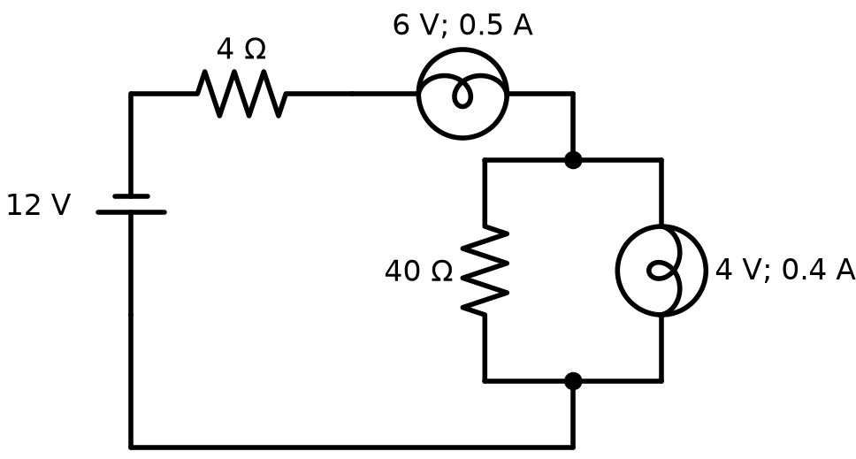
Figure: circuit 2, bulbs in series with a shunt and a series resistor
Now the battery supplies only $0.5 \text{A}$, so $P=6 \text{W}$, and
$$P_{\text{lost}}=6 \text{W}−4.6 \text{W}=1.4 \text{W}$$
which is $1.4/6=23.3 \%$. For example, in one hour of operation, circuit 1 wastes $6.2 \text{W}⋅3600 \text{s}≈22 \text{kJ}$ and circuit 2 wastes only about $5.0 \text{kJ}$. Circuit 2 is therefore the better design.

Question 23
Source: Sheet 3, Q.58
A toroidal coil with an iron core and three terminals (the two ends plus a centre tap) is connected into a circuit as shown in the figure. The two batteries have the same voltage $U$, and the two resistors are equal, $R$. Before the switch is closed, the current in the circuit is $I_{0}$. What is the current through switch K right after it is closed? (The ohmic resistance of the coil is negligible compared with $R$.)
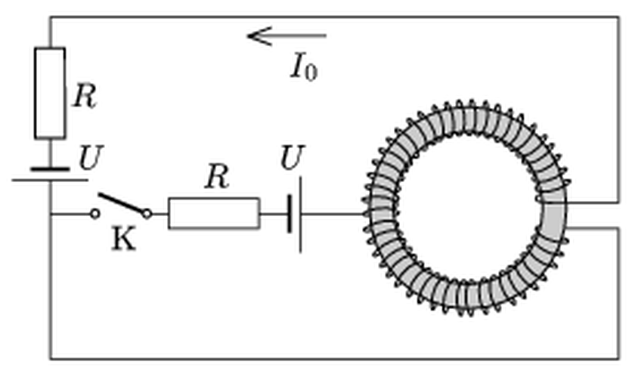
Figure: toroid with centre tap, two batteries, two resistors and switch K
Answer: $I_{K}=\frac{4}{5}I_{0}$
Solution:
Description of the circuit. The centre tap T divides the winding into two equal halves, each with $N/2$ turns:
- the upper half, between T and the upper right terminal P;
- the lower half, between the lower right terminal Q and T.
Both halves sit on the same closed iron core, so they are linked by one common flux $Φ$. The outer branch (battery $U$ and resistor $R$) connects P to Q. The switch branch (K, $R$ and the second battery $U$) connects Q to T, so it is in parallel with the lower half. Before switching, $I_{0}=U/R$ flows through the whole winding from Q to P.
Principles.
- The magnetic flux in the closed iron core cannot change abruptly, because that would require an infinite induced voltage. Right after closing, the total magnetomotive force is therefore unchanged. If $a$ is the current in the upper half and $b$ the current in the lower half (both counted in the original direction Q $→$ T $→$ P):
$$\frac{N}{2}a+\frac{N}{2}b=NI_{0}⇒a+b=2I_{0}$$
- The coil has no resistance, and both halves have the same number of turns on the same flux. Each half therefore has the same induced voltage across it, $ε=\frac{N}{2}\frac{dΦ}{dt}$, and the whole winding has $2ε$.
Equations. Let $j$ be the current in the switch branch, which flows from Q through K, $R$ and the battery to T. Kirchhoff’s current law at T gives
$$a=b+j$$
Outer loop (battery $U$, resistor $R$ carrying current $a$, whole coil):
$$2ε=U−aR$$
Switch loop (battery $U$, resistor $R$ carrying current $j$, lower half of the coil, which is driven against the direction of $j$):
$$ε=jR−U$$
Eliminating $ε$ and using $U=I_{0}R$:
$$2j+a=3I_{0}$$
From $a+b=2I_{0}$ and $b=a−j$ we get $j=2a−2I_{0}$. Substituting:
$$5a=7I_{0}⇒a=1.4 I_{0}, j=0.8 I_{0}, b=0.6 I_{0}$$
The current through the switch right after closing is
$$I_{K}=j=\frac{4}{5}I_{0}$$

Question 24
Source: Sheet 3, Q.65
Three open rings of thin wire, with radii $R$, $2R$ and $4R$, lie concentrically on a horizontal tabletop as shown in the figure. The current in the middle ring is varied with time. The induced emf between the ends of the smallest ring is $U_{0}$. Find the induced emf in the largest ring.
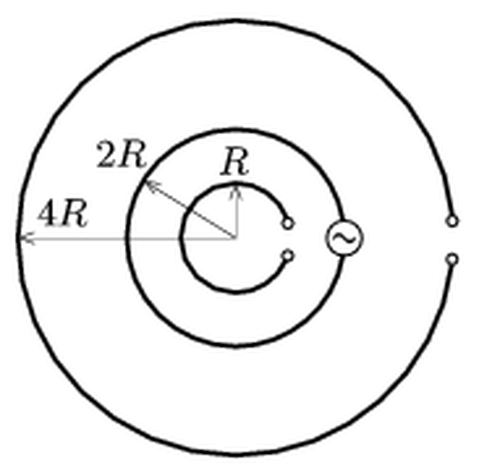
Figure: three concentric open rings, the middle one fed by an AC source
Answer: $U=2U_{0}$
Solution:
The emf induced in a ring by the changing current $I$ of the middle ring is
$$U=M\frac{dI}{dt}$$
where $M$ is the mutual inductance between that ring and the middle ring. Two facts about $M$ give the answer without computing it.
1. Symmetry (reciprocity). For any two circuits, $M_{12}=M_{21}$. So $M(4R←2R)$, the flux through the $4R$ ring per unit current in the $2R$ ring, equals $M(2R←4R)$.
2. Scaling (dimensional analysis). For two coplanar concentric circles, $M$ can depend only on $μ_{0}$ and the radii. It has the dimension $μ_{0}×\text{length}$, so it must have the form
$$M(a,b)=μ_{0} a f\left(\frac{b}{a}\right)$$
If every length is doubled, $M$ doubles. The pair (radius $2R$, radius $4R$) is a copy of the pair (radius $R$, radius $2R$) magnified by a factor of 2, with the same ratio $1:2$. Therefore
$$M(2R,4R)=2 M(R,2R)$$
Result. The emf in the largest ring is
$$U_{4R}=M(4R,2R)\frac{dI}{dt}=2M(R,2R)\frac{dI}{dt}=2U_{0}$$

Question 25
Source: Sheet 3, Q.75
What must the resistance of resistor $R$ in the figure be if:
- there is no current in branch AB;
- the current in branch AC is the greatest;
- the potential difference between points A and C is the greatest;
- the power dissipated in $R$ is the greatest;
- the current in branch DC is the greatest;
- the current in branch AB is the greatest?
Data: $U_{1}=60 \text{V}$, $U_{2}=20 \text{V}$, $R_{1}=80 Ω$, $R_{2}=320 Ω$.
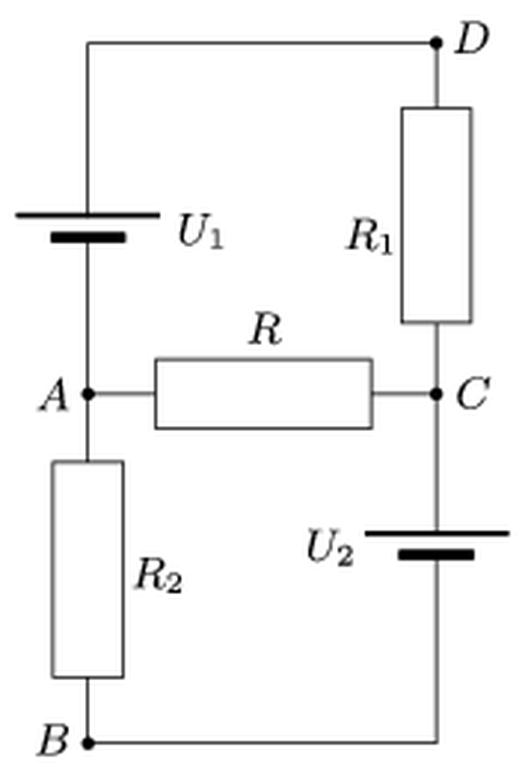
Figure: two-battery network with resistor R between A and C
Answer: (a) $R=40 Ω$
(b) $R=0$ (short circuit), giving $I_{AC}=0.81 \text{A}$
(c) $R→∞$ (open circuit), giving $U_{AC}=52 \text{V}$
(d) $R=64 Ω$
(e) $R=0$, giving $I_{DC}=0.75 \text{A}$
(f) In magnitude, the current in AB is greatest for $R→∞$ ($0.10 \text{A}$, flowing from B to A). Counted in the direction A $→$ B, it is greatest for $R=0$ ($62.5 \text{mA}$).
Solution:
Take the potential of B as zero. From the figure, the positive terminal of $U_{1}$ faces D and the positive terminal of $U_{2}$ faces C. Hence
$$V_{C}=U_{2}=20 \text{V}$$
and, if the unknown potential of A is $x$,
$$V_{D}=x+U_{1}=x+60 \text{V}$$
The branch currents leaving node A are:
- through $U_{1}$ and $R_{1}$ to C: $(x+40)/80$;
- through $R_{2}$ to B: $x/320$;
- through $R$ to C: $(x−20)/R$.
By Kirchhoff’s current law their sum is zero. Multiplying by 320 (all values in volts and ohms):
$$5x+160+\frac{320(x−20)}{R}=0$$
The solution can be written as
$$x=20−\frac{260}{5+320/R}$$
So $x$ increases monotonically from $−32 \text{V}$ (when $R→∞$) to $20 \text{V}$ (when $R=0$).
(a) No current in AB means $x=0$. Then $0.5 \text{A}=20 \text{V}/R$, so $R=40 Ω$.
(b) The current in AC is
$$I_{AC}=\frac{260}{5R+320}$$
It grows as $R$ decreases, so it is greatest for $R=0$: $I_{AC}=260/320=0.81 \text{A}$.
(c) The voltage between A and C is
$$U_{AC}=\frac{260R}{5R+320}$$
It is greatest for $R→∞$: $U_{AC}=52 \text{V}$.
(d) Seen from the terminals A and C, the rest of the network is a Thévenin source. With the batteries replaced by short circuits, $R_{1}$ and $R_{2}$ are in parallel between A and C:
$$R_{\text{Th}}=\frac{R_{1}R_{2}}{R_{1}+R_{2}}=\frac{80⋅320}{400} Ω=64 Ω$$
Maximum power is delivered when the load matches this resistance, so $R=64 Ω$. Check: $P={260}^{2}R/(5R+320)^{2}$ has its maximum at $5R=320$.
(e) $I_{DC}=(x+40)/80$ increases with $x$, so it is greatest for $R=0$: $I_{DC}=60/80=0.75 \text{A}$.
(f) $I_{AB}=x/320$. Its magnitude is greatest where $\left|x\right|$ is greatest. That is $\left|x\right|=32 \text{V}$ at $R→∞$, giving $0.10 \text{A}$ flowing from B to A, compared with $20/320=0.0625 \text{A}$ at $R=0$. Counted with sign in the direction A $→$ B, the current is greatest at $R=0$.
Note: the original sheet gives 6 Ω for (d), evidently a truncated 64 Ω. For (f) it gives R = 0, which holds only if the current is counted in the direction A → B. In magnitude, the maximum is at R → ∞.

Question 26
Source: Sheet 3, Q.77
The electrolytic capacitor that stores the energy for a photographic flash has a capacitance of $3300 μ\text{F}$ and an operating voltage of $350 \text{V}$. What percentage of the stored energy can be used for the flash, if the discharge in the flash tube stops when the voltage falls to $50 \text{V}$?
Answer: About $98 \%$ ($198 \text{J}$ of the $202 \text{J}$ stored)
Solution:
The energy stored in a capacitor charged to voltage $U$ is
$$W=\frac{1}{2}CU^{2}$$
Initially:
$$W_{1}=\frac{1}{2}⋅3300×{10}^{−6} \text{F}⋅(350 \text{V})^{2}=202.1 \text{J}$$
When the discharge stops at $50 \text{V}$, the energy left on the capacitor is
$$W_{2}=\frac{1}{2}⋅3300×{10}^{−6} \text{F}⋅(50 \text{V})^{2}=4.1 \text{J}$$
The usable fraction is
$$\frac{W_{1}−W_{2}}{W_{1}}=1−{\left(\frac{50}{350}\right)}^{2}=1−\frac{1}{49}=0.98$$
So about $98 \%$ of the stored energy ($≈198 \text{J}$) is used for the flash.

Question 27
Source: Sheet 3, Q.94
A tetrahedron ABCD is soldered together from six different resistors, one on each edge. A battery is connected between two vertices (for example A and B), and a sensitive ammeter between the other two (C and D). Surprisingly, the ammeter reads zero, whichever pair of vertices is chosen for the battery. What is the relation between the six resistances?
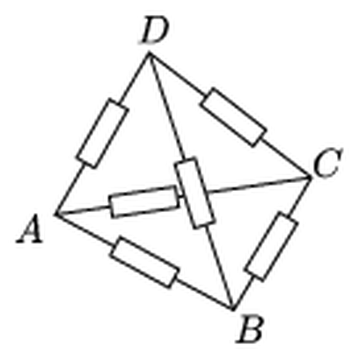
Figure: tetrahedron of six resistors
Answer: The products of the resistances on opposite (skew) edges are all equal: $R_{AB}R_{CD}=R_{AC}R_{BD}=R_{AD}R_{BC}$
Solution:
With the battery between A and B and the ammeter between C and D, the network is a Wheatstone bridge:
- the four bridge arms are $R_{AC}$, $R_{CB}$, $R_{AD}$ and $R_{DB}$;
- $R_{AB}$ is simply in parallel with the battery;
- $R_{CD}$ is in parallel with the ammeter.
The ammeter reads zero when C and D are at the same potential, i.e. when the voltage divides in the same ratio along both paths from A to B:
$$\frac{R_{AC}}{R_{CB}}=\frac{R_{AD}}{R_{DB}}⇒R_{AC}R_{BD}=R_{AD}R_{BC}$$
The resistances $R_{AB}$ and $R_{CD}$ do not appear in this condition.
Choosing the battery between A and C, with the meter between B and D, gives the same kind of condition for that bridge:
$$R_{AB}R_{CD}=R_{AD}R_{BC}$$
Choosing the battery between A and D, with the meter between B and C, gives
$$R_{AB}R_{CD}=R_{AC}R_{BD}$$
Any other choice of the battery’s pair of vertices reproduces one of these three conditions. Since the meter reads zero in every case, all three must hold together. The tetrahedron has three pairs of opposite (non-touching) edges, and the products of the resistances along each pair must all be equal:
$$R_{AB}R_{CD}=R_{AC}R_{BD}=R_{AD}R_{BC}$$

Question 28
Source: Sheet 3, Q.99
An electric locomotive can exert a pulling force of $310 \text{kN}$ at a speed of $57.6 \text{km/h}$. The supply voltage is $3.6 \text{kV}$, and each of its eight electric motors draws a current of $230 \text{A}$. Determine the efficiency of the locomotive.
Answer: $η≈75 \%$
Solution:
Efficiency is the useful mechanical power divided by the electrical power taken from the line.
The speed is $v=57.6 \text{km/h}=16 \text{m/s}$. The mechanical power is
$$P_{\text{mech}}=Fv=310×{10}^{3} \text{N}⋅16 \text{m/s}=4.96 \text{MW}$$
The eight motors each take $230 \text{A}$ at $3.6 \text{kV}$:
$$P_{\text{el}}=8UI=8⋅3600 \text{V}⋅230 \text{A}=6.62 \text{MW}$$
The efficiency is
$$η=\frac{P_{\text{mech}}}{P_{\text{el}}}=\frac{4.96}{6.62}=0.749≈75 \%$$

Question 29
Source: Sheet 3, Q.102
The switch in the circuit shown in the figure has been closed for a long time. Data: $U=100 \text{V}$, $C=2 μ\text{F}$, $R_{1}=20 Ω$, $R_{2}=30 Ω$, $R_{3}=12 Ω$.
- Determine the charge on the capacitor.
- The switch is now opened. How much charge flows through resistor $R_{1}$ after the switch is opened?
- How much heat is produced in resistor $R_{1}$ after the switch is opened?
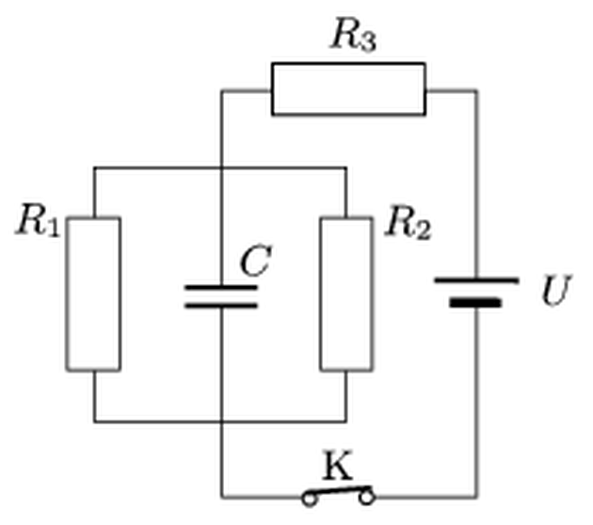
Figure: circuit with R1, R2, C, R3, battery U and switch K
Answer: (a) $Q=100 μ\text{C}$
(b) $60 μ\text{C}$
(c) $1.5 \text{mJ}$
Solution:
In the figure, $R_{1}$, $C$ and $R_{2}$ are connected in parallel between the same two wires. With K closed, this group is in series with $R_{3}$ and the battery.
(a) In steady state, no current flows into the capacitor. The parallel resistance is
$$R_{12}=\frac{R_{1}R_{2}}{R_{1}+R_{2}}=\frac{20⋅30}{50} Ω=12 Ω$$
The current is
$$I=\frac{U}{R_{3}+R_{12}}=\frac{100 \text{V}}{24 Ω}=4.17 \text{A}$$
The capacitor voltage equals the voltage across the parallel group:
$$U_{C}=IR_{12}=50 \text{V}$$
so the charge is
$$Q=CU_{C}=2 μ\text{F}⋅50 \text{V}=100 μ\text{C}$$
(b) Opening K disconnects the battery and $R_{3}$. The capacitor then discharges through $R_{1}$ and $R_{2}$, which are in parallel. Both resistors always have the same voltage $u(t)$ across them, so the currents divide in the inverse ratio of the resistances at every instant:
$$\frac{i_{1}}{i_{2}}=\frac{R_{2}}{R_{1}}$$
The fraction of the total charge that passes through $R_{1}$ is
$$Q_{1}=Q\frac{R_{2}}{R_{1}+R_{2}}=100 μ\text{C}⋅\frac{30}{50}=60 μ\text{C}$$
(c) The stored energy is
$$W=\frac{1}{2}CU_{C}^{2}=\frac{1}{2}⋅2×{10}^{−6} \text{F}⋅(50 \text{V})^{2}=2.5 \text{mJ}$$
All of it turns into heat in $R_{1}$ and $R_{2}$. With the same voltage across both, the powers are $u^{2}/R$, in the ratio $P_{1}:P_{2}=R_{2}:R_{1}=3:2$. Therefore
$$W_{1}=\frac{3}{5}⋅2.5 \text{mJ}=1.5 \text{mJ}$$

Question 30
Source: Sheet 3, Q.104
You have 4 identical ideal diodes for rectifying the sinusoidal mains voltage, which has an r.m.s. value of $230 \text{V}$ and a frequency of $50 \text{Hz}$. (Any number of the diodes, up to 4, may be used.)
- What circuit would you build to get a half-wave rectifier, giving the output voltage shown below?
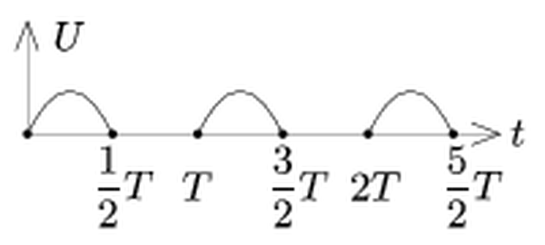
Figure: half-wave rectified voltage
- What circuit would you build to get a full-wave rectifier, giving the output voltage shown below?
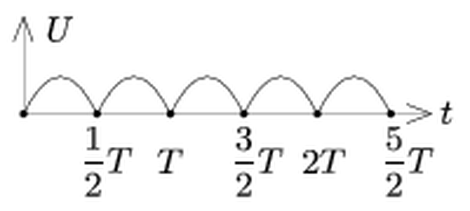
Figure: full-wave rectified voltage
- Determine the r.m.s. value of the output voltage in both cases.
Answer: (a) One diode in series with the load (see figure)
(b) A bridge (Graetz) rectifier built from all four diodes (see figure)
(c) $U_{\text{rms}}≈163 \text{V}$ for half-wave and $230 \text{V}$ for full-wave rectification
Solution:
(a) Half-wave rectifier. A single diode in series with the load $R_{L}$ conducts only while the mains voltage has the forward polarity. During the other half-period the diode blocks and the load voltage is zero. This produces the “every other hump” waveform.
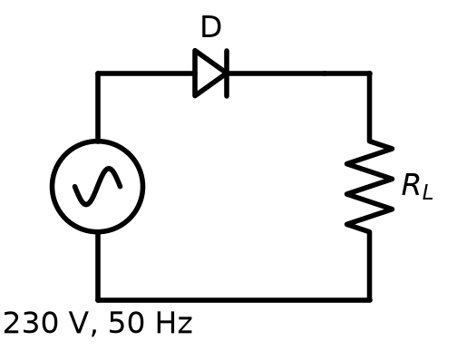
Figure: half-wave rectifier, one diode in series with the load
(b) Full-wave (bridge) rectifier. The four diodes form a bridge:
- the mains is connected to one diagonal (top and bottom nodes);
- the load is connected to the other diagonal (left and right nodes).
In one half-period, current flows through D1, then the load from + to $−$, then D4. In the other half-period, it flows through D3, then the load in the same direction, then D2. Current therefore passes through the load in the same direction in both half-periods, and the load voltage is $\left|u(t)\right|$.
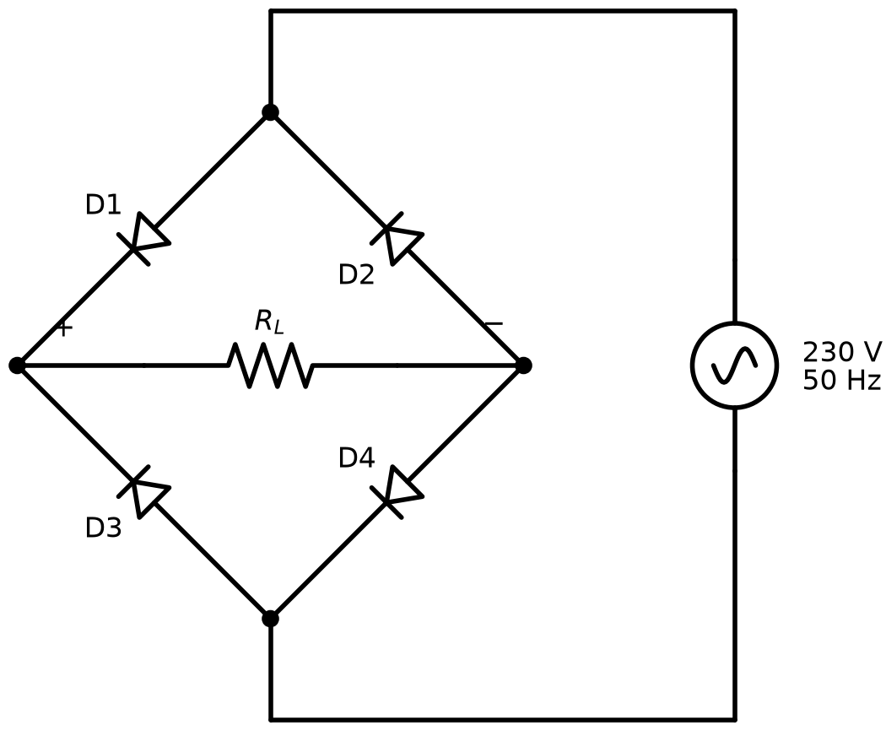
Figure: bridge rectifier with four diodes
For comparison, the original answer figure is reproduced below.
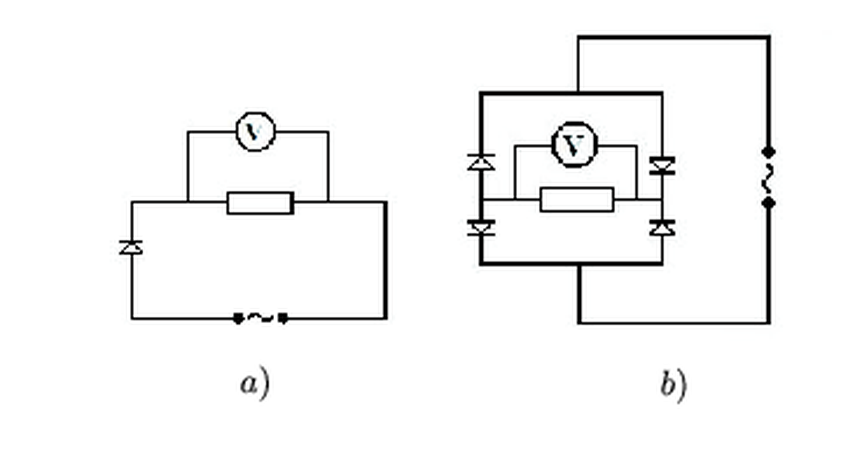
Figure: original answer circuits, a) half-wave, b) bridge
(c) R.m.s. values. The peak voltage is
$$U_{0}=\sqrt{2}⋅230 \text{V}=325 \text{V}$$
The r.m.s. value is the square root of the time average of $u^{2}$.
Full wave: $u^{2}=U_{0}^{2}\sin^{2}ωt$, the same as for the unrectified voltage, so
$$U_{\text{rms,full}}=\frac{U_{0}}{\sqrt{2}}=230 \text{V}$$
Half wave: $u^{2}$ equals the full-wave value during one half-period and is zero during the other. The time average of $u^{2}$ is therefore halved:
$$U_{\text{rms,half}}=\sqrt{\frac{1}{2}⋅\frac{U_{0}^{2}}{2}}=\frac{U_{0}}{2}=\frac{230 \text{V}}{\sqrt{2}}≈163 \text{V}$$

Question 31
Source: Sheet 3, Q.105
Two unknown impedances are connected in parallel to the $230 \text{V}$, $50 \text{Hz}$ mains. The peak value of the current in the main branch is $20 \text{A}$. The current in one impedance leads the main-branch current by $π/3$, and the current in the other lags behind it by $π/6$.
- What are the instantaneous currents in the two branches at $t=0.01 \text{s}$, if the main-branch current is zero at $t=0$?
- What inductances and capacitances can be in the two branches?
Answer: (a) The main-branch current is $0$. The branch currents are $i_{1}=−8.66 \text{A}$ and $i_{2}=+8.66 \text{A}$ (equal and opposite).
(b) One possibility: a resistor $R=32.5 Ω$ in one branch and a coil $L≈60 \text{mH}$ in the other. The other possibility: a capacitor $C≈98 μ\text{F}$ ($≈100 μ\text{F}$) in one branch and a resistor $R=18.8 Ω$ in the other.
Solution:
Let the main current be $i=I_{0}sinωt$, with $I_{0}=20 \text{A}$ and $ω=2π⋅50 {\text{s}}^{−1}=314 {\text{s}}^{−1}$. The branch currents are
$$i_{1}=I_{1}sin\left(ωt+\frac{π}{3}\right)$$
$$i_{2}=I_{2}sin\left(ωt−\frac{π}{6}\right)$$
Their phase difference is $π/3+π/6=π/2$, so the two branch phasors are perpendicular. By Kirchhoff’s law their phasor sum is the main-current phasor. The two branch phasors are therefore the legs of a right triangle whose hypotenuse is $I_{0}$:
$$I_{1}=I_{0}cos\frac{π}{3}=10 \text{A}$$
$$I_{2}=I_{0}cos\frac{π}{6}=17.3 \text{A}$$
Check of the component perpendicular to $I_{0}$: $10sin60°−17.3sin30°=0$.
(a) At $t=0.01 \text{s}$, half a period has passed, so $ωt=π$. Then $i=20sinπ=0$, and
$$i_{1}=10 \text{A}⋅sin\frac{4π}{3}=−8.66 \text{A}$$
$$i_{2}=17.3 \text{A}⋅sin\frac{5π}{6}=+8.66 \text{A}$$
The branch currents are equal and opposite, and their sum is zero, as it must be.
(b) The two branch currents are $90°$ apart. If each branch contains a single ideal element, one branch must be a resistor (current in phase with the voltage) and the other a pure reactance ($90°$ shifted). The peak voltage is $U_{0}=\sqrt{2}⋅230 \text{V}=325 \text{V}$.
Case 1: branch 1 resistive, branch 2 inductive. The voltage is in phase with $i_{1}$, and $i_{2}$ lags it by $90°$. Then
$$R=\frac{U_{0}}{I_{1}}=\frac{325 \text{V}}{10 \text{A}}=32.5 Ω$$
$$L=\frac{U_{0}}{ωI_{2}}=\frac{325 \text{V}}{314 {\text{s}}^{−1}⋅17.3 \text{A}}=0.060 \text{H}=60 \text{mH}$$
Case 2: branch 2 resistive, branch 1 capacitive. The voltage is in phase with $i_{2}$, and $i_{1}$ leads it by $90°$. Then
$$R=\frac{U_{0}}{I_{2}}=18.8 Ω$$
$$C=\frac{I_{1}}{ωU_{0}}=\frac{10 \text{A}}{314 {\text{s}}^{−1}⋅325 \text{V}}=9.8×{10}^{−5} \text{F}≈98 μ\text{F}$$

Question 32
Source: Sheet 3, Q.113
An electron is shot with initial speed $v_{0}=4×{10}^{7} \text{m/s}$ into a parallel-plate capacitor, halfway between the plates. The plate separation and the plate length are unknown. A constant voltage $U=500 \text{V}$ is applied between the plates. If, in addition, a uniform magnetic field $B=6.25×{10}^{−5} {\text{Vs/m}}^{2}$ is applied between the plates in the appropriate direction, the electron passes between the plates without changing its direction, at constant speed.
- Determine the electric field between the plates.
- Find the distance $d$ between the plates.
- When the magnetic field is switched off, the speed of the electron increases by $6 \%$ while it passes through the capacitor. What is the length $L$ of the plates?
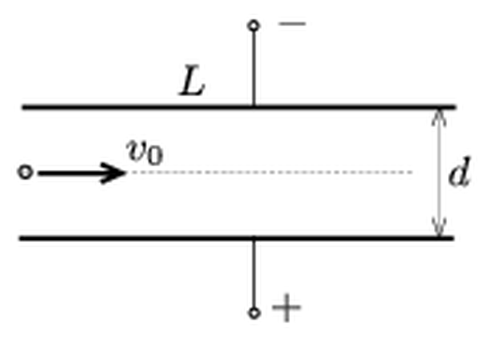
Figure: electron entering a parallel-plate capacitor midway between the plates
Answer: (a) $E=2.5×{10}^{3} \text{V/m}$
(b) $d=0.2 \text{m}$
(c) $L≈1.3 \text{m}$ (the intended result; as shown in the solution, the data of part (c) are physically inconsistent)
Solution:
(a) The electron moves undeflected when the electric and magnetic forces cancel (velocity selector):
$$eE=ev_{0}B$$
$$E=v_{0}B=4×{10}^{7} \text{m/s}⋅6.25×{10}^{−5} \text{T}=2.5×{10}^{3} \text{V/m}$$
(b) In a uniform field $E=U/d$, so
$$d=\frac{U}{E}=\frac{500 \text{V}}{2500 \text{V/m}}=0.2 \text{m}$$
(c) Without $B$, the electron moves like a projectile: its horizontal velocity stays $v_{0}$, while a transverse acceleration acts on it,
$$a=\frac{eE}{m}=1.76×{10}^{11} \text{C/kg}⋅2500 \text{V/m}=4.40×{10}^{14} {\text{m/s}}^{2}$$
If the exit speed is $1.06 v_{0}$, the transverse velocity component at exit is
$$v_{y}=v_{0}\sqrt{{1.06}^{2}−1}=0.352 v_{0}=1.41×{10}^{7} \text{m/s}$$
The time spent between the plates is
$$t=\frac{v_{y}}{a}=3.20×{10}^{−8} \text{s}$$
so the plate length is
$$L=v_{0}t=4×{10}^{7} \text{m/s}⋅3.20×{10}^{−8} \text{s}≈1.3 \text{m}$$
Consistency check. During this time the transverse displacement would be
$$y=\frac{1}{2}at^{2}=0.22 \text{m}$$
This is more than the available $d/2=0.1 \text{m}$. In energy terms, the electron enters with kinetic energy $\frac{1}{2}mv_{0}^{2}≈4.55 \text{keV}$. Between the midplane and a plate it can gain at most $eU/2=250 \text{eV}$, which limits its speed increase to about $2.7 \%$. A $6 \%$ speed increase is therefore impossible: the electron would strike the positive plate before leaving the capacitor.
Note: the original sheet gives L ≈ 1.3 m, which is the result of the intended calculation, but the data of part (c) are inconsistent with d = 0.2 m.

Question 33
Source: Sheet 3, Q.114
The current in a toroidal coil changes at a rate of $10 \text{A/s}$. The coil has 2000 turns, a cross-section of $2 {\text{cm}}^{2}$, and its central circle has a radius of $0.5 \text{m}$. With what acceleration does a proton, or an electron, start to move if it is initially at rest at the centre of the toroidal coil?
Hint: the electric field produced by the changing magnetic field of the toroidal coil is similar to the magnetic field produced by a circular current.
Answer: The induced field at the centre is
$$E=\frac{μ_{0}NA}{4πr^{2}}\frac{ΔI}{Δt}=1.6×{10}^{−6} \text{V/m}$$
directed along the symmetry axis of the toroid. The accelerations are $a_{p}≈1.5×{10}^{2} {\text{m/s}}^{2}$ for the proton and $a_{e}≈2.8×{10}^{5} {\text{m/s}}^{2}$ for the electron, in opposite directions.
Solution:
Analogy. Without charges, the induced electric field obeys
$$∇×\vec{E}=−\frac{∂\vec{B}}{∂t}$$
$$∇⋅\vec{E}=0$$
These have the same form as the magnetostatic equations $∇×\vec{B}=μ_{0}\vec{J}$ and $∇⋅\vec{B}=0$. Hence $\vec{E}$ follows from the Biot–Savart law with $μ_{0}\vec{J}$ replaced by $−∂\vec{B}/∂t$. The changing flux, confined to the thin core of the toroid, plays the role of a current flowing in a circular wire of radius $r$. The “current strength” corresponds to
$$μ_{0}I↔\frac{dΦ}{dt}$$
Flux in the core. The field in the toroid is
$$B=\frac{μ_{0}NI}{2πr}$$
so the rate of change of flux is
$$\frac{dΦ}{dt}=\frac{μ_{0}NA}{2πr}\frac{dI}{dt}$$
Field at the centre. A circular current produces $B=μ_{0}I/(2r)$ at its centre. By the analogy, the induced field at the centre of the toroid is
$$E=\frac{1}{2r}\frac{dΦ}{dt}=\frac{μ_{0}NA}{4πr^{2}}\frac{dI}{dt}$$
It is directed along the symmetry axis of the toroid. Numerically:
$$E={10}^{−7} \frac{\text{Vs}}{\text{Am}}⋅\frac{2000⋅2×{10}^{−4} {\text{m}}^{2}}{(0.5 \text{m})^{2}}⋅10 \frac{\text{A}}{\text{s}}=1.6×{10}^{−6} \text{V/m}$$
Accelerations. The acceleration is $a=QE/m$:
$$a_{p}=\frac{1.60×{10}^{−19} \text{C}⋅1.6×{10}^{−6} \text{V/m}}{1.67×{10}^{−27} \text{kg}}≈1.5×{10}^{2} {\text{m/s}}^{2}$$
$$a_{e}=\frac{1.60×{10}^{−19} \text{C}⋅1.6×{10}^{−6} \text{V/m}}{9.11×{10}^{−31} \text{kg}}≈2.8×{10}^{5} {\text{m/s}}^{2}$$
The proton and the electron accelerate in opposite directions along the axis.
Note: the original sheet’s formula contains an extra factor of 1/(4π), giving accelerations 4π times smaller. The analogy stated in the hint gives the result above.

Question 34
Source: Sheet 3, Q.122
Two identical pendulums of length $L$ hang from the same point. At the end of each there is a small sphere of mass $m$. When both spheres are given the same charge $Q$, the threads move apart as shown in the figure: the distance between the spheres becomes $L$.
- Determine the mass $m$ of the spheres.
- In another experiment, the right sphere is replaced by one with the same charge but three times the mass. How must the charge of the left sphere be changed so that, in equilibrium, the distance between the spheres remains $L$? (The mass of the left sphere is unchanged.)
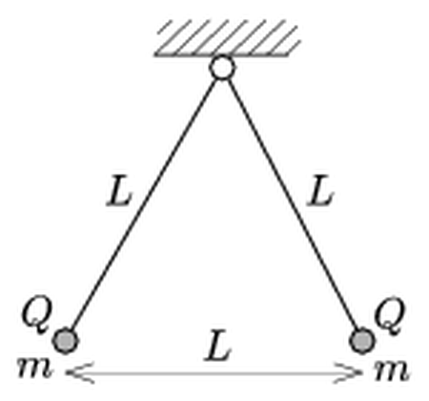
Figure: two charged pendulums forming an equilateral triangle
Answer: (a) $m=\frac{\sqrt{3} kQ^{2}}{gL^{2}}$
(b) $Q^{′}=\sqrt{\frac{27}{13}} Q≈1.44 Q$
Solution:
(a) The two threads and the line joining the spheres form an equilateral triangle, so each thread makes $30°$ with the vertical. Three forces act on each sphere: gravity $mg$, the thread tension $T$, and the horizontal Coulomb repulsion
$$F=\frac{kQ^{2}}{L^{2}}$$
Balance of the horizontal and vertical components gives
$$tan30°=\frac{F}{mg}$$
so
$$m=\frac{kQ^{2}}{gL^{2}tan30°}=\frac{\sqrt{3} kQ^{2}}{gL^{2}}$$
(b) The triangle is still equilateral (sides $L$, $L$, $L$), but it is no longer symmetric about the vertical. Let the left thread make angle $θ_{1}$ and the right thread angle $θ_{2}$ with the vertical, with $θ_{1}+θ_{2}=60°$.
Whole system. Take torques about the suspension point for the two spheres together. The tensions pass through that point, and the Coulomb forces are an internal action–reaction pair along one line, so they cancel. Only gravity remains:
$$mgLsinθ_{1}=3mgLsinθ_{2}$$
Substituting $θ_{1}=60°−θ_{2}$:
$$\frac{\sqrt{3}}{2}cosθ_{2}−\frac{1}{2}sinθ_{2}=3sinθ_{2}$$
$$tanθ_{2}=\frac{\sqrt{3}}{7}$$
Hence
$$sinθ_{2}=\frac{\sqrt{3}}{\sqrt{52}}$$
$$sinθ_{1}=3sinθ_{2}=\frac{3\sqrt{3}}{\sqrt{52}}$$
Left sphere alone. Take torques about the suspension point again. The Coulomb force $F^{′}=kQQ^{′}/L^{2}$ acts along the side of the triangle opposite the suspension point. Its lever arm is the height of the equilateral triangle, $\frac{\sqrt{3}}{2}L$:
$$F^{′}\frac{\sqrt{3}}{2}L=mgLsinθ_{1}$$
$$F^{′}=\frac{2mgsinθ_{1}}{\sqrt{3}}$$
From part (a), $kQ^{2}/L^{2}=mg/\sqrt{3}$. Dividing the two forces:
$$\frac{Q^{′}}{Q}=\frac{F^{′}}{F}=2sinθ_{1}=\frac{6\sqrt{3}}{\sqrt{52}}=\sqrt{\frac{27}{13}}≈1.44$$
The charge of the left sphere must be increased to about $1.44 Q$.

Question 35
Source: Sheet 3, Q.133
A solenoid (straight coil) of length $L=0.5 \text{m}$ has $N=2000$ turns and a cross-section of $A=16 {\text{cm}}^{2}$. It has an iron core of relative permeability $μ_{r}=2500$. At a given moment, the current in the coil changes at a rate of $100 \text{A/s}$. What voltage is induced in a straight wire of length $2l=20 \text{cm}$ lying in the plane through the centre of the coil, perpendicular to the coil axis, in each of the following positions?
- The midpoint of the wire is at distance $l$ from the coil axis, and its two ends are equidistant from the coil.
- The wire has the same direction as in (a), but one of its ends is at distance $l$ from the axis of the coil (this end is the foot of the perpendicular from the axis to the wire).
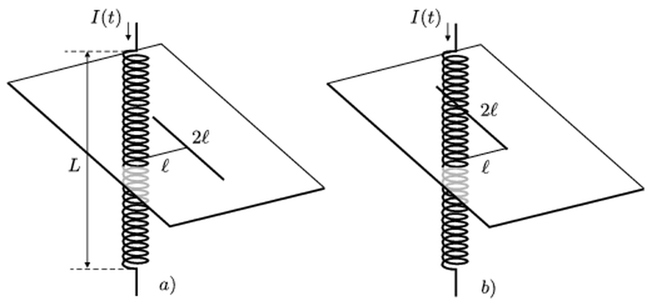
Figure: straight wire in the mid-plane of a long solenoid, positions a) and b)
Answer: (a) $U_{a}=\frac{1}{4}μ_{0}μ_{r}\frac{NA}{L}\frac{ΔI}{Δt}≈0.50 \text{V}$
(b) $U_{b}=\frac{arctan2}{2π}μ_{0}μ_{r}\frac{NA}{L}\frac{ΔI}{Δt}≈0.35 \text{V}$
Solution:
Field and flux. Inside the long solenoid,
$$B=μ_{0}μ_{r}\frac{NI}{L}$$
The rate of change of the flux is
$$\frac{ΔΦ}{Δt}=μ_{0}μ_{r}\frac{NA}{L}\frac{ΔI}{Δt}=4π×{10}^{−7}⋅2500⋅\frac{2000⋅1.6×{10}^{−3}}{0.5}⋅100 \text{V}=2.01 \text{V}$$
Induced electric field outside the coil. By symmetry, the induced field lines in the mid-plane are circles around the axis. Faraday’s law, applied to a circle of radius $ρ$, gives
$$E⋅2πρ=\frac{ΔΦ}{Δt}$$
$$E=\frac{1}{2πρ}\frac{ΔΦ}{Δt}$$
Emf along a straight wire. The emf is $∫\vec{E}⋅d\vec{s}$ along the wire. Only the azimuthal component of a wire element counts, and $ds_{⟂}=ρ dφ$. Therefore
$$U=∫\frac{1}{2πρ}\frac{ΔΦ}{Δt}ρ dφ=\frac{φ}{2π}\frac{ΔΦ}{Δt}$$
where $φ$ is the angle the wire subtends at the axis.
(a) Each half of the wire (length $l$, at perpendicular distance $l$) subtends $45°$, so $φ=90°=π/2$:
$$U_{a}=\frac{1}{4}\frac{ΔΦ}{Δt}=\frac{2.01 \text{V}}{4}≈0.50 \text{V}$$
(b) The wire runs from the foot of the perpendicular (distance $l$) out to a length $2l$. It subtends $φ=arctan(2l/l)=arctan2=1.107 \text{rad}$ ($63.4°$):
$$U_{b}=\frac{1.107}{2π}⋅2.01 \text{V}≈0.35 \text{V}$$

Question 36
Source: Sheet 3, Q.137
In a cathode-ray tube, when the deflecting plates are uncharged, the electrons leaving the electron gun travel through the tube at constant velocity and hit the screen at this speed. What can be said about the speed at which the electrons hit the screen when there is a constant charge on the pair of plates?
Answer: The electrons hit the screen at the same speed as before. Only the direction of their velocity changes.
Solution:
The work done on an electron by the electrostatic field of the plates depends only on the potential difference between its start and end points:
$$ΔE_{\text{kin}}=−e (V_{\text{end}}−V_{\text{start}})$$
The charged plates carry equal and opposite charges, so their field is concentrated between them. Far in front of the plates, where the electrons come from the gun, and far behind them, near the screen, the field of the plates is practically zero. These regions are at the same potential as they were with uncharged plates.
While the electron is between the plates, its speed does change: it speeds up as it moves toward the positive plate and gains a transverse velocity component. On leaving the plates, however, it passes through the fringing field and returns to a point of the same potential. The work done by the plate field over the whole path is therefore zero.
Consequently:
- the magnitude of the velocity, i.e. the speed, at the screen is the same as without charge on the plates;
- the direction is different, which is exactly what deflects the spot on the screen.

Question 37
Source: Sheet 3, Q.138
What are the currents in the connecting wires that join point A with point X, and point Y with point B, in the circuit shown in the figure? Data: $R=6 Ω$, $U=24 \text{V}$.
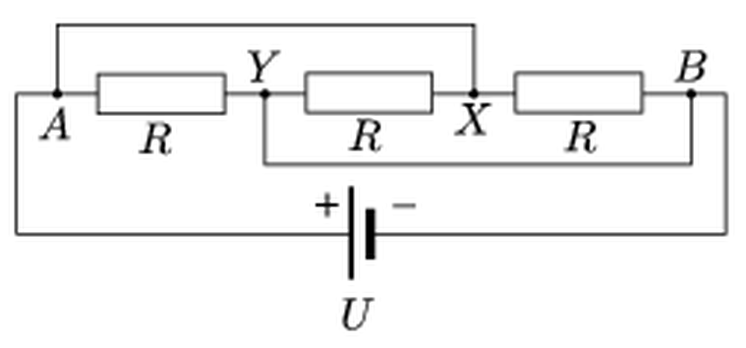
Figure: three resistors with two shorting wires A–X and Y–B
Answer: $8 \text{A}$ in each connecting wire (each resistor carries $4 \text{A}$, and the battery supplies $12 \text{A}$)
Solution:
Redrawing the circuit. A wire of zero resistance makes its two endpoints one node. The upper wire connects A and X, so $V_{X}=V_{A}$. The lower wire connects Y and B, so $V_{Y}=V_{B}$. Then:
- the resistor between A and Y lies between A and B;
- the resistor between Y and X lies between B and A;
- the resistor between X and B lies between A and B.
All three resistors are therefore in parallel across the battery, and each carries
$$I_{R}=\frac{U}{R}=\frac{24 \text{V}}{6 Ω}=4 \text{A}$$
The battery supplies $3⋅4 \text{A}=12 \text{A}$.
Wire A–X. Node X is connected only to this wire and to the two resistors Y–X and X–B. Both resistor currents flow away from X, toward Y and toward B. They are both fed through the wire from A:
$$I_{AX}=4 \text{A}+4 \text{A}=8 \text{A}$$
Wire Y–B. Node Y receives $4 \text{A}$ from the resistor A–Y and $4 \text{A}$ from the resistor X–Y. Both currents leave through the wire toward B:
$$I_{YB}=8 \text{A}$$
At B, these $8 \text{A}$ combine with the $4 \text{A}$ of resistor X–B, and the total of $12 \text{A}$ returns to the battery.
Note: the original question text speaks of the wire joining “X and Y”. In the figure, the second connecting wire joins Y and B. Its current is 8 A, while the resistor between X and Y carries 4 A.

Question 38
Source: Sheet 3, Q.139
The rigid wire frame shown in the figure can turn freely about the vertical axis PQ. It is placed in a uniform horizontal magnetic field. Data: $B=0.05 \text{T}$, $r=0.05 \text{m}$, $l=0.3 \text{m}$. A current $I=10 \text{A}$ flows in the wire, and the mass of one metre of the wire is $10 \text{dkg}$ ($0.1 \text{kg}$). What is the period of small oscillations of the frame?
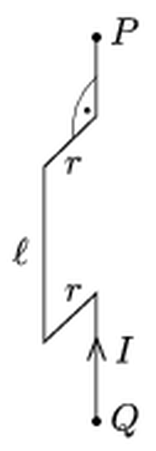
Figure: wire frame with arms r and vertical side l, rotating about axis PQ
Answer: $T≈0.66 \text{s}$
Solution:
Restoring torque. Only the vertical side of length $l$, at distance $r$ from the axis, produces a torque about the vertical axis. On the two horizontal arms of length $r$, the forces $IrB$ are vertical, and the segments on the axis have no lever arm. The force on the vertical side,
$$F=IlB$$
is horizontal and perpendicular to $\vec{B}$. In equilibrium, the arm $r$ points along $F$. When the frame is turned by a small angle $θ$, the torque is
$$M=−Frsinθ≈−IlBr θ$$
This is equivalent to a magnetic moment $m=Ilr$ in the field $B$. The torsional constant is
$$D=IlrB=10 \text{A}⋅0.3 \text{m}⋅0.05 \text{m}⋅0.05 \text{T}=7.5×{10}^{−3} \text{N m}$$
Moment of inertia. With $λ=0.1 \text{kg/m}$:
- the vertical side has mass $λl$ at distance $r$, giving $λlr^{2}$;
- each horizontal arm rotates about its end, giving $λr⋅r^{2}/3$;
- the parts on the axis contribute nothing.
$$Θ=λ\left(lr^{2}+\frac{2}{3}r^{3}\right)=0.1⋅\left(0.3⋅0.0025+\frac{2}{3}⋅1.25×{10}^{−4}\right) {\text{kg m}}^{2}=8.33×{10}^{−5} {\text{kg m}}^{2}$$
Period. The motion is a torsional oscillation:
$$T=2π\sqrt{\frac{Θ}{D}}=2π\sqrt{\frac{8.33×{10}^{−5}}{7.5×{10}^{−3}}} \text{s}=0.66 \text{s}$$

Question 39
Source: Sheet 3, Q.140
An immersion heater is rated at $350 \text{W}$ when operated from the sinusoidal $230 \text{V}$ mains.
- What are the smallest and the greatest instantaneous powers of the heater during operation?
- What is the peak value of the current through the heater?
- Why must the heater not be switched on before it is immersed in water?
Answer: (a) $P_{\text{min}}=0$, $P_{\text{max}}=700 \text{W}$
(b) $I_{\text{max}}≈2.15 \text{A}$
(c) Without water, the heat is not carried away, so the heating element overheats and burns out.
Solution:
(a) For a resistor, the voltage and current are in phase. The instantaneous power is
$$p(t)=U_{0}I_{0}\sin^{2}ωt$$
Its average value, the rated power, is $P=U_{0}I_{0}/2=350 \text{W}$. The power varies between
$$P_{\text{min}}=0$$
when the voltage passes through zero, and
$$P_{\text{max}}=U_{0}I_{0}=2P=700 \text{W}$$
(b) The r.m.s. current is
$$I_{\text{rms}}=\frac{P}{U_{\text{rms}}}=\frac{350 \text{W}}{230 \text{V}}=1.52 \text{A}$$
so the peak value is
$$I_{\text{max}}=\sqrt{2}⋅1.52 \text{A}=2.15 \text{A}$$
(c) The heater is designed to give off $350 \text{W}$ to water, which has a large heat capacity and conducts heat away from the surface very well. In air, the heat transfer is poor. The element would heat up until its temperature became very high, so it would overheat, damage its insulation and burn through within a short time.

Question 40
Source: Sheet 3, Q.142
Triply ionised ${\text{UF}}_{6}$ molecules are accelerated through a voltage of $5 \text{kV}$. They then pass through a small hole into a region with a magnetic field of $1 \text{T}$, perpendicular to their velocity.
- What is the path of the ions? Give the characteristic parameters of the paths of the ions containing the uranium isotopes 238 and 235.
- This method can separate the two uranium isotopes. During the Second World War, the available ion sources could produce an ion current of $1 \text{mA}$. How long would it have taken to separate $1 \text{kg}$ of pure $​^{235}\text{U}$ with this method?
Answer: (a) Circular paths (semicircles before the ions reach the detector). The ions have speed $v≈9.1×{10}^{4} \text{m/s}$ and period $T≈7.6 μ\text{s}$. The radii are $r_{238}≈11.03 \text{cm}$ and $r_{235}≈10.98 \text{cm}$, so after a half circle the two beams are about $0.94 \text{mm}$ apart.
(b) About $1.8×{10}^{11} \text{s}$, i.e. roughly $5500$ years.
Solution:
(a) The molecular masses are:
- $​^{238}{\text{UF}}_{6}$: $238+6⋅19=352 \text{u}$, so $m=352⋅1.66×{10}^{−27} \text{kg}=5.85×{10}^{−25} \text{kg}$;
- $​^{235}{\text{UF}}_{6}$: $349 \text{u}$.
The charge is $q=3e=4.81×{10}^{−19} \text{C}$.
Each ion gains kinetic energy $qU$ during acceleration:
$$v=\sqrt{\frac{2qU}{m}}=\sqrt{\frac{2⋅4.81×{10}^{−19}⋅5000}{5.85×{10}^{−25}}} \text{m/s}=9.07×{10}^{4} \text{m/s}$$
This is the value for mass 352. For mass 349 it is $0.4 \%$ larger.
The magnetic force is perpendicular to the velocity, so the ions move on circles, $qvB=mv^{2}/r$:
$$r=\frac{mv}{qB}=\frac{1}{B}\sqrt{\frac{2mU}{q}}$$
$$r_{238}=\sqrt{\frac{2⋅5.85×{10}^{−25}⋅5000}{4.81×{10}^{−19}}} \text{m}=0.1103 \text{m}$$
$$r_{235}=r_{238}\sqrt{\frac{349}{352}}=0.1098 \text{m}$$
After a half circle, the two beams land $2Δr≈0.94 \text{mm}$ apart. The period of revolution is
$$T=\frac{2πm}{qB}≈7.6 μ\text{s}$$
(b) Each ion carries charge $3e$, so the number of ions per second in the beam is
$$\frac{I}{3e}=\frac{{10}^{−3} \text{A}}{4.81×{10}^{−19} \text{C}}=2.08×{10}^{15} {\text{s}}^{−1}$$
Natural uranium contains only about $0.7 \%$ $​^{235}\text{U}$, so the $​^{235}\text{U}$ ions arrive at a rate of
$$0.007⋅2.08×{10}^{15} {\text{s}}^{−1}=1.46×{10}^{13} {\text{s}}^{−1}$$
One kilogram of $​^{235}\text{U}$ contains
$$N=\frac{1000 \text{g}}{235 \text{g/mol}}⋅6.02×{10}^{23} {\text{mol}}^{−1}=2.56×{10}^{24}$$
atoms. The time required is
$$t=\frac{2.56×{10}^{24}}{1.46×{10}^{13} {\text{s}}^{−1}}=1.76×{10}^{11} \text{s}≈5.6×{10}^{3} \text{years}$$
That is about 5500 years, so a single such device is hopelessly slow. In practice, thousands of separators were run in parallel.

Question 41
Source: Sheet 3, Q.151
A wire carrying current $I$ runs along the axis of an infinitely long straight metal tube. The tube has radius $r$, wall thickness $d$ ($d≪r$), and its material has Young’s modulus $E$. A current of the same magnitude $I$, but opposite in direction to the current in the wire, is then started in the tube. By how much does the radius of the tube change? Does it increase or decrease?
Answer: $Δr=\frac{μ_{0}I^{2}}{8π^{2}dE}$. The radius increases.
Solution:
Magnetic field at the wall. By Ampère’s law:
- inside the tube, only the wire’s current is enclosed, so $B_{\text{in}}=\frac{μ_{0}I}{2πr}$;
- outside the tube, the net enclosed current is zero, so $B_{\text{out}}=0$.
The current-carrying wall itself experiences the average of the fields on its two sides:
$$B_{\text{wall}}=\frac{1}{2}(B_{\text{in}}+B_{\text{out}})=\frac{μ_{0}I}{4πr}$$
Magnetic pressure. The current per unit length of circumference is $K=I/(2πr)$. The force per unit area of the wall is
$$p=KB_{\text{wall}}=\frac{I}{2πr}⋅\frac{μ_{0}I}{4πr}=\frac{μ_{0}I^{2}}{8π^{2}r^{2}}$$
Antiparallel currents repel, so the wall is pushed outward, away from the wire. This is a radial outward pressure, like a gas pressure inside the tube.
Hoop stress and strain. Consider a thin-walled tube of length $ℓ$ cut along a diameter. The pressure force on one half, $p⋅2rℓ$, is balanced by the tension in the two cut walls, $2σdℓ$. Hence
$$σ=\frac{pr}{d}=\frac{μ_{0}I^{2}}{8π^{2}rd}$$
The circumference, and therefore the radius, stretches by the relative amount $σ/E$ (Hooke’s law):
$$\frac{Δr}{r}=\frac{σ}{E}$$
$$Δr=\frac{μ_{0}I^{2}}{8π^{2}dE}$$
The radius increases.

Question 42
Source: Sheet 3, Q.154
How can a neutral metal object be given a negative charge with the help of a positively charged object?
Answer: By induction. Bring the positive object close to the metal without touching it, earth the metal briefly, break the earth connection, and only then remove the positive object.
Solution:
The method uses electrostatic induction (charge separation by influence). Touching the metal with the positive object would make it positive, so the positive object must never touch the metal.
- Bring the positively charged object near the metal object, without touching it. The free electrons of the metal are attracted toward the near side. The near side becomes negative and the far side positive, while the total charge is still zero.
- Earth the metal object, for example by touching it with a finger or connecting it to earth with a wire, while the positive object is still nearby. Attracted by the positive object, electrons flow from the earth onto the metal and neutralise the positive charge on the far side. The metal now carries a net excess of electrons.
- Remove the earth connection while the positive object is still in place, so that the extra electrons cannot flow back.
- Remove the positive object. The excess electrons spread over the surface of the metal object, which is now negatively charged.

Question 43
Source: Sheet 3, Q.155
The voltage of the power supply in the circuit shown in the figure is $15 \text{V}$. When the switch is open, the voltmeter reads $10 \text{V}$ and the ammeter reads $200 \text{mA}$.
- Find the resistances of the resistors.
- What do the meters read when the switch is closed?
- Find the power dissipated in each resistor with the switch open and with the switch closed.
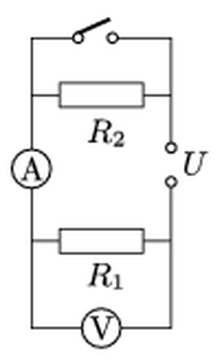
Figure: circuit with R1, R2, switch, ammeter and voltmeter
Answer: (a) $R_{1}=50 Ω$, $R_{2}=25 Ω$
(b) $300 \text{mA}$ and $15 \text{V}$
(c) Switch open: $P_{1}=2 \text{W}$, $P_{2}=1 \text{W}$. Switch closed: $P_{1}=4.5 \text{W}$, $P_{2}=0$.
Solution:
Reading the circuit. Following the wires from the supply terminals:
- current from one terminal passes through $R_{2}$ (or through the switch, which is in parallel with $R_{2}$);
- it then flows through the ammeter and through $R_{1}$ back to the other terminal;
- the voltmeter is connected across $R_{1}$.
So $R_{1}$ and $R_{2}$ are in series, and closing the switch short-circuits $R_{2}$. The meters are taken as ideal.
(a) With the switch open, $I=0.2 \text{A}$ and $U_{1}=10 \text{V}$:
$$R_{1}=\frac{10 \text{V}}{0.2 \text{A}}=50 Ω$$
The rest of the supply voltage falls on $R_{2}$:
$$R_{2}=\frac{15 \text{V}−10 \text{V}}{0.2 \text{A}}=25 Ω$$
(b) With the switch closed, $R_{2}$ is bypassed and the whole $15 \text{V}$ is across $R_{1}$:
$$I=\frac{15 \text{V}}{50 Ω}=0.3 \text{A}=300 \text{mA}$$
The voltmeter reads $15 \text{V}$.
(c) The power in each resistor is $P=UI$.
Switch open:
$$P_{1}=10 \text{V}⋅0.2 \text{A}=2 \text{W}$$
$$P_{2}=5 \text{V}⋅0.2 \text{A}=1 \text{W}$$
Switch closed:
$$P_{1}=15 \text{V}⋅0.3 \text{A}=4.5 \text{W}$$
$$P_{2}=0$$
$R_{2}$ dissipates nothing because it carries no current when it is short-circuited.

Question 44
Source: Sheet 3, Q.159
Two identical discharge lamps are operated from the $230 \text{V}$, $50 \text{Hz}$ mains. Each is connected in series with an inductor, and the two inductors are identical. A capacitor is also connected in series with one of the lamps. This arrangement ensures that when the current through one lamp is at its maximum, the current through the other is at its minimum (zero), and vice versa (anti-stroboscopic connection). The power in each branch is $8 \text{W}$.
What is the total ohmic resistance of a discharge tube and its inductor together during operation? Find the capacitance of the capacitor and the inductance of the coils.
Answer: $R≈3.3 \text{k}Ω$, $L≈10.5 \text{H}$, $C≈0.48 μ\text{F}$
Solution:
Let $R$ be the total ohmic resistance of a lamp plus its inductor. The branch impedances are:
- branch 1: $R$ in series with $L$;
- branch 2: $R$ in series with $L$ and $C$.
Condition 1: equal powers. The two branches have the same $R$ and the same power $P=I^{2}R$, so their currents and their impedances are equal in magnitude:
$$R^{2}+(ωL)^{2}=R^{2}+{\left(ωL−\frac{1}{ωC}\right)}^{2}$$
The reactances must therefore be equal and opposite, $ωL−\frac{1}{ωC}=−ωL$, which gives
$$\frac{1}{ωC}=2ωL$$
Branch 1 is inductive with phase angle $+φ$, and branch 2 is capacitive with $−φ$.
Condition 2: anti-phase maxima. One current is at its maximum when the other is zero, so the currents are $90°$ out of phase. Hence $2φ=90°$ and $φ=45°$, which means
$$ωL=R$$
Power. The impedance of each branch is $Z=\sqrt{2}R$. Then
$$P=I^{2}R=\frac{U^{2}}{2R^{2}}R=\frac{U^{2}}{2R}$$
$$R=\frac{U^{2}}{2P}=\frac{(230 \text{V})^{2}}{16 \text{W}}=3.31×{10}^{3} Ω≈3.3 \text{k}Ω$$
Inductance and capacitance.
$$L=\frac{R}{ω}=\frac{3306 Ω}{314 {\text{s}}^{−1}}=10.5 \text{H}$$
$$C=\frac{1}{2ωR}=\frac{1}{2⋅314 {\text{s}}^{−1}⋅3306 Ω}=4.8×{10}^{−7} \text{F}=0.48 μ\text{F}$$

Question 45
Source: Sheet 3, Q.167
Hollow metal spheres of radii $R$, $2R$ and $3R$ are placed one inside another with a common centre. The inner sphere is given a charge $Q$, the middle one $2Q$, and the outer one $3Q$. Data: $R=10 \text{cm}$, $Q=2×{10}^{−6} \text{C}$.
- Taking the potential at the centre as zero, find the potentials at distances $R$, $2R$, $3R$ and $4R$ from the common centre.
- What is the energy of the electric field in the regions between the spheres and outside the spheres?
Answer: (a) $V(R)=0$, $V(2R)=−\frac{kQ}{2R}=−90 \text{kV}$, $V(3R)=−\frac{kQ}{R}=−180 \text{kV}$, $V(4R)=−\frac{3kQ}{2R}=−270 \text{kV}$
(b) $W_{r<R}=0$, $W_{R\text{–}2R}=\frac{kQ^{2}}{4R}=0.09 \text{J}$, $W_{2R\text{–}3R}=\frac{3kQ^{2}}{4R}=0.27 \text{J}$, $W_{r>3R}=\frac{6kQ^{2}}{R}=2.16 \text{J}$
Solution:
Field. By Gauss’s law, at distance $r$ the field is $E=kq_{\text{enc}}/r^{2}$, where $q_{\text{enc}}$ is the charge enclosed:
Region | Enclosed charge | Field
$r<R$ | $0$ | $0$
$R<r<2R$ | $Q$ | $kQ/r^{2}$
$2R<r<3R$ | $3Q$ | $3kQ/r^{2}$
$r>3R$ | $6Q$ | $6kQ/r^{2}$
In the numbers below, $kQ/R=9×{10}^{9}⋅2×{10}^{−6}/0.1 \text{V}=180 \text{kV}$.
(a) The field points outward, so the potential decreases outward:
$$V(r_{2})=V(r_{1})−\int_{r_{1}}^{r_{2}}{E} dr$$
The field is zero inside the inner sphere, so $V(R)=V(0)=0$. Then
$$V(2R)=0−kQ\left(\frac{1}{R}−\frac{1}{2R}\right)=−\frac{kQ}{2R}=−90 \text{kV}$$
$$V(3R)=V(2R)−3kQ\left(\frac{1}{2R}−\frac{1}{3R}\right)=−\frac{kQ}{R}=−180 \text{kV}$$
$$V(4R)=V(3R)−6kQ\left(\frac{1}{3R}−\frac{1}{4R}\right)=−\frac{3kQ}{2R}=−270 \text{kV}$$
(b) The energy density is $w=\frac{1}{2}ε_{0}E^{2}$. For the field $kq/r^{2}$ in a spherical shell between radii $a$ and $b$:
$$W=\int_{a}^{b}{\frac{1}{2}}ε_{0}\frac{k^{2}q^{2}}{r^{4}} 4πr^{2} dr=\frac{kq^{2}}{2}\left(\frac{1}{a}−\frac{1}{b}\right)$$
Applying this to each region:
- $r<R$: no field, so $W=0$.
- $R<r<2R$: $W=\frac{kQ^{2}}{2}\left(\frac{1}{R}−\frac{1}{2R}\right)=\frac{kQ^{2}}{4R}=0.09 \text{J}$.
- $2R<r<3R$: $W=\frac{9kQ^{2}}{2}\left(\frac{1}{2R}−\frac{1}{3R}\right)=\frac{3kQ^{2}}{4R}=0.27 \text{J}$.
- $r>3R$: $W=\frac{36kQ^{2}}{2}⋅\frac{1}{3R}=\frac{6kQ^{2}}{R}=2.16 \text{J}$.
Here $kQ^{2}/R=9×{10}^{9}⋅4×{10}^{−12}/0.1 \text{J}=0.36 \text{J}$.

Question 46
Source: Sheet 3, Q.170
Which of the points A, B, C and D in the circuit shown in the figure are at the same potential? Between which two points is the potential difference the greatest?
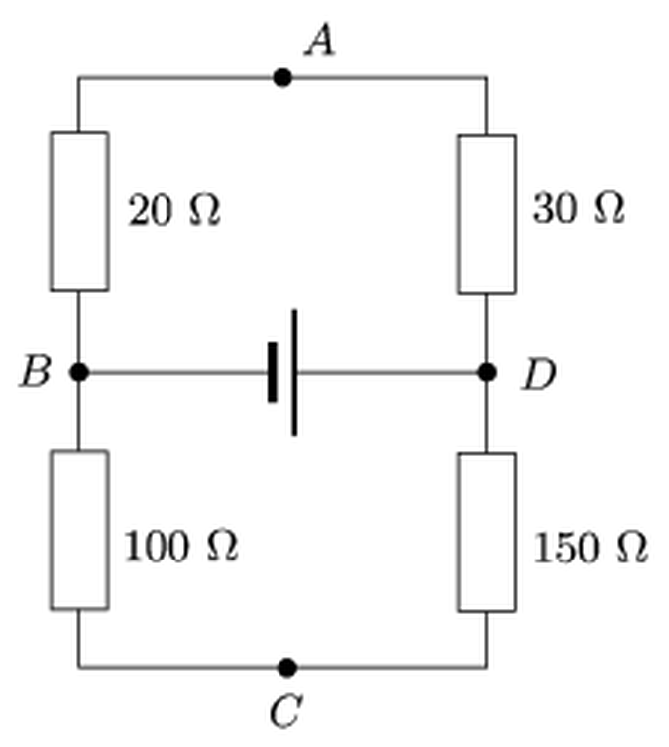
Figure: bridge of 20, 30, 100 and 150 ohm resistors with a battery between B and D
Answer: A and C are at the same potential. The potential difference is greatest between B and D (the full battery voltage).
Solution:
The battery is connected between B and D. Two voltage dividers lie in parallel across it:
- the upper path $B→20 Ω→A→30 Ω→D$;
- the lower path $B→100 Ω→C→150 Ω→D$.
Each divider gets the full battery voltage $U$. In a divider, the voltage splits in proportion to the resistances:
$$V_{B}−V_{A}=\frac{20}{20+30}U=0.4 U$$
$$V_{B}−V_{C}=\frac{100}{100+150}U=0.4 U$$
So $V_{A}=V_{C}$: points A and C are at the same potential. This is the balance condition of a Wheatstone bridge, $20/30=100/150$.
The voltages between the pairs are:
- B and A, or B and C: $0.4 U$;
- A and D, or C and D: $0.6 U$;
- A and C: $0$;
- B and D: $U$, the battery voltage.
The greatest potential difference is between B and D.

Question 47
Source: Sheet 3, Q.174
A point-like body of mass $m$ and charge $Q$ is initially at rest on a horizontal tabletop, as shown in the figure. It is given a vertical upward velocity $v_{0}$. A uniform horizontal electric field $E$ acts on the body. With what speed does the body hit the table when it falls back, and how far from the starting point does it land?
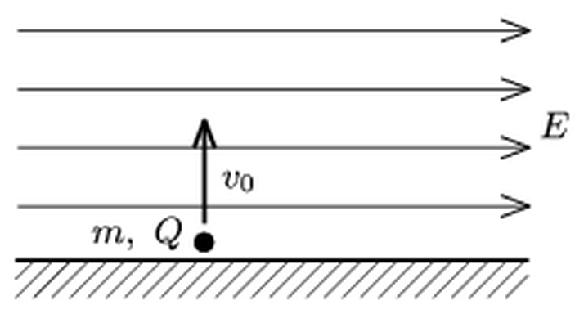
Figure: charged body launched vertically in a horizontal electric field
Answer: $v=v_{0}\sqrt{1+{\left(\frac{2QE}{mg}\right)}^{2}}$ and $s=\frac{2\left|Q\right|Ev_{0}^{2}}{mg^{2}}$
Solution:
Two constant forces act on the body: gravity $mg$ (vertical) and the electric force $QE$ (horizontal). The two directions of motion are independent.
Vertical motion. This is a vertical throw with initial speed $v_{0}$. The body returns to the table after
$$t=\frac{2v_{0}}{g}$$
and its vertical velocity is then $v_{0}$, pointing downward.
Horizontal motion. The body starts from rest horizontally, with constant acceleration
$$a=\frac{QE}{m}$$
At landing, the horizontal displacement is
$$s=\frac{1}{2}at^{2}=\frac{1}{2}\frac{\left|Q\right|E}{m}\frac{4v_{0}^{2}}{g^{2}}=\frac{2\left|Q\right|Ev_{0}^{2}}{mg^{2}}$$
This displacement is in the direction of $\vec{E}$ for positive $Q$ and opposite to it for negative $Q$. The horizontal velocity at landing is
$$v_{x}=at=\frac{2QEv_{0}}{mg}$$
Landing speed.
$$v=\sqrt{v_{0}^{2}+v_{x}^{2}}=v_{0}\sqrt{1+{\left(\frac{2QE}{mg}\right)}^{2}}$$
The same result follows from the work–energy theorem. Gravity does no net work on the round trip, while the electric force does work $\left|Q\right|Es$. Hence $\frac{1}{2}mv^{2}=\frac{1}{2}mv_{0}^{2}+\left|Q\right|Es$.

