Physics Problem Set: Optics
  - Questions, answers and fully worked solutions (from Sheets 1-3)
Each problem is given in the order Question → Answer → Solution. The source sheet and original question number are shown under each heading.

Question 1
Source: Sheet 1, Q.1
A point-like light source rises at a speed of $v=0.8 \text{m/s}$ in a deep lake. The water surface is perfectly calm (no waves). At what rate does the diameter of the bright circle formed on the water surface by the light refracted out of the water change? (The refractive index of water is $n=4/3$.)
Answer: The diameter decreases at a rate of $\frac{2v}{\sqrt{n^{2}−1}}≈1.8 \text{m/s}$.
Solution:
Light can leave the water only where its angle of incidence on the surface is smaller than the critical angle $α_{c}$ of total internal reflection. Rays striking the surface at larger angles are totally reflected back into the water, so the light escapes through a bright circle of radius $r$ centred directly above the source.
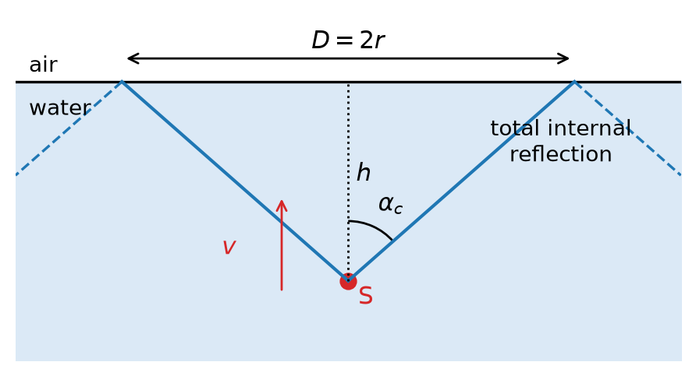
Figure: The light source S at depth h; only rays inside the critical angle leave the water
The critical angle follows from
$$sinα_{c}=\frac{1}{n}=\frac{3}{4}$$
so
$$tanα_{c}=\frac{sinα_{c}}{\sqrt{1−\sin^{2}α_{c}}}=\frac{1}{\sqrt{n^{2}−1}}=\frac{3}{\sqrt{7}}≈1.134$$
If the source is at depth $h$, the diameter of the circle is
$$D=2r=2htanα_{c}$$
The angle $α_{c}$ is constant, so $D$ is proportional to the depth. As the source rises, the depth decreases at the rate $Δh/Δt=−v$. Therefore
$$\frac{ΔD}{Δt}=2tanα_{c} \frac{Δh}{Δt}=−\frac{2v}{\sqrt{n^{2}−1}}$$
Substituting the values:
$$\left|\frac{ΔD}{Δt}\right|=2⋅0.8 \text{m/s}⋅1.134≈1.8 \text{m/s}$$
The bright circle shrinks: its diameter decreases at about $1.8 \text{m/s}$. The rate is constant and does not depend on the depth.

Question 2
Source: Sheet 1, Q.19
Two lenses with a common principal axis are placed $5 \text{cm}$ apart. One is a converging lens with an optical power of $+10$ dioptres and the other is a diverging lens with an optical power of $−5$ dioptres. A small filament lamp is placed $20 \text{cm}$ from the converging lens, on the side away from the diverging lens.
Where should the screen be placed to get a sharp image of the filament on it?
Where will the image be if the lamp is moved closer to the converging lens by one-sixth of the initial $20 \text{cm}$ distance?
Answer: The screen should be $60 \text{cm}$ behind the diverging lens. In the second case the light leaves the system as a parallel beam, so the image is at infinity and no image can be caught on a screen.
Solution:
We apply the thin-lens equation $\frac{1}{f}=\frac{1}{t}+\frac{1}{k}$ to each lens in turn. Here $t$ is the object distance, $k$ is the image distance, and a virtual object has a negative $t$. The image formed by the first lens is the object for the second lens.
Focal lengths:
$$f_{1}=\frac{1}{10 \text{D}}=10 \text{cm}, f_{2}=\frac{1}{−5 \text{D}}=−20 \text{cm}$$
First case. The converging lens images the lamp ($t_{1}=20 \text{cm}=2f_{1}$) at
$$k_{1}=\frac{f_{1}t_{1}}{t_{1}−f_{1}}=\frac{10⋅20}{20−10} \text{cm}=20 \text{cm}$$
which is behind $L_{1}$. The diverging lens lies only $5 \text{cm}$ behind $L_{1}$, so the converging rays reach $L_{2}$ before they meet. The intermediate image $I_{1}$ therefore acts as a virtual object $15 \text{cm}$ beyond $L_{2}$, so $t_{2}=−15 \text{cm}$:
$$\frac{1}{k_{2}}=\frac{1}{f_{2}}−\frac{1}{t_{2}}=−\frac{1}{20 \text{cm}}+\frac{1}{15 \text{cm}}=\frac{1}{60 \text{cm}}$$
$$k_{2}=60 \text{cm}$$
The final image is real, and the screen must be placed $60 \text{cm}$ behind the diverging lens, which is $65 \text{cm}$ from the converging lens. The total magnification is $(−1)⋅\frac{60}{15}=−4$, so the image is inverted and four times enlarged.
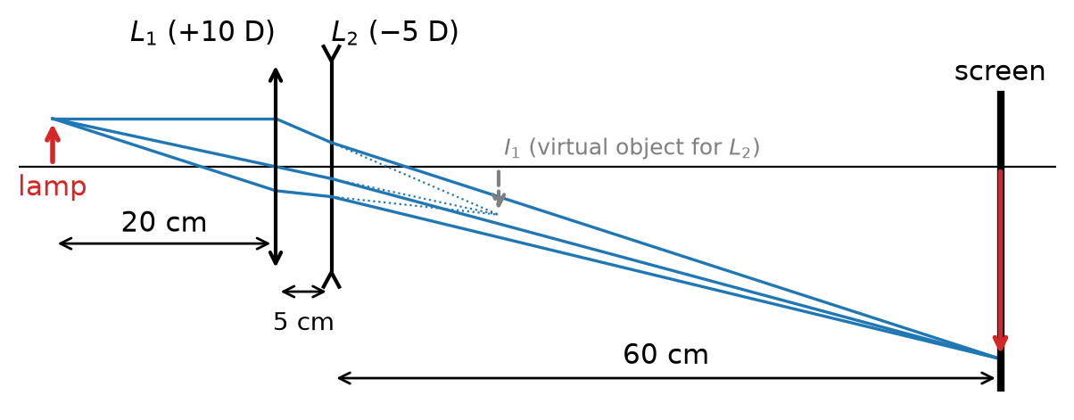
Figure: Ray diagram of the two-lens system in the first case
Second case. The new object distance is
$$t_{1}^{′}=20 \text{cm}−\frac{20 \text{cm}}{6}=\frac{50}{3} \text{cm}≈16.7 \text{cm}$$
$$\frac{1}{k_{1}^{′}}=\frac{1}{10 \text{cm}}−\frac{3}{50 \text{cm}}=\frac{1}{25 \text{cm}}$$
$$k_{1}^{′}=25 \text{cm}$$
This intermediate image lies $25−5=20 \text{cm}$ beyond $L_{2}$, so $t_{2}^{′}=−20 \text{cm}$. That point is exactly the (virtual) focal point of the diverging lens:
$$\frac{1}{k_{2}^{′}}=−\frac{1}{20 \text{cm}}+\frac{1}{20 \text{cm}}=0$$
so $k_{2}^{′}→∞$.
Rays converging towards the focal point of a diverging lens leave it parallel to the axis. The system therefore turns the filament’s light into a parallel beam. The image is at infinity, and no sharp image can be formed on a screen at any finite distance.

Question 3
Source: Sheet 1, Q.29
An object moves with speed $v$ along the principal axis of a converging lens. What is the speed of the image at the moment when the magnification is $N$?
Answer: $v_{\text{image}}=N^{2}v$
Solution:
We use Newton’s form of the lens equation. Let $x$ be the distance of the object from the front focal point and $x^{′}$ the distance of the image from the rear focal point. Then
$$x x^{′}=f^{2}$$
and the magnification is
$$N=\frac{f}{x}=\frac{x^{′}}{f}$$
Now let the object move a small distance $Δx$ along the axis. Since $x^{′}=f^{2}/x$,
$$Δx^{′}=−\frac{f^{2}}{x^{2}} Δx=−N^{2} Δx$$
Dividing by the short time interval $Δt$ gives the relation between the velocities:
$$v_{\text{image}}=\left|\frac{Δx^{′}}{Δt}\right|=N^{2}\left|\frac{Δx}{Δt}\right|=N^{2}v$$
The same result follows from the ordinary lens formula $\frac{1}{o}+\frac{1}{i}=\frac{1}{f}$, where $o$ is the object distance and $i$ the image distance. A small change gives $−\frac{Δo}{o^{2}}−\frac{Δi}{i^{2}}=0$, so $Δi=−\frac{i^{2}}{o^{2}}Δo=−N^{2} Δo$.
The minus sign means that when the object approaches the lens, the image moves away from it. For a real image, which is on the other side of the lens, this means the object and the image move in the same direction along the axis. The longitudinal magnification is the square of the lateral magnification $N$. So a strongly enlarged image moves much faster than the object, and a reduced image moves more slowly.

Question 4
Source: Sheet 2, Q.9
On a sunny day with a cloudless sky, someone noticed an interesting phenomenon. A transparent plastic set square (triangular ruler) was lying on the table next to the window. Looking at it, the observer saw a pattern of coloured bands, similar to the colours of an oil film on wet asphalt.
- Could this be the result of interference between light beams reflected from the top and bottom surfaces of the ruler, as with the oil film?
- If not, what is the explanation?
Answer: (a) No. The ruler is millimetres thick, far too thick for thin-film interference colours with white light.
(b) The ruler is birefringent because of internal stresses frozen in during manufacture. Partially polarized light (skylight, light reflected near the Brewster angle) passes through it, and the light reaching the eye is again partly polarized by reflection. The result is chromatic polarization (photoelastic colours).
Solution:
(a) An oil film shows colours because it is very thin, typically a few hundred nanometres. The path difference between the beams reflected from its two surfaces is then only a few wavelengths. For a given thickness, only some wavelengths interfere constructively, so a definite colour appears.
A plastic ruler is about $d≈2 \text{mm}$ thick. The path difference is about $2nd≈6 \text{mm}$, which is roughly ${10}^{4}$ wavelengths of visible light. This has two consequences:
- Within the visible range, an enormous number of wavelengths satisfy the maximum condition and just as many satisfy the minimum condition. The maxima and minima of neighbouring colours mix completely, and the reflected light looks white.
- The coherence length of sunlight is only about a micrometre, so the two reflected beams are not even coherent with each other.
Thin-film interference is therefore impossible here.
(b) Set squares are made by injection moulding. As the plastic cools quickly, mechanical stresses are frozen into it. A stressed transparent plastic becomes optically anisotropic (birefringent): light polarized in two perpendicular directions travels through it at different speeds. This is the photoelastic effect.
Two polarizing elements are needed to see colours, and nature provides both here:
- Light from the blue sky is strongly partially polarized because it is produced by scattering (Rayleigh scattering).
- Light reflected from the table or from the ruler’s surface at an oblique angle, near the Brewster angle, is also polarized. This acts as the analyser.
Inside the ruler, the two polarization components acquire a phase difference that depends on the local stress, the thickness and the wavelength. After the analyser, some wavelengths are suppressed and others are transmitted, depending on position. The result is coloured bands that follow the stress pattern of the ruler. This effect is called chromatic polarization. The colour sequence resembles that of thin films because, in both cases, a path difference that depends on wavelength removes certain colours from white light.

Question 5
Source: Sheet 2, Q.20
An object of height $2 \text{cm}$ is placed $40 \text{cm}$ from a glass lens, close to its principal axis. The lens forms an image of height $2 \text{cm}$. What will the size and nature of the image be if the lens and the object, in the same arrangement, are immersed in water? The refractive index of the lens is $1.5$ and that of water is $1.33$.
Answer: In water the image is virtual, upright and about $4.1 \text{cm}$ ($≈4 \text{cm}$) high, located about $82 \text{cm}$ from the lens on the same side as the object.
Solution:
Lens in air. The image is the same size as the object. A virtual image could only have magnification 1 if the object were at the lens itself. So the image is real and inverted with magnification $−1$, which happens when the object is at twice the focal length:
$$t=2f⇒f_{\text{air}}=20 \text{cm}$$
Lens in water. By the lensmaker’s formula, the focal length depends on the refractive index of the lens relative to its surroundings. The curvatures $\frac{1}{R_{1}}+\frac{1}{R_{2}}$ stay the same:
$$\frac{1}{f}=\left(\frac{n_{\text{lens}}}{n_{\text{medium}}}−1\right)\left(\frac{1}{R_{1}}+\frac{1}{R_{2}}\right)$$
Taking the ratio of the two cases:
$$\frac{f_{\text{water}}}{f_{\text{air}}}=\frac{n_{\text{lens}}−1}{\frac{n_{\text{lens}}}{n_{\text{water}}}−1}=\frac{0.5}{\frac{1.5}{1.33}−1}=\frac{0.5}{0.128}≈3.91$$
$$f_{\text{water}}≈3.91⋅20 \text{cm}≈78.2 \text{cm}$$
The lens is still converging but much weaker. The object at $t=40 \text{cm}$ is now inside the focal length, so the lens acts as a magnifying glass:
$$\frac{1}{k}=\frac{1}{f_{\text{water}}}−\frac{1}{t}=\frac{1}{78.2 \text{cm}}−\frac{1}{40 \text{cm}}$$
$$k≈−81.8 \text{cm}$$
The negative image distance means the image is virtual and on the same side as the object. The magnification is
$$N=\frac{\left|k\right|}{t}=\frac{81.8}{40}≈2.05$$
so the image height is
$$K=N⋅T≈2.05⋅2 \text{cm}≈4.1 \text{cm}$$
In water the lens therefore produces a virtual, upright, enlarged image about $4 \text{cm}$ high.

Question 6
Source: Sheet 2, Q.33
One of the spectral lines of a star has a measured wavelength of $591.26 \text{nm}$. The wavelength of the same line measured in the laboratory is $592.00 \text{nm}$.
- Is the star moving towards us or away from us?
- At what rate is the distance between the star and us changing?
Answer: (a) The star is approaching us (blue shift).
(b) The distance decreases at about $3.75×{10}^{5} \text{m/s}=375 \text{km/s}$, which is $0.125\%$ of the speed of light.
Solution:
(a) The observed wavelength is shorter than the laboratory value, so the line is shifted towards the blue end of the spectrum. By the Doppler effect, a blue shift means the source is approaching the observer. The star is moving towards us, or more precisely, the radial component of its velocity points towards us.
(b) The speed is much smaller than $c$, so the classical Doppler formula for light is accurate enough:
$$\frac{Δλ}{λ_{0}}=\frac{λ−λ_{0}}{λ_{0}}=−\frac{v_{r}}{c}$$
$$\frac{Δλ}{λ_{0}}=\frac{591.26 \text{nm}−592.00 \text{nm}}{592.00 \text{nm}}=−1.25×{10}^{−3}$$
$$v_{r}=1.25×{10}^{−3}⋅3.00×{10}^{8} \text{m/s}=3.75×{10}^{5} \text{m/s}$$
As a check, we use the relativistic formula $\frac{λ}{λ_{0}}=\sqrt{\frac{1−β}{1+β}}$. Solving it for $β$ gives
$$β=\frac{1−(λ/λ_{0})^{2}}{1+(λ/λ_{0})^{2}}≈1.2508×{10}^{−3}$$
This is practically the same result. The distance between the star and the Earth decreases at about $375 \text{km/s}$, which is $0.125\%$ of the speed of light. Only the radial component of the star’s velocity (along the line of sight) can be determined this way.

Question 7
Source: Sheet 3, Q.59
Why do transparent objects, such as glasses, cast shadows?
Answer: Not all of the incident light passes straight through. Part of it is reflected or absorbed, and the transmitted part is refracted. How much is transmitted, and in which direction, depends strongly on the angle of incidence. This varies across a curved object, so some places behind it receive less light (shadow, dark edges) and others receive more (bright caustic lines).
Solution:
When light reaches the surface of a transparent body, it splits into three parts:
- a reflected part (about $4\%$ for glass at normal incidence, and much more at oblique incidence, up to $100\%$ at grazing incidence);
- a refracted part that enters the body;
- a part that is absorbed in the material (small for clear glass, but not zero; tinted glass absorbs more).
So behind a glass, less light arrives from the region it covers than from the surroundings. The glass casts a faint shadow.
The more important effect is refraction. A drinking glass has curved walls and edges, so the angle of incidence changes from point to point:
- At the edges and steep side walls, light arrives at grazing angles. A large fraction is reflected there, and some is totally internally reflected inside the glass wall. Little light gets through in these directions, so the outline of the glass appears as a dark rim in the shadow.
- The refracting surfaces act like weak lenses and prisms. They redirect the transmitted light, so some areas behind the glass receive less light than they would without it. Other areas, where the deflected rays converge, receive more. That is why the shadow of a glass of water has bright lines (caustics) next to darker regions.
A transparent object therefore does not block the light, but it redistributes it unevenly, and that pattern is what we see as its shadow.

Question 8
Source: Sheet 3, Q.87
We can see clearly through the glass of an ordinary window. What happens when the glass cracks? The crack is noticed immediately. What is the reason?
Answer: A crack creates a thin air gap inside the glass with two new glass–air interfaces. These surfaces are roughly perpendicular to the pane, so light reaches them at large angles of incidence. They reflect a large part of the light, often by total internal reflection, and the rough crack edges scatter light. The crack therefore shows up as a bright or dark line.
Solution:
An intact window pane is optically homogeneous. Light crosses only two parallel glass surfaces at nearly normal incidence. Each surface reflects only about $4\%$, and the transmitted rays are merely shifted slightly sideways, so the view is undistorted.
A crack is a very thin air layer inside the glass. It creates two new glass–air boundaries, and it has a very different geometry from the faces of the pane:
- The crack surface runs roughly perpendicular to the pane, more or less parallel to the light passing through. Light meets it at a large (grazing) angle of incidence.
- At large angles of incidence, reflection at a glass–air boundary is strong. If the angle inside the glass exceeds the critical angle ($α_{c}=arcsin(1/1.5)≈42°$), the light is totally reflected. The crack therefore acts like a mirror inside the glass.
- The crack surfaces and edges are rough and irregular, so they also scatter light in all directions.
As a result, light coming from behind the crack in the viewing direction is sent elsewhere. Light from other directions (for example from the bright sky) is reflected or scattered into the eye. Depending on the lighting, the crack looks like a sharp bright or dark line that stands out strongly from the uniformly transparent glass.

Question 9
Source: Sheet 3, Q.115
A cat walks carefully towards a plane mirror at a speed of $1 \text{m/s}$. To her great surprise, she sees her mirror image moving away from her at $5 \text{m/s}$, instead of approaching as she would expect. What can explain this strange experience?
Answer: The mirror itself is moving away from the cat, in the same direction as the cat’s motion, at $3.5 \text{m/s}$ relative to the ground.
Solution:
Let the $x$-axis point from the cat towards the mirror, with all positions measured relative to the ground. The cat is at $x_{c}$ and the mirror at $x_{m}$. A plane mirror forms the image as far behind it as the object is in front of it:
$$x_{i}=x_{m}+(x_{m}−x_{c})=2x_{m}−x_{c}$$
So the image velocity is
$$v_{i}=2v_{m}−v_{c}$$
and the velocity of the image relative to the cat is
$$v_{i}−v_{c}=2 (v_{m}−v_{c})$$
If the mirror were at rest ($v_{m}=0$), the image would approach the cat at $2 \text{m/s}$. That is what the cat expects.
The cat actually walks at $v_{c}=1 \text{m/s}$ (relative to the ground) and sees the image recede at $5 \text{m/s}$, so $v_{i}−v_{c}=+5 \text{m/s}$:
$$2 (v_{m}−1 \text{m/s})=5 \text{m/s}$$
$$v_{m}=3.5 \text{m/s}$$
The explanation is that the mirror is not at rest. It moves away from the cat, in the direction of the cat’s walking, at $3.5 \text{m/s}$ relative to the ground. For example, it could be fixed to a vehicle or held by someone walking backwards. The mirror moves away from the cat at $2.5 \text{m/s}$, so the image, which recedes twice as fast relative to the cat, moves away at $5 \text{m/s}$. Relative to the ground, the image moves at $2⋅3.5−1=6 \text{m/s}$.
Note: the original sheet’s answer is garbled and omits the numerical value of the mirror’s speed.

Question 10
Source: Sheet 3, Q.123
A strongly short-sighted man wore glasses of power $−12$ dioptres for both eyes, with the lenses $2 \text{cm}$ from his eyes. In a cataract operation, plastic lenses were implanted in his eyes. With these he can now see a book held $25 \text{cm}$ from his eyes sharply. He is surprised that he now sees not only better than before, but also sees the book and the letters larger than he did with his glasses.
- How many times larger does he now see objects $25 \text{cm}$ from his eyes, compared with how he saw objects $25 \text{cm}$ from his glasses before the operation?
- What power of glasses (in dioptres) does he need to see the Moon sharply?
Answer: (a) About $1.3$ times larger ($33/25≈1.32$).
(b) About $−4.3$ dioptres, i.e. roughly $−4$ dioptres.
Solution:
The apparent size of an object is set by the visual angle it subtends at the eye, which is approximately $θ≈\text{size}/\text{distance}$ for small angles.
(a) Before the operation. The glasses have focal length $f=\frac{1}{−12 \text{D}}≈−8.33 \text{cm}$. For an object $T=25 \text{cm}$ in front of the glasses, the image distance is
$$\frac{1}{k}=\frac{1}{f}−\frac{1}{T}=−12 \text{D}−4 \text{D}=−16 \text{D}$$
$$k=−6.25 \text{cm}$$
The image is virtual, $6.25 \text{cm}$ in front of the glasses, which is $6.25+2=8.25 \text{cm}$ from the eye. Its size is
$$h^{′}=h \frac{\left|k\right|}{T}=h \frac{6.25}{25}=0.25 h$$
so the visual angle was
$$θ_{\text{before}}=\frac{0.25 h}{8.25 \text{cm}}=\frac{h}{33 \text{cm}}$$
After the operation. He looks at the object directly from $25 \text{cm}$:
$$θ_{\text{after}}=\frac{h}{25 \text{cm}}$$
The ratio is
$$\frac{θ_{\text{after}}}{θ_{\text{before}}}=\frac{33}{25}≈1.32$$
He sees things about $1.3$ times larger than before. The strong diverging glasses, held in front of the eye, made everything look smaller.
(b) The implanted plastic lens cannot accommodate, so his eye is now sharply focused only at $25 \text{cm}$. That is now his far point. To see the Moon, which is effectively at infinity, the glasses must form a virtual image of very distant objects at that far point. The far point is $25−2=23 \text{cm}$ from the glasses, so the required focal length is $f=−23 \text{cm}$:
$$D=\frac{1}{f}=\frac{1}{−0.23 \text{m}}≈−4.3 \text{D}$$
If we neglect the $2 \text{cm}$ distance between the glasses and the eye, the value is $−4$ dioptres. He needs glasses of about $−4$ dioptres.
Note: the original sheet’s answer to (a) is missing its numerical value.

Question 11
Source: Sheet 3, Q.132
A candle burns inside a vertical cylinder standing on a table. The inner wall of the cylinder is a mirror. The cylinder is $30 \text{cm}$ high and $12 \text{cm}$ in diameter. The centre of the candle flame is at a height of $14 \text{cm}$, $2 \text{cm}$ from the axis of the cylinder. From which direction, looking in over the top of the cylinder, can you see an image of the flame that is three times wider than the flame?
Answer: Look in the vertical plane through the axis and the flame, from the side farther from the flame. Look downwards at $45°$ below the horizontal, just over the near rim, towards the part of the wall nearest the flame. There you see the flame three times wider.
Solution:
The cylindrical mirror is curved only horizontally. In the vertical direction it behaves as a plane mirror and gives no magnification, while horizontally it is a concave mirror. A cylindrical surface reflects the horizontal projection of every ray exactly as a circular mirror in the plane would. So the width of the image can be found from a top view, and the direction of viewing from a vertical section.
Horizontal magnification (top view). The cross-section is a concave mirror of radius $R=6 \text{cm}$ and focal length $f=R/2=3 \text{cm}$. The flame C is $2 \text{cm}$ from the axis, so the nearest part of the wall is $t_{1}=6−2=4 \text{cm}$ away and the farthest part is $t_{2}=6+2=8 \text{cm}$ away.
Near wall:
$$\frac{1}{k_{1}}=\frac{1}{3 \text{cm}}−\frac{1}{4 \text{cm}}=\frac{1}{12 \text{cm}}$$
$$k_{1}=12 \text{cm}, N_{1}=\frac{k_{1}}{t_{1}}=3$$
Far wall:
$$k_{2}=\frac{3⋅8}{8−3} \text{cm}=4.8 \text{cm}, N_{2}=0.6$$
So the three-times-wider (horizontally inverted) image comes from the part of the wall nearest the flame. Its projection C’ lies $12 \text{cm}$ from that wall, which is exactly at the opposite wall (at the rim on the observer’s side).
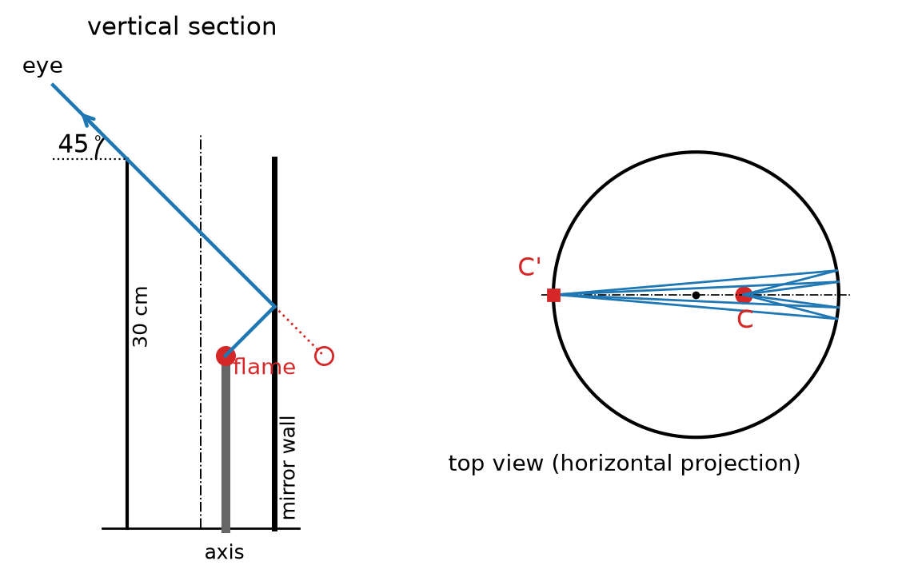
Figure: Vertical section through the axis and the flame (left) and top view (right)
Direction of viewing (vertical section). In the vertical plane through the axis and the flame, the wall acts as a plane mirror. The mirror image of the flame is $4 \text{cm}$ behind the near wall, i.e. $10 \text{cm}$ from the axis at a height of $14 \text{cm}$. The reflected rays must get out over the opposite rim, which is $6 \text{cm}$ from the axis on the other side at a height of $30 \text{cm}$. From the mirror image to this rim:
$$Δx=10+6=16 \text{cm}, Δz=30−14=16 \text{cm}$$
so
$$tanφ=\frac{Δz}{Δx}=1⇒φ=45°$$
This ray strikes the wall at a height of $14+4=18 \text{cm}$, which is well within the mirror. The emerging ray points upwards at $45°$, just grazing the rim on the observer’s side.
The observer must therefore stand on the side opposite the flame, in the vertical plane through the axis and the flame. Looking down at $45°$ below the horizontal, just over the near rim, they see the reflection of the flame from the opposite (nearest-to-flame) part of the wall, three times wider than the flame itself.

Question 12
Source: Sheet 3, Q.141
The base of a glass prism is an isosceles triangle. The angle between the two equal sides is $40°$, and the refractive index of the glass is $1.5$. At what angle of incidence must a light beam strike one of the two equal faces so that the refracted ray inside the prism is parallel to the base of the triangle? What is the answer if the prism is placed in water (refractive index $1.33$) or in benzene (refractive index $1.6$)?
Answer: In air $30.9°$; in water $22.7°$; in benzene $18.7°$.
Solution:
Geometry. The base is perpendicular to the symmetry axis of the isosceles triangle. A ray parallel to the base is therefore perpendicular to the bisector of the apex angle $A=40°$. Each equal face makes an angle of $A/2=20°$ with the bisector, so the face normal makes $20°$ with the ray. The refraction angle inside the prism is
$$β=\frac{A}{2}=20°$$
This is the symmetric path, which also gives minimum deviation.
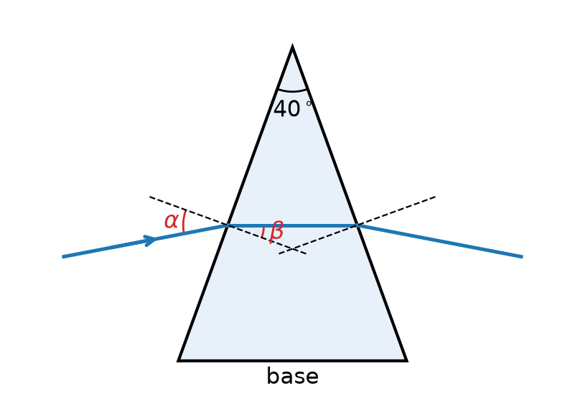
Figure: Ray passing through the prism parallel to its base
Snell’s law at the entrance face, with surrounding medium $n_{0}$ and glass $n=1.5$:
$$n_{0}sinα=nsinβ$$
$$sinα=\frac{n}{n_{0}}sin20°=\frac{1.5⋅0.342}{n_{0}}$$
In air ($n_{0}=1$):
$$sinα=0.513⇒α≈30.9°$$
In water ($n_{0}=1.33$):
$$sinα=\frac{0.513}{1.33}=0.386⇒α≈22.7°$$
In benzene ($n_{0}=1.6$):
$$sinα=\frac{0.513}{1.6}=0.321⇒α≈18.7°$$
In benzene the glass is optically less dense than its surroundings ($n<n_{0}$). The ray then bends away from the normal on entering, so $α<β$ would be expected, and indeed $18.7°<20°$. In air and water the glass is denser, so $α>β$.

Question 13
Source: Sheet 3, Q.144
What colour is the daytime sky on the Moon? Seen from the Moon, what colour are the Earth and Mars?
Answer: The lunar sky is black even in the daytime, because there is no atmosphere. The Earth looks mainly blue with white clouds. Mars looks reddish (orange-red).
Solution:
The lunar sky. On Earth the daytime sky is blue because air molecules scatter sunlight, and the scattered intensity grows strongly as wavelength decreases (Rayleigh scattering, $I∝1/λ^{4}$). Blue light is scattered most, so the whole sky glows blue. The Moon has practically no atmosphere, so nothing scatters sunlight. Light reaches the eye only from the Sun itself and from objects it illuminates. Every other direction is dark, so the sky is black even in full sunshine, and the stars are visible next to the Sun.
The Earth. Seen from outside, the Earth is mainly blue:
- the oceans, which cover about $70\%$ of the surface, absorb red light and reflect or scatter mostly blue light;
- the atmosphere itself scatters blue light, so the whole disc has a bluish haze.
White cloud bands and patches are superimposed on this, together with brown and green continents. The overall impression is of a bright blue-and-white planet.
Mars. Its surface is covered with dust and rocks rich in iron oxides (rust). These absorb blue and green light and reflect mainly red-orange light. Its thin atmosphere contains fine dust of the same kind. From the Moon, as from the Earth, Mars appears as a reddish (orange-red) point of light.

Question 14
Source: Sheet 3, Q.160
A beam of light passes through a wedge-shaped piece of glass and is deflected by $2°$ from its original direction of travel. The refractive index of the glass is $1.5$. Find the angle between the two faces of the wedge.
Answer: $φ≈4°$
Solution:
A glass wedge with a small angle is a thin prism. For small angles of incidence (near-normal passage), $sinx≈x$, and Snell’s law at both faces gives a deviation that does not depend on the angle of incidence:
$$δ=(n−1) φ$$
Here $φ$ is the angle between the two faces (the refracting angle of the wedge). Solving for $φ$:
$$φ=\frac{δ}{n−1}=\frac{2°}{1.5−1}=4°$$
As a check, the exact minimum-deviation condition is
$$sin\frac{φ+δ}{2}=nsin\frac{φ}{2}$$
With $δ=2°$ this gives $φ=3.997°$, practically the same value.
At more oblique incidence the same wedge deviates the beam somewhat more than this minimum. So a deviation of (at least) $2°$ corresponds to a wedge angle of about $4°$.

Question 15
Source: Sheet 3, Q.168
A light ray travels parallel to the optical axis of a glass sphere of radius $R$. After refraction it leaves the glass exactly at the point where the optical axis intersects the sphere. What is the distance between this ray and the optical axis? (The refractive index is $1.6$.)
Answer: $d=0.96 R$
Solution:
Let the ray enter the sphere at point P and leave at point B, where the axis meets the back of the sphere. Let O be the centre of the sphere. The normal at P is the radius OP. Let $α$ be the angle of incidence and $β$ the angle of refraction.
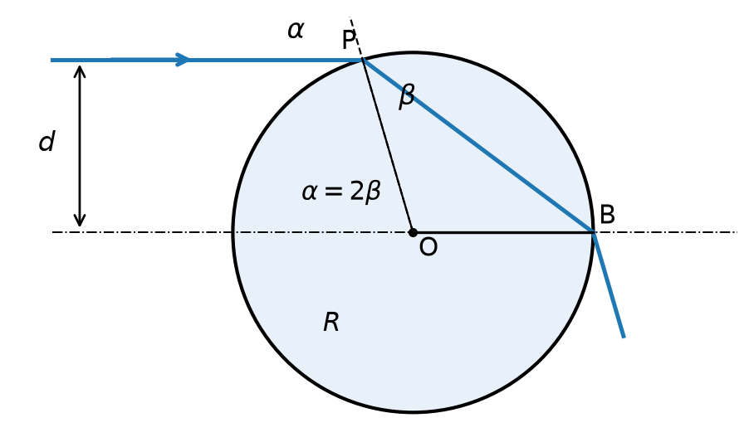
Figure: Ray entering the glass sphere at height d and leaving at the axis point B
Geometry. The incident ray is parallel to the axis. So the radius OP makes the same angle $α$ with the axis at O as it makes with the ray at P (alternate angles). Hence
$$d=Rsinα$$
Triangle OPB is isosceles because $OP=OB=R$, so its angles at P and B are both $β$. The angle $α$ at O, between OP and the axis on the entry side, is an exterior angle of this triangle. It therefore equals the sum of the two opposite interior angles:
$$α=2β$$
Snell’s law at P:
$$sinα=nsinβ$$
$$sin2β=2sinβcosβ=nsinβ$$
$$cosβ=\frac{n}{2}=0.8$$
so $β≈36.9°$ and $α=2β≈73.7°$.
Distance from the axis.
$$d=Rsinα=R⋅2sinβcosβ=R⋅2⋅0.6⋅0.8=0.96 R$$
The ray must travel at a distance of $0.96R$ from the optical axis. A solution exists only when $n<2$; for $n=2$ the ray would be the paraxial one, $d→0$.

