**Section I Use of English**

**Directions:**

**Read the following text. Choose the best word (s) for each numbered blank and mark**

**A, B, C or D on the ANSWER SHEET. (10 points)**

Weighing yourself regularly is a wonderful way to stay aware of any significant weight

fluctuations. 1 ,when done too often, this habit can sometimes hurt more than it 2 .

As for me, weighing myself every day caused me to shift my focus from being generally

healthy and physically active to focusing 3 on the scale. That was bad to my overall fitness

goals. I had gained weight in the form of muscle mass, but thinking only of 4 the number on

the scale, I altered my training program. That conficted with how I needed to train to 5 my

goals.

I also found that weighing myself daily did not provide an accurate 6 of the hard work and

progress I was making in the gym. It takes about three weeks to a month to notice any

significant changes in your weight 7 altering your training program. The most 8 changes will

be observed in skill level,strength and inches lost

For these 9 , I stopped weighing myself every day and switched to a bimonthly weighing

schedule 10 . Since weight loss is not my goal, it is less important for meto_ 11 _ my weight

each week. Weighing every other week allows me to observe and 12 any significant weight

changes. That tells me whether I need to 13 my training program.

I use my bimonthly weigh-in 14 to get information about my nutrition as well. If my

training intensity remains the same, but I'm constantly 15 and dropping weight, this is a 16

that I need to increase my daily caloric intake.

The 17 to stop weighing myself every day has done wonders for my overall health, fitness

and well-being. I'm experiencing increased zeal for working out since I no longer carry the

burden of a 18 morming weigh-in. I've also experienced greater success in achieving my

specific ftness goals, 19 I'm training according to those goals, not the numbers on a scale.

Rather than 20 over the scale, turn your focus to how you look, feel how your clothes fit

and your overall energy level.

1. [A] Besides [B] Therefore [C]Otherwise [D] However

2. [A] helps [B]cares [C]warns [D] reduces

3. [A] initially [B] solely [C] occasionally [D] formally

4. [A] recording [B] lowering [C] explaining [D] accepting

5. [A] modify [B] set [C]review [D] reach

6. [A] definition [B] depiction [C] distribution [D] prediction

7. [A] due to [B]regardless of [C] aside from [D] along with

8. [A] orderly [B] rigid [C] precise [D] immediate

9. [A] claims [B]judgments [C] reasons [D] methods

10. [A] instead [B]though [C]again [D]indeed

11. [A] report [B] share [C] share [D] share

12. [A] depend on [B]approve of [C]hold onto [D]account for

13. [A] prepare [B]share [C]share [D] share

14. [A] results [B]features [C]rules [D]tests

15. [A] bored [B]anxious [C]hungry [D] sick

16. [A] principle [B]secret [C]belief [D]sign

17. [A] request [B]necessity [C]decision [D]wish

18. [A] disappointing [B]surprising [C]restricting [D]consuming

19. [A] if because [B]unless [C]until [D]consuming

20. [A] obsessing [B]dominating [C]puzzling [D]triumphing

**Section II Reading Comprehension**

**Part A**

**Directions:**

**Read the following four texts. Answer the questions below each text by choosing A,**

**B, C or D. Mark your answers on the ANSWER SHEET. (40 points)**

Text 1

Unlike so-called basic emotions such as sadness, fear, and anger, guilt emerges a little

later, in conjunction with a child's growing grasp of social and moral norms. Children aren't

born knowing how to say "I'm sorry"; rather, they learn over time that such statements

appease parents and friends -- and their own consciences. This is why researchers generally

regard so-called moral guilt, in the right amount, to be a good thing.

In the popular imagination, of course, guilt still gets a bad rap. It is deeply uncomfortable-

- it's the emotional equivalent of wearing a jacket weighted with stones. Yet this

understanding is outdated. "There has been a kind of revival or a rethinking about what guilt

is and what role guilt can serve," says Amrisha Vaish, a psychology researcher at the

University of Virginia, adding that this revival is part of a larger recognition that emotions

aren't binary -- feelings that may be advantageous in one context may be harmful in

another. Jealousy and anger, for example, may have evolved to alert us to important

inequalities. Too much happiness can be destructive.

And quilt , by prompting us to think more deeply about our goodness, can encourage

humans to make up for errors and fix relationships. Guilt, in other words, can help hold a

cooperative species together. It is a kind of social glue.

Viewed in this light, guilt is an opportunity. Work by Tina Malti , a psychology professor at

the University of Toronto ,suggests that guilt may compensate for an emotional deficiency. In a

number of studies, Malti and others have shown that guilt and sympathy may represent

different pathways to cooperation and sharing. Some Kids who are low in sympathy may make

up for that shortfall by experiencing more guilt, which can rein in their nastier impulses. And

vice versa : High sympathy can substitute for low guilt.

In a 2014 study, for example, Malti looked at 244 children. Using caregiver assessments

and the children's self-observations, she rated each child's overall sympathy level and his or

her tendency to feel negative emotions after moral transgressions. Then the kids were handed

chocolate coins, and given a chance to share them with an anonymous child. For the low-

sympathy kids, how much they shared appeared to turn on how inclined they were to feel

guilty. The guilt-prone ones share more, even though they hadn't magically become more

sympathetic to the other child's deprivation.

"That's good news," Malti says, "We can be prosocial because we caused harm and

we feel regret."

21. Researchers think that guilt can be a good thing because it may help _______.

A. regulate a child's basic emotions

B. improve a child's intellectual ability

C. foster a child's moral development

D. intensify a child's positive feelings

22. According to Paragraph 2, many people still consider guilt to be _______.

A. deceptive

B. burdensome

C. addictive

D. inexcusable

23. Vaish holds that the rethinking about guilt comes from an awareness that _______.

A. emotions are context-independent

B. emotions are socially constructive

C. emotional stability can benefit health

D. an emotion can play opposing roles

24. Malti and others have shown that cooperation and sharing _______.

A. may help correct emotional deficiencies

B. can result from either sympathy or guilt

C. can bring about emotional satisfaction

D. may be the outcome of impulsive acts

25. The word "transgressions" (Line 4, Para. 5) is closest in meaning to _______.

A. teachings

B. discussions

C. restrictions

D. wrongdoings

Text 2

Forests give us shade, quiet and one of the harder callenges in the fight against climate

change. Even as we humans count on forests to soak up a good share of the carbon dioxide

we produce, we are threatening their ability to do so.The climate change we are hastening

could one day leave us with forests that emit more carbon than they absorb.

Thankfully, there is a way out of this trap - but it involves striking a subtle balance. Helping

forests flourish as valuable "carbon sinks" long into the future may require reducing their

capacity to absorb carbon now. Califormia is leading the way, as it does on so many climate

efforts, in figuring out the details.

The state's proposed Forest Carbon Plan aims to double efforts to thin out young trees

and clear brush in parts of the forest. This temporarily lowers carbon-carrying capacity. But the

remaining trees draw a greater share of the available moisture, so they grow and thrive,

restoring the forest's capacity to pull carbon from the air. Healthy trees are also better able to

fend off insects. The landscape is rendered less easily burnable. Even in the event of a fire,

fewer trees are consumed.

The need for such planning is increasingly urgent. Already, since 2010,drought and insects

have killed over 100 million trees in California, most of them in 2016 alone, and wildfires have

burned hundreds of thousands of acres.

California plans to treat 35,000 acres of forest a year by 2020, and 60,000 by 2030 -

financed from the proceeds of the state' s emissions- permit auctions. That's only a small share

of the total acreage that could benefit, about half a million acres in all, so it will be vital to

prioritize areas at greatest risk of fire or drought.

The strategy also aims to ensure that carbon in woody material removed from the forests

is locked away in the form of solid lumber or burned as biofuel in vehicles that would

otherwise run on fossil fuels. New research on transportation biofuels is already under way.

State governments are well accustomed to managing forests, but traditionally they've

focused on wildlife, watersheds and opportunities for recreation. Only recently have they

come to see the vital part forests will have to play in storing carbon. Califormia's plan, which is

expected to be finalized by the governor next year, should serve as a model.

26. By saying "one of the harder challenges ,"the author implies that_________.

A. global climate change may get out of control

B. people may misunderstand global warming

C. extreme weather conditions may arise

D. forests may become a potential threat

27. To maintain forests as valuable "carbon sinks," we may need to__________.

A. preserve the diversity of species in them

B. accelerate the growth of young trees

C. strike a balance among different plants

D. lower their present carbon-absorbing capacity

28. California's Forest Carbon Plan endeavors to_______.

A. cultivate more drought-resistant trees

B. reduce the density of some of its forests

C. find more effective ways to kill insects

D. restore its forests quickly after wildfires

29.What is essential to California's plan according to Paragraph 5?

A. To handle the areas in serious danger first.

B. To carry it out before the year of 2020.

C. To perfect the emissions-permit auctions.

D. To obtain enough financial support.

30. The author's attitude to California's plan can best be described as________.

A. ambiguous

B. tolerant

C. supportive

D. cautious

Text 3

American farmers have been complaining of labor shortages for several years now. Given

a multi-year decline in illegal immigration, and a similarly sustained pickup in the U.S. job

market, the complaints are unlikely to stop without an overhaul of immigration rules for farm

workers.

Efforts to create a more straightforward agricultural-workers visa that would enable

foreign workers to stay longer in the U.S. and change jobs within the industry have so far

failed in Congress. If this doesn't change, American businesses, communities and consumers

will be the losers.

Perhaps half of U.S. farm laborers are undocumented immigrants. As fewer such workers

enter the U.S., the characteristics of the agricultural workforce are changing. Today's farm

laborers, while still predominantly born in Mexico, are more likely to be settled, rather than

migrating, and more likely to be married than single. They are also aging. At the start of this

century, about one-third of crop workers were over the age of 35. Now, more than half are.

And crop picking is hard on older bodies.One oft-debated cure for this labor shortage remains

as implausible as it has been all along: Native U.S. workers won't be returning to the farm.

Mechanization is not the answer either — not yet at least. Production of corn, cotton, rice,

soybeans and wheat have been largely mechanized, but many high-value, labor-intensive

crops, such as strawberries, need labor. Even dairy farms, where robots currently do only a

small share of milking, have a long way to go before they are automated.

As a result, farms have grown increasingly reliant on temporary guest workers using the

H-2A visa to fill the gaps in the agricultural workforce. Starting around 2012, requests for the

visas rose sharply; from 2011 to 2016 the number of visas issued more than doubled.

The H-2A visa has no numerical cap, unlike the H-2B visa for nonagricultural work, which

is limited to 66,000 annually. Even so, employers frequently complain that they aren't allotted

all the workers they need. The process is cumbersome, expensive and unreliable. One survey

found that bureaucratic delays led H-2A workers to arrive on the job an average of 22 days

late. And the shortage is compounded by federal immigration raids, which remove some

workers and drive others underground.

In a 2012 survey ，71 percent of tree-fruit growers and nearly 80 percent of raisin and

berry growers said they were short of labor. Some western growers have responded by

moving operations to Mexico. From 1998-2000, 14.5 percent of the fruit Americans consumed

was imported. Little more than a decade later, the share of imported fruit had increased to

25.8 percent.

In effect, the U.S. can import food or it can import the workers who pick it.

31.What problem should be addressed according to the first two paragraphs?

A.Discrimination against foreign workers in the U.S.

B.Biased laws in favor of some American businesses.

C.Flaws in U.S. immigration rules for farm workers.

D. Decline of job opportunities in U.S. agriculture.

32. One trouble with U.S. agricultural workforce is_______.

A.the rising number of illegal immigrants

B.the high mobility of crop workers

C.the lack of experienced laborers

D.the aging of immigrant farm workers

33. What is the much-argued solution to the labor shortage in U.S. farming?

A. To attract younger laborers to farm work.

B. To get native U.S. workers back to farming.

C. To use more robots to grow high-value crops.

D. To strengthen financial support for farmers.

34. Agricultural employers complain about the H-2A visa for its ___.

A. slow granting procedures

B. limit on duration of stay

C. tightened requirements

D. control of annual admissions

35.Which of the following could be the best title for this text?

A. U.S. Agriculture in Decline?

B. Import Food or Labor?

C. America Saved by Mexico?

D. Manpower vs. Automation?

Text 4

Amold Schwarzenegger, Dia Mirza and Adrian Grenier have a message for you: It's easy to

beat plastic. They're part of a bunch of celebrities starring in a new video for World

Environment Day — encouraging you, the consumer, to swap out your single-use plastic

staples like straws and cutlery to combat the plastics crisis.

The key messages that have been put together for World Environment Day do include a

call for governments to enact legislation to curb single-use plastics. But the overarching

message is directed at individuals.

My concern with leaving it up to the individual, however, is our limited sense of what

needs to be achieved. On their own, taking our own bags to the grocery store or quitting

plastic straws, for example, will accomplish little and require very little of us. They could even

be detrimental, satisfying a need to have "done our bit" without ever progressing onto bigger,

bolder, more effective actions — a kind of "moral licensing" that allays our concerns and stops

us doing more and asking more of those in charge.

While the conversation around our environment and our responsibility toward it remains

centered on shopping bags and straws, we're ignoring the balance of power that implies that

as "consumers" we must shop sustainably, rather than as "citizens" hold our governments and

industries to account to push for real systemic change.

It's important to acknowledge that the environment isn't everyone's priority - or even

most people's. We shouldn't expect it to be. In her latest book, Why Good People Do Bad

Environmental Things, Wellesley College professor Elizabeth R. DeSombre argues that the best

way to collectively change the behavior of large numbers of people is for the change to be

structural.

This might mean implementing policy such as a plastic tax that adds a cost to

environmentally problematic action, or banning single-use plastics altogether. India has just

announced it will "eliminate all single-use plastic in the country by 2022." There are also

incentive-based ways of making better environmental choices easier, such as ensuring

recycling is at least as easy as trash disposal.

DeSombre isn't saying people should stop caring about the environment. It's just that

individual actions are too slow, she says, for that to be the only, or even primary, approach to

changing widespread behavior.

None of this is about writing off the individual. It's just about putting things into

perspective. We don't have time to wait. We need progressive policies that shape collective

action (and rein in polluting businesses), alongside engaged citizens pushing for change.

36. Some celebrities star in a new video to

A. demand new laws on the use of plastics

B. urge consumers to cut the use of plastics

C. invite public opinion on the plastics crisis

D. disclose the causes of the plastics crisis

37. The author is concerned that "moral licensing" may

A. mislead us into doing worthless things

B. prevent us from making further efforts

C. weaken our sense of accomplishment

D. suppress our desire for success

38. By pointing out our identity as "citizens,",the author indicates that

A: our focus should be shifted to community welfare

B: our relationship with local industries is improving

C: We have been actively exercising our civil rights

D: We should press our government to lead the combat

39. DeSombre argues that the best way for a collective change should be

A: a win-win arrangement

B: a self-driven mechanism

C: a cost-effective approach

D: a top down process

40. The author concludes that individual efforts

A: can be too aggressive

B: can be too inconsistent

C: are far from sufficient

D: are far from rational

**Part B**

**Directions:**

**You are going to read a list of headings and a text. Choose the most suitable heading**

**from the list A-G for each numbered paragraph (41-45). Mark your answers on the**

**ANSWER SHEET. (10 points)**

Five ways to make conversation with anyone

In choosing a new home, Camille McClain's kids have a single demand: a backyard.

McClain's little ones aren't the only kids who have an opinion when it comes to

housing, and in many cases youngsters' views weigh heavily on parents' real estate

decisions, according to a 2018 Harris Poll survey of more than 2,000 U.S. adults.

While more families buck an older-generation proclivity to leave kids in the dark about

real estate decisions, realty agents and psychologists have mixed views about the financial,

personal and long-term effects kids' opinions may have.

The idea of involving children in a big decision is a great idea because it can help them

feel a sense of control and ownership in what can be an overwhelming process, said Ryan

Hooper, a clinical psychologist in Chicago.

"Children may face serious difficulties in coping with significant moves, especially if it

removes them from their current school or support system," he said.

Greg Jaroszewski, a real estate brokers with Gagliardo Realty Associates, said he's not

convinced that kids should be involved in selecting a home --- but their opinions should be

considered in regards to proximity to friends and social activities, if possible.

Younger children should feel like they're choosing their home --- without actually

getting a choice in the matter, said Adam Bailey, a real estate attorney based in New York.

Asking them questions about what they like about the backyard of a potential home will

make them feel like they're being included in the decision-making process, Bailey said.

Many of the aspects of homebuying aren't a consideration for children, said Tracey

Hampson, a real estate agent based in Santa Clarita, Calif. And placing too much emphasis on

their opinions can ruin a fantastic home purchase.

"Speaking with your children before you make a real estate decision is wise, but I

wouldn't base the purchasing decision solely on their opinions." Hampson said.

The other issue is that many children - especially older ones - may base their real estate

knowledge on HGTV shows, said Aaron Norris of The Norris Group in Riverside ,Calif .

"They love Chip and Joanna Gaines just as much as the rest of us," he said. "HGTV has

seriously changed how people view real estate. It's not shelter , it's a lifestyle. With that

mindset change come some serious money consequences."

Kids tend to get stuck in the features and the immediate benefits to them personally,

Norris said.

Parents need to remind their children that their needs and desires may change over time,

said Julie Gurner, a real estate analyst with FitSmallBusiness.com.

"Their opinions can change tomorrow," Gurner said. "Harsh as it may be to say, that

decision should likely not be made contingent on a child's opinions, but rather made for

them with great consideration into what home can meet their needs best - and give them an

opportunity to customize it a bit and make it their own."

This advice is more relevant now than ever before, even as more parents want to embrace

the ideas of their children, despite the current housing crunch.

A. remarks that significant moves may pose challenges to children.

A. remarks that significant moves may pose challenges to children.

41. Ryan Hooper B. says that it is wise to leave kids in the dark about real estate decisions.

42. Adam Bailey C. advises that home purchases should not be based only on children's opinions.

43. Tracey Hampson

44. Aaron Norris

45. Julie Gurner

D. thinks that children should be given a sense of involvement in homebuying decisions.

E. notes that aspects like children's friends and social activities should be considered upon homebuying.

F. believes that homebuying decisions should be based on children's needs

rather than their opinions.

G. assumes that many children's views on real estate are influenced by the media.

**Section III Translation**

**46.Directions:**

**Translate the following text into Chinese. Write your translation neatly on the**

**ANSWER SHEET. (15 points)**

It is easy to underestimate English writer James Heriot. He had such a pleasant, readable

style that one might think that anyone could imitate it. How many times have I heard people

say "I could write a book. I just haven't the time." Easily said. Not so easily done. James Herriot,

contrary to popular opinion, did not find it easy in his early days of, as he put it,"having a go

at the writing game". While he obviously had an abundance of natural talent, the final,

polished work that he gave to the world was the result of years of practising. re-writing and

reading. Like the majority of authors, he had to suffer many disappointments and rejections

along the way, but these made him all the more determined to succeed. Everything he

achieved in life was earned the hard way and his success in the literary field was no exception.

**Section IV Writing**

**Part A**

47、Directions：Suppose you have to cancel your travel plan and will not be able to visit

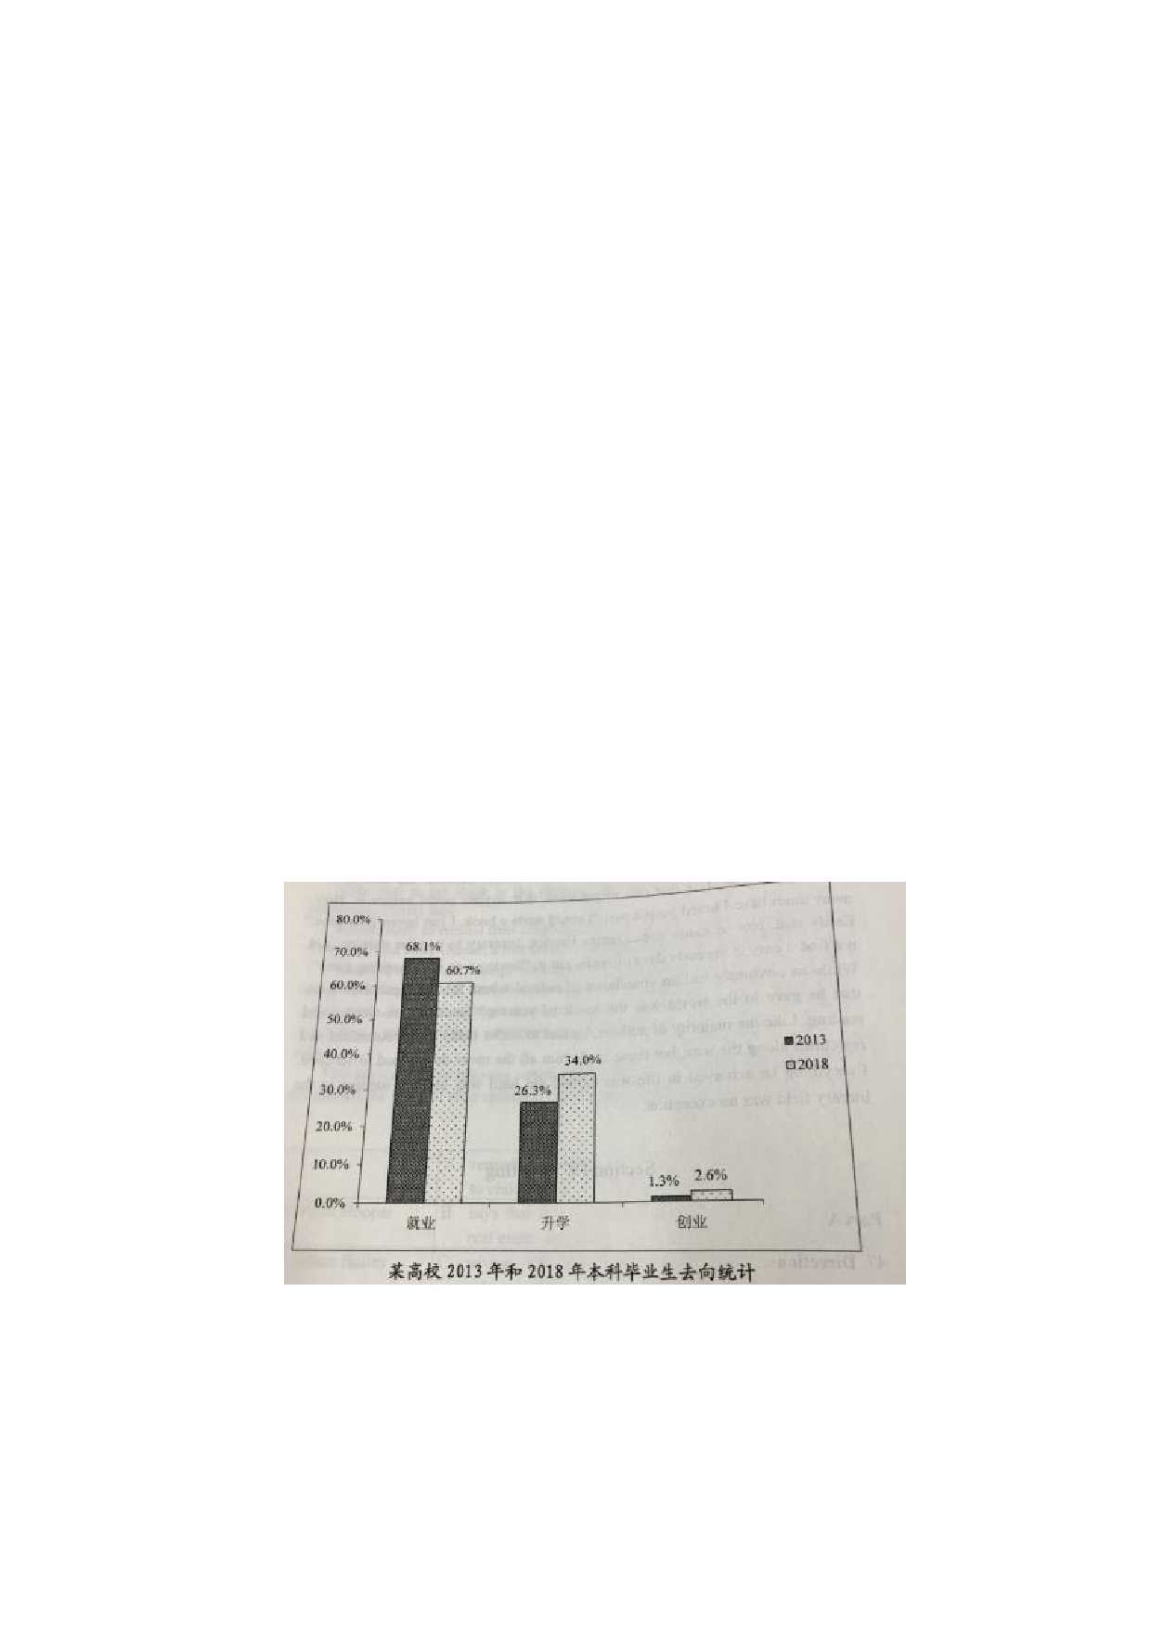professor Smith, write him an email to

Suppose Professor Smith asked you to plan a debate on the theme of city traffic. Write

him an email to

1) suggest a specific topic with your reasons, and

2) tell him about your arrangements.

You should write about 100 words on the ANSWER SHETE.

Do not use your own name. Use "Li Ming" instead (10points)

**Part B**

48、Directions：Write an essay based on the chart below. In your writing , you should

1) interpret the chart, and

2) give your comments

You should write about 150 words on the ANSWER SHEET.(15 points)