

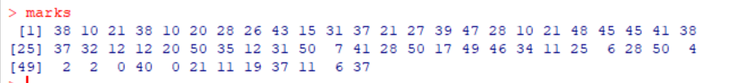

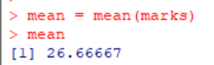

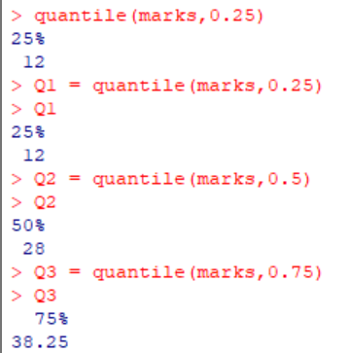

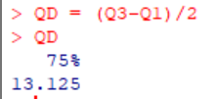

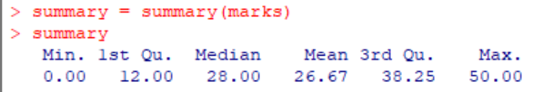

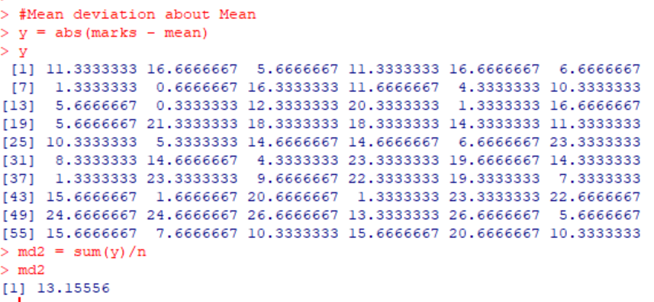

Mean deviation about Mode, not possible because it is multi-modal series

