**22MCA0223**

**KAMRAN ANSARI**

1. Create tables identifying the primary keys and foreign keys.

CREATE TABLE **EMPLOYEE**(

SSN INT,

NAME VARCHAR(40),

SEX VARCHAR(1),

ADDRESS VARCHAR(100),

SALARY DOUBLE PRECISION,

DEPT INT,

DESIGNATION VARCHAR(20),

SUPERVISORSSN INT,

CONSTRAINT EMPLOYEE__PK PRIMARY KEY(SSN)

);

CREATE TABLE **DEPT**(

DEPT_NUMBER INT,

NAME VARCHAR(40),

MANAGERSSN INT,

MANAGER_DOB DATE,

LOCATION VARCHAR(20),

CONSTRAINT DEPARTMENT_PK PRIMARY KEY(DEPT_NUMBER),

CONSTRAINT DEPT_MANAGERSSN_PK FOREIGN KEY(MANAGERSSN) REFERENCES EMPLOYEE(SSN)

);

CREATE TABLE **PROJECT**(

PROJECT_NUMBER INT,

NAME VARCHAR(30),

LOCATION VARCHAR(20),

CONTROLLING_DEPARTMENT INT,

BUDGET DOUBLE PRECISION,

CONSTRAINT PROJECT_PK PRIMARY KEY(PROJECT_NUMBER),

CONSTRAINT PROJECT_DEPT_FK FOREIGN KEY(CONTROLLING_DEPARTMENT) REFERENCES DEPT(DEPT_NUMBER)

);

CREATE TABLE **WORKS_ON**(

SSN INT,

PROJECT_NUM INT,

HOURS INT,

CONSTRAINT WORKS_ON_PK PRIMARY KEY(SSN, PROJECT_NUM),

CONSTRAINT WORKS_ON_EMPLOYEE_FK FOREIGN KEY(SSN) REFERENCES EMPLOYEE(SSN),

CONSTRAINT WORKS_ON_PROJECT_FK FOREIGN KEY(PROJECT_NUM) REFERENCES PROJECT(PROJECT_NUMBER)

);

**Constraints to be added after insertion** -

ALTER TABLE

**EMPLOYEE**

ADD CONSTRAINT

EMPLOYEE_EMP_FK FOREIGN KEY(SSN)

REFERENCES

EMPLOYEE(SSN);

ALTER TABLE

**EMPLOYEE**

ADD CONSTRAINT

EMPLOYEE_DEPT_FK FOREIGN KEY(DEPT)

REFERENCES

DEPT(DEPT_NUMBER);

2. Insert necessary tuples into the tables. (min 5 rows)

INSERT INTO EMPLOYEE VALUES(

1,

'E1',

'M',

'A1',

40000,

1,

'DE1',

2

);

INSERT INTO EMPLOYEE VALUES(

2,

'E2A',

'F',

'A2',

80000,

2,

'DE3',

3

);

INSERT INTO EMPLOYEE VALUES(

3,

'E3',

'F',

'A23',

30000,

2,

'DE44',

1

);

INSERT INTO EMPLOYEE VALUES(

4,

'E4',

'M',

'A24',

40000,

2,

'DE2',

1

);

INSERT INTO EMPLOYEE VALUES(

5,

'E5',

'F',

'A25',

10000,

2,

'DE1',

2

);

INSERT INTO DEPT VALUES(

1,

'D1',

1,

'20-DEC-2001',

'L2'

);

INSERT INTO DEPT VALUES(

2,

'D2',

3,

'24-DEC-2001',

'L3'

);

INSERT INTO DEPT VALUES(

3,

'D3',

null,

'24-JAN-2001',

'L4'

);

INSERT INTO DEPT VALUES(

4,

'D4',

3,

'24-FEB-2001',

'L5'

);

INSERT INTO DEPT VALUES(

5,

'D5',

2,

'24-FEB-1999',

'L6'

);

INSERT INTO PROJECT VALUES(

1,

'P1',

'L1',

1,

6000

);

INSERT INTO PROJECT VALUES(

2,

'P2',

'L2',

2,

7000

);

INSERT INTO PROJECT VALUES(

3,

'P3',

'L3',

1,

1000

);

INSERT INTO PROJECT VALUES(

4,

'P4',

'L4',

1,

8000

);

INSERT INTO PROJECT VALUES(

5,

'P5',

'L5',

2,

5000

);

INSERT INTO WORKS_ON VALUES(

1,

2,

33

);

INSERT INTO WORKS_ON VALUES(

1,

3,

43

);

INSERT INTO WORKS_ON VALUES(

2,

1,

50

);

INSERT INTO WORKS_ON VALUES(

4,

1,

100

);

INSERT INTO WORKS_ON VALUES(

5,

2,

40

);

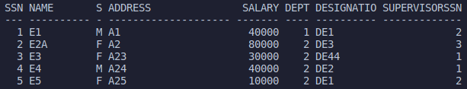

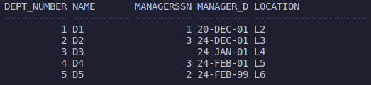

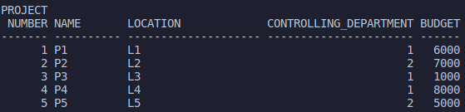

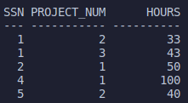

3. Queries (1 × 5 = 5) (1) Project names which are in a particular location. (2) Retrieve the customer whose name end with A. (3) Department details which has a nomanager. (4) Display all the department names in upper case and lower case. (5) Find the employee who have taken the salary more than 50000

