NAME: KAMRAN ANSARI
REG NO: 22MCA0223
LAB FAT: SET 3

Question-1
Consider the Hotel database
Hotel (Hotel_No, Name, Address)
Room (Room_No, Hotel_No, Type, Price)
Guest (Guest_No, Name, Address, phone_num)
1. Create tables identifying primary keys and foreign keys and insert necessary records.
[15M]

CREATE TABLE
HOTEL (
HOTEL_NO NUMBER,
NAME VARCHAR(50),
ADDRESS VARCHAR(100),
CONSTRAINT HOTEL_HOTEL_NO_PK PRIMARY KEY (HOTEL_NO)
);

CREATE TABLE
ROOM (
ROOM_NO NUMBER UNIQUE,
HOTEL_NO NUMBER,
TYPE VARCHAR(20),
PRICE DOUBLE PRECISION,
CONSTRAINT ROOM_HOTEL_NO_FK FOREIGN KEY (HOTEL_NO) REFERENCES HOTEL (HOTEL_NO),
CONSTRAINT ROOM_ROOM_NO_PK PRIMARY KEY (HOTEL_NO, ROOM_NO)
);

CREATE TABLE
GUEST (
GUEST_NO NUMBER,
NAME VARCHAR(50),
ADDRESS VARCHAR(100),
PHONE_NUM NUMBER,
ROOM_NO NUMBER,
CONSTRAINT GUEST_GUEST_NO_PK PRIMARY KEY (GUEST_NO),
CONSTRAINT GUEST_ROOM_NO_FK FOREIGN KEY (ROOM_NO) REFERENCES ROOM (ROOM_NO)
);

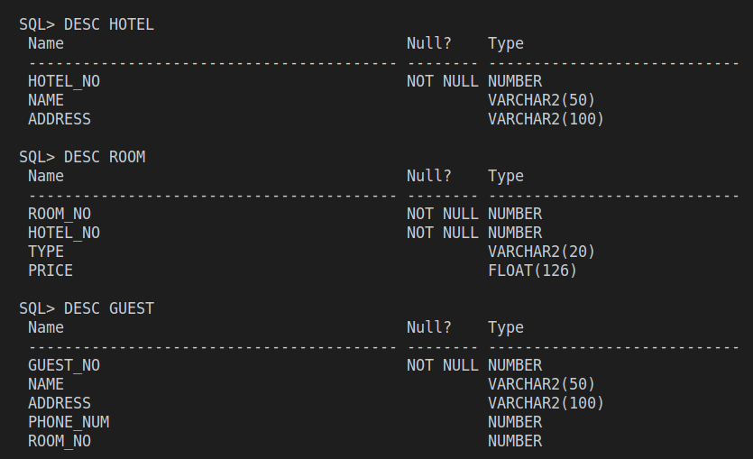

---
INSERT INTO
HOTEL
VALUES
(1, 'H1', 'A1');

INSERT INTO
HOTEL
VALUES
(2, 'H2', 'A2');

INSERT INTO
HOTEL
VALUES
(3, 'PARADISE', 'A3');

INSERT INTO
HOTEL
VALUES
(4, 'H4', 'A4');

INSERT INTO
HOTEL
VALUES
(5, 'H5', 'A5');

---
INSERT INTO
ROOM
VALUES
(1, 1, 'T1', 2000);

INSERT INTO
ROOM
VALUES
(2, 1, 'T2', 8000);

INSERT INTO
ROOM
VALUES
(3, 2, 'DOUBLE', 30);

INSERT INTO
ROOM
VALUES
(4, 2, 'FAMILY', 20);

INSERT INTO
ROOM
VALUES
(5, 3, 'T3', 2000);

INSERT INTO
ROOM
VALUES
(6, 3, 'T4', 12000);

--
INSERT INTO
GUEST
VALUES
(
1,
'G1',
'A1, Hyderabad, Telangana',
1234562891,
1
);

INSERT INTO
GUEST
VALUES
(
2,
'G2',
'A2, Hyderabad, Telangana',
2343924233,
2
);

INSERT INTO
GUEST
VALUES
(3, 'G3', 'A3', 2343334233, 5);

INSERT INTO
GUEST
VALUES
(4, 'G4', 'A4', 9823924233, 5);

INSERT INTO
GUEST
VALUES
(5, 'G5', 'A5', 9823234232, 1);

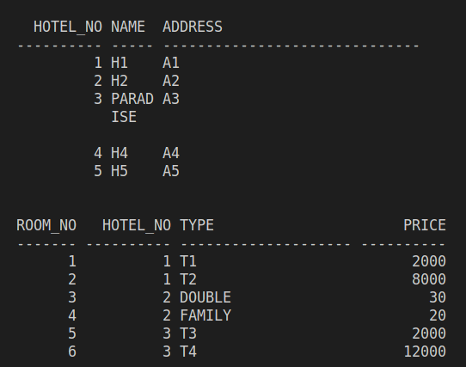

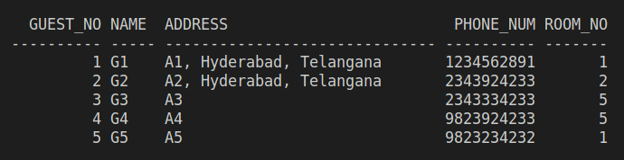

2. Write the following queries in SQL (4*5 =20)
a) List the names and addresses of all guests in Hyderabad, ordered by name.
b) Find the average price of a room?
c) List all double or family rooms with a price below £40.00 per night, in ascending order of price.
d) List all guests currently staying at the paradise Hotel.
E) List the price and type of all rooms at the Paradise Hotel.

SELECT
NAME,
ADDRESS
FROM
GUEST
WHERE
LOWER(ADDRESS) LIKE ('%hyderabad%')
ORDER BY
NAME;

-- b.
SELECT
AVG(PRICE)
FROM
ROOM;

-- c.
SELECT
*
FROM
ROOM
WHERE
TYPE IN ('DOUBLE', 'FAMILY')
AND PRICE < 40
ORDER BY
PRICE;

-- d.
SELECT
GUEST.NAME
FROM
GUEST,
ROOM,
HOTEL
WHERE
GUEST.ROOM_NO = ROOM.ROOM_NO
AND ROOM.HOTEL_NO = HOTEL.HOTEL_NO
AND HOTEL.NAME LIKE('PARADISE');

-- e.
SELECT
PRICE,
TYPE
FROM
ROOM,
HOTEL
WHERE
ROOM.HOTEL_NO = HOTEL.HOTEL_NO
AND HOTEL.NAME LIKE('PARADISE');

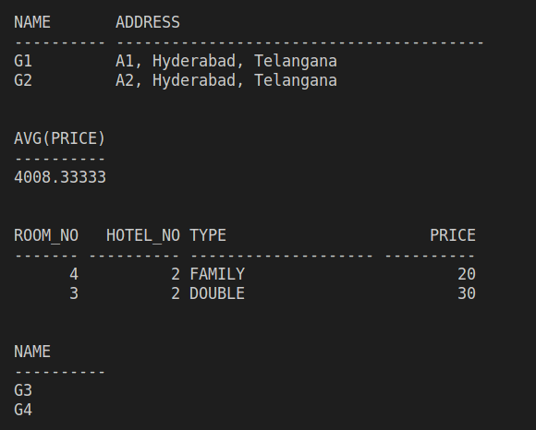
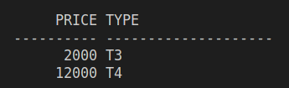

Question-2
Write the PL/SQL programs to create the procedure to find Fibonacci series. [15M]

CREATE OR REPLACE PROCEDURE FIBONACCI(TERMS NUMBER) AS
A NUMBER;
B NUMBER;
TEMP NUMBER;
CURR NUMBER;
BEGIN
A := 0;
B := 1;
DBMS_OUTPUT.PUT_LINE(A);
DBMS_OUTPUT.PUT_LINE(B);
FOR I IN 3..TERMS LOOP
CURR := A + B;
DBMS_OUTPUT.PUT_LINE(CURR);
A := B;
B := CURR;
END LOOP;
END;
/

