Ravie Requirements

# Introduction

Ravie is a social networking web app for planning group events. Users must be able to make their own group. They then must view all events in their group. They must also be able to create their own events. The app will be a website made with Node.js with a MongoDB database. Users will need an internet connection and a modern web browser to use the application.

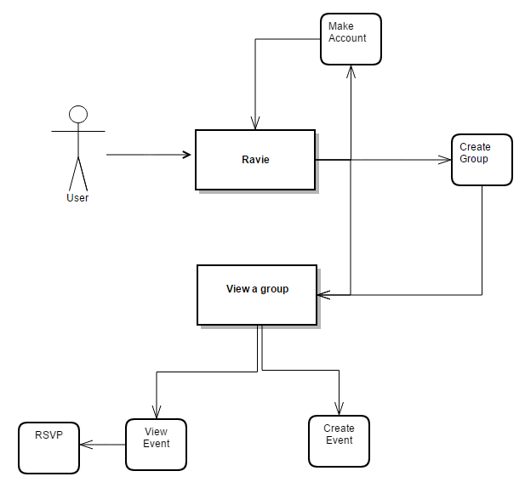

# Functional Requirements

The purpose of the application is to give members of a group a way to coordinate events. Thus, the application must have three main functions: creating a group, creating events in a group, and viewing events in a group. These are, in essence, the only functions of the site. All other functionality enhances these three activities in some way. The only function of the site that does not directly facilitate one of these activities is the creation of user profiles. This functionality exists for no other purpose than to facilitate the three main functions and does not, in and of itself, contribute anything to the site. But since it does not directly facilitate one specific activity, it is noteworthy and has to be categorized separately.

## Groups

1. Ravie will have a very prominent button for creating a group.
2. Ravie will provide a step-by-step “wizard” for setting up a group.
3. Groups will have numerous configuration options.
   1. A group will either be public or private.
      * *Clarification:* the events of the group will either be public to all users, or limited only to those in the group.
   2. Event creation will either be public, private.
      * *Clarification:* either anyone can post a new event, or only those who are members of the group can do so.
   3. Submitted events will either be automatic, or require approval.
      * *Clarification:* posted events will either appear in the group instantly upon submission, or they will be logged in a queue awaiting an administrator sign-off.
      * *Motivation:* some groups may want to be public, but worry about offensive or abusive content from nefarious individuals, for instance. Such groups will require all posts to be approved by an administrator.
   4. Users will be able to specify additional administrators.
      * *Note:* the user creating a group will automatically be made an administrator.
4. All configuration options will be changeable at any time after the creation of the group.
5. Some users will be administrators.
   1. Administrators will have the ability to approve posts (when the group is configured to require administrator approval).
   2. Administrators will have the ability to invite members to the group.
   3. Administrators will have the ability to approve requests to join the group.
   4. Administrators will have the ability to promote members to administrators.
   5. Administrators will have the ability to edit and delete events.
6. All groups will be autonomous; there will be no connection between individual groups other than user accounts that belong to multiple groups.

## Event Browsing

1. Users will be able to see a list of upcoming events in their group.
2. Users will be able to view events in order from soonest to latest.
3. Users will be able to filter events based on proximity to their current GPS location or a zip code.
4. Users will be able to view events in two views.
   1. Users will be able to view events as a stacked list of cards, with the soonest event at the top of the stack.
   2. Users will be able to view events in a calendar.
5. Users will be able to see how many people have RSVP’d for an event.
6. Users will be able to RSVP for events.

## Event Creation

1. Users will be able to create events.
2. The event creation process will be a step-by-step “wizard,” much like the group creation setup.
3. Each event will have several configuration options.
   1. An event will have a name.
   2. An event will have a description.
   3. An event will have a location.
   4. The location will be passed to a Google Maps API.
   5. An event will have either public or private RSVPs
      * *Clarification*: users who have RSVP’d to the event will be viewable by other users depending on this setting. If this setting is private, only the number of RSVP’s will be viewable.
   6. An event will have an associated image.
   7. Users will be able to choose from a set of stock images, upload an image, or include a link to an image.
   8. Stock images will be searchable by keyword

## User Profiles

1. Users will be able to make user profiles.
2. Users will be able to associate an email address with their account for password recovery.
   * *Clarification*: email address will be optional.
3. Users will be able to change their passwords.
4. Users will be able to leave groups.
5. Users will be able to request entrance into groups.
6. Users will be able to specify aliases for individual groups.
   * *Motivation*: for a specific group, particularly if it’s a small community, “Bob” or “Mrs. Harris” will be a more appropriate identifier than “hockeyluver1975”. Additionally, a group might desire anonymity, such as an Alcoholics Anonymous group or an online video game guild whose members do not know each other in real life.

# Performance Requirements

Since this is a web technology, there are only two performance metrics available: page load time and script performance. Google specifies that a page should never take longer than one second to load. Google discriminates against sites that take more than a second to load in search results. Thus, the first performance requirement is that every page on the site load in less than one second. This site will not have complex client-side scripts. But, for completeness, we will specify that no client-side JavaScript will have noticeably slow performance; i.e. all scripts will execute instantaneously from the user’s perspective.

1. All pages will load completely in no more than one second.
2. All JavaScript will be instantaneous from the user’s perspective.

# Environment Requirements

## Browser Requirements

* 1. The user must use Google Chrome version 35 or later, Mozilla Firefox version 31 or later, Safari version 7 or later, Internet Explorer version 10 or later, or Microsoft Edge.