PBA Final Project Report

An Explainable Bankruptcy Risk Analysis:
Evidence from Taiwanese Firms

Team 14
112070034 范辰于 (Chen-Yu Fan)
112070026 范嘉尹 (Chia-Yin Fan)
112070007 周昱丞 (Yu-Cheng Chou)
112081001 方以佳 (Yi-Chia Fang)

- Introduction
Corporate bankruptcy represents a severe form of financial distress with significant consequences for firms, creditors, employees, and the broader economy. Accurately identifying firms at high risk of bankruptcy is therefore a central concern in corporate finance and risk management, as early detection allows stakeholders to take preventive actions such as improving liquidity management or restructuring debt to mitigate potential losses.
Prior research shows that bankruptcy risk is closely related to firms’ financial fundamentals, particularly profitability, leverage, and liquidity, though empirical challenges arise when financial ratios convey overlapping information. This study examines bankruptcy risk among Taiwanese firms using accounting-based financial ratios. I employ multivariate logistic regression to assess the joint effects of profitability, leverage, and liquidity, and complement this analysis with cross-validated LASSO logistic regression to balance predictive performance and model parsimony. Together, these approaches provide an interpretable and robust assessment of bankruptcy risk.
- Research Design
This study analyzes the relationship between firm-level financial characteristics and bankruptcy risk using a binary response framework. Since bankruptcy is a discrete event, I model the probability that a firm is bankrupt using logistic regression, which allows for a nonlinear relationship between explanatory variables and the probability of bankruptcy.

2.1 Empirical Framework
Let $p_{i}$denote the probability that firm $i$is bankrupt. The baseline empirical specification is a multivariate logistic regression of the form:
$$log⁡\left(\frac{p_{i}}{1-p_{i}}\right)=α+X_{i}^{'}β,$$
where $X_{i}$is a vector of financial ratios capturing profitability, leverage, and liquidity, and $β$is the corresponding coefficient vector. The estimated coefficients reflect how changes in financial ratios affect the log-odds of bankruptcy.
To improve interpretability, I also report odds ratios, which translate coefficient estimates into percentage changes in bankruptcy odds associated with a one-percentage-point change in each explanatory variable.

2.2 Model Specifications
Two logistic regression models are estimated:
Model 1 (Full Specification Model) includes two profitability measures, Net Income to Total Assets and ROA(A) before interest and % after tax, along with leverage and liquidity indicators. This model captures a broad set of financial information but may suffer from redundancy due to overlapping profitability measures.
Model 2 (Parsimonious Specification Model) excludes Net Income to Total Assets and retains ROA(A) as the sole profitability indicator. This reduced specification aims to assess whether a simpler model can preserve explanatory power while improving interpretability and stability.
To further guide model selection, I implement a LASSO logistic regression with cross-validation. LASSO imposes an $l_{1}$penalty on coefficients, shrinking less informative variables toward zero and effectively performing variable selection. The regularization parameter $λ$is chosen using both the minimum cross-validation error criterion and the one-standard-error rule to balance predictive performance and model complexity.

- Data Observation and Visualization
3.1 Data Source
The data used in this study are obtained from the Taiwanese Bankruptcy Prediction dataset provided by the UCI Machine Learning Repository. The dataset contains firm-level financial information for Taiwanese companies, including a binary bankruptcy indicator and a large set of accounting-based financial ratios derived from firms’ financial statements.
The target variable, Bankrupt, is defined as a binary indicator equal to 1 if the firm is bankrupt and 0 otherwise. Financial ratios cover multiple dimensions of firm performance, such as profitability, leverage, liquidity, operating efficiency, and solvency. This rich set of variables makes the dataset well-suited for bankruptcy risk analysis while also posing challenges related to multicollinearity and high dimensionality.
3.2 Sample Characteristics
The final sample consists of 6,819 firm observations, among which 220 firms (approximately 3.23%) are classified as bankrupt. This severe class imbalance implies that naïve classification accuracy can be misleading, as predicting all firms as non-bankrupt would yield high accuracy but provide no meaningful insight. Therefore, subsequent analysis focuses on group-wise comparisons between bankrupt and non-bankrupt firms and emphasizes interpretable risk factors rather than raw predictive accuracy.
3.3 Key Variables
This study focuses on four core financial ratios motivated by corporate finance theory:
- ROA(A) before interest and % after tax
Measures operating profitability relative to total assets, capturing firms’ ability to generate earnings from their asset base independent of financing structure.
- Net Income to Total Assets
A profitability indicator reflecting bottom-line performance relative to firm size.
- Debt Ratio (%)
Measures leverage as the proportion of assets financed by liabilities. Higher values indicate greater financial leverage and exposure to default risk.
- Working Capital to Total Assets
Captures liquidity buffers and short-term financial flexibility. Higher values suggest a stronger ability to absorb short-term cash-flow shocks.
These variables are selected to represent the three fundamental dimensions of bankruptcy risk: profitability, leverage, and liquidity. Summary statistics and distributional comparisons between bankrupt and non-bankrupt firms are presented in the subsequent section to provide descriptive evidence on how these financial characteristics differ across firm outcomes.
Below is manly focused of The analysis of single variable.
3.4 The Bankruptcy Rate
Figure 1 shows that the target variable is highly imbalanced: Bankrupt = 1 has 220 observations (3.23%), while non-bankrupt firms account for about 96.77% of the sample. With such severe imbalance, overall accuracy can be misleading because a classifier can achieve a high accuracy by predicting the majority class (0) most of the time. Therefore, subsequent analysis of bankruptcy should focus on group-wise comparisons (bankrupt vs. non-bankrupt) rather than overall averages.
Figure 1: The Bankruptcy Rate
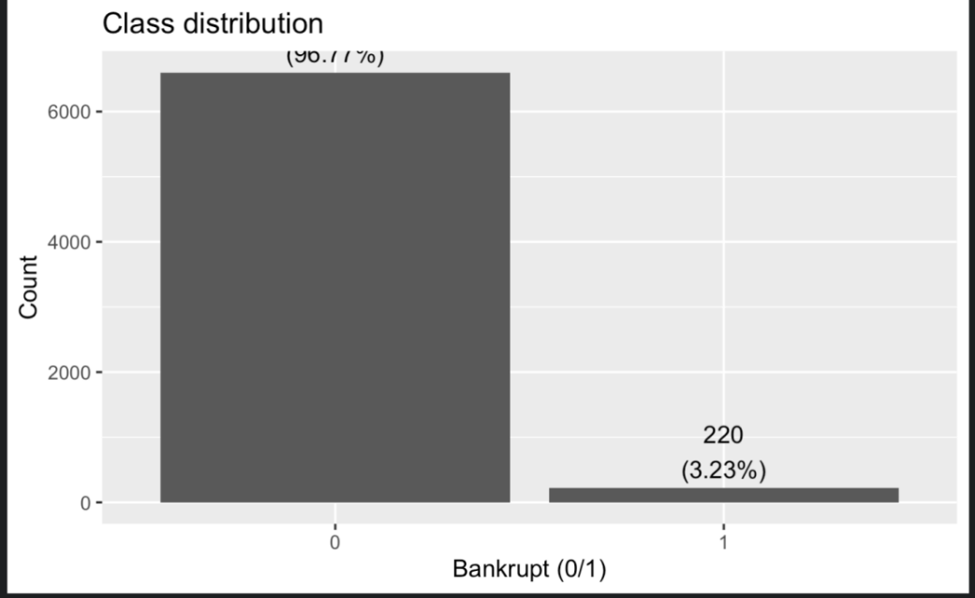
3.5 Net Income to Total Assets
Net Income to Total Assets captures profitability and asset-use efficiency. As figure 2 shows, lower values typically indicate weaker performance and may be associated with higher bankruptcy risk. The density curve for the bankrupt group (1) is shifted to the left relative to the non-bankrupt group (0), suggesting that bankrupt firms tend to have lower net income relative to assets. The bankrupt distribution is also more dispersed with a heavier left tail, indicating greater instability or weaker profitability. However, the two distributions still overlap, implying that this single ratio alone cannot perfectly separate the two classes.
Figure 2: Net Income to Total Assets
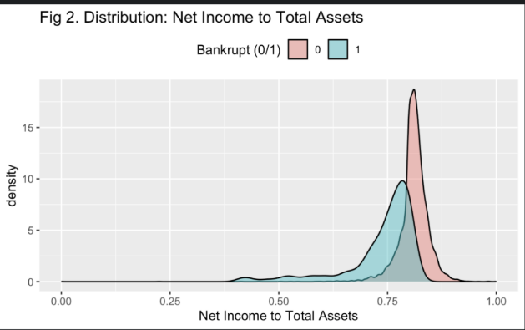
3.6 ROA(A) before interest and % after tax
ROA(A) before interest and % after tax measures asset-based profitability after taxes but before interest expenses, capturing operational earning power with less direct influence from capital structure (interest burden). In general, higher ROA indicates stronger operating performance and a lower likelihood of financial distress. The bankrupt group (1) is clearly shifted to the left relative to the non-bankrupt group (0), suggesting systematically lower profitability among bankrupt firms. The bankrupt distribution is also more dispersed with a heavier low-end tail, while the non-bankrupt group is more tightly concentrated at higher ROA values. Some overlap remains in the mid-range, implying ROA(A) is informative but not sufficient on its own to perfectly separate the classes. Overall, the plot indicates a negative association between ROA(A) and bankruptcy risk: firms with lower asset profitability are more likely to be bankrupt. Economically, weaker operating profitability reduces a firm’s ability to cover fixed obligations and withstand shocks, increasing vulnerability to bankruptcy. In later analysis, ROA(A) should be interpreted jointly with leverage and liquidity indicators to assess whether combinations such as low profitability + high leverage amplify bankruptcy risk.
Figure 3: ROA(A) before interest and % after tax
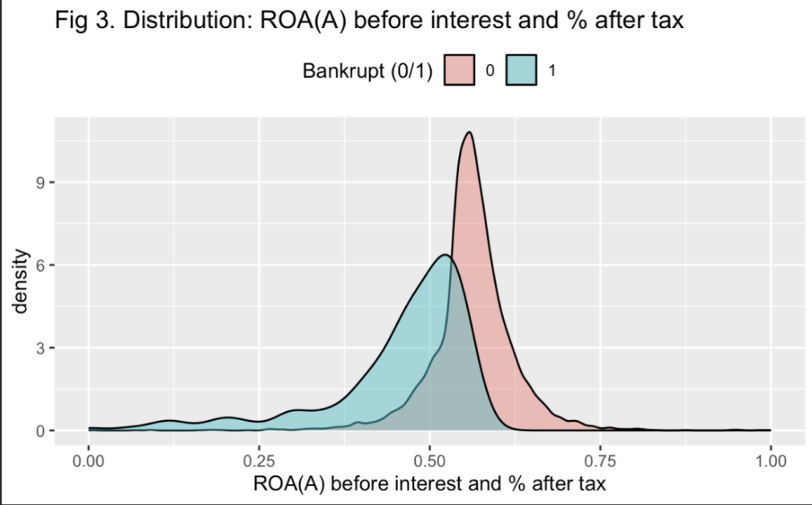
3.7 Debt ratio %
Debt ratio % captures leverage by measuring the share of assets financed by liabilities. A higher debt ratio implies greater debt burden and lower financial flexibility, which can increase vulnerability to distress, especially when cash flows weaken or financing conditions tighten. The bankrupt group (1) is shifted to the right compared with the non-bankrupt group (0), indicating that bankrupt firms tend to have higher debt ratios. The bankrupt distribution also exhibits a heavier right tail, suggesting that some bankrupt firms operate under extremely high leverage. Although the two groups overlap, the overall shift is pronounced, implying strong discriminative power of leverage for bankruptcy status. Overall, the plot indicates a positive association between leverage and bankruptcy risk: firms with higher debt ratios are more likely to go bankrupt. Economically, high leverage amplifies exposure to cash-flow shocks and refinancing risk. In subsequent analysis, it is useful to interpret debt ratio jointly with profitability measures (e.g., ROA, Net Income to Assets) to assess whether the combination of high leverage + low profitability characterizes the highest-risk firms.
Figure 4: Debt ratio
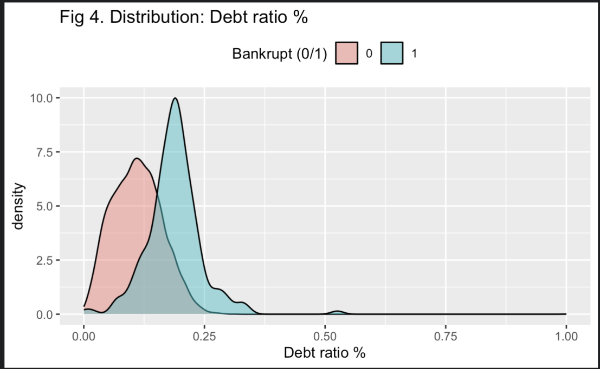
3.8 Working Capital to Total Assets
Working Capital to Total Assets captures liquidity buffer relative to firm size. Since working capital (current assets minus current liabilities) reflects short-term financial flexibility, higher values generally indicate stronger ability to absorb cash-flow shocks and meet near-term obligations; thus, lower values are typically associated with higher bankruptcy risk. The bankrupt group (1) is shifted to the left relative to the non-bankrupt group (0), suggesting that bankrupt firms tend to have lower working capital relative to total assets, i.e., weaker liquidity buffers. The non-bankrupt distribution is more concentrated at higher values and shows a longer right tail, indicating that some healthy firms maintain substantial liquidity/short-term flexibility. Some overlap remains, implying liquidity is informative but not sufficient alone. Overall, the plot indicates a negative association between Working Capital to Total Assets and bankruptcy risk: firms with weaker liquidity buffers are more likely to go bankrupt. Economically, insufficient working capital increases vulnerability to short-term funding stress, payment delays, and costly refinancing, especially under revenue downturns or credit tightening. In later analysis, it is useful to consider this liquidity measure jointly with leverage and profitability to assess whether low liquidity + high leverage / low profitability characterizes the highest-risk firms.

Figure 5: Working Capital to Total Assets
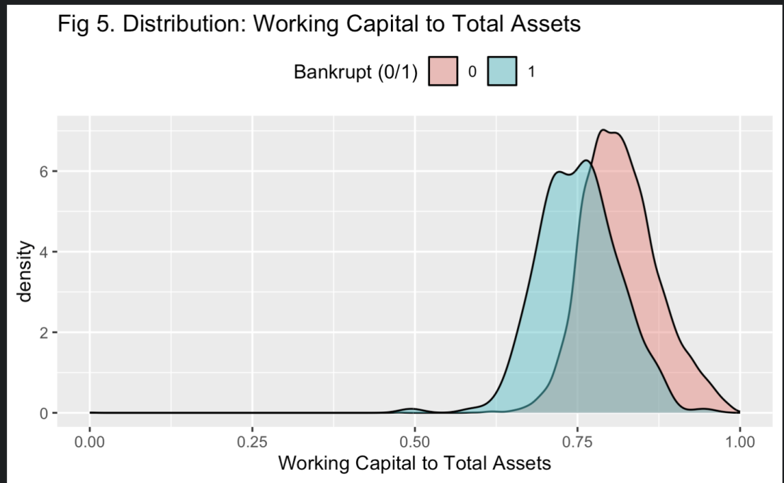
- Methodology
4.1 Model 1: Full Specification Model
$$log((1-p)/p=5.062+2.652⋅(Net Income to Total Assets)-14.217⋅(ROA(A) before interest and \% after tax)+16.960⋅(Debt ratio \%)-7.052⋅(Working Capital to Total Assets)$$
The multivariate logistic regression results show that bankruptcy risk is jointly driven by profitability, leverage, and liquidity. After controlling other factors, ROA and working capital are significantly negatively associated with bankruptcy, while debt ratio exhibits a strong positive association. Net Income to Total Assets becomes insignificant once ROA is included, indicating overlapping profitability information. Overall, the results suggest that firms with weak operating profitability, high leverage, and insufficient liquidity buffers face the highest bankruptcy risk.
Table 1: Model 1 Results
Variable | Coefficient (β) | Std. Error | Odds Ratio | z-value | p-value
ROA (before interest and after tax) | -14.217 | 3.286 | 0.867 | 4.327 | < 0.001
Debt Ratio (%) | 16.960 | 1.731 | 1.185 | 9.796 | < 0.001
Working Capital / Total Assets | -7.052 | 1.582 | 0.932 | -4.458 | < 0.001
Net Income / Total Assets | 2.652 | 4.503 | 1.027 | 0.589 | 0.556
Intercept | 5.062 | 2.410 | 1.052 | 2.101 | 0.036 *

To improve interpretability, we report odds ratios corresponding to a one-percentage-point change in each explanatory variable. A 1% increase in ROA is associated with a 13% decrease in the odds of bankruptcy, while a 1% increase in the debt ratio raises bankruptcy odds by approximately 18.5%. Similarly, a 1% increase in working capital to total assets reduces bankruptcy odds by about 6.8%. In contrast, net income to total assets does not exhibit a statistically significant effect once ROA is included, suggesting overlapping profitability information. Overall, the results highlight the joint roles of profitability, leverage, and liquidity in determining bankruptcy risk.
Table 2: Effects of Financial Ratios on Bankruptcy Risk
Variable | Odds Ratio | Interpretation
ROA | 0.867 | Higher ROA is associated with lower odds of bankruptcy
Debt Ratio | 1.185 | A higher debt ratio is associated with higher odds of bankruptcy
Working Capital | 0.932 | Greater liquidity is associated with lower odds of bankruptcy
Net Income / Total Assets | 1.027 | Not statistically significant
Intercept | 1.052 | Not interpreted

4.2 Model 2: Parsimonious Specification Model
$$log(1-pp​)=6.2227-12.3938⋅(ROA(A) before interest and \% after tax)+16.9060⋅(Debt ratio \%)-7.076⋅(Working Capital to Total Assets)$$
It estimates bankruptcy risk using ROA, debt ratio, and working capital as explanatory variables. The results show that ROA is strongly and negatively associated with bankruptcy, indicating that firms with higher operating profitability face substantially lower financial distress risk. In contrast, debt ratio exhibits a large and positive effect, suggesting that higher leverage significantly increases bankruptcy likelihood. Working capital to total assets is negatively related to bankruptcy risk, highlighting the protective role of liquidity buffers in absorbing short-term shocks. Overall, the findings indicate that bankruptcy risk is jointly driven by low profitability, high leverage, and weak liquidity.
Table 3: Model 2 Results
Variable | Estimate (β) | Std. Error | z value | p-value
Intercept | 6.2227 | 1.4288 | 4.355 | 1.33e-05
ROA (before interest and after tax) | -12.3938 | 0.9792 | -12.658 | < 2e-16
Debt Ratio (%) | 16.9060 | 1.7309 | 9.767 | < 2e-16
Working Capital / Total Assets | -7.0766 | 1.5830 | -4.470 | 7.81e-06

4.3 Difference between Model 1 and Model 2
Compared with Model 1, which includes two overlapping profitability measures, Model 2 adopts a more parsimonious specification by retaining ROA as the sole profitability indicator. Despite this simplification, the estimated effects of profitability, leverage, and liquidity remain qualitatively unchanged, with consistent signs and statistical significance across models. The exclusion of Net Income to Total Assets does not alter the main conclusions, indicating that ROA sufficiently captures the relevant profitability information. The slightly lower AIC further suggests that Model 2 achieves comparable, if not improved, model fit with fewer explanatory variables, supporting the robustness of the results.

4.4 Model Selection via Cross-Validated LASSO Logistic Regression
Figure X illustrates the cross-validated binomial deviance of the LASSO logistic regression across different values of the regularization parameter λ. As λ decreases, model complexity increases and more variables enter the model, leading to lower in-sample error but higher risk of overfitting. The plot shows that the cross-validation error reaches its minimum at a relatively small λ, while remaining relatively flat within one standard error over a range of larger λ values. This pattern indicates that near-optimal predictive performance can be achieved with a substantially simpler model, motivating the use of the one-standard-error rule to balance predictive accuracy and model parsimony.
Figure 6: Cross-Validated Binomial Deviance for LASSO Logistic Regression
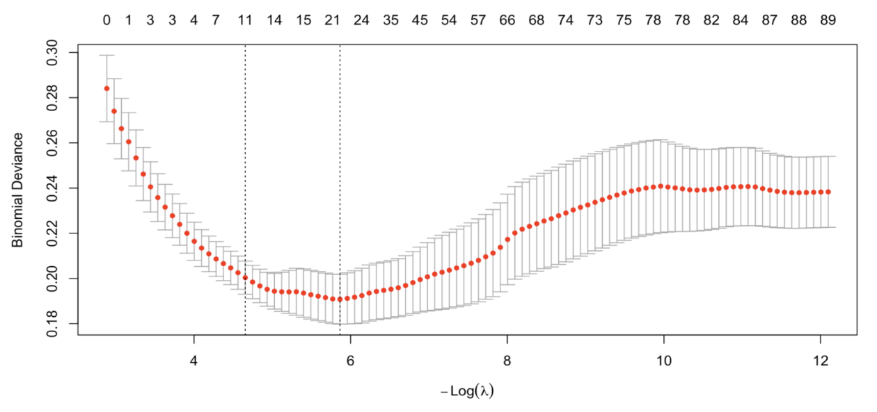
Cross-validation identifies two candidate regularization parameters. The value λ = 0.00284 minimizes the cross-validated binomial deviance, while λ = 0.00952 corresponds to the one-standard-error rule. Following standard practice, we adopt the latter to favor a more parsimonious and stable model. This choice yields comparable predictive performance while substantially reducing model complexity, which is particularly important in a high-dimensional setting with correlated financial ratios.
- Results
  - Bankruptcy Risk and Class Imbalance
Consistent with the descriptive statistics presented earlier, the bankruptcy indicator exhibits severe class imbalance, with bankrupt firms accounting for only 3.23% of the sample. This imbalance underscores the importance of focusing on distributional differences and interpretable financial drives, rather than relying on overall classification accuracy. Consequently, the empirical analysis emphasizes how key financial ratios differ systematically between bankrupt and non-bankrupt firms and how these ratios jointly explain bankruptcy risk in a multivariate setting.
  - Evidence from Univariate Distributions
The univariate density plots (Figures 2–5) reveal clear and economically intuitive patterns across profitability, leverage, and liquidity dimensions. Bankrupt firms consistently exhibit lower profitability, higher leverage, and weaker liquidity buffers than non-bankrupt firms.
Profitability measures show that both Net Income to Total Assets and ROA(A) before interest and after tax are shifted leftward for bankrupt firms, indicating weaker earnings capacity. Among the two, ROA(A) displays a more pronounced separation, suggesting that operating profitability is particularly informative for bankruptcy risk. Leverage, measured by the debt ratio, shows a strong rightward shift for bankrupt firms, highlighting the role of excessive debt burdens. Liquidity, captured by working capital relative to total assets, is systematically lower among bankrupt firms, reflecting limited short-term financial flexibility.
While none of these ratios perfectly separate the two groups on its own, the consistent directional shifts across all measures suggest that bankruptcy risk is driven by joint financial weakness, rather than by a single dominant factor.
  - Multivariate Logistic Regression Results
Table 1 reports the results of the full multivariate logistic regression (Model 1). After jointly controlling profitability, leverage, and liquidity, ROA(A) and Working Capital to Total Assets are significantly negatively associated with bankruptcy, while the Debt Ratio exhibits a strong positive association. In contrast, Net Income to Total Assets becomes statistically insignificant once ROA(A) is included, indicating that the two profitability measures convey overlapping information.
To enhance interpretability, odds ratios are reported. A one-percentage-point increase in ROA(A) is associated with an approximately 13% reduction in the odds of bankruptcy, while a one-percentage-point increase in the debt ratio raises bankruptcy odds by about 18.5%. Similarly, higher working capital reduces bankruptcy odds by roughly 6.8%. These magnitudes indicate economically meaningful effects and confirm that bankruptcy risk is jointly shaped by profitability, leverage, and liquidity conditions.
  - Parsimonious Specification and Model Robustness
Model 2 adopts a more parsimonious specification by excluding Net Income to Total Assets and retaining ROA(A) as the sole profitability indicator. The estimated effects remain qualitatively unchanged: ROA(A) and working capital continue to exhibit strong negative associations with bankruptcy, while the debt ratio remains strongly positive. The slightly lower AIC suggests that Model 2 achieves comparable, if not improved, model fit with fewer explanatory variables. This result indicates that ROA(A) sufficiently captures the relevant profitability information and supports the robustness of the main findings.
  - LASSO Logistic Regression and Variable Selection
Figure 6 presents the cross-validated binomial deviance for the LASSO logistic regression. As the regularization parameter λ decreases, model complexity increases and in-sample fitness improves, but at the cost of higher overfitting risk. The cross-validation error reaches its minimum at λ = 0.00284, while remaining relatively flat within one standard error up to λ = 0.00952. Following standard practice, the one-standard-error rule is adopted to favor a more parsimonious and stable model.
The LASSO results reinforce the conclusions from the logistic regression models: profitability, leverage, and liquidity variables emerge as the most informative predictors of bankruptcy risk, even under regularization. This consistency across modeling approaches strengthens confidence in the empirical findings.

- Discussion
The empirical results provide a coherent and economically intuitive explanation of bankruptcy risk among Taiwanese firms. Across univariate distributions, multivariate logistic regressions, and regularized models, three financial dimensions consistently emerge as central: profitability, leverage, and liquidity.
Operating profitability, measured by ROA(A), plays a dominant protective role. Firms with stronger operating returns are better positioned to generate internal cash flows, service obligations, and absorb adverse shocks. The insignificance of Net Income to Total Assets once ROA(A) is included suggests that operating profitability captures the relevant earnings information more effectively than bottom-line measures, which may be more sensitive to accounting adjustments or financing structure.
Leverage amplifies bankruptcy risk by increasing exposure to cash-flow volatility and refinancing pressure. The strong positive effect of the debt ratio indicates that highly leveraged firms are particularly vulnerable when profitability weakens. This finding is especially relevant in the Taiwanese context, where many firms—particularly small and medium-sized enterprises—rely heavily on debt financing and bank credit.
Liquidity provides an additional and complementary buffer. Firms with higher working capital relative to total assets exhibit lower bankruptcy risk, reflecting greater short-term financial flexibility. The joint interpretation of liquidity with profitability and leverage highlights that bankruptcy risk is rarely driven by a single weakness. Instead, firms facing low profitability combined with high leverage or weak liquidity are most vulnerable to financial distress.
From an explainability perspective, these results are particularly valuable. The key predictors identified by the models correspond closely to well-established financial theory and intuitive economic mechanisms. Rather than relying on opaque or highly complex predictors, the analysis shows that a small set of economically meaningful ratios can explain bankruptcy risk in a transparent and interpretable manner. The robustness of these findings across logistic regression specifications and LASSO regularization further supports their reliability.
Overall, the analysis suggests that effective bankruptcy risk assessment should prioritize interpretable financial fundamentals over model complexity. By focusing on profitability, leverage, and liquidity, stakeholders such as lenders, regulators, and corporate managers can develop early-warning systems that are both analytically sound and practically actionable.

