LAB Logbook

Lab 1
- A DataFrame is basically a table with rows and columns, which makes it easy to organise and work with structured data in one place.

- A Series is like a single column of data, and the index attached to it makes it easier to match values up correctly.

- An Index is the set of labels Pandas uses to identify rows or columns, so you can find and line up data without guessing positions.

- A Timestamp is a single date and time value, which is handy when you’re dealing with things like logs or any time-based records.

- A Timedelta represents a time difference, which is useful for calculating how long something took, like the gap between two timestamps in a log.

Lab 2
- MOVEit File Transfer Hack (2023)
- Emsisoft (https://www.emsisoft.com/en/blog/44123/unpacking-the-moveit-breach-statistics-and-analysis/)

Lab 3
EDA plot created by me is boxplot
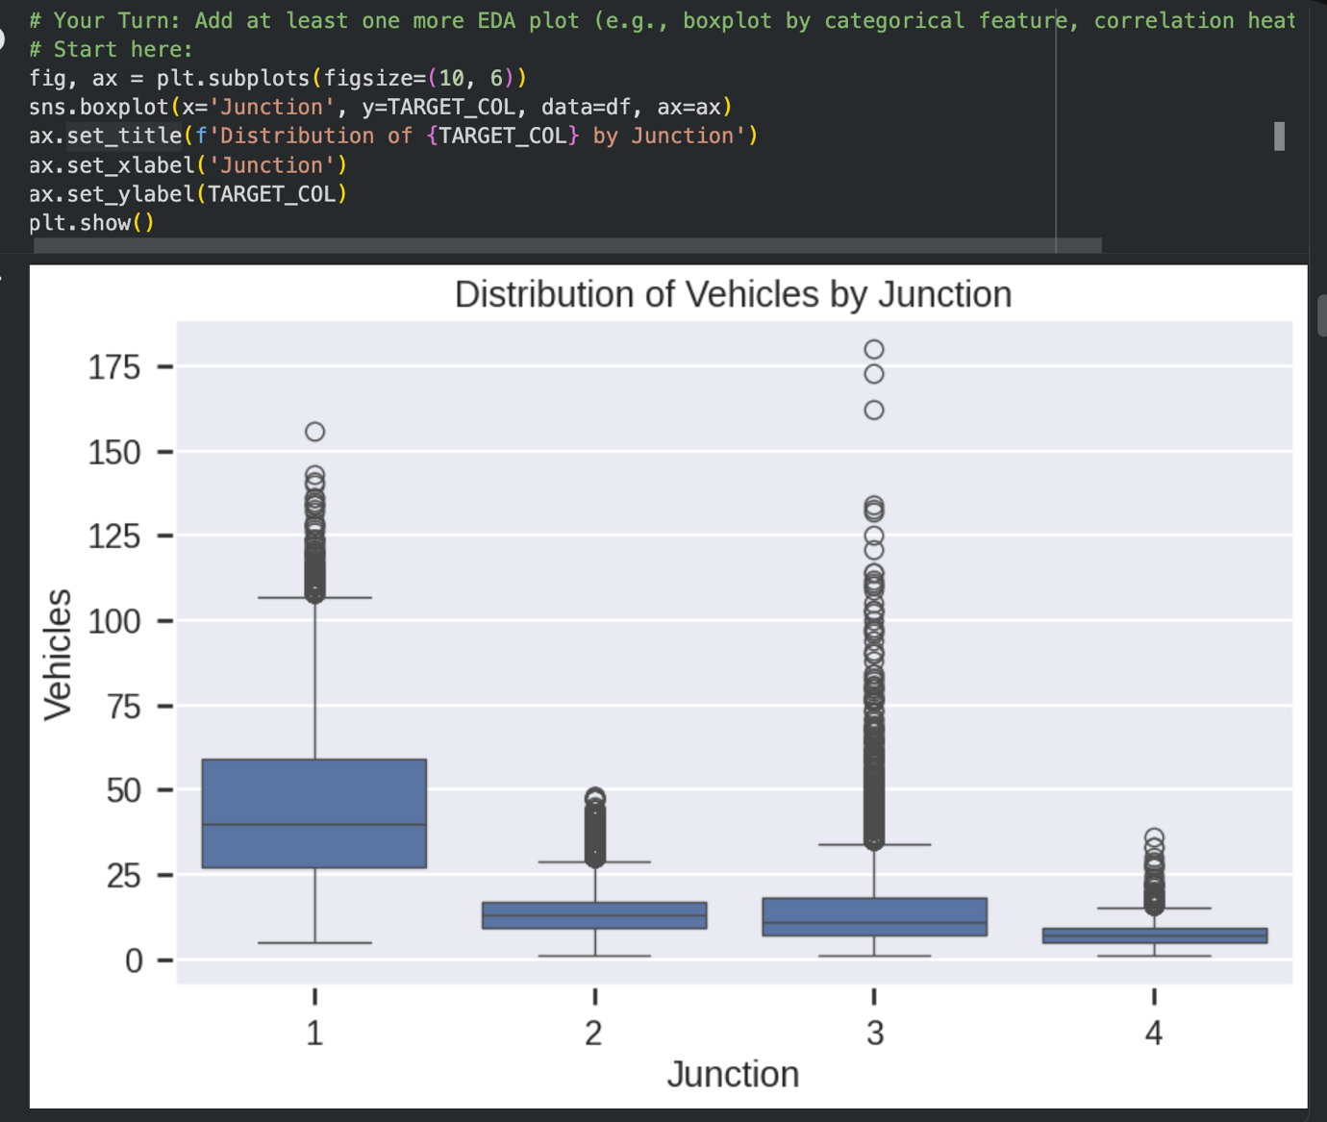

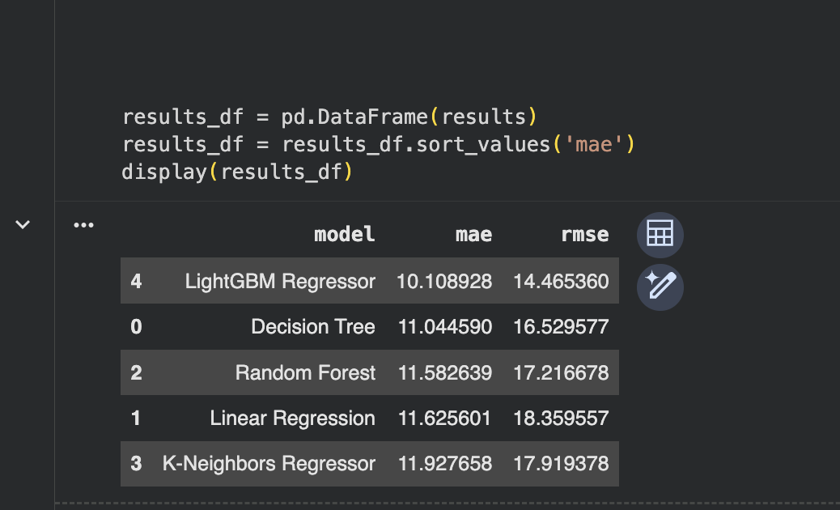

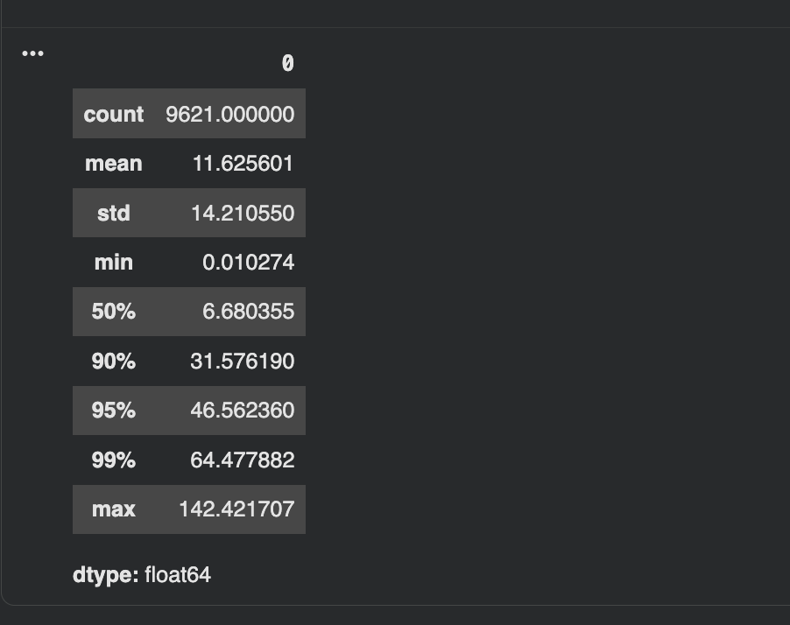

Lab 4

Lab 5

Lab 6

Lab 7

Lab 8

Lab 9

Lab 10

Lab 11

Lab 12

