1. Testazbanner：安卓序广告

public enum bannerType { 轮播, Banner图片 }

[SugarTable("TestAzBanner", "安卓序广告")]

public class TestAzBanner

{

[SugarColumn(ColumnDescription = "ID", IsPrimaryKey = true, IsIdentity = true)]

public int id { get; set; }

[SugarColumn(ColumnDescription = "名称", Length = 30)]

public string banner_name { get; set; }

[SugarColumn(ColumnDescription = "图片", ColumnDataType = DbCfg.PictFiledName, IsNullable = true)]

public byte[] banner_pict { get; set; }

[SugarColumn(ColumnDescription = "类型", IsNullable = true)]

public bannerType banner_type { get; set; }

[SugarColumn(ColumnDescription = "启用", IsNullable = true)]

public bool banner_enable { get; set; }

[SugarColumn(ColumnDescription = "创建时间")]

public DateTime createtime { get; set; }

}

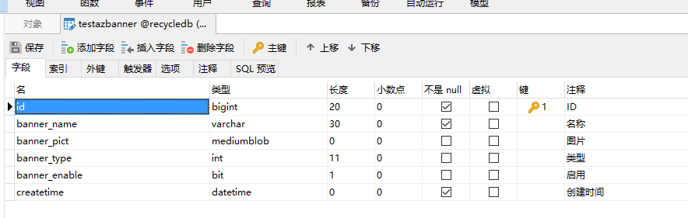

1. Testdevinfo: 设备信息
2. public enum deviceState { 未知, 正常, 异常 }
3. public enum deviceOnline { 未知, 在线, 离线 }
4. [SugarTable("TestDevInfo", "设备信息")]
5. public class TestDevInfo
6. {
7. [SugarColumn(ColumnDescription = "ID", IsPrimaryKey = true, IsIdentity = true)]
8. public int id { get; set; }
9. [SugarColumn(ColumnDescription = "机器编号", Length = 20)]
10. public string dev_no { get; set; }
11. [SugarColumn(ColumnDescription = "机器名称", Length = 80)]
12. public string dev_name { get; set; }
13. [SugarColumn(ColumnDescription = "投放时间")]
14. public DateTime? putintime { get; set; }
15. [SugarColumn(ColumnDescription = "机器状态", IsNullable = true)]
16. public deviceState dev_state { get; set; }
17. [SugarColumn(ColumnDescription = "在线状态", IsNullable = true)]
18. public deviceOnline dev_online { get; set; }
19. [SugarColumn(ColumnDescription = "IMEI码", Length = 30, IsNullable = true)]
20. public string dev_imei { get; set; }
21. [SugarColumn(ColumnDescription = "注册时间")]
22. public DateTime regtiem { get; set; }
23. [SugarColumn(ColumnDescription = "联系电话", Length = 30, IsNullable = true)]
24. public string telephone { get; set; }
25. [SugarColumn(ColumnDescription = "投放地点", Length = 120, IsNullable = true)]
26. public string dev_addr { get; set; }
27. [SugarColumn(ColumnDescription = "百度经度", IsNullable = true)]
28. public Double longitude { get; set; }
29. [SugarColumn(ColumnDescription = "百度纬度", IsNullable = true)]
30. public Double latitude { get; set; }
31. [SugarColumn(ColumnDescription = "备注", Length = 120, IsNullable = true)]
32. public string remark { get; set; }
33. }

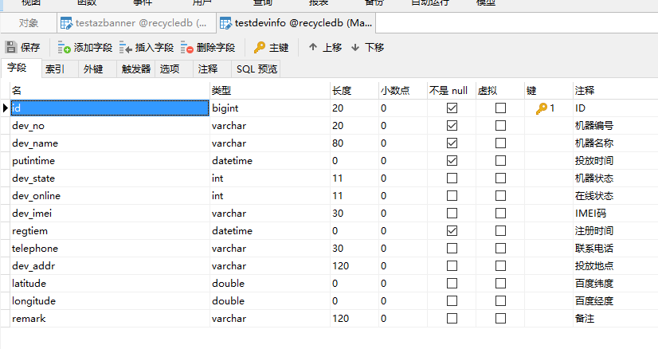

3. testobjecttype: 回收物品分类表

public enum objectUnit { KG, 个 }

[SugarTable("TestObjectType", "回收物品分类表")]

public class TestObjectType

{

[SugarColumn(ColumnDescription = "类型ID", IsPrimaryKey = true, IsIdentity = true)] //主键

public int id { get; set; }

[SugarColumn(ColumnDescription = "图片", ColumnDataType = DbCfg.PictFiledName, IsNullable = true)]

public byte[] object_pict { get; set; }

[SugarColumn(ColumnDescription = "分类", Length = 20)]

public string object_type { get; set; }

[SugarColumn(ColumnDescription = "单位", IsNullable = true)]

public objectUnit object_unit { get; set; }

[SugarColumn(ColumnDescription = "回收价(元)", IsNullable = true)]

public decimal reclaim_price { get; set; }

[SugarColumn(ColumnDescription = "保洁员回收价(元)", IsNullable = true)]

public decimal cleaner_price { get; set; }

[SugarColumn(ColumnDescription = "出售价(元)", IsNullable = true)]

public decimal sell_price { get; set; }

[SugarColumn(ColumnDescription = "说明", Length = 200, IsNullable = true)]

public string remark { get; set; }

}

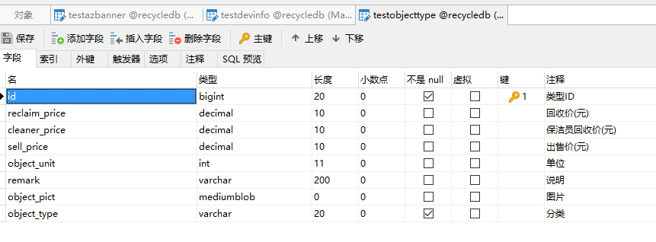

4. testrecycler: 回收员表

public enum roleType { 内部回收员, 外部回收员, 运维员 }

public enum onoffType { 打开, 关闭 }

[SugarTable("TestRecycler", "回收员表")]

public class TestRecycler

{

[SugarColumn(ColumnDescription = "ID", IsPrimaryKey = true, IsIdentity = true)] //主键

public int id { get; set; }

[SugarColumn(ColumnDescription = "昵称", Length = 50)]

public string nick_name { get; set; }

[SugarColumn(ColumnDescription = "头像", ColumnDataType = DbCfg.PictFiledName, IsNullable = true)]

public byte[] recycler_pict { get; set; }

[SugarColumn(ColumnDescription = "电话", Length = 30, IsNullable = true)]

public string telephone { get; set; }

[SugarColumn(ColumnDescription = "角色", IsNullable = true)]

public roleType recycler_role { get; set; }

[SugarColumn(ColumnDescription = "密码", Length = 30, IsNullable = true)]

public string recycler_pass { get; set; }

[SugarColumn(ColumnDescription = "性别", IsNullable = true)]

public userSex recycler_sex { get; set; }

[SugarColumn(ColumnDescription = "溢满报警", IsNullable = true)]

public onoffType fullwarning { get; set; }

[SugarColumn(ColumnDescription = "故障报警", IsNullable = true)]

public onoffType faultwarning { get; set; }

[SugarColumn(ColumnDescription = "分配设备", Length = 50, IsNullable = true)]

public string allocatedevice { get; set; }

}

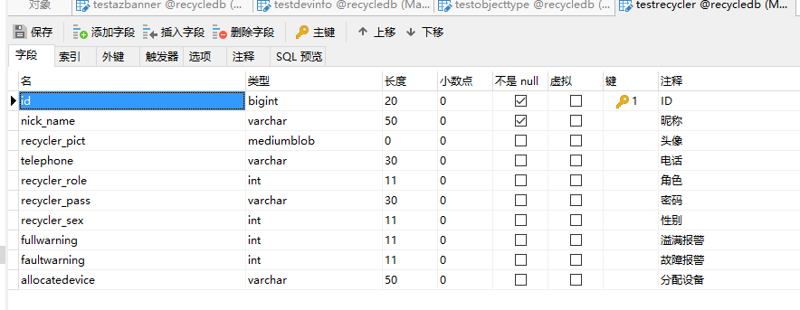

5. testuserinfo: 用户管理

public enum userType { 普通用户, 管理员, 超级管理员 }

public enum userSex { 男 = 1, 女 = 2 }

public enum limitState { 允许登录, 禁止登录,暂停登录 }

[SugarTable("TestUserInfo", "用户管理")]

public class TestUserInfo

{

[SugarColumn(ColumnDescription = "ID", IsPrimaryKey = true, IsIdentity = true)] //主键

public int id { get; set; }

[SugarColumn(ColumnDescription = "用户ID", Length = 20)]

public string user_id { get; set; }

[SugarColumn(ColumnDescription = "用户类别")]

public userType user_type { get; set; }

[SugarColumn(ColumnDescription = "等级", Length = 20)]

public string user_level { get; set; }

[SugarColumn(ColumnDescription = "昵称", Length = 128)]

public string nick_name { get; set; }

[SugarColumn(ColumnDescription = "头像", ColumnDataType = DbCfg.PictFiledName, IsNullable = true)]

public byte[] user_pict { get; set; }

[SugarColumn(ColumnDescription = "性别")]

public userSex user_sex { get; set; }

[SugarColumn(ColumnDescription = "电话", Length = 20)]

public string telephone { get; set; }

[SugarColumn(ColumnDescription = "总积分", Length = 20)]

public decimal totalintegral { get; set; }

[SugarColumn(ColumnDescription = "当前积分", Length = 20)]

public decimal currintegral { get; set; }

[SugarColumn(ColumnDescription = "登陆限制")]

public limitState loginlimit { get; set; }

[SugarColumn(ColumnDescription = "注册设备", Length = 20)]

public string registedev { get; set; }

[SugarColumn(ColumnDescription = "注册时间")]

public DateTime registetime { get; set; }

}

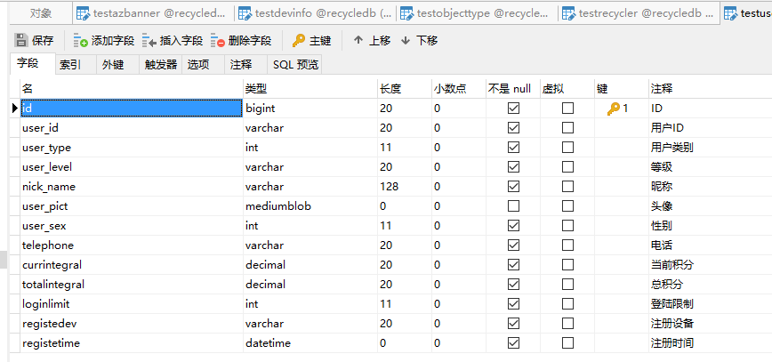

6. testxcxbanner: 小程序广告

[SugarTable("TestXcxBanner", "小程序广告")]

public class TestXcxBanner

{

[SugarColumn(ColumnDescription = "ID",IsPrimaryKey = true, IsIdentity = true)]

public int id { get; set; }

[SugarColumn(ColumnDescription = "名称", Length = 30)]

public string banner_name { get; set; }

[SugarColumn(ColumnDescription = "图片", ColumnDataType = DbCfg.PictFiledName, IsNullable = true)]

public byte[] banner_pict { get; set; }

[SugarColumn(ColumnDescription = "类型", IsNullable = true)]

public bannerType banner_type { get; set; }

[SugarColumn(ColumnDescription = "启用", IsNullable = true)]

public bool banner_enable { get; set; }

[SugarColumn(ColumnDescription = "创建时间")]

public DateTime createtime { get; set; }

}

