Programming Assignment 02

Patient Vitals Management System

Design Document

Name - Lonath Ransilu Ranaweera
Email – a3011471@adelaide.edu.au
Student Id – A3011471

Introduction
This design document explains the changes made to the Patient Vitals Management System for Assignment 2. It presents the final class design and explains how the Adapter, Composite, Strategy, and Observer patterns were used to satisfy the four functional requirements within the overall system.

FR1: Load Patients from a file
- Class diagram –
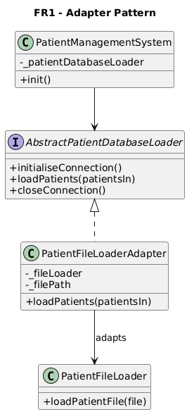
Figure 1 – FR1 Adapter pattern class diagram.

- Design Pattern – Adapter Pattern
- Reasoning –
The Adapter pattern was chosen because the existing PatientManagementSystem works through the AbstractPatientDatabaseLoader interface, but the given PatientFileLoader has a different interface through loadPatientFile().
It was also stated in the instructions that this PatientFileLoader header interface must not be changed, while the file loading still needs to use the AbstractPatientDatabaseLoader. The PatientFileLoaderAdapter here solves this problem by wrapping PatientFileLoader and allowing the same functions expected by the patient management system. This allows the system to load patients from a file without changing the main system design.
- How it works –
PatientManagementSystem stores the loader as an AbstractPatientDatabaseLoader so that it does not need to know the exact loader type.
- PatientFileLoaderAdapter inherits from the AbstractPatientDatabaseLoader.
- PatientFileLoaderAdapter stores an object of PatientFileLoader and the file path of patients.txt.
- When the loadPatients() is called, the adapter calls PatientFileLoader::loadPatientFile().
- PatientFileLoader then reads each line of the file, splits the details, creates Patient objects and adds any previous Vitals.
- So, switching from the database loader and file loader now only needs to change the loader object in the patient management system.
- Git commits –
- I first completed the PatientFileLoader to setup parsing logic in commit – 42325e0.
- Then, I added an adapter to wrap the patient file loader in commit - 6bcd1c7.
- Finally, in commit 0f029a8, I used the file loader adapter in the patient system.

FR2: Load Patients from file and database
- Class diagram –
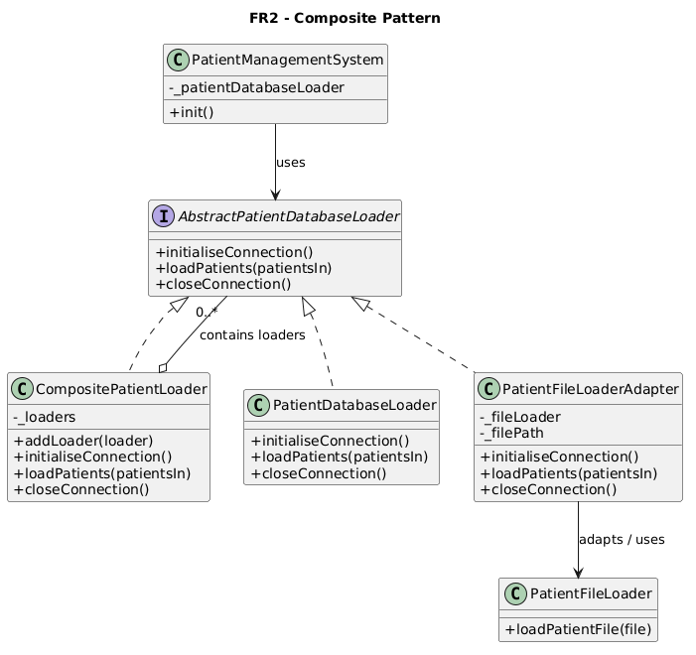
Figure 2 – FR2 Composite pattern class diagram.

- Design Pattern – Composite Pattern
- Reasoning –
The Composite pattern was chosen because multiple loaders need to be treated as one loader. FR2 requires patients to be loaded from the database first and file loaded second. So instead of making PatientManagementSystem directly manage many loaders, the CompositePatientLoader implements the same AbstractPatientDatabaseLoader interface and stores a collection of loaders. This lets PatientManagementSystem interact with one loader object while the composite runs both the database loader and the file loader adapter in order internally.
- How it works –
- PatientManagementSystem creates a CompositePatientLoader.
- A PatientDatabaseLoader is first added to the composite.
- A PatientFileLoaderAdapter is then added to the composite.
- PatientManagementSystem stores the composite as an AbstractPatientDatabaseLoader.
- When initialiseConnection() is called, the composite forwards the call to each contained loader.
- When loadPatients() is called, the composite loads the database patients first, then file patients.
- Both loaders add their patients into the same patient vector.
- PatientManagementSystem then builds the patient lookup map from the combined patient list.
- Because the composite still uses the abstract loader interface, switching between database-only, file-only, or database-plus-file can be done in one place.
- Git commits –
- I first added the composite patient loader class and functionality in commit - 75a0d4f.
- I then updated the system so that patients are loaded from the database first and from the file second in commit - bcc5d2c.

FR3: Calculate the patient alert levels.
- Class diagram –
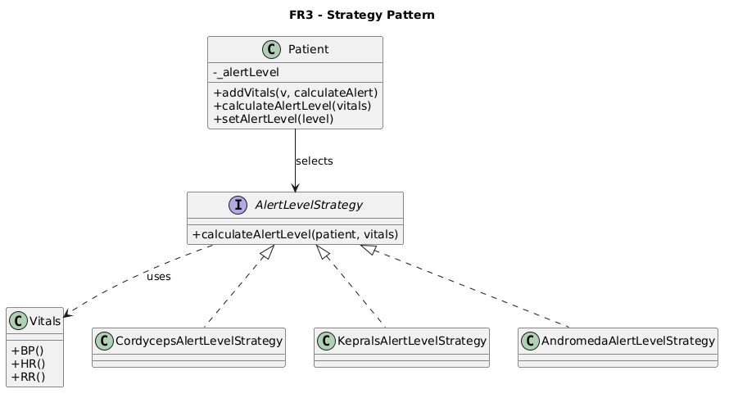
Figure 3 – FR3 Strategy pattern class diagram.

- Design Pattern – Strategy Pattern
- Reasoning –
The Strategy pattern was chosen because each disease has a different algorithm for calculating a patient’s alert level. Cordyceps Brain Infection uses respiratory rate, Kepral’s Syndrome uses heart rate and age, and Andromeda Strain uses blood pressure. Keeping all these rules inside Patient would have made the class harder to maintain and extend. So, by using different strategy classes, each disease-specific calculation was isolated in its own class, while the Patient would only need to select the correct strategy based on their diagnosis.
- How it works –
  - When new vitals are recorded, PatientManagementSystem creates a new Vitals object.
  - The new vitals are added to the selected patient using Patient::addVitals().
  - For new vitals records, alert calculation is enabled by default.
  - Patient::calculateAlertLevel() checks the patient’s primary diagnosis.
  - If the patient has Cordyceps Brain Infection, CordycepsAlertLevelStrategy is used.
  - If the patient has Kepral’s Syndrome, KepralsAlertLevelStrategy is used.
  - If the patient has Andromeda Strain, AndromedaAlertLevelStrategy is used.
  - The selected strategy returns an AlertLevel.
  - Patient::setAlertLevel() then updates the patient’s alert level.
  - Historical vitals loaded from the database or file use addVitals(v, false), so that they would not trigger any alert calculations.
- Git commits –
- I first added an Alert Level strategy interface for the alert level calculation design in commit - 84ca4d1.
- I then added disease specific alert strategy classes for each disease in commit - 742be7e.
- Finally, I connected the strategy logic for alert levels to be calculated for newly recorded vitals in commit - 5f90828.

FR4: Alert the hospitals and GPs.
- Class diagram –
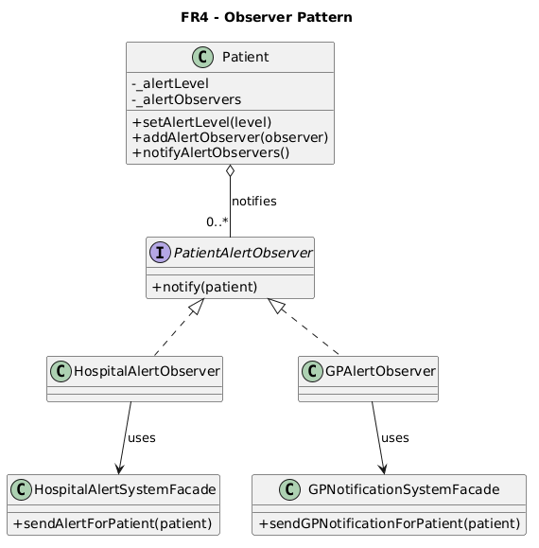
Figure 4 – FR4 Observer pattern class diagram.
- Design Pattern – Observer Pattern
- Reasoning –
The Observer pattern was chosen because the hospital and GP systems need to immediately react when a patient’s alert level changes to Red. The Patient class is the subject because its alert level is the state that’s monitored. The hospital and GP observer classes are notified when this state becomes Red. This avoids placing hospital and GP notification logic inside the alert calculation code, while also still connecting the provided facade classes to patient alert changes as needed.

- How it works –
  - PatientAlertObserver defines a common notify(Patient*) function for alert observers.
  - HospitalAlertObserver implements this interface and contains a HospitalAlertSystemFacade.
  - GPAlertObserver then implements this interface and contains a GPNotificationSystemFacade.
  - During system initialisation, PatientManagementSystem registers both observers with each patient.
  - When new vitals are recorded, the Strategy pattern calculates the patient’s alert level.
  - Patient::setAlertLevel() would then update the alert level.
  - If the alert level is Red, Patient::notifyAlertObservers() is called.
  - Each registered observer receives the patient through notify().
  - HospitalAlertObserver will then call HospitalAlertSystemFacade::sendAlertForPatient().
  - GPAlertObserver will call GPNotificationSystemFacade::sendGPNotificationForPatient().
  - Finally, if the alert level becomes Yellow or Orange, the patient alert level is printed, but hospital and GP notifications will not be sent.
- Git commits –
- I first added the PatientAlertObserver interface for the observer design in commit - 51f2e9c.
- I then set up hospital and GP alert observer classes that use the given facade classes in commit - 2d2a4b.
- Finally, I connected the observer notification process so patients would notify observers when the alert level becomes red in commit - 3abc748.

NFR1 - Class Diagram of the Final Design:
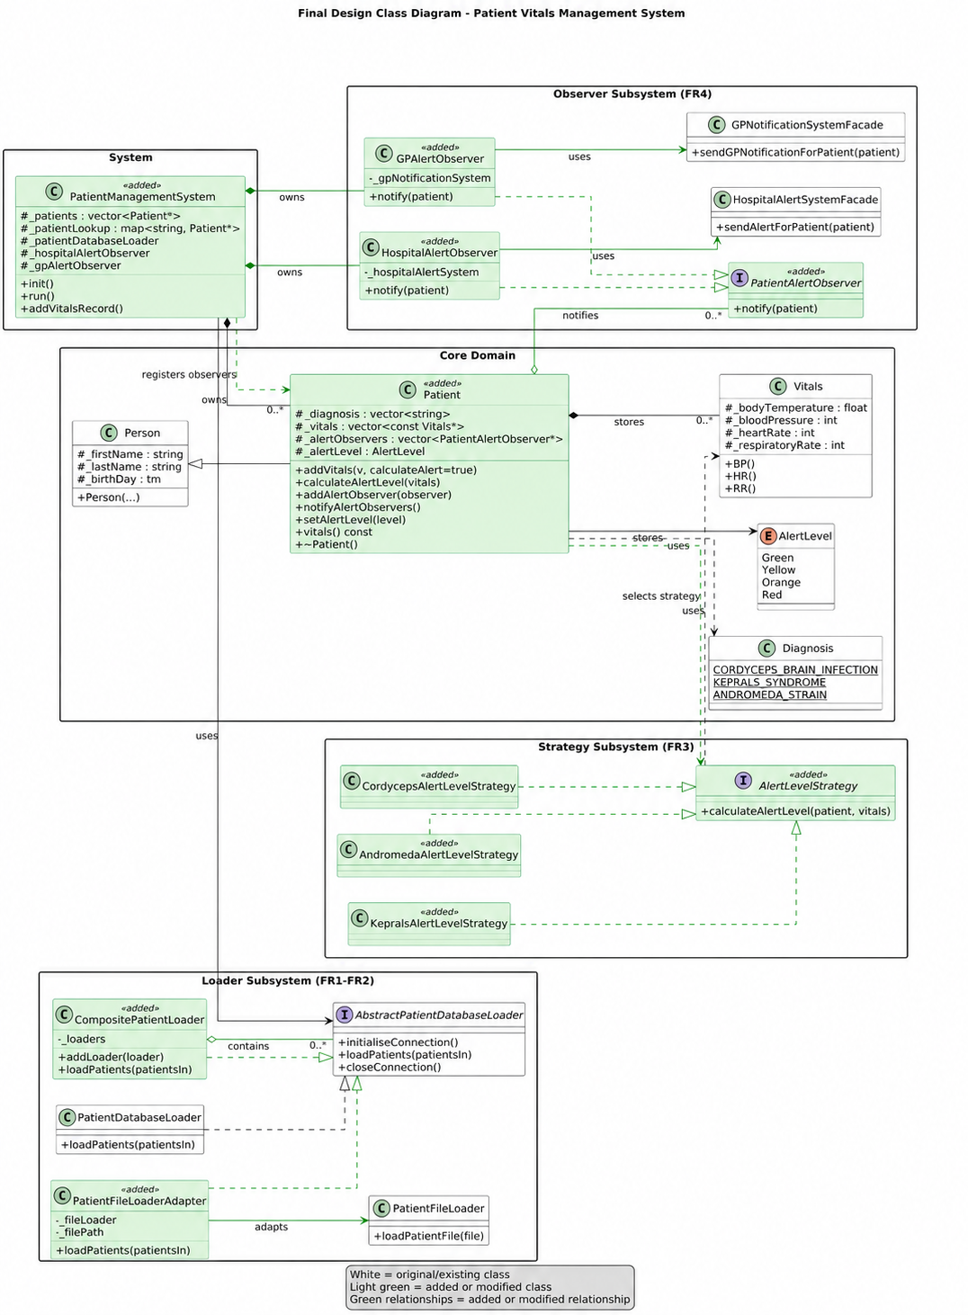
Figure 5 – Final design overview class diagram

The above class diagram shows the final design overview of the Patient Vitals Management System after the implementation of FR1 - FR4. Green highlighting above identifies the new and modified classes and relationships. The diagram includes the original classes, the main new and modified classes, and the key relationships added in the Adapter, Composite, Strategy, and Observer patterns.

Project Repository -
https://github.com/ransiSe7en/programming-assignment-2-patient-system

