SQL Hands on:

Schema:

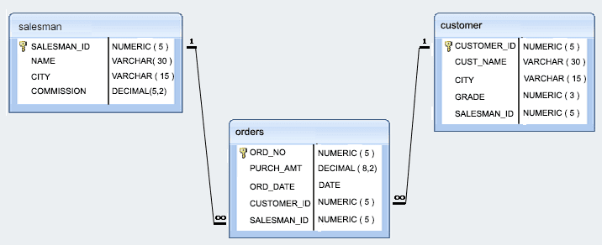

*Sample table*: salesman

salesman_id | name | city | commission

-------------+------------+----------+------------

5001 | James Hoog | New York | 0.15

5002 | Nail Knite | Paris | 0.13

5005 | Pit Alex | London | 0.11

5006 | Mc Lyon | Paris | 0.14

5007 | Paul Adam | Rome | 0.13

5003 | Lauson Hen | San Jose | 0.12

*Sample table*: orders

ord_no purch_amt ord_date customer_id salesman_id

---------- ---------- ---------- ----------- -----------

70001 150.5 2012-10-05 3005 5002

70009 270.65 2012-09-10 3001 5005

70002 65.26 2012-10-05 3002 5001

70004 110.5 2012-08-17 3009 5003

70007 948.5 2012-09-10 3005 5002

70005 2400.6 2012-07-27 3007 5001

70008 5760 2012-09-10 3002 5001

70010 1983.43 2012-10-10 3004 5006

70003 2480.4 2012-10-10 3009 5003

70012 250.45 2012-06-27 3008 5002

70011 75.29 2012-08-17 3003 5007

70013 3045.6 2012-04-25 3002 5001

*Sample table*: customer

customer_id | cust_name | city | grade | salesman_id

-------------+----------------+------------+-------+-------------

3002 | Nick Rimando | New York | 100 | 5001

3007 | Brad Davis | New York | 200 | 5001

3005 | Graham Zusi | California | 200 | 5002

3008 | Julian Green | London | 300 | 5002

3004 | Fabian Johnson | Paris | 300 | 5006

3009 | Geoff Cameron | Berlin | 100 | 5003

3003 | Jozy Altidor | Moscow | 200 | 5007

3001 | Brad Guzan | London | | 5005

1. Write a query to display the columns in a specific order like order date, salesman id, order number and purchase amount from for all the orders
2. write a SQL query to find the unique salespeople ID. Return salesman_id.
3. write a SQL query to find the salespeople who lives in the City of 'Paris'. Return salesperson's name, city
4. write a SQL query to find the orders, which are delivered by a salesperson of ID. 5001. Return ord_no, ord_date, purch_amt
5. write a SQL query to find all the customers in ‘New York’ city who have a grade value above 100. Return customer_id, cust_name, city, grade, and salesman_id.
6. write a SQL query to find the details of those salespeople whose commissions range from 0.10 to0.12. Return salesman_id, name, city, and commission
7. write a SQL query to calculate total purchase amount of all orders. Return total purchase amount.
8. write a SQL query to calculate average purchase amount of all orders. Return average purchase amount.
9. write a SQL query to count the number of unique salespeople. Return number of salespeople.
10. write a SQL query to find the highest purchase amount ordered by each customer. Return customer ID, maximum purchase amount
11. write a SQL query to find the highest purchase amount ordered by each customer on a particular date. Return, order date and highest purchase amoun
12. write a SQL query to find the highest purchase amount on '2012-08-17' by each salesperson. Return salesperson ID, purchase amount.
13. write a SQL query to find the salesperson and customer who belongs to same city. Return Salesman, cust_name and city.
14. write a SQL query to find those orders where order amount exists between 500 and 2000. Return ord_no, purch_amt, cust_name, city
15. write a SQL query to find those salespersons who received a commission from the company more than 12%. Return Customer Name, customer city, Salesman, commission
16. write a SQL query to display the cust_name, customer city, grade, Salesman, salesman city. The result should be ordered by ascending on customer_id.