Jenkins URL : <http://15.206.34.235:8080/view/SurveyShrike/>

Application URL on AWS : <http://15.206.34.235:4200>

AWS public Image name (AMI) (With Jenkins and application) on **Asia Pacific (Mumbai) Region** : **SurveyShrike-RanuGhosh**

**About**

Survey shrike is a free online survey tool. SurveyShrike help businesses conduct surveys. SurveyShrike believes every customer has different views or comments about services and over all products. And every business needs to know right customer mindset to engage customers for long run. SurveyShrike is trying to solve this problem and needs your help to build a web-based application.

**Architecture**

Below is the application Architecture diagram.

Where We have two major components:

* **SurveyShrike-Backend:** Exposes Rest Webservice for SurveyShrike Frontends to communicate to Persistence layer (Mongo DB)

**Tech Stack:**

* Java 1.8
* Maven
* Spring Boot
* JWT for Authentication
* Mongo DB (No SQL Database) for persisting Data
* Spring Data Rest: Spring Data REST is part of the umbrella Spring Data project and makes it easy to build hypermedia-driven REST web services on top of Spring Data repositories
* Testing frame work
* **SurveyShrike-UI:** Provides the User Interface for Survey Shrike.

**Tech Stack:**

* Angular
* npm
* [Angular CLI](https://github.com/angular/angular-cli) version 8.3.
* Bootstrap

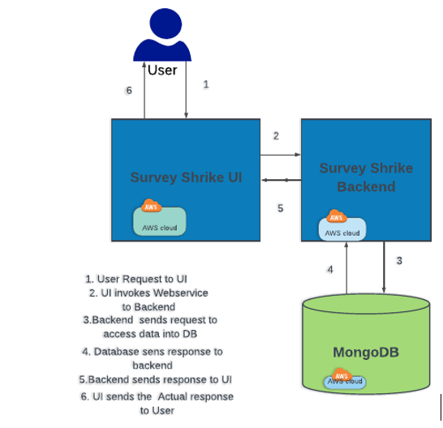

**Functional Overview**

* SuerveyShrike provides a Page for Register a User with option Admin or NonAdmin. Once the User is registered. User will be asked to Login.
* User will be authenticated using JWT
* **Non Admin user:**
* If logged in using Non admin user, user will be able to view and fill various available Survey for that at first user will be asked to select a specific survey and fill the information and submit.
* The submitted survey information will be persisted into Database (Mongo DB)
* **Admin user:**
* If logged in using Admin user, they will be having multiple option such as

1) Creating a new Survey format

2)View all the filled Survey information

3) Fill a specific Survey information.

**Deployment Into AWS**

Survey Shrike is configured to be deployed on AWS EC2 Instance.

We have created an EC2 instance with following properties:

* CPU: 1
* Memory: 1GB
* EBS: 60GB
* Type: t2.micro
* Operation System: Windows

**Final AWS AMI Image on Asia Pacific (Mumbai) Region: SurveyShrike-RanuGhosh**

**Elastic Ip :** **15.206.34.235**

**SurveyShrike-Backend:**

We have used **Jenkins CI CD Pipeline (which is hosted on an AWS EC2 Instance)** to Build and test on every git commit and on demand deployment on AWS Ec2 instance.

**Server Host:** 15.206.34.235

**Hosted application URL:** <http://15.206.34.235:9092/SurveyShrike>

**Jenkins Details:**

Url: <http://15.206.34.235:8080/view/SurveyShrike>

User Name:

Password:

# **Pipeline: Build And Test-SurveyShrike-backend:**

**URL :** <http://15.206.34.235:8080/job/Build%20And%20Test-SurveyShrike-backend/>

**Pipeline file Name:**

**Build Trigger:** After Each git push using git Webhook trigger this build gets triggered.

**Result:** It build the projects and publish the junit report

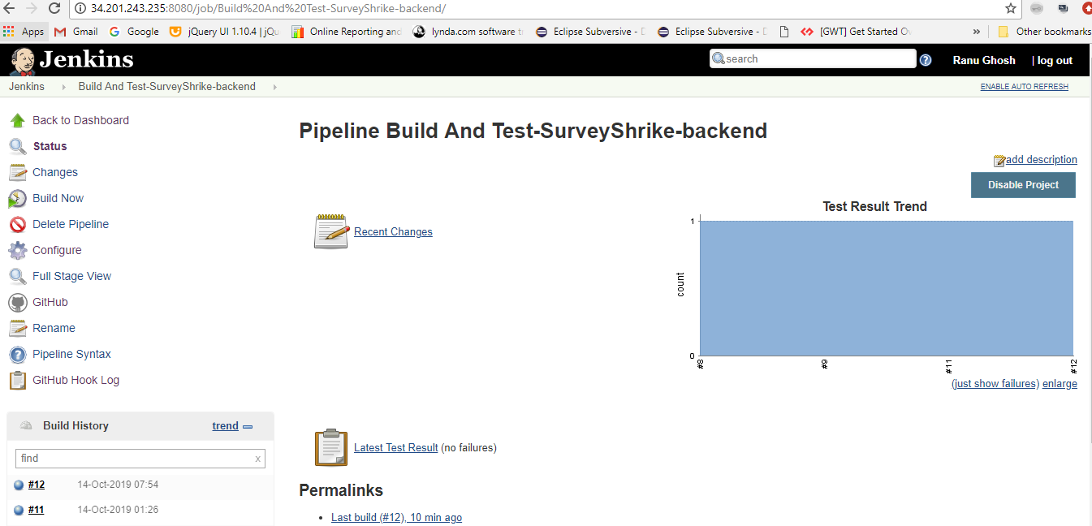

# **Pipeline: Build And Deploy-SurveyShrike-backend:**

**URL :** <http://15.206.34.235:8080/job/Build%20And%20Deploy-SurveyShrike-backend/>

**Pipeline file Name:**

**Build Trigger:** On Demand.

**Result:** It build the projects and deployed the application on configured AWS EC2 instance.

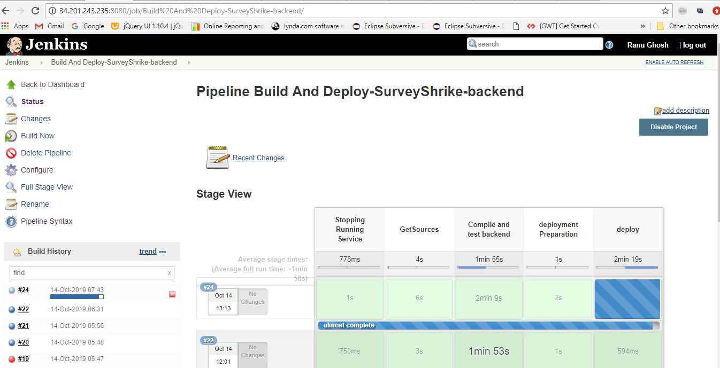

**SurveyShrike-UI:**

We have used **Jenkins CI CD Pipeline (which is hosted on a AWS EC2 Instance)** to deploy SurveyShrike-Ui on AWS Ec2 instance on demand.

**Server Host: 34.201.243.235**

**Hosted application URL:** <http://15.206.34.235:4200>

**Jenkins Details:**

Url: <http://15.206.34.235:8080/view/SurveyShrike>

User Name:

Password:

# **Pipeline: Deploy-SurveyShrike-ui:**

**URL :** <http://15.206.34.235:8080/view/SurveyShrike/job/Deploy-SurveyShrike-ui/>

**Pipeline file Name:**

**Build Trigger:** On Demand.

**Result:** It deploy the SurveyShrike-ui components on configured AWS EC2 instance.

