

Software Architecture

MTIT GROUP ASSIGNMENT - 01

MICRO-KERNEL ARCHITECTURE

2020.02.24

**GROUP MEMBERS**

IT16151420 - Sankalpa M.A.R.L

Explain the Scenario Using a Diagrams

System Overview

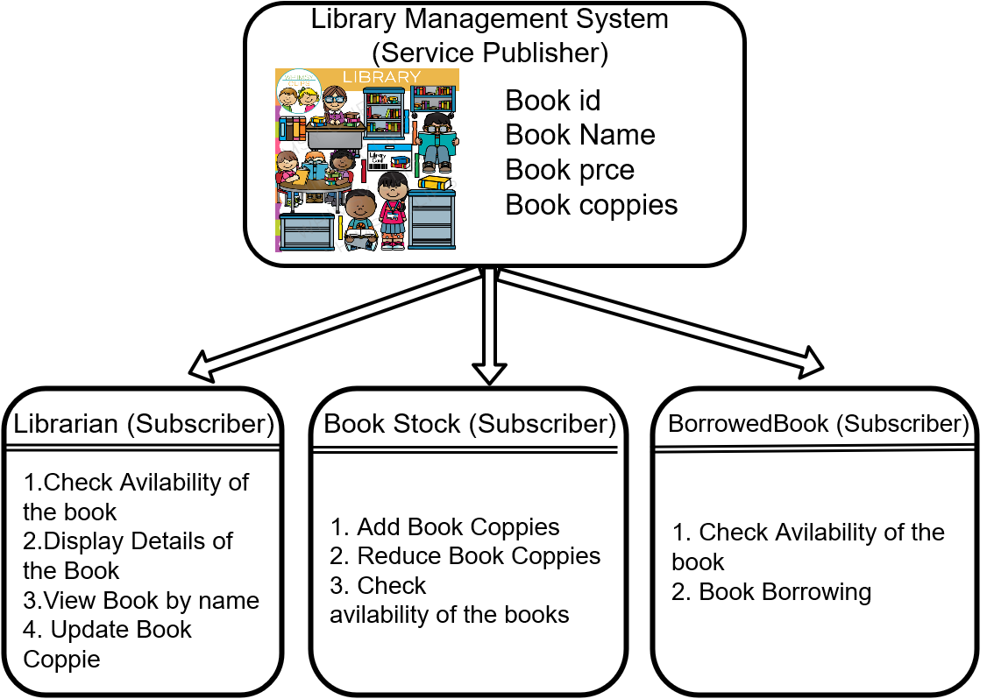

This system is an implementation of an library management system to describe the **Producer-Consumer scenario**. There are three actors in this case who get the service of library.

We have implemented a separate publisher bundle for library service and three consumer bundles which consume the publisher service.

We created two diagrams to explain the system.

* Use Case Diagram
* Sequence Diagram

## Use Case Diagram

Library Management System

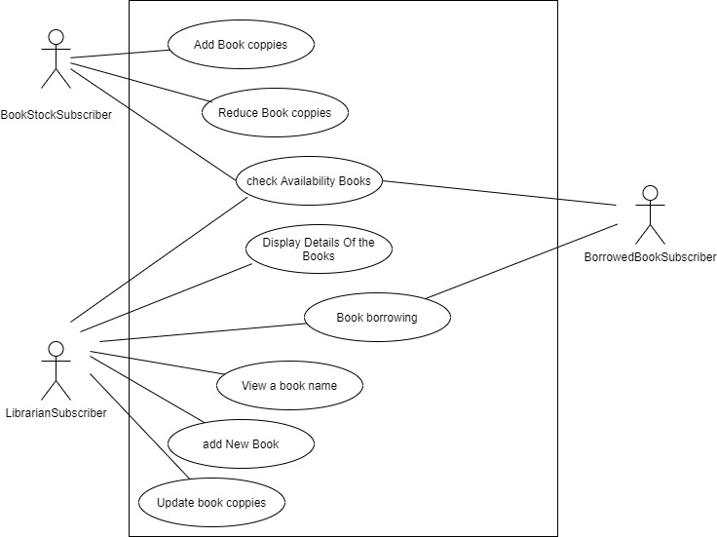

**PART – B**

### Manifest Implementation (Exported Services/Imported Services)

* **Publisher Manifest**

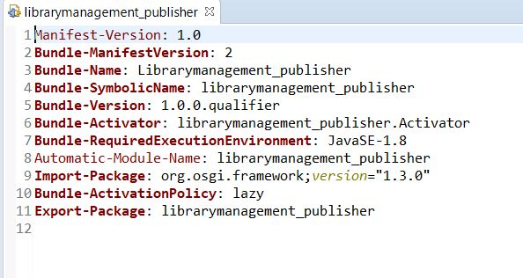

* **(1) Subscriber Manifest –**

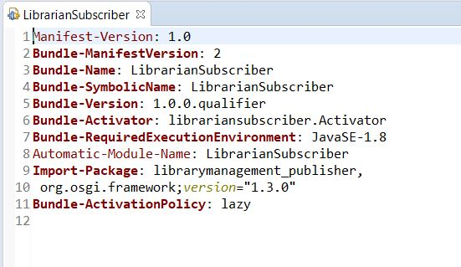

* **(2) Subscriber Manifest –**

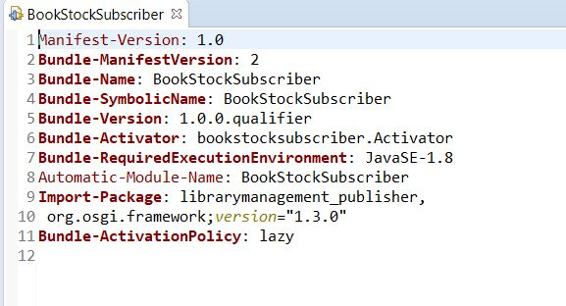

* **(3) Subscriber Manifest –**

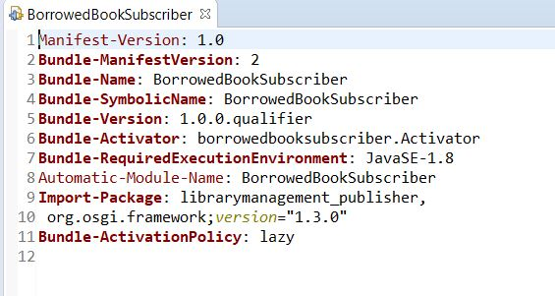

**PART – C**

All Commands of bundle install and run in OSGi framework.

(Step wise mention producer installation and consumer installation and running services)

## Producer Bundle

### Run Configuration

1. Select the **manifest** and **run as => run configuration**. Then modify the name **Library_Management.**
2. Under Workspace, check **librarymanagement_Publisher _1.0.0.qualifier.**
3. Then click Run.

This will run only the LibraryManagement_Publisher. (Not any of the consumer bundles)

In the console enter **ss** (or **lb**) to display all available bundles in equinox OSGi console. In the console, **librarymanagement_Publisher _1.0.0.qualifier** will be displayed as **ACTIVE.**

To stop the service type **stop <bundle id>**.

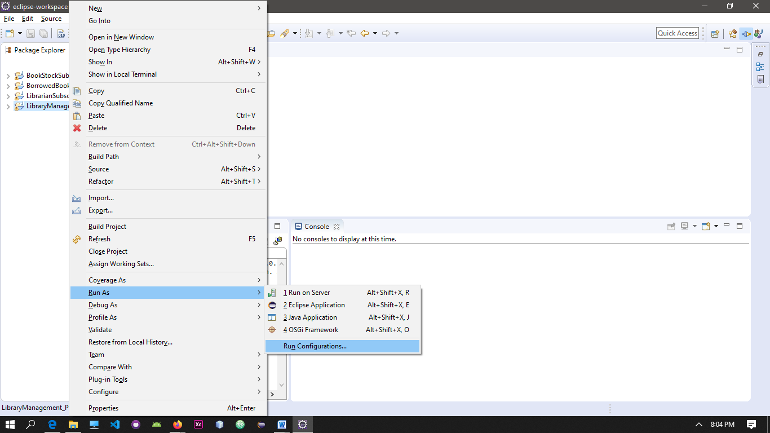

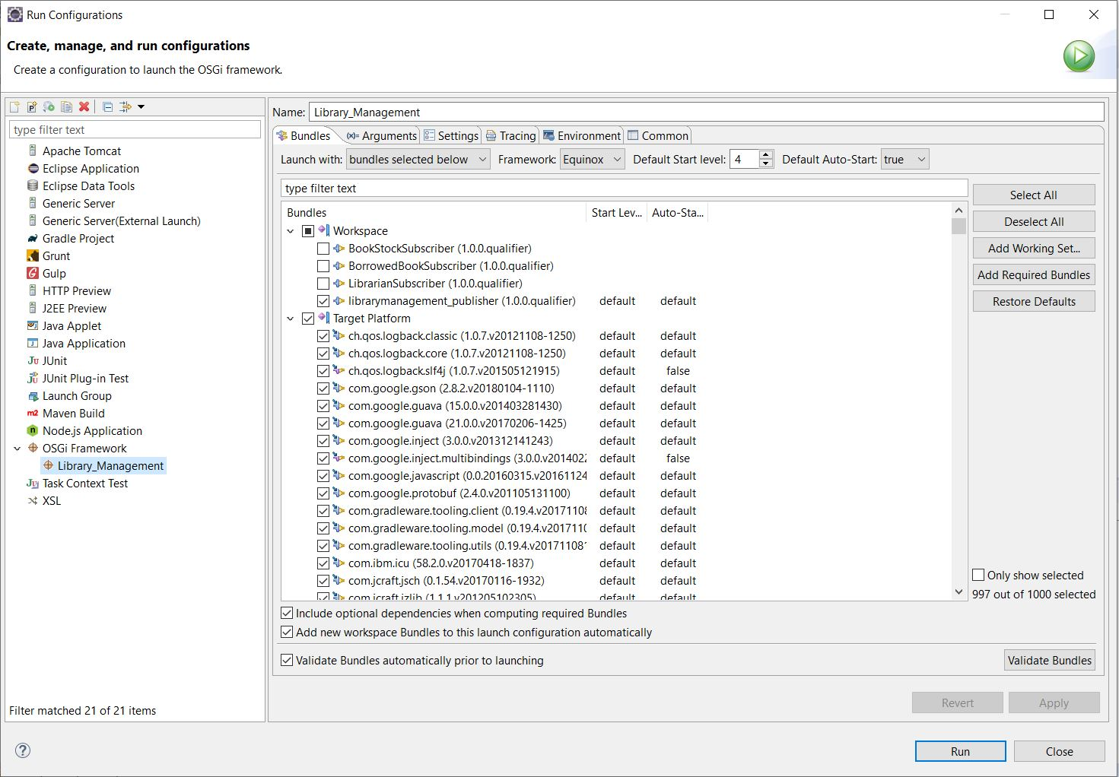

## Subscriber Bundle

### Run Configuration

1. Select the **manifest** and **run as => run configuration**. Then modify the name **Library_Management.**
2. Under Workspace, check both **librarymanagement_Publisher _1.0.0.qualifier** and the **subscriber bundle** (**ServicerSubscriber(1.0.0.qualifier )).**
3. Then click Run.

**PART – D**

Sample Screenshots of its behavior and outputs.

* **Publisher (librarymanagement_Publisher)**

* + **Start the Service**

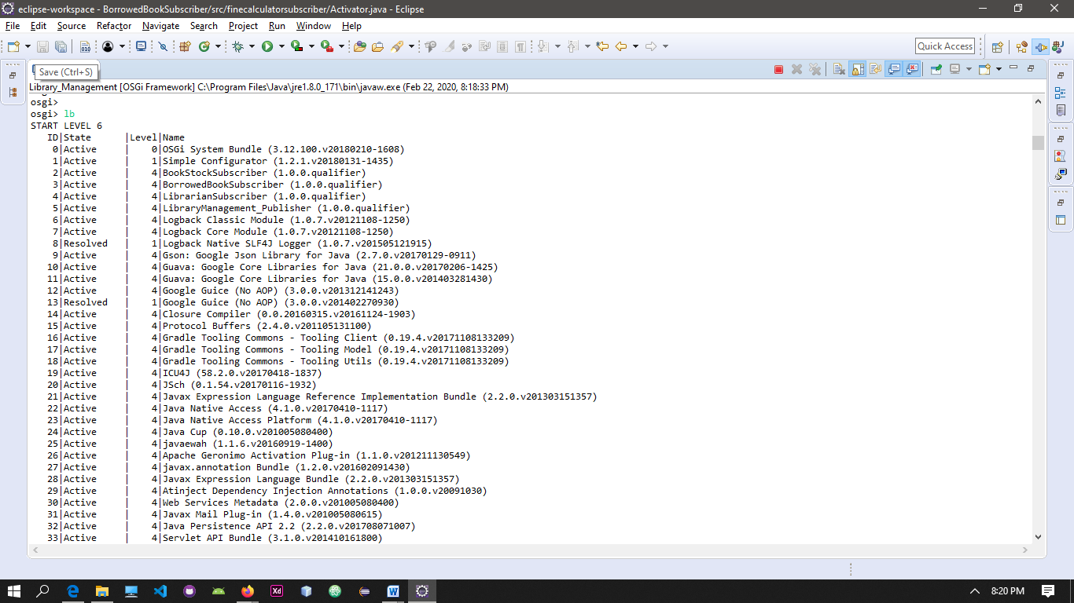

* + **Stop the Service**

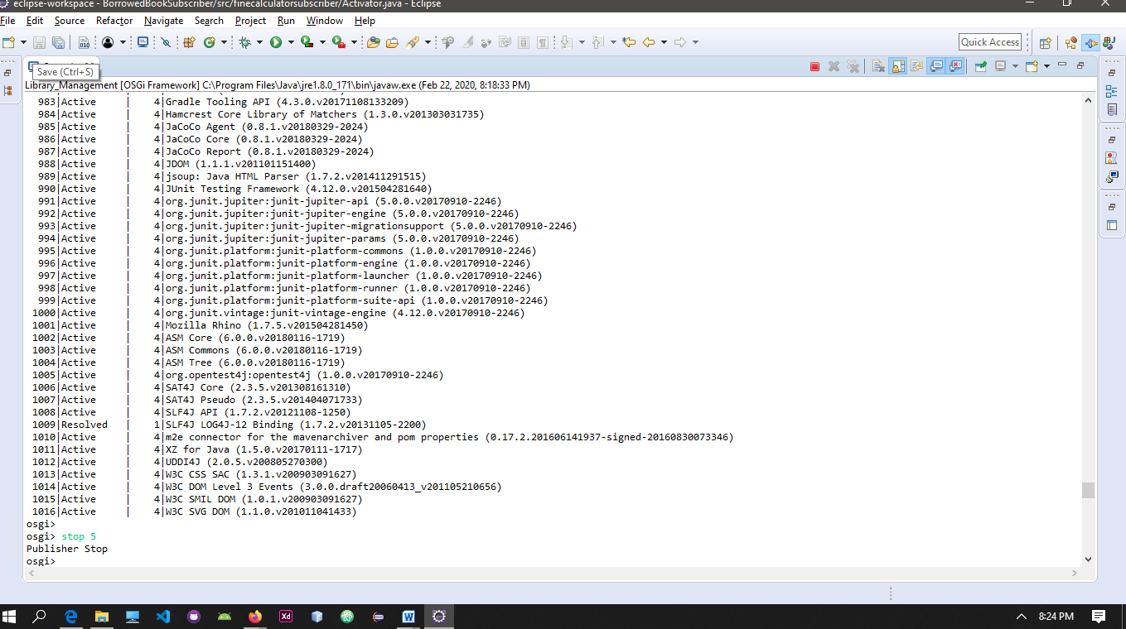

* **BookStockSubscriber**

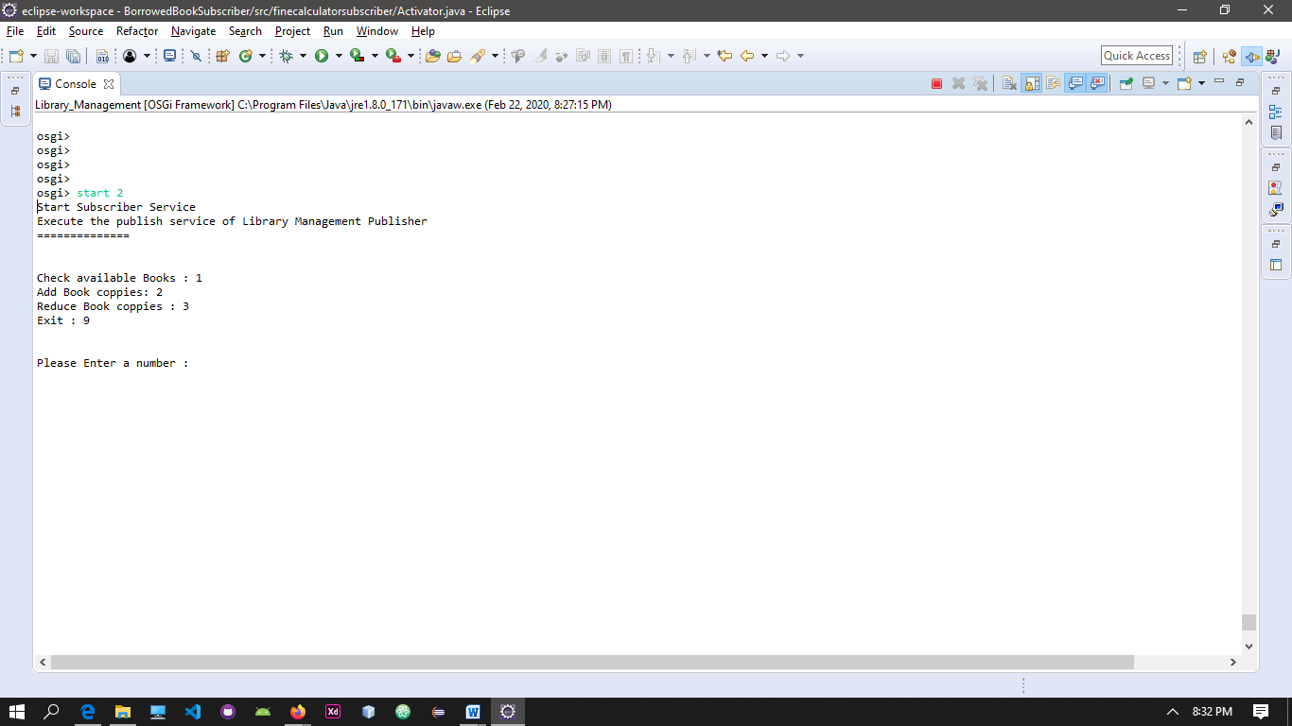

* + **Add New Books**

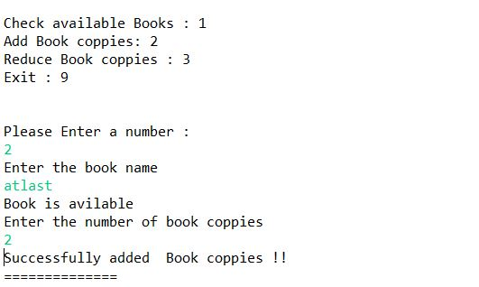

* **Remove Book Copies**

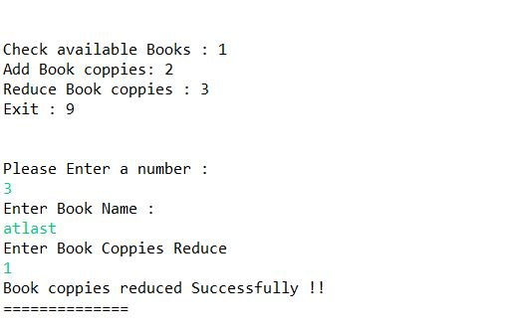

* + **Exit from the Service**

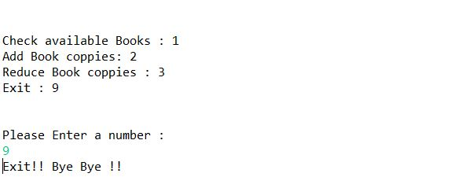

* **Librarian Subscriber** 
  + **Display All Items in the Library**

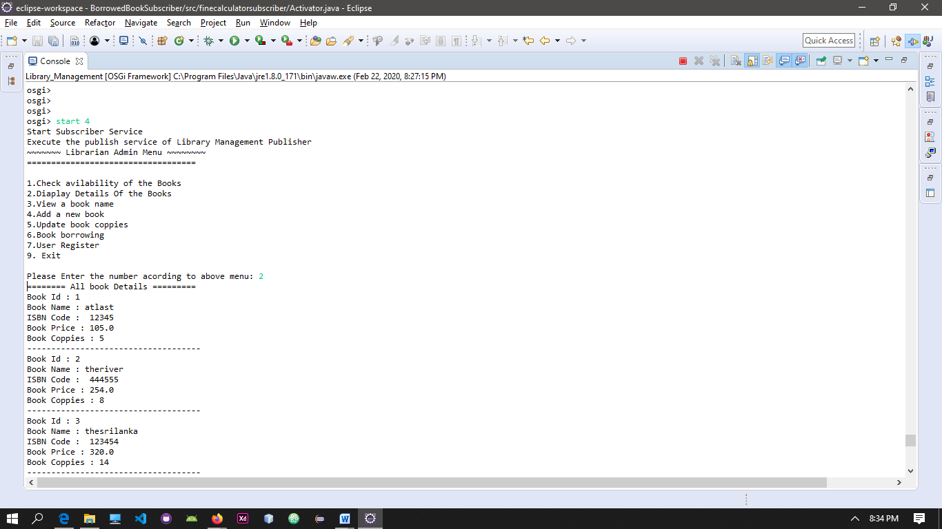

* **View Books**

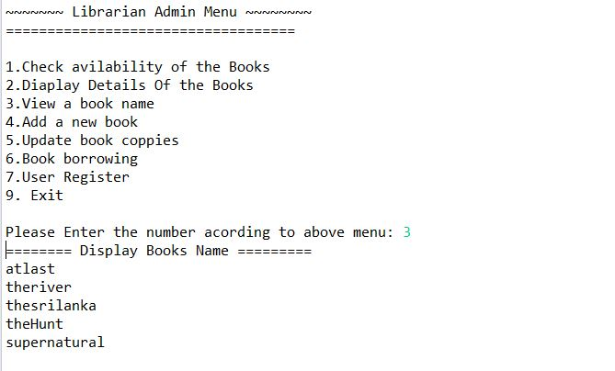

* **Add a new book**

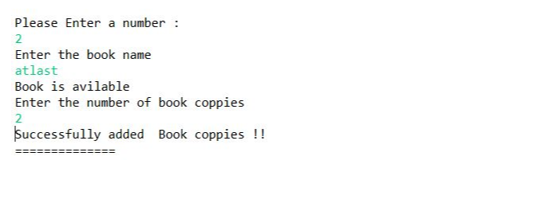

* **Librarian Subscriber**
* **Start the Service**

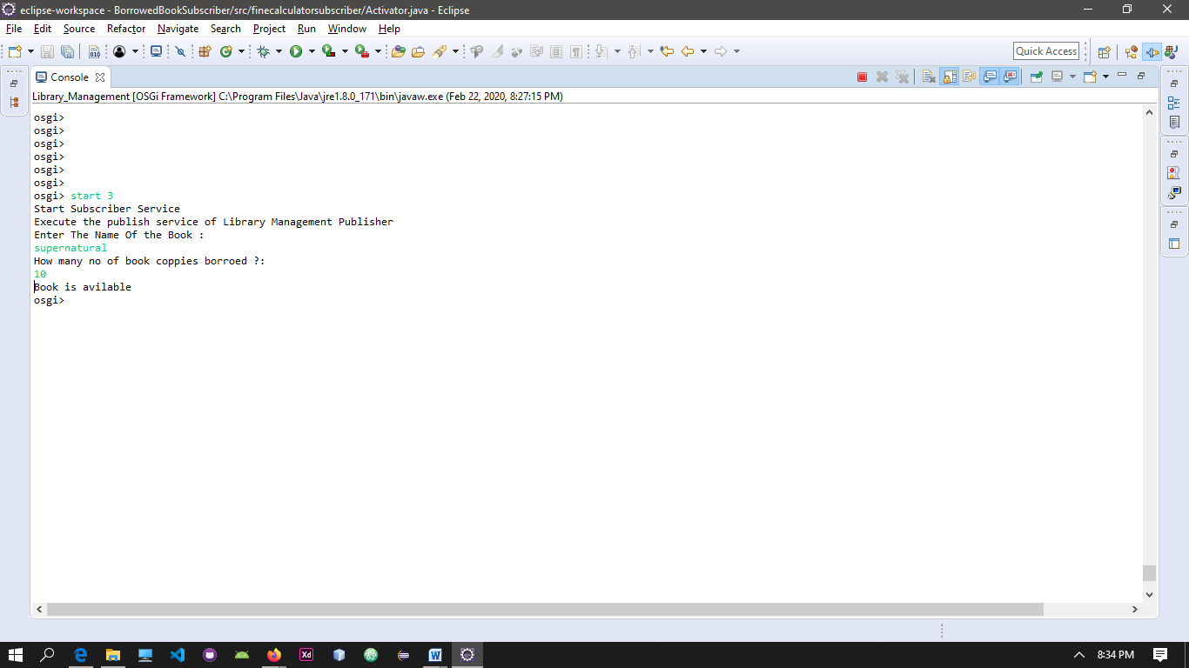

* + **Stop the Service**

