1. To include the app in your project, we need to add a reference to its configuration class in the [**INSTALLED_APPS**](https://docs.djangoproject.com/en/dev/ref/settings/#std:setting-INSTALLED_APPS) setting.

Open your project1.settings and make the following changes

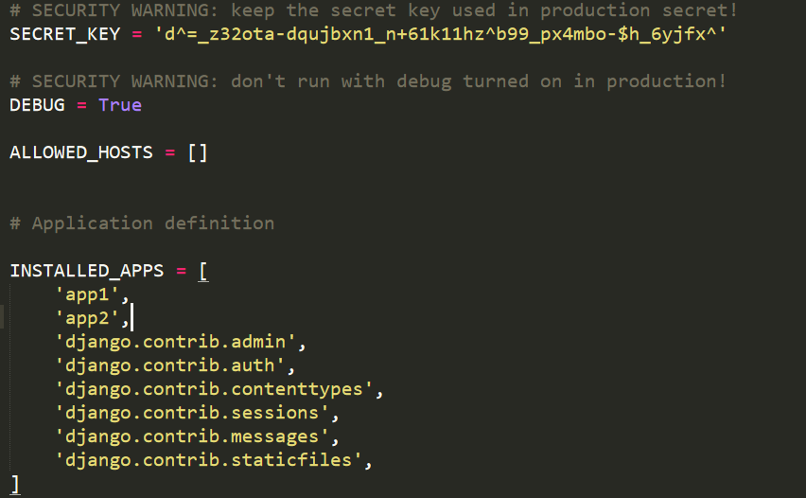

1. The next step is to go in **project1/urls.py**, add an import for **django.urls.include** and insert an [**include()**](https://docs.djangoproject.com/en/dev/ref/urls/#django.urls.include) in the **urlpatterns** list(include is used to include the module passed as an argument to the function), so you have:

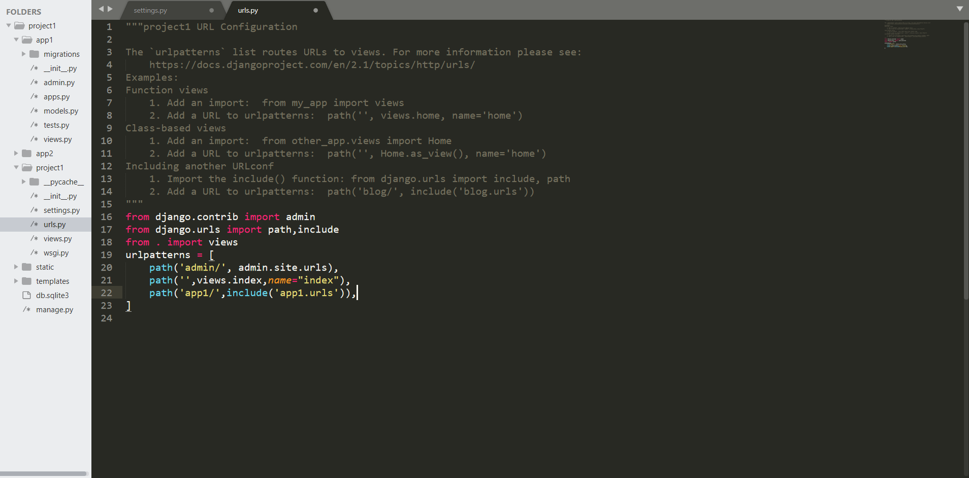

1. Now define the urls of app1 in app1.urls

In the file below the path(‘ ’) is to define the path(‘localhost/app1’).

In the file below it is defined that whenever there will be request for url ‘localhost/app1’ then the request will be forwarded to index function in views.py file.

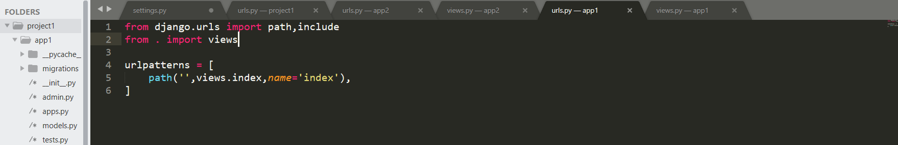

1. Now go to app1.views to define the index function which will return the response to the request.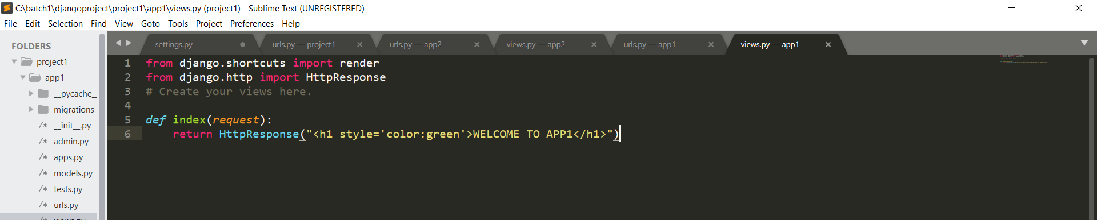
2. To define the path after ‘app1/’ follow the code below:

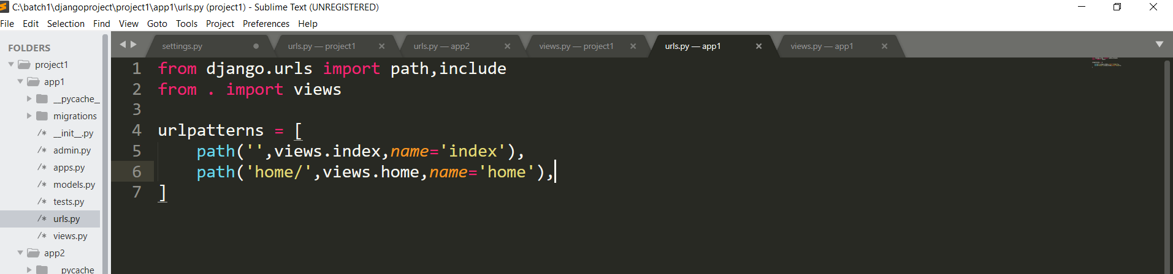

1. Now in the views.py file define the home function to return response of a request.

