# Models

1. To invoke the shell use the following command:

Python manage.py shell

1. After getting into the shell import the model you have created in models.py using the following command:
   1. From app_name.models import class_name

If the app name is app1 and class name is Users then the command will be:

From app1.models import Users.

* 1. You can print the directory of Users if you want to know the functions you can apply.
  2. To check the entries in your model you can use the following:

Users.objects.all() (to check all the objects of your class,here objects are the users those who have signed up)

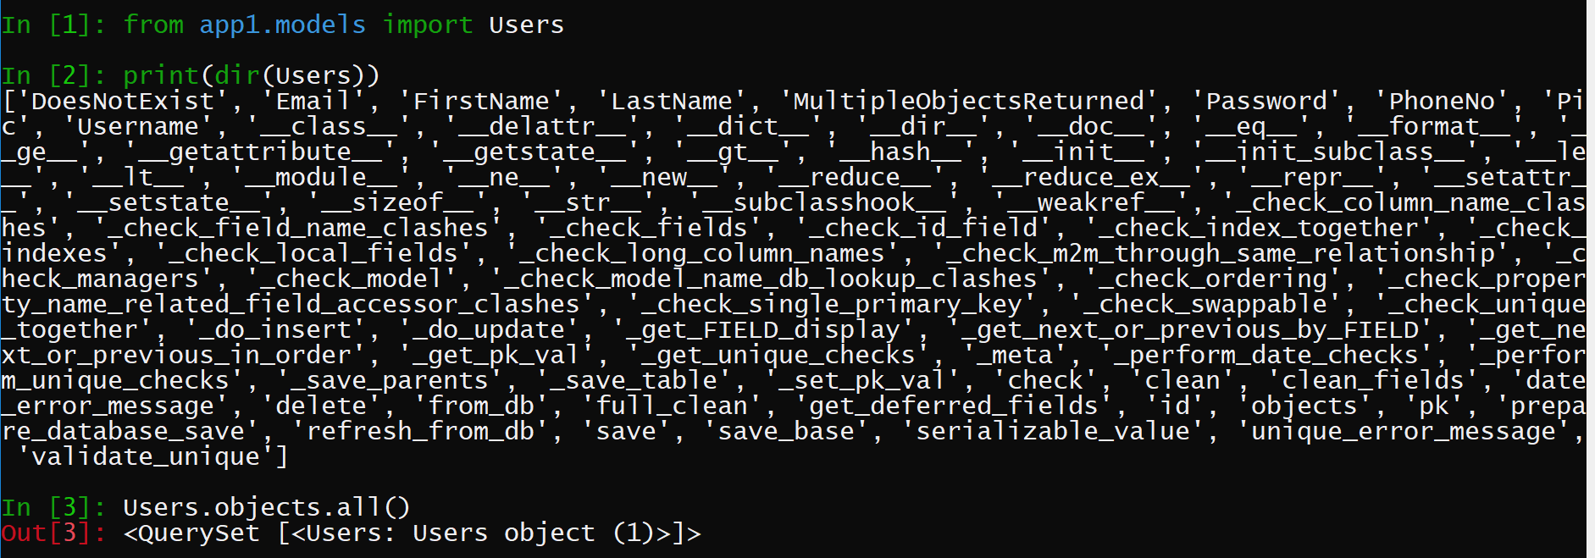

1. If you want to represent each object with its username(i.e primary key of model) then it can be done using ‘__str__’ method.

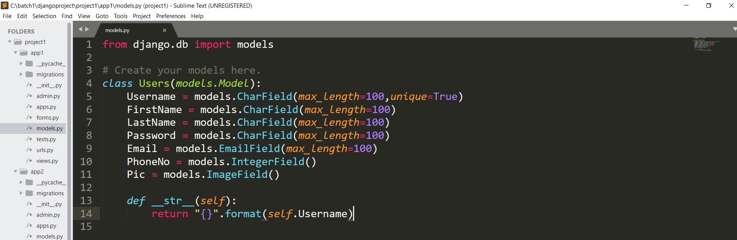



1. Using shell the new objects can be created using the following statement:

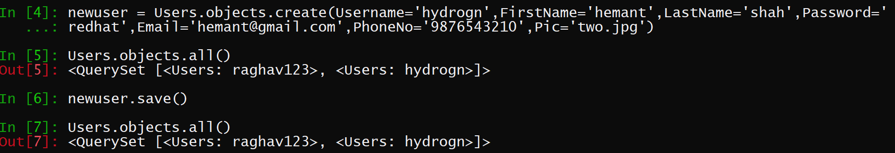

The arguments passed as an argument are the fields of table and its value.

To save objects permanently save() function is used.

1. To get the data of any user or of any object of our model then: (it is equivalent to mysql command i.e select * from user where username=’hydrogn’)

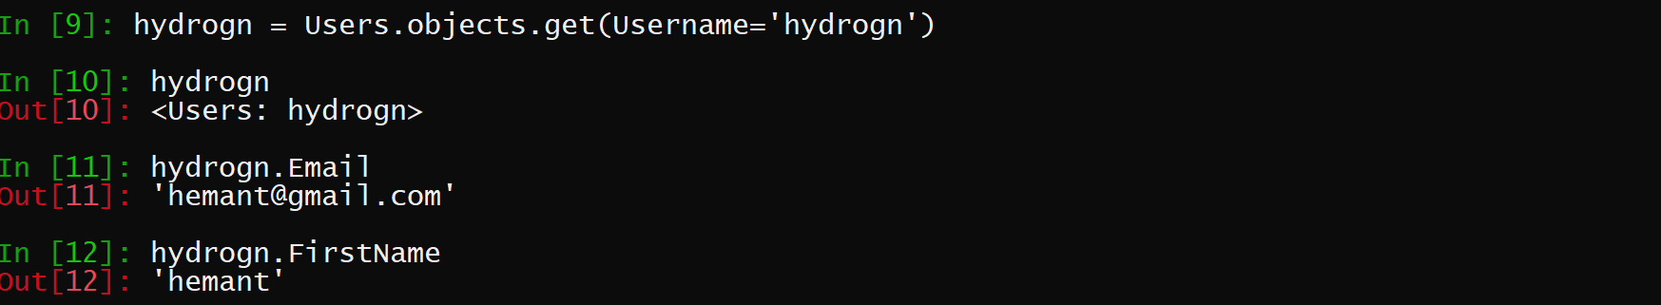

The entire data of user ‘hydrogn’ is stored in hydrogn and the rest of the values of that user can be seen or accessed using hydrogn object.

1. 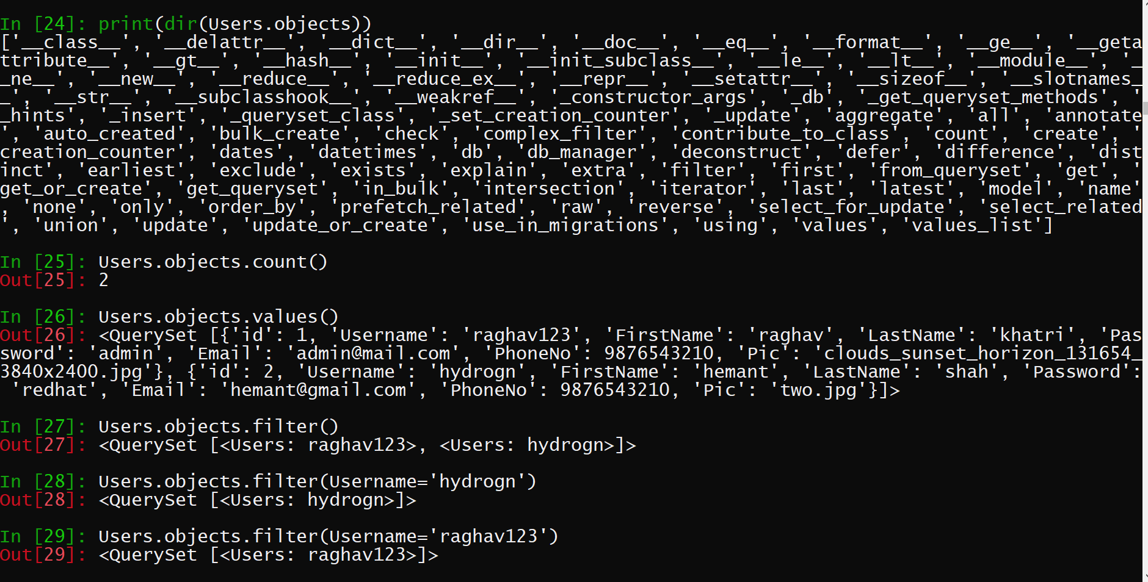

Count() function is used to find the total number of objects of our model.

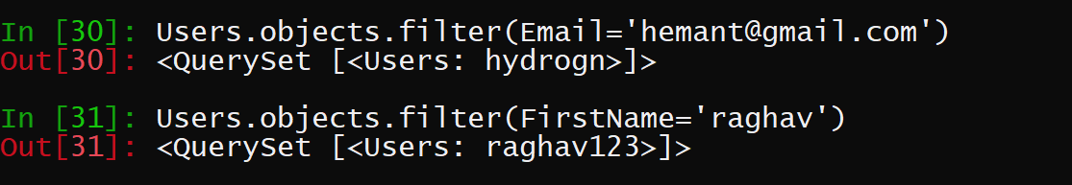

1. For automatic entry in the model function is to be defined in app1.views for which the url has to be defined in app1.urls.

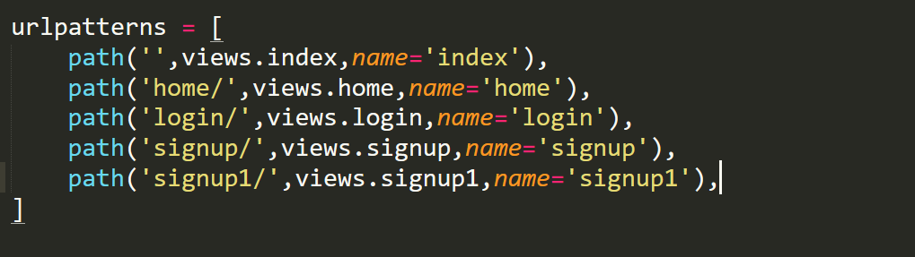

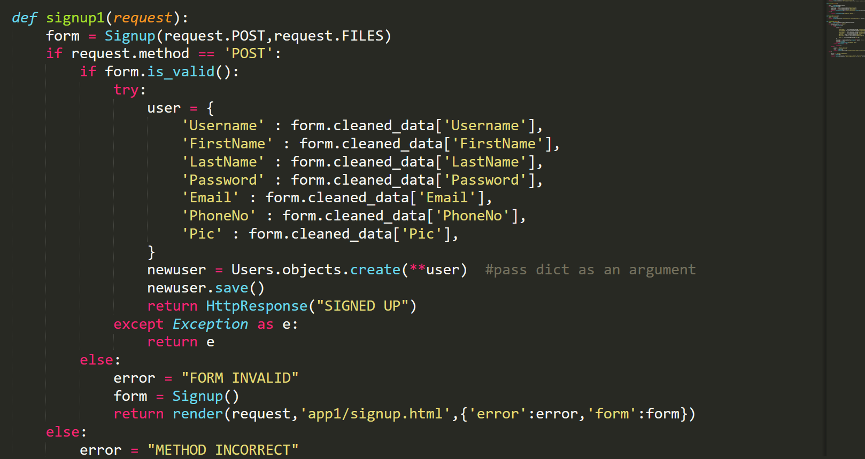

Like we have created a new user in shell similarly we can create in our function.