Flask

Request Object

The data from a client’s web page is sent to the server as a global request object. In order to process the request data, it should be imported from the Flask module.

Important attributes of request object are listed below −

* **Form** − It is a dictionary object containing key and value pairs of form parameters and their values.
* **args** − parsed contents of query string which is part of URL after question mark (?).
* **Cookies** − dictionary object holding Cookie names and values.
* **files** − data pertaining to uploaded file.
* **method** − current request method.

In the following example, **‘/’** URL renders a web page (login.html) which has a login form. The data filled in it is posted to the **‘/login/’** URL which triggers the **login()** function.

The **login()** function collects form data present in **request.form** in variables and return a string.



Similarly the ‘/signup/’ url will render the ‘signup.html’ from templates folder.



The signup.html template is:

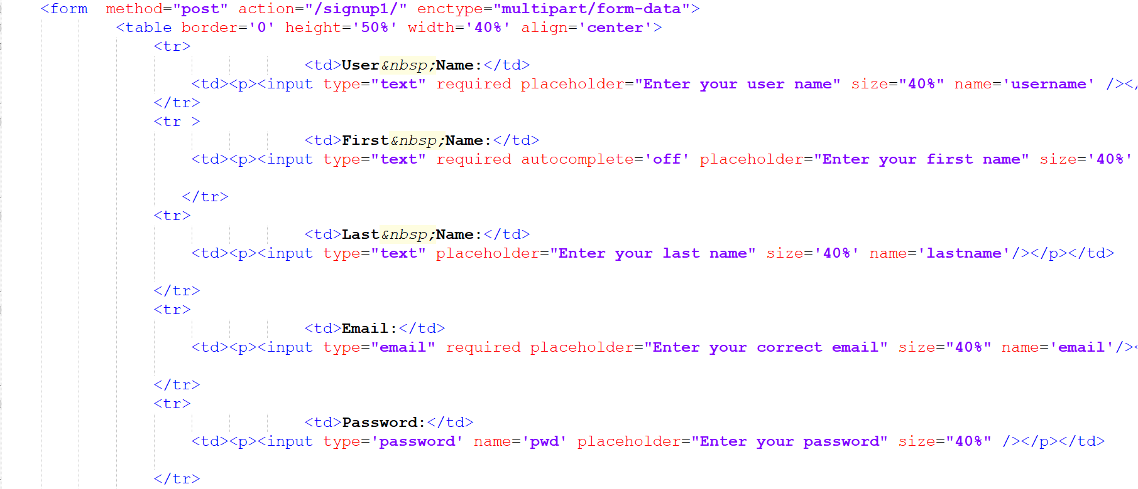

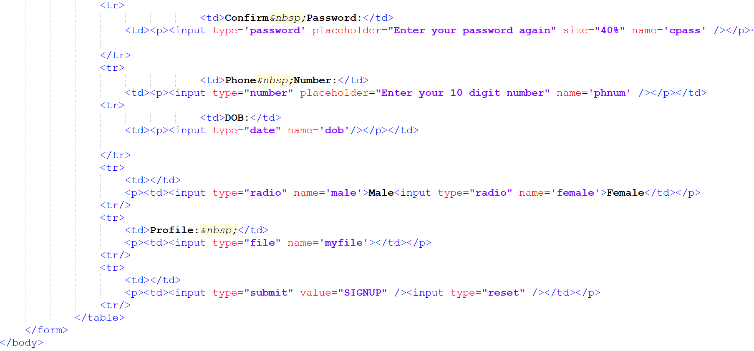

The data filled in it is posted to the **‘/signup1/’** URL which triggers the **signup1()** function.

The **signup1()** function collects form data present in **request.form** in variables.