**LAR Liyanage**

**27336**

**Lab 03**

1. **Write a C# program that takes an integer as input and checks whether it is even or odd. Display the result “Even” or “Odd” accordingly.**

using System;

class Program {

static void Main(string[] args) {

Console.Write("Enter an integer: ");

string input = Console.ReadLine();

int number;

if (int.TryParse(input, out number)) {

if (number % 2 == 0) {

Console.WriteLine("Even"); }

Else {

Console.WriteLine("Odd"); } }

Else {

Console.WriteLine("Invalid input: not an integer."); } } }

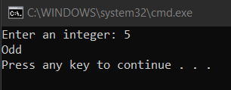

1. **Write a C# program that counts the number of vowels in a given string. Consider both uppercase and lowercase vowels.**

using System;

class Program {

static void Main(string[] args) {

Console.Write("Enter a string: ");

string input = Console.ReadLine();

string lowerCaseInput = input.ToLower();

int count = 0;

foreach (char c in lowerCaseInput) {

if (c == 'a' || c == 'e' || c == 'i' || c == 'o' || c == 'u') {

count++; } }

Console.WriteLine("The number of vowels in the string is: " + count); } }

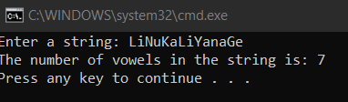

1. **Write a C# program to find the sum of the digits of a given number using a for loop.**

using System;

class Program {

static void Main(string[] args) {

Console.Write("Enter a number: ");

string input = Console.ReadLine();

int number = int.Parse(input);

int sum = 0;

for (int i = number; i > 0; i /= 10) {

int digit = i % 10;

sum += digit; }

Console.WriteLine("The sum of the digits of the number is: " + sum); } }

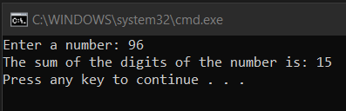

1. **Write a C# program to calculate the sum of all the odd numbers from to a given positive integer.**

using System;

class Program {

static void Main(string[] args) {

Console.Write("Enter a positive integer: ");

string input = Console.ReadLine();

int number = int.Parse(input);

int sum = 0;

for (int i = 1; i <= number; i += 2) {

sum += i; }

Console.WriteLine("The sum of all odd numbers from 1 to " + number + " is: " + sum); }}

