**LAR Liyanage**

**27336**

**Lab 05**

**Question 03.**

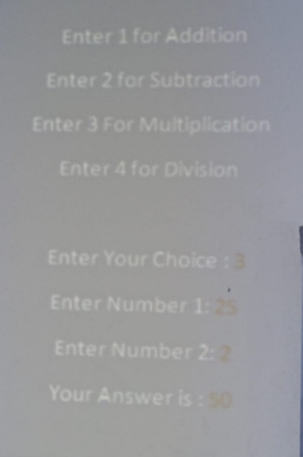

**Create the above mentioned console application and display it to the user. If user need to do an Addition user need to insert 1 as the choice. For subtraction it should be 2 etc.**

**Your program should contain a separate class call “CalculateValues” and inside the class you should add *four methods* which perform *four arithmetic operations*. All the methods should take two parameters which are user inserted numbers.**

**And at the end of the method return the answer out of the method.**

**In main class if user want to do an addition call only the addition method in separate class.**

**If user want to do a subtraction call only the subtraction method in separate class. ETC.**

**And display the final answer as shown in the figure 01.**

using System;

using System.Collections.Generic;

using System.Linq;

using System.Text;

using System.Threading.Tasks;

namespace LS05

{

internal class Program

{

static void Main(string[] args)

{

Console.WriteLine("Choose an operation:");

Console.WriteLine("1. Addition");

Console.WriteLine("2. Subtraction");

Console.WriteLine("3. Multiplication");

Console.WriteLine("4. Division");

Console.Write("Enter your choice: ");

int choice = int.Parse(Console.ReadLine());

Console.Write("Enter the first number: ");

double num1 = double.Parse(Console.ReadLine());

Console.Write("Enter the second number: ");

double num2 = double.Parse(Console.ReadLine());

switch (choice)

{

case 1:

Console.WriteLine("Result: " + CalculateValues.Addition(num1, num2));

break;

case 2:

Console.WriteLine("Result: " + CalculateValues.Subtraction(num1, num2));

break;

case 3:

Console.WriteLine("Result: " + CalculateValues.Multiplication(num1, num2));

break;

case 4:

Console.WriteLine("Result: " + CalculateValues.Division(num1, num2));

break;

default:

Console.WriteLine("Invalid choice!");

break;

}

Console.ReadLine();

}

}

public static class CalculateValues

{

public static double Addition(double num1, double num2)

{

return num1 + num2;

}

public static double Subtraction(double num1, double num2)

{

return num1 - num2;

}

public static double Multiplication(double num1, double num2)

{

return num1 * num2;

}

public static double Division(double num1, double num2)

{

if (num2 == 0)

{

throw new DivideByZeroException();

}

return num1 / num2;

}

}

}

**Question 04.**

**Add a separate class file to Console application program and create a method call *private void sayHello().***

**Inside the method display hello world.**

**In main class create object and try to access the sayHello() method by using the class object.**

**Can you access the method? Explain why?**

public class Greetings

{

private void sayHello()

{

Console.WriteLine("Hello, World!");

}

}

class Program

{

static void Main(string[] args)

{

Greetings greetings = new Greetings();

greetings.sayHello();

}

}

**Question 05.**

**Declare a Single dimensional array with 10 elements. Input the values to the array and find the followings,**

* **Minimum value.**
* **Maximum value.**
* **Average value.**
* **Reverse order of values.**

**Hint – use a method which in separate class. And call the method from main the method.**

using System;

using System.Collections.Generic;

using System.Linq;

using System.Text;

using System.Threading.Tasks;

namespace LS05

{

internal class Program

{

static void Main(string[] args)

{

int[] arr = new int[10];

Console.WriteLine("Enter 10 integers to populate the array:");

for (int i = 0; i < arr.Length; i++)

{

arr[i] = int.Parse(Console.ReadLine());

}

ArrayStats stats = new ArrayStats(arr);

Console.WriteLine("Minimum value: {0}", stats.GetMinValue());

Console.WriteLine("Maximum value: {0}", stats.GetMaxValue());

Console.WriteLine("Average value: {0}", stats.GetAverageValue());

Console.WriteLine("Array in reverse order:");

foreach (int num in stats.GetReversedArray())

{

Console.Write("{0} ", num);

}

Console.ReadLine();

}

}

public class ArrayStats

{

private int[] arr;

public ArrayStats(int[] arr)

{

this.arr = arr;

}

public int GetMinValue()

{

int min = arr[0];

for (int i = 1; i < arr.Length; i++)

{

if (arr[i] < min)

{

min = arr[i];

}

}

return min;

}

public int GetMaxValue()

{

int max = arr[0];

for (int i = 1; i < arr.Length; i++)

{

if (arr[i] > max)

{

max = arr[i];

}

}

return max;

}

public double GetAverageValue()

{

double sum = 0;

foreach (int num in arr)

{

sum += num;

}

return sum / arr.Length;

}

public int[] GetReversedArray()

{

int[] reversedArr = new int[arr.Length];

for (int i = 0; i < arr.Length; i++)

{

reversedArr[arr.Length - 1 - i] = arr[i];

}

return reversedArr;

}

}

}

