**ICU waveform extraction toolbox**

Ran Xiao, Emory University, Apr 2024

1. **Config.txt** contains the connection information to the BMI database, modify it before using

1. **Key Function: mapValidWaveTime.py**
   1. The function takes a list of encounter IDs as input and outputs an Excel file (ValidWaveTime_allEnc.xlsx) that contains the valid waveform start and end times for these encounter IDs.
   2. Mapping logic: the valid waveform time is defined as the intersection of the waveform time and the bed transfer time
   3. It also handles the case where the waveform end time is missing (assigned with a date in 1969) and sets it to the bed transfer out time

1. **Key Function: extractContinuousWaveforms.py**
   1. The function takes the Excel file (ValidWaveTime_allEnc.xlsx) as input and extract all the valid waveforms from adibin files
   2. Key features:
      1. Look through adibin files from each wave cycle from each encounter and select only valid waveform determined by the valid wave start and end times, restructure into [time_vector, waveforms] with channel names, and save them in .pkl format (most storage efficient among three formats tested )

* + 1. Generate meta data reports at the encounter level that indicate whether there are matched waveform, and the total duration of the waveform

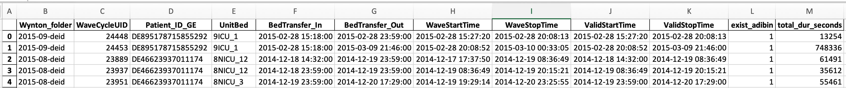

* + 1. Generate meta data reports at the adibin file level that describe the valid start and end times, duration of waveform, and channel names



* + 1. Handle missing channel name situation by replacing with Unnamed_Channel

1. **Key Function: extractSpotWaveforms.py**
   1. Coming soon