E-Commerce Customer Purchase Analysis

Name: Ranya
Roll No.: 2305558
Program: Data Fundamentals with Data Warehousing, SQL, Python
Batch: 2025-26
Submission date: 19-04-2026

Q) An online shopping platform records information about customer purchases including customer details, product purchased, quantity, price, and city location.
The marketing department wants to analyze purchasing behavior to improve promotional campaigns and identify valuable customers.
They want to answer questions such as:
- Which customers spend the most money?
- Which products are most popular?
- Which cities generate the most revenue?
Students must analyze the dataset and generate insights to support marketing decisions.

Problem statement
This project analyses customer purchase data from an e-commerce platform to identify high-value customers, popular products, and revenue-generating cities. The insights help businesses improve marketing strategies and customer targeting.
Objectives
- Identify top spending customers
- Analyse most popular products
- Calculate city-wise revenue
- Perform analysis using SQL, Excel, and Python
- Create visualizations for better understanding

Dataset Description
The dataset contains customer purchase information including customer ID, name, city, product, quantity, and price.

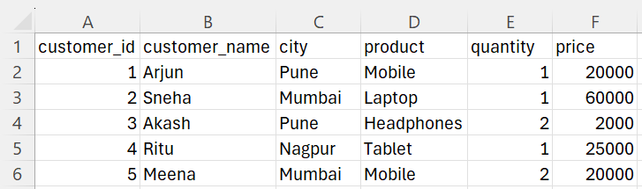

SQL Analysis
1. Display all purchase records
SELECT * FROM purchases;
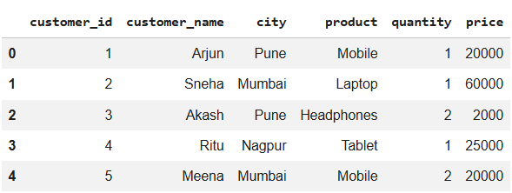

2. Total spending per customer
SELECT customer_name, SUM(quantity * price) AS total_spending
FROM purchases
GROUP BY customer_name;
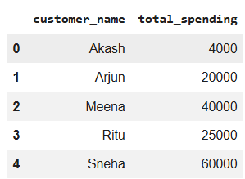
3. Most purchased product (by quantity)
SELECT product, SUM(quantity) AS total_quantity
FROM purchases
GROUP BY product
ORDER BY total_quantity DESC
LIMIT 1;
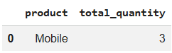

4. City-wise revenue
SELECT city, SUM(quantity * price) AS total_revenue
FROM purchases
GROUP BY city;
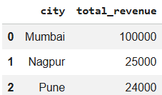

Excel Analysis
Excel is used to perform quick analysis. A total purchase column is created using a formula. Pivot tables are used to analyse product sales and city-wise revenue.
A new column “Total Purchase” is created using the formula:
Total Purchase = Quantity × Price
Pivot tables are used to analyse product-wise sales and city-wise revenue. This helps summarize the data efficiently and identify trends.

Total Purchase Column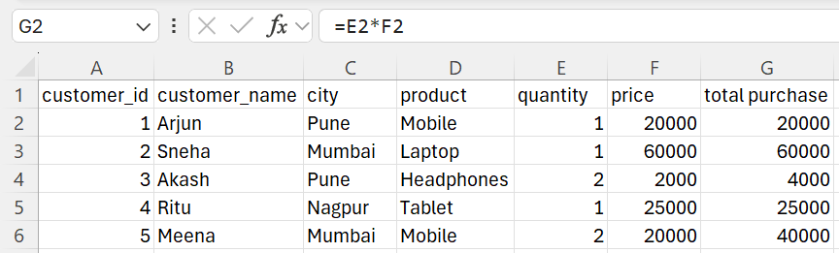
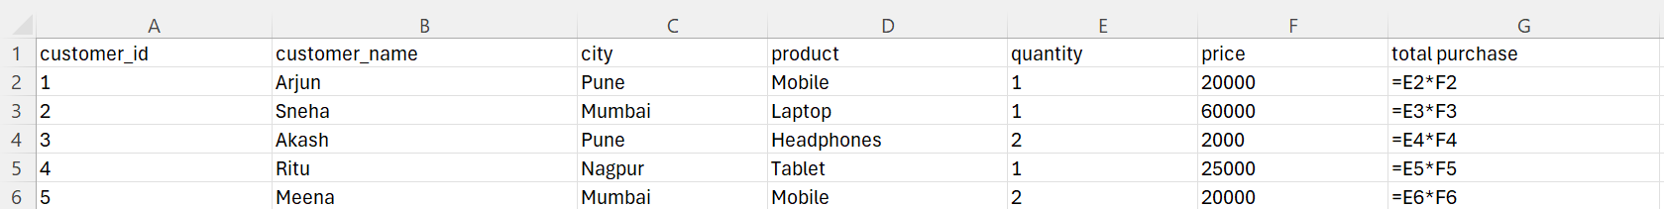

Product-wise Sales (Pivot Table)
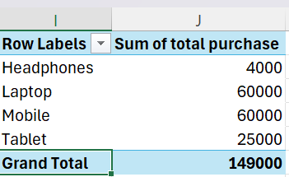

City-wise Revenue (Pivot Table)
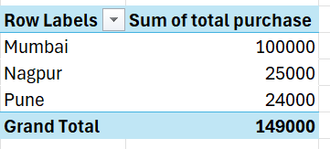

Python Analysis
Python (Pandas library) is used to analyse the dataset programmatically. It helps identify top customers and product popularity. The dataset is loaded using pandas, and a new column “total_purchase” is created. Groupby operations are used to identify top customers and product popularity.
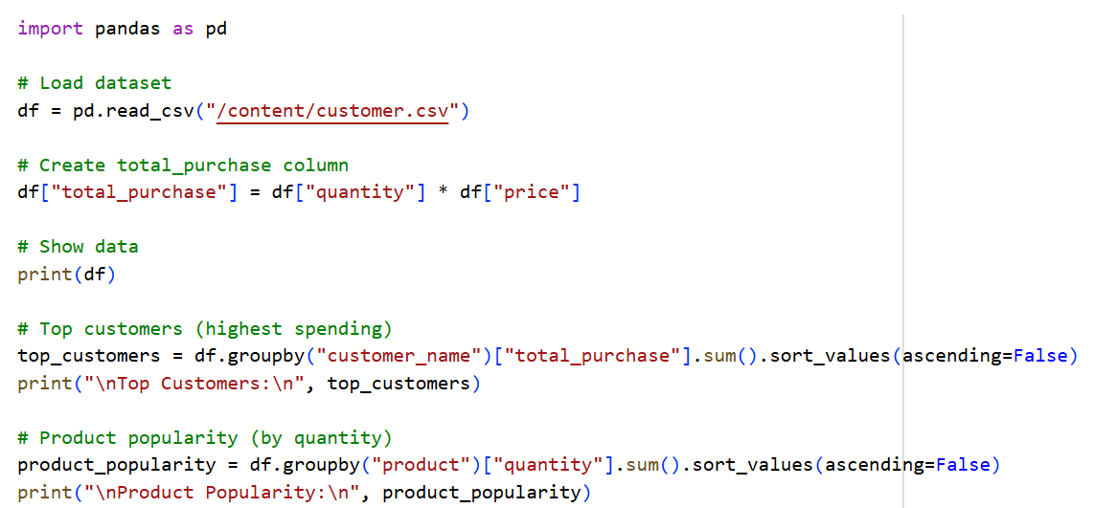
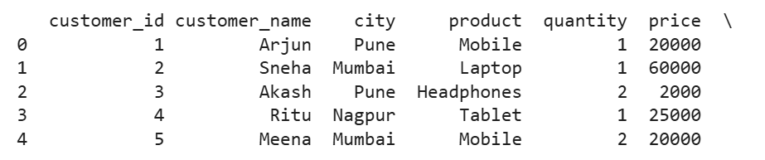
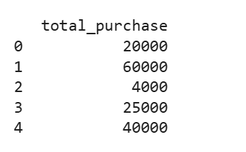
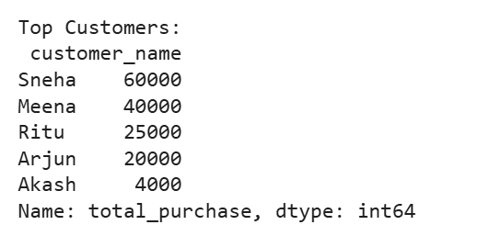
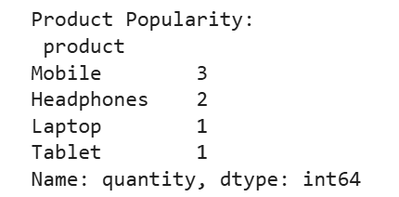

Visualizations
A bar chart is used to represent product sales, and a pie chart is used to show city-wise revenue distribution. These visualizations help in quick understanding of trends.

Product Sales Analysis

Insights
- Sneha is the highest spending customer
- Mobile is the most popular product
- Mumbai generates the highest revenue
- Pune and Nagpur contribute less revenue
- High-value products like laptops generate more revenue

Conclusion
The project successfully analysed customer purchasing behaviour using SQL, Excel, and Python. The insights can help businesses improve marketing strategies and focus on high-value customers and products.

Tech Stack
- SQL
- Python (Pandas)
- Microsoft Excel

Future Improvements
- Add real-time dashboard
- Use machine learning for predictions
- Analyse customer buying behaviour in detail
- Deploy as a web application

