PLEASE REFER TO FIGURE 11 and the related images to be added in supplementary. Table S3 is required for a statement. Table and figure 11 is attached here.

1) The biomass in intraseasonal band is comparable to the variability range in seasonal band.

2) There are instances (July 2019 off Kollam) when the seasonal variation is weak, but Intraseasonal variations are responsible for fluctuations occurring in short time scales. The variability strength at 40 m decreases from SEAS to NEAS, however no such pattern is there at 104 m (Table S3).

2.a) Together they determine low-frequency variabilities greater than 5 days seen in biomass and ZSS.

2.b) There are shifts occuring in sign of seasonal variation from positive to negatice at surface, and negative to positive in 104 m across the SEAS till Goa during October. Depending on the signs of variation whether positive or negative, the intraseasonal variation riding the seasonal cycle either enhances or subdues the estimated biomass.

2.c) The response of biomass in seasonal scale is positive for both the depths only during October, indicating even at seasonal scale, it’s not necessary that the biomass in entire water column responds the same way at all the depths.

2.d) High SLA coincides with lower 40 m biomass. Low in SLA coincides with higher 40 m biomass

3) The “difference” of mean removed biomass and 5 day low pass filter still retains fluctuations of the order of 1 SD (14 mg m-3 ) often or on some occasions crossing 2 SD (28 mg m-3) and rarely spikes as high as 50 mg m-3. For Kollam’s case, the mean biomass at 40 m (104 m) is about 272 mgm-3 (198 mg m-3), and the high-frequency fluctuations are not negligible.

S = X (1D) – Xmean (1D) – XLP (5D)

The above is the background signal of high-frequency fluctuations in biomass.

4) The fluctuations seen in 3). are always present in the difference time series or background signal S.

4.a) They are present even when Chl-a is low e.g., year round except monsoon time off Kollam, Kanyakumari, indicating role of microbial loop in sustenance and possible role in the high-frequency (less than 5 day) variability seen in the zooplankton biomass.

4.b) The spikes in background signal S doesn’t necessarily coincide with spikes or blooms in Chl-a, implying that the spikes in biomass in daily basis doesn’t arise from chl-a but from the functioning of microbial loop. This is truer for the cases like Jaigarh, where chl-a variation is non-existent, nontheless a seasonal cycle is observed for biomass and ZSS.

4.c) The classical food web is still active and sometimes dominant in determining the surface ocean biomass as seen in Kanyakumari during July 2019 even though the background signal is present.

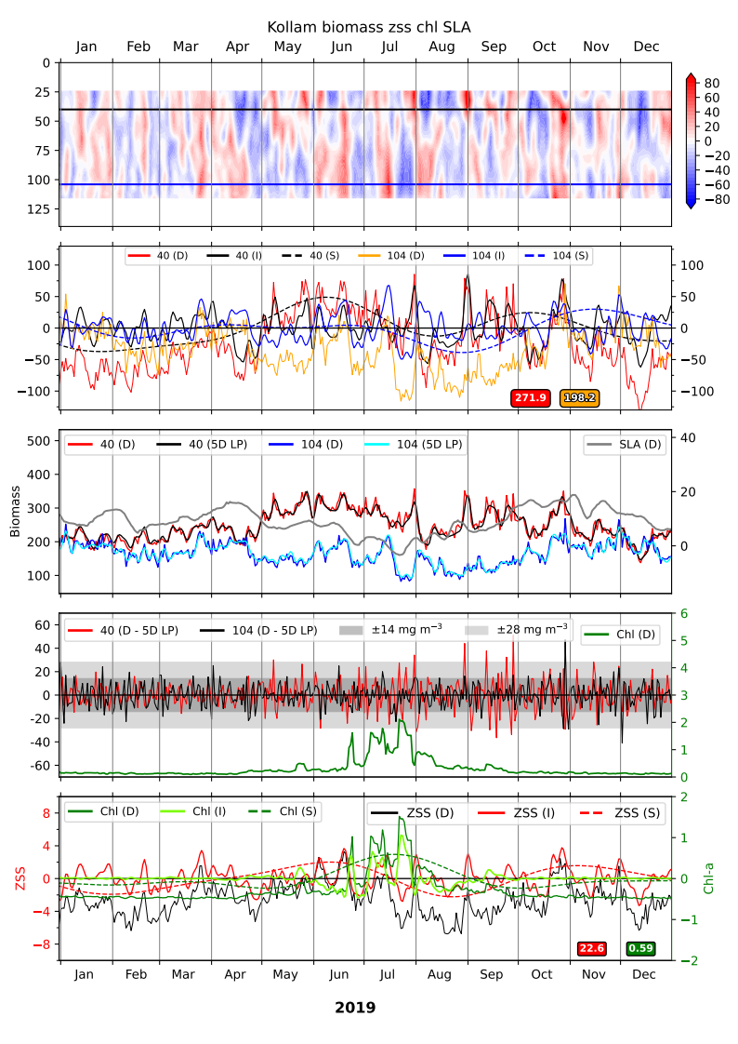

The first panel shows time vs depth plot of intraseasonal biomass (5--90 days), 40 (104) m depths are marked by black (blue) lines, and vertical Grey line separate months. The second panel from top shows 40 and 104 m daily, intraseasonal (5--90 days), and seasonal (100- 400 days) biomass, mean of daily biomass for respective depth is shown in bottom right of the panel. The third panel represents the daily biomass overlaid by 5 day low-pass filtered biomass and daily SLA. Notice the high (low) SLA coinciding with lower (higher) 40 m biomass. The fourth panel shows the difference between daily and 5 day low-pass filtered biomass at 40 and 104 m, Grey (light Grey) shaded region highlights SD (2*SD) region of backscatter-biomass equation onto which the daily Chl-a is overlaid. The bottom-most panel shows the Chl-a and ZSS in Intraseasonal and seasonal band. See \textbf{Figure SX} for a detailed comparison of variability in distinct bands.

Table S3:

|  |  |  |  |  |
| --- | --- | --- | --- | --- |
| Mooring | Seasonal | Annual | Intra-annual | Intraseasonal |
| Location | (100-400 Days) | (300-400 days) | (100–250 days) | (5–90 days) |
| Okha | 7.3 (15.6) | 2.6 (2.8) | 5.5 (11.4) | 20.4 (18.9) |
| Mumbai | 22.2 (21.9) | 6.5 (6.6) | 15.4 (14.4) | 23.5 (22.6) |
| Jaigarh | 16.7 (23.9) | 6.3 (9.1) | 14.2 (13.8) | 24.6 (27.3) |
| Goa | 18.8 (20.1) | 3.4 (7.3) | 14.2 (11.5) | 23.3 (19.2) |
| Udupi | 25.8 (28.3) | 5.8 (9.4) | 17.7 (17.2) | 27.6 (17.6 |
| Kollam | 28.6 (17.8) | 7.7 (5.9) | 21.7 (12.5) | 31.3 (20.0) |
| Kanyakumari | 16.2 (10.2) | 4.4 (3.9) | 11.5 (6.3) | 24.4 (16.2) |

Note: The numbers are from older analysis.