I. RNA-seq analysis question (9 pt):

You should have the initial analysis pipeline completed in your Partek Flow account, as shown below. We are now going to explore impact of different methods within the RNAseq analysis pipeline.
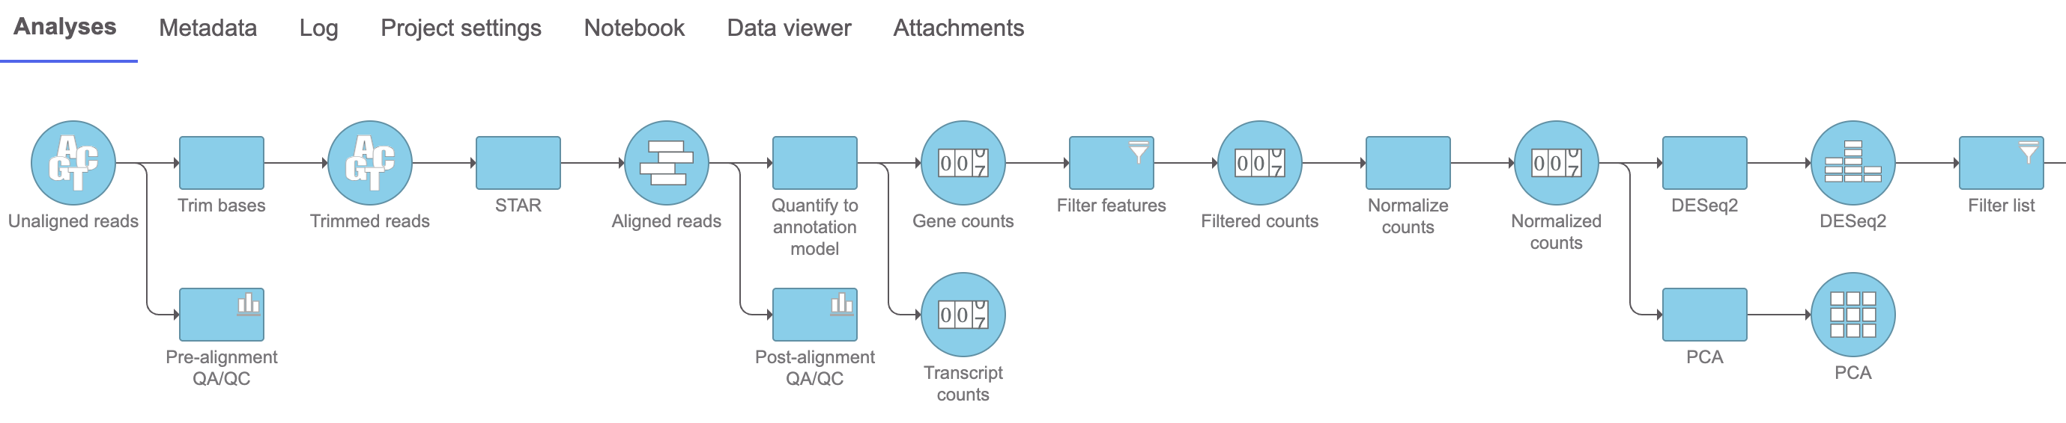
Key parameters used in the initial analysis:
• Trim bases: Quality Score trimming
• Alignment: STAR – Assembly hg38 and Index Gencode genes - release 48; Align to Genome and Transcriptome
• Quantification: Partek E/M - Annotation model Gencode genes - release 48
• Filter features: Noise reduction - Exclude features where maximum <10
• Normalization: Median ratio (DESeq2)
• Differential expression: DESeq2

1. Examine the impact of different aligners (3 pt). From the Trimmed reads, perform alignment with HISAT2 (Assembly hg38 and Index Whole Genome)

A. What are the runtimes for HISAT2 and STAR (check the Task details)? Which aligner is faster?
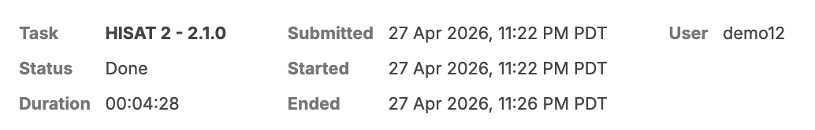
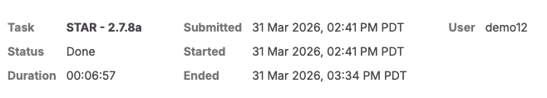
- HISAT2 runtimes 00:04:28
- STAR runtimes 00:06:57
- HISAT2 aligner is faster.

B. Compare key metrics in the HISAT2 and STAR post-alignment QA/QC reports. What are the major differences?
- HISAT2:
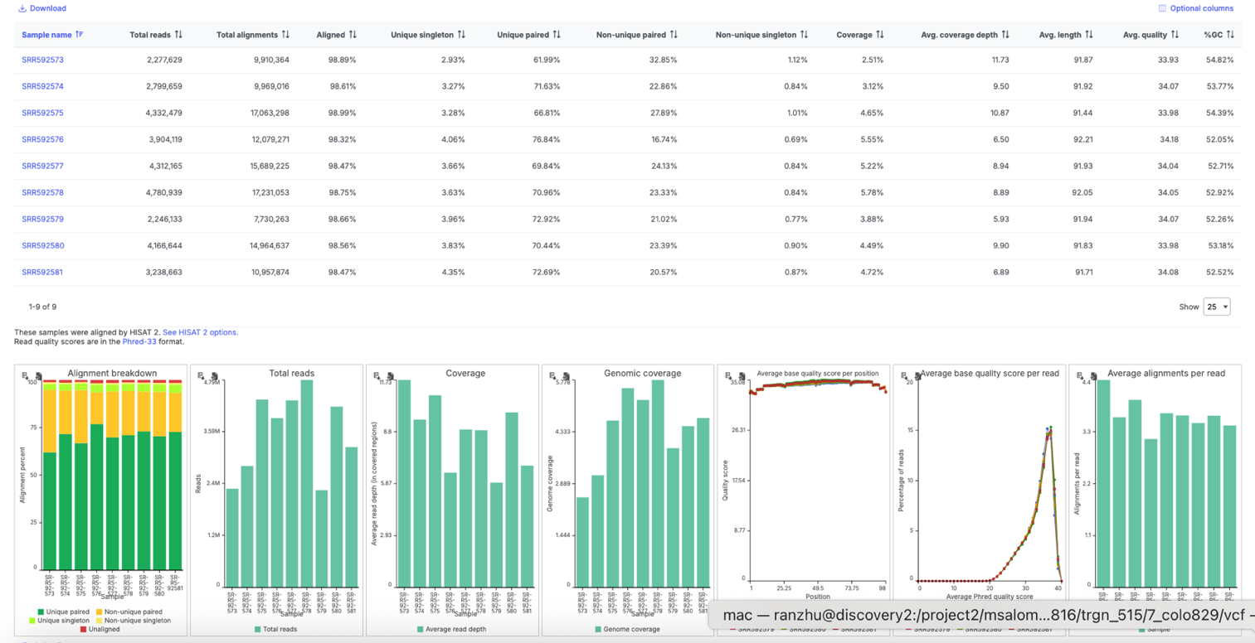
STAR:
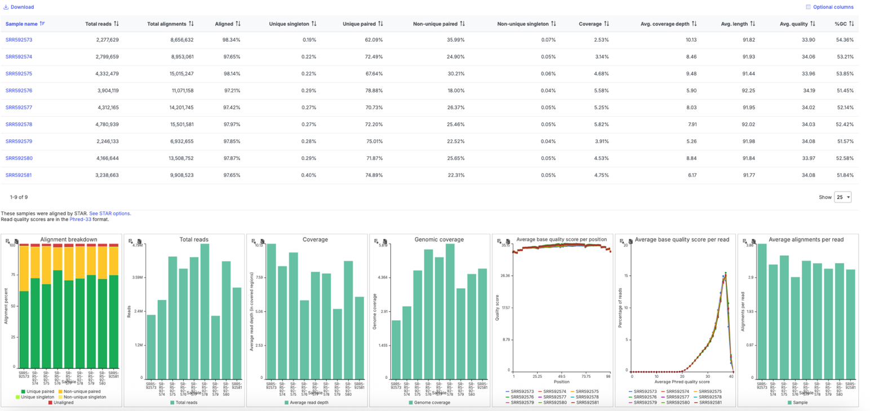

Comparing the HISAT2 and STAR post-alignment QA/QC reports across all 9 samples reveals several differences in key metrics:

- Aligned%: HISAT2 had slightly higher alignment rates, ranging from 98.32% to 98.99%, compared to STAR, which ranged from 97.21% to 98.34%, meaning more reads were successfully mapped to the hg38 reference genome.
- Unique paired%: Unique paired read percentages were similar between the two aligners. HISAT2 ranged from 61.99% to 76.84%, while STAR ranged from 62.09% to 78.88%, suggesting both aligners performed similarly in uniquely mapping paired-end reads.
- Unique singleton%: This was the most notable difference between the two aligners. HISAT2 reported much higher unique singleton rates, ranging from 2.93% to 4.35%, compared to STAR, which ranged from only 0.19% to 0.40%. Unique singleton reads refer to reads where only one mate of a paired-end read is successfully and uniquely aligned to the reference genome, while the other mate either fails to map or maps to multiple locations. This shows that HISAT2 retains more reads where only one mate maps uniquely. In contrast, STAR applies much stricter criteria, resulting in very few singleton alignments being reported.
- Non-Unique Paired Reads %: HISAT2 showed lower non-unique paired read rates, ranging from 16.74% to 32.85%, compared to STAR, which ranged from 18.00% to 35.99%, indicating that HISAT2 produced slightly fewer multi-mapped reads.
- Average Coverage Depth% and Coverage% : Both coverage percentage and average coverage depth were similar between the two aligners. Coverage percentage ranged from 2.51% to 5.78% for HISAT2 and 2.53% to 5.82% for STAR. Average coverage depth ranged from 2.93x to 11.73x for HISAT2 and 2.53x to 10.13x for STAR. These results indicate that both HISAT2 and STAR produced comparable proportions of the genome covered by reads, as well as similar average sequencing depth in the covered regions.

C. Based on your findings, which aligner do you think performs better for this dataset? Justify your answer.
- Based on the findings, I think that STAR performs better for this dataset. Although HISAT2 is faster (00:04:28) compared to STAR (00:06:57), speed alone does not indicate better alignment quality. The most significant difference between the two aligners is the unique singleton rate. HISAT2 reported much higher unique singleton rates, ranging from 2.93% to 4.35%, compared to STAR, which ranged from only 0.19% to 0.40%. For paired-end RNA-seq data, a higher singleton rate may indicate less reliable alignments, as reads are expected to map in pairs. Therefore, STAR's much lower singleton rate suggests more reliable and stable alignment results for this paired-end dataset.
- For other metrics, including aligned %, unique paired %, non-unique paired %, coverage %, and average coverage depth, the two aligners performed very similarly, with no major differences observed. Overall, while both aligners produced comparable results across most metrics, STAR is slightly better suited for this dataset due to its more reliable paired-end alignment behavior.

2. Analyze differential expression results from DESeq2 (4 pt).

From the DESeq2 result, create a Filtered gene list for the DEGs in 10uM vs. 0uM using the same criteria FDR<0.05 AND Fold Change (FC)>|2|.

A. How many genes are upregulated in 10uM compared to 0uM?
- 501 (FC > 2)

B. How many genes are downregulated in 10uM compared to 0uM?
- 207 (FC < -2)
C. What is the top upregulated gene in 10uM compared to 0uM?
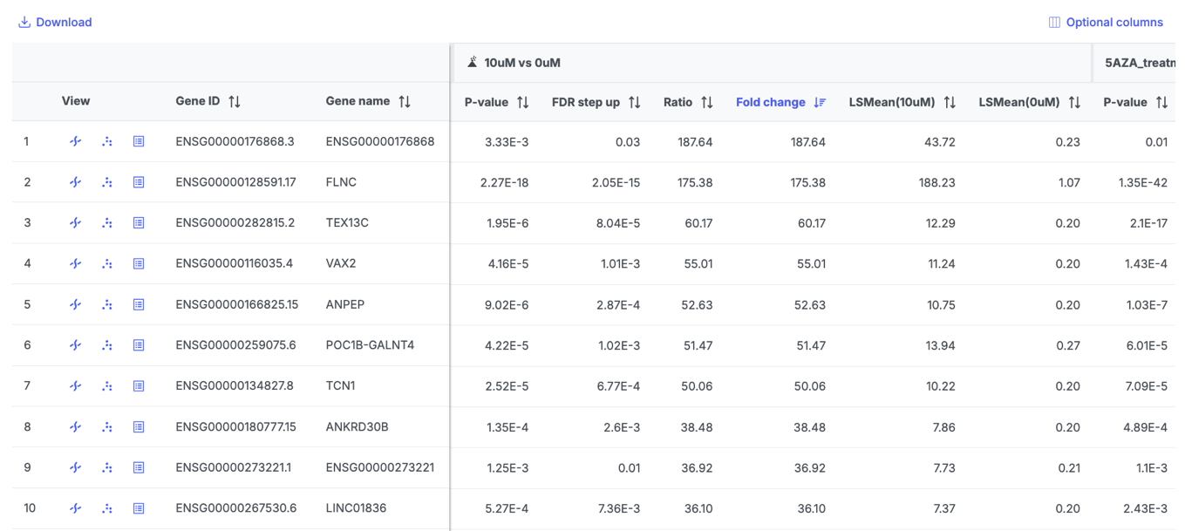
- Top 1 regulated gene: Gene ID: ENSG00000176868.3, Gene name: ENSG00000176868, Fold change: 187.64
D. Generate the Volcano plot.
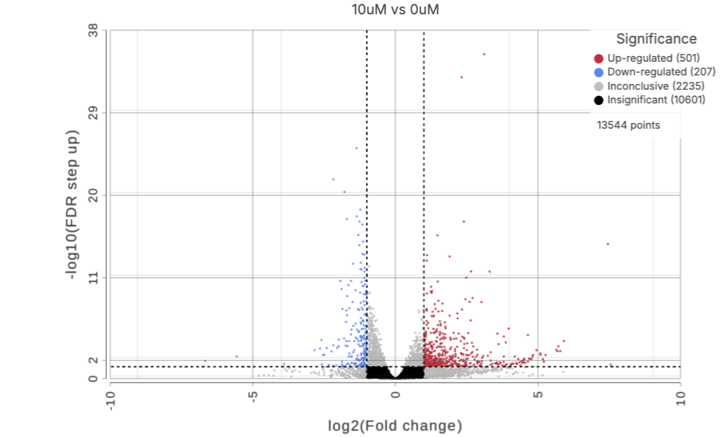
3. IPA analysis (2 pt): Finish before April 30 as IPA training License Expires.

You should have two Core Analysis results in IPA – one for 5uM vs. 0uM DEG list and the other for 10uM vs. 0uM DEG list. We reviewed the 5uM vs. 0uM results together in class. Now, please review the 10uM vs. 0uM Core Analysis results and answer the following question.

- What are the top 10 biological pathways impacted by 10uM 5-AZA treatment?
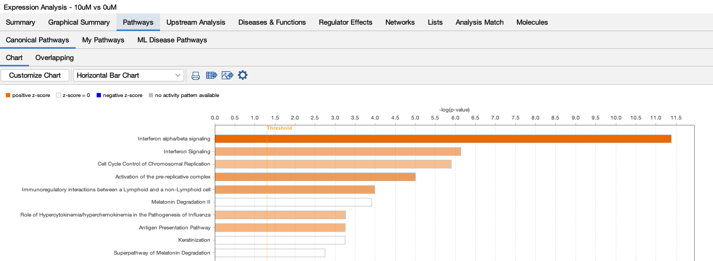
- Interferon alpha/beta Signaling
- Interferon Signaling
- Cell Cycle Control of Chromosomal Replication
- Activation of the Pre-replicative Complex
- Immunoregulatory Interactions between a Lymphoid and a Non-Lymphoid Cell
- Melatonin Degradation II
- Role of Hypercytokinemia/Hyperchemokinemia in the Pathogenesis of Influenza
- Antigen Presentation Pathway
- Keratinization
- Superpathway of Melatonin Degradation

- Include p-value, z-score, gene count for the top 10 biological pathways and indicate whether the pathway is predicted to be activated or repressed.

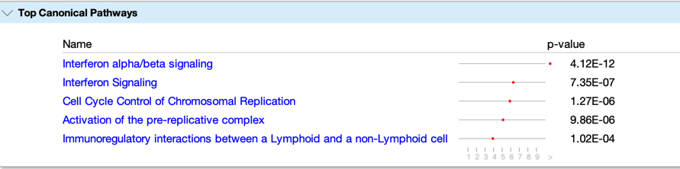 Top 5 pathways p value evidence support from IPA

Rank | Pathway | -log(p-value) | p-value | z-score | Gene Count | Predicted Status
1 | Interferon alpha/beta Signaling | 11.385 | 4.12×10⁻¹² | 4.472 | 20 | Activated
2 | Interferon Signaling | 6.134 | 7.35×10⁻⁷ | 2.449 | 10 | Activated
3 | Cell Cycle Control of Chromosomal Replication | 5.898 | 1.27×10⁻⁶ | 1.941 | 14 | Activated
4 | Activation of the Pre-replicative Complex | 5.006 | 9.86×10⁻⁶ | 3.000 | 9 | Activated
5 | Immunoregulatory Interactions between a Lymphoid and a Non-Lymphoid Cell | 3.99 | 1.02×10⁻⁴ | 2.828 | 8 | Activated
6 | Melatonin Degradation II | 3.911 | 1.23×10⁻⁴ | NAN | 3 | N/A
7 | Role of Hypercytokinemia/Hyperchemokinemia in the Pathogenesis of Influenza | 3.263 | 5.46×10⁻⁴ | 2.000 | 7 | Activated
8 | Antigen Presentation Pathway | 3.253 | 5.58×10⁻⁴ | 2.236 | 6 | Activated
9 | Keratinization | 3.25 | 5.62×10⁻⁴ | 0.00 | 8 | Undetermined
10 | Superpathway of Melatonin Degradation | 2.747 | 1.79×10⁻³ | NAN | 6 | N/A

II. ChIP-seq and ATAC-seq analysis question (22 pt):

- Running ChIP-seq pipeline (10 pt)

Download a fastq file from /project2/rhie_131/bioc599/shared/final.project/ChIPseq.fastq.gz and make a new fastq file that include the lines 12,000,001 to 32,000,000

A. Using the newly made fastq file, run ChIP-seq pipeline to generate a bw file. Write down command lines you used.

# 1. Make my own working directory
mkdir /project2/rhie_131/bioc599/users/ranzhu/final_project
cd /project2/rhie_131/bioc599/users/ranzhu/final_project

# 2. Extract lines 12,000,001 to 32,000,000
zcat /project2/rhie_131/bioc599/shared/final.project/ChIPseq.fastq.gz | \
sed -n '12000001,32000000p' | \
gzip > ChIPseq_subset.fastq.gz

# Request compute resources
salloc --ntasks=1 --mem-per-cpu=59GB --time=47:59:59 --account=rhie_131 --partition=main

# 3. BWA alignment
module load gcc/13.3.0 bwa/0.7.17 bwa mem -t 4 /project2/rhie_131/bioc599/shared/genomes/hg38/bwa_index/hg38 ChIPseq_subset.fastq.gz > ChIPseq.sam

# 4. SAM to BAM
module load gcc/13.3.0 samtools/1.19.2
samtools view -Su ChIPseq.sam > ChIPseq.bam
samtools sort ChIPseq.bam -o ChIPseq.sorted.bam

# 5. Mark duplicates
module load gcc/13.3.0 picard/3.1.1
picard MarkDuplicates I=ChIPseq.sorted.bam O=ChIPseq.sorted.filt.bam M=ChIPseq.sorted.picard.txt

# 6. Flagstat
module load gcc/13.3.0 samtools/1.19.2
samtools flagstat ChIPseq.sorted.filt.bam > ChIPseq.sorted.filt.flagstat.txt

# 7. Make tag directory
module load legacy/CentOS7 gcc/8.3.0 homer/4.9.1
module load samtools
makeTagDirectory ChIPseq.homer ChIPseq.sorted.filt.bam -format sam

# 8. Make bedGraph
makeUCSCfile ChIPseq.homer -fragLength given -o auto

# 9. Convert to bigwig
cd ChIPseq.homer
gunzip -c ChIPseq.homer.ucsc.bedGraph.gz > ChIPseq.homer.ucsc.bedGraph
/project2/rhie_131/bioc599/shared/tools/ucsc/bedGraphToBigWig ChIPseq.homer.ucsc.bedGraph /project2/rhie_131/bioc599/shared/genomes/hg38.chrom.sizes ChIPseq.ucsc.bw

B. How many reads are mapped to hg38? Add the screenshot of flagstat file.
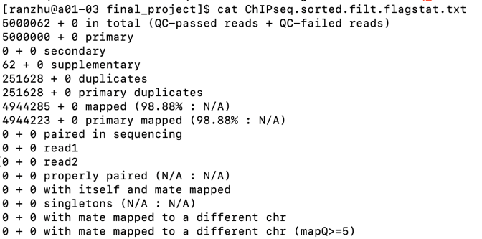
- 4,944,223 reads mapped to hg38 (98.88%)

C. Visualize the generated bw file using IGV and add the screenshot of the SKIL gene.
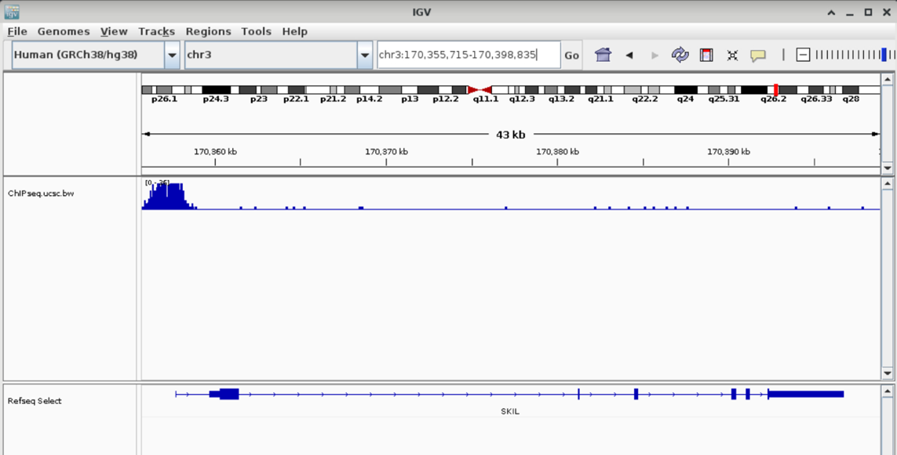

- I loaded my generated bigwig file (ChIPseq.ucsc.bw) into IGV using hg38/GRCh38 reference genome and navigated to the SKIL gene on chromosome 3 (chr3:170,355,715–170,398,835, ~43 kb view). The ChIP-seq signal shows a sharp enrichment peak localized at the 5' end of the SKIL gene, coinciding with its transcription start site and promoter region. The signal drops off quickly after that, with very low signal seen across the rest of the gene body. This highly localized enrichment pattern at the TSS, indicating that there is activate chromatin or transcription factor binding happening at the SKIL promoter, which is consistent with the gene being transcriptionally active in this sample.

D. Using the newly made ChIP bam file and the input bam file located in /project2/rhie_131/bioc599/shared/final.project/Input.sorted.mkdup.bam, call peaks using MACS2 with the setting -p 1e-2. How many peaks are called? Write down command lines you used.

# Activate macs2 environment
conda activate c.macs2

# Call peaks using MACS2
mkdir macs2_output
macs2 callpeak \
-t ChIPseq.sorted.filt.bam \
-c /project2/rhie_131/bioc599/shared/final.project/Input.sorted.mkdup.bam \
-f BAM \
-n macs2_output/ChIPseq_1e2 \
-g hs \
-p 1e-2

# Count peaks
wc -l macs2_output/ChIPseq_1e2_peaks.narrowPeak

- 43,362 peaks were called.

E. Using the generated bw file, create a heatmap ±1000 bp around the identified peaks, clustering them into four groups using k-means.

# Activate deeptools environment
conda activate c.deeptools

# Compute matrix ±1000 bp around peak centers
computeMatrix reference-point --referencePoint center \
-a 1000 -b 1000 \
-S ChIPseq.homer/ChIPseq.ucsc.bw \
-R macs2_output/ChIPseq_1e2_peaks.narrowPeak \
-p 4 \
-o ChIP.matrix.gz

# Plot heatmap with k-means clustering (k=4)
plotHeatmap -m ChIP.matrix.gz \
-out ChIP.heatmap.png \
--colorMap YlOrRd \
--kmeans 4 \
--outFileSortedRegions ChIP.heatmap.km4.bed

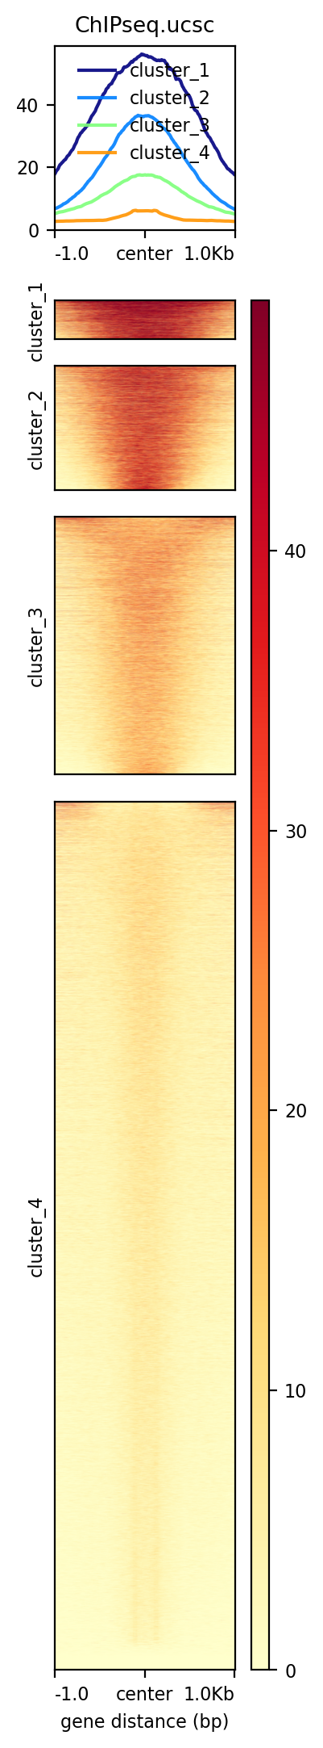

- The heatmap shows the ChIP-seq signal intensity centered on all 43,362 MACS2-called peaks, extending ±1000 bp in each direction, with peaks grouped into four clusters using k-means clustering. K-means clustering works by grouping peaks together based on how similar their signal patterns are, which helps us identify different classes of binding events.
- Cluster 1 has the strongest and broadest signal across the whole window. This kind of broad, high-intensity enrichment is typically associated with active regulatory regions marked by histone modifications like H3K4me3 or H3K27ac, which are commonly found at active promoters and enhancers.
- Cluster 2 shows the classic ChIP-seq peak shape — a sharp, well-defined peak right at the center that drops off symmetrically on both sides. This punctate pattern is what we would expect from transcription factor binding or a specific histone modification concentrated at a particular site.
- Cluster 3 has a more moderate and diffuse signal. The enrichment is still visible but much weaker, which could indicate lower-occupancy binding sites where the protein or histone mark is present but not as strongly enriched.
- Cluster 4 is the largest cluster but shows very little signal, almost at background level. This is likely because we used a relatively permissive p-value threshold of 1e-2 in MACS2, which increases sensitivity and captures more peaks, but also introduces more false positives. A stricter threshold like q-value 0.05 would probably filter out most of these low-signal peaks.
- Overall, the four clusters show that there is a lot of variability in signal strength across the called peaks.

2. ATAC-seq analysis (12 pt)

Visualize the /project2/rhie_131/bioc599/shared/final.project/ATACseq2.hg38.narrowPeak file in hg38 using IGV.

A. Among AMN1, ZNF496, DYRK1A genes, which genes have the peaks in their genebody? Add the screenshots.

AMN1: has 1peak within the genebody.
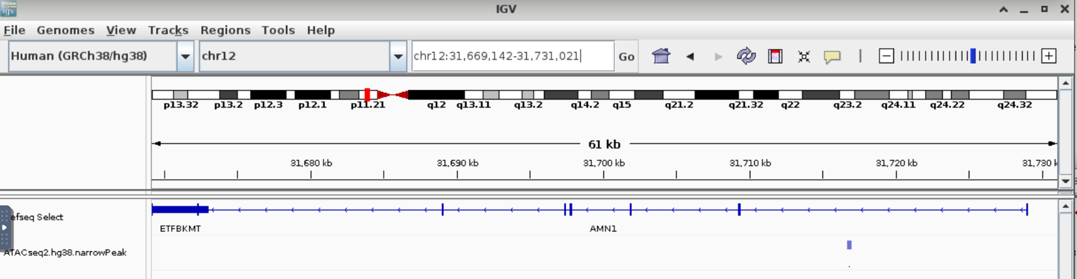
ZNF496: does not show any peaks within its genebody.
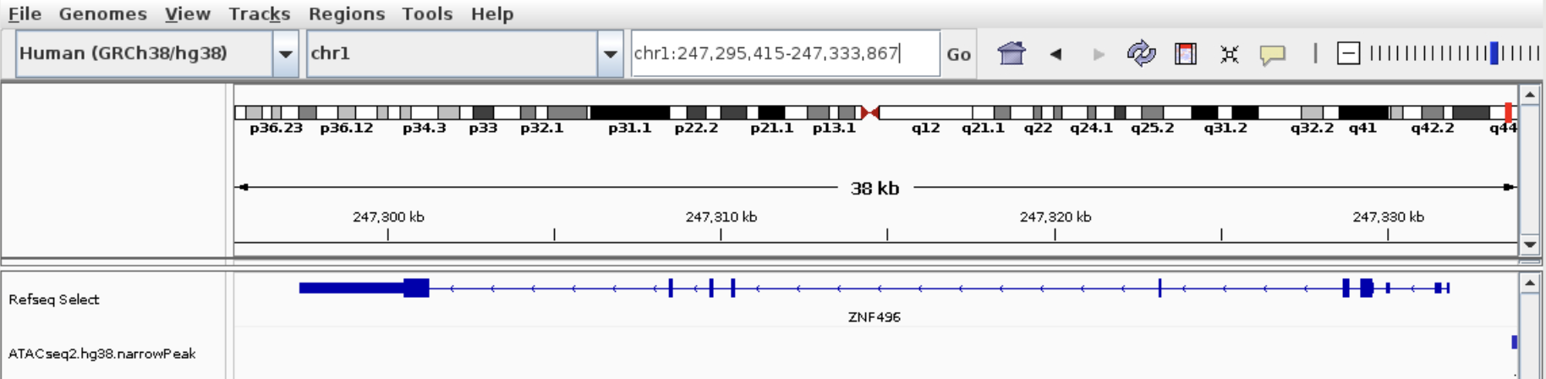
DYRK1A: has 2 peaks within the genebodies.
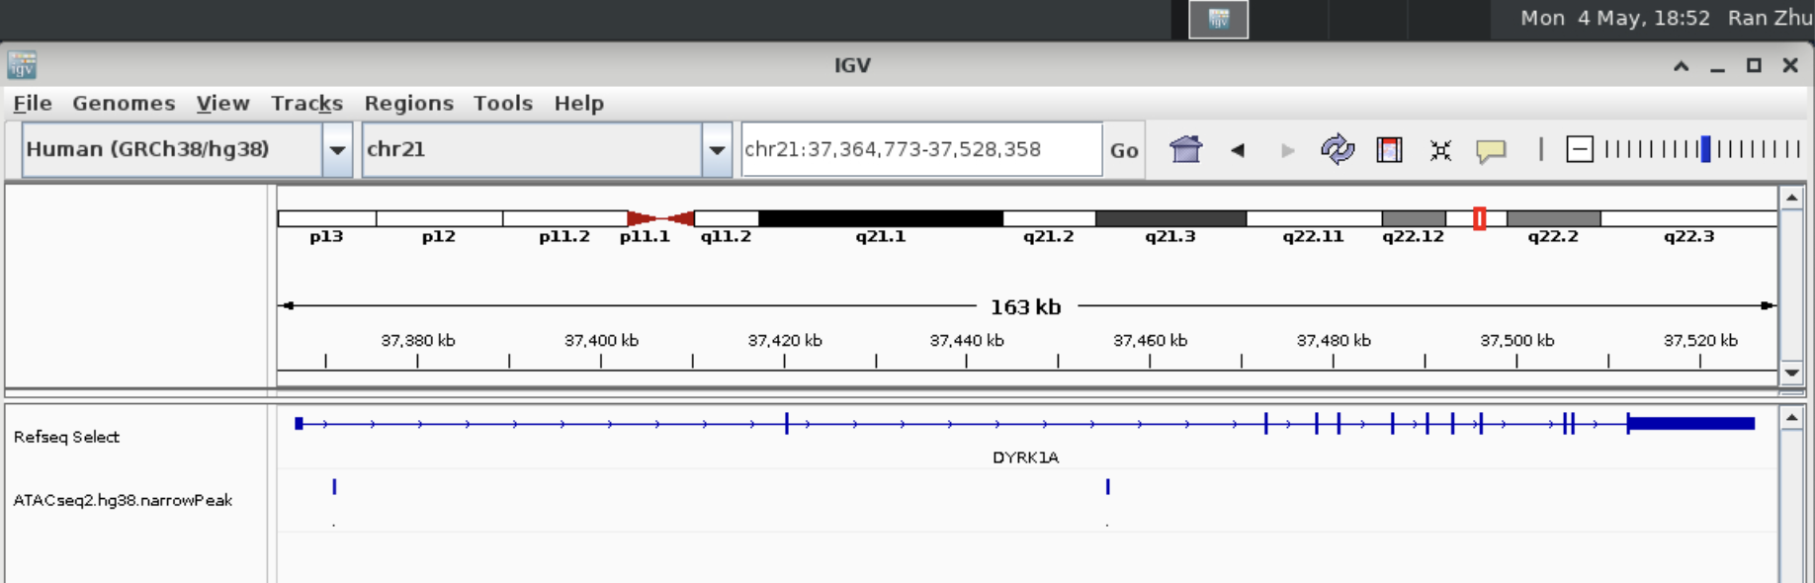

B. Using R, read the peaks and determine the average (mean), minimum, and maximum size of the peaks. Write down command lines you used in R.

R code:

peaks <- read.delim(
file = "/project2/rhie_131/bioc599/shared/final.project/ATACseq2.hg38.narrowPeak",
header = FALSE
)

summary(peaks$V3 - peaks$V2)

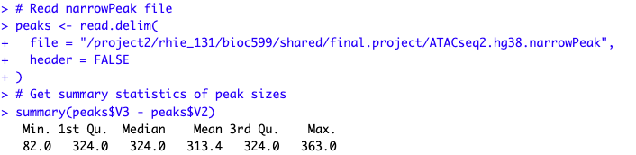

- As a result, the mean peak size is 313.4 bp, minimum peak size is 82 bp, and maximum size of the peak is 363 bp.

C. How many peaks have q-value<0.01? Write down command lines you used in R.

nrow(subset(peaks, peaks$V9 > 2))
y <- subset(peaks, peaks$V9 > 2)

# Save filtered peaks to file
write.table(y,
file = "ATAC.FDR0.01.narrowPeak",
row.names = FALSE,
col.names = FALSE,
quote = FALSE,
sep = "\t"
)

- As a result, there are 290 peaks have q-value<0.01.

D. In R, make a scatterplot between –log10(q-value) and peak size, using the peaks selected with the q-value<0.01 Write down command lines you used.

# Scatterplot between -log10(q-value) and peak size
pdf("ATAC.scatterplot.pdf")
plot(y$V9, (y$V3 - y$V2),
xlab = "-log10(q-value)",
ylab = "Peak size (bp)",
main = "ATAC-seq: Q-value vs Peak Size")
dev.off()
- Looking at the scatterplot, I noticed that the 290 significant peaks don't scatter randomly, instead they actually form three separate clusters. The first two clusters around -log10(q-value) of 2.05 and 2.2 are mostly peaks of the same size (~324 bp), which matches the mean peak size of 313.4 bp that I calculated in part B. Since these peaks are just barely above the significance cutoff of 2 (-log10(0.01) = 2), they are statistically significant but not highly enriched. The third cluster at around 2.63 is the most statistically significant group and also shows the widest range of peak sizes, going from about 82 bp to 363 bp, which is consistent with the minimum and maximum values I found in part B.

E. Determine how many peaks from the above ATACseq2.hg38.narrowPeak overlap with ENCFF285OXK narrowPeak file (download from ENCODE). Write down command lines you used.

cd /project2/rhie_131/bioc599/users/ranzhu/final_project/ATAC-seq_results

wget https://www.encodeproject.org/files/ENCFF285OXK/@@download/ENCFF285OXK.bed.gz
gunzip ENCFF285OXK.bed.gz

module load bedtools2/2.31.1

bedtools intersect \
-a /project2/rhie_131/bioc599/shared/final.project/ATACseq2.hg38.narrowPeak \
-b ENCFF285OXK.bed \
-u | wc -l

- There are 175 peaks that has overlap with ENCFF285OXK narrowPeak file.

F. Call the motifs enriched in the ATACseq2.hg38.narrowPeak against the background file, /project2/rhie_131/bioc599/shared/final.project/background.narrowPeak. What are the top 5 most statistically significantly enriched known motifs? Write down command lines you used. Include a screenshot of the enriched known motifs HTML output from HOMER.

# Load HOMER
module load legacy/CentOS7 gcc/8.3.0 homer/4.9.1

# Run motif enrichment
mkdir motif_output

findMotifsGenome.pl \
/project2/rhie_131/bioc599/shared/final.project/ATACseq2.hg38.narrowPeak \
hg38 \
motif_output/ \
-bg /project2/rhie_131/bioc599/shared/final.project/background.narrowPeak \
-size given \
-p 4

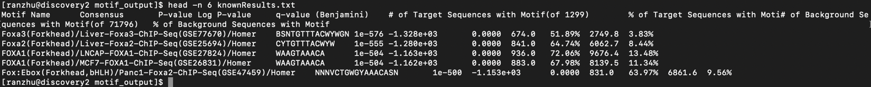
- The top 5 most statistically significantly enriched known motifs identified by HOMER are:
1. Foxa3(Forkhead) — Consensus: BSNTGTTTACWYWGN — p-value = 1e-576
2. Foxa2(Forkhead) — Consensus: CYTGTTTACWYW — p-value = 1e-555
3. FOXA1(Forkhead)/LNCAP — Consensus: WAAGTAAACA — p-value = 1e-504
4. FOXA1(Forkhead)/MCF7 — Consensus: WAAGTAAACA— p-value = 1e-504
5. Fox:Ebox(Forkhead,bHLH) — Consensus: NNNVCTGWGYAAACASN — p-value = 1e-500
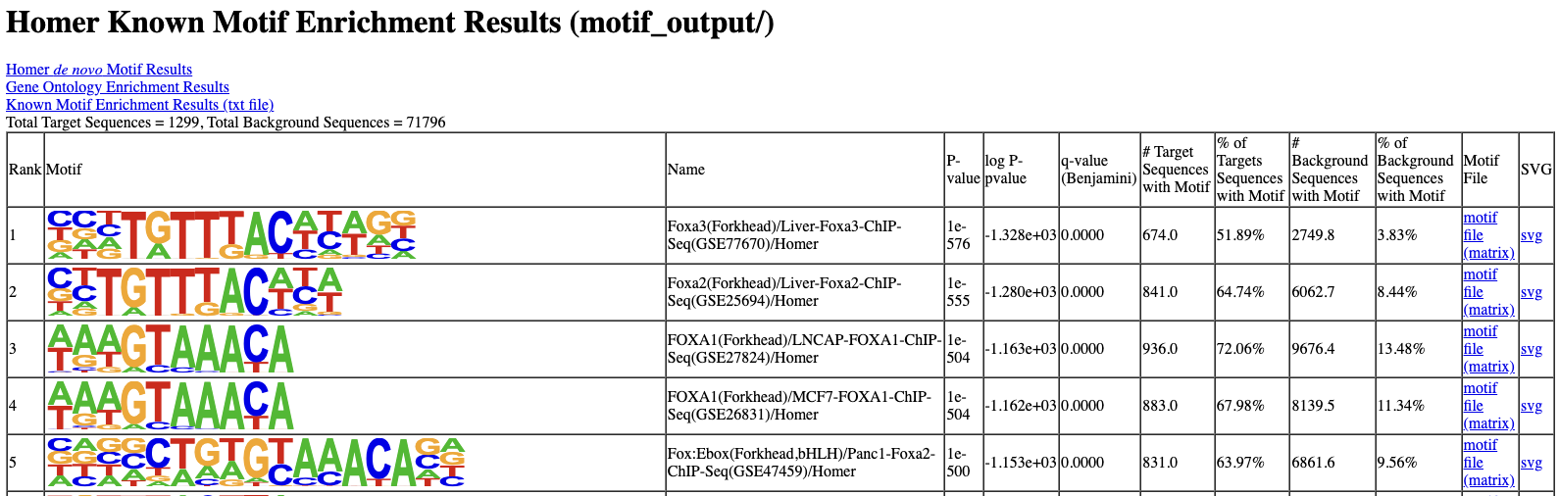

III. Long-read seq analysis question (9 pt)

- NANOME pipeline analysis (2 pt)
You are assigned to analyze the Nanopore long-read NA24385 (HG002) BAM-format data.
Input files:
- BAM file:
/project2/rhie_131/bioc599/shared/long_read_nanome/in_bam/hg002_all.bam
- Human reference genome (hg38):
/project2/rhie_131/bioc599/shared/long_read_nanome/hg38
Using the BAM file as input, run the NANOME pipeline to perform:
- methylation detection
- phasing

Write down the exact command lines you used.

salloc -p debug -c 4 --mem=20G

module purge
module load ver/2506 gcc/14.3.0 openjdk/21.0.7_6 nextflow/25.04.8
module load apptainer

WDIR="/project2/rhie_131/bioc599/users/ranzhu/final_project/nanome"
mkdir -p $WDIR
cd $WDIR

export NXF_SINGULARITY_CACHEDIR=/project2/rhie_131/bioc599/shared/long_read_nanome/local_singularity_cache

nextflow pull LabShengLi/nanome -r rev6

nextflow run LabShengLi/nanome -r rev6 -resume \
-profile singularity \
--dsname hg002 \
--input_bam --dorado \
--input /project2/rhie_131/bioc599/shared/long_read_nanome/in_bam \
--genome /project2/rhie_131/bioc599/shared/long_read_nanome/hg38 \
--phasing --cpu_processors 4 \
--singularity_cache ${NXF_SINGULARITY_CACHEDIR}

- The pipeline completed successfully in 26m 33s, generating methylation detection results (HP1, HP2, all) and phasing results in /project2/rhie_131/bioc599/users/ranzhu/final_project/nanome/results/

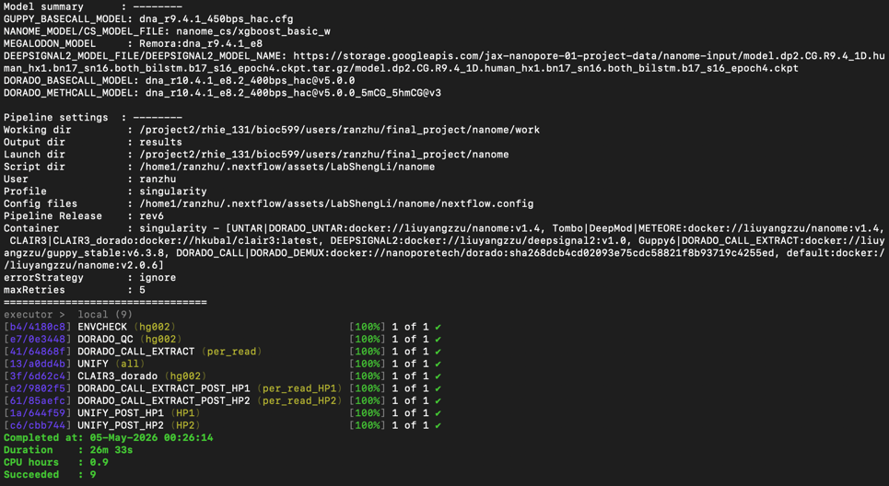

2. Region assignment and haplotype analysis (3 pt)

chr8 | 37747474 | 37748570
chr8 | 142670377 | 142670384
chr15 | 23039853 | 23039919
chr1 | 36450238 | 36451005
chr1 | 240492916 | 240493438
For the 5 regions above, complete the following:
- Extract the data corresponding to your assigned regions from the table.
- Calculate the following values for each region:
  - HP1
  - HP2
  - Absolute difference: |HP1 – HP2|
- Provide your analysis in two parts:
  - Scripts: Submit the code you used in R to perform the calculations.
  - Results: Present your output in a clear table that includes:
    - Region ID
    - HP1
    - HP2
    - |HP1 – HP2|
A : R code - Extract the data corresponding to your assigned regions from the table
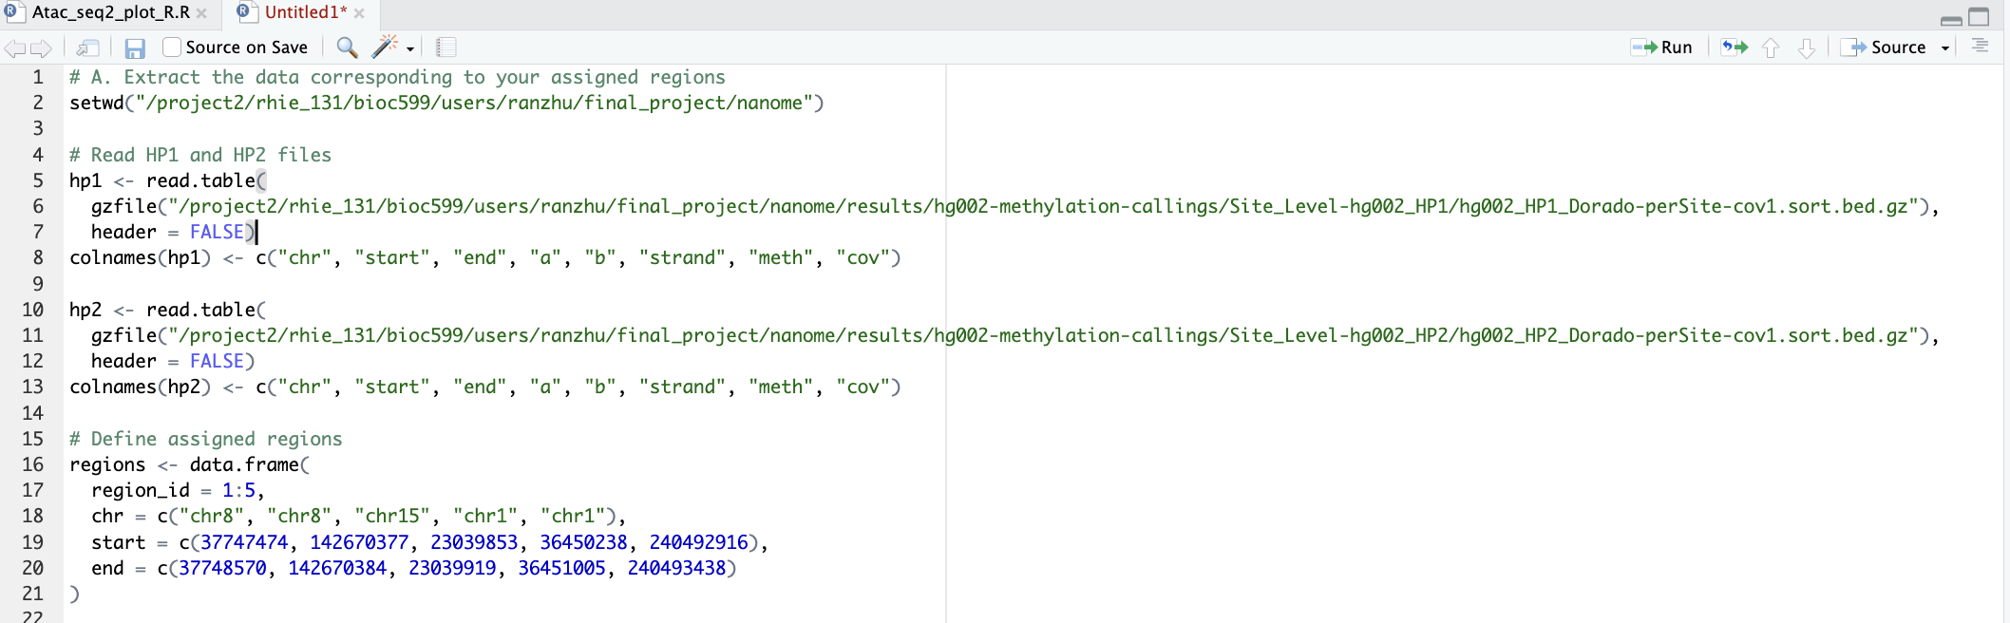
B & C: R Code
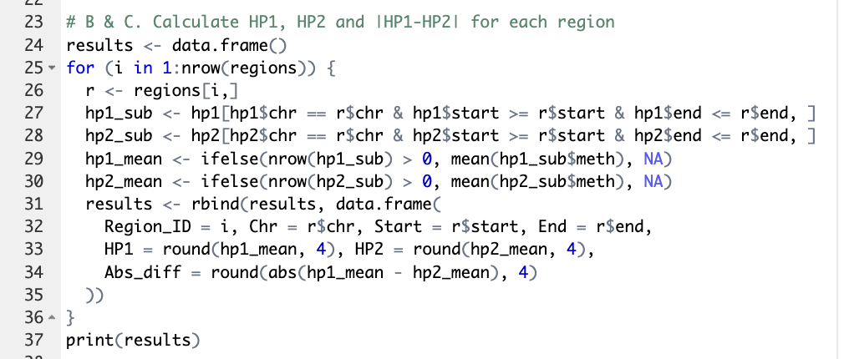
Results Table:
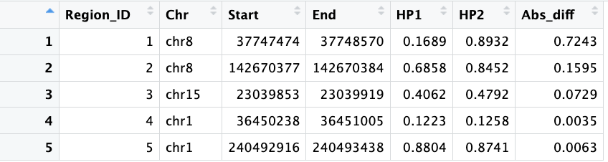
3. Boxplot visualization (2 pt)

Create a boxplot to compare the methylation levels of two groups (HP1 vs. HP2). Describe any differences you observe between the groups based on the visualization (e.g., median, spread, and potential outliers).
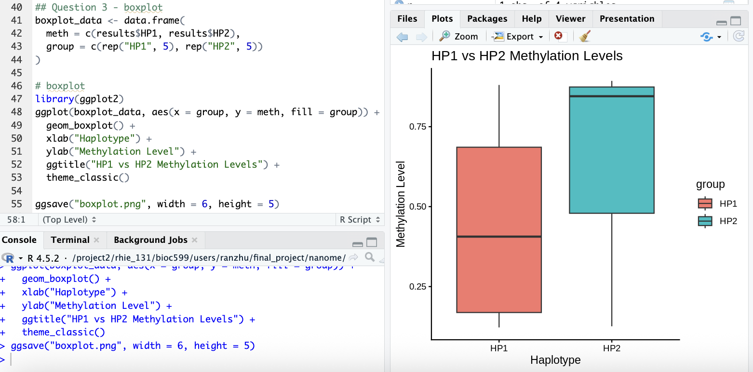

- Median: HP2 (~0.87) has a notably higher median methylation level than HP1 (~0.41), indicating that HP2 regions are more heavily methylated overall.
- Spread: HP1 shows a much wider interquartile range (IQR ~0.12 to ~0.65), suggesting greater variability in methylation levels across regions. HP2 has a narrower IQR (~0.49 to ~0.89), indicating more consistent methylation.
- Potential outliers: No obvious outliers are observed in either group.
- The boxplot shows that HP2 has a higher overall methylation level compared to HP1.

4. IGV visualization (2 pt)

Use IGV to visualize HP1 and HP2 methylation patterns in your assigned regions (at least two different regions). Include screenshots in your report.

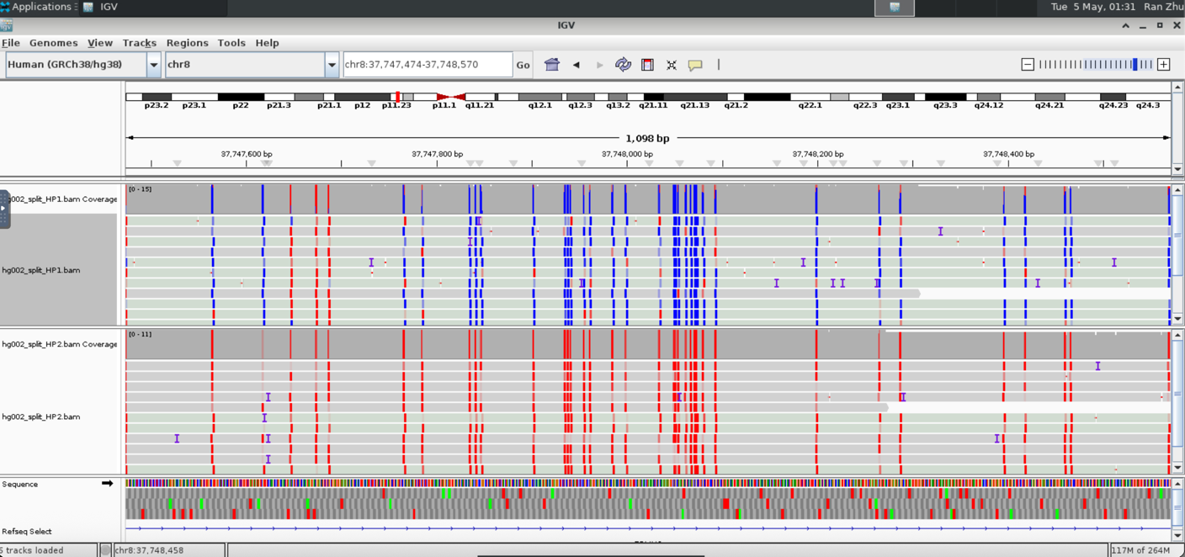

- Region 1: chr8:37747474-37748570
- To visualize DNA methylation patterns, we used IGV's 2-color base modification display. In this view, each CpG site on individual reads is colored by its 5mC modification probability, where red indicates hypermethylated CpG sites and blue indicates hypomethylated CpG sites.
- HP1 reads are predominated by blue signals throughout the region, suggesting that most CpG sites are hypomethylated in haplotype 1. This result aligns with its low mean methylation level of 0.1689. In contrast, HP2 shows a different pattern that the majority of CpG sites are hypermethylated in haplotype 2. This result is consistent with its high mean methylation level of 0.8932. The large absolute difference of 0.7243 between the two haplotypes strongly suggests that this region undergoes haplotype-specific epigenetic regulation.

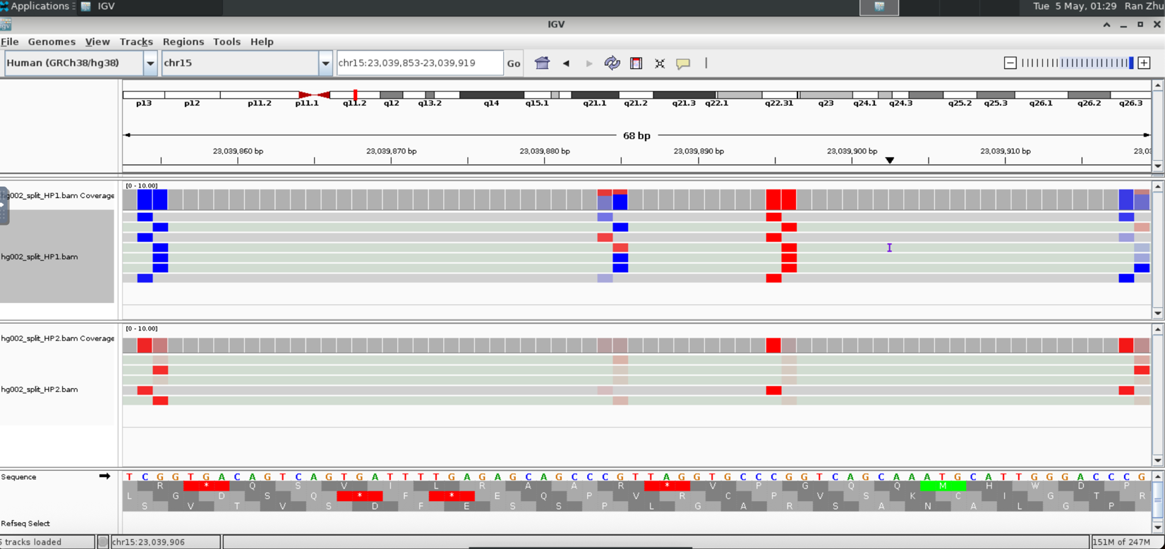
- Region 2: chr15: 23039853 – 23039919
- HP1 reads show a mixture of both red and blue signals throughout the region, suggesting that CpG sites in haplotype 1 have intermediate methylation levels, consistent with its mean methylation level of 0.4062.
- In contrast, HP2 displays predominantly red signals with little to no blue, suggesting higher methylation in haplotype 2. However, the mean methylation level of HP2 is only 0.4792. This discrepancy between the visual pattern and the calculated mean may be attributed to the limited number of CpG sites in this short region (only 66 bp, compared to 1096 bp in Region 1), where a few highly methylated sites could dominate the visual appearance.
- Overall, the absolute difference of 0.0729 is relatively small, indicating that this region does not undergo strong haplotype-specific epigenetic regulation, and both haplotypes maintain relatively similar methylation states.

Extra credit (up to 3 pt)
I. R programming
a) There are 60,609 unique gene_id entries that begin with "ENSG".
b) There are 108,610 unique transcript_id entries that begin with "ENST".
c) There are 42 unique transcript_type values.
d) R scripts and screenshots, along with 4 output files after completing the analysis.
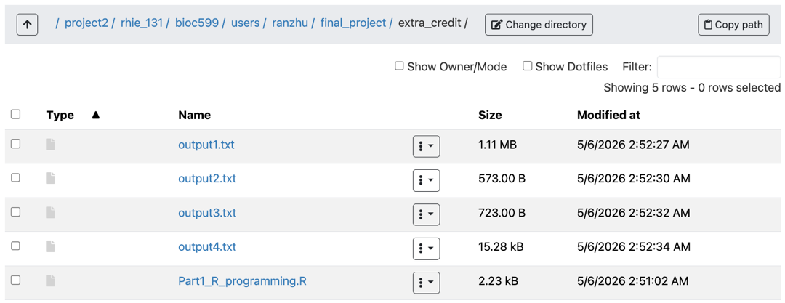
- All files including R script, output files, and screenshots are saved in /project2/rhie_131/bioc599/users/ranzhu/final_project/extra_credit
R scripts :
setwd("/project2/rhie_131/bioc599/users/ranzhu/final_project/extra_credit")
# Read the file
df <- read.table( gzfile("/project2/rhie_131/bioc599/shared/test.anno.gtf.gz"), header = FALSE, sep = "\t",
quote = "", comment.char = "# )
head(df)
dim(df)

# a) Number of unique gene_id entries beginning with "ENSG"
gene_rows <- df[df$V3 == "gene", ]
gene_id <- sapply(strsplit(gene_rows$V9, ";"), function(x) x[1])
gene_id <- gsub('gene_id "|"', "", gene_id)
ensg_ids <- unique(gene_id[grepl("^ENSG", gene_id)])
print(length(ensg_ids))

# b) Number of unique transcript_id entries beginning with "ENST"
transcript_rows <- df[df$V3 == "transcript", ]
transcript_id <- sapply(strsplit(transcript_rows$V9, ";"), function(x) x[2])
transcript_id <- gsub(' transcript_id "|"', "", transcript_id)
enst_ids <- unique(transcript_id[grepl("^ENST", transcript_id)])
print(length(enst_ids))

# c) Number of unique transcript_type values
transcript_type <- sapply(strsplit(transcript_rows$V9, ";"), function(x) x[5])
transcript_type <- gsub(' transcript_type "|"', "", transcript_type)
print(length(unique(transcript_type)))

# d) Generate a table containing the list of unique gene_id values
output1 <- data.frame(gene_id = ensg_ids)
write.table(output1, "output1.txt", row.names = FALSE, quote = FALSE)

# e) Number of unique gene_type values
gene_type <- sapply(strsplit(gene_rows$V9, ";"), function(x) x[2])
gene_type <- gsub(' gene_type "|"', "", gene_type)
output2 <- data.frame(gene_type = unique(gene_type))
write.table(output2, "output2.txt", row.names = FALSE, quote = FALSE)

# f) Create a table with gene_type and gene counts
gene_type_count <- as.data.frame(table(gene_type))
colnames(gene_type_count) <- c("gene_type", "number_of_genes")
write.table(gene_type_count, "output3.txt", row.names = FALSE, quote = FALSE)

# g) Create a table of unique gene_name values for gene_type "miRNA"
mirna_rows <- gene_rows[gene_type == "miRNA", ]
gene_name <- sapply(strsplit(mirna_rows$V9, ";"), function(x) x[3])
gene_name <- gsub(' gene_name "|"', "", gene_name)
output4 <- data.frame(gene_name = unique(gene_name))
write.table(output4, "output4.txt", row.names = FALSE, quote = FALSE)
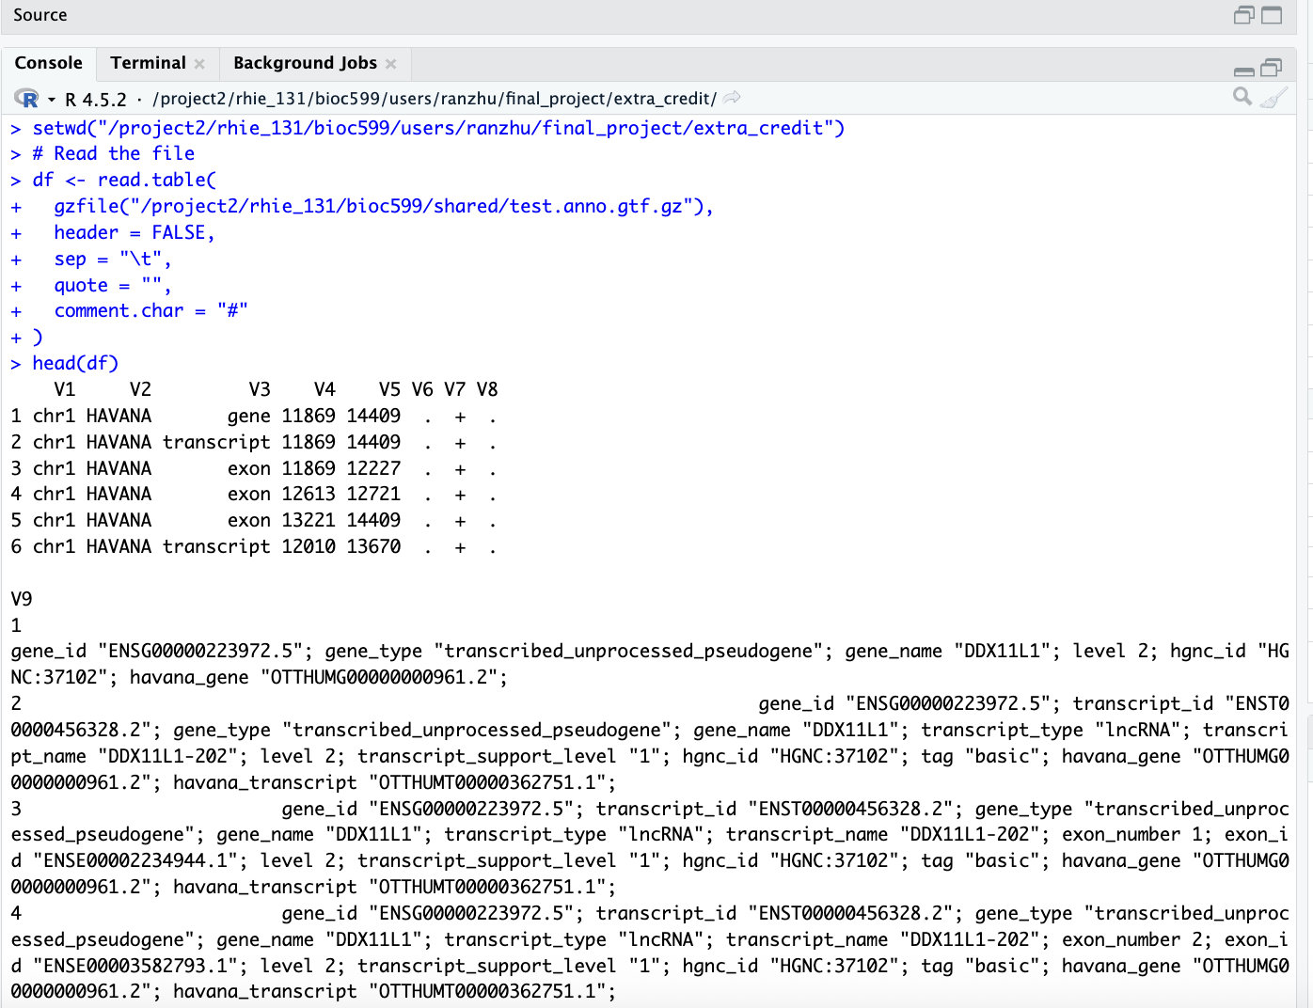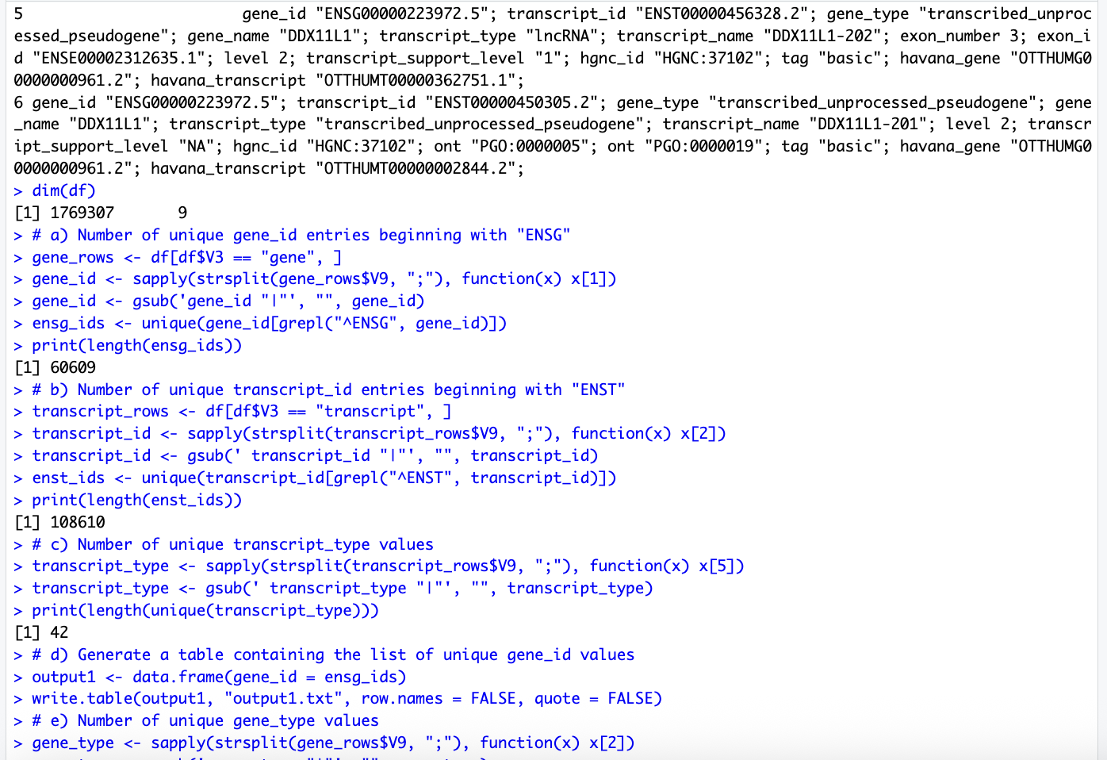
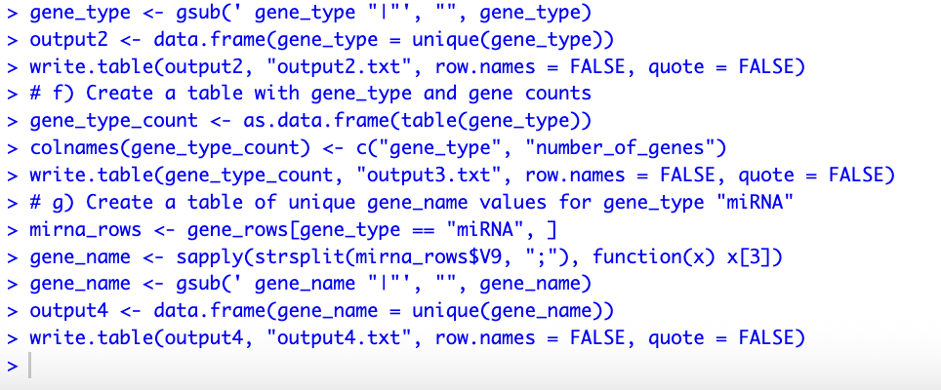
Output 1
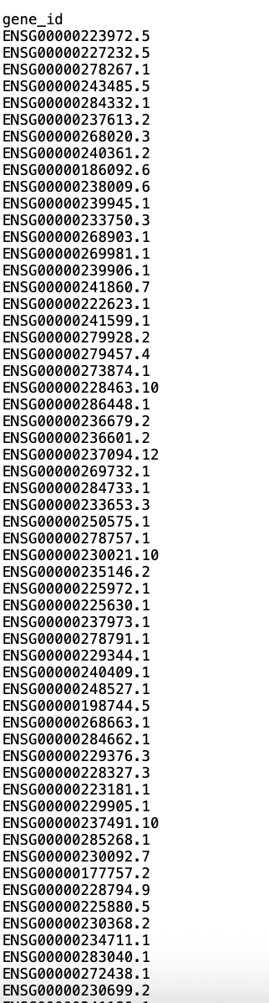 see full: /project2/rhie_131/bioc599/users/ranzhu/final_project/extra_credit/output1.txt

Output 2
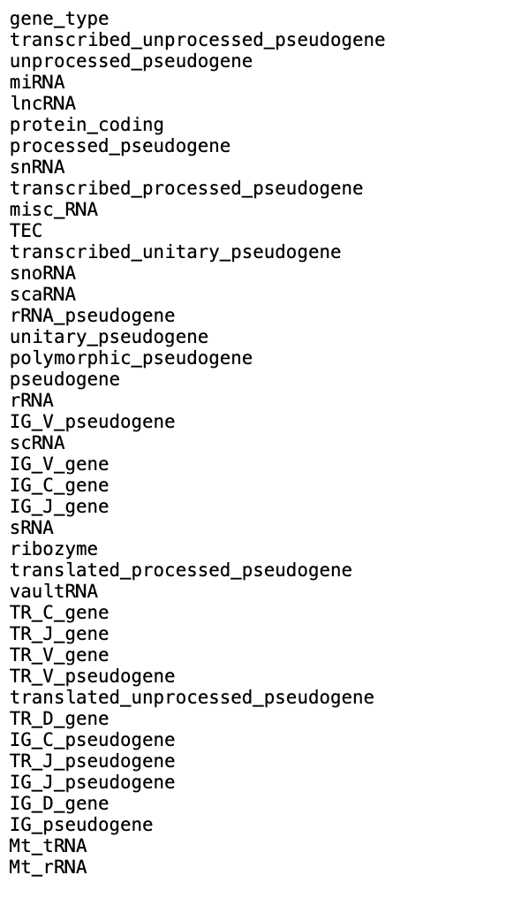
Output 3:
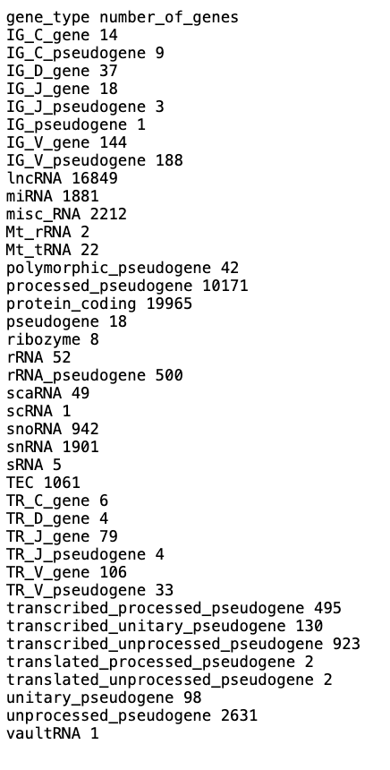
Output 4
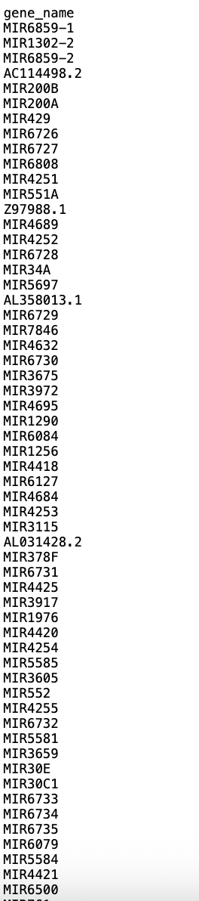 see full text: /project2/rhie_131/bioc599/users/ranzhu/final_project/extra_credit/output4.txt

Part II. ChIP-seq data analysis
a) Download ZFX ChIP-seq datasets generated in HCT116 cells from GSE102616. For each replicate, perform peak calling using MACS2 with a significance threshold of -p 1e-2. Use the corresponding input control for each replicate (i.e., use rep1 input for rep1 ChIP-seq data and rep2 input for rep2 ChIP-seq data).
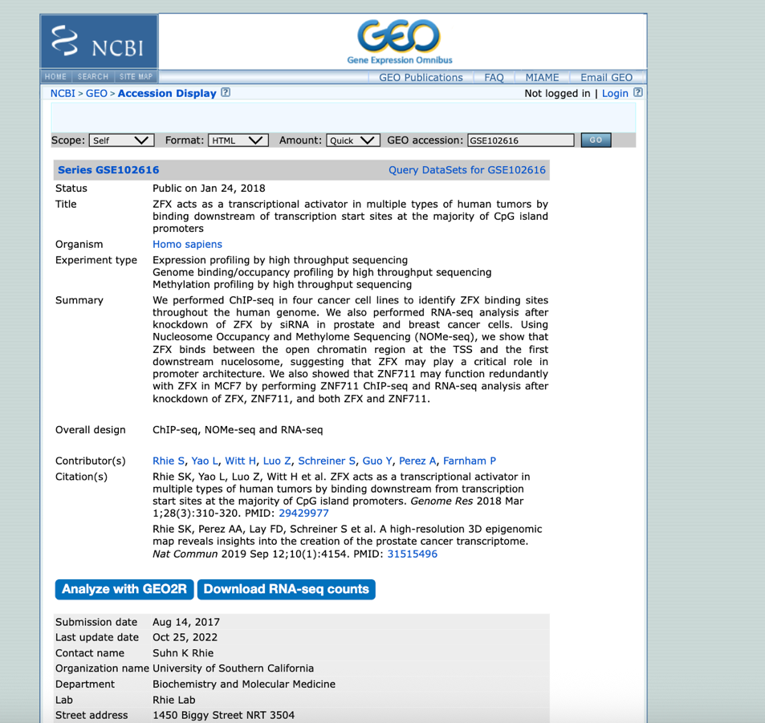
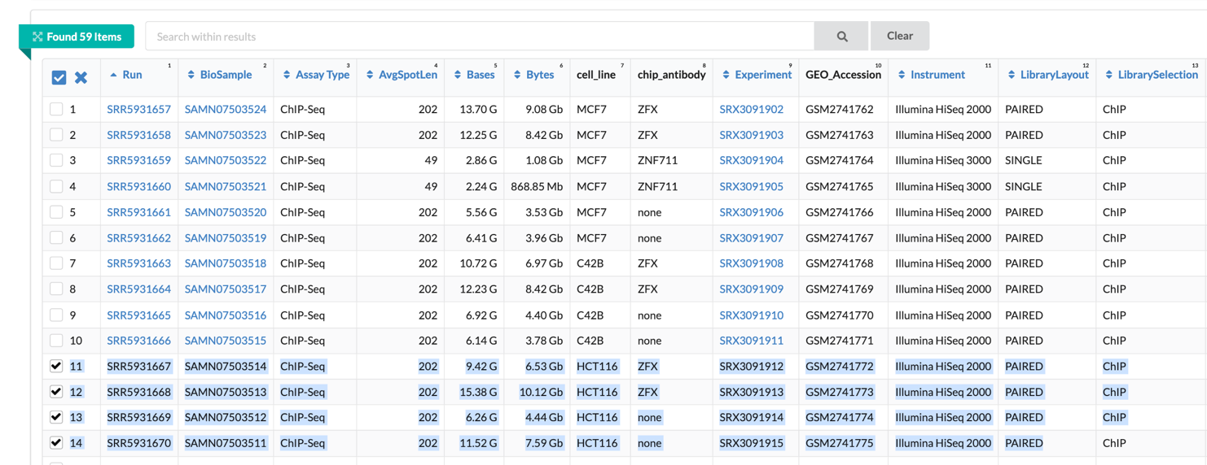
Sample Type | GEO Accession | SRA Run Accession
ZFX ChIP-seq rep1 | GSM2741772 | SRR5931667
ZFX ChIP-seq rep2 | GSM2741773 | SRR5931668
Input control rep1 | GSM2741774 | SRR5931669
Input control rep2 | GSM2741775 | SRR5931670

Scripts to download the data:
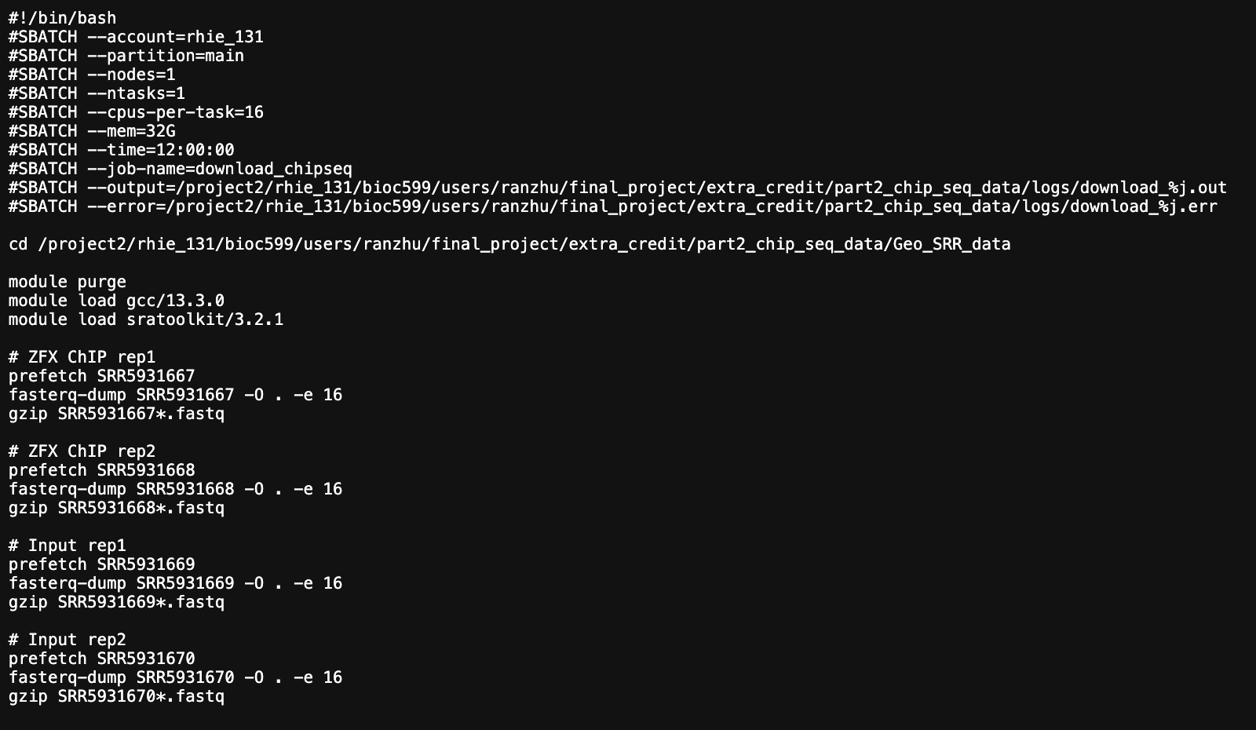
- Scripts to perform from alignment to peak calling:
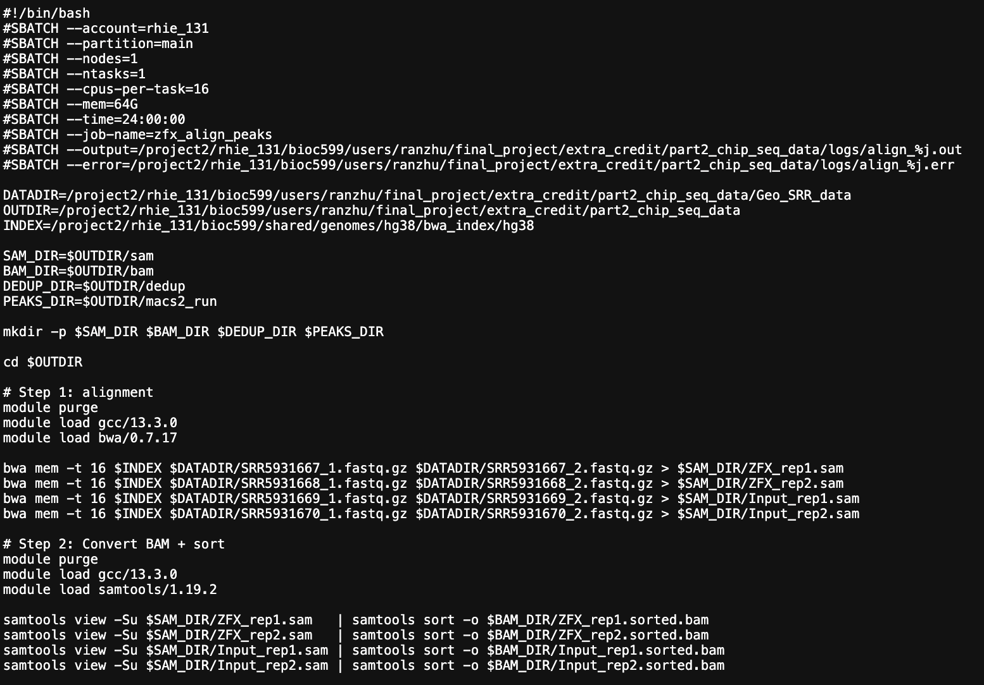
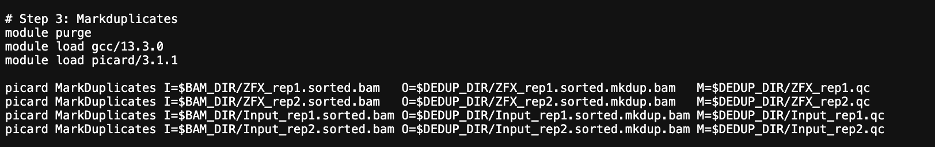
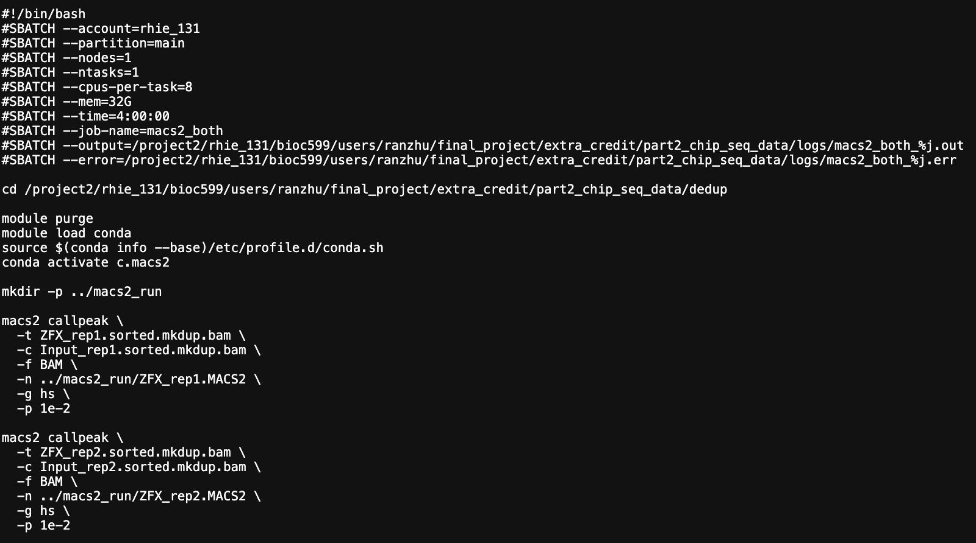
b) Report the total number of reads sequenced and total number of reads aligned to hg38. (scripts shown in Q g))
- Total reads sequenced: the total number of sequenced reads was calculated as the number of lines in one FASTQ file divided by 4 (single FASTQ lines / 4).
- ZFX ChIP-seq rep1 (SRR5931667): FASTQ R1/R2 lines 186,545,476, (186,545,476 / 4) = 46,636,369
- ZFX ChIP-seq rep2 (SRR5931668): FASTQ R1/R2 lines 304,553,532, (304,553,532 / 4) = 76,138,383
- Input control rep1 (SRR5931669): FASTQ R1/R2 lines 124,046,160, (124,046,160 / 4) = 31,011,540
- Input control rep2 (SRR5931670): FASTQ R1/R2 lines 228,030,752, (228,030,752 / 4) = 57,007,688
Total reads aligned to hg38:
- ZFX ChIP-seq rep1 (SRR5931667): 46,265,081 read pairs + 217,985 unpaired = 46,483,066 total mapped
- ZFX ChIP-seq rep2 (SRR5931668): 75,679,105 read pairs + 317,807 unpaired = 75,996,912 total mapped
- Input control rep1 (SRR5931669): 30,120,244 read pairs + 813,387 unpaired = 30,933,631 total mapped
- Input control rep2 (SRR5931670): 56,657,298 read pairs + 256,484 unpaired = 56,913,782 total mapped
c) Report total number of peaks identified for each replicate.
- ZFX rep1: 40,037 peaks
- ZFX rep2: 18,547 peaks
d) Determine how many peaks are shared (overlapping) between the two replicates.
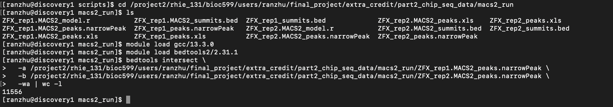
- 11,556 peaks are overlapping between ZFX ChIP-seq replicate 1 and replicate 2.
e) Using the generated bigWig files for both replicates, create a heatmap centered on the overlapping peaks with a window of ±1000 bp. Cluster the regions into five groups using k-means clustering.
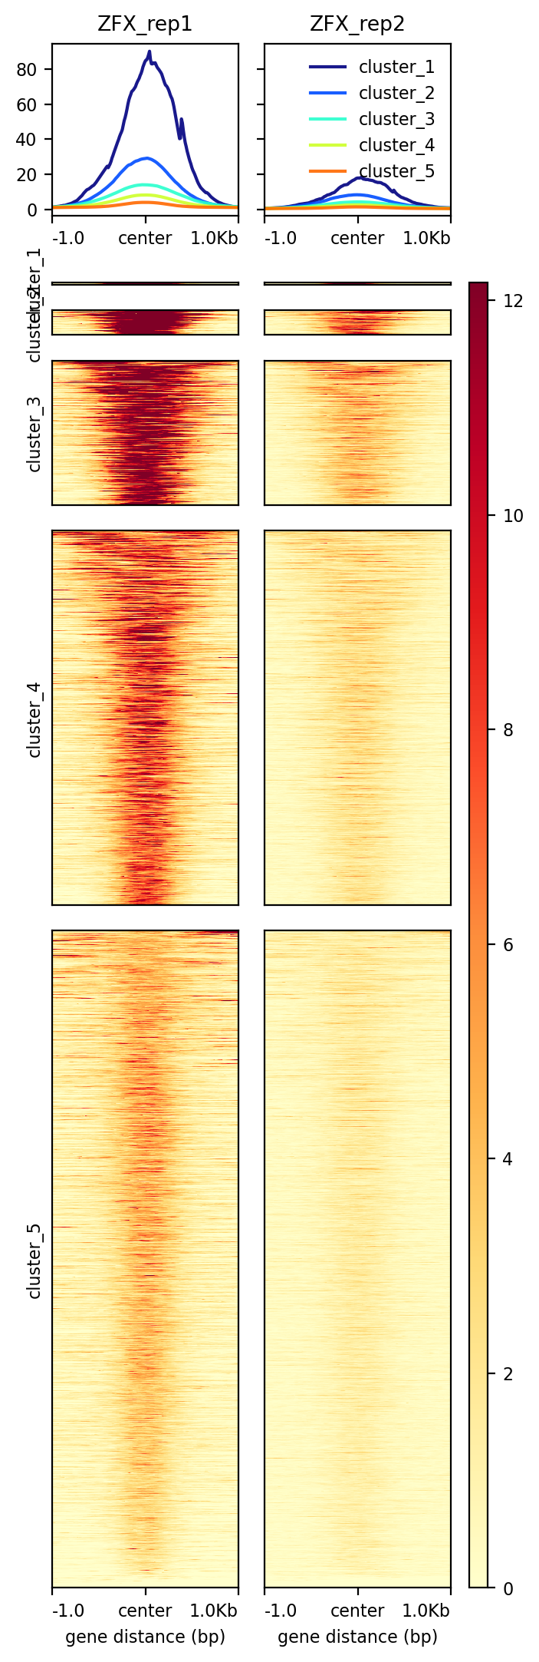

- From the heatmap, the 11,556 overlapping ZFX peaks are divided into 5 clusters with different signal intensities.
- In both rep1 and rep2, cluster 1 appears as a very thin band in the heatmap, indicating that it contains very few peaks relative to the other clusters. deepTools generated a warning during plotting: "Group 'cluster_1' is too small for plotting", suggesting that the k-means algorithm assigned only a minimal number of peaks to this cluster, which is insufficient for visualization.
- Cluster 2 is relatively small shows the strong and sharp enrichment at the peak center in rep1, suggesting that it represents high-confidence ZFX binding sites with strong and focused occupancy. In rep2, cluster 2 also shows enrichment at the peak center, but with relatively lower signal intensity.
- In rep1, cluster 3 shows strong enrichment at the peak center, while cluster 4 shows moderate signal. Cluster 5 has very weak signal with low visible enrichment at the peak center, suggesting these peaks may represent less specific or low-confidence ZFX binding sites. In rep2, cluster 3 still shows some enrichment at the peak center, but clusters 4 and 5 show almost no detectable signal, suggesting that the ZFX binding at these sites is either very weak or not reproducible between the two replicates.
f) After loading the bigWig files and the overlapping peaks into IGV, examine and interpret the ZFX binding profiles with respect to their genomic distribution (e.g., promoter, intron, exon, intergenic regions). Add example screenshots of IGV session to support your interpretation.
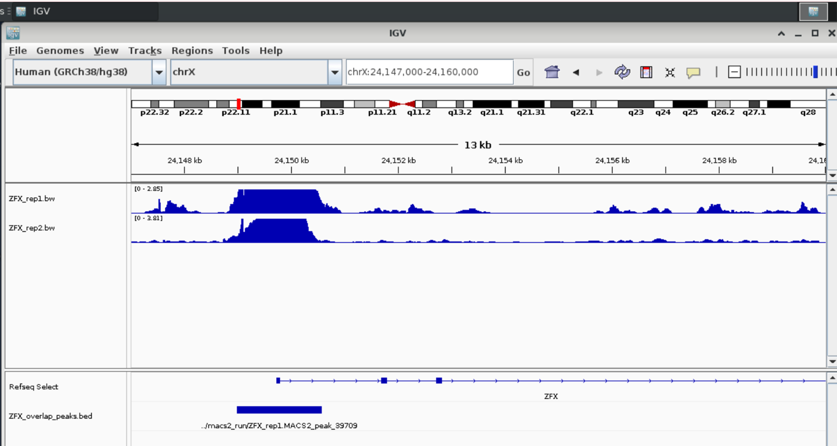
- ZFX binding at the promoter region of the ZFX gene (chrX:24,147,000-24,160,000)
- In this IGV screenshot, I can see a strong ZFX binding peak in both rep1 and rep2 at chrX:24,148,973-24,150,584. The RefSeq track shows that the ZFX gene is transcribed from left to right (arrows pointing right), and the peak is sitting right at the beginning of the gene, overlapping with the TSS and the first exon (the thick blue box at the left end of the gene). This is a promoter binding pattern for transcription factors, where binding is concentrated around the TSS. The overlapping peak (ZFX_rep1.MACS2_peak_39709) is identified at this exact location in both replicates, which strongly supports that ZFX protein directly binds to its own promoter.
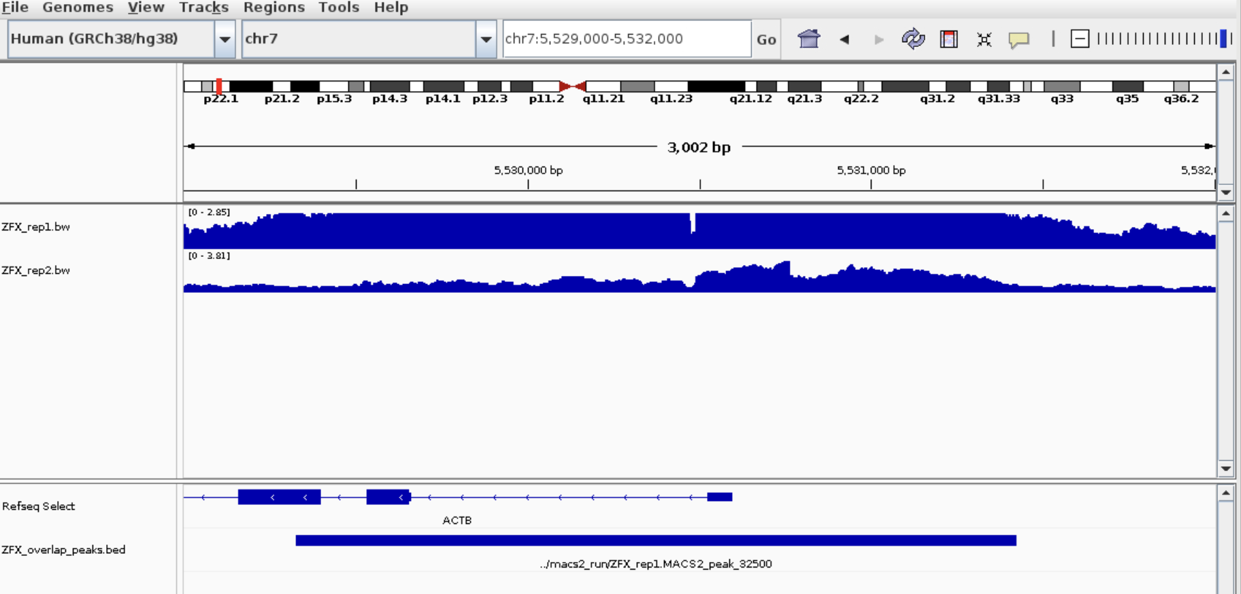
- ZFX binding within the gene body of ACTB (intron and exon regions) (chr7:5,529,000-5,532,000)
- A ZFX binding peak (ZFX_rep1.MACS2_peak_32500) is observed within the gene body of the ACTB gene at chr7:5,529,326-5,531,425. The ACTB gene is transcribed from right to left (arrows pointing left). Looking at the RefSeq track, the peak spans across both exonic regions (thick blue boxes) and intronic regions (thin lines) within the ACTB gene body. Both rep1 and rep2 show signal across this region, although rep1 has stronger signal than rep2. This suggests that ZFX binding is not restricted to promoter regions but can also occur within gene bodies, spanning both introns and exons.

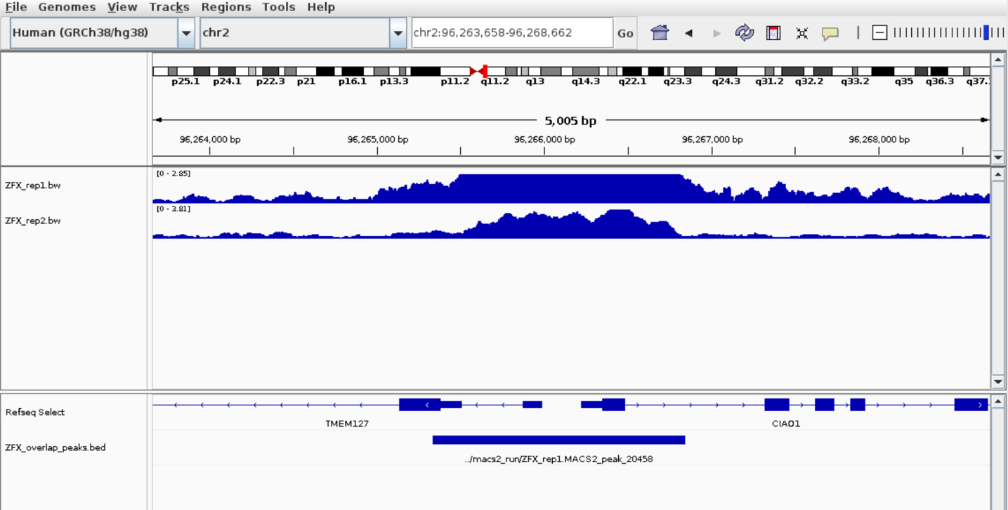
- ZFX binding at an intergenic region (chr2:96,263,658-96,268,662)
- A ZFX binding peak (ZFX_rep1.MACS2_peak_20458) is observed at chr2:96,265,331-96,266,845. Looking at the RefSeq Select track in IGV, this peak is located between the TMEM127 gene and the CIAO1 gene, with no RefSeq-annotated genes overlapping this peak. Both rep1 and rep2 show clear signal at this location, with rep1 having stronger signal than rep2. This suggests that ZFX can also bind to intergenic regions between annotated genes, which may potentially play a regulatory role for the neighboring TMEM127 or CIAO1 genes, though further experiments would be needed to confirm this.
Overall: Based on the IGV screenshots, ZFX binding peaks are observed across different genomic regions. The strongest and most prominent peak is found at the promoter region near the TSS of the ZFX gene, which is consistent with ZFX's role as a transcription factor. However, ZFX binding is not restricted to promoters — peaks are also found within gene bodies spanning both introns and exons (as seen in ACTB), as well as in intergenic regions between genes (as seen between TMEM127 and CIAO1). Overall, these examples suggest that ZFX can bind to diverse genomic locations, though promoter binding appears to produce the strongest signal, possibly reflecting its primary role in transcriptional regulation.
g) Provide your scripts and screenshots after completing the analysis.
Question A. 1. Downloading SRR datasets
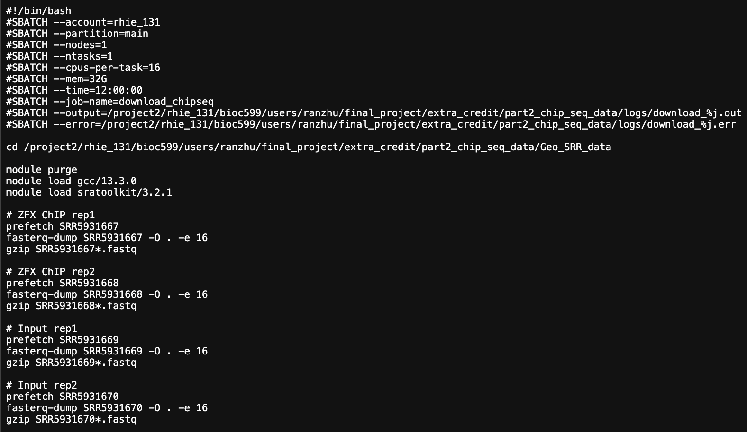
2. Scripts to perform Alignment to Peak calling
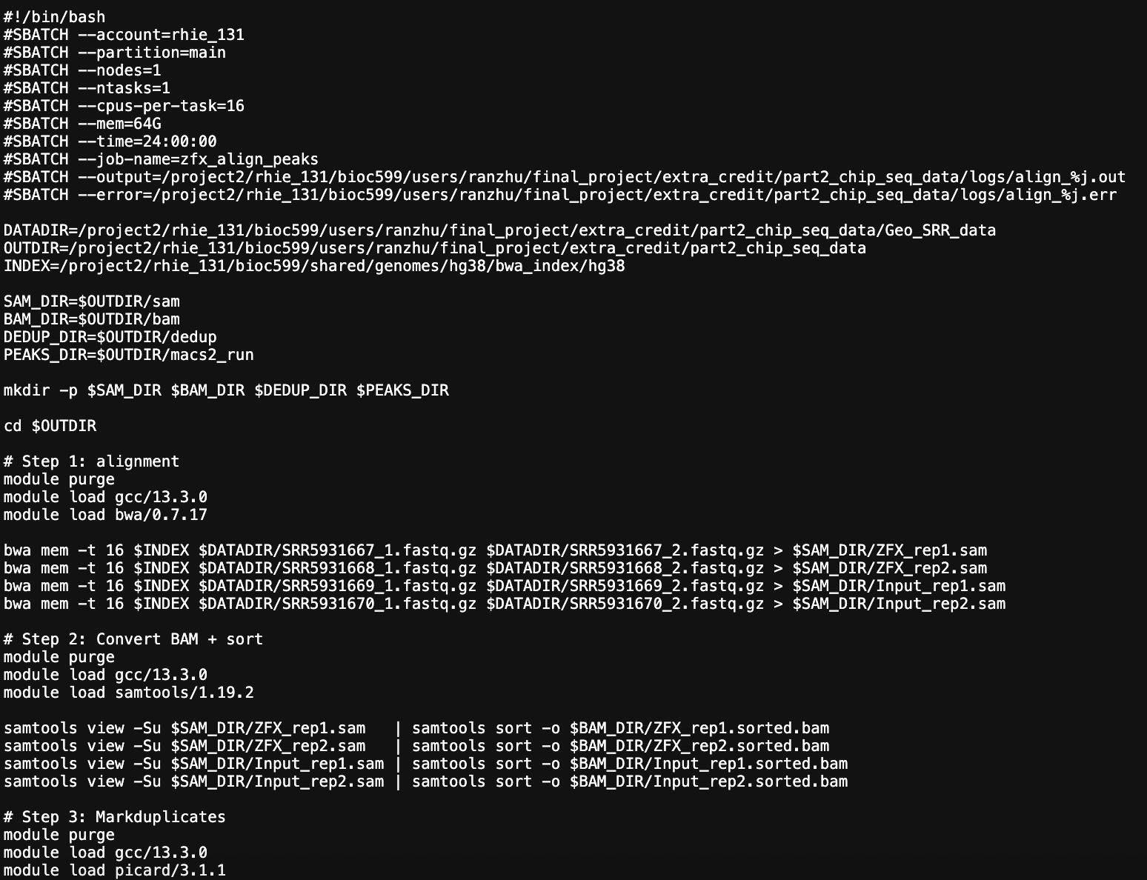
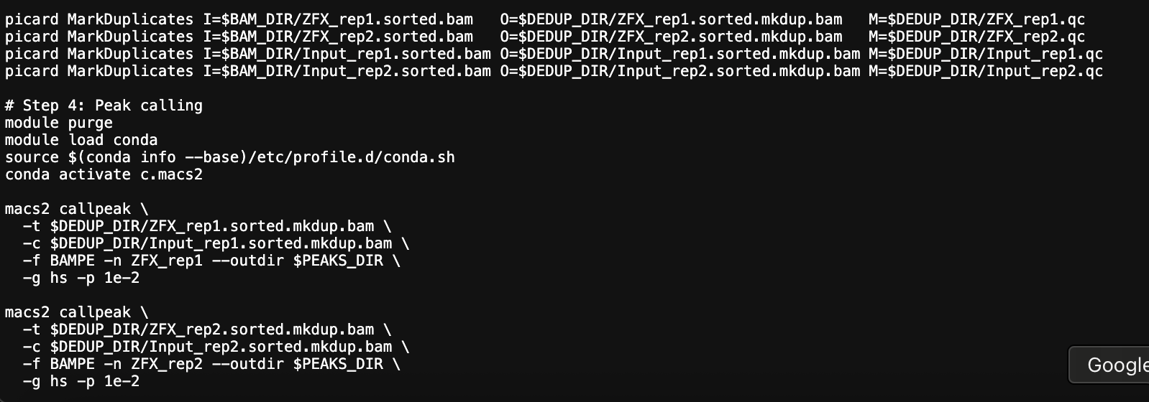
Troubleshooting: during the analysis, I ran into two issues with MACS2 peak calling.
1. When running the full pipeline, MACS2 finished for ZFX rep2 but failed to generated output files for rep1. When I checked the SLURM error log, MACS2 had only printed the run parameters and stopped, which suggested the job ran out of time. I resubmitted rep1 as a separate job to fix this.
2. However, the resubmitted job failed with a ZeroDivisionError. This happened because I was using -f BAMPE, and the deduplicated BAM for rep1 had an 83% redundancy rate, leaving too few fragments after filtering. I switched to -f BAM instead, which lets MACS2 estimate the fragment size on its own rather than using the paired-end insert size. This fixed the error and both replicates finished successfully.
Fix MacS2 peak calling script:
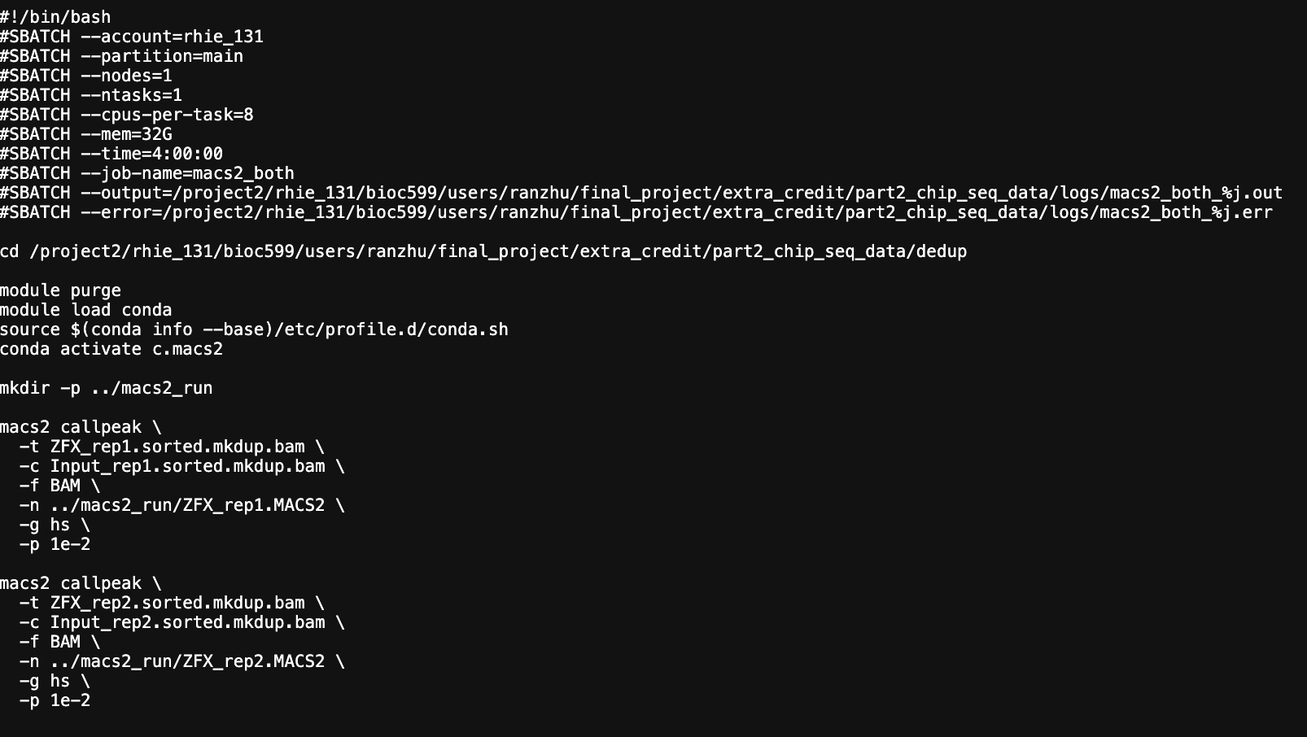
Question B:
1. Report the total number of reads sequenced.
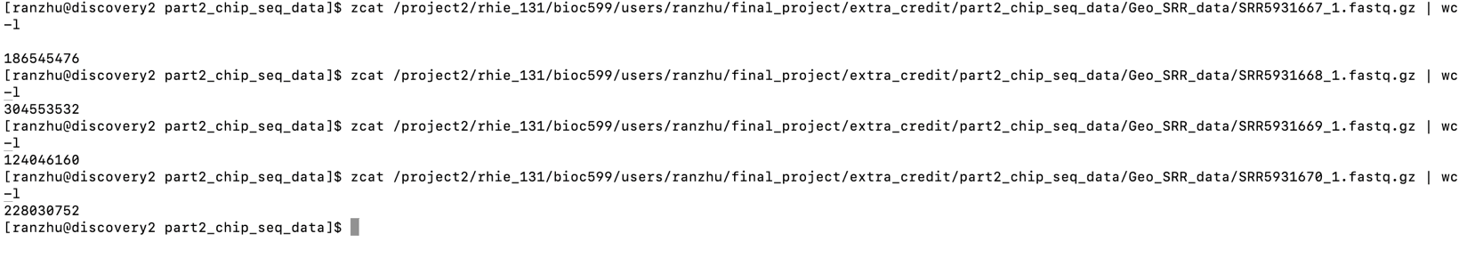
2. Report total number of reads aligned to hg38.
- ZFX ChIP-seq rep1 (SRR5931667)
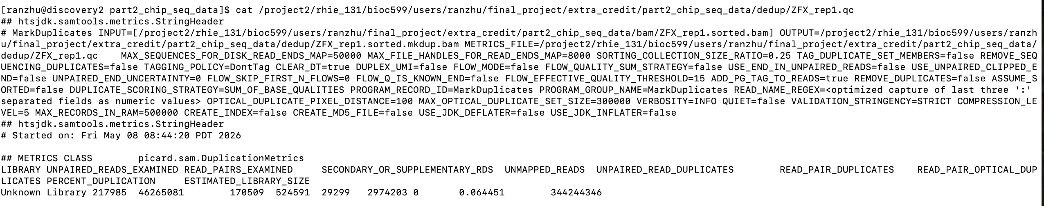
- ZFX ChIP-seq rep2 (SRR5931668)
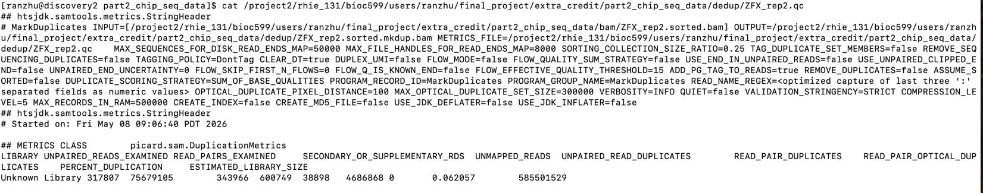
- Input control rep1 (SRR5931669)
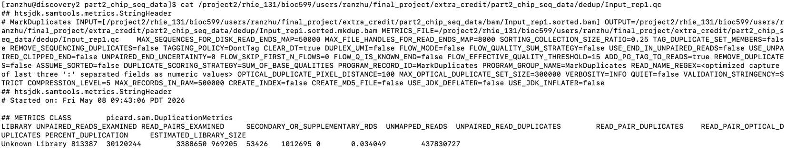
- Input control rep2 (SRR5931670)
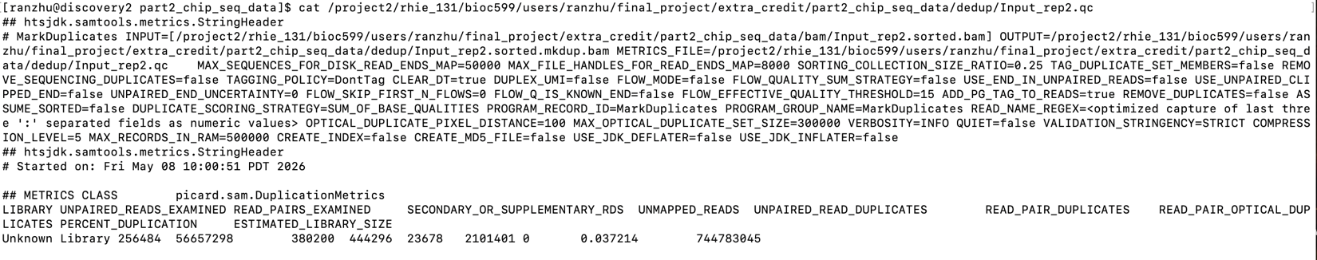
Question C
Question D
Question E
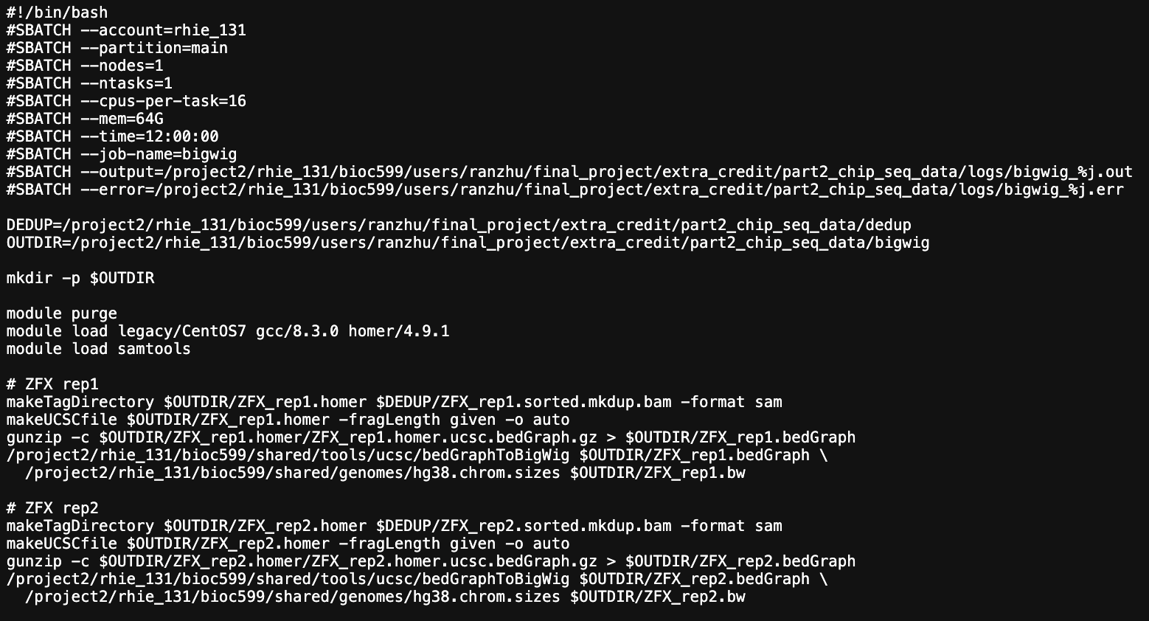
Troubleshooting
- When converting the bedGraph file to bigWig format for ZFX rep2, bedGraphToBigWig reported an error: "End coordinate 16572 bigger than chrM size of 16569". This was because Homer generated a bedGraph with coordinates slightly exceeding the chromosome size in the hg38.chrom.sizes file.
- I initially thought the error was because the provided hg38.chrom.sizes file had a different chrM size than the reference genome I used for alignment. So I generated a new chrom.sizes file directly from my BAM file using samtools, but the BAM file also showed chrM = 16,569, which means the mismatch was not caused by a version difference. The real issue was that Homer itself generated bedGraph coordinates slightly beyond the actual chromosome boundary for rep2.
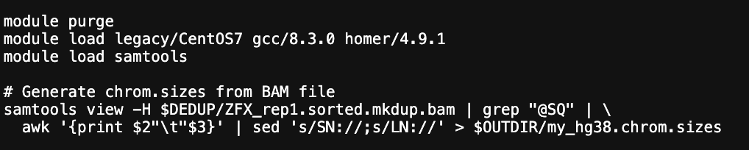
- Rep1 worked fine because its chrM coordinates in the bedGraph never exceeded 16,569 (the last coordinate was 16,568–16,569), whereas rep2 had coordinates extending to 16,572, which is 3 bp beyond the chromosome boundary.
- I applied awk to filter out the out-of-bound lines for rep2 only, then reran bedGraphToBigWig, which completed successfully.
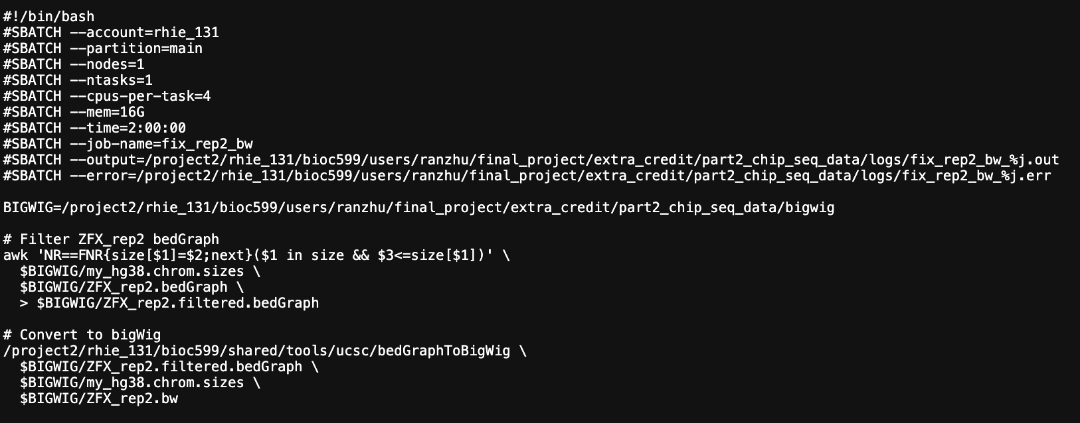
Heatmap:
