PALU

(PAUNANG LUNAS)

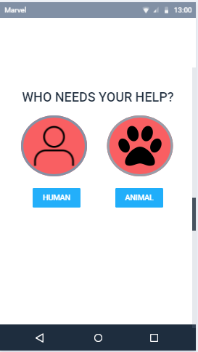

PALU (Paunang Lunas) -a mobile app which can be use when in case of emergency situations that allows the user to know the right steps on applying a specific first aid to an injured person or animal.

-the app will let you choose who needs your help then the illnesses, injury will pop up together with its treatment and procedure. The app also will provide emergency hotlines to seek for help