Documentation

In order to show case the learnings in HTML, CSS and JavaScript, a Game website was created.

The main page has 4 links: Home, Documentation, Game ( itself) and ImpressumDatenSchutz



Looking at the home page we have, details of our support, as well as available time and our physical office ( embedded google maps)

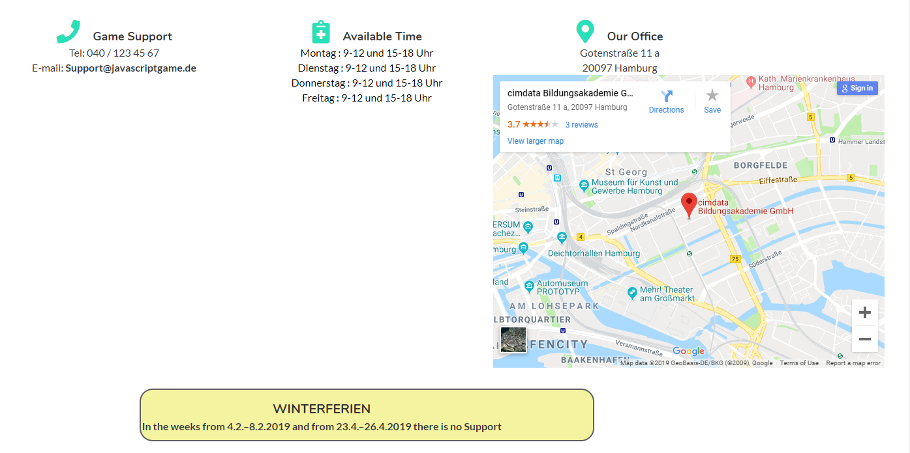

Last part is a about us and about game information

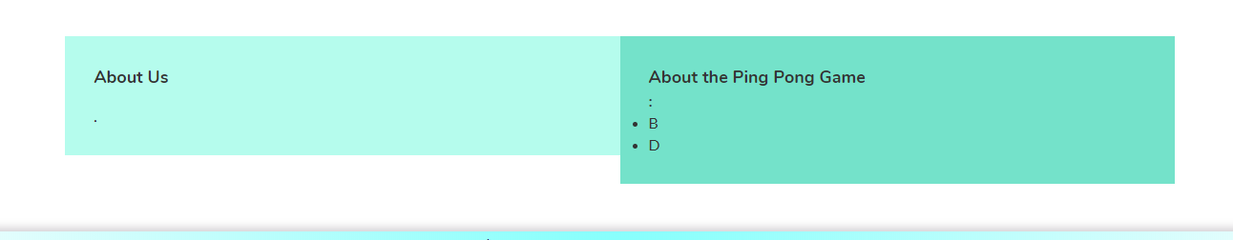

On the Documentation side, there will be this document as functional documentation as well as the code of the game documented

On the page GAME, there will be the ping pong game itself

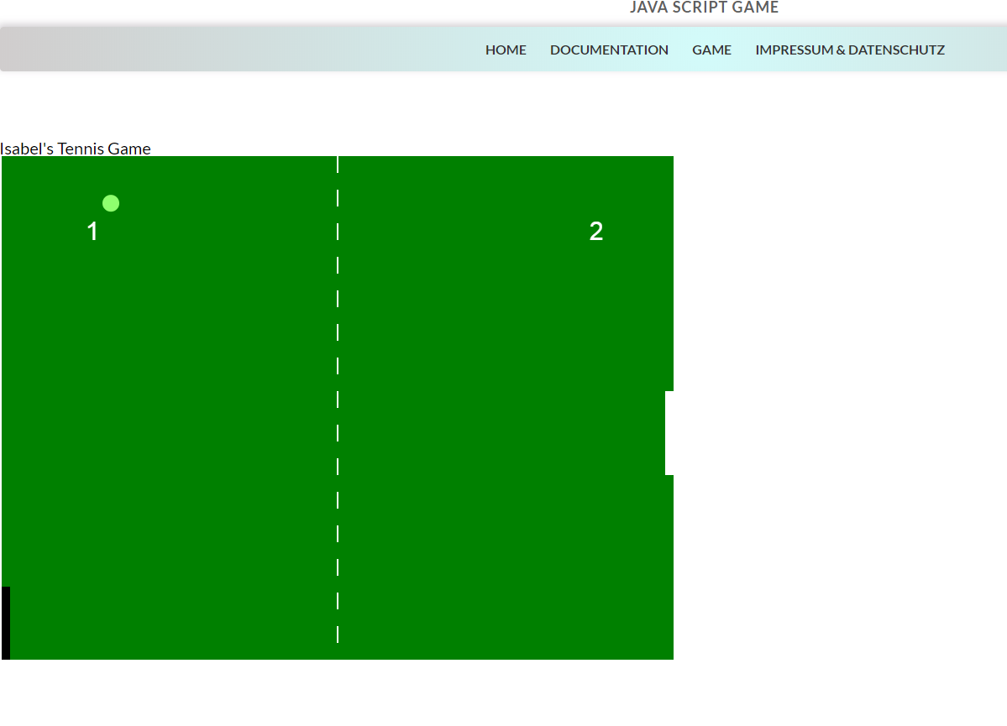

and finally a page with the open source license

