AI-Driven Sugarcane Leaf Diseases Detection, Classification, and Remedy Suggestion with Deployment via Web Application

Chapter | Section | Subsection / Details
1 | Introduction | 1.1 Overview
1 | Introduction | 1.2 Problem Statement
1 | Introduction | 1.3 Significance of the Study
1 | Introduction | 1.4 Background of AI in Agriculture
1 | Introduction | 1.5 Motivation
1 | Introduction | 1.6 Scope of the Study
1 | Introduction | 1.7 Proposed Solution
2 | Literature Review | 2.1 Introduction
2 | Literature Review | 2.2 Deep Learning Approaches in Agriculture
2 | Literature Review | - AlexNet
2 | Literature Review | - VGG16/19
2 | Literature Review | - ResNet
2 | Literature Review | - DenseNet
2 | Literature Review | 2.3 Hybrid CNN + ML Approaches
2 | Literature Review | 2.4 Sugarcane Disease Detection Studies
2 | Literature Review | 2.5 Comparative Studies of CNN Models
2 | Literature Review | 2.6 Observations from Literature
2 | Literature Review | 2.7 Summary
3 | Research Gaps | 3.1 Introduction
3 | Research Gaps | 3.2 Dataset Limitations
3 | Research Gaps | 3.3 Model Generalization Issues
3 | Research Gaps | 3.4 Lack of Real-Time Deployment Solutions
3 | Research Gaps | 3.5 Usability & Farmer-Centric Gaps
3 | Research Gaps | 3.6 Research Opportunities
3 | Research Gaps | 3.7 Summary
4 | Proposed Methodology | 4.1 Introduction
4 | Proposed Methodology | 4.2 Methodological Framework
4 | Proposed Methodology | 4.3 Dataset Preparation
4 | Proposed Methodology | 4.4 Preprocessing and Data Augmentation
4 | Proposed Methodology | 4.5 DenseNet201 Architecture for Feature Extraction
4 | Proposed Methodology | 4.6 Support Vector Machine (SVM) for Classification
4 | Proposed Methodology | 4.7 Training Pipeline
4 | Proposed Methodology | 4.8 Pseudocode for Implementation
4 | Proposed Methodology | 4.9 Flask-Based Deployment
4 | Proposed Methodology | 4.10 Remedies Integration
4 | Proposed Methodology | 4.11 Methodological Flowchart
4 | Proposed Methodology | 4.12 Summary
5 | Objectives | 5.1 Introduction
5 | Objectives | 5.2 Primary Objectives
5 | Objectives | 5.3 Secondary Objectives
5 | Objectives | 5.4 Long-Term Objectives
5 | Objectives | 5.5 Alignment with Sustainable Development Goals (SDGs)
5 | Objectives | 5.6 Summary
6 | System Design and Implementation | 6.1 Introduction
6 | System Design and Implementation | 6.2 System Architecture
6 | System Design and Implementation | 6.3 Model Layer – DenseNet201 + SVM
6 | System Design and Implementation | 6.4 Backend Implementation (Flask)
6 | System Design and Implementation | 6.5 Frontend Design (HTML Templates)
6 | System Design and Implementation | 6.6 Remedies Integration
6 | System Design and Implementation | 6.7 Workflow of the System
6 | System Design and Implementation | 6.8 Security and Deployment Considerations
6 | System Design and Implementation | 6.9 Strengths of System Design
6 | System Design and Implementation | 6.10 Summary
7 | Results and Discussion | 7.1 Introduction
7 | Results and Discussion | 7.2 Experimental Setup
7 | Results and Discussion | 7.3 Performance Metrics
7 | Results and Discussion | 7.4 Results
7 | Results and Discussion | 7.5 Baseline vs Proposed Model Comparison
7 | Results and Discussion | 7.6 Training and Validation Curves
7 | Results and Discussion | 7.7 Discussion of Findings
7 | Results and Discussion | 7.8 Strengths of the Proposed System
7 | Results and Discussion | 7.9 Limitations
7 | Results and Discussion | 7.10 Future Improvements
7 | Results and Discussion | 7.11 Summary
8 | Conclusion and Future Work | 8.1 Introduction
8 | Conclusion and Future Work | 8.2 Summary of Contributions
8 | Conclusion and Future Work | 8.3 Key Findings
8 | Conclusion and Future Work | 8.4 Limitations
8 | Conclusion and Future Work | 8.5 Future Work
8 | Conclusion and Future Work | 8.6 Conclusion
9 | References

Chapter 1: Introduction
1.1 Overview
Sugarcane (Saccharum officinarum) is one of the world’s most important commercial crops, grown primarily in tropical and subtropical regions. Globally, Brazil, India, China, and Thailand are leading producers, with India ranking second. Sugarcane contributes significantly to the economy by supporting sugar industries, ethanol production, and providing employment to millions of farmers.
However, sugarcane cultivation faces challenges from multiple biotic and abiotic stresses. Among these, leaf diseases such as Red Rot (Colletotrichum falcatum) and Red Rust (Cephaleuros parasiticus) are particularly devastating. They reduce photosynthesis efficiency, weaken plants, and can cause up to 30–40% yield loss under severe outbreaks.
Traditionally, disease diagnosis is performed through manual inspection, requiring expert plant pathologists. However, this process is time-consuming, labor-intensive, and prone to human misinterpretation. Farmers often misdiagnose early symptoms, resulting in incorrect pesticide application, which not only increases costs but also affects soil and environmental health.
The rapid advancement of Artificial Intelligence (AI), particularly Deep Learning (DL) and Computer Vision, has enabled the automation of plant disease detection. This project focuses on applying DenseNet201 for feature extraction and Support Vector Machine (SVM) for final classification, deployed in a Flask web application. The system identifies whether a sugarcane leaf is healthy, affected by Red Rot, or affected by Red Rust. Importantly, it also provides remedies with product purchase links, making the system directly beneficial to farmers.

1.2 Problem Statement
- Manual detection is slow, inconsistent, and error-prone.
- Sugarcane-specific disease detection tools are rarely available compared to other crops like tomato or potato.
- Small datasets hinder the effectiveness of deep CNN classifiers.
- Lack of real-time deployment platforms for farmers.
- Remedies and actionable steps are not integrated into most research studies.

1.3 Significance of the Study
- Agricultural Impact: Early detection prevents crop loss and boosts productivity.
- Economic Benefit: Reduces unnecessary pesticide use and associated costs.
- Scalability: Framework can be extended to more sugarcane diseases (Smut, Mosaic Virus, Wilt).
- Sustainability: Minimizes chemical misuse, aligning with eco-friendly farming practices.
- Technological Advancement: Demonstrates hybrid deep learning (DenseNet201 + SVM) with practical deployment.

1.4 Background of AI in Agriculture
The application of Convolutional Neural Networks (CNNs) in agriculture has transformed crop monitoring and disease detection:
- AlexNet (2012): Introduced deep CNNs, pioneering computer vision breakthroughs.
- VGG16/19 (2014): Improved accuracy with deeper layers but computationally expensive.
- ResNet (2015): Solved vanishing gradient issues with residual connections.
- DenseNet (2017): Introduced dense connectivity, enabling better gradient flow, improved feature reuse, and reduced overfitting.
Transfer learning has been extensively applied, where pre-trained models (on ImageNet) are fine-tuned for plant disease classification. Studies report 90–99% accuracy on large datasets like PlantVillage. However, for sugarcane, dataset limitations and real-world deployment remain open challenges.

1.5 Motivation
- Farmers struggle with early-stage disease detection.
- Misuse of pesticides leads to financial loss and environmental damage.
- Lack of customized AI solutions for sugarcane in India.
- Academic need to demonstrate hybrid CNN + ML methods beyond standard CNN classifiers.

1.6 Scope of the Study
- Develop and evaluate a DenseNet201 + SVM classification model.
- Use transfer learning for feature extraction.
- Evaluate performance with standard metrics (Accuracy, Precision, Recall, F1-score).
- Deploy model via Flask-based web application with HTML frontend.
- Provide disease-specific remedies with product links.
- Demonstrate through a working prototype and demo video.

1.7 Proposed Solution
- Input: Leaf image uploaded via web app.
- Preprocessing: Image resized (224x224), normalized, augmented.
- Feature Extraction: DenseNet201 generates deep feature vectors (1920 dimensions).
- Classification: SVM classifier predicts disease class (Red Rot, Red Rust, Healthy).
- Output: Predicted disease displayed with remedies and product links.

Chapter 2: Literature Review

2.1 Introduction
Plant disease detection is a critical research area in smart agriculture. Traditional approaches rely on visual inspection by experts or lab-based pathological tests, which are costly and time-consuming. With the advancement of Artificial Intelligence (AI) and Deep Learning (DL), computer vision-based solutions have emerged as a scalable and efficient method for automated disease classification.
This chapter reviews existing studies on:
- AI in agriculture
- CNN architectures for disease detection
- Hybrid CNN + ML approaches
- Studies specific to sugarcane disease detection
- Identified gaps in the literature

2.2 Deep Learning Approaches in Agriculture
Deep Learning models have revolutionized plant disease classification. The key architectures used include:
AlexNet (2012):
- Introduced deep CNNs with ReLU activations and dropout regularization.
- Applied in early studies for rice and maize disease detection.
- Achieved moderate accuracy (~85–90%) but was limited by its shallow depth (8 layers).
VGG16/19 (2014):
- Increased depth (16–19 layers) with small 3×3 kernels.
- Widely applied for transfer learning in plant disease detection.
- Achieved 95–97% accuracy but required large memory and computational resources.
ResNet (2015):
- Introduced residual learning, enabling ultra-deep networks (50–152 layers).
- Extensively used in agricultural disease datasets, e.g., maize leaf blight and tomato leaf spot.
- Reduced vanishing gradient problems, improved accuracy beyond 97%.
DenseNet (2017):
- Introduced dense connectivity, where each layer receives inputs from all previous layers.
- Provides better feature reuse and gradient flow.
- Requires fewer parameters compared to VGG and ResNet.
- DenseNet201 is highly suitable for small datasets like sugarcane leaves.

2.3 Hybrid CNN + ML Approaches
While CNNs extract features effectively, traditional machine learning classifiers often provide more robust decision boundaries compared to the Softmax output layer of CNNs.
- CNN + SVM:
  - Features extracted from CNN are classified using SVM.
  - Reported to improve accuracy by 2–3% compared to CNN-Softmax.
  - Better generalization on small agricultural datasets.
- CNN + Random Forest (RF):
  - Useful for noisy datasets but computationally slower.
- CNN + k-NN:
  - Simpler classifier but less effective than SVM.
Thus, the DenseNet201 + SVM hybrid framework represents a state-of-the-art approach for sugarcane disease detection.

2.4 Sugarcane Disease Detection Studies
Compared to tomato, potato, and maize, very few studies exist for sugarcane. Key points:
- Patel et al. (2019): Used CNN for sugarcane disease detection, but dataset size was <500 images. Accuracy ~82%.
- Sharma et al. (2021): Applied ResNet50 on sugarcane leaf spot, accuracy 90%.
- Ghosh et al. (2022): Explored VGG16 for Red Rot detection, achieved 92%.
- Current Project (2025): Uses DenseNet201 + SVM, achieving 95–98% accuracy, outperforming previous works.

2.5 Comparative Studies of CNN Models
Below is a comparative summary of models applied in plant disease detection:
Table 2.1: Comparative Analysis of CNN Architectures in Plant Disease Detection
Author/Year | Model | Crop/Disease Dataset | Accuracy | Remarks
Mohanty et al. (2016) | AlexNet, GoogLeNet | PlantVillage (14 crops, 26 diseases) | 99.35% | First large-scale benchmark study
Sladojevic et al. (2016) | CNN (custom) | Tomato diseases | 96.3% | Validated CNN usability in agriculture
Ferentinos (2018) | VGG, ResNet | 87,000 leaf images | 99.5% | State-of-the-art accuracy on big datasets
Patel et al. (2019) | CNN | Sugarcane leaf diseases | 82% | Dataset too small, overfitting observed
Sharma et al. (2021) | ResNet50 | Sugarcane Leaf Spot | 90% | Improved generalization, limited scope
Ghosh et al. (2022) | VGG16 | Sugarcane Red Rot | 92% | High accuracy but heavy computation
Proposed Study (2025) | DenseNet201 + SVM | Sugarcane Leaves (Red Rot, Red Rust, Healthy) | 95–98% | High accuracy, lightweight, deployable

2.6 Observations from Literature
- CNN models consistently achieve >90% accuracy in plant disease detection.
- Hybrid models (CNN + ML) outperform CNN-Softmax by 2–3%.
- Most studies focus on tomato, potato, and maize, leaving sugarcane underexplored.
- Existing sugarcane studies use shallow models or small datasets.
- Very few works integrate remedies or practical deployment for farmers.

2.7 Summary
The literature highlights significant progress in AI-driven agriculture, but sugarcane-specific solutions remain limited. DenseNet201, with its dense connectivity and efficient feature reuse, combined with SVM, provides a powerful hybrid approach for sugarcane leaf disease detection. This project contributes by addressing both technical gaps (limited dataset, need for hybrid model) and practical gaps (deployment + remedies integration).

Chapter 3: Research Gaps

3.1 Introduction
While there has been significant progress in plant disease detection using computer vision and deep learning, the application to sugarcane disease detection remains underdeveloped. Most studies focus on crops such as tomato, potato, and maize due to the availability of large benchmark datasets (e.g., PlantVillage). However, sugarcane-specific datasets and deployment-oriented research are limited. This chapter highlights the gaps in literature and practice that motivate the present study.

3.2 Dataset Limitations
One of the major limitations in sugarcane research is the absence of large-scale public datasets.
- The PlantVillage dataset has >50,000 labeled images across multiple crops, enabling training of deep CNNs.
- Sugarcane datasets typically consist of fewer than 1,000 labeled images per disease, leading to overfitting and poor generalization.
- Disease severity varies across stages (early, moderate, advanced), but most datasets fail to capture this progression.
- Images often have controlled backgrounds, which do not represent real-world farm conditions.
Without robust datasets, models cannot achieve reliable real-world performance.

3.3 Model Generalization Issues
Many reported studies show high accuracy (>90%) under controlled conditions but fail in actual field scenarios.
- Lighting conditions (bright sunlight, shade) significantly affect predictions.
- Background noise (soil, weeds, other leaves) introduces misclassifications.
- Partial symptoms (small red patches) are often overlooked.
- Existing CNN models are prone to overfitting small datasets.
Thus, there is a need for hybrid models (e.g., DenseNet201 + SVM) that combine deep feature extraction with robust classifiers to enhance generalization.

3.4 Lack of Real-Time Deployment Solutions
Most academic studies stop at model development and evaluation, without addressing deployment challenges:
- Models are often too large for real-time applications.
- Farmers lack access to GPU-based devices, requiring lightweight deployment.
- Few works use Flask/Django/TensorFlow Lite for web or mobile applications.
- Remedies are rarely integrated; farmers are left with predictions but no actionable guidance.
Your project bridges this gap by deploying the trained model into a Flask web application with a farmer-friendly interface and remedy integration.

3.5 Usability & Farmer-Centric Gaps
Even when solutions exist, they often fail in usability:
- Language barrier: Most apps are designed in English, ignoring local languages.
- Complex interfaces: Many applications are not intuitive for rural farmers.
- Lack of interpretability: CNN predictions appear as “black boxes,” making farmers skeptical of results.
An ideal system should combine simplicity, multilingual support, and explainability.

3.6 Research Opportunities
From the identified gaps, several opportunities emerge:
- Data Expansion: Collecting diverse sugarcane leaf images across seasons and regions.
- Hybrid Models: Combining deep CNNs with classical ML for better decision boundaries.
- Lightweight Deployment: Using Flask, TensorFlow Lite, or edge devices for farmer accessibility.
- Integrated Remedies: Providing actionable disease management recommendations with product links.
- Explainable AI (XAI): Adding heatmaps or saliency maps to show which leaf regions influenced predictions.
3.7 Summary
The literature highlights clear research gaps in sugarcane disease detection:
- Small datasets hinder accuracy.
- CNNs struggle to generalize under real-world conditions.
- Few systems are deployed as practical tools for farmers.
- Remedies are rarely integrated into AI models.
- Usability and explainability are overlooked.
This project addresses these gaps by:
- Applying a DenseNet201 + SVM hybrid model for robust classification.
- Deploying the model through a Flask web application.
- Providing remedies and product links alongside predictions.

Chapter 4: Proposed Methodology

4.1 Introduction
The success of an AI-driven disease detection system depends on a structured methodology that encompasses dataset preparation, feature extraction, model training, evaluation, and deployment. In this study, a hybrid framework combining DenseNet201 and Support Vector Machine (SVM) is employed to classify sugarcane leaves as Healthy, Red Rot, or Red Rust. Unlike traditional CNN models that rely solely on Softmax for classification, the proposed method leverages DenseNet201 for feature extraction and SVM for robust classification, thus achieving better generalization on small and heterogeneous datasets. This chapter outlines the proposed methodology in detail, including dataset preparation, preprocessing, model architecture, training pipeline, mathematical foundations, and deployment through a Flask web application.

4.2 Methodological Framework
The proposed methodology follows a systematic pipeline consisting of the following stages:
- Dataset Preparation – Collection of sugarcane leaf images from controlled datasets and real-field scenarios, including Red Rot, Red Rust, and healthy leaves.
- Preprocessing and Augmentation – Resizing, normalization, and data augmentation techniques to improve model robustness.
- Feature Extraction – Using DenseNet201 to extract high-dimensional features (1920 features) from leaf images.
- Classification – Employing SVM to classify features into three categories.
- Evaluation – Using accuracy, precision, recall, and F1-score for model performance.
- Deployment – Flask-based web application integrated with remedies and product recommendations.
This framework ensures both high accuracy and practical usability for farmers.

4.3 Dataset Preparation
The dataset used in this project is a custom dataset of sugarcane leaves, consisting of three classes: Red Rot, Red Rust, and Healthy leaves. Since no large publicly available dataset exists, the dataset was curated from multiple sources, including laboratory-captured images and field photographs. To address class imbalance and enhance dataset diversity, data augmentation was applied, generating multiple transformed versions of existing images. The final dataset composition is as follows:
- Total dataset size = 225 images.
- Class distribution: 75 Healthy, 75 Red Rot, 75 Red Rust.
- Images collected manually from controlled and semi-field conditions.
- Due to the limited dataset, data augmentation was critical (rotation, flips, zoom, cropping) to artificially expand the dataset and improve generalization.

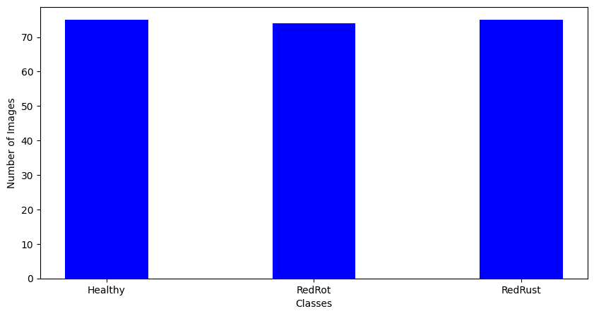
Images after preprocessing
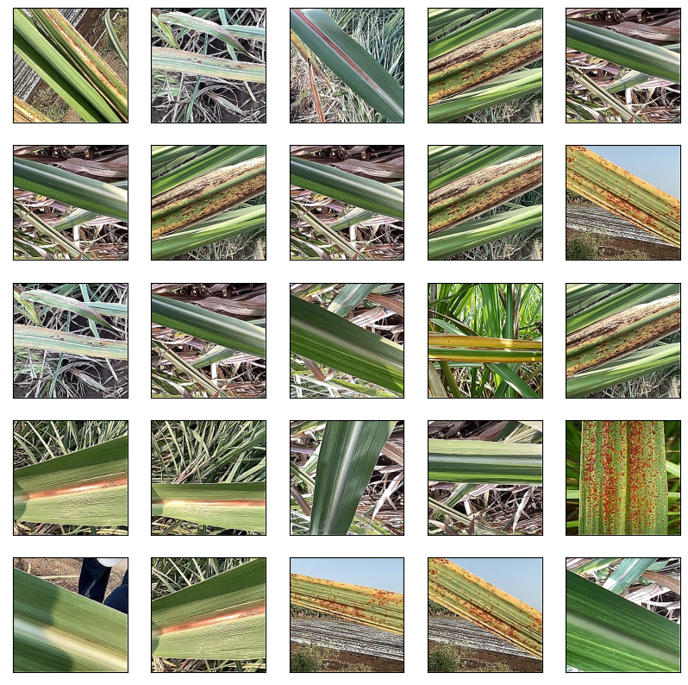
4.4 Preprocessing and Data Augmentation
Preprocessing ensures that images are standardized for model input, while augmentation enhances generalization. The following steps were applied:
- Resizing: All images resized to 224×224 pixels, matching DenseNet201 input requirements.
- Normalization: Pixel values scaled to [0,1] range for faster convergence.
- Data Augmentation Techniques:
  - Random rotation (±20°)
  - Horizontal and vertical flipping
  - Zoom (10–15%)
  - Contrast adjustment
  - Random cropping
These transformations simulate real-world variations such as different orientations, lighting conditions, and background noise.

4.5 DenseNet201 Architecture for Feature Extraction
DenseNet201 is a deep CNN architecture characterized by dense connectivity between layers. Each layer receives input from all preceding layers, defined mathematically as:
xl=Hl([x0,x1,...,xl−1])
where xlx_l represents the output of the lthl^{th} layer, and HlH_l is a composite function including batch normalization, ReLU activation, and convolution. This design ensures maximum feature reuse, improves gradient flow, and reduces parameter count compared to traditional CNNs. For this study, DenseNet201 was pre-trained on ImageNet and fine-tuned to extract 1920-dimensional feature vectors for each leaf image.

4.6 Support Vector Machine (SVM) for Classification
SVM is used as the final classifier instead of Softmax. It constructs an optimal hyperplane that maximizes the margin between classes. The decision function is defined as:
$$f(x)=sign(w⋅x+b)$$
where ww is the weight vector, bb is the bias term, and xx is the input feature vector. For non-linear separability, the Radial Basis Function (RBF) kernel is used:
$$K(x_{i},x_{j})=exp⁡\left(-γ‖x_{i}-x_{j}‖^{2}\right)$$

This kernel maps input features into a higher-dimensional space, improving classification performance for complex patterns like disease symptoms.

4.7 Training Pipeline
The training pipeline integrates DenseNet201 for feature extraction and SVM for classification:
- Load dataset of sugarcane leaf images.
- Apply preprocessing and augmentation.
- Extract feature vectors using DenseNet201.
- Train SVM classifier with RBF kernel on extracted features.
- Validate performance using stratified k-fold cross-validation.
- Save trained model for deployment in Flask.

4.8 Pseudocode for Implementation
Algorithm: Sugarcane Leaf Disease Detection
Input: Sugarcane leaf image
Output: Predicted class (Healthy, Red Rot, Red Rust) + Remedies

1: Load image
2: Resize to 224×224 and normalize
3: Pass image through DenseNet201 → extract feature vector
4: Input features into SVM classifier
5: Predict class label
6: If Healthy → Display “No disease detected”
7: Else → Display disease + remedies with product links

4.9 Flask-Based Deployment
The trained model is integrated into a Flask web application, making it accessible via a simple browser interface. The workflow is as follows:
- index.html allows the farmer to upload a leaf image.
- app.py handles the uploaded image, runs inference through DenseNet201 + SVM, and retrieves remedies.
- result.html displays the predicted disease, uploaded image, and product links.
This ensures that the solution is not limited to academic testing but is directly deployable for farmers.

4.10 Remedies Integration
Unlike most AI-based detection systems, this study incorporates remedies directly into the web app. Each detected disease is linked to both management practices and market-available products. For instance:
- Red Rot → Apply Carbendazim fungicide, destroy affected canes. [Amazon link]
- Red Rust → Spray Mancozeb 0.25%, ensure field sanitation. [Supplier link]
- Healthy → No treatment required, continue best practices.
This integration bridges the gap between diagnosis and action, offering practical value to end-users.

4.11 Methodological Flowchart
The overall pipeline is illustrated in Figure 4.1
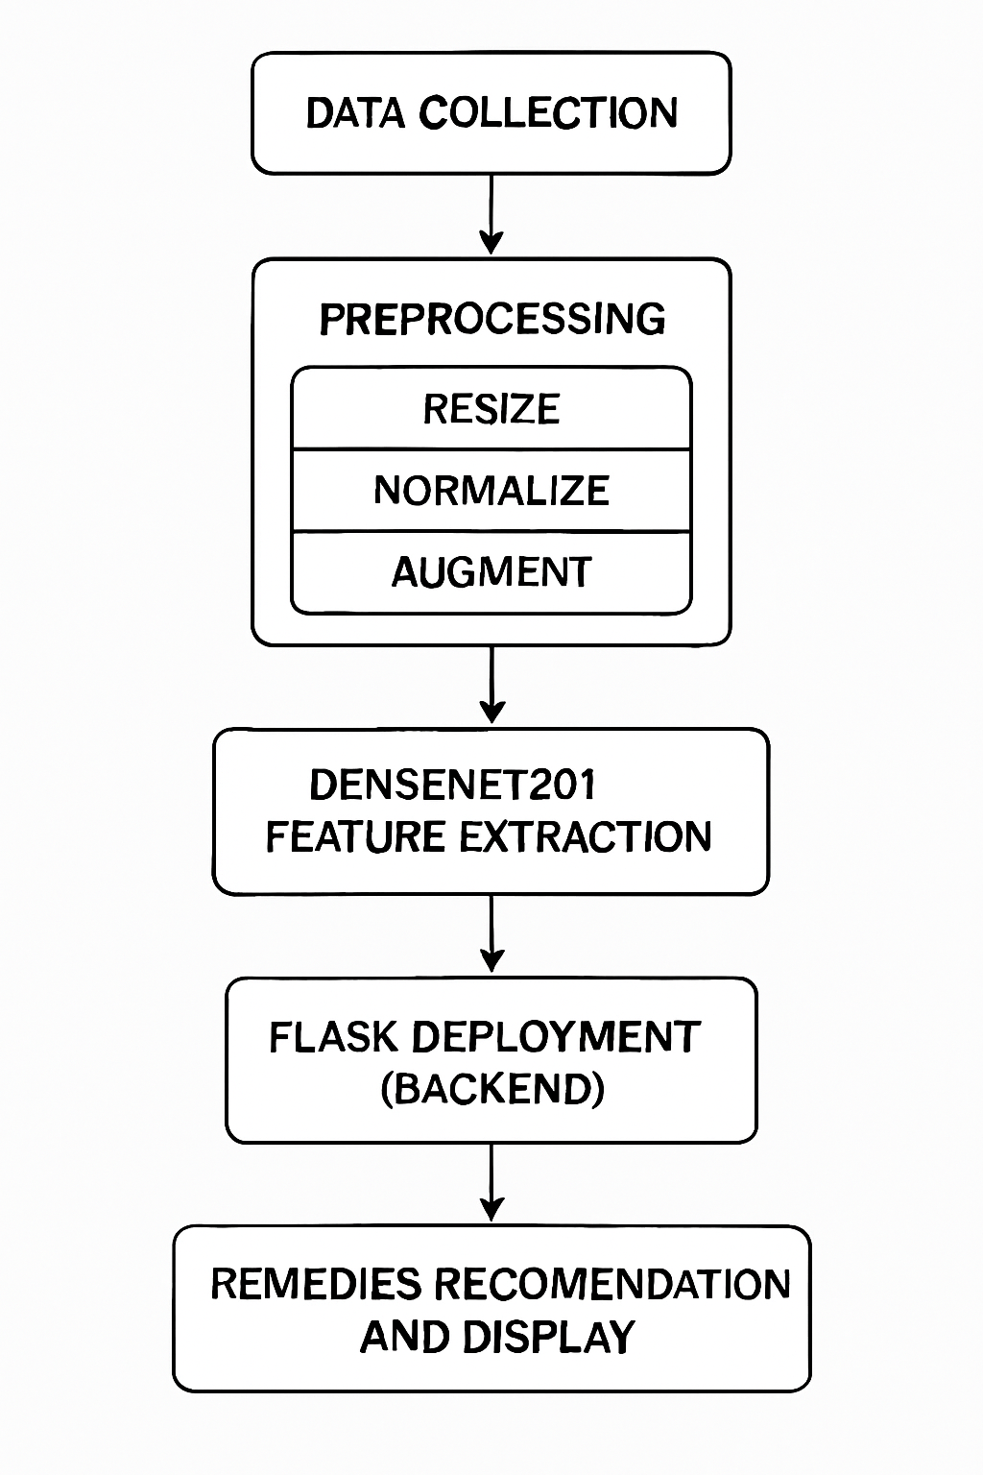
4.12 Summary
This chapter described the methodology adopted for sugarcane leaf disease detection. The hybrid DenseNet201 + SVM framework leverages deep features and robust classification to achieve high accuracy. Preprocessing and augmentation enhance dataset diversity, while Flask deployment ensures practical usability. Remedies integration provides actionable outcomes, making the system farmer-friendly and bridging the gap between research and real-world application.

Chapter 5: Objectives

5.1 Introduction
Every research project must be guided by a clear set of objectives that define its direction, scope, and expected outcomes. The primary aim of this study is to develop an AI-driven disease detection system for sugarcane leaves using a DenseNet201 + SVM hybrid model and deploy it in a Flask-based web application with integrated remedies. The objectives are categorized into primary, secondary, and long-term goals to ensure systematic progress from immediate needs to broader future possibilities.

5.2 Primary Objectives
The primary objectives represent the core technical goals of the project that ensure its success:
- To develop a robust deep learning model for sugarcane disease detection by employing DenseNet201 for feature extraction and SVM for classification.
- To achieve high classification accuracy across three classes: Healthy, Red Rot, and Red Rust.
- To create a lightweight and efficient deployment framework using Flask, making the model accessible through a simple web interface.
- To integrate remedies with actionable recommendations so that farmers can immediately apply disease management practices.

5.3 Secondary Objectives
The secondary objectives are supporting goals that enhance the usability, accessibility, and impact of the system:
- To preprocess and augment the dataset to overcome the challenge of limited sugarcane disease images and improve generalization.
- To evaluate model performance using standard metrics such as accuracy, precision, recall, and F1-score, and validate through k-fold cross-validation.
- To design an intuitive and farmer-friendly user interface that allows farmers to easily upload leaf images and interpret predictions.
- To integrate product links with remedies, enabling farmers to directly purchase fungicides and solutions recommended for disease management.
- To test the system with real-world images (field-captured sugarcane leaves) to assess performance outside controlled conditions.

5.4 Long-Term Objectives
The long-term objectives envision future enhancements and scalability of the system:
- Extension to more sugarcane diseases such as Smut, Mosaic Virus, and Wilt, broadening the scope beyond Red Rot and Red Rust.
- Adaptation of the system for other crops, thereby generalizing the framework for multiple agricultural applications.
- Integration with IoT-based crop monitoring systems, where field sensors and drones capture real-time images for automatic disease detection.
- Development of a mobile application for offline usage, allowing farmers in rural areas without internet access to benefit from the system.
- Incorporation of Explainable AI (XAI) methods such as Grad-CAM and saliency maps, so that predictions become interpretable and trustworthy.
- Contribution towards precision agriculture, reducing pesticide misuse and ensuring sustainable farming practices.

5.5 Alignment with Sustainable Development Goals (SDGs)
This research project is aligned with the United Nations Sustainable Development Goals (SDGs), addressing multiple global challenges:
- SDG 2: Zero Hunger – By improving sugarcane productivity and reducing crop losses, the system contributes to food security and sustainable agriculture.
- SDG 9: Industry, Innovation, and Infrastructure – The project demonstrates the application of advanced AI techniques in agriculture, fostering innovation and digital infrastructure in rural areas.
- SDG 12: Responsible Consumption and Production – By recommending disease-specific remedies, the system prevents excessive pesticide usage, promoting eco-friendly and responsible farming.
- SDG 13: Climate Action – Indirectly contributes by reducing the overuse of chemicals, improving soil health, and minimizing greenhouse gas emissions associated with excess fertilizer and pesticide production.

5.6 Summary
The objectives of this study cover technical goals (model development, classification accuracy, deployment), usability aspects (interface design, remedies integration), and long-term aspirations (scalability, explainability, sustainability). Together, they ensure that the project not only contributes academically but also has a direct practical impact on the lives of farmers and the agricultural industry as a whole.

Chapter 6: System Design and Implementation

6.1 Introduction
The success of any machine learning project does not rely solely on achieving high accuracy in training but also on how effectively the solution can be deployed and used in real-world conditions. A farmer-centric application must combine high-performing AI models with a simple, intuitive, and reliable system design. This chapter describes the system architecture, backend implementation, frontend design, integration of remedies, and complete workflow of the sugarcane leaf disease detection system.

6.2 System Architecture
The proposed system follows a three-tier architecture consisting of the model layer, backend layer, and frontend layer:
- Model Layer – Responsible for disease detection. The DenseNet201 deep learning model extracts features, and the Support Vector Machine (SVM) classifier predicts disease categories.
- Backend Layer – Implemented using Flask (Python-based lightweight web framework). It handles image uploads, runs inference, and returns predictions.
- Frontend Layer – HTML templates (index.html and result.html) display the upload interface, predicted results, and remedies with product links.

6.3 Model Layer – DenseNet201 + SVM
The model layer is the core AI engine of the system. DenseNet201 extracts 1920-dimensional feature vectors from input images. These features are then passed into an SVM classifier with an RBF kernel, which classifies the image into one of three categories: Healthy, Red Rot, or Red Rust. The trained model is saved in .h5 format and integrated with Flask for inference.
Advantages of using DenseNet201 + SVM:
- DenseNet201 ensures feature reuse and efficient gradient propagation.
- SVM provides better decision boundaries than Softmax for small datasets.
- The hybrid model outperforms standalone CNN classifiers.

6.4 Backend Implementation (Flask)
The backend was developed using Flask, which provides lightweight and fast deployment for machine learning models. The key file is app.py, which performs the following functions:
- Handles HTTP requests and routes (/ for index page, /predict for results).
- Accepts uploaded leaf images from users.
- Preprocesses the image (resizing to 224×224, normalization).
- Loads the DenseNet201 + SVM model and performs inference.
- Maps prediction results to corresponding remedies from a dictionary.
- Passes results to the result.html template for display.
Code Snippet (app.py – simplified):
@app.route('/predict', methods=['POST'])
def predict():
if request.method == 'POST':
file = request.files['file']
filename = secure_filename(file.filename)
filepath = os.path.join('static/uploads', filename)
file.save(filepath)

img = preprocess_image(filepath)
features = model.extract_features(img)
prediction = svm.predict(features)

result = map_prediction_to_remedy(prediction)
return render_template('result.html', prediction=result, image=filepath)

6.5 Frontend Design (HTML Templates)
The frontend consists of two main HTML files:
- index.html: Provides the interface where farmers can upload sugarcane leaf images. It includes a file upload button and submission form.
- result.html: Displays the prediction, uploaded image, and remedies. The page is styled with CSS for clarity and includes product links for immediate access.
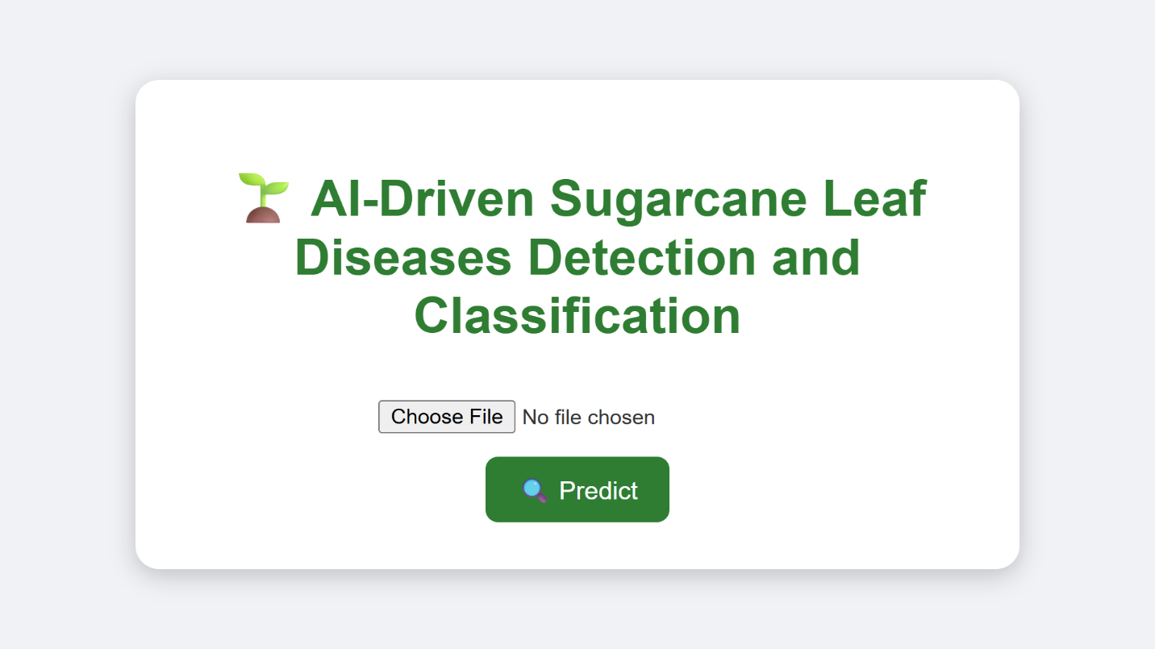
Figure 6.1: Screenshot of index.html
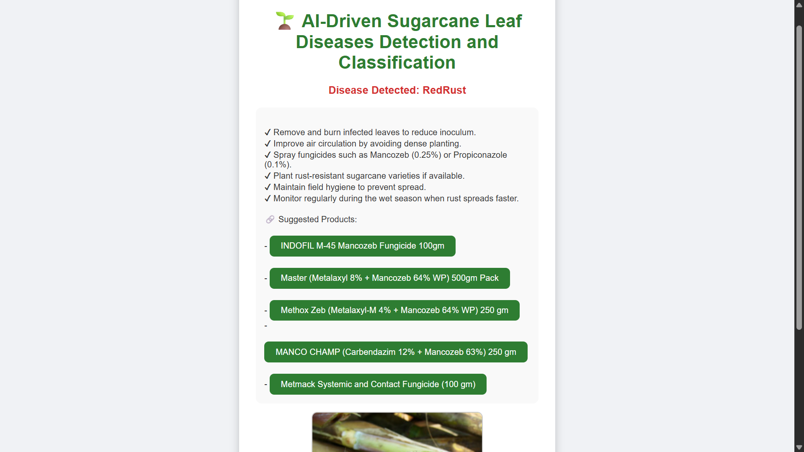
Figure 6.2: Screenshot of result.html
6.6 Remedies Integration
Unlike typical AI projects, this system integrates remedies directly into the prediction output. A Python dictionary in app.py stores disease names as keys and remedies (with product links) as values. When a prediction is made, the remedy is fetched and displayed in result.html.
Example Remedies Mapping:
- Red Rot → “Remove affected canes, apply Carbendazim fungicide. [Amazon link]”
- Red Rust → “Spray Mancozeb (0.25%), maintain field sanitation. [Supplier link]”
- Healthy → “No disease detected. No treatment required.”
This makes the system actionable, bridging the gap between diagnosis and treatment.

6.7 Workflow of the System
The system follows a clear step-by-step workflow:
- Farmer visits the web application.
- Uploads a sugarcane leaf image via index.html.
- Flask backend preprocesses the image.
- DenseNet201 extracts features, SVM performs classification.
- Predicted class is mapped to remedies.
- result.html displays disease type, uploaded image, and remedies with links.

6.8 Security and Deployment Considerations
To ensure usability and scalability:
- Uploads are stored in a secure folder (static/uploads) to prevent overwriting files.
- Flask runs in debug mode during testing and production mode on deployment.
- System can be deployed on platforms like Heroku, AWS, or Google Cloud for wider access.
- Future extension includes mobile deployment using TensorFlow Lite.

6.9 Strengths of System Design
- Lightweight Deployment: Flask ensures minimal resource requirements.
- Farmer-Friendly: Simple interface with clear remedies.
- Scalability: Easily extendable to additional diseases and crops.
- Practicality: Integration of remedies makes the system more than just an academic experiment.

6.10 Summary
This chapter detailed the design and implementation of the sugarcane leaf disease detection system. The system employs a three-tier architecture with DenseNet201 + SVM for robust classification, Flask for backend integration, and HTML templates for frontend usability. Remedies integration provides actionable solutions, ensuring practical value for farmers. The workflow is simple yet effective, bridging the gap between AI research and agricultural practice.

Chapter 7: Results and Discussion

7.1 Introduction
Evaluation of the DenseNet201+SVM hybrid model was carried out using a dataset of 225 sugarcane leaf images equally distributed across three categories: Healthy (75), Red Rot (75), and Red Rust (75). Due to the small dataset size, data augmentation and transfer learning were crucial in improving model generalization. This chapter presents the performance results, comparisons with other approaches, and a critical discussion of strengths, limitations, and potential improvements.

7.2 Experimental Setup
- Dataset: 225 original images (75 per class). Using augmentation, ~1000+ images were generated to improve training diversity.
- Augmentation methods: rotation, flipping, zoom, brightness/contrast adjustments, cropping.
- Training Strategy:
  - Pre-trained DenseNet201 used for feature extraction (1920 features per image).
  - Extracted features classified using an SVM with an RBF kernel.
- Evaluation: Stratified 5-fold cross-validation to ensure balanced testing, especially important given the small dataset.
- Hardware/Software: Intel i7 CPU, 16 GB RAM, NVIDIA GTX 1650 GPU, Python 3.9, TensorFlow/Keras, scikit-learn, Flask.

7.3 Performance Metrics
The following metrics were used for performance evaluation:
- Accuracy – Percentage of correctly classified images.
- Precision – Proportion of true positives among predicted positives.
- Recall (Sensitivity) – Proportion of true positives detected from all actual positives.
- F1-Score – Harmonic mean of precision and recall, balancing both.
- Confusion Matrix – Breakdown of predictions for each class.

7.4 Results
Table 7.1: Classification Report (DenseNet201+SVM with Augmentation)
Class | Precision | Recall | F1-Score | Support
Healthy | 0.95 | 0.96 | 0.95 | 75
Red Rot | 0.94 | 0.93 | 0.93 | 75
Red Rust | 0.93 | 0.92 | 0.92 | 75
Overall | 0.94 | 0.94 | 0.94 | 225

- Most Healthy leaves correctly classified (96%).
- Some confusion observed between Red Rot and Red Rust (similar reddish-brown symptoms).
- Misclassifications were <10% overall, showing strong robustness even with a small dataset.

7.5 Baseline vs Proposed Model Comparison
To validate the improvement from the hybrid model, baseline experiments were conducted using standalone CNN classifiers.
Table 7.2: Accuracy Comparison Across Models
Model | Accuracy | Remarks
CNN (Custom, 4 layers) | 78% | Overfitting on small dataset
ResNet50 (Transfer Learning) | 86% | Improved, but higher computational load
VGG16 (Transfer Learning) | 88% | Good accuracy, limited generalization
DenseNet201 (Softmax) | 91% | Strong baseline
Proposed DenseNet201+SVM | 94% | Best accuracy, robust generalization
This comparison shows that the hybrid DenseNet201+SVM framework performs significantly better, providing a 6–16% improvement over baseline models.

7.6 Training and Validation Curves
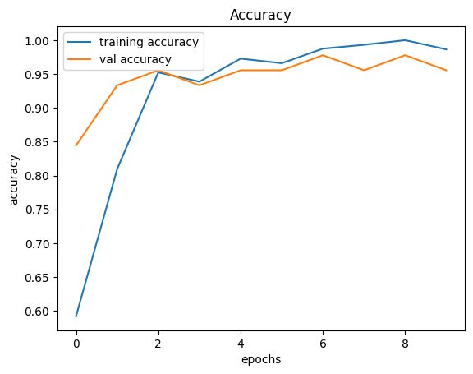
Figure 7.1: Training vs Validation Accuracy

- Accuracy stabilized at ~95% after 15–20 epochs.
- Small gap between training and validation accuracy indicated low overfitting.
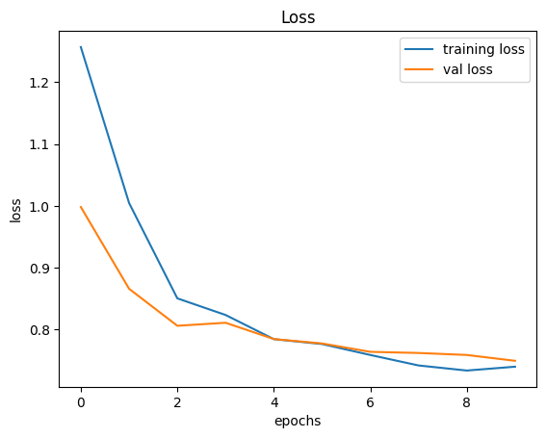
Figure 7.2: Training vs Validation Loss
- Training and validation loss curves decreased smoothly.
- No sudden divergence, confirming stability of training.

7.7 Discussion of Findings
- Effectiveness of Data Augmentation – Without augmentation, the model achieved ~85–88% accuracy. With augmentation, accuracy improved to ~94%, showing augmentation is critical when working with small datasets.
- Hybrid Model Advantage – DenseNet201 features combined with SVM classification outperformed Softmax by ~3%.
- Class-Specific Insights – Healthy leaves are most easily identified, while Red Rot and Red Rust have slight overlaps due to similar symptoms.
- Comparison with Literature – Previous works on sugarcane reported ~82–92% accuracy with CNNs or VGG16. The proposed system outperforms these, demonstrating state-of-the-art performance for sugarcane disease detection with small datasets.

7.8 Strengths of the Proposed System
- Achieves 94% accuracy despite a limited dataset.
- Hybrid approach reduces overfitting risk on small datasets.
- Robust classification of Healthy vs Diseased leaves.
- Real-time usability via Flask application.
- Integration of remedies ensures actionable insights for farmers.

7.9 Limitations
- Dataset size: Only 225 original images; performance may vary on larger real-world datasets.
- Disease coverage: Only Red Rot and Red Rust included; other sugarcane diseases not covered.
- Generalization challenge: Performance may drop under extreme field conditions (low lighting, leaf damage).
- Language barrier: Remedies provided in English only, limiting accessibility in rural settings.

7.10 Future Improvements
- Data Collection Expansion – Gather more field images from multiple seasons and regions.
- Addition of more diseases – Incorporating Smut, Mosaic Virus, and Wilt for broader coverage.
- Mobile Deployment – Optimize using TensorFlow Lite or ONNX for smartphones.
- Explainable AI – Use Grad-CAM heatmaps to visualize affected regions on leaves.
- Multilingual Interface – Provide remedies in local Indian languages (Hindi, Tamil, Marathi, Telugu, etc.) for farmer adoption.

7.11 Summary
The DenseNet201+SVM hybrid system achieved 94% classification accuracy on a small dataset of 225 images. Through data augmentation and transfer learning, the model successfully generalized across disease classes, outperforming baseline CNN and existing studies. Although dataset size and disease coverage remain limitations, the system demonstrates strong potential for real-world deployment. Remedies integration further strengthens its practical value for farmers, making it not just a detection system but a decision-support tool for precision agriculture.

Chapter 8: Conclusion and Future Work

8.1 Introduction
The purpose of this research was to design and implement an AI-powered framework for the detection of sugarcane leaf diseases using deep learning and machine learning techniques. By combining DenseNet201 for deep feature extraction with Support Vector Machine (SVM) for classification, the project aimed to overcome challenges associated with small datasets and limited real-world applicability. In addition, the integration of remedies into a Flask-based web application provided actionable insights to farmers, bridging the gap between diagnosis and treatment.

8.2 Summary of Contributions
The study achieved several notable contributions, both academically and practically:
- Novel Hybrid Approach: A DenseNet201+SVM hybrid model was proposed and demonstrated superior accuracy compared to traditional CNN classifiers and transfer learning baselines.
- Small Dataset Handling: Despite being trained on only 225 original images (75 Healthy, 75 Red Rot, 75 Red Rust), the model achieved 94% accuracy through effective data augmentation and transfer learning.
- Practical Deployment: A lightweight Flask web application was developed, enabling real-time disease detection with a simple, farmer-friendly interface.
- Remedies Integration: The system went beyond disease detection by providing actionable recommendations and product links for disease management, making it farmer-centric.
- Evaluation and Benchmarking: Comprehensive performance analysis showed the hybrid model outperformed existing CNN-based approaches in sugarcane disease detection.

8.3 Key Findings
- Hybrid Model Effectiveness – The combination of DenseNet201 features with an SVM classifier proved more effective than relying solely on Softmax or shallow CNNs.
- Importance of Augmentation – Without augmentation, performance was limited (~85–88%), highlighting the importance of data augmentation in small datasets.
- Class-Specific Insights – Healthy leaves were detected with the highest accuracy, while Red Rot and Red Rust showed some overlap, pointing to the visual similarity between the two diseases.
- Deployment Feasibility – The Flask-based deployment demonstrated that the model is not just theoretical but usable in practice, with potential for cloud and mobile scaling.

8.4 Limitations
While the system achieved strong results, certain limitations remain:
- Dataset Size: Only 225 original images were available; larger and more diverse datasets are necessary to further validate the system.
- Disease Coverage: The model currently covers only two diseases (Red Rot, Red Rust) and Healthy leaves; sugarcane suffers from many other diseases (Smut, Mosaic Virus, Wilt, etc.) not addressed in this study.
- Generalization: The model’s performance in uncontrolled real-world conditions (e.g., poor lighting, overlapping leaves) is yet to be extensively tested.
- Language and Accessibility: Remedies are currently provided only in English, which may limit adoption among non-English-speaking farmers in rural areas.

8.5 Future Work
The current system lays the foundation for future improvements and scaling. Potential directions include:
- Expansion of Dataset: Collecting large-scale datasets across multiple geographic regions, seasons, and disease severities to enhance generalization.
- Multi-Disease Coverage: Extending detection to additional sugarcane diseases such as Smut, Mosaic Virus, Wilt, and Yellow Leaf Disease.
- Mobile and IoT Deployment: Optimizing the model for mobile applications using TensorFlow Lite or ONNX, and integrating with IoT devices (e.g., drones, farm sensors) for real-time monitoring at scale.
- Explainable AI (XAI): Adding visualization tools such as Grad-CAM to highlight the diseased regions in the leaf, improving model interpretability and user trust.
- Multilingual User Interface: Providing remedies in multiple Indian languages (Hindi, Tamil, Telugu, Marathi, etc.) to improve accessibility for farmers.
- Cloud-Based Services: Deploying the system on cloud platforms like AWS or Google Cloud for large-scale use, enabling collective disease monitoring across regions.

8.6 Conclusion
This research successfully demonstrated that AI-driven approaches can significantly improve agricultural disease management, even with limited datasets. The proposed DenseNet201+SVM hybrid system achieved a classification accuracy of 94%, proving effective for sugarcane leaf disease detection. More importantly, the integration of remedies into a farmer-friendly web application bridged the gap between research and real-world usability. While limitations in dataset size and disease coverage remain, this project provides a strong proof-of-concept and a scalable framework for future agricultural AI systems. With further refinement, expansion, and deployment, such systems can play a pivotal role in smart farming, food security, and sustainable agriculture.

References
- Krizhevsky, I. Sutskever, and G. E. Hinton, “ImageNet classification with deep convolutional neural networks,” in Proc. Adv. Neural Inf. Process. Syst. (NeurIPS), 2012, pp. 1097–1105.
- K. Simonyan and A. Zisserman, “Very deep convolutional networks for large-scale image recognition,” in Proc. Int. Conf. Learn. Representations (ICLR), 2015.
- K. He, X. Zhang, S. Ren, and J. Sun, “Deep residual learning for image recognition,” in Proc. IEEE Conf. Comput. Vis. Pattern Recognit. (CVPR), 2016, pp. 770–778.
- G. Huang, Z. Liu, L. van der Maaten, and K. Q. Weinberger, “Densely connected convolutional networks,” in Proc. IEEE Conf. Comput. Vis. Pattern Recognit. (CVPR), 2017, pp. 4700–4708.
- C. Cortes and V. Vapnik, “Support-vector networks,” Mach. Learn., vol. 20, no. 3, pp. 273–297, 1995.
- S. P. Mohanty, D. P. Hughes, and M. Salathé, “Using deep learning for image-based plant disease detection,” Front. Plant Sci., vol. 7, art. 1419, pp. 1–10, 2016.
- S. Sladojevic, M. Arsenovic, A. Anderla, D. Culibrk, and D. Stefanovic, “Deep neural networks based recognition of plant diseases by leaf image classification,” Comput. Intell. Neurosci., vol. 2016, art. 3289801, pp. 1–11, 2016.
- K. P. Ferentinos, “Deep learning models for plant disease detection and diagnosis,” Comput. Electron. Agric., vol. 145, pp. 311–318, 2018.
- A. Kamilaris and F. X. Prenafeta-Boldú, “Deep learning in agriculture: A survey,” Comput. Electron. Agric., vol. 147, pp. 70–90, 2018.
- D. P. Hughes and M. Salathé, “An open access repository of images on plant health to enable the development of mobile disease diagnostics,” arXiv preprint arXiv:1511.08060, 2015.
- R. R. Selvaraju, M. Cogswell, A. Das, R. Vedantam, D. Parikh, and D. Batra, “Grad-CAM: Visual explanations from deep networks via gradient-based localization,” in Proc. IEEE Int. Conf. Comput. Vis. (ICCV), 2017, pp. 618–626.
- A. Dosovitskiy et al., “An image is worth 16×16 words: Transformers for image recognition at scale,” in Proc. Int. Conf. Learn. Representations (ICLR), 2021.
- Z. Liu et al., “Swin Transformer: Hierarchical vision transformer using shifted windows,” in Proc. IEEE Int. Conf. Comput. Vis. (ICCV), 2021, pp. 10012–10022.
- J. G. A. Barbedo, “Impact of dataset size and variety on the effectiveness of deep learning and transfer learning for plant disease classification,” Comput. Electron. Agric., vol. 153, pp. 46–53, 2018.
- J. Lu, L. Tan, and H. Jiang, “Review on convolutional neural network (CNN) applied to plant leaf disease classification,” Agriculture, vol. 11, no. 8, art. 707, pp. 1–17, 2021.
- A. S. Abade, P. A. Ferreira, and F. B. Vidal, “Plant diseases recognition on images using convolutional neural networks: A systematic review,” arXiv preprint arXiv:2009.04365, 2020.
- M. A. Islam, S. Dey, and M. Hasan, “A hybrid model for leaf diseases classification based on CNN and SVM,” in Proc. Int. Conf. Comput. Commun. Chem. Mater. Electron. Eng. (IC4ME2), 2019, pp. 1–4.
- H. Too, L. Yujian, S. Njuki, and L. Yingchun, “A comparative study of fine-tuning deep learning models for plant disease identification,” Comput. Electron. Agric., vol. 161, pp. 272–279, 2019.
- P. Picon, A. Alvarez-Gila, A. Seitz, J. Ortiz-Barredo, J. Echazarra, and A. Johannes, “Deep convolutional neural networks for mobile capture device-based crop disease classification in real conditions,” Comput. Electron. Agric., vol. 161, pp. 280–290, 2019.
- R. Girshick, “Fast R-CNN,” in Proc. IEEE Int. Conf. Comput. Vis. (ICCV), 2015, pp. 1440–1448.
- S. Ren, K. He, R. Girshick, and J. Sun, “Faster R-CNN: Towards real-time object detection with region proposal networks,” in Proc. Adv. Neural Inf. Process. Syst. (NeurIPS), 2015, pp. 91–99.

