CHAPTER:7
TESTING

7.1 Test Cases

Test Cases are essential in ensuring the quality and dependability of our system. Test cases are precise, step-by-step instructions meant to ensure that the system works as expected in a variety of circumstances. They serve as a methodical technique to ensuring that each system feature, functionality, and need fits its original requirements.
7.1.1. TC01 - User Authentication
User authentication is necessary to ensure that only the authorized user can access this system. It involves verifying a user's identity through credentials such as a username, email, password.
Traceability Matrix Reference
4.3.2.1: SF-01: User Authentication
Test Case ID | Test Case Description | Preconditions | Test Steps | Expected Results | Actual Results | Status
UA-01 | Valid Registration | User is on the sign-up page | 1. Enter valid details.  2. Click 'Sign Up'.  3. Verify email. | Account created and verified successfully. | Account created and verified successfully. | Pass
UA-02 | Missing Name | User is on the sign-up page | 1. Leave name blank.  2. Fill other details.  3. Click 'Sign Up'. | Error for missing name. | Error for missing name. | Pass
UA-03 | Invalid Email Format | User is on the sign-up page | 1. Enter invalid email format.  2. Fill other details.  3. Click 'Sign Up'. | Error for invalid email format. | Error for invalid email format. | Pass
UA-04 | Existing Email | User is on the sign-up page | 1. Enter already registered email.  2. Fill other details.  3. Click 'Sign Up'. | Error for existing email. | Error for existing email. | Pass
UA-05 | Valid Credentials | User is on the login page | 1. Enter valid email and password.  2. Click 'Log In'. | Login successful. | Login successful. | Pass
UA-06 | Missing Email | User is on the login page | 1. Leave email blank.  2. Enter password.  3. Click 'Log In'. | Error for missing email. | Error for missing email. | Pass
UA-07 | Missing Password | User is on the login page | 1. Enter email.  2. Leave password blank.  3. Click 'Log In'. | Error for missing password. | Error for missing password. | Pass
UA-08 | Invalid Credentials | User is on the login page | 1. Enter invalid email and password.  2. Click 'Log In'. | Error for invalid credentials. | Error for invalid credentials. | Pass
UA-09 | Valid Forget Password | User is on Forget Password page | 1. Enter registered email.  2. Click 'Submit'. | Reset password email sent. | Reset password email sent. | Pass
UA-10 | Unregistered Email | User is on Forget Password page | 1. Enter unregistered email.  2. Click 'Submit'. | Error email not found. | Error email not found. | Pass
UA-11 | Missing Email Field | User is on Forget Password page | 1. Leave email field blank.  2. Click 'Submit'. | Error missing email. | Error missing email. | Pass
UA-12 | Valid OTP | User is on Verify Email page | 1. Enter valid OTP.  2. Click 'Verify'. | Email verified successfully. | Email verified successfully. | Pass
UA-13 | Invalid OTP | User is on Verify Email page | 1. Enter invalid OTP.  2. Click 'Verify'. | Error invalid OTP. | Error invalid OTP. | Pass
UA-14 | Expired OTP | User is on Verify Email page | 1. Enter expired OTP.  2. Click 'Verify'. | Error expired OTP. | Error expired OTP. | Pass
UA-15 | Resend OTP | User is on Verify Email page | 1. Click 'Resend OTP'.  2. Enter new OTP.  3. Click 'Verify'. | New OTP verified successfully. | New OTP verified successfully. | Pass
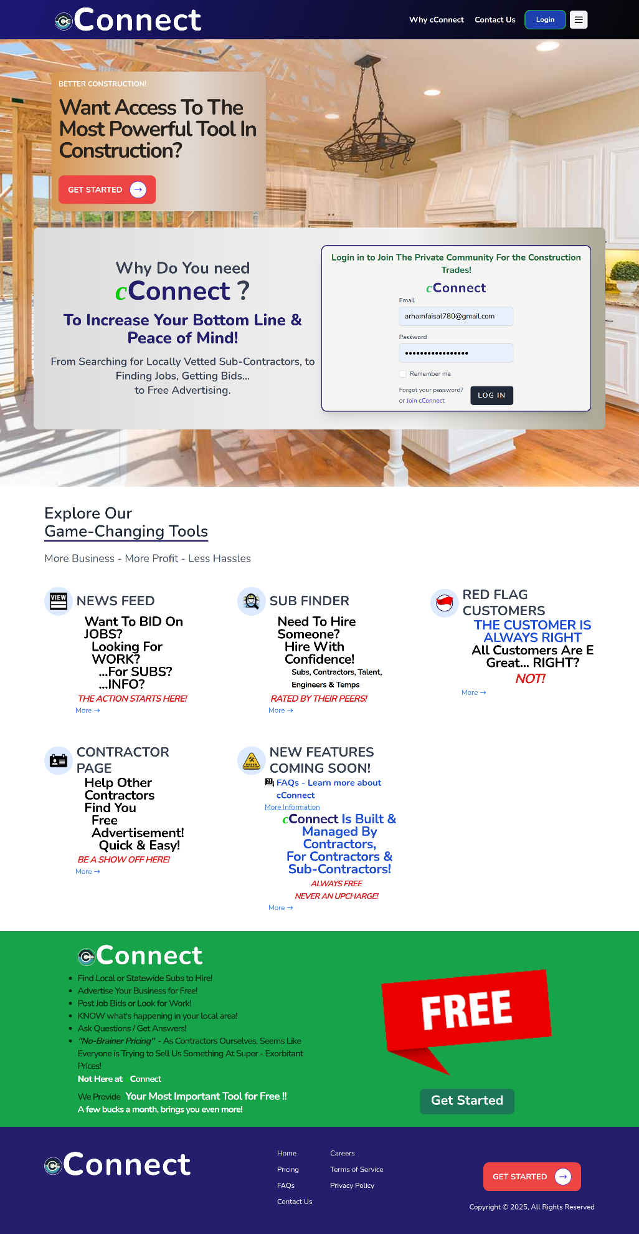
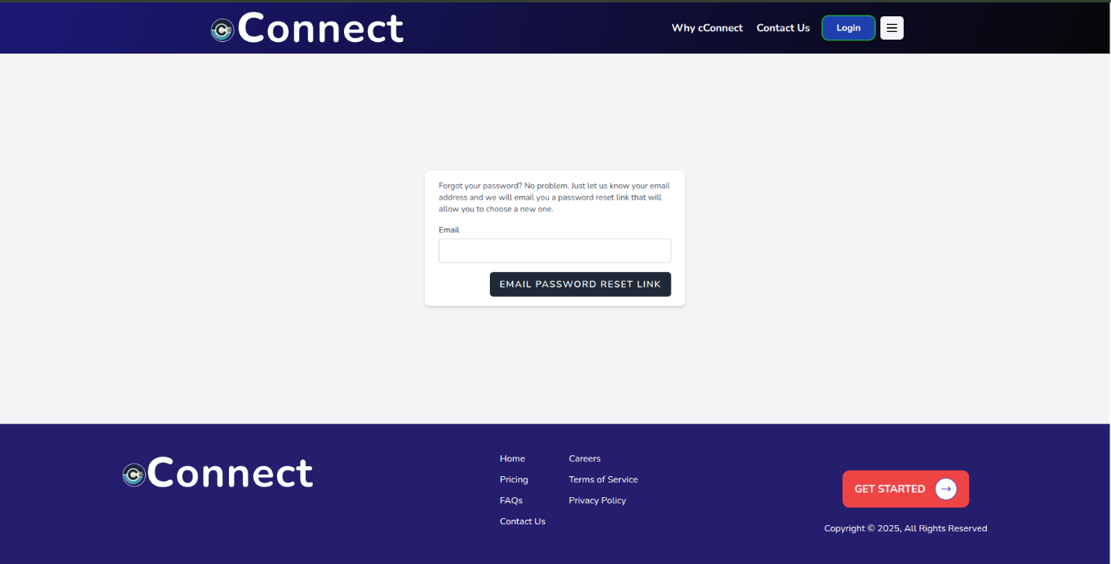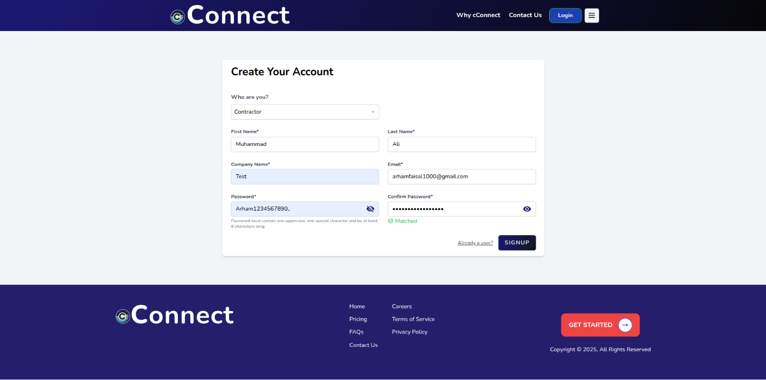

7.1.2. Profile Setup
Profile setup is an essential component of any application. This enables users to personalize their accounts, manage personal information, and configure settings according to their preferences. These test cases ensure that the profile setup process is intuitive, secure, and functions correctly across different scenarios.
Traceability Matrix Reference
4.3.2.2: SF-02: Profile Setup and Profile Management
Test Case ID | Test Case Description | Preconditions | Test Steps | Expected Results | Actual Results | Status
PS-01 | Valid General Info Entry | User is on Profile Setup - General Info page | 1. Enter valid Email, Name, Phone, Company, Address, etc.  2. Click Save/Continue. | Profile general information saved successfully. | Profile general information saved successfully. | Pass
PS-02 | Missing Required Field | User is on Profile Setup - General Info page | 1. Leave mandatory fields blank.  2. Click Save/Continue. | Error message for required fields. | Error message for required fields. | Pass
PS-03 | Invalid Email Format | User is on Profile Setup - General Info page | 1. Enter invalid email format.  2. Fill other fields.  3. Click Save/Continue. | Error message for invalid email. | Error message for invalid email. | Pass
PS-04 | Select All Trades | User is on Profile Setup - Trades page | 1. Toggle 'Select All' option. | All trades are selected successfully. | All trades are selected successfully. | Pass
PS-05 | Deselect Individual Trades | User is on Profile Setup - Trades page | 1. Turn off specific trades manually. | Selected trades are deselected successfully. | Selected trades are deselected successfully. | Pass
PS-06 | View Regional Selection | User is on Profile Setup - Views page | 1. Enable View Regional toggle.  2. Save changes. | Regional view selection saved successfully. | Regional view selection saved successfully. | Pass
PS-07 | View Nationwide Selection | User is on Profile Setup - Views page | 1. Enable View Nationwide toggle.  2. Save changes. | Nationwide view selection saved successfully. | Nationwide view selection saved successfully. | Pass
PS-08 | Select Free Package | User is on Profile Setup - Billing page | 1. Click 'Select' under Free Package. | Free Package selected successfully. | Free Package selected successfully. | Pass
PS-09 | Select Gold Package | User is on Profile Setup - Billing page | 1. Click 'Select' under Gold Package. | Gold Package selected successfully. | Gold Package selected successfully. | Pass
PS-10 | Select Platinum Package | User is on Profile Setup - Billing page | 1. Click 'Select' under Platinum Package. | Platinum Package selected successfully. | Platinum Package selected successfully. | Pass
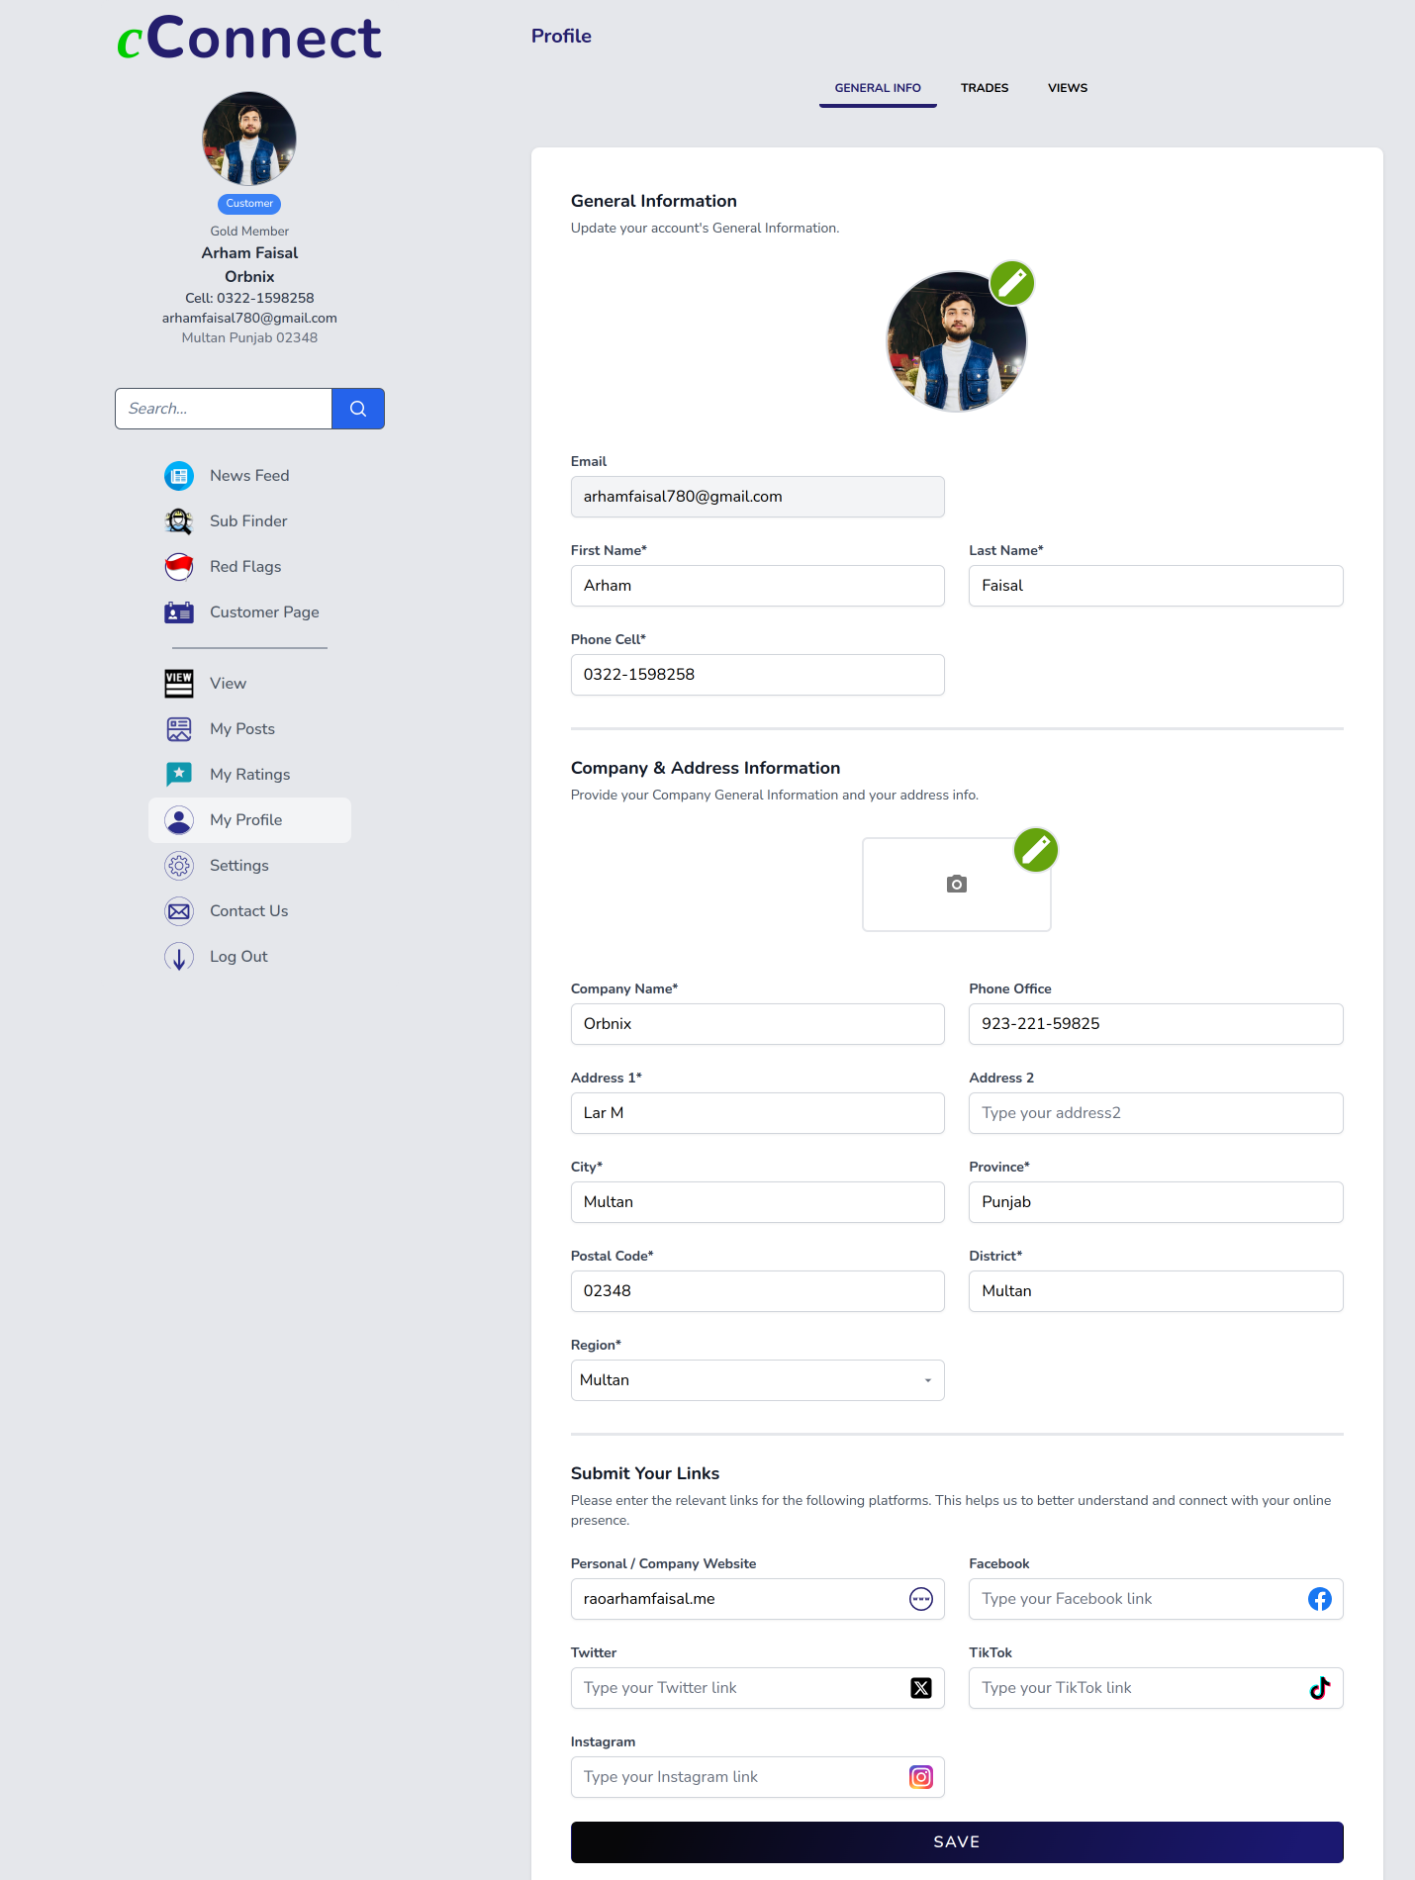

6.3. News Feed
News Feed is an important feature that serves as a central hub for displaying posts, updates, interactions, and announcements within the application. The primary goal of News Feed testing is to check the correct functionality, user experience, and performance of the feed.
Traceability Matrix Reference
4.3.2.3: SF-03: News Feed
Test Case ID | Test Case Description | Preconditions | Test Steps | Expected Results | Actual Results | Status
NF-01 | Valid Post Creation | User is logged in and on News Feed page | 1. Click 'Post'.  2. Enter Title and Text.  3. Upload images.  4. Click 'Save Post'. | Post created successfully and displayed on News Feed. | Post created successfully and displayed on News Feed. | Pass
NF-02 | Create Post Without Title | User is logged in and on News Feed page | 1. Leave Title blank.  2. Enter Text.  3. Upload images.  4. Click 'Save Post'. | Error message for missing Title. | Error message for missing Title. | Pass
NF-03 | Create Post Without Text | User is logged in and on News Feed page | 1. Enter Title.  2. Leave Text blank.  3. Upload images.  4. Click 'Save Post'. | Error message for missing Text. | Error message for missing Text. | Pass
NF-04 | Expand Post Details | User is on News Feed page | 1. Click on a post.  2. Expand to view full text and images. | Post expanded and full details shown. | Post expanded and full details shown. | Pass
NF-05 | Like a Post | User is on News Feed page | 1. Click 'Like' button on a post. | Like count incremented by 1. | Like count incremented by 1. | Pass
NF-06 | Dislike a Post | User is on News Feed page | 1. Click 'Dislike' button on a post. | Dislike count incremented by 1. | Dislike count incremented by 1. | Pass
NF-07 | Comment on a Post | User is on News Feed page | 1. Write a comment.  2. Click 'Submit'. | Comment posted successfully. | Comment posted successfully. | Pass
NF-08 | Repost a Post | User is on News Feed page | 1. Click 'Repost' button.  2. Confirm repost. | Post reposted successfully. | Post reposted successfully. | Pass
NF-09 | Edit Existing Post | User is on News Feed and has a post | 1. Click '...' on post.  2. Click 'Edit'.  3. Modify Title/Text/Images.  4. Click 'Update Post'. | Post updated successfully. | Post updated successfully. | Pass
NF-10 | Edit Existing Post | User is on News Feed and has a post | 1. Click '...' on post.  2. Click 'Edit'.  3. Modify Title/Text/Images.  4. Click 'Update Post'. | Post updated successfully. | Post updated successfully. | Pass
NF-11 | Edit Existing Comment | User is on News Feed and has posted a comment | 1. Click '...' on comment.  2. Click 'Edit'.  3. Modify comment text.  4. Click 'Submit'. | Comment updated successfully. | Comment updated successfully. | Pass
NF-12 | Delete Existing Comment | User is on News Feed and has posted a comment | 1. Click '...' on comment.  2. Click 'Delete'.  3. Confirm deletion. | Comment deleted successfully. | Comment deleted successfully. | Pass

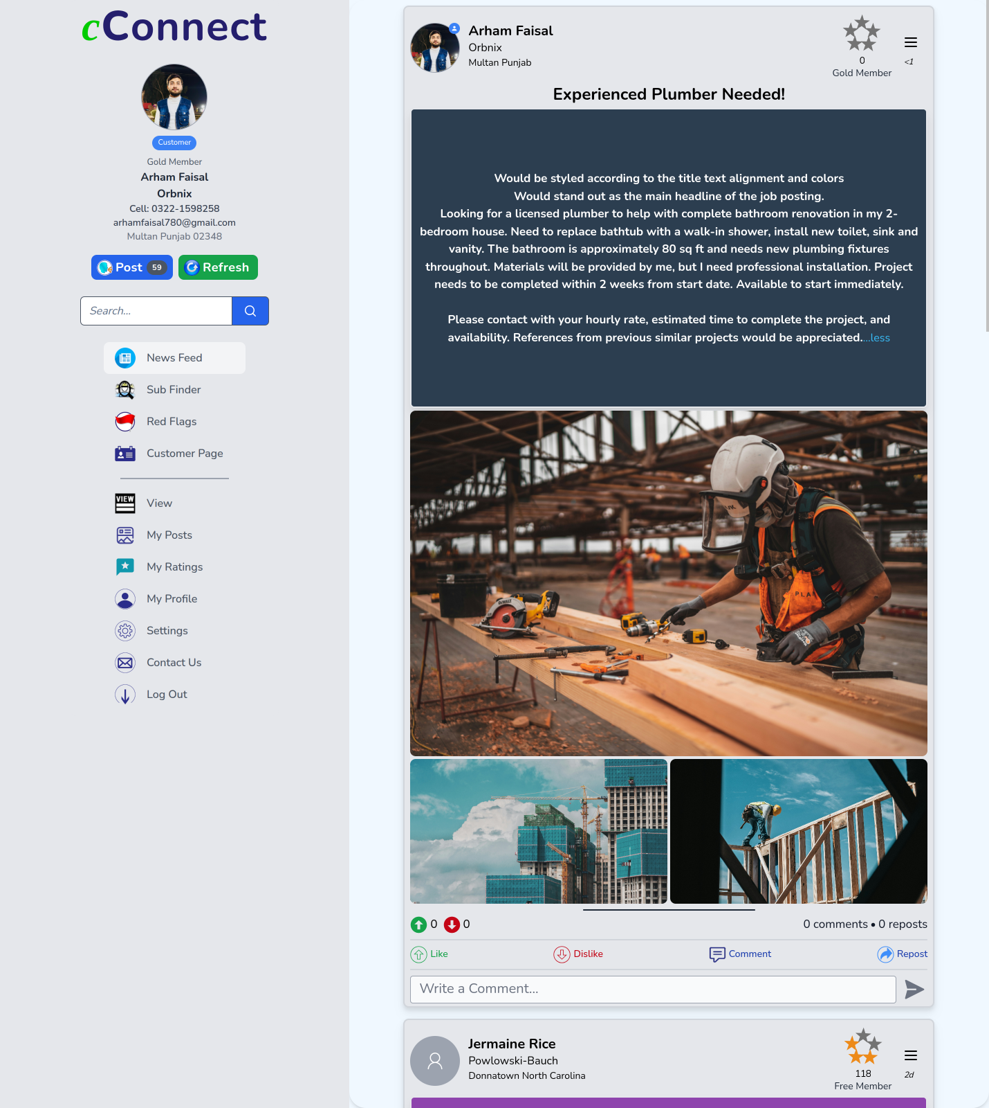
6.4. Sub Finder
The Sub Finder feature enables users to efficiently search, filter, and locate contractors based on specific criteria such as location, trade, ratings, and experience. The objective of Sub Finder testing is to ensure that the search and filtering mechanisms work accurately according to user inputs and system requirements.
Traceability Matrix Reference
4.3.2.4: SF-04: Sub Finder
Test Case ID | Test Case Description | Preconditions | Test Steps | Expected Results | Actual Results | Status
SF-01 | Search Contractors by Name | User is on Sub Finder page | 1. Enter contractor name in Search field.  2. Click Search. | Relevant contractor(s) displayed. | Relevant contractor(s) displayed. | Pass
SF-02 | Filter by Region | User is on Sub Finder page | 1. Select a Region from dropdown.  2. Click Find a Sub. | Contractors filtered by selected Region. | Contractors filtered by selected Region. | Pass
SF-03 | Filter by Trade | User is on Sub Finder page | 1. Select a Trade from dropdown.  2. Click Find a Sub. | Contractors filtered by selected Trade. | Contractors filtered by selected Trade. | Pass
SF-04 | Filter by Preferred | User is on Sub Finder page | 1. Click 'Preferred' button. | Only Preferred contractors displayed. | Only Preferred contractors displayed. | Pass
SF-05 | Filter by Back-Up | User is on Sub Finder page | 1. Click 'Back-Up' button. | Only Back-Up contractors displayed. | Only Back-Up contractors displayed. | Pass
SF-06 | Filter by Possible | User is on Sub Finder page | 1. Click 'Possible' button. | Only Possible contractors displayed. | Only Possible contractors displayed. | Pass
SF-07 | Filter by Rejected | User is on Sub Finder page | 1. Click 'Rejected' button. | Only Rejected contractors displayed. | Only Rejected contractors displayed. | Pass
SF-08 | Sort by High Rated | User is on Sub Finder page | 1. Click 'High Rated'. | Contractors sorted by highest rating. | Contractors sorted by highest rating. | Pass
SF-09 | Sort by Low Rated | User is on Sub Finder page | 1. Click 'Low Rated'. | Contractors sorted by lowest rating. | Contractors sorted by lowest rating. | Pass
SF-10 | Sort by Newly Registered | User is on Sub Finder page | 1. Click 'Newly Registered'. | Contractors sorted by latest registration. | Contractors sorted by latest registration. | Pass
SF-11 | Sort by Oldest Registered | User is on Sub Finder page | 1. Click 'Oldest Registered'. | Contractors sorted by oldest registration. | Contractors sorted by oldest registration. | Pass

SF-12 | Mark Contractor as Preferred | User is on Sub Finder page | 1. Click 'Preferred' button on contractor card. | Contractor marked as Preferred. | Contractor marked as Preferred. | Pass
SF-13 | Mark Contractor as Back-Up | User is on Sub Finder page | 1. Click 'Back-Up' button on contractor card. | Contractor marked as Back-Up. | Contractor marked as Back-Up. | Pass
SF-14 | Mark Contractor as Possible | User is on Sub Finder page | 1. Click 'Possible' button on contractor card. | Contractor marked as Possible. | Contractor marked as Possible. | Pass
SF-15 | Mark Contractor as Rejected | User is on Sub Finder page | 1. Click 'Rejected' button on contractor card. | Contractor marked as Rejected. | Contractor marked as Rejected. | Pass

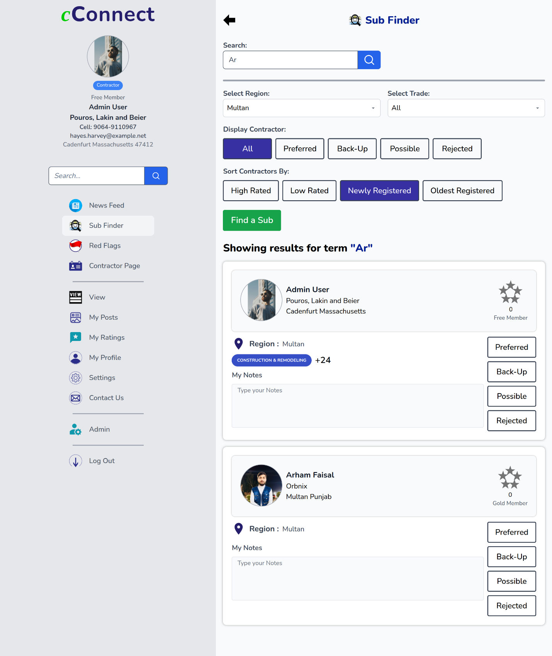

6.5. Contractor Page
The Contractor Page serves as a dedicated profile space where contractors can showcase their skills, services, completed projects, portfolios, and client testimonials. The purpose of Contractor Page testing is to verify that all contractor-related information is displayed accurately, updates are saved correctly.
Traceability Matrix Reference
4.3.2.5SF-05: Contractor Page

Test Case ID | Test Case Description | Preconditions | Test Steps | Expected Results | Actual Results | Status
CP-01 | Edit and Save Contact Information | User is on Contractor Page Edit | 1. Click Edit on Contact Info.  2. Update phone, email, address.  3. Save changes. | Contact info updated successfully. | Contact info updated successfully. | Pass
CP-02 | Edit and Save Social Links | User is on Contractor Page Edit | 1. Click Edit on Social Links.  2. Enter/Update Website, Facebook, Instagram, TikTok links.  3. Save changes. | Social links updated successfully. | Social links updated successfully. | Pass
CP-03 | Edit Title and Upload Image | User is on Contractor Page Edit | 1. Click Edit on Title/Image Section.  2. Enter Title text.  3. Upload cover image.  4. Save changes. | Title and image updated successfully. | Title and image updated successfully. | Pass
CP-04 | Edit About Us Content | User is on Contractor Page Edit | 1. Click Edit on About Us section.  2. Add company description.  3. Save changes. | About Us section updated successfully. | About Us section updated successfully. | Pass
CP-05 | Edit Brag Section | User is on Contractor Page Edit | 1. Click Edit on Brag Section.  2. Enter bragging details and upload image.  3. Save changes. | Brag section updated successfully. | Brag section updated successfully. | Pass
CP-06 | Add New Section | User is on Contractor Page Edit | 1. Click 'Add Title/Image Section' or 'Add Brag Section'.  2. Fill in details and Save. | New section added successfully. | New section added successfully. | Pass
CP-07 | Delete Existing Section | User is on Contractor Page Edit | 1. Click Delete icon on any section.  2. Confirm deletion. | Section deleted successfully. | Section deleted successfully. | Pass
CP-08 | View Live Contractor Page | Contractor Page must be saved | 1. Click 'See Live View'. | Contractor Page displayed with all updated sections properly. | Contractor Page displayed with all updated sections properly. | Pass

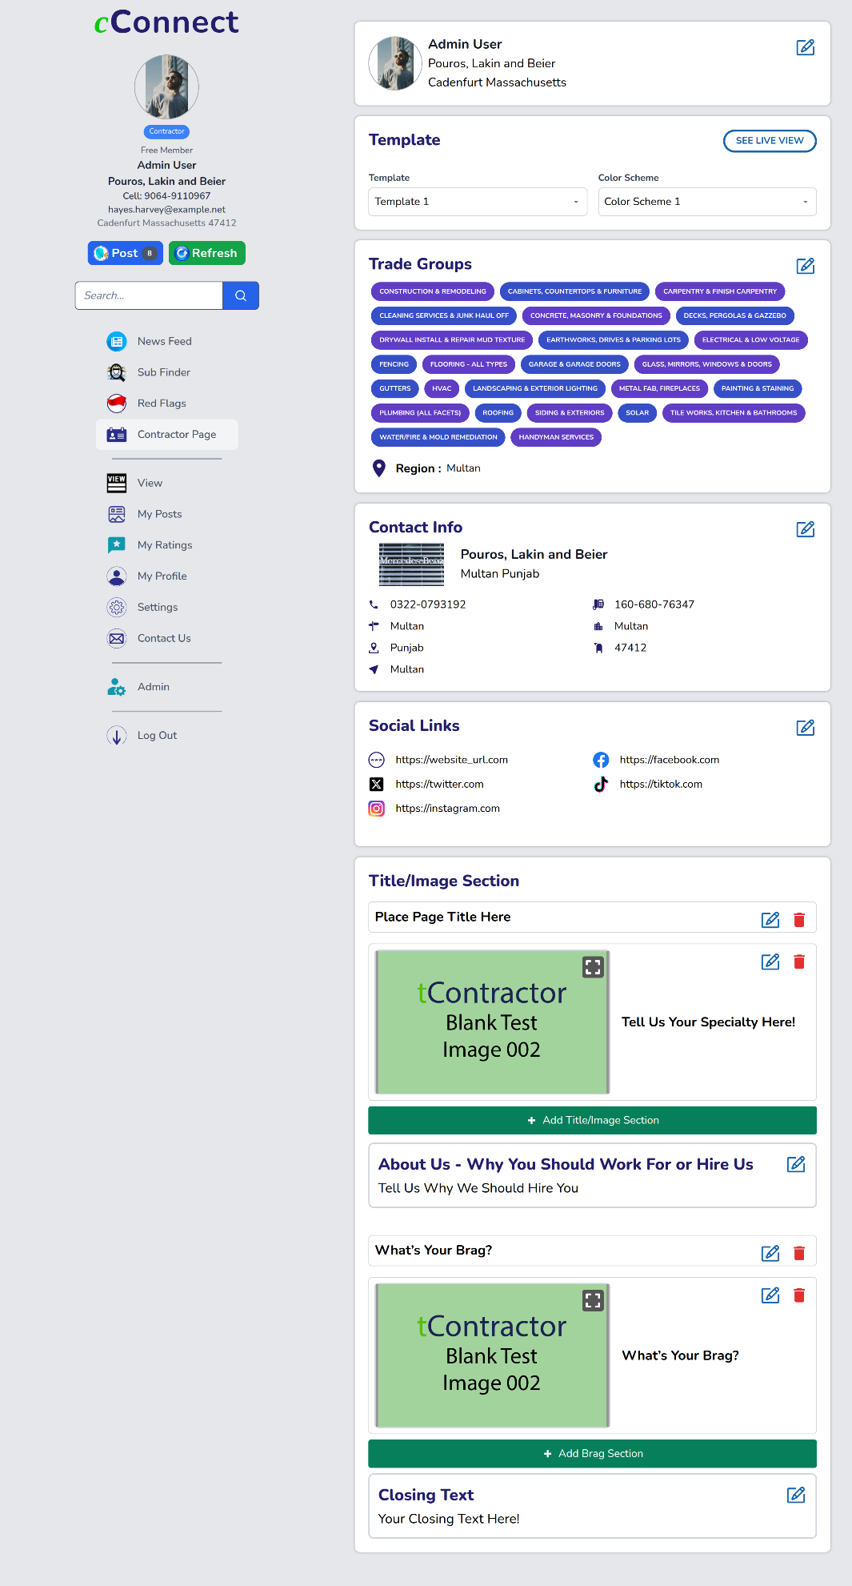

6.6. Rating & Review
The Rating and Review feature allows clients to provide feedback on contractors’ services and enables contractors to share feedback about clients. The goal of testing this feature is to make sure that users can submit, view, edit, and delete ratings and reviews correctly, and that all feedback is displayed accurately on relevant profiles.
Traceability Matrix Reference
4.3.2.6: SF-06: Rating & Review

6.7. Red Flag
The Red Flag System is designed to help users report problematic or unprofessional client and customer behavior, contributing to a safer and more transparent working environment within the platform. The objective of testing is to ensure that contractors can successfully submit red flag reports with valid justifications, and that the system accurately stores, displays, and manages these reports.
Traceability Matrix Reference
4.3.2.7: SF-07: Red Flag
Test Case ID | Test Case Description | Preconditions | Test Steps | Expected Results | Actual Results | Status
RF-01 | Add a Valid Red Flag | User is logged in | 1. Click 'Add Red Flag'.  2. Enter Title, Description, attach document.  3. Click Save. | Red Flag created and shown in list. | Red Flag created and shown in list. | Pass
RF-02 | Missing Title in Red Flag | User is on Add Red Flag page | 1. Leave Title blank.  2. Fill Description and upload.  3. Click Save. | Error shown for missing Title. | Error shown for missing Title. | Pass
RF-03 | Missing Description in Red Flag | User is on Add Red Flag page | 1. Fill Title.  2. Leave Description blank.  3. Click Save. | Error shown for missing Description. | Error shown for missing Description. | Pass
RF-04 | View Red Flag List | User is on Red Flag page | 1. Open Red Flag tab.  2. Observe list of flags. | All Red Flags listed correctly. | All Red Flags listed correctly. | Pass
RF-05 | Expand Red Flag Details | User is on Red Flag list page | 1. Click any Red Flag.  2. View Title, Description, Attachment. | Full Red Flag details displayed. | Full Red Flag details displayed. | Pass
RF-06 | Edit an Existing Red Flag | User has a Red Flag | 1. Click Edit button.  2. Update Title/Description.  3. Click Save. | Red Flag updated successfully. | Red Flag updated successfully. | Pass
RF-07 | Delete a Red Flag | User has a Red Flag | 1. Click Delete button.  2. Confirm Deletion. | Red Flag deleted successfully. | Red Flag deleted successfully. | Pass

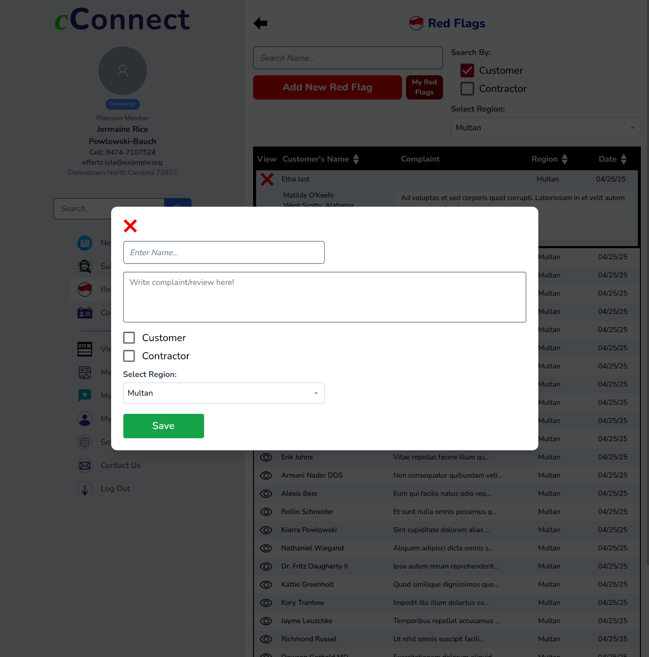

6.8. Pricing Plan
Pricing Plan feature allows users to view and subscribe to different service packages offered by the platform, each providing varying levels of access and benefits. The goal of this testing is to confirm that all pricing options are displayed correctly, the subscription process functions smoothly, and that payment methods are properly integrated.
Traceability Matrix Reference
4.3.2.8: SF-08: Red Flag
Test Case ID | Test Case Description | Preconditions | Test Steps | Expected Results | Actual Results | Status
PP-01 | Verify visibility of Pricing Plans page | User is logged in | 1. Navigate to Pricing Plans page from main menu. | Pricing Plans page should be displayed correctly. | Pricing Plans page displayed correctly. | Pass
PP-02 | Verify Free package details | User is on Pricing Plans page | 1. View Free package section.  2. Check postings limit, images allowed, features listed. | Free Package allows 8 postings, 3 images, basic features only. | Free Package allows 8 postings, 3 images, basic features only. | Pass
PP-03 | Verify Gold package details | User is on Pricing Plans page | 1. View Gold package section.  2. Check postings limit, images allowed, features listed. | Gold Package allows 60 postings, 15 images, extended features. | Gold Package allows 60 postings, 15 images, extended features. | Pass
PP-04 | Verify Platinum package details | User is on Pricing Plans page | 1. View Platinum package section.  2. Check postings limit, images allowed, features listed. | Platinum Package allows unlimited postings, 20 images, all features unlocked. | Platinum Package allows unlimited postings, 20 images, all features unlocked. | Pass
PP-05 | Verify Select button for Free Package | User is on Pricing Plans page | 1. Click 'Select' under Free Package. | Free Package should be selected successfully. | Free Package selected successfully. | Pass
PP-06 | Verify Select button for Gold Package | User is on Pricing Plans page | 1. Click 'Select' under Gold Package. | Gold Package should be selected successfully. | Gold Package selected successfully. | Pass
PP-07 | Verify Select button for Platinum Package | User is on Pricing Plans page | 1. Click 'Select' under Platinum Package. | Platinum Package should be selected successfully. | Platinum Package selected successfully. | Pass
PP-08 | Verify FAQs visibility under Pricing Plans | User is on Pricing Plans page | 1. Scroll down to FAQs section. | FAQs section should be visible and expandable. | FAQs section visible and expandable. | Pass
PP-09 | Verify expand/collapse FAQ functionality | User is on Pricing Plans page | 1. Click on a FAQ question.  2. Click again to collapse. | Answer should expand on click and collapse on re-click. | Answer expands and collapses correctly. | Pass
PP-10 | Verify accuracy of listed features for each plan | User is on Pricing Plans page | 1. Compare feature availability (News Feed, Sub Finder, Trade Groups, Red Flags, Contractor Page) per plan. | Each feature should match the plan description accurately. | Each feature matches the plan description accurately. | Pass

