**PROJECT BRIEF**

PROJECT NAME Automated Heart Disease Detection

ORGANIZATION NAME COMSATS UNIVERSITY ISLAMABAD, WAH CAMPUS

OBJECTIVE TO PROVIDE A SYSTEM WHERE A PERSON

CAN CHECK HIS/HER HEART CONDITION

UNDERTAKEN BY Rao Babar Ali & M. Tariq

SUPERVISED BY MAM Rabbia Mahum

Lecturer

DEPARTMENT OF COMPUTER SCIENCE

COMSATS UNIVERSITY ISLAMABAD, WAH CAMPUS

Started On OCTOBER 2018

Completed On MAY 2019

COMPUTER USED DELL INTEL CORE I3 4th GENERATION

SOURCE LANGUAGE PYTHON, HTML, CSS, JQUERY, BOOTSTRAP

OPERATING SYSTEM WINDOWS

TOOLS USED PYCHARM, JUPYTER NOTEBOOK, GOOGLE COLAB

**ABSTRACT**

The degree project aims to allow users to get instant guidance on their heart disease through an intelligent system online. The designed system (Heart Disease Prediction System) uses 14 medical parameters such as age, sex, blood pressure, cholesterol, and obesity for prediction. The EHDPS predicts the likelihood of patients getting heart disease. It enables significant knowledge, e.g., relationships between medical factors related to heart disease and patterns, to be established. The System will generate results according to the data provided by the user. Using the obtained results the designed diagnostic system will effectively predict the heart disease.

The system provides the GUI for the user and the administrator to interact with the system. The administrator panel is to provide all the functionalities to the administrator from where he performs the specific tasks. The site allows administrator to manage all the records and information including the insertion of new records, updating and deletion of the records.

There is an absence of successful analysis methods to find connections and patterns in health care data. Heart disease is the [number one cause of death worldwide](https://www.world-heart-federation.org/resources/cardiovascular-diseases-cvds-global-facts-figures/), so to learn how to prevent heart disease we must first reliably detect it. Our System (Heart Disease Prediction System) will allow users to get instant guidance on their heart disease through an intelligent system online.

The system also leverages user security by providing registered logins.

**TABLE OF CONTENTS**

Contents

1 INTRODUCTION 2

1.1 Introduction to Project 2

1.2 General Information 2

1.3 Product Function 2

1.6 Machinery 3

1.7 Hardware Requirements 3

1.8 Tools and Techniques 3

2 LITERATURE REVIEW 5

2.1 Background 5

2.2 Business Context 5

3 PROPOSED SYSTEM 7

3.1 Introduction to Proposed System 7

3.2 Overview of Proposed System 7

3.3 Features of Proposed System 7

4 SYSTEM SPECIFICATION 11

4.1 System Design 11

4.1.1 System Use Case Diagram 11

4.1.2 System Activity Diagram 13

4.2 Non Functional Requirements 17

4.2.2 Maintainability 17

4.2.3 Extensibility 17

4.2.4 Reusability 17

4.2.5 Compatibility 17

6 TESTING 23

6.1 System Testing 23

6.2 Testing Strategies 23

6.3 Unit Testing 23

6.4 Test Cases 24

6.4.1 Registration 24

6.4.2 Login 24

6.5 Integration Testing 25

6.6 Testing with Devices 25

7 CONCLUSION 27

7.1 Conclusion 28

8 REFERENCES 29

8.1 References 30

**List of Figures**

Web Interface 08

Login Panel 08

Registration Panel 09

Profile Panel 10

Use Case Diagram 13

Activity Diagram 14

System Sequence Diagram 15

System Entity Relationship Diagram 16

Class Diagram 17

Databse Diagram 20

Self Analysis 21

Edit Doctor 22

Edit Profile 23

**List of Tables**

Hardware Requirements 03

Registration 26

Login 26

**CHAPTER 1**

**INTRODUCTION**

# **1 INTRODUCTION**

## **Introduction to Project**

## The term ‘Heart Disease’ encompasses the diverse diseases that affect heart. The number of people suffering from heart disease is on the rise (Health Topics, 2010). The report from World Health Organization shows us a large number of people that die every year due to the heart disease all over the world. Heart disease is also stated as one of the greatest killer in Africa, America and also Asia. A major challenge faced by health care organizations, such as hospitals and medical centers, is the provision of quality services at affordable costs. The diagnosis of heart disease is a challenging task, we developed an automated heart diseases prediction system we use datamining algorithms to predict heart diseases.

## **General Information**

## Our system check the patient have the heart diseases or not. If the patient have the heart diseases then our system suggest different heart specialist doctors, and Patient will contact them. The system uses 14 medical parameters such as age, sex, blood pressure, cholesterol, and obesity for prediction.

## **Product Function**

## This project Automated Heart Disease Detection will provide following different functionalities.

* Customer oriented functionalities
* Registration
* Login
* Enter Data/Report
* View data
* Contact with the Doctors
* System oriented functionalities
* System predict the heart diseases
* Admin would be able to put the previous records of Patients who have heart disease or normal heart.
* Admin would be able to put the Doctors information and contact info.
  1. **Purpose of Project**

The system will provide the facility to detect heart disease of patient. The system analyze heart disease from values of different related features using classification algorithms to provide effective and efficient solution to this problem. System will use 13 features for this purpose. Further this system will have GUI to interact with user and make our system easy to be practical. Medical data is in the form of text values. It is easier for every patient or medical staff the person have heart disease or not. Our System will be developed on python using anaconda. For front end designing we will going to use HTML, CSS, and Bootstrap etc. The Dataset is collected from Kaggle website where different datasets for different areas are available. The Dataset collected publicly.

* 1. **Scope of Project**

The System is useful for accessing data anywhere on web devices as it is a responsive system. The system is also useful in all medical centers and hospitals.

* 1. **Machinery**

With the fast growth in the world of technologies for latest hardware and software of today are becoming the older versions for tomorrow. So here, we are using latest tools and technologies while enabling the users efficiently meet their requirements. The suggested software and hardware requirements are discussed over here.

**1.7 Hardware Requirements**

Table 1.Hardware Requirements

|  |  |
| --- | --- |
| **Processor** | Minimum dual core, Recommended Quad Core |
| **Memory** | Minimum 512 MB, Recommended 2 GB |
| **System** | Dual core, Quad core, core i3, core i5 and core i7 |
| **WIFI module** | Compatible |

## 

## **Tools and Techniques**

## Selection of most suitable tool for development of software plays an important role in the development of project. Our System will be developed on python using anaconda. For front end designing we will going to use HTML, CSS, and Bootstrap etc. The Dataset is collected from Kaggle website where different datasets for different areas are available. The Dataset collected publicly. We use Pycharm, Jupiter Notebook, Google Colab to develop.

**CHAPTER 2**

**LITERATURE REVIEW**

# **LITERATURE REVIEW**

# **Background**

# In the last decades, several tools and various methodologies have been proposed by the researchers for developing effective medical decision support systems. Moreover, new methodologies and new tools are continued to develop and represent day by day. Diagnosing of the heart disease is one of the important issue and many researchers investigated to develop intelligent medical decision support systems to improve the ability of the physicians.

## **Business Context**

## Clinical guidelines provide recommendations to assist clinicians in making decisions regarding appropriate medical care for specific patient situations. However, characterizing these situations is difficult as it requires taking into account all the variations that patients may present. We propose an approach which helps with identifying and categorizing the contexts that need to be taken into account within a clinical process. Our methodology is based on a formal process model and on a collection of process execution instances. We apply machine-learning algorithms to group process instances by similarity of their paths and outcomes and derive the contextual properties of each group. We illustrate the application of our methodology to a urinary tract infection management process. Our approach yields promising results with high accuracy for some of the context groups that were identified.

**CHAPTER 3**

**PROPOSED SYSTEM**

# **PROPOSED SYSTEM**

## **Introduction to Proposed System**

## The proposed system implements Machine learning and deep learning based website that is used for prediction of Heart disease. The prediction or detection of heart disease was very expensive and mostly un-accurate before the invention of Machine. Our proposed system implements machine learning algorithm for highly accurate prediction. Google offers Google collab for implementing different machine learning and deep learning tasks by offering free GPU. We implemented many machine learning algorithms on the dataset but the final most algorithm is from deep learning which is highly accurate.

## **Overview of Proposed System**

## The Proposed system running on windows OS. The system have two types of users. Individual (mean Patient) and medical staff users. The web application is made interactive and easily usable. The user can access every feature of web application on one click.

## **Features of Proposed System**

## Web Interface

* 1. **Software Interface**
     1. **Web Interface**

The interface that the registered user will interact is provided in web application. The interface is very easy to use and operations are normally on one click.

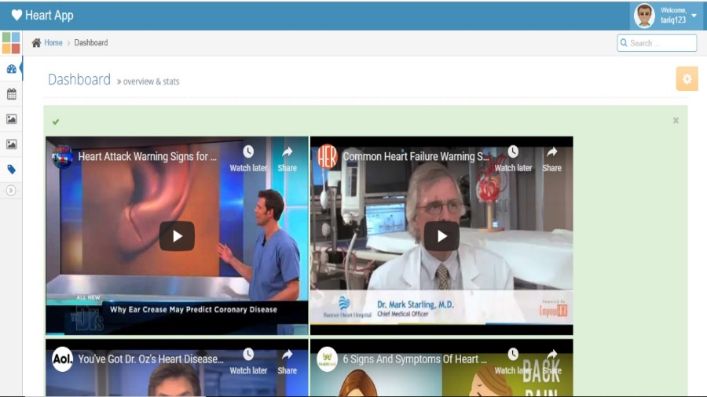

Figure 1 Web Interface

##### **Registration and Login Panel**

##### The user will register by providing email, password, confirm password and username. After clicking on Signup button and login the web will appear where user have to provide the personal detail.

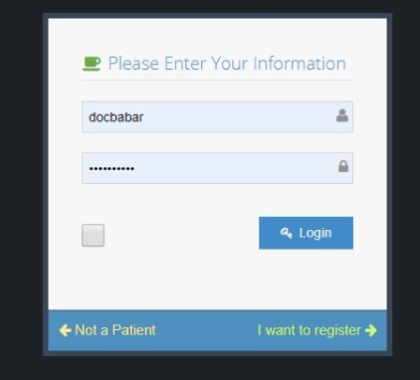

Figure 2 login panel

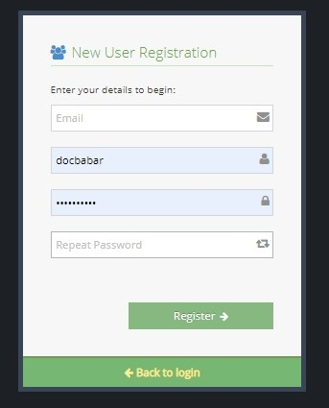

Figure 3 Registration panel

##### **Profile Panel**

##### User can see his profile and can edit it.

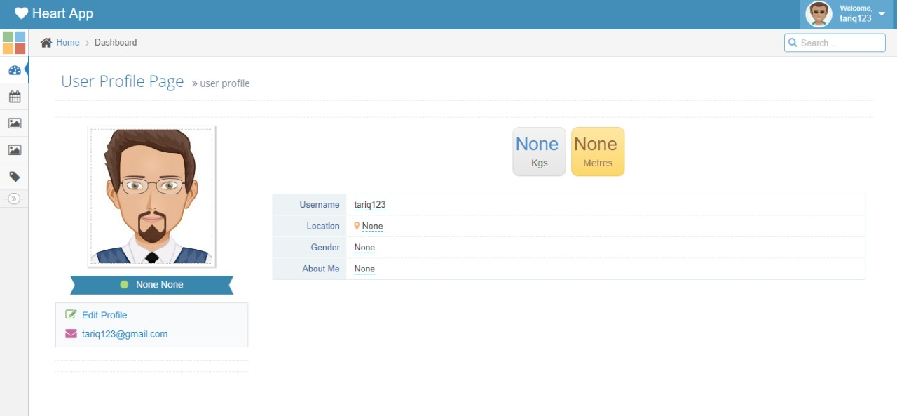

Figure 4 profile panel

**CHAPTER 4**

**SYSTEM SPECIFICATION**

# **SYSTEM SPECIFICATION**

## **System Design**

## System design is the process of defining the architecture, modules, interfaces and data for a system to specify specified requirements. System design could be seen as the application of systems theory to product development. In system design, we describe the project in the form of diagrams and flow charts. The logical design of a system pertains to an abstract representation of the data flows, input and outputs of the system. This is often conducted via modelling, using an over-abstract (and sometimes graphical) model of the actual system. In the context of systems, designs are included. Logical design includes entity-relation diagrams (ER diagrams). In system design, we describe the project in the form of UML.

### **System Use Case Diagram**

### Use case diagram Provide complete information about system. In this diagram, Actor (User of the system) is linked with all the functions and activities of the system which user can perform. The complete information and activities are seen in diagram below

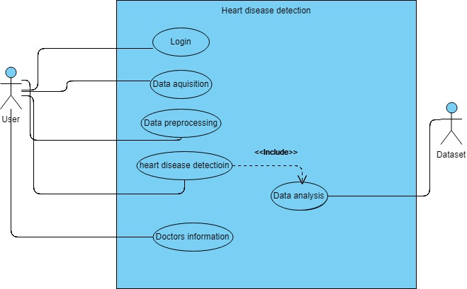

Figure 5 System Use Case diagram

### **System Activity Diagram**

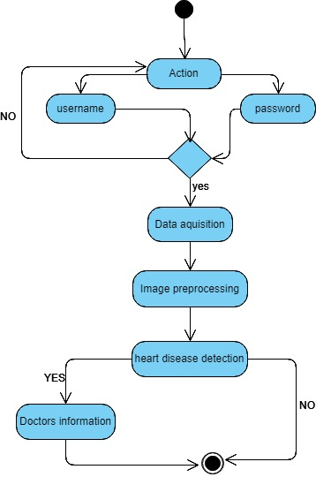

Figure 6 System Activity Diagram

### **System Sequence Diagram**

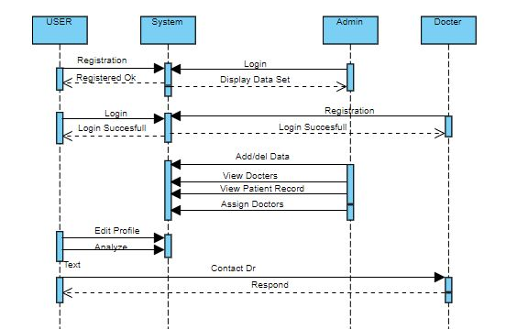

Figure 7 Sequence Diagram

### **System Entity Relationship Diagram**

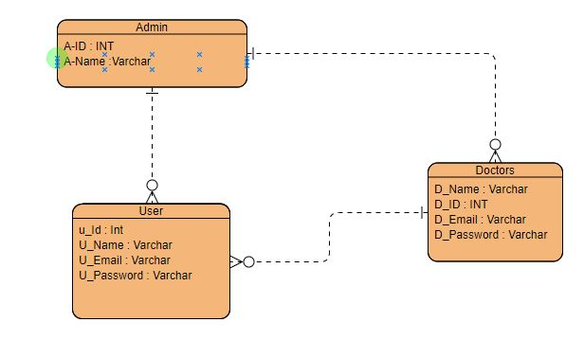

Figure 8 ER-Diagram

* + 1. **Class Diagram**

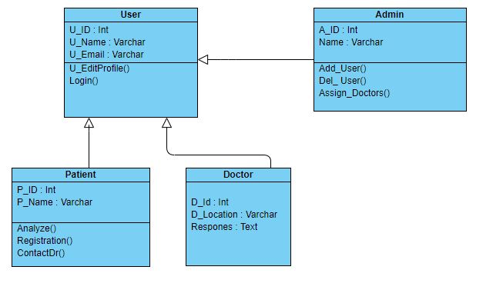

Figure 9 Class Diagram

## **Non Functional Requirements**

## **Reliability**

## The system will never crash or hang, other than as the result of an operating system error. It will always be available to the user end. If the system gets crashed then it will be recover in minimum time. The application would be quite reliable.

## **Maintainability**

## This Project will maintains all the records of the users registered in it. The system will be maintained properly by the developers. The system will be modified if found any flaws or bugs. . The code shall be modular to permit future modifications.

### **Extensibility**

### The system will be extensible as we can go to another window of disease detection. In future, the android version of this project can also be launched, such that to compete with the latest technology & society.

### **Reusability**

### The languages & sources used for developing this project are free. Therefore, we can reuse or update anything in this project very easily at any time.

### **Compatibility**

### This project will be compatible on all major operating systems & different screen sizes.

**CHAPTER 5**

**IMPLEMENTATION**

1. **Implementation**
   1. **Implementation**

An implementation is a realization of a technical specification or algorithm as a program, software component, or other computer system through programming and deployment. Implementation is the carrying out, execution, or practice of a plan, a method, or any design for doing something. As such, implementation is the action that must follow any preliminary thinking in order for something to actually happen. In an information technology context, implementation encompasses all the processes involved in getting new software or hardware operating properly in its environment, including installation, configuration, running, testing, and making necessary changes.

* Implement a website for users to predict heart disease with maximum accuracy.
* After implementation of this system patient is able to predict heart disease and prevent or cure to some extent.

Implementation is the final and the most important phase. The most critical stage in achieving a successful new system is giving the users confidence that the new system will work and be effective. The system can be implemented only after through testing is done and if it is found to be working according to the specification.

* + 1. **Database**

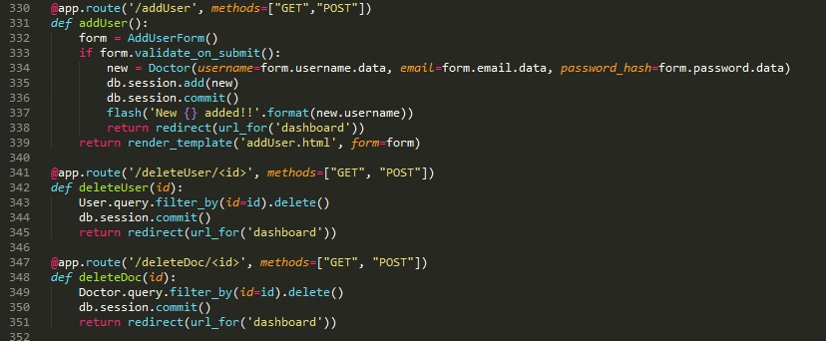

Figure 10 Database

* 1. **Self Analysis**

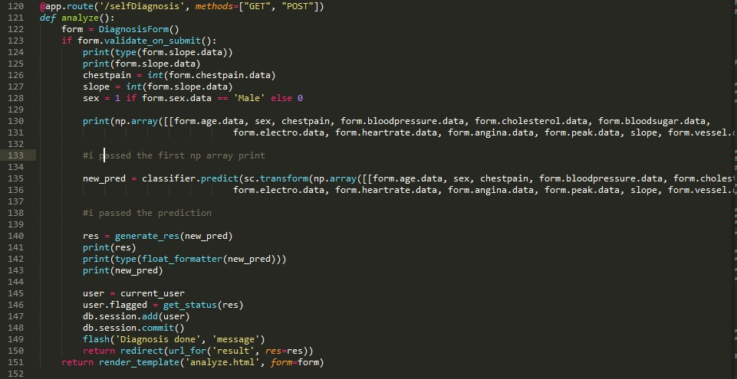

Figure 11 Self Analysis

* 1. **Edit Doctor**

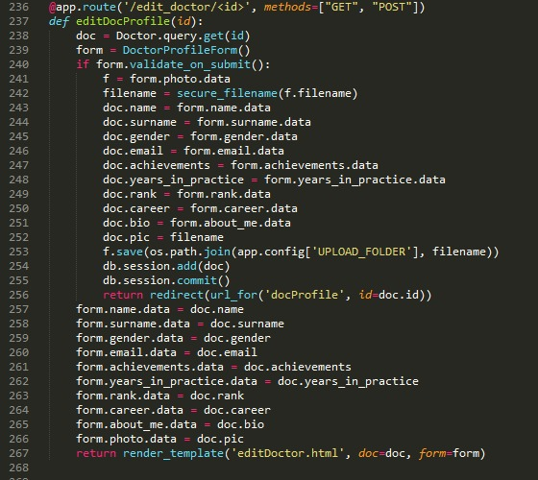

Figure 12 Edit Doctor

**5.4 Edit Profile**

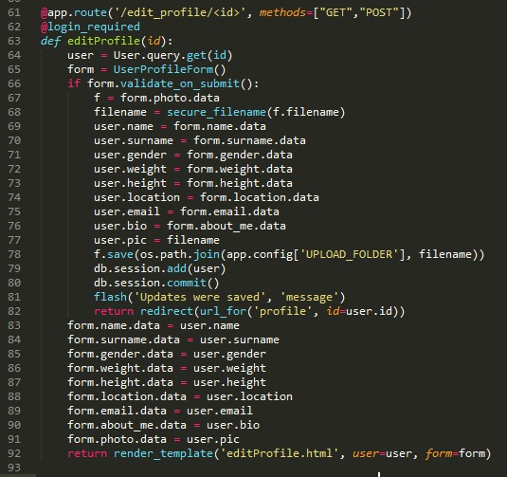

Figure 13. Edit Profile

**CHAPTER 6**

**TESTING**

# **TESTING**

# **System Testing**

# System testing of software or hardware is testing conducted on a complete, integrated system to evaluate the system's compliance with its specified requirements. System testing is the stage of implementation, which ensures that system working efficiently and accurately. Testing means finding errors and missing operations and a complete verification to determine whether the objectives meet and the user requirements are satisfied. The ultimate aim is quality assurance. There are different types of testing which perform on the system to find the working of the software on different stages.

# **Testing Strategies**

# The basic principles for distinct are:

# All tests should be traceable to user requirement.

# Test should be planned long before testing begins.

# Testing should begin in the small and progress toward testing in the large.

# Software testability is simply how easily a computer program can be tested. Testability is used to be how adequately a particular set of test will cover the product. The following set of characteristics needs to the testable software

# Operability

# Controllability

# Simplicity

# Understandability

## **Unit Testing**

## Unit testing is a method by which individual units of source code are tested to determine if they are fit for use. A unit is the smallest testable part of an application. This enables, to detect errors in coding and logic that are contained within each module. The various controls are tested to ensure that each performs its action as required.

## **6.4 Test Cases**

## **6.4.1 Registration**

|  |  |  |  |  |  |
| --- | --- | --- | --- | --- | --- |
| **Case #** | **Test Case** | **Test Execution** | **Expected Result** | **Pass/Fail** | **Remarks** |
| 1 | Register | Enter the username, password, confirm password and email | Login interface open | Pass | Register Success |
| 2 |  | Enter the username, password, confirm password not same as password and email | Server response Registration failed | Fail | Password and confirm password do no match |

### **6.4.2 Login**

|  |  |  |  |  |  |
| --- | --- | --- | --- | --- | --- |
| **Case #** | **Test Case** | **Test Execution** | **Expected Result** | **Pass/Fail** | **Remarks** |
| 1 | Login | Enter correct username and password | Dashboard of user profile opens | Pass | Login success |
| 2 |  | Enter correct user name and wrong password | Server response Login failed | Fail | Username or password is incorrect |

## **Integration Testing**

## Integration testing is the phase in software testing in which individual software modules are combined and tested as a group. It occurs after unit testing and before system testing. In integration testing, I apply test on user operations.

## Input: Registration done

## Output: Login Screen appears

## View, Delete, Update, Share Files

## **Testing with Devices**

## For testing the compatibility and performance of application, it was tested on different devices, the application performed well. The application is tested on following devices with results below:

## Acer Intel core i5-2450m @ 2.50GHz

## Hp Intel core i7-6420 @ 2.52GHz 2.52GHz

**CHAPTER 7**

**CONCLUSION**

# **7 CONCLUSION**

## **7.1 Conclusion**

## Automated heart disease prediction system helps both patient and medical staff to know about patient have Heart disease or not. This system analysis if patient have heart disease this system provide the doctors information (ph.no, address etc. Patient take their appointment. When user register yourself they can see any time previous.

**7.2 Future Work**

Infuture we develop the android application while every easily access this service. In future we work on brain tumor detection functionality and combine in one system.

**CHAPTER 8**

**REFERENCES**

**8 Reference**

[1] K.VEMBANDASAMY, IJISET - International Journal of Innovative Science, Engineering & Technology, Vol. 2 Issue 9, September 2015 Heart Diseases Detection Using Naive Bayes Algorithm

## [2] Kalyan Netti, International Journal of Innovative Research in Computer and Communication Engineering, Vol.3, Special Issue 6, August 2015 A web Implementation of Naive Bayes Classifier

## [3] O. Kwon and J. Lee, “Web page classification based on k-nearest neighbour approach”, in Proc. of the 5th Int. Workshop on Information Retrieval with Asian languages, Hong Kong, China, 2000

## [4] MANASWINI PRADHAN (International Journal of Innovative Research in Computer and Communication Engineering Vol. 2, Issue 12, December 2014 Data Mining& Health Care: Techniques Of Application

## [5] DR.B.SRINIVASAN, International Research Journal of Engineering and Technology (IRJET) Volume: 03 Issue: 03 | Mar-2016 A Study On Data Mining Prediction Techniques In Healthcare Sector K.PAVYA, International Research Journal of Engineering and Technology (IRJET) Volume: 03 Issue: 03 | Mar-2016 A Study On Data Mining Prediction Techniques In Healthcare Sector