This Chicago Open Street Maps (OSM) data was downloaded from extract.bbbike.org as shown in the screenshot below. This approach was taken because the size of the export is pretty large (~910 MB uncompressed) and most of the standard WEB API's did not permit downloading such a large region. Ofcourse, one option was to download small sections and then find/develop software to combine them. However, that would be a bit more cumbersome than just downloading the large data set and working with it.

The metropolitan area for which Taxi rides were available was obtained from https://data.cityofchicago.org/Facilities-Geographic-Boundaries/Boundaries-Community-Areas-current-/cauq-8yn6. This map shows the region around the city of Chicago for which Taxi ride data is available.

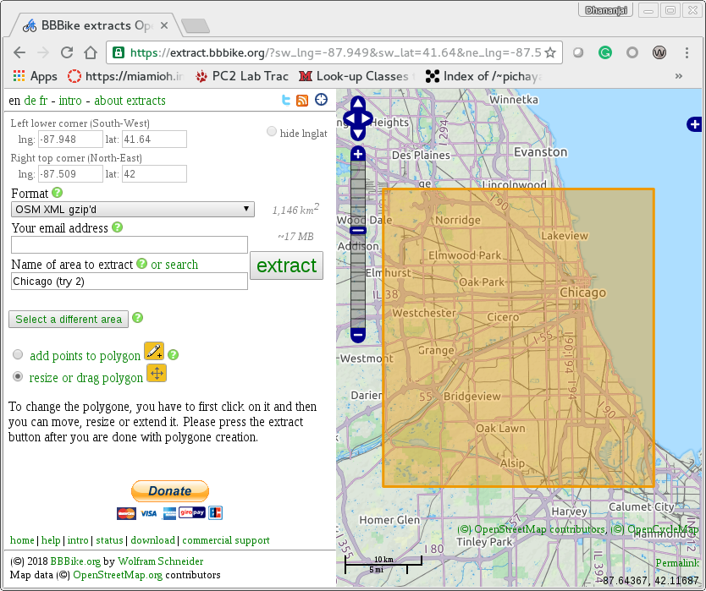
The Chicago.osm has 6, 675, 249 (~6.68 million) nodes in the graph. There are 23, 248 amenities geocoded into the OSM. The initial idea was to use the amenities as potential locations where people would travel to/from.

Boundaries – Community Areas
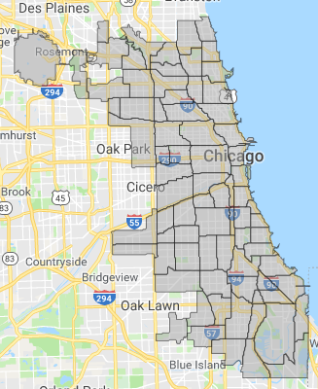
The Chicago data was exported as a rectangle. However, the data collected is focused on community boundaries as shown in the adjacent figure. The boundary image was obtained from https://data.cityofchicago.org/Facilities-Geographic-Boundaries/Boundaries-Community-Areas-current-/cauq-8yn6

So the next issue with data processing is to restrict the data from various data sources to coincide with the community boundaries for which Taxi data is available from the Chicago Data Portal.

There are 133 unique types of amenities in the data. The list of unique amenities is: animal_boarding, animal_shelter, arts_centre, artwork, atm, ATM, b, bank, banquet_hall, bar, batting_cage, bbq, bench, bicycle_parking, bicycle_rental, bicycle_repair_station, biergarten, bleachers, BMO, boat_rental, book_return, brewery, bureau_de_change, bus_station, cafe, carousel, car_rental, car_sharing, car_wash, casino, charging_station, childcare, cinema, clinic, clock, college, community_center, community_centre, conference, conference_centre, courthouse, cultural_center, dance_theater, dancing_school, dental, dentist, disused, doctors, dojo, dormitory, drinking_water, driving_school, embassy, fast_food, ferry_terminal, fire_station, food_court, fountain, fuel, grave_yard, gym, gymnasium, health_center, hookah_lounge, hospital, ice_cream, institute, insurance, internet_access, kindergarten, library, lifeguard, loans, marketplace, monastery, money_transfer, motel, music_school, music_venue, nightclub, nursing_home, optometrist, outdoor_seating, parking, parking_entrance, parking_space, pharmacy, picnic_table, place_of_worship, planetarium, police, post_box, post_office, prison, proposed, pub, public_bath, public_bookcase, public_building, ranger_station, recycling, research_institute, restaurant, retail, retirement_home, salon, school, shelter, shop, shower, smoking_area, social_centre, social_facility, spa, storage, stripclub, studio, swimming_pool, taxi, telephone, theatre, toilets, townhall, trailer_park, training, university, variety_store, vending_machine, venue, veterinary, waste_basket, waste_disposal, water_point.

The above amenities were extracted using the following command-line:
$ grep 'k="amenity"' Chicago.osm | cut -d" " -f3 | cut -d '"' -f2 | sort -u

Building types
The following types of builds are included in OSM data. Specifically residential houses are typically simply tagged with a sub-element of the form: <tag k="building" v="yes"/>. Some the buildings are tagged as: “residential”, “apartments”, “condominium” as listed in the table below. Note that the table is sorted on number of occurrences and 53 entries with counts less than 10 are not shown in the table below.

Count | Building Type | Count | Building Type | Count | Building Type
814785 | yes | 538 | roof | 79 | shed
10080 | house | 525 | commercial | 77 | entrance
9640 | residential | 302 | Public | 63 | hotel
9217 | garage | 291 | university | 61 | dormitory
3641 | industrial | 157 | construction | 17 | College
1848 | apartments | 106 | garages | 17 | greenhouse
1563 | retail | 104 | supermarket | 15 | synagogue
1044 | school | 98 | hospital | 12 | manufacture
900 | church | 87 | train_station | 11 | condominium
636 | terrace | 86 | warehouse
542 | office | 79 | detached

The above building types were extracted using the following command-line:
$ grep 'k="building"' Chicago.osm | cut -d" " -f3 | cut -d '"' -f2 | sort | uniq -c

Building assignments worked nicely overall. However, for some regions the square footage was either overestimated or underestimated. Overestimation occurred in regions with low population but with large industrial complexes that significantly increased the square footage. For human population assignments, these industrial building complexes were manually tagged to be ignored.

Underestimation occurred in a few regions due to minor differences between LandScan boundaries (that are approximate to 0.5 miles) versus the more precise locations in Open Street Map. That is, the regions did not have any buildings. Specifically, for the following regions the populations were reassigned to their adjacent neighbors with homes to accommodate the human population. The adjacent neighbors were manually determined by inspecting the neighborhood via Open Street Map.

S.No | PopID | Pop | Re-ID | Notes
172 | 252 | 1399 |  | No buildings. Have to generate some houses
199 | 279 | 610 | 331 | O'Hare airport. Misalignment. Move down by 1
26 | 106 | 445 | N/A | Next to O'Hare (moved up-right but falls off edge)
225 | 305 | 408 | ?? | Misalignment. Move up-left
192 | 272 | 385 | N/A | O'Hare. Move down-left but falls off edge
994 | 1074 | 369 | 1073 | Misalignment. Edge of lake. Move left
162 | 242 | 315 | N/A | O'Hare. Misalignment. Ignore as it is edge of map
193 | 273 | 238 | N/A | O'Hare. Misalignment. Move 1 diagonal down-left by falls off edge
73 | 153 | 179 | N/A | O'Hare Misalignment. Move horizontal left by 1 or 2 but off edge
868 | 948 | 139 | 947 | Misalignment (lake edge). Move horizontal by 1 left
534 | 614 | 13 | 554 | Misalignment (highway area). Move vertically down by 1

Nearby roads

Added a feature to include nearby roads when computing the entrance intersection to buildings. This is important to correctly handle some of the edge cases as illustrated in the two figures below:
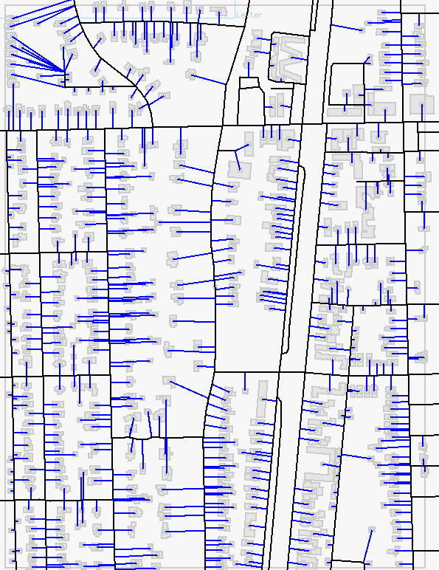 | 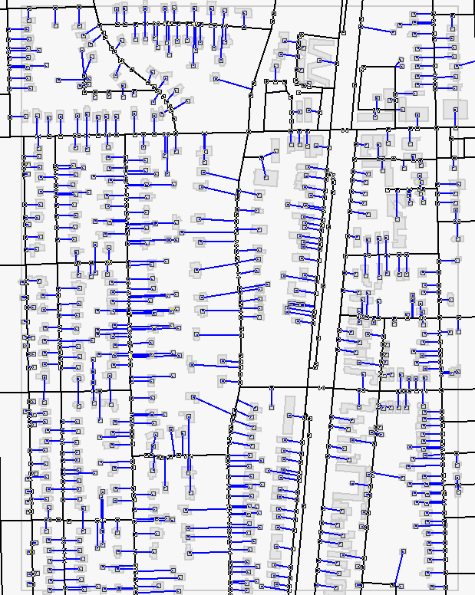
Population index number 875 without nearby roads. Notice the long intersections at the top-left corner that are not correct. | Population index number 875 with nearby roads. Notice that the intersections at the top-left corner are now correct.

In OSM many of the ways do not have a speed limit specified. Consequently, we have estimated the speed limit for the different types of roads as tabulated below:

$ tail -n +7045603 ../Chicago.osm | grep 'k="highway"' | cut -d'"' -f4 | sort | uniq -c | tr -s " " | sort -nr

Count | Way type | Speed limit
82173 | service | 25
30464 | Residential | 25
15524 | Footway | 0
10136 | Primary | 65
9788 | Secondary | 55
2831 | Path | 0
2704 | Tertiary | 35
1466 | motorway_link | 45
1409 | motorway | 65
1131 | Track | 0
960 | cycleway | 0
698 | steps | 0
563 | Pedestrian | 0
555 | Unclassified | 0
395 | trunk | 55
377 | primary_link | 45
186 | trunk_link | 45
142 | secondary_link | 25
64 | Proposed | 0
55 | construction | 0
36 | tertiary_link | 25
11 | living_street | 0
10 | busy_stop | 0
8 | Elevator | 0
8 | crossing | 0
6 | Bridleway | 0
2 | Services | 0
1 | Platform | 0
1 | Abandoned | 0

