Lab notebook with research notes recorded by DJ Rao

This Chicago Open Street Maps (OSM) data was downloaded from extract.bbbike.org as shown in the screenshot below. This approach was taken because the size of the export is pretty large (~910 MB uncompressed) and most of the standard WEB API's did not permit downloading such a large region. Ofcourse, one option was to download small sections and then find/develop software to combine them. However, that would be a bit more cumbersome than just downloading the large data set and working with it. The metropolitan area for which Taxi rides were available was obtained from https://data.cityofchicago.org/Facilities-Geographic-Boundaries/Boundaries-Community-Areas-current-/cauq-8yn6. This map shows the region around the city of Chicago for which Taxi ride data is available.

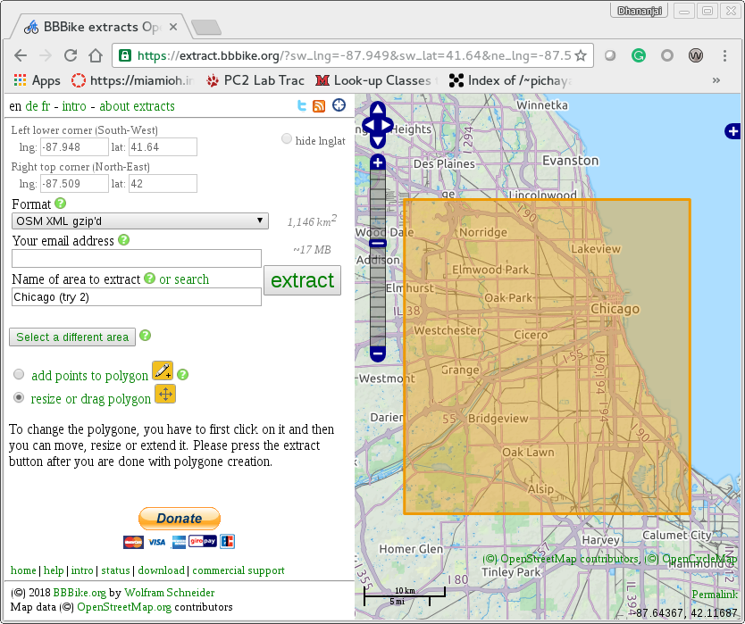
The Chicago.osm has 6, 675, 249 (~6.68 million) nodes in the graph. There are 23, 248 amenities geocoded into the OSM. The initial idea was to use the amenities as potential locations where people would travel to/from.

LandScan population data

The population of Chicago was extracted from LandScan GIS data set. The LandScan data is maintained by Oak Ridge National Lab (ORNL) – https://landscan.ornl.gov/. However, for this research the LandScan data was obtained from Miami Libraries. LandScan has global population data that is approximately at 1 KM resolution (30”×30”) in a binary raster format (with 20,880 rows and 43,200 columns). However, for this research we are interested only in the population areas of Metropolitan Chicago area as defined by the boundaries specified by – https://data.cityofchicago.org/Facilities-Geographic-Boundaries/Boundaries-Community-Areas-current-/cauq-8yn6. The population grids for the Chicago has been extracted by intersecting the Chicago community boundaries with the LandScan grids as shown in the figure below. The population grid is then used to distribute people to homes based on building data from Open Steret Maps.

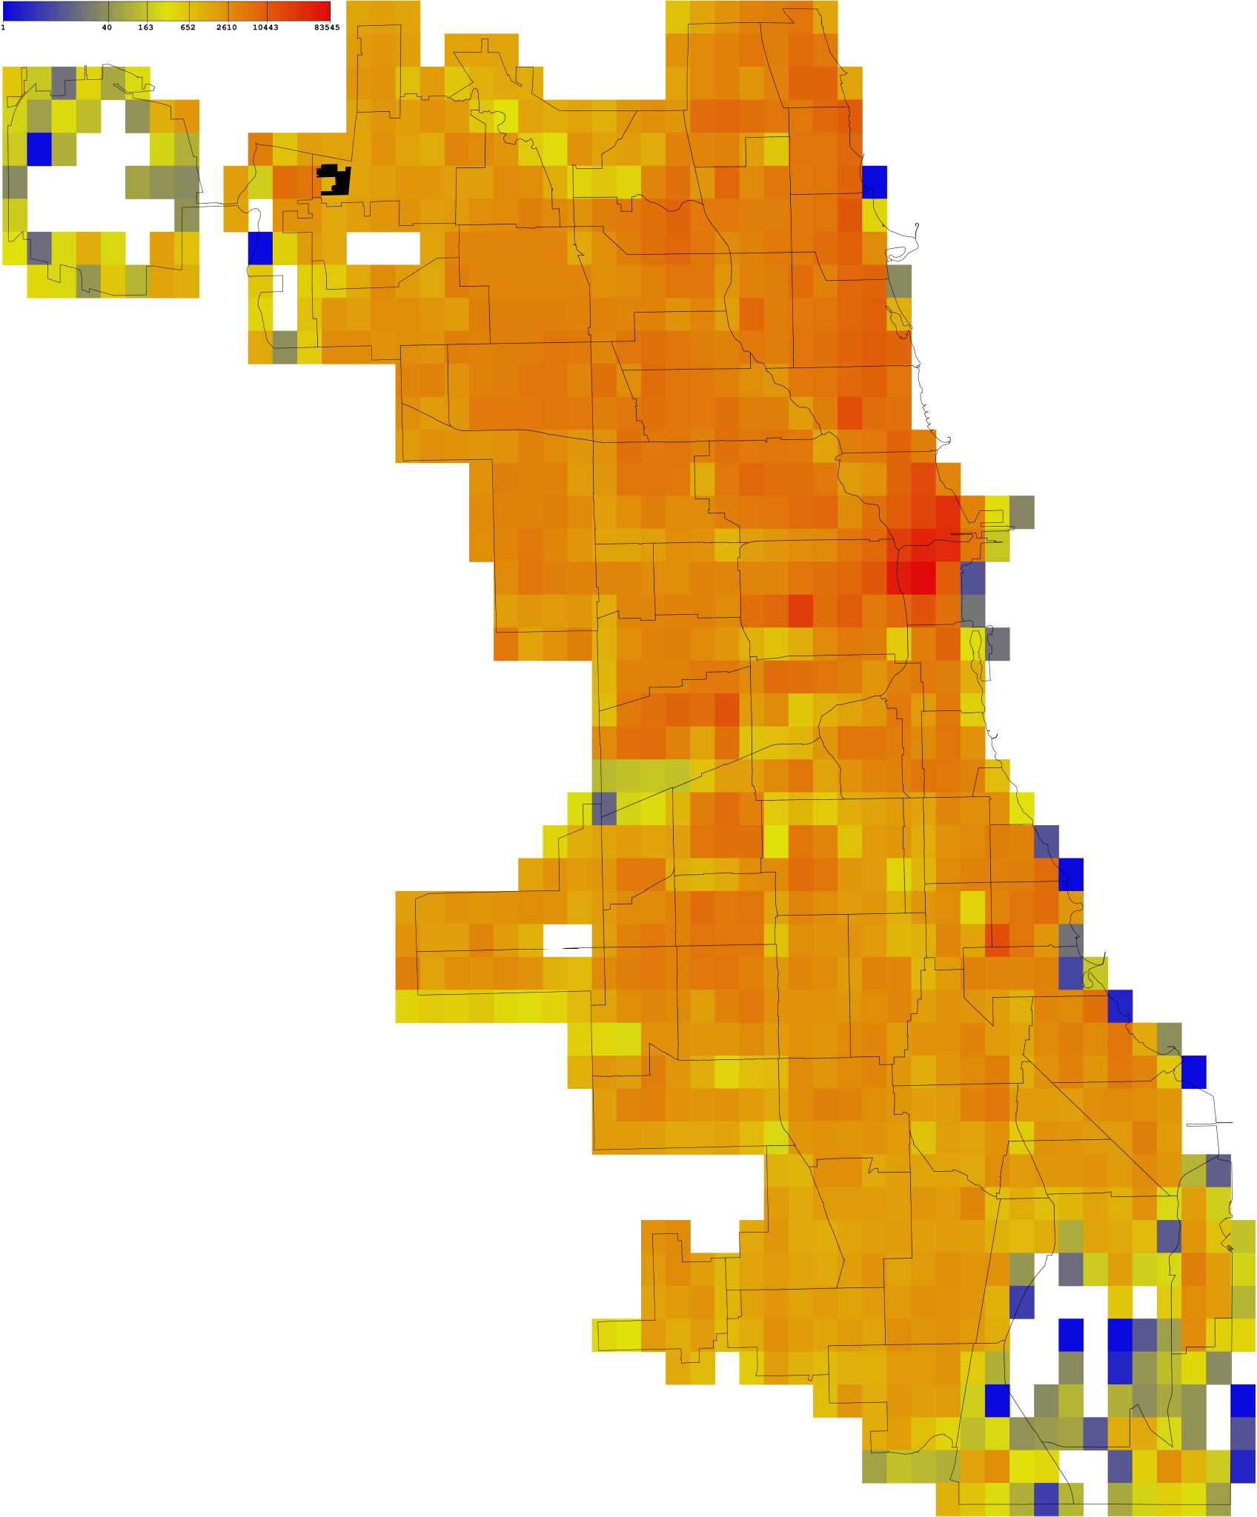

Boundaries – Community Areas
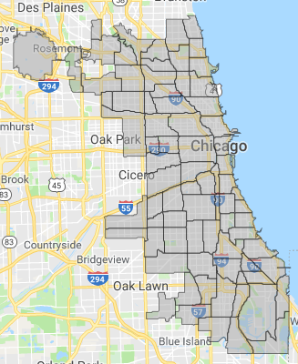
The Chicago data was exported as a rectangle. However, the data collected is focused on community boundaries as shown in the adjacent figure. The boundary image was obtained from https://data.cityofchicago.org/Facilities-Geographic-Boundaries/Boundaries-Community-Areas-current-/cauq-8yn6

So the next issue with data processing is to restrict the data from various data sources to coincide with the community boundaries for which Taxi data is available from the Chicago Data Portal.

There are 133 unique types of amenities in the data. The list of unique amenities is: animal_boarding, animal_shelter, arts_centre, artwork, atm, ATM, b, bank, banquet_hall, bar, batting_cage, bbq, bench, bicycle_parking, bicycle_rental, bicycle_repair_station, biergarten, bleachers, BMO, boat_rental, book_return, brewery, bureau_de_change, bus_station, cafe, carousel, car_rental, car_sharing, car_wash, casino, charging_station, childcare, cinema, clinic, clock, college, community_center, community_centre, conference, conference_centre, courthouse, cultural_center, dance_theater, dancing_school, dental, dentist, disused, doctors, dojo, dormitory, drinking_water, driving_school, embassy, fast_food, ferry_terminal, fire_station, food_court, fountain, fuel, grave_yard, gym, gymnasium, health_center, hookah_lounge, hospital, ice_cream, institute, insurance, internet_access, kindergarten, library, lifeguard, loans, marketplace, monastery, money_transfer, motel, music_school, music_venue, nightclub, nursing_home, optometrist, outdoor_seating, parking, parking_entrance, parking_space, pharmacy, picnic_table, place_of_worship, planetarium, police, post_box, post_office, prison, proposed, pub, public_bath, public_bookcase, public_building, ranger_station, recycling, research_institute, restaurant, retail, retirement_home, salon, school, shelter, shop, shower, smoking_area, social_centre, social_facility, spa, storage, stripclub, studio, swimming_pool, taxi, telephone, theatre, toilets, townhall, trailer_park, training, university, variety_store, vending_machine, venue, veterinary, waste_basket, waste_disposal, water_point.

The above amenities were extracted using the following command-line:
$ grep 'k="amenity"' Chicago.osm | cut -d" " -f3 | cut -d '"' -f2 | sort -u

Building types
The following types of builds are included in OSM data. Specifically residential houses are typically simply tagged with a sub-element of the form: <tag k="building" v="yes"/>. Some the buildings are tagged as: “residential”, “apartments”, “condominium” as listed in the table below. Note that the table is sorted on number of occurrences and 53 entries with counts less than 10 are not shown in the table below.

Count | Building Type | Count | Building Type | Count | Building Type
814785 | yes | 538 | roof | 79 | shed
10080 | house | 525 | commercial | 77 | entrance
9640 | residential | 302 | Public | 63 | hotel
9217 | garage | 291 | university | 61 | dormitory
3641 | industrial | 157 | construction | 17 | College
1848 | apartments | 106 | garages | 17 | greenhouse
1563 | retail | 104 | supermarket | 15 | synagogue
1044 | school | 98 | hospital | 12 | manufacture
900 | church | 87 | train_station | 11 | condominium
636 | terrace | 86 | warehouse
542 | office | 79 | detached

The above building types were extracted using the following command-line:
$ grep 'k="building"' Chicago.osm | cut -d" " -f3 | cut -d '"' -f2 | sort | uniq -c

Building assignments worked nicely overall. However, for some regions the square footage was either overestimated or underestimated. Overestimation occurred in regions with low population but with large industrial complexes that significantly increased the square footage. For human population assignments, these industrial building complexes were manually tagged to be ignored.

Underestimation occurred in a few regions due to minor differences between LandScan boundaries (that are approximate to 0.5 miles) versus the more precise locations in Open Street Map. That is, the regions did not have any buildings. Specifically, for the following regions the populations were reassigned to their adjacent neighbors with homes to accommodate the human population. The adjacent neighbors were manually determined by inspecting the neighborhood via Open Street Map.

S.No | PopID | Pop | Re-ID | Notes
172 | 252 | 1399 |  | No buildings. Have to generate some houses
199 | 279 | 610 | 225 | O'Hare airport. Misalignment. Move down by 1
26 | 106 | 445 | -1 | Next to O'Hare (moved up-right but falls off edge)
192 | 272 | 385 | N/A | O'Hare. Move down-left but falls off edge
994 | 1074 | 369 | 993 | Misalignment. Edge of lake. Move left
162 | 242 | 315 | N/A | O'Hare. Misalignment. Ignore as it is edge of map
193 | 273 | 238 | N/A | O'Hare. Misalignment. Move 1 diagonal down-left by falls off edge
73 | 153 | 179 | N/A | O'Hare Misalignment. Move horizontal left by 1 or 2 but off edge
868 | 948 | 139 | 867 | Misalignment (lake edge). Move horizontal by 1 left
534 | 614 | 13 | 554 | Misalignment (highway area). Move vertically down by 1
968 | 768 | 37 | 983 | Edge of wetland, move vertically down by 1
710 | 790 | 375 | 687 | Edge of a school district. Move vertically up
865 | 945 | 10 | 843 | Edge of a factory area. Moved vertically up.

Automatic home generation

The Open Street Maps (OSM) data currently does not include homes in certain parts of Chicago. The region spans about 2 sq. miles and was causing inconsistent distribution of population. In order to address this issue, the model generator automatically generates homes on residential ways that do not have any buildings associated with them in OSM data. Currently, homes are generated to have 1000 sq. ft area and 1 level as shown in the figures below. Out of 69503 ways, 3041 residential ways had 0 buildings and 31238 total homes have been generated on them.

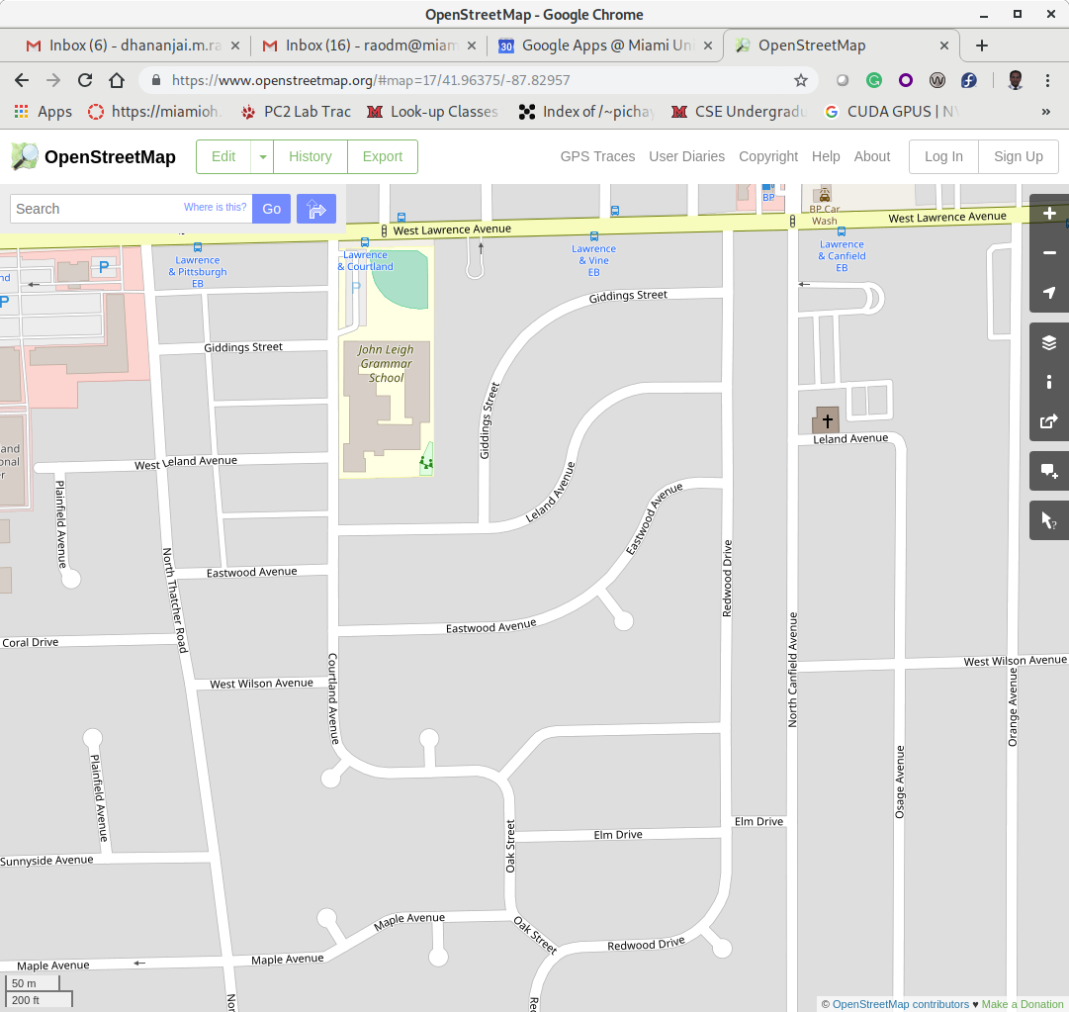 | 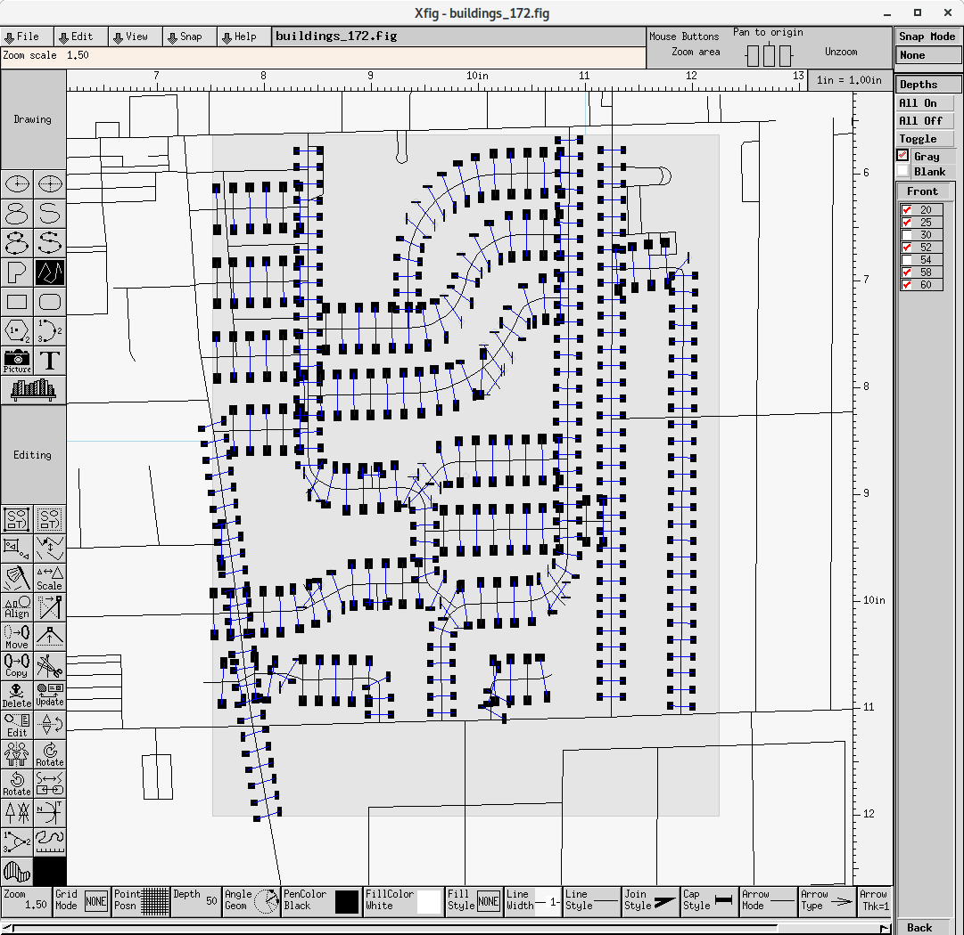
Area in OSM where there is no data for homes in this region. | View of homes automatically generated on “residential” ways in the region.

Nearby roads

Added a feature to include nearby roads when computing the entrance intersection to buildings. This is important to correctly handle some of the edge cases as illustrated in the two figures below:
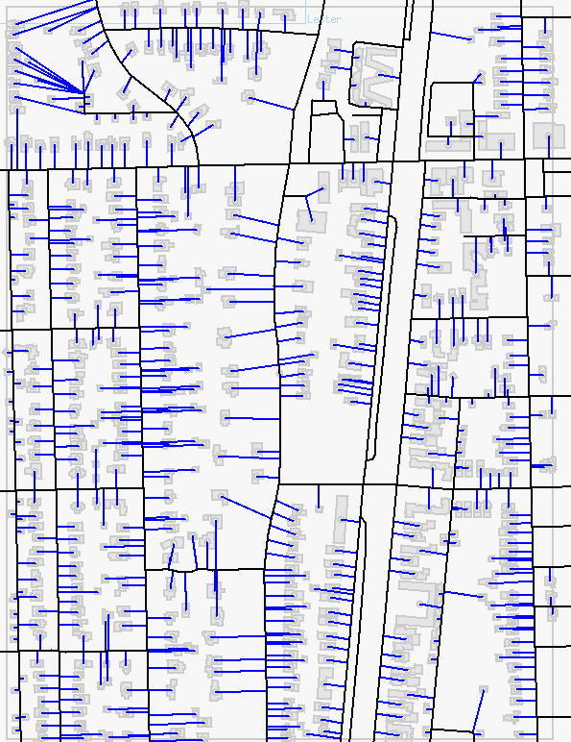 | 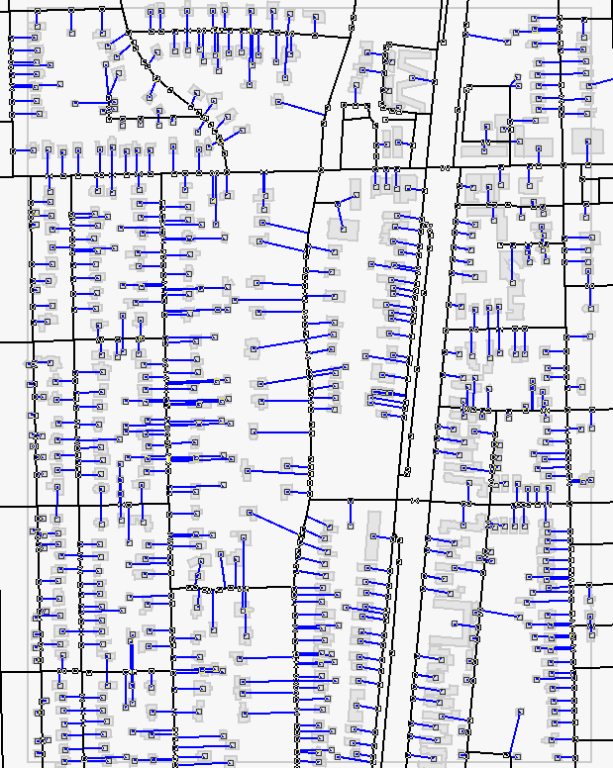
Population index number 875 without nearby roads. Notice the long intersections at the top-left corner that are not correct. | Population index number 875 with nearby roads. Notice that the intersections at the top-left corner are now correct.

In OSM many of the ways do not have a speed limit specified. Consequently, we have estimated the speed limit for the different types of roads as tabulated below:

$ tail -n +7045603 ../Chicago.osm | grep 'k="highway"' | cut -d'"' -f4 | sort | uniq -c | tr -s " " | sort -nr

Count | Way type | Speed limit
82173 | service | 25
30464 | Residential | 25
15524 | Footway | 0
10136 | Primary | 65
9788 | Secondary | 55
2831 | Path | 0
2704 | Tertiary | 35
1466 | motorway_link | 45
1409 | motorway | 65
1131 | Track | 0
960 | cycleway | 0
698 | steps | 0
563 | Pedestrian | 0
555 | Unclassified | 15
395 | trunk | 55
377 | primary_link | 45
186 | trunk_link | 45
142 | secondary_link | 25
64 | Proposed | 0
55 | construction | 0
36 | tertiary_link | 25
11 | living_street | 0
10 | busy_stop | 0
8 | Elevator | 0
8 | crossing | 0
6 | Bridleway | 0
2 | Services | 0
1 | Platform | 0
1 | Abandoned | 0

Accounting for unclassified ways
The OSM data currently has streets tagged as -- <tag k="highway" v="unclassified"/>. These unclassified ways are still meaningful. Currently we assume that the speed limit on these streets is 15 miles an hour. Without these unclassified ways some buildings will be unreachable as shown in the two maps below:

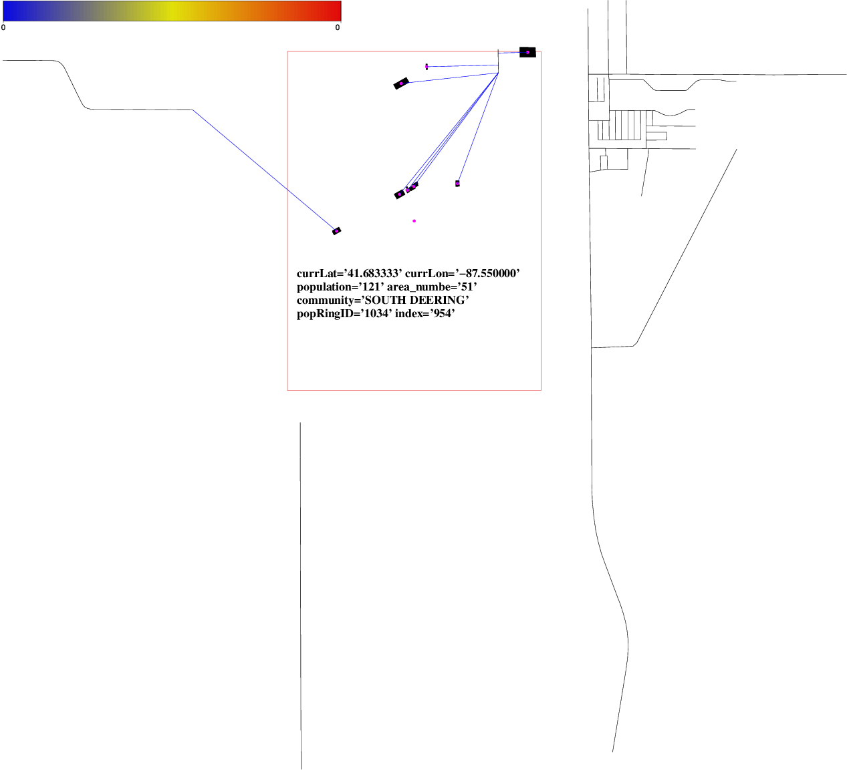 | 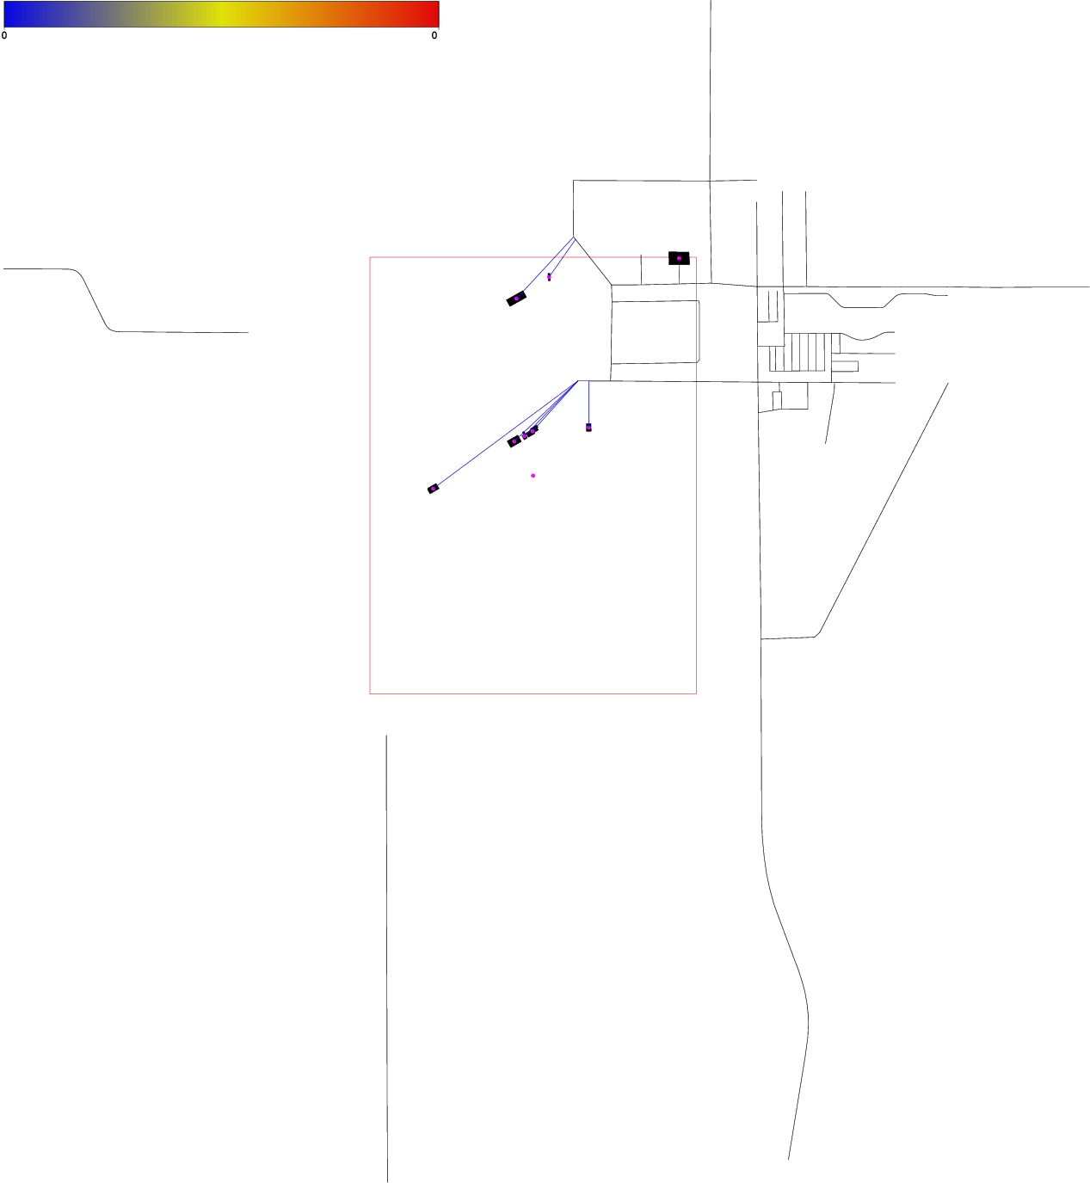
Missing East 117th Street because of which South Mackinaw Avenue, becomes disconnected. | With unclassified ways added, note the few extra ways that showed up enabling interconnection between the streets

Loop handling when computing routes
One of the sources of the errors that was observed during route computation was the presence of loops in paths as shown in the figure below. In these cases, the same node is repeated more than once in the list of vertices in a given path. The path finding algorithm would ignore the repeated node (as it would be marked as having already been explored). For example, at 6900 South Crandon Avenue, there is a service lane (way id: 577109133) with a loop (shown in red in figure below). Consequently, buildings 6900 and 6920 that have entrance on this service lane would not be able to find a path to other buildings.

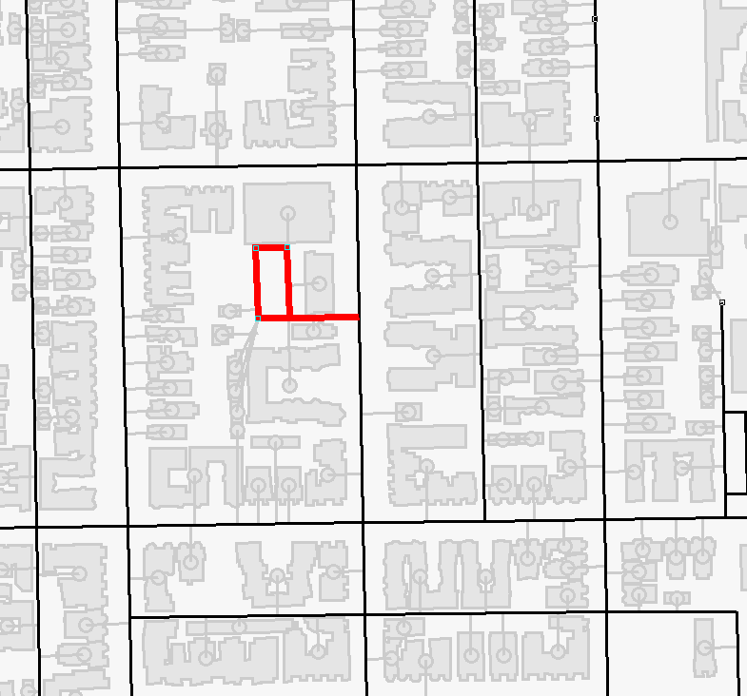 | 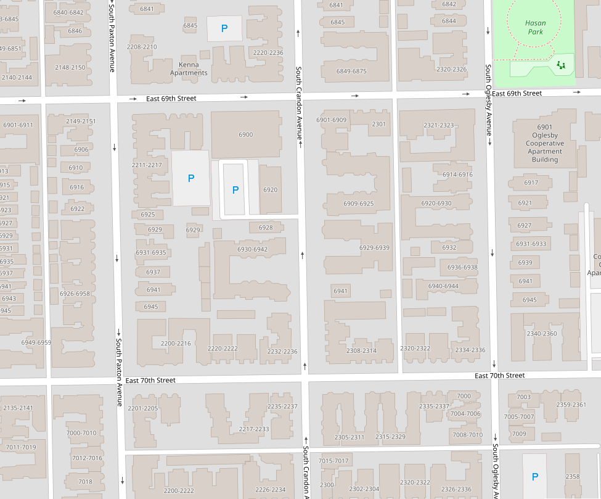
Loop construct in generated model | Corresponding Open Street Map view of the loop around a parking lot

This issue has addressed in the following manner – First, during model generation ways that have loops in them (i.e., ways have the same node repeated) are identified and tagged. Currently, in the Chicago model there are 800 loops. Second, during route computation, as nodes are explored, nodes on ways with loops are checked for repetition and adjacent nodes are handled appropriately.

Disconnected ways
Currently, the model has about 48 disconnected ways (out of 69503 ways or 0.07%) – i.e., ways that are not connected to any other ways and consequently buildings on these ways are not reachable. The reason for disconnected ways is two fold:
- Disconnected ways in data: The OSM data includes disconnected ways associated with service lanes in parking lots around buildings or railroad ways.
- Edge case cutoffs: Currently, the model only includes ways that fall within the boundaries of the Chicago metropolitan region (see boundary image at https://data.cityofchicago.org/Facilities-Geographic-Boundaries/Boundaries-Community-Areas-current-/cauq-8yn6). Therefore, if a way starts within the boundary but its connection lies outside the boundary then the way would be cutoff and not reachable.

Routing optimization
In order to improve performance of finding routes a rectangular area is used to limit the number of nodes that are explored. These experiments were run using the following command-line (on an Intel(R) Core(TM) i7-3770K CPU @ 3.50GHz machine). The data was collected using the following command:

$ time ../../pathfinder --model chicago_model.txt --best-time search-dist 0.5 –search-scale 0.1 --rnd-test 50000 --rnd-start 100000 > rnd_path_test_100k.txt

Min dist, scale | Not found | Time | Retry
-1, -1 | 14 of 50,000 | 109m58.591s | 0
2, 0.25 | 14 of 50,000 | 81m52.868s | 0
1, 0.1 | 14 of 50,000 | 32m29.118s | 801
0.5, 0.1 | 14 of 50,000 | 25m55.530s | 1391
0.25, 0 | 14 of 50,000 | 87m51.147s | 31593
0.25, 0.25 | 14 of 50,000 | 48m4.366s | 380
0.25, 0.1 | 14 of 50,000 | 24m19.072s | 2037

The experimental data shows that for fast path computation the following approach works best --

- Set the minimum search distance to 0.25 and the search scale to 0.1 – i.e., 0.1 miles is added for each mile between the source and destination. The tight search bounds makes overall path computation fast as it limits the number of nodes to be checked.
- This setting results in about 4% of the cases falling outside the about tight bound on search. In these 4% of cases, a second search without bounds is required. The second search increases the search time.

However, on an average the combination works best to provide a fast time for computing routes between pairs of buildings. The distribution of times for path computation is summarized in the Violin plot below (generated using R version 3.1.2). The total runtime for this test was 23m23.115s. The data involved computing path between 50,000 pairs of buildings. Out of the 50,000 pairs, 1960 pairs (~3.92%) required retrying and 6 pairs failed (i.e., route could not be computed). The average path computing time was 30.51 milliseconds. The standard deviation was 37.35 ms. The time taken to compute pathways is directly proportional to the number of nodes in the pathway. The histogram below shows the distribution of the number of nodes in the pathways. The average path length was 389 nodes. Note that the distribution of times illustrated in the Violin plot is consistent with the distribution of path sizes shown in the histogram.

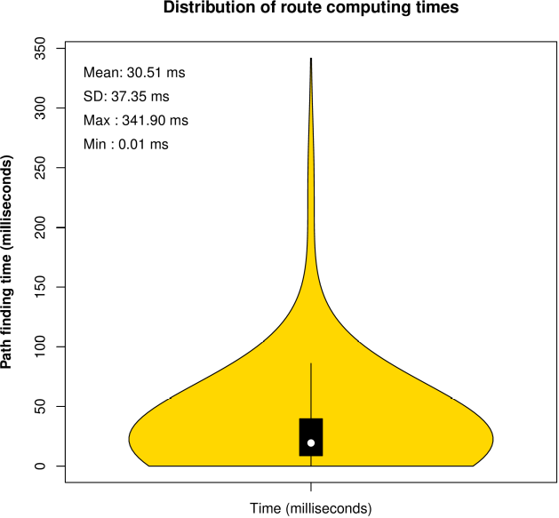 | 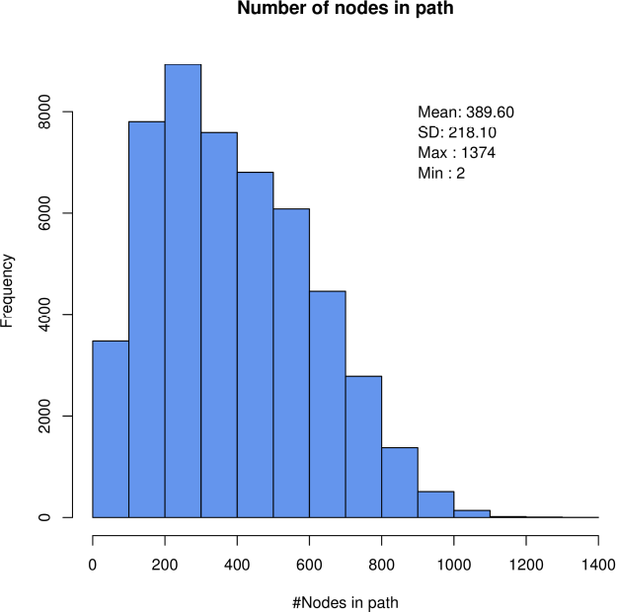
Distribution of time (in milliseconds) to compute paths | Distribution of number of nodes in paths computed

Example routing testing

Path from 6900 South Crandon Avenue (building id: 211318368) to 6016 N Landers Ave, Chicago, IL 60646 (building id: 162836650) best time routing (estimated travel time about 23 minutes):

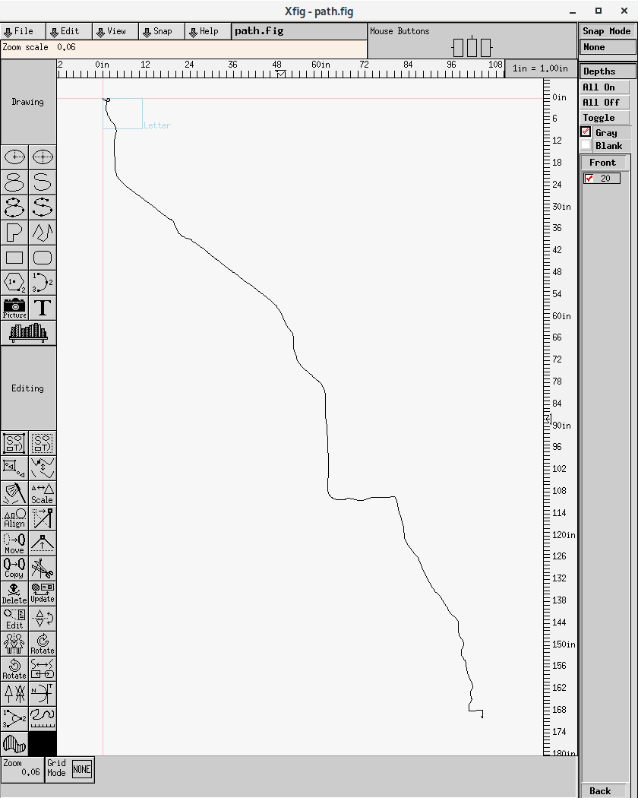 | 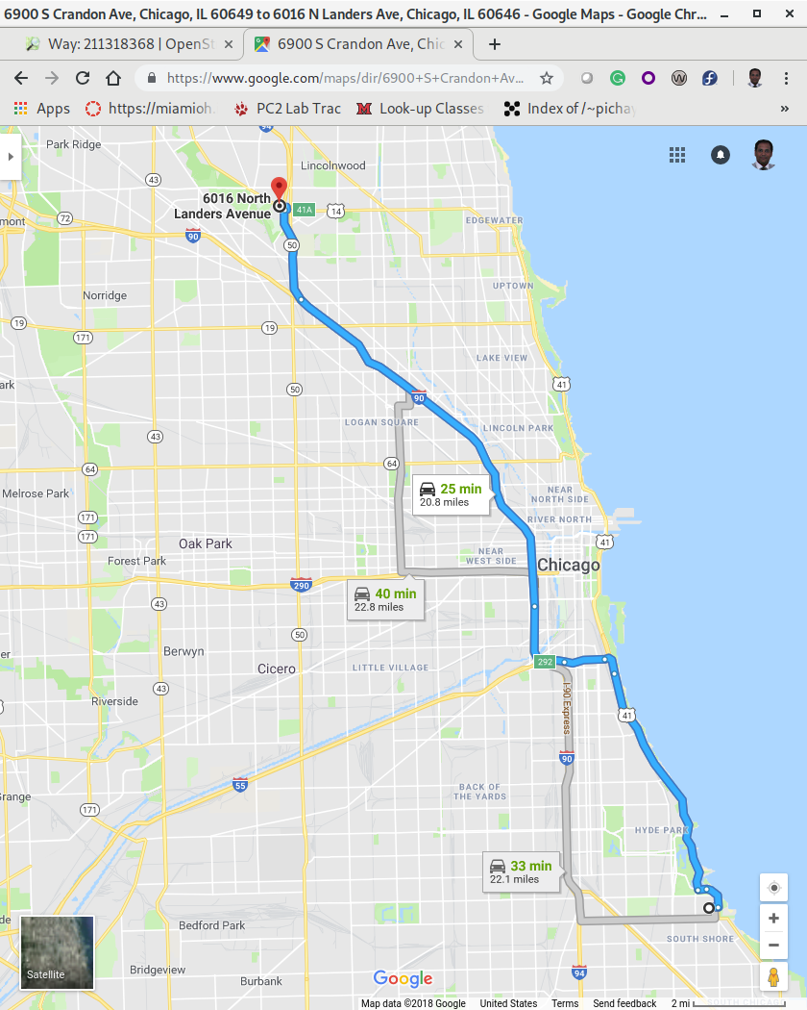
Route generated by custom Path finder (with estimated time of about 23 minutes) | Route generated by Google maps (with estimated time of about 25 minutes)

