MUSE
A parallel Agent-based Simulation Environment

Meseret Gebre
Advisor: Dr. Rao

0. Abstract

The use of agent-based modeling and simulation-based analysis is rapidly gaining importance in many areas. Realizing the advantages of simulation-based methodologies requires the use of a software environment that is conducive for modeling, simulation, and analysis. Furthermore, parallel simulation methods must be employed to reduce the time for simulation, particularly for
large problems, to enable analysis in reasonable timeframes. Unfortunately, effective and efficient parallel, agent-based simulation software is not available as of this proposal. Accordingly, this thesis proposes to develop a general purpose agent-based, parallel simulation environment called MUSE (Miami University Simulation Environment). MUSE, provides an Application Program Interface (API) for agent-based modeling and a framework for parallel simulation. The research proposes to develop the API in C++ using its object oriented features. The core parallel simulation capabilities of MUSE will be realized using the Time Warp synchronization methodology and the Message Passing Interface (MPI). We envision MUSE to be a scalable and efficient simulation environment for a broad spectrum of models. Accordingly, the research proposes to explore the qualitative advantages of MUSE by using several well-defined criteria. In addition, the proposed investigations include empirical analysis to quantitatively assess the efficiency and scalability of MUSE using suitable benchmark applications.

1. Introduction
Agent-based models have been used since the mid-1990s to solve a variety of business, technology, and medical problems [2]. The following are example of such applications:
- Supply chain optimization
- The spread of epidemics
- Threat of bio-warfare
- Modeling of consumer behavior
- Social network effects
- Workforce management

The examples above are important topics and the amount of time required to reach valuable solutions can make the difference between success and failure or even life and death. There are five main Agent-based simulation frameworks that are in use. NetLogo, MASON, Repast, Swarm (Objective-C), and Swarm (Java). None of these frameworks utilize parallelism and most with the exception of Swarm (Objective-C) and NetLogo are written in Java. NetLogo uses its own language that is at a very high-level and is menu driven, which several researchers believe to be very restrictive.
From literature surveys [2], the following key issues with agent-based modeling and simulation software were identified:

- Platform complexity is a major concern.
  - Very large API can be intimidating to users.
- Is Java the right language?
  - Syntax and object typing.
- Error checking and garbage collection
  - Error must be easy to identify and troubleshoot.
  - Memory management is going to be a tough concept to beginners (coders). Need a way to minimize memory leaks from within the MUSE kernel.
- Availability of development tools
  - List the types of development tools you are referring to (editor, compiler, linker, debugger, etc.)
  - Many tools are readily available for Java. This may be a battle that cannot be won. However it can be minimized, C++ is also has many development tools.

We propose developing a new framework that will be written in C++. MUSE (Miami University Simulation Environment) will be a parallel agent-based simulation framework and as of the writing of this proposal, is the first of its kind. MUSE’s main advantage will be its speedup, which will be derived from the use of parallelism. We will use the recommendations from Railsback et. al [1] to help shape the API of this framework. The frameworks mentioned above were all ranked based on well-defined criteria. These include:
- Complete documentation of classes and methods, with examples.
- Follow standard terminology to ease effective use of API for modeling.
  - Most users developing simulations are novices and have little knowledge of programming.
- Provide tools for generating statistical output.
- Provide tools for setting up and executing simulation experiments.

In concordance with these criteria, we propose to develop MUSE and use the aforementioned criteria to measure its qualitative characteristics. In addition, we propose to develop empirical tests to quantitatively assess the parallel simulation characteristics such as: speedup, scalability, and efficiency. Section 2 presents some of the closely related works. The section also describes other frameworks that have been used to motivate the design of MUSE. Section 3 gives a brief introduction to MPI and discusses the motivation for its use to develop MUSE. Section 4 elaborates on the reasons behind the programming language of choice for implementing MUSE. Section 5 gives a brief introduction to different synchronization methods for parallel simulation and presents the rationale for using Time Warp. Section 6 will describe the steps taken to insure proper quality and quantitative results are obtained when evaluating MUSE. Section 7 describes the initial design of MUSE. Section 8 concludes the proposal and discusses future tasks.

2. Related Works
This section will present popular agent based frameworks and some parallel simulation frameworks. As a part of our initial investigations we have already tried to use these past frameworks. In addition, we are also using the experiences and observations to drive the design and implementation of the proposed simulation environment.

2.1 Non-parallel Agent based frameworks
Railsback et. al present a detailed survey of several agent-based simulation frameworks that are similar to MUSE. The frameworks under review were NetLogo, SWARM Objective-C, SWARM Java, Repast, and MASON. Each framework had advantages and disadvantages. NetLogo’s strong points include its detailed documentation and ease of use. However, it uses proprietary code, and users have to learn a custom language for modeling [2]. The original SWARM uses the Objective-C language. This is the most mature and stable framework, which makes it well organized [2]. While Objective-C is more natural to model with [2], it has weak error-handling. Another downside is the availability of tools for developing with Objective-C. Java SWARM is simply a wrapper that allows Java developers to call Objective-C SWARM libraries. While Java has strong error-handling capabilities, the framework does not effectively take advantage of the two languages [2]. Moreover, both versions of SWARM, proved to be the slowest for very complex models [2].

Repast was meant to mimic SWARM using Java, but the design and organization of the framework has several drawbacks [2]. Furthermore, the learning curve for using the API is very steep, because it has numerous features, often making it overwhelming for most casual developers [2]. MASON is a light weight framework that aims to achieve high execution speeds [2]. It is also the most recent of all the frameworks and in terms of execution speed; it was indeed the fastest amongst those surveyed by Railsback et. al[2].

2.2 Parallel simulation frameworks
In conjunction with our initial investigations, we also reviewed three parallel simulation frameworks namely WRAPED [3], GTW [5], and Parsec [4]. It must be noted that these are general purpose discrete event, parallel simulation frameworks and not necessarily agent-based simulation environments. The strong point of WARPED was that, it is freely available and open-sourced [3]. Another important similarity to MUSE is that it uses the Time Warp synchronization method. It also uses MPI as its message passing protocol and C++ as the language. However, several issues posed serious hurdles for effective use of the framework. The most important one is the lack of documentation. Furthermore, the simulator has not been actively maintained and therefore several issues prevented even compiling the core framework using recent compilers. Since WARPED development started in 1998, it clearly went through several upgrades in features, but the changes were not documented clearly. GTW also uses Time Warp, and similar to WARPED, it lacks documentation and has not been actively maintained. Furthermore, GTW was primarily developed for shared memory architectures while today’s supercomputing clusters primarily used distributed memory architectures. However, GTW includes several beneficial design solutions. One of the important design solutions that will be used in MUSE is controlling optimism during simulation. Controlling optimism is necessary because, Time Warp has a tendency to be too optimistic, this could lead to cascading rollbacks. GTW avoids cascading rollbacks by using time windows that throttle optimism [5]. Another attractive feature is the local message sends, meaning if a message is meant for the local LP it is simply enqueued directly to its input queue.

Parsec is most the complicated parallel framework from the group. Strong points of Parsec include its visual environment. Developers modeled via a GUI [4]. Parsec implements many conservative synchronization methods and many communication libraries [4]. However, conservative synchronization requires the modeler to be cognizant about look ahead in simulation-time during model development. Look ahead is necessary to avoid deadlocks that potentially occur during simulation. However, look ahead can be complex to extract when developing models and small look ahead negatively impacts simulation performance.

On the other hand, Time Warp does not rely on look ahead making it easier for the model developer. However, Time Warp uses state saving and rollback to recover from causal violations; thereby requiring additional memory and CPU time for rollback processing. In other words, in conservatively synchronization simulations time is spent waiting for other parallel processes to coordinate while in Time Warp time is spent recovering from rollbacks. However, several Time Warp optimizations are available to minimize rollbacks and these optimizations can be implemented without impacting the API or placing overhead on the modeler. Consequently, we chose to use Time Warp as the synchronization protocol for MUSE.

3. Message Passing Interface
The message passing programming paradigm is the most well known and widely used approaches for programming parallel computers [23]. One of the main reasons it spread fast is because it imposes minimal requirements on the underlying hardware [23]. In the early stages, many hardware developers have implemented custom MPI-compliant libraries that performed efficiently for their own hardware. This required developers to know many different libraries of programming with the message passing paradigm. The Message Passing Interface (MPI) was developed to solve this issue of too many different implementations.

MUSE will be using MPI version 2.0 for the message passing requirements. We decided to adopt MPI because it is well documented and widely used. Moreover, MPI handles hardware-specific details on passing messages between interconnected compute nodes. Lastly, since MUSE will primarily operate on Linux based distributed machines; it would be a benefit to use MPI, because it is supported by most supercomputers.

4. Language of Choice (C++)
There are many variables to consider when developing a simulation environment. One design decision to be made was the language in which we choose to implement. All simulation frameworks or libraries that we have seen have used some of the more well known languages for implementation. The three languages include C++, Java, and Objective-C. We eliminated Objective-C as a candidate due to the following two reasons. The main reason is the development tools are scarce. The only development tools that are easily accessible are provided via Apple’s xcode, which requires an Apple machine. This differs dramatically from C++ and Java, which both have many freely available tools to choose from. Although, Objective-C is more natural to code with, it also lacks for the ability to catch errors easily. Ultimately, semantic gap does not make a difference if you do not have users to realize the improvements; this is why Objective-C is not a reliable solution.

In order to identify between Java and C++, we empirically explored the semantic gap between C++ and Java, both in terms of computation and communication. Note that these two aspects are crucial for realizing effective performance improvements in distributed memory super computer architectures. A discussion on the semantic gap between the languages is presented in the following subsection.

4.1 Semantic Gap
In distributed computing, the logical distance from the hardware that your code executes onto the high-level semantics you use to code in the given language is called the semantic gap. In other words, the smaller the semantic gap, the more the developer must worry about hardware details, which could slow down development time. On the bright side, it could allow developers to realize great increase in speed by taking advantage of hardware design. Thus, semantic gap is needed because it increases development time, but a good balance will allow significant performance increase. C++ has an excellent balance because it has been designed with the hardware in mind. Fortunately, it is able convert high-level code to assembly efficiently. Also more importantly, C++ allows the use of registers; this allows all microprocessors to optimize execution speed using registers. Java on the other hand uses a stack based Java Virtual Machine (JVM). This means no registers can be used. The cost of this is portability. When Java compiles code, it is first converted to Java byte code, and then runs on the JVM. There are many systems that can effectively run without the need for optimization, but a parallel simulation environment is not one of them. There are two types of semantic gaps, the first being computational gap, and the second being communicational gap.

Computation gap was already discussed above, but communication gap refers to the steps that must be taken to convert the high-level communication to the hardware level. Java relies heavily on stream I/O. These streams are mapped to the hardware. The high-level abstraction again allows developers to code with greater speed, but the overhead for managing the streams can be very expensive in the long run. C++ allows developers to send different size of data, this increases speed because the underlying hardware may transmit data as packets, via C++ you can send data packet at a time. For Java it is fixed as bytes, you can easily see the overhead for handling the conversion of bytes to packets. Figure 1 exposes the difference in computational gap differences between C and Java. Keep in mind that the results are for C, but we can conclude with confidence the result would be similar with C++.
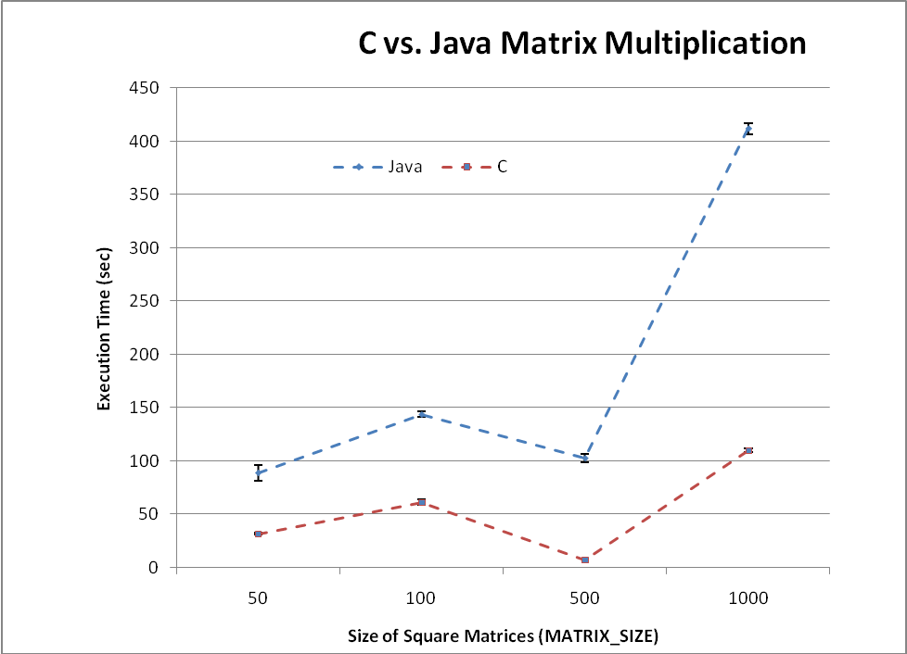
Figure 1 : computation speed test

From figure 1, we can see that Java takes far longer to execute, thus it is safe to say C++ is the better choice when we implement MUSE.

5. Synchronization Methods
For all parallel simulation environments the parallel processes must be coordinated in order to ensure that events are processed in their correct causal order. These techniques are called synchronization strategies. Synchronization strategies can be broadly classified into two distinct categories, namely: synchronous and asynchronous strategies.

5.1 Synchronous method
Synchronous strategies were the first method that were developed and were inherently developed for single node. The main idea is that all processes must synchronize at each time step [20]. However, such approaches are not effective for realizing horizontal scalability. When having to synchronize at each time step when working parallel simulation, the overhead of the synchronization time increase as the number of nodes increase. Realizing this being a serious issue, asynchronous methods were introduced. Another reason for introducing asynchronous methods was to eliminate the need for global queue storage of events [20].

5.2 Asynchronous method
Asynchronous methods can further be classified into two types, conservative and optimistic.
The most known and accepted conservative method is the CMB algorithm [21, 22]. It was developed by Bryant [22], Chandy [21], and Misra [21] independently. In this method each process keeps its own simulation clock. The clocks advance separately. Each process can advance its clock only if it is guaranteed that no event will arrive with a timestamp less than its clock value [20]. If a parallel process needs to process an event with a timestamp greater than the global clock, then that process will perform a block operation. This operation not only accumulates the overhead of waiting to unblock as the number of processors increase, but it can also lead to a deadlock situation during simulation [20].

In optimistic methods, processes have their own clocks and each process’s clock is advanced whether or not they are guaranteed to be correct. If a future event arrives with a timestamp less than the current clock, some recovery mechanism is used to restore the simulation to a consistent state [20]. Time Warp is a famous optimistic method that was invented by Jefferson [9]. The overhead of the waiting time in the conservative methods is traded for the extra work done due to processing erroneous events and the rollbacks in time warp [20]. Fortunately, Time Warp is not susceptible to deadlocks. This turns out to be a very good incentive for choosing Time Warp over a conservative method like CMB. Although it is known that conservative and optimistic methods sometime outperform one another [20]. For large parallel environments, deadlocks are situations that can quickly get out of hand. Lastly, Time Warp has been heavily studied and every aspect has been dissected and ways to improve Time Warp is readily available [9, 10, 11, 12, and 14]. For MUSE, we have decided to use Time Warp. We’ll further look at the Time Warp protocol in detail next.

5.2.1 Time Warp

Time Warp is optimistic; hence events are processed as and when they are available. In Time Warp, a simulation is organized as a collection of communicating Logical Processes. Communication between logical processes is performed by exchanging virtual time stamped messages or events. Figure 2 presents a conceptual view of a Time Warp Logical Processes (LP). As shown in the figure, each LP has an input queue, output queue, and a state queue. A LP advances its Local Virtual Time (LVT) by processing events from its input queue, updating its state, and generating new events. The three queues are used to recover from causal violations that are detected when a LP receives a straggler event. Straggler events have timestamps that are lower than the LVT of a given LP. Events in the queues are never fully committed, until it is safe, this means that each LP knows it will never get a straggler event. If the case arises where a straggler event arrives, then a rollback mechanism is used to restore to a consistent state. To perform a rollback the following three steps must take place [9, 10].
    - Using the state queue, restore the state of the LP to a state earlier than the time stamp of the straggler event. Then set the LP’s LVT to that of the restored state.
    - For every message that the LP has dispatched to other LPs are cancelled by sending an anti-message, which are typically stored in the output queue. These anti-messages undo all events that have been sent from the LP that is rolling back.
    - Finally, the straggler message is reprocessed in the correct timestamp order.
The aforementioned three steps will insure that the LP is synchronized with other LPs. The Global Virtual Time (GVT) algorithm is used to garbage collect unneeded information from the three queues [9].
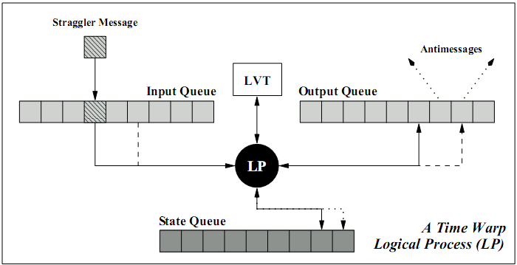
Figure 2: A logical process in a time warp simulation [3]

In MUSE an Agent corresponds to the concept of a LP. In terms of parallel simulation, each node will have a muse::Simulation singleton. The simulation contains a collection of Agents that are coordinated via a simulation kernel. One of the issues with Time Warp [9], is the high use of memory, here is why this problem occurs. The agent is always receiving events. The agent simply processes events and stores the result in the output queue; however, the agent does not really know if it is safe to commit. The only way to know if it is safe to commit is to update the global GVT. Once it has be updated, each agent knows that all states in the state queue and all date in the output queue that have a time stamp less than the global GVT can be deleted. If the global GVT is not updated frequently enough, then the state and output queue begin to grow very fast. Hence, the memory issue. A simple solution to this problem is to throttle the optimism. More details can be obtained about Time Warp from the literature [9, 10].

6. Quality and Empirical testing procedures
Early in this proposal we described some of the qualities that we plan to implement in MUSE during the development phase. The well-defined criteria were:
- Complete documentation of classes and methods, with examples.
- Follow standard terminology to ease effective use of API for modeling.
  - Most users developing simulations are novices and have little knowledge of programming.
- Provide tools for generating statistical output.
- Provide tools for setting up and executing simulation experiments.
For this thesis we plan on insuring proper implementation on issues one and two. Three and Four will be extra requirements for future development. However, design decisions will be made with all issues in mind, which will make future implementation a less challenging task. Quality design will insure MUSE is easy to use and maintainable for future developers working to enhance or use MUSE.

MUSE will also undergo proper empirical testing. Since development with MUSE will be geared towards high performance distributed machines, we can use standardized metrics [23], which include:
- Raw execution time
- Speedup
- Total Parallel Overhead

6.1 Raw execution Time
This is the most commonly used metric for comparing performance improvements [23]. First step is to capture the wall runtime of the fastest non-parallel agent-based simulation framework, for our case MASON [2]. The serial runtime can be denoted by Ts [23]. Second step is to capture the wall runtime of MUSE, this is denoted by Tp.

6.2 Speedup
Once you know that the raw execution time of going parallel is better than the serial counterpart, then you should figure out just how much you speed is improved. Speedup, denoted by S, is defined as the ratio between the raw execution time of the serial program to the raw execution time of the parallel program.

S = Ts/Tp

6.3 Total Parallel Overhead
Due to the nature of parallel algorithms, they always have that extra overhead. Overhead are usually from idling, inter-process interaction, and excess computation [23]. We can a measure on these overheads, by calculating the total parallel overhead, which is denoted by To [23]. The formula for this is as follows:

To = pTp – Ts, p is the number of processes.

The idea behind this is to compare the fastest serial algorithm, and by taking that algorithm and implement as a parallel program, then To will give you the difference between the two version and that should be the total overhead of going parallel. Realistically, for large input, the overhead should be amortized over the duration of the simulation [23].

7. MUSE Design Overview
Since MUSE is being developed from the ground up, it is important to set requirements that make it more reliable and easy to maintain. Placing high priority on criteria from [2], we made sure to use well-known concepts when we created terminology for the framework. In addition, the design objective was to ensure the API is relatively easy to use with a good balance of features to usability, where the user does not feel over whelmed by the steep learning curve. Another important aspect is the level of documentation. Some of the frameworks we discussed in the related works section did a great job at this, NetLogo [2] for example. In terms of performance, MUSE also has to excel. MUSE is being developed as a tool to help harness high performance distributed computing (HPDC), therefore it is natural that is should be efficient internally in order to be a good starting base. Although MUSE design is subject to change, the remaining of this section will describe MUSE in more detail.

7.1 MUSE base classes
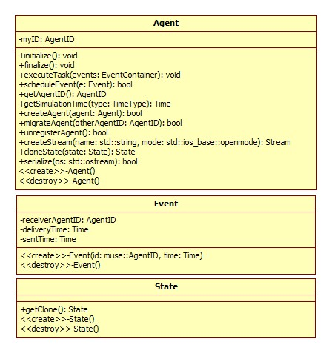
Figure 3: base classes
Using MUSE to develop models and run simulations will require the modeler to first define various agents. For each agent, the modeler must also define a state; this is just information that can be altered by the agent due to event processing. MUSE provides these basic concepts via the provided base classes shown in figure 3. Once the Agent class is extended, the developer must override three methods, the initialize, finalize, and the executeTask. Agents should use the initialize method to setup any information before the simulation starts. The finalize method is used for any clean up the agent should perform after the simulation ends. If an agent has one or more events to process during a time step, then the executeTask method is called with the list of events that is should process as input. Event class requires no override of methods, but any data that the agent will need to modify its state should be stored here. The State class should be extended and developers must override the getClone method. Since Time Warp requires states of agents be archived until they can be safely processed and removed, MUSE needs a way to create a copy of the agent’s state. In addition, any data that can be altered by processing events must be stored in the State class. The remaining classes are for starting the simulations and data types that help MUSE function.

7.2 MUSE time concepts

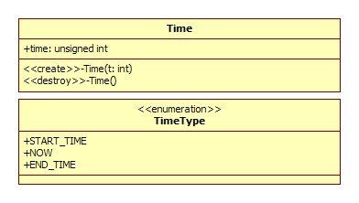
Figure 4: MUSE time concepts

MUSE needs a way to represent virtual time in order for the Time Warp synchronization to operate correctly. The Time class is used to represent this virtual time described earlier in the paper. Currently, time just would return and integer value, but we are experimenting with templates, and perhaps allowing developers to represent time in their own way, but more testing is required and for now we’ll leave it as an integer. The TimeType is an enumeration type. When you ask the simulation kernel for the time, you can pass in one of the enumeration type. The default being the NOW will return the current time. Similarly, START_TIME returns when you started the simulations and END_TIME returns when the simulation should end. If an end time is not specified, then a representation for practical infinity will be returned.

7.3 MUSE Simulation class
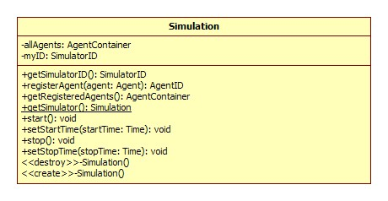
Figure 5: Simulation class <Singleton>

The Simulation class is the heart of MUSE. If you think of the simulation running in a distributed fashion, then every node will have at most one Simulation class. The process of using the Simulation class is straight forward. In addition to the following short description, there will be an example later in this section. In order to use the functionality of the Simulation class, the getSimulator() method must be used to obtain a reference to the singleton instance. Once you have the agents defined you must register all agents with the simulation instance. The registration action indicates where the agent will execute. After agents are registered, simply set the start and end time and execute the start method.

7.4 MUSE Scheduler class
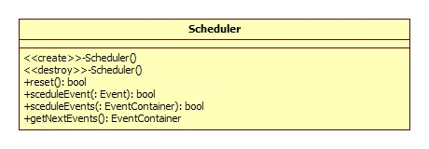
Figure 6: Scheduler Class

The Scheduler class handles the task of properly scheduling events. It will essentially be a wrapper for some underlying heap implementation. When the agent calls to schedule an event, the underlying code is actually calling the scheduleEvent method.

7.5 MUSE Communicator class
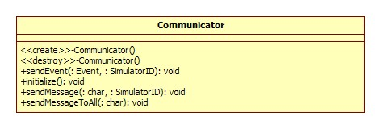
Figure 7: Communicator Class

MUSE is being developed as a tool that can scale. The Communicator class is an example of this idea. The underlying protocols used to send events or message across the network is encapsulated. Currently however we are using MPI, but if in the future a chance arise where there is something better the MPI, then easily switching out the underlying process should not affect past simulations that have been developed via MUSE. Similarly, if for some reason one would like to implement Socket based communication, maybe because the overhead of MPI is simply not outweigh the performance gain, then simple implementing socket based Communicator class is available.

7.5 MUSE data types
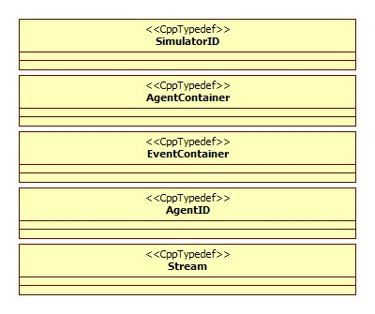
Figure 8: MUSE data types

In order to minimize ambiguities while using the MUSE API, we believe it is best to specify custom data types for MUSE users. We believe introducing an extra layer and defining them as data types can serve two fold. First, developers input are clear and unambiguous. This serves as an attempt to gain some of the advantages from using Objective-C and Swarm [2]. Secondly, the underlying implementation can change with future releases, but that will not affect previous development. Hence we get a more stable framework that is consistent.

The SimulatorID is used to represent globally unique id of each simulation instance. In the current implementation, the id will simply be the MPI rank. Also globally unique is the AgentID data type. We are still discussing good alternatives for assigning this, but currently we plan to have the developer be responsible for the assignment. This puts another burden on the developers, which means a possible point of failure for the framework. The simulation instance will have a list of agents that are registered to it. The AgentContainer is used to store agents in a list format.

The EventContainer is used to store events in a list format. In every simulation, developers need ways to I/O. The Stream type is used for this purpose. In the future, this will most likely be a dignified class, but for now we have it as a type def.

7.5 MUSE clock example
The following example is an early example developed to test how well the concepts come together in actual code. The extremely simple example that simulates a clock and all it does is print out a notice every hour that passes. An hour in terms of virtual time could be anything, some user defined value. The purpose of this example is to show basic usage of MUSE.

Let’s start by first defining our base classes. We only define the ClockAgent class. We do not need to store anything for state information. Also if we receive an event we can assume that an hour of virtual time has elapsed.
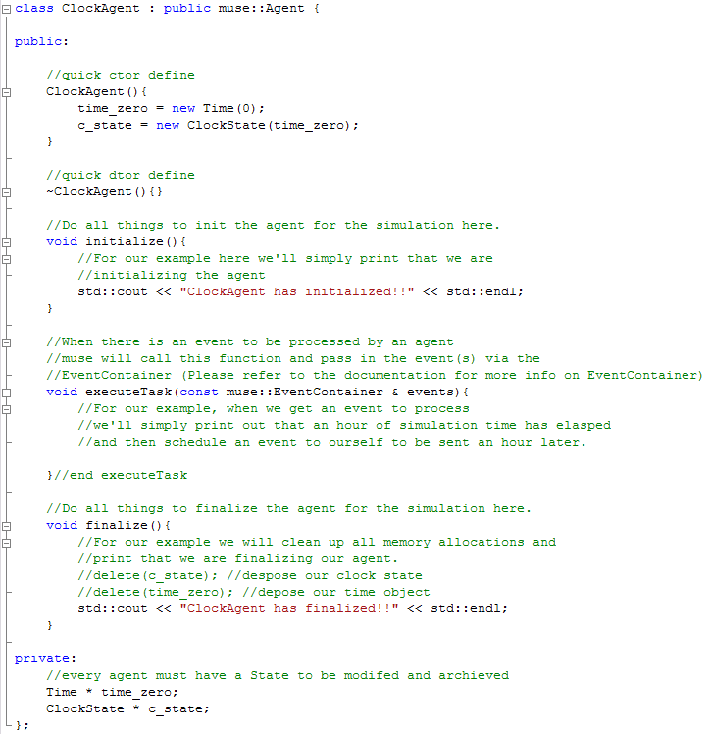

Now that we have our base classes established, the next step is to register our agent. This will look like the following code.
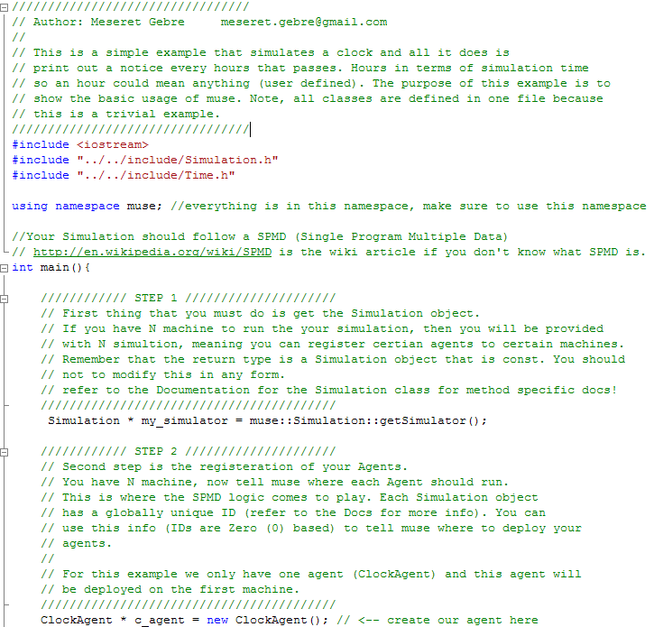
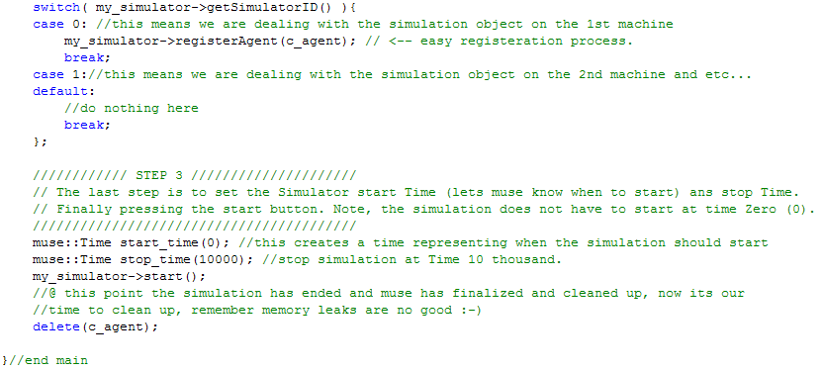

The example demonstrates the simplicity of using MUSE. We believe the initial design effectively meets the design requirements. Any changes will be reflected in the final report.

8. Research plan
We believe the agile development methodology would work best in implementing MUSE. Constant unit testing and refactoring should make the daunting task of thinking in parallel much easier. Different iterations of MUSE will add new pieces to the puzzle. The successful completion of this project will require hard work. The following is my estimated time line of events and milestones to aim for.

Milestone | Dead Line Date
Have design of MUSE and approved for implementation with Dr. Rao | 11/03/2008
Iteration 1 – implementation of base code {Time, and State} and develop unit test for testing. | 11/10/2008
Iteration 2 – implementation of base code {Agent, and Event} and develop unit test for testing. | 12/01/2008
Iteration 3 – implementation of {Simulation} class and develop unit test for testing. | 01/15/2009
Beta version of MUSE should be read for testing and further refinement at this point | 02/01/2009
MUSE should be completely implemented and should be verified with a code review by Dr. Rao and interested committee members. | 02/23/2009
Complete quality and empirical testing of MUSE against other frameworks. | 03/20/2009
Complete Thesis write-up. | 04/01/2009
Thesis defense | 04/10/2009

References

[1] Railsback, S. F., Lytinen, S. L., Jackson, S. K., Sep. 2006. "Agent-based simulation platforms: Review and development recommendations" Simulation (A journal from The Society for Modeling and Simulation International) Volume 82 (Number: 9), pages: 609--623.

[2] http://en.wikipedia.org/wiki/Agent_based_modeling

[3] Radhakrishnan, R., Martin, D. E., Chetlur, M., Rao, D. M., and Wilsey, P. A. 1998. An Object-Oriented Time Warp Simulation Kernel. In Proceedings of the Second international Symposium on Computing in Object-Oriented Parallel Environments (December 08 - 11, 1998). D. Caromel, R. R. Oldehoeft, and M. Tholburn, Eds. Lecture Notes In Computer Science, vol. 1505. Springer-Verlag, London, 13-23.

[4] R. Bagrodia, R. Meyerr, et al., "PARSEC: A Parallel Simulation Environment for Complex System", UCLA technical report, 1997.

[5] D. Das, R. Fujimoto, K. Panesar, D. Allison, and M. Hybinette, “GTW: A Time Warp system for shared memory multiprocessors”. In Proceedings of the 26th Winter Simulation Conference, pages 1332–1339. 1994.

[6] Cleary, J. G. and Tsai, J. 1996. Conservative parallel simulation of ATM networks. SIGSIM Simul. Dig. 26, 1 (Jul. 1996), 30-38. DOI= http://doi.acm.org/10.1145/238793.238807

[7] Hassan Rajaei , Rassul Ayani , Lars-Erik Thorelli, The local Time Warp approach to parallel simulation, Proceedings of the seventh workshop on Parallel and distributed simulation, p.119-126, May 16-19, 1993, San Diego, California, United States

[8] MPI-2: Extensions to the Message-Passing Interface, October 18, 2008, http://www.mpi-forum.org/docs/mpi-20-html/mpi2-report.html

[9] JEFFERSON, D. Virtual time. ACM Trans. Program. Lang. Syst. 7, 3 (July). 1985, pp.404-425.
[10] Yi-Bing Lin , Edward D. Lazowska, A study of time warp rollback mechanisms, ACM Transactions on Modeling and Computer Simulation (TOMACS), v.1 n.1, p.51-72, Jan. 1991 [doi>10.1145/102810.102813]

[11] Jeff S. Steinman, Breathing Time Warp, Proceedings of the seventh workshop on Parallel and distributed simulation, p.109-118, May 16-19, 1993, San Diego, California, United States

[12] Samir R. Das , Richard M. Fujimoto, Adaptive memory management and optimism control in time warp, ACM Transactions on Modeling and Computer Simulation (TOMACS), v.7 n.2, p.239-271, April 1997 [doi>10.1145/249204.249207]
[13] Makoto Matsumoto , Takuji Nishimura, Mersenne twister: a 623-dimensionally equidistributed uniform pseudo-random number generator, ACM Transactions on Modeling and Computer Simulation (TOMACS), v.8 n.1, p.3-30, Jan. 1998 [doi>10.1145/272991.272995]
[14] Gilbert Chen , Boleslaw K. Szymanski, DSIM: scaling time warp to 1,033 processors, Proceedings of the 37th conference on Winter simulation, December 04-07, 2005, Orlando, Florida
[15] Tisue, S. and U. Wilensky. NetLogo: A Simple Environment for Modeling Complexity. Proc. International Conference on Complex Systems (2004).

[16] Nick Collier. RePast: An Extensible Framework for Agent Simulation. http://www.econ.iastate.edu/tesfatsi/RepastTutorial.Collier.pdf.

[17] Minar N, Burkhart R, Langton C, Askenazi M. The Swarm simulation system: A
toolkit for building multi-agent simulations. Santa Fe (NM): Santa Fe Institute;
1996 June. Report No.: 96-06-042.

[18] Luke, S., C. Cioﬃ-Revilla, L. Panait, and K. Sullivan. 2004. MASON: A new multi-agent
simulation toolkit. In Proceedings of the Eighth Annual Swarm Users/Researchers Con-
ference (SwarmFest 2004).

[19] R. Minson, G. Theodoropoulos, Distributing repast agent based simulations with
HLA, in: Proceedings of the 2004 European Simulation Interoperability Workshop,
Edinburgh, UK, 2004.

[20] M. Bailey, L. Snyder, A Model for Comparing Synchronization Strategies for Parallel
Logic-Level Simulation (1989).

[21] K.M. Chandy and J. Misra. "Distributed simulation: a case study in design and verification of distributed programs". IEEE Transactions on Software Engineering, Vol. SE-5, No. 5, Sept. 1979,440-452.

[22] Bryant, R. E. Simulation on a distributed system. In Proc. Of the 16th Design automation Conference (1979), pp. 544-552.

[23] "Introduction to Parallel Computing" (Second Edition) by Ananth Grama,
Anshul Gupta, George Karypis, and Vipin Kumar; Published by Addison-Wesley (ISBN-
10: 0-201-64865-2, ISBN-13: 978-0-201-64865-2).
