ABSTRACT

**MUSE: A parallel Agent-based Simulation Environment**

By Meseret R. Gebre

The use of agent-based modeling and simulation-based analysis is rapidly gaining importance in many areas. Realizing the advantages of simulation-based methodologies requires the use of a software environment that is conducive for modeling, simulation, and analysis. Furthermore, parallel simulation methods must be employed to reduce the time for simulation, particularly for  
large problems, to enable analysis in reasonable timeframes. Unfortunately, effective and efficient parallel, agent-based simulation software is not available as of this proposal. Accordingly, this thesis covers the development of a general purpose agent-based, parallel simulation environment called MUSE (Miami University Simulation Environment). MUSE, provides an Application Program Interface (API) for agent-based modeling and a framework for parallel simulation. The API was developed in C++ using its object oriented features. The core parallel simulation capabilities of MUSE were realized using the Time Warp synchronization methodology and the Message Passing Interface (MPI). We envision MUSE to be a scalable and efficient simulation environment for a broad spectrum of models. Accordingly, the research demonstrates the qualitative advantages of MUSE by using several well-defined criteria. In addition, the investigations include empirical analysis to quantitatively assess the efficiency and scalability of MUSE using suitable benchmark applications.

**MUSE: A parallel Agent-based Simulation Environment**

A Thesis

Submitted to the Faculty of Miami University

in partial fulfillment of

the requirements for the degree of

Masters of Computer Science

Department of Computer Science and System Analysis

by

Meseret R. Gebre

Miami University

Oxford, Ohio

2009

Advisor______________________________________

Dr. DHANAJAI M. RAO

Reader_______________________________________

Dr. MUFIT OZDEN

Reader_______________________________________

Dr. LUKASZ OPYRCHAL

**TABLE OF CONTENTS**

1. Introduction 9

2. Background and Related Work 12

2.1 Message Passing Interface (MPI) 12

2.2 Choosing the Programming Language (C++) 12

2.2.1 Semantic Gap 13

2.3 Synchronization Methods 15

2.3.1 Synchronous Method 15

2.3.2 Asynchronous Method 16

2.3.2.1 Time Warp 17

2.3.2.2 Mattern GVT Algorithm 19

2.4 Non-parallel Agent based Simulation frameworks 20

2.5 Parallel Non-Agent based simulation frameworks 22

2.6 Choosing data structure for scheduling 23

2.6.1 Fibonacci vs. Binary testing procedure 24

2.6.2 Fibonacci vs. Binary data collection, results, and discussion 25

3 MUSE Design and Implementation Details 29

3.1 General Overview 29

3.2 MUSE Components detail 31

3.3 MUSE classes and methods detail 34

3.3.1 The Agent class 35

3.3.1.1 The Event class 38

3.3.1.2 The oSimStream and SimStream class 39

3.3.2 The Simulation class 40

3.3.2.1 The Scheduler class 43

3.3.2.2 The Communicator class 44

3.3.2.3 The GVTManager and GVTMessage class 46

3.4 MUSE Code Generator 48

4 MUSE Installation and API Details 57

4.1 Configuring and Installing MUSE 57

4.2 Background on Ping-Pong Simulation 60

4.3 Implementing Ping-Pong Simulation 60

5 Benchmarking 75

5.1 Synthetic Simulation PHOLD 75

5.2 Implementation and Code Snippets 77

5.3 Metrics used for MUSE analysis 80

5.4 Empirical evaluation of MUSE 83

5.5 Benchmarking MUSE 87

6 Conclusion and Future Work 93

References 94

**LIST OF FIGURES**

Figure 1 : C vs. Java Computation Speed 13

Figure 2 : C vs. Java Communication speed test 14

Figure 3 : A logical process in a time warp simulation (Radhakrishnan) 17

Figure 4 : A time diagram with a cut (Mattern) 18

Figure 5 : Fibonacci vs. Binary at tier 1 trend 25

Figure 6 : Fibonacci vs. Binary plot for tier 2 26

Figure 7 : Fibonacci vs. priority_queue vs. BinaryHeapWrapper plot 27

Figure 8: General overview of class relationships 29

Figure 9: Components for Agent creation 30

Figure 10: Agent registration component 30

Figure 11: Event scheduling component 31

Figure 12: Event path follow through MUSE 32

Figure 13 : Simulation data commit component 32

Figure 14: Synchronize component 33

Figure 15 : The Agent class 34

Figure 16 : The ProcessNextEvents method 35

Figure 17 : The doRollbackRecovery method 36

Figure 18 : The garbageCollect method 37

Figure 19 : The Event class 38

Figure 20 : The SimStream class 38

Figure 21 : The oSimStream class 39

Figure 22 : The Simulation class 40

Figure 23 : The start method part 1 40

Figure 24 : The start method part 2 41

Figure 25 : The Scheduler class 42

Figure 26 : Snippet of scheduleEvent method 42

Figure 27 : The processNextAgentEvents method 43

Figure 28 : The Communicator class 44

Figure 29 : Agent Map 3 step construction process 44

Figure 30 : The GVTManager class 45

Figure 31 : The GVTMessage class 46

Figure 32 : GVT message passing 46

Figure 33: The MUSE Code Generator help menu 48

Figure 34: Directories create via MUSE code generator 49

Figure 35: Content of main executable file generated by code generator 50

Figure 36: Bug.h generated with MUSE code generator 51

Figure 37: Bug.cpp generated with MUSE code generator 52

Figure 38: BugState.h created with MUSE code generator 53

Figure 39: BugState.cpp created with MUSE code generator 54

Figure 40: BugEvent.h created by MUSE code generator 55

Figure 41: BugEvent.cpp created by MUSE code generator 55

Figure 42 : SVN checkout command 56

Figure 43 : Generated Directories 57

Figure 44 : Configure script running 58

Figure 45 : MUSE finish compiling 58

Figure 46 : Creating project with code generator 59

Figure 47 : Executing stub file generated by code generator 60

Figure 48: The State class 60

Figure 49 : Creating state with code generator 61

Figure 50 : PingPongState file created with code generator 62

Figure 51 : PingPongState generated header file 62

Figure 52: The Event class 63

Figure 53 : DataTypes header 63

Figure 54 : Creating Ball event with code generator 64

Figure 55: Ball class generated source file 65

Figure 56: Ball class generated header file 65

Figure 57 : The Agent class public methods 66

Figure 58 : Sequence of initializing and finalizing an agent 66

Figure 59 : getTime method time types 67

Figure 60 : Creating PingPongPlayer agent with code generator 68

Figure 61 : Generated PingPongPlayer header file 69

Figure 62 : PingPongPlayer source file 70

Figure 63 : Simulation Class 71

Figure 64 : Sequence Diagram of starting a simulation 72

Figure 65 : PingPong Main executable file 73

Figure 66 : Running Ping-Pong example 74

Figure 67 : 3 x 3 PHOLD simulations on three compute nodes 75

Figure 68 : PHOLD implementation for MUSE 76

Figure 69 : PHOLD implementation for WARPED 77

Figure 70 : Section of PHOLD class for MASON 78

Figure 71 : PHOLDAgent class snippet for MASON 79

Figure 72 : PHOLD trend with increasing nodes on MUSE 83

Figure 73 : Speedup on MUSE 84

Figure 74 : Efficiency on MUSE 85

Figure 75 : PHOLD on MUSE with increasing nodes and agents 86

Figure 76 : PHOLD Simulation on MUSE and WARPED 88

Figure 77 : MUSE vs. MASON PHOLD with one node and varying agents 90

Figure 78 : MUSE outperforming MASON after 7 nodes 91

**Acknowledgements**

I would like to give my appreciation to Dr. Dhanajai M. Rao for his unvarying support and guidance. I also show gratitude to my committee members Dr. Mufit Ozden, and Dr. Lukasz Opyrchal for their involvement. Lastly would like to thank my friends, and family for their love and encouragement.

# Introduction

Research and development of modern systems consume countless man hours and money. Maximizing the output of any system requires plenty of study, which will yield effective procedures to design, develop, and maintain them. These decisions become more important when dealing with systems that can be life threatening or resource consuming if not handled correctly. A decision of what to do if a bio-warfare every breaks out or how to correctly allocate energy resources in the dangers of global warming are good examples of these systems of study. Usually the studies of systems like bio-ware scenarios or global warming are unrealistic without the help of modern technology. Analysis requires millions of entities interacting over a long period of times to get valuable information on different decision paths. Computer-based simulations play a very important role analyzing and studying complex system as described above. This is the main motivation behind the need to advance technology in computer-based simulations.

In agent-based modeling (ABM), a system is modeled as a collection of independent decision-making entities called agents . Typically the agent has a set of rules to follow and based on these rules the agent can make decisions. Bonabeau stated in his paper the three main benefits to ABM. The first is the most important being ABM can capture emergent phenomena . ABM is also more natural and when it comes to modeling systems are easier to describe . Lastly, ABM is flexible . Furthermore, he goes on to describe why ABM captures emergent phenomena, this is mainly due to the combination of agent reactions in the system can always produce a different result based on the decisions made by each agent. He described best when he said, “the whole is more than the sum of its part because of the interactions between the parts” . A simple but great example of ABM is as follows. Imagine there was a model of an apple. Also imagine that worms that are in the apple were agents. The worm can eat, remain in the apple, or leave the apple. The decisions the worm makes will ultimately affect the apple as a whole. Further complicating the model by introducing human agents makes the simulation reveal event more information. The human agent can eat the apple, sell the apple, or throw the apple away because it’s damaged by the worm agent. This simple example shows how the decisions of all the agents in the model affect the system or apple as a whole. In essence ABM is the ability of individual entities to affect the system as a whole and ultimately can produce different results with different decisions.

Agent-based models have been used since the mid-1990s to solve a variety of business, technology, and medical problems (www.wikipedia.org). The following are examples of such applications:

* Supply chain optimization
* The spread of epidemics
* Threat of bio-warfare
* Modeling of consumer behavior
* Social network effects
* Workforce management

The examples above are important topics and the amount of time required to reach valuable solutions can make the difference between success and failure or even life and death. There are five main Agent-based simulation frameworks that are in use. NetLogo, MASON, Repast, Swarm (Objective-C), and Swarm (Java). None of these frameworks utilize parallelism and most with the exception of Swarm (Objective-C) and NetLogo are written in Java. NetLogo uses its own language that is at a very high-level and is menu driven, which several researchers believe to be very restrictive.

From literature surveys (Railsback and Lytinen), the following key issues with agent-based modeling and simulation software were identified:

1. Platform complexity is a major concern.
   1. Very large API can be intimidating to users.
2. Is Java the right language?
   1. Syntax and object typing.
3. Error checking and garbage collection
   1. Error must be easy to identify and troubleshoot.
   2. Memory management is going to be a tough concept to beginners (coders). Need a way to minimize memory leaks from within the MUSE kernel.
4. Availability of development tools
   1. List the types of development tools you are referring to (editor, compiler, linker, debugger, etc.)
   2. Many tools are readily available for Java. This may be a battle that cannot be won. However it can be minimized, C++ is also has many development tools.

This proposal will develop a new framework that will be written in C++. MUSE (Miami University Simulation Environment) will be a parallel agent-based simulation framework and as of the writing of this proposal, is the first of its kind. MUSE’s main advantage will be its speedup, which will be derived from the use of parallelism. The recommendations from (Railsback and Lytinen) are used to help shape the API of this framework. The frameworks mentioned above were all ranked based on well-defined criteria. These include:

1. Complete documentation of classes and methods, with examples.
2. Follow standard terminology to ease effective use of API for modeling.
   1. Most users developing simulations are novices and have little knowledge of programming.
3. Provide tools for generating statistical output.
4. Provide tools for setting up and executing simulation experiments.

In concordance with these criteria, MUSE will be developed using the aforementioned criteria to measure its qualitative characteristics. In addition, empirical tests will be developed to quantitatively assess the parallel simulation characteristics such as: speedup, scalability, and efficiency. Section 2 presents background and some of the closely related works. Section 3 describes in detail the design process for MUSE. Section 4 describes how to install and use MUSE; usage explanation is done with a step by step example of a simple simulation. Section 5 describes the benchmarks used to insure proper quality and quantitative results are obtained. Section 6 concludes the thesis and discusses future works.

# Background and Related Work

This section will present popular agent based frameworks and some parallel simulation frameworks. As a part of the initial investigations an effort to use these past frameworks was taken. In addition, background on various ideas and tools used to develop MUSE are explained.

## Message Passing Interface (MPI)

The message passing programming paradigm is the most well known and widely used approaches for programming parallel computers (Grama, Gupta and Karypis). One of the main reasons it became popular is because it imposes minimal requirements on the underlying hardware (Grama, Gupta and Karypis). In the early stages, many hardware developers have implemented custom MPI-compliant libraries that performed efficiently for their own hardware. This required developers to know many different libraries of programming with the message passing paradigm. The Message Passing Interface (MPI) was developed to solve this issue of too many different implementations.

MUSE will be using MPI version 2.0 for the message passing requirements. MPI was adopted because it is well documented and widely used. Moreover, MPI handles hardware-specific details on passing messages between interconnected compute nodes. Lastly, since MUSE will primarily operate on Linux based distributed machines; it would be a benefit to use MPI, because it is supported by most supercomputers.

## Choosing the Programming Language (C++)

There are many variables to consider when developing a simulation environment. One design decision to be made is the language chosen for implementation. All simulation frameworks or libraries examined in section 2.4 and 2.5 use some of the better known languages for implementation. The three languages include C++, Java, and Objective-C. Objective-C was eliminated as a candidate due to the following two reasons. The main reason is the development tools are scarce. The only development tools that are easily accessible are provided via Apple’s Xcode, which requires an Apple machine. This differs dramatically from C++ and Java, which both have many freely available tools to choose from. Although, Objective-C is more natural to code with, it also lacks for the ability to catch errors easily (Railsback and Lytinen). Ultimately, semantic gap does not make a difference if you do not have users to realize the improvements; this is why Objective-C is not a reliable solution.

In order to identify between Java and C++, the semantic gap between C++ and Java are empirically explored, both in terms of computation and communication. Note that these two aspects are crucial for realizing effective performance improvements in distributed memory super computer architectures. A discussion on the semantic gap between the languages is presented in the following subsection.

### 2.2.1 Semantic Gap

In distributed computing, the logical distance from the hardware that your code executes onto the high-level semantics you use to code in the given language is called the semantic gap. In other words, the smaller the semantic gap, the more the developer must worry about hardware details, which could slow down development time. On the bright side, it could allow developers to realize great increase in speed by taking advantage of hardware design. Thus, semantic gap is needed because it increases development time, but a good balance will allow significant performance increase. C++ has an excellent balance because it has been designed with the hardware in mind. Fortunately, it is able convert high-level code to assembly efficiently. Also more importantly, C++ allows the use of registers; this allows all microprocessors to optimize execution speed using registers. Java on the other hand uses a stack based Java Virtual Machine (JVM). This means no registers can be used. The cost of this is portability. When Java compiles code, it is first converted to Java byte code, and then runs on the JVM. There are many systems that can effectively run without the need for optimization, but a parallel simulation environment is not one of them. There are two types of semantic gaps, the first being computational gap, and the second being communicational gap.

Figure 1 : C vs. Java Computation Speed

Computation gap was already discussed above, and figure 1 shows the difference in speed computation wise. The computation test used was matrix multiplication of an *NxN* matrix. Started with a 50x50 matrix and ran both C and Java five times each and got the average with a 95% confidence interval. As the size of the matrix increased you can clearly see the speed difference in computation. One odd detail to notice about the graph is the time it takes 100x100 matrix to finish computing is greater than the time it takes for a 500x500 matrix. This is due to cache affects. However, C still has a better time, which is consistent. Communication gap refers to the steps that must be taken to convert the high-level communication to the hardware level. Java relies heavily on stream I/O. These streams are mapped to the hardware. The high-level abstraction again allows developers to code with greater speed, but the overhead for managing the streams can be very expensive in the long run. C++ allows developers to send different size of data, this increases speed because the underlying hardware may transmit data as packets, via C++ you can send data packet at a time. For Java it is fixed as bytes, you can easily see the overhead for handling the conversion of bytes to packets. Figure 2 below exposes the difference in communication gap differences between C and Java. Keep in mind that the results are for C, but in a confident conclusion the result would be similar with C++.

Figure 2 : C vs. Java Communication speed test

## Synchronization Methods

For all parallel simulation environments the parallel processes must be coordinated in order to ensure that events are processed in their correct causal order. These techniques are called synchronization strategies. Synchronization strategies can be broadly classified into two distinct categories, namely: synchronous and asynchronous strategies.

### Synchronous Method

Synchronous strategies were the first method that were developed and were inherently developed for single node. The main idea is that all processes must synchronize at each time step (Bailey and Snyder). However, such approaches are not effective for realizing horizontal scalability. When having to synchronize at each time step when working parallel simulation, the overhead of the synchronization time increase as the number of nodes increase. Realizing this being a serious issue, asynchronous methods were introduced. Another reason for introducing asynchronous methods was to eliminate the need for global queue storage of events (Bailey and Snyder).

### Asynchronous Method

Asynchronous methods can further be classified into two types, conservative and optimistic.

The most known and accepted conservative method is the CMB algorithm [ (Chandy and Misra), (Bryant)]. It was developed by Bryant (Bryant), Chandy (Chandy and Misra), and Misra (Chandy and Misra) independently. In this method each process keeps its own simulation clock. The clocks advance separately. Each process can advance its clock only if it is guaranteed that no event will arrive with a timestamp less than its clock value (Bailey and Snyder). If a parallel process needs to process an event with a timestamp greater than the global clock, then that process will perform a block operation. This operation not only accumulates the overhead of waiting to unblock as the number of processors increase, but it can also lead to a deadlock situation during simulation (Bailey and Snyder).

In optimistic methods, processes have their own clocks and each process’s clock is advanced whether or not they are guaranteed to be correct. If a future event arrives with a timestamp less than the current clock, some recovery mechanism is used to restore the simulation to a consistent state (Bailey and Snyder). Time Warp is a famous optimistic method that was invented by Jefferson (Jefferson). The overhead of the waiting time in the conservative methods is traded for the extra work done due to processing erroneous events and the rollbacks in time warp (Bailey and Snyder). Fortunately, Time Warp is not susceptible to deadlocks. This turns out to be a very good incentive for choosing Time Warp over a conservative method like CMB. Although it is known that conservative and optimistic methods sometime outperform one another (Bailey and Snyder). For large parallel environments, deadlocks are situations that can quickly get out of hand. Lastly, Time Warp has been heavily studied and every aspect has been dissected and ways to improve Time Warp is readily available [ (Jefferson), (LIN and LAZOWSKA), (Steinrnan), (Das and Fujimoto), and (Chen and Szymanski)]. Time Warp was chosen for MUSE. Further discussion of the Time Warp protocol is provided next.

#### 2.3.2.1 Time Warp

Time Warp is optimistic; hence events are processed as they are available. In Time Warp, a simulation is organized as a collection of communicating Logical Processes. Communication between logical processes is performed by exchanging virtual time stamped messages or events. Figure 3 below presents a conceptual view of a Time Warp Logical Processes (LP). As shown in the figure, each LP has an input queue, output queue, and a state queue. A LP advances its Local Virtual Time (LVT) by processing events from its input queue, updating its state, and generating new events. The input queue stores the messages that the LP should process. When a message is processed, the LP’s state gets modified. The state queue is used to collect the state of the LP at each time step. The output queue is used to store outgoing message from the LP. The three queues are used to recover from causal violations that are detected when a LP receives a straggler event. Straggler events have timestamps that are lower than the *LVT* of a given LP. Events in the queues are never fully committed, until it is safe, Time Warp uses *GVT* calculations for fossil collection. *GVT* and fossil collection will be described after clarifying how a LP recovers from a casual violation. If the case arises where a straggler event arrives, then a casual violation occurs and a rollback mechanism is used to restore to a consistent state. To perform a rollback the following three steps must take place [ (Jefferson), (LIN and LAZOWSKA)].

* + 1. Using the state queue, restore the state of the LP to a state earlier than the time stamp of the straggler event. Then set the LP’s *LVT* to that of the restored state.
    2. For every message that the LP has dispatched to other LPs are cancelled by sending an anti-message, which are typically stored in the output queue. These anti-messages undo all events that have been sent from the LP that is rolling back.
    3. Finally, the straggler message is reprocessed in the correct timestamp order.

The aforementioned three steps will insure that the LP is synchronized with other LPs. The Global Virtual Time (GVT) algorithm is used to garbage collect unneeded information from the three queues.

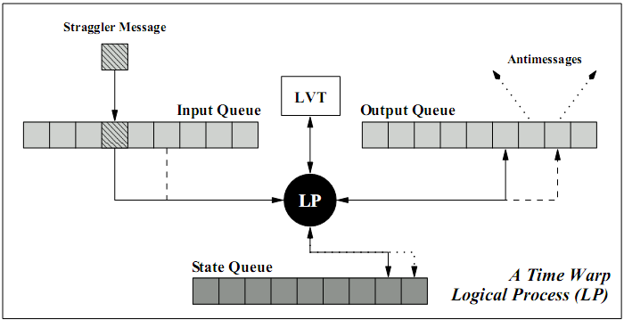

Figure 3 : A logical process in a time warp simulation (Radhakrishnan)

*GVT* is considered a safe point, because it is the time of the LP with the smallest *LVT*. When *GVT* is calculated, there is a guarantee that no event with a smaller time stamp will ever arrive at any of the LPs. One issue with Time Warp is the memory that is required (Jefferson). Until *GVT* is calculated, the incoming, outgoing events and all the states will need to be stored. The act of removing old events and states is known as fossil collection. If an algorithm calculates *GVT*, then it can iterate through all the LP queues and remove all events and states with a time stamp smaller than the *GVT*. It will then need to commit all I/O operations with a smaller time stamp. Fossil collection keeps a control on the memory requirement. How often fossil collection occurs will be based on how fast *GVT* is calculated. Typically to reduce communication overhead from *GVT* calculation, another technique employed to reduce memory requirement is to throttle the optimism [ (Jefferson), (LIN and LAZOWSKA)]. This is achieved by creating a restriction on the LP. A simple method is to wait until the difference between the event being processed and the *GVT* is within a given range. The algorithm chosen for GVT calculation is the Mattern’s GVT algorithm (Mattern).

#### 2.3.2.2 Mattern GVT Algorithm

The Mattern’s GVT algorithm is a simply yet effect way to approximate *GVT*. There are two main concepts to understand before realizing the end goal, *GVT* calculation. First is the notion of a consistent cut.

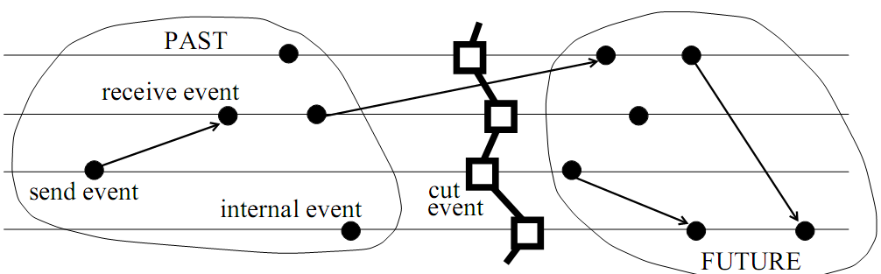

Figure 4 : A time diagram with a cut (Mattern)

When *GVT* calculation starts, it begins from the process called the initiator and a control message is passed around to the remaining processes in a round robin fashion, this is called a control round. When the control message gets back to the initiator it is referred to as a “cut”. A cut is consistent if no event from the future (to the right of the cut) lands in the past (to the left of the cut). Figure 4 above shows a consistent cut. The second main concept is the color of the process. The process starts out as a white process, when a control message reaches the process, the color changes to red. Therefore, when the initiator gets the control message back the control rounds ends and all processes should be colored red. Also any event that the process sends out inherits the color of the process, so if the process is white (red) then the event leaving the process is white (red) (Mattern). The third concept is the use of a vector for each process. The vector contains the number of white events that the process receives from another process. Hence, for process *P1*, it would contain vector *V1*. Each index in the vector is a reference to how many white events were received, for example *V1[2]* represents how many white events process *P1* received from process *P2*. For more information about the vector counter, please refer to (Mattern). These two ideas in mind are used to describe the algorithm.

Mattern’s algorithm uses two control rounds to approximate the *GVT*. The first round is used to figure out which of the processes has the white event with the smallest timestamp. When the first control round has ended and all the vector *V* for all the process report a zero count then the smallest timestamp recorded in the control message is the new *GVT*. A second round is necessary if there is a process that reports a white event count greater than zero. For the second round, the control message will not move to the next process unless that process has received all the white events from the other processes. Once the second round is over, all white events have been received by the appropriate process and the initiator can finally broadcast the new *GVT*. For more information regarding the algorithm, please refer to Mattern’s paper (Mattern).

## Non-parallel Agent based Simulation frameworks

Railsback *et. al* presents a detailed survey of several agent-based simulation frameworks that are similar to MUSE. The varying platforms were compared in three areas. Programming experience, execution speed, and general simulation issues (Railsback and Lytinen). A bug’s life simulation was developed as a measuring tool. Programming experience exposes some of the features and characteristics of each platform. The execution speed testing was not a complete and controlled test, but it was enough to get a picture (Railsback and Lytinen). Lastly, general simulation issues were discussed for each platform and how they handle areas like model structures and scheduling.

The frameworks under review were NetLogo, SWARM Objective-C, SWARM Java, Repast, and MASON. Each framework had advantages and disadvantages. NetLogo’s strong points include its detailed documentation and ease of use. However, it uses proprietary code, and users have to learn a custom language for modeling (Railsback and Lytinen). The original SWARM uses the Objective-C language. This is the most mature and stable framework, which makes it well organized (Railsback and Lytinen). While Objective-C is more natural to model with (Railsback and Lytinen), it has weak error-handling. Another downside is the availability of tools for developing with Objective-C. Java SWARM is simply a wrapper that allows Java developers to call Objective-C SWARM libraries. While Java has strong error-handling capabilities, the framework does not effectively take advantage of the two languages (Railsback and Lytinen). Moreover, both versions of SWARM proved to be the slowest for very complex models (Railsback and Lytinen).

Repast was meant to mimic SWARM using Java, but the design and organization of the framework has several drawbacks (Railsback and Lytinen). Furthermore, the learning curve for using the API is very steep, because it has numerous features, often making it overwhelming for most casual developers (Railsback and Lytinen). MASON is a light weight framework that aims to achieve high execution speeds (Railsback and Lytinen). It is also the most recent of all the frameworks and in terms of execution speed; it was indeed the fastest amongst those surveyed by Railsback *et. al*. One of MASON’s main issues was adding multiple agent actions, for example in the bug’s life simulation; the bugs had a move and grow action. Due to the way the scheduler was designed in MASON it was not trivial to add multiple actions (Railsback and Lytinen). MASON used the template method design pattern. Meaning, for an agent to act a method called “step” had to be implemented and perform the action in that method. “An advantage of this design is the time MASON saves in the scheduler because it constantly knows to execute a method named ‘step’.” (Railsback and Lytinen) The real disadvantage to this design pattern used by MASON is when you want to have all the bugs move, and then in the next time step all to grow. The agent had a reference to the scheduler and if he wanted to be scheduled for the next time step, the agent adds itself to the schedule for the next time step. Since you only have one method available this becomes a less trivial task to complete.

MUSE will use the same template design pattern, more importantly MUSE will get all the benefits and none of the drawbacks. At its heart MUSE is an agent base framework, the method that the agent must provide is “executeTask”. However since it is designed with parallelism in mind the only way to communicate with agents is with events. Providing different event types, one can easily perform anything in the “executeTask” method. In the bugs life example, simply have a move event and a grow event. Therefore, scheduling the needed event (action) at the right time will yield the desired result. More on the design of the scheduler will be discussed in Section 3.

## Parallel Non-Agent based simulation frameworks

In conjunction with initial investigations, three parallel simulation frameworks were reviewed, namely WRAPED (Radhakrishnan), GTW (D. Das, R. Fujimoto and K. Panesar), and Parsec (R. Bagrodia). It must be noted that these are general purpose discrete event, parallel simulation frameworks and not necessarily agent-based simulation environments. The strong point of WARPED is the similarities is has to MUSE. This proved to be a valuable resource during the design stage of MUSE. One similarity to MUSE is the use of the Time Warp synchronization method. It also uses MPI as its message passing protocol and C++ as the language. However, several issues posed serious hurdles for effective use of the framework. The most important one is the lack of documentation. Furthermore, the simulator has not been actively maintained and therefore several issues prevented even compiling the core framework using recent compilers. Since WARPED development started in 1998, it clearly went through several upgrades in features, but the changes were not documented clearly. GTW also uses Time Warp, and similar to WARPED, it lacks documentation and has not been actively maintained. Furthermore, GTW was primarily developed for shared memory architectures while today’s supercomputing clusters primarily used distributed memory architectures. However, GTW includes several beneficial design solutions. One of the important design solutions that will be used in MUSE is controlling optimism during simulation. Controlling optimism is necessary because, Time Warp has a tendency to be too optimistic, this could lead to cascading rollbacks. GTW avoids cascading rollbacks by using time windows that throttle optimism (D. Das, R. Fujimoto and K. Panesar). Another attractive feature is the local message sends, meaning if a message is meant for the local LP it is simply enqueued directly to its input queue.

Parsec is most the complicated parallel framework from the group. Strong points of Parsec include its visual environment. Developers modeled via a GUI (R. Bagrodia). Parsec implements many conservative synchronization methods and many communication libraries (R. Bagrodia). However, conservative synchronization requires the modeler to be cognizant about look ahead in simulation-time during model development. Look ahead is necessary to avoid deadlocks that potentially occur during simulation. However, look ahead can be complex to extract when developing models and small look ahead negatively impacts simulation performance.

On the other hand, Time Warp does not rely on look ahead making it easier for the model developer. However, like previously mentioned, Time Warp uses state saving and rollback to recover from causal violations; thereby requiring additional memory and CPU time for rollback processing. In other words, in conservatively synchronization simulations time is spent waiting for other parallel processes to coordinate while in Time Warp time is spent recovering from rollbacks. However, several Time Warp optimizations are available to minimize rollbacks and these optimizations can be implemented without impacting the API or placing overhead on the modeler. Consequently, Time Warp will be the synchronization protocol for MUSE.

## Choosing data structure for scheduling

Having a scalable and efficient simulation environment is very dependent on the data structure used to maintain the events and the agents for scheduling. MUSE has a two tier scheduling system. The very top tier is the scheduler and it maintains the agents and knows which agent to process at any given time. The second tier is in the agent. All incoming events to a given agent must be stored and correctly scheduled in increasing fashion according to the time of the delivery. The heap data structure seemed a great fit for both tiers. The heap data structures under consideration are the Fibonacci heap (Fredman and Tarjan) and the Binary Heap. Binary heaps are heaps that are implemented with binary trees (Wikipedia). Fibonacci heaps have very impressive runtime results, however these results are amortized. The following table shows the runtimes of both binary and Fibonacci heaps.

|  |  |  |
| --- | --- | --- |
| Standard Operations | Fibonacci Heap | Binary Heap |
| Insert | O(1) | O(log*n) |
| Get Min | O(1) | O(1) |
| Delete Min | O(log*n) <amortized> | O(log*n) |
| Decrease Key | O(1) <amortized> | O(log*n) |
| Delete | O(log*n) <amortized> | O(n) |
| Merge | O(1) | O(m log(n+m)) |

Table 1 : Fibonacci and Binary Heap runtimes

Fibonacci heap showed impressive runtimes, but how much amortization is needed before the gains can be realized is still unknown. Binary heap on the other hand has good runtimes and no amortized costs. The two tiers make more use of different operations. Hence, there is a good chance of using a combination of the two heaps in MUSE. The first task is identifying which operations were frequent in each tier. In the first tier, once the agents are added, the agents should never be removed until the end of simulation. Therefore the only operation to compare is the *decrease key* operation. Decreasing the key in short is just an operation to reorder an element in the heap. An early conclusion is that Fibonacci heap should be used, but it is better to let the numbers speak. In the second tier, frequent use of the *insert, get min, and delete min* process events. Also whenever there was a rollback the *delete* operation is used. For binary heap implementation the *priority_queue* from the C++ STL containers is used. The Fibonacci heap that was integrated can be found following this reference (Kühl).

### 2.6.1 Fibonacci vs. Binary testing procedure

Finding a good heap for both tiers is critical for the performance of MUSE. Key decreasing operation is evaluated for the first tier using a couple of controlled variables. In experiment the time is fixed to 400 simulation time steps. This allowed a notable difference in performance between the two heaps and the time to run the tests was reasonable. The basic idea is to keep increasing the number of agents, starting from 100 and ending at 100,000 agents. At each time step the test will iterate over the number of agents and randomly (P = .5) increase or decrease the value of the agent’s key, and call the *decrease* operation on the key. Observed times will be recorded, and the average of five runs will be used for each increase in the number of agents. Fibonacci heap implementation has a *change(element, key)* method which is used. However, the priority queue does not implement a way to change the key, so the solution is to pop the top element and then update the value and push it back into the heap. This makes the runtime from *O(log*n)* to *O(log*n+log*n)*. The new runtime can be calculated simply by adding the runtimes for *delete min* and *insert* operations.

The second tier deals with processing events. Simulation time steps will be fixed to 5000 iterations. The number of events processed will slowly increase starting from 100 events per time step all the way to 100,000 events per time steps. There are two cases to test in the second tier. First case is just going to be a test to see how long it takes to insert *X* number of events and then *delete min* until the heap is empty again. The second case is testing how long it takes to delete arbitrary elements from the heap. The test will loop through and delete the top element until the heap is empty. The STL container *priority_queue* does not support iterators. In order to get elements in the back, the test will first remove all the elements and store the valid ones into a temporary storage. Once the invalid elements are removed, the test will push all the elements from the temporary storage back into the priority queue. Like the first test, the average of five runs will be recorded. The big deciding factor for the second tier will be the first case, as this is the most frequent operations. However, since *priority_queue* does not support iterators, the second case must be added into comparison test.

### 2.6.2 Fibonacci vs. Binary data collection, results, and discussion

The table below is the collection of data comparing the two heaps for tier one. Keep in mind that that the execution times are the average of five runs and represent execution time in seconds.

|  |  |  |  |  |
| --- | --- | --- | --- | --- |
| Agents | Time steps | Fibonacci execution time | Binary execution time | Speedup |
| 100 | 400 | 6 | 16 | 2.66 |
| 1000 | 400 | 78 | 222 | 2.84 |
| 10000 | 400 | 949 | 2721 | 2.86 |
| 100000 | 400 | 14090 | 34179 | 2.42 |

Table 2 : Fibonacci vs. Binary at tier 1 results

Figure 5 : Fibonacci vs. Binary at tier 1 trend

The graph above (figure 5) shows clearly the expected trends. The results above were expected because for binary heap the best and worst case is *O(log*n+log*n).* However, fibonacci heap has a best amortized run time of *O(1),* but the worst case is *O(log*n).* Derived proof of worst case times for fibonacci heap can be found in the reference (Fredman and Tarjan). From these results the choice for tier one is fibonacci heap.

The table below is the collection data comparing the two heaps for tier two. Here are the execution times of case one and case two combined as discussed earlier.

|  |  |  |  |  |
| --- | --- | --- | --- | --- |
| Events | Time steps | Fibonacci execution time | Binary execution time | Speedup |
| 100 | 5000 | 2 | 1 | 2 |
| 1000 | 5000 | 23 | 18 | 1.27 |
| 10000 | 5000 | 300 | 203 | 1.47 |
| 100000 | 5000 | 3236 | 1794 | 1.80 |

Table 3 : Fibonacci vs. binary heap Tier 2 results

Figure 6 : Fibonacci vs. Binary plot for tier 2

The results for tier one were expected, however the results from the test for tier two revealed surprising information. The amortized cost of the *delete min* operation proved to be too great. Since *priority_queue* did not support iterators, adding the time to actually remove arbitrary elements from the heap was also necessary. Using the naïve approach and popping all elements into a temporary storage and pushing in the valid elements back into the heap, Fibonacci heap still proved to be slower than the binary heap. In a clear conclusion from the results, the amortized run times claimed by fibonacci heap would require very large data in the heap. Hence, for tier two, binary heap is used, but can better performs be attained?

For tier two, the speedup column in table 3 showed that the improvements were not great. This was due greatly to the performance hit taken from *priority_queue* and its lack of iterators. Earlier the runtime to delete arbitrary elements from the binary heap was showed to be worst case *O(log*n+log*n).* The speedup would be even greater if the experiment used the original worst case runtime of *O(n).* This need to improve performance was the motivation behind the development of the *BinaryHeapWrapper*. The new implementation used a vector and represented it as a binary heap. Most importantly it allowed the removal of arbitrary elements at *O(n).* *BinaryHeapWrapper* was specialized for MUSE and the disadvantage being reusability, the binary heap implementation could only be used within the MUSE framework. The tests for tier two compared *BinaryHeapWrapper* against *priority_queue* and fibonacci heap*.* The following table shows the results from the experiment. Since there are two binary heaps, the names in the table column are changed to the actual class names.

|  |  |  |  |  |
| --- | --- | --- | --- | --- |
| Events | Time steps | Fibonacci execution time | Binary execution time | BinaryHeapWrapper execution time |
| 100 | 5000 | 2 | 1 | 1 |
| 1000 | 5000 | 23 | 18 | 13 |
| 10000 | 5000 | 300 | 203 | 125 |
| 100000 | 5000 | 3236 | 1794 | 1041 |

Table 4 : Fibonacci vs. Binary vs. BinaryHeapWrapper results

Figure 7 : Fibonacci vs. priority_queue vs. BinaryHeapWrapper plot

A dramatic increase in performance from the custom built binary heap is evident from the results. From these experiments and results, fibonacci heap had great amortized times; yet, there are cases where the benefits do not outweigh the cost. However, there was a case where fibonacci turned out to be very beneficial and hence its use for tier one. Lastly, the experiments showed that priority_queue actually turned out to be faster for tier two over fibonacci heap, but its lack of iterator support motivated the need for a custom built binary heap. The *BinaryHeapWrapper* turned out to have the best time and speedup out of all three heaps and thus was chosen as the heap for tier two.

# MUSE Design and Implementation Details

This section will go into detail about the design of MUSE. First, the general overview of the entire framework will be discussed. Second, the discussion will then explore the different components and what classes are used to make them work. Third, a discussion will explain the classes the kernel uses and how the *Agent* class actually handles processing events, and recover from rollbacks. Finally, the MUSE code generator, which helps users get started more efficiently, is described; this demonstrates MUSE’s user friendly strengths.

## General Overview

Developing models and running simulations requires a number of actions to take place. The following requirements are issues that MUSE must address in order to have a successful framework.

1. A way to create agents.
2. A way to create states for agents.
3. A way to register agents with the simulation kernel.
4. A way to create messages (events) for agents to communicate.
5. A way to schedule events.
6. A way to safely commit the simulation data to any output stream.
7. A way to communicate with agents on different kernels (other nodes).
8. A way to synchronize all the kernels.

The following classes below help accomplish the requirements listed above to create parallel simulation. MUSE core has seven classes available to the API user. All of these classes are provided under the namespace *muse*. These publicly visible classes are used in different ways to get a simulation running with MUSE. The classes are:

1. muse::DataTypes
2. muse::Simulation
3. muse::Agent
4. muse::State
5. muse::Event
6. muse::oSimStream
7. muse::SimStream

MUSE core also has classes not available to the API user. These classes are used by the simulation kernel to help with getting the simulation to schedule agents correctly, synchronize multi-kernels in the simulation and also to communicate with other simulation kernel when sending events across the wire. The four classes are:

1. muse::Scheduler
2. muse::Communicator
3. muse::GVTManager
4. muse::GVTMessage

Figure 5 gives a graphical representation of the classes and their relationships to each other. The figure shows that the *Simulation* class is dependent on the *Scheduler and Communicator* class and has an *Agent* class. The *Agent* class is dependent on the *State* class to function correctly and so on… Another detail to note is that the *DataTypes* class is actually just a header with custom defined date types.

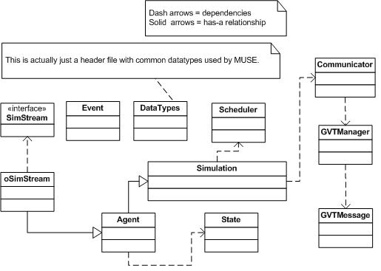

Figure 8: General overview of class relationships

The next section will list and describe each components of the framework. The components simply mean a group of classes that carry out a specific task in the framework.

## MUSE Components detail

|  |  |
| --- | --- |
| The first component deals with creating agents for the simulation. When dealing with agent-based simulations, agents in the simulation need to be clearly described. MUSE defines this concept by the *Agent* class. The *Agent* class is dependent on the *State* class. | C:\Documents and Settings\gebremr\Desktop\thesis-figures\create-agent-component.JPG  Figure 9: Components for Agent creation |

The state of an agent is all the information that can be modified by the execution of messages from other agents or the agent itself. The *DataTypes* header was added because it contains the definition for data type *AgentID.* This *AgentID* uniquely identifies an agent across the entire simulation. This component satisfies requirements one and two from above. More detail of this data type will be described in the *DataTypes* header discussion.

Once a definitive way to create agents for a simulation is established, there needs to be a way to actual notify the simulation kernel of these agents. That is what the agent registration component handles.

|  |  |
| --- | --- |
| From figure 7 to the right, two classes must be made aware of the agent. First, is the *Simulation* class; when accessing the singleton instance of the simulation kernel one can register the agent and the kernel will take responsibility. Once the agent is registered with the simulation kernel, the kernel will register the agent with the scheduler. | C:\Documents and Settings\gebremr\Desktop\thesis-figures\agent-register-component.JPG  Figure 10: Agent registration component |

When the registration process is successful the kernel will know that it is responsible for the registered agent. Note that the *Simulation* class is also used for setting begin and end time of the simulation. This takes care of requirement three from above. The only way that agents can communicate with each other is through events. Since MUSE is parallel capable, agents cannot get an instance to another *Agent* class and tell it to execute a task. Instead MUSE needs to create a way for an agent to send an event. The receiving agent will use this message to execute the required task. For this requirement the *Event* class is created, as seen in figure 8 above. The use of the *Event* class handles requirement four. The next component will help deliver the events to the correct agent. The event scheduling component is quite complex.

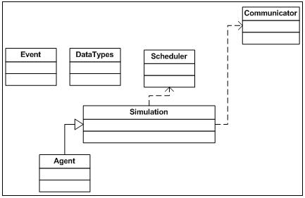

Figure 11: Event scheduling component

Figure 11 above, shows the classes that are used to handle scheduling of events. When an agent wants to communicate to another agent it must create an event. The *Event* class uses data types described in *DataTypes* header for construction parameters. Scheduling of events is done through the *Agent* class. The *Agent* class intelligently decides internally to either pass the work onto the simulation kernel or if the event is to itself, it bypasses the kernel and automatically adds it to its heap of events to process. Now if the event being scheduled is not to itself, there are two paths that it can take. The event can be to an agent that is locally registered (within the same kernel) or running on another kernel (another process). The agent’s simulation kernel will figure this out and either pushes the event to the *Scheduler* class (meaning the receiving agent was local) or the *Communicator* class (the agent resides on another kernel). The following figure 12, will visually describe the event’s path follow. With that the demands of requirement five are complete. The creation of the *Communicator* class also satisfies requirement seven.

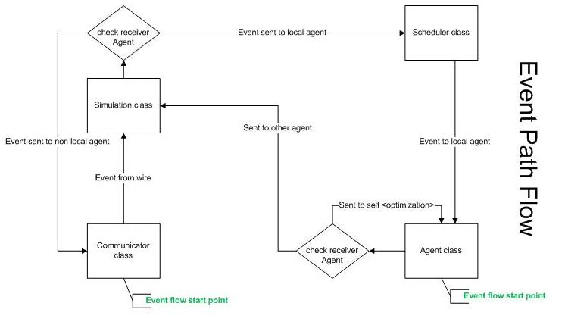

Figure 12: Event path follow through MUSE

When the simulation is proceeding, the user will want to extract necessary data from the simulation. However, due to the complexity of parallelism and possible rollbacks users should not use standard IO libraries. The next component deals with safely committing simulation data.

Ideally the user should be able to safely commit data into any stream they wish. This can range from the monitor display, file, or even socket streams. MUSE handles any assortment of streams. The way it works is simple. Any class that inherits the interface or pure virtual class *SimStream* can be registered with a given agent.

|  |  |
| --- | --- |
| Within the agent the user can use these subclasses of *SimStream* to perform IO operations. The *oSimStream* was created to safely handle outputting data to any stream. There is a default *oSimStream* object in the *Agent* class called *oss*. The user can use this just like using *std::cout*. | C:\Documents and Settings\gebremr\Desktop\thesis-figures\data-commit-component.JPG  Figure 13 : Simulation data commit component |

The last requirement that MUSE must provide a solution for is the synchronization of multi-kernels (requirement 8). The synchronize component deals with this requirement. Figure 14 below shows the different class that go into keeping all kernels synchronized. The key class in this process is the *GVTManager* class. This implements Mattern’s *GVT* algorithm (Mattern). The root kernel (usually has *SimulatorID* zero, more detail when describing the *DataTypes* header) starts circulating a *GVTMessage.* When a message reaches a kernel, the kernel polls the scheduler for the agent that will execute next. This agent by definition will have the *LGVT* (local global virtual time). *LGVT* is the least timestamp of all agents’ *LVT* (local virtual time). It updates the *GVTMessage* accordingly and passes it to the next kernel in a ring fashion.

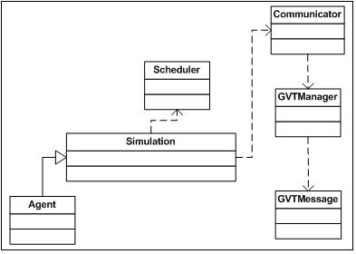

Figure 14: Synchronize component

## MUSE classes and methods detail

Since MUSE is developed from the ground up, it is important to set requirements that make it more reliable and easy to maintain. Placing high priority on criteria from (Railsback and Lytinen), well-known concepts and terminology of simulation for the framework were integrated. In addition, the design objective was to ensure the API is relatively easy to use with a good balance of features to usability, where the user does not feel over whelmed by the steep learning curve. Another important aspect is the level of documentation. Some of the frameworks discussed in the related works section did a great job at this, NetLogo (Railsback and Lytinen) for example. In terms of performance, MUSE also has to excel. MUSE is being developed as a tool to help harness high performance distributed computing (HPDC), therefore it is natural that is should be efficient internally in order to be a good starting base. Although MUSE design is subject to change, the remaining of this section will describe MUSE in more detail.

### The Agent class

MUSE is an agent-based distributed framework. As such the *Agent* class is a very critical piece of the framework. TimeWarp implementation and rollback recovery are among many that the *Agent* class handles internally. The *Agent* class uses the *Event* and *State* class heavily during a given simulation.

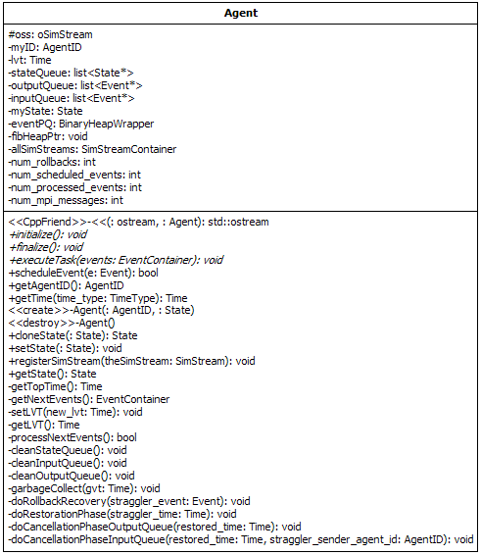

Figure 15 : The Agent class

Detailed explanations of the public methods are discussed in the next chapter. How the agent gets the next set of events to process is one of the most important questions to answer. It starts from the *ProcessNextEvents* method. This method is invoked from the Scheduler class. The Agent class maintains a heap of events to process. The events are stored in the *eventPQ* heap, which is actually the *BinaryHeapWrapper* discussed earlier. The following figure is used to explain how events are processed in detail.

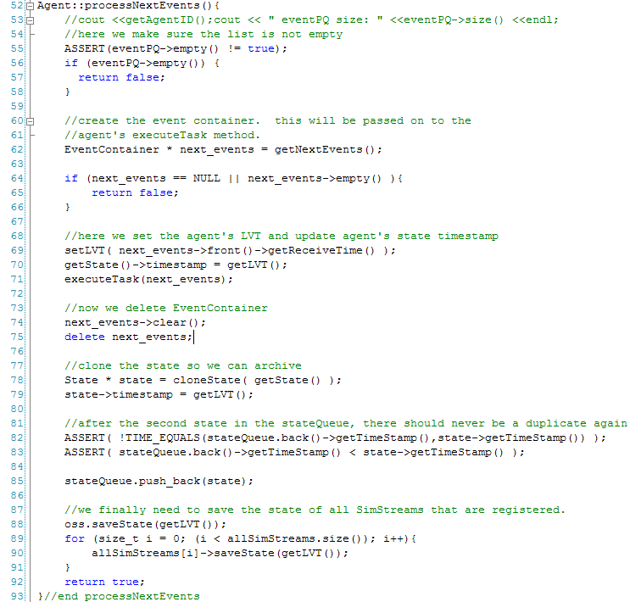

Figure 16 : The ProcessNextEvents method

After the next set of events is extracted from the heap (figure 16 line 62), the agent sets its LVT to that of the events to be processed (figure 16 line 69). At this point, the events and the agent invoke the *executeTask* method passing the events in as parameter (figure 16 line 71). Once control is returned from the *executeTask* method, the agent clones the updated stat and achieves it (figure 16 line 78 and line 85). After the events are processed, the agent makes sure to save the state of all *SimStream* based classes that are registered (figure 16 lines 88-91). When the *Scheduler* class detects a straggler event, it invokes the agent’s *doRollbackRecovery* method.

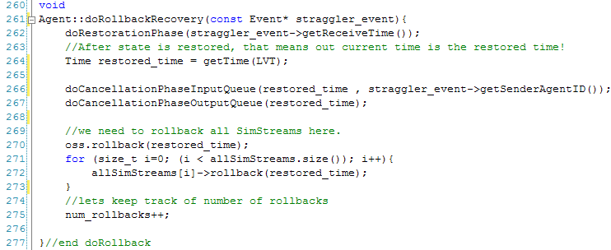

Figure 17 : The doRollbackRecovery method

The agent recovers from a rollback in three steps and implements a variation of Jefferson’s Time Warp protocol . The agent has three queues, the *inputQueue*, *outputQueue*, and *stateQueue*. The *doRestorationPhase* method is straight forward. It goes through the *stateQueue* and finds the state with a timestamp one below the straggler events time. Once the state has been restored, the *inputQueue* is rearranged next (figure 17 line 266) this again is exactly as described in the Time Warp protocol . The last step is to rearrange the outputQueue (figure 17 line 267). Instead of sending anti-messages for every invalid event, only the invalid event with the smallest time is sent. This way communication overhead is minimized, because the receiving agent can conclude any other event from the sender agent with a time equal to or greater than the anti-message time is invalid. Once a new *GVT* value has been calculated, then it is time to free some resource and get rid of old states and events, this is known as fossil collection. The *garbageCollect* method takes care of the cleanup.

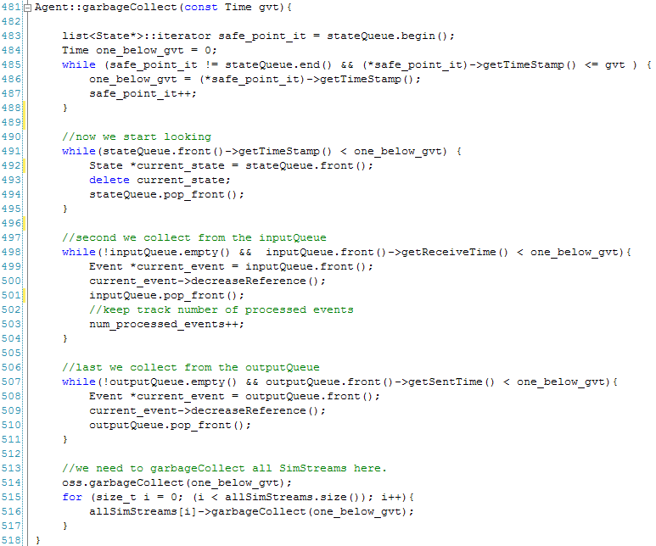

Figure 18 : The garbageCollect method

In the *garbageCollect* method, first a safe point is calculated. A safe point is the time the agent had that is one below the *GVT* (figure 18 lines 483-488). One below *GVT* does not necessarily mean *GVT* minus one, because simulation time is user define it can jump in different patterns. Once the safe point is calculated all of the queues are cleared up to the safe point. This includes the *SimStream* based objects the agent is responsible for (figure 18 lines 514-517). This is actually where data is committed to any output format registered by the user.

#### 3.3.1.1 The Event class

The *Event* class is very simple. The only interesting point to note is the *getEventSize* method. This developer should override this method. The size of the event becomes critical when it is sent over the network. MPI does not provide any feature to serialize objects, therefore by typecasting the object to a char pointer of size returned by *getEventSize*, the event can be sent across the network as a string of characters. MUSE tries to minimize the creation of event objects by using pointers. For this reason the *Event* class has a built in reference counter. Every time the event is stored in some container MUSE keeps track and when all containers have released the event, the reference counter is set to zero and the event is properly deleted. Lastly, an event has the potential to become an anti-message. This is done by the *makeAntiMessage* method and once it becomes an anti-message it cannot be restored to a valid event.

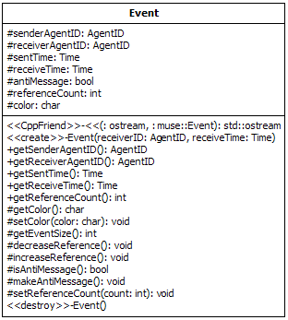

Figure 19 : The Event class

#### 3.3.1.2 The oSimStream and SimStream class

When the agent performs garbage collection, it also commits simulation data. To safely commit simulation in MUSE, the developer must use a *SimStream* based class.

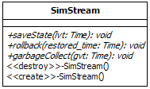

Figure 20 : The SimStream class

During simulation with MUSE developers are prohibited from using the standard I/O library. The possibility of receiving outdated information is the reason. The *SimStream* class is a pure virtual class. Any subclass has to implement the three methods. One such subclass provided by MUSE is the *oSimStream* class.

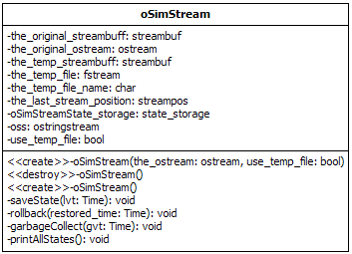

Figure 21 : The oSimStream class

The agent class has a default *oSimStream* object that commits data to std::cout from the C++ STL class *iostream*. The *oSimStream* object is called ‘*oss’* figure 15. The *oSimStream* can be created with any output stream that inherits from the *ostream* class. The *oSimStream* class also has the ability to use a temporary file as storage incase the modeler has large amounts of data to be stored before committing.

### The Simulation class

The *Simulation* class also known as the kernel oversees the operation of the simulation for a given process. Figure 22 below shows all the components in the *Simulation* class. Among these components the most important pieces are the *Scheduler*, *Communicator*, and *GVTManager* classes.

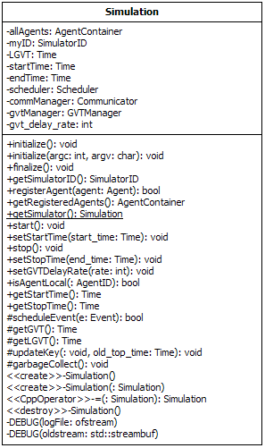

Figure 22 : The Simulation class

When the simulation is started, the *start* method is called. The agents registered to the *Simulation* class are registered with the *Communicator* class (figure 23 line 127). The *GVTManager* objects are created and all the agents are initialized (figure 23 lines 129-145).

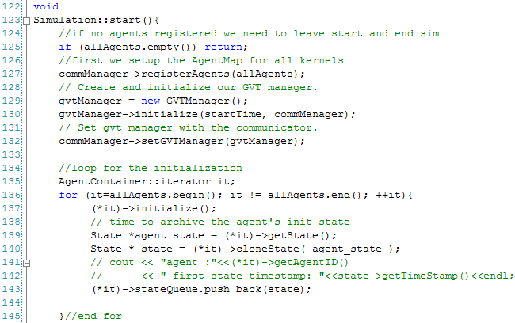

Figure 23 : The start method part 1

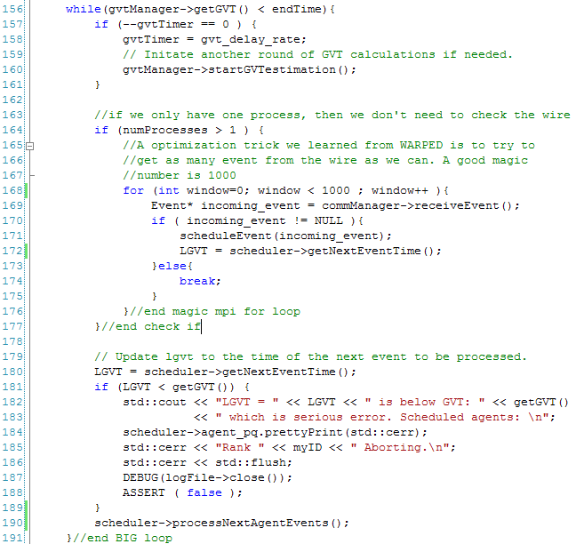

Figure 24 : The start method part 2

Figure 24 shows two important features that improved MUSE performance by roughly 84%. The first (figure 24 line 164), is to only check for events from the wire if there is more than one kernel in the simulation. The second feature which was obtained from WARPED helps with minimizing rollbacks (figure 24 lines 175). If there is an incoming event from the wire, the communicator is polled again for a maximum of 1000 tries. The window size is set to 1000; this means that each kernel can potentially grab 1000 events from the wire before processing events again. However, it is not necessary to check 1000 times, if the communicator is polled and no incoming event is available the loop is broken and the next set of events is processed (figure 24 line 190).

#### 3.3.2.1 The Scheduler class

The first tier for scheduling in MUSE is handled with the *Scheduler* class. The *Scheduler* class uses a fibonacci heap data structure to store all the agents registered to the *Simulation* class.

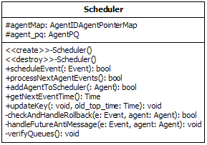

Figure 25 : The Scheduler class

The most important method in the *Scheduler* class is the *scheduleEvent* method.

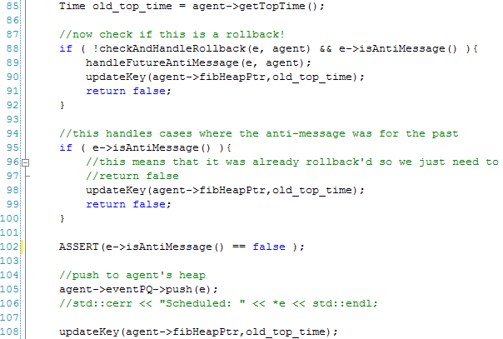

Figure 26 : Snippet of scheduleEvent method

Once an event is sent to the Scheduler from scheduling it must be checked to make sure that it is not a straggler event or an anti-message. Checking if the event will cause a rollback is done in line 88 in figure 26. There is a case when the event does not cause a rollback and at the same time be an anti-message. This usually happens when the event is yet to be processed at the receiver agent. In this case, purging the future event is handled in line 89 in figure 26. If the event is not an anti-message or causes a rollback, then it is pushed directly into the agent’s event heap. Finally, the agent’s key in the fibonacci heap is updated (figure 26 line 108). The *Scheduler* class will always know the next agent to process. This is done in the *processNextAgentEvents* method.

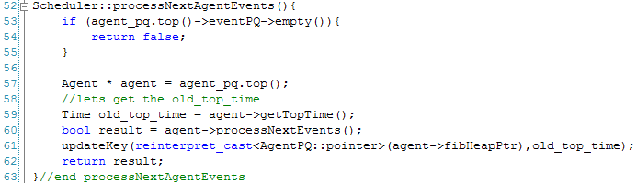

Figure 27 : The processNextAgentEvents method

The method is relatively straight forward. A pointer to the next agent is obtained (figure 27 line 57) and as discussed in the agent section earlier the ProcessNextEvents is invoked on behalf of the next agent (figure 27 line 60). After the events are process, the agent must again update its key in the fibonacci heap to maintain the heap properties.

#### 3.3.2.2 The Communicator class

The *Communicator* class is used to send events to agents that reside on other kernels. To perform this important task, every *Communicator* class must have a map that tells where each agent is registered. In the *start* method in the *Simulation* class (figure 23 line 127) is where the kernel registers all the agents its responsible for.

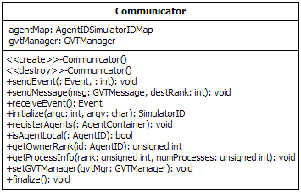

Figure 28 : The Communicator class

The Communicator class holds an agent map that is created when the agents are registered by each kernel. Minimizing the number of communications between the kernels and completing the agent map was done in three steps. When MPI is initialized it assigns each kernel with an ID. The kernel that receives the ID zero is known as the root kernel. Essentially the root kernel collects all agent IDs from the other kernels and then broadcasts the entire list back out to all the kernels.

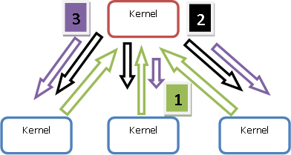

Figure 29 : Agent Map 3 step construction process

Figure 29 visually shows how the agent map is created in the *Communicator* class. The kernel with the red box (figure 29) represents the root kernel. The three steps are as followed.

1. Root kernel waits to collect list of agent IDs from all other kernels (figure 29 green arrows).
2. Root kernel broadcasts the length of the complete agent map to all other kernels (figure 29 black arrows).
3. Root kernel broadcasts the agent map list to all other kernels (figure 29 purple arrows).

After the agent map is created, any agent can send an event to any other agent. The *Communicator* class is also used to send *GVT* messages.

#### 3.3.2.3 The GVTManager and GVTMessage class

The GVTManager is an implementation of Mattern’s *GVT* algorithm discussed earlier .

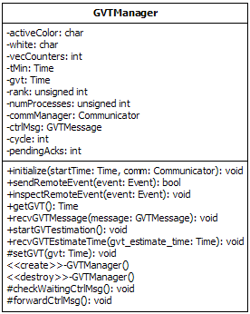

Figure 30 : The GVTManager class

GVT is calculated in two rounds. The root kernel starts the *GVT* estimation by invoking the *startGVTestimation* method. In the method a *GVTMessage* (figure 31) is created, the message is tag as a control message.

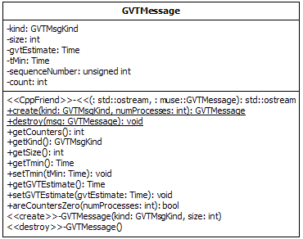

Figure 31 : The GVTMessage class

During the first round, every kernel updates the control message if the *LGVT* it has is smaller than that of the time in the *GVT* control message. Also every event that is sent across the wire is color coded to white. Every kernel keeps track of how many white events it sent out. When the root kernel gets the control message back, the first round is over and all events sent across the wire now are tagged with the color red. Events are tagged with the color white or red in the *sendRemoteEvent* method. When the second consistent cut (second round) is over, all events tag with the color white should have been processed. This way the root kernel can guarantee that the *GVT* estimation it has is the actual *GVT* value.

Figure 32 : GVT message passing

## MUSE Code Generator

The MUSE code generator was a late but exciting simple edition that made developing with MUSE much more enjoyable. A lot of the startup code with every simulation created is basically the same procedure. For every simulation that is created, the developer must create agents, states, and events. Users will also no doubt organize these files somehow. To add to the tedious startup, is creating make files to compile and link to the MUSE kernel code. Lastly is the main execution file that you must create to get simulation started. The MUSE code generator takes care of all the tedious, redundant process to get started.

The MUSE code generator was developed using Python. With Python, a simple, robust code generator was operational very quickly. As of this writing, version 0.2 is released. There are two python files *muse.py* and *templates.py* that make up the code generator. The template file contains the templates for the following:

* The Agent header file
* The State header file
* The Event header file
* The Agent source file
* The State source file
* The Event source file
* The main execution source file
* The Makefile file

The *muse.py* file uses *templates.py* to create the needed files. The following figure 33 is a screen capture of the help menu and this is used to explain each available option.

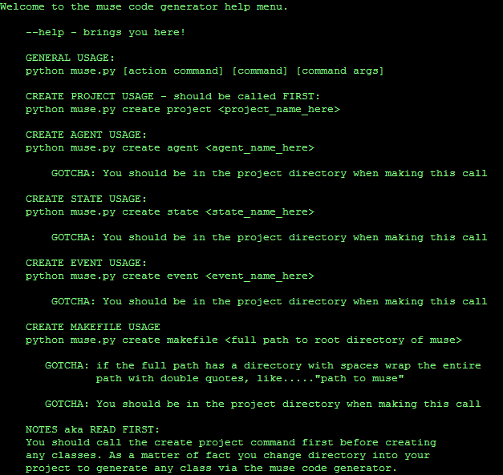

Figure 33: The MUSE Code Generator help menu

It is highly advised to use the code generator to start a simulation project for MUSE. It creates the necessary directories MUSE needs to run your simulations correctly. Also, when it comes time to update or debug a simulation project, knowledgeable modelers that worked with MUSE already would know the layout of the project and can easily enhance or debug the project.

The first command the user must call is the *create project* command. As an argument, pass in the name of the project. The code generator will never overwrite any file or directory so never worry about losing projects or files within projects. Once the project is created, the user must be in the project directory to execute the rest of the available commands. The *create project* command will generate a number of directories and the main executable file. For example creating a project called *BugLife*, the directories created are as follow:

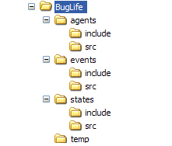

Figure 34: Directories create via MUSE code generator

Figure 34 shows the directories, but the *create project* like mentioned above also created the main executable file. In this case it would generate *BugLife_main.cpp*. The following figure 35 displays the content of *BugLife_main.cpp*.

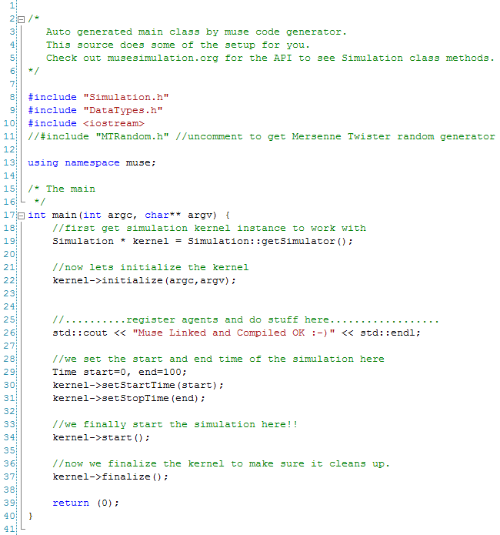

Figure 35: Content of main executable file generated by code generator

Using only one command a directory for organizing the project and a half finished executable file are created. From within the *BugLife* directory, the user can call to create a *Makefile.* The *Makefile* template is really simple and can be modified. Calling the *create makefile* will generate a file and it will scan the agents, states, and events directories to include the source files for compiling. Every time the user adds or removes a source file simply executing the *create makefile* command will generate an updated version. As an argument, pass in the path to root directory of MUSE. Users can also easily get started with creating an agent by calling the *create agent* command with the agent class name as an argument. Users can optionally pass in more than one agent delimited with a space between each agent class name. The *create agent* command generates two files. The header file, which is placed in the *agents/include* directory and the source file which is placed in the *agents/src* directory. The following two figures 36 and 37 show the content of the generated header and source files of the *Bug* agent class.

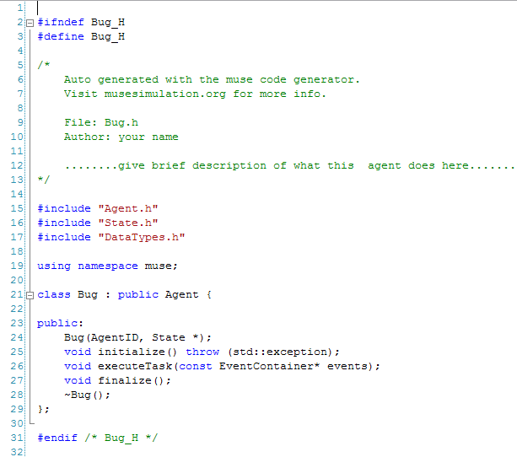

Figure 36: Bug.h generated with MUSE code generator

All the needed header includes are already added for a basic class that inherits from the *Agent* class. The source file is the same way, just fill in the stub methods and update the makefile to compile and run.

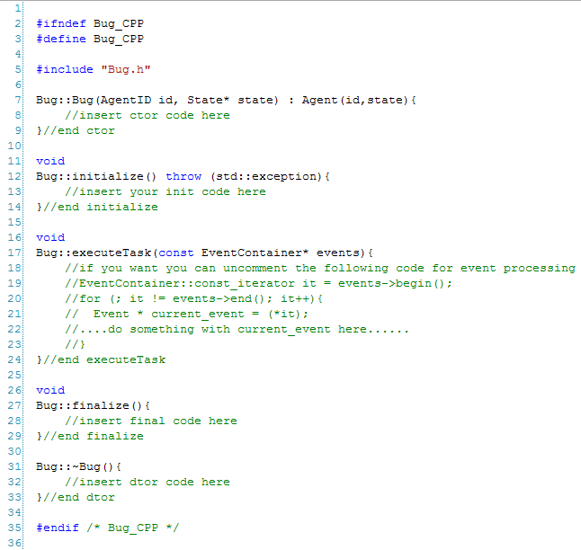

Figure 37: Bug.cpp generated with MUSE code generator

MUSE code generator also lets users create classes that inherit from the *State* class. Running the *create state* followed by the class name will generate the corresponding class *State* based class. Optionally, the user can create multiple *State* based class by delimiting each name with a space. Figure 38 and 39 show the generated header and source file for the class *BugState*.

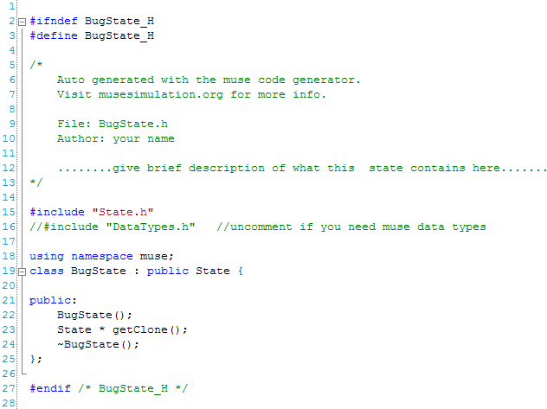

Figure 38: BugState.h created with MUSE code generator

Keep in mind the code generator creates the bare minimum of the class and it is up to the developer to add in more functionalilty. The last available option as of version 0.2 of MUSE code generator is the option to create *Event* based class. The *create event* command does the trick and it works just like the *create agent* and *create state* commands. The user must pass in one or more class names and it will generate the class for you in the *events* directory. Figures 40 and 41 show the content produced for the class *BugEvent* by the code generator.

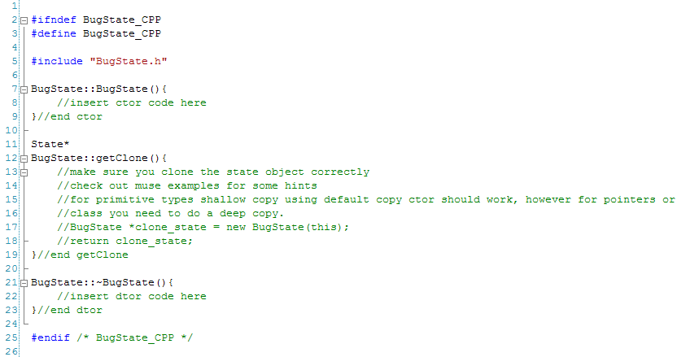

Figure 39: BugState.cpp created with MUSE code generator

This completes the design section and the design choices made stay true to (Railsback and Lytinen). Even more detailed documentation can be found on the MUSE site at www.musesimulation.org.

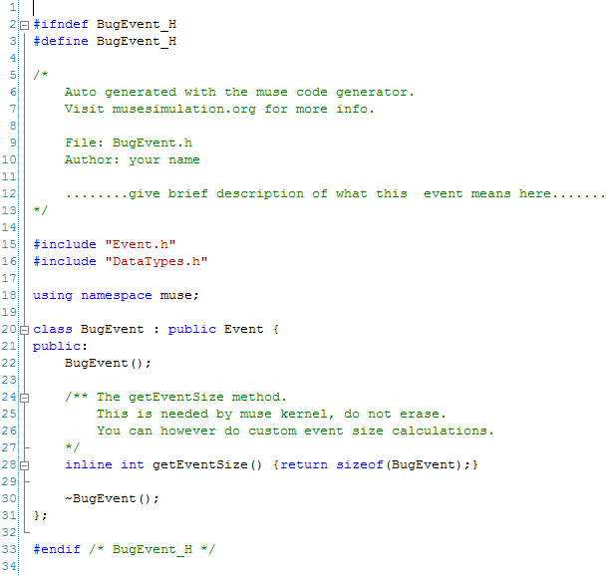

Figure 40: BugEvent.h created by MUSE code generator

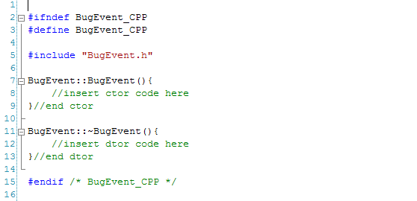

Figure 41: BugEvent.cpp created by MUSE code generator

# MUSE Installation and API Details

This section will present the seven public classes that are available to the user. MUSE has the following classes available for the user:

* muse::DataTypes
* muse::Simulation
* muse::Agent
* muse::State
* muse::Event
* muse::oSimStream
* muse::SimStream

The header files for these classes are available *MUSE_ROOT_DIR/include* directory. The best way to learn MUSE API is by creating a simple simulation. This example will serve two reasons. The first is to show how easy it is to get setup and going with MUSE. The second reason is to demonstrate how to use each available class within the example. After describing how to configure and install MUSE, this section will describe the ping-pong simulation example. While building the example from the ground up, a description of the different classes are discussed as each class is used.

## Configuring and Installing MUSE

There are a couple of steps the user completes before actually using MUSE. However, getting started with MUSE is as painless as possible. In this section the user will learns how to download, configure and install MUSE. First, the user must grab MUSE. As of this writing MUSE is not publicly available (password protected), however it will soon be available through SVN. The current stable release is MUSE beta version 0.1. To get the latest release make sure SVN client is installed and execute the following command in the shell.

*svn co https://svn.csi.muohio.edu/raodm/muse/release* ***.***



Figure 42 : SVN checkout command

The following command above will download the latest tar ball of MUSE beta version 0.1, which is stored in the release directory. Next, expand the tar ball and rename the directory to *muse*.

**

*mv muse_v0.1 muse*

The two commands above will give a directory called *muse*, which will house MUSE source code and examples.



Figure 43 : Generated Directories

MUSE has a couple of dependencies. The following were tested and used to develop MUSE beta 0.1.

* GCC version 3.3.4
* MPI version 1.2.5
* GNU AutoConf version 2.59

If the user installs MUSE on Miami’s Redhawk cluster then all of the dependencies are already installed. These tools are freely available and installation of these tools is out of the scope of this thesis.

Once a directory and all its content are installed the user is ready to configure MUSE. To configure MUSE first, change into the *muse* directory and run *autoreconf*, which will generate a configure script.

autoreconf -i -v

**./**configure

Executing the configure script will check for needed dependencies and created the make files for MUSE and all the examples. The figure below shows the script in action.

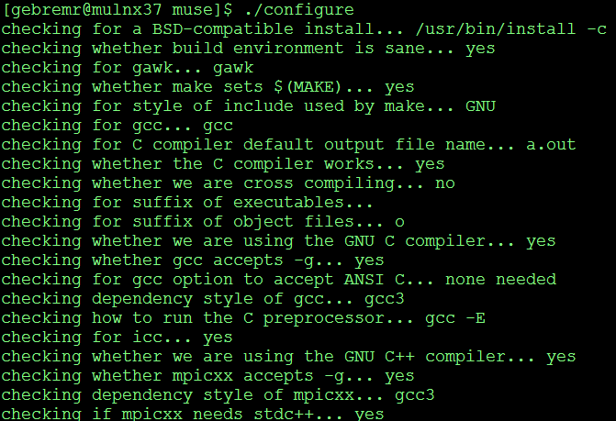

Figure 44 : Configure script running

When the script is complete and the system has all the needed dependencies all that is left to do is run the *make* command and MUSE source will compile. Run the following command.

*make*

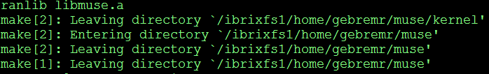

Figure 45 : MUSE finish compiling

The figure above show what the user should see if MUSE compiled correctly. At this point the user has installed, configured, and compiled MUSE and the provided examples.

## Background on Ping-Pong Simulation

This section will describe the case problem in more detail. Ping-Pong simulation is meant to be an easy simulation that can be implemented and at the same time be used as a learning tool to understand MUSE API. A simulation of a rally between two ping-pong players is developed. When a player receives a ball, the player will return the ball to the opposite player. The simulation will go on for a given amount of time. At the end of the simulation the user will know how many times each player hit the ping-pong ball. Hence, this simulation needs a ping-pong player, a ping-pong ball and an ability to maintain the number of balls each player returns.

## Implementing Ping-Pong Simulation

Implementing a simulation with MUSE is very easy and enjoyable. One of the requirements was ease of use. Development with MUSE is very intuitive. To get started, first setup the project; here the MUSE code generator is used. The MUSE code generator was explained earlier, so create the project and call it *PingPong* with the following command.

*python MUSE_ROOT/tools/muse_code_generator/muse.py create project PingPong*

The above command, replace *MUSE_ROOT* with the path to directory that holds MUSE source code and examples. The following figure shows what happens after the *create project* command is executed.

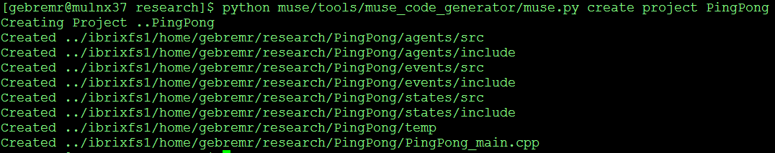

Figure 46 : Creating project with code generator

During the description of the MUSE code generator, there was a talk of the ability to create *makefile* on the fly. Change into the *PingPong* directory, which is the project directory. The following command is to create the *makefile* for this example.

*python MUSE_ROOT/tools/muse_code_generator/muse.py create makefile MUSE_ROOT*

With two commands, the MUSE code generator has created and setup a MUSE project. Now the user can compile the code by running *make* command. Once the user compiles the project, run the main stub class. This will verify everything went well and the following figure is the output the user should see.



Figure 47 : Executing stub file generated by code generator

Most of the hassle with most simulation framework is getting started and setup. MUSE handles all of the setup, so the user can just get started on development. From here on, development will be from bottom up. The user starts by creating the class that holds the information for each ping-pong player. In MUSE, this is represented with the *State* class. Create a class called *PingPongState*. This class inherits from the base class *State* and will house our information about the player.



Figure 48: The State class

The state can be seen as all information needed to be known about an agent at any given time. The state by definition should not be anything that is static and can change at any time. The amount of information in the state can shrink or grow. Therefore, the user should put any data that needs to be modified in the state. There are only two public methods in the *State* class. The information stored in the state can change, so a method needs to be created to record at what time the information was changed. The MUSE kernel automatically handles this, but you can get the time stamp of the state by invoking the *getTimeStamp()* method. The most important method, which is heavily used by the kernel is the *getClone()* method. This method is declared virtual and must be implemented by the subclass. Not implementing this method will give unknown behaviors, which will cause MUSE to abort. Typically for classes that have primitive types only, a shallow copy is sufficient, however class with pointers or objects as variables should implement deep copy to return a proper clone. Once the user subclass from the *State* class, the user should feel free to add any data type needed. A good rule of thumb is to try and minimize the information required for the time it is needed. The user can really improve simulation time by wisely using different versions of the same state. If the state has static data, refactor it to the agent class. If the data never changes there is no sense in having multiple copies. The *getClone()* method also must return a pointer to a heap allocated object. If the kernel calls for a clone it will handle disposing the memory, however, if the user calls for a clone the user must remember to release the memory. State cloning is very important; the kernel depends on these clones for storage purposes. If there is ever a rollback, MUSE can revert to a safe state from the past.

Reverting back to the example, create a stub *State* class with the MUSE code generator. The following command will generate *PingPongState* class.

*python MUSE_ROOT/tools/muse_code_generator/muse.py create state PingPongState*



Figure 49 : Creating state with code generator

In the header file of the *PingPongState* class, add a variable to keep track of the number of balls each ping-pong player hits. Figure below is what the header file looks like.

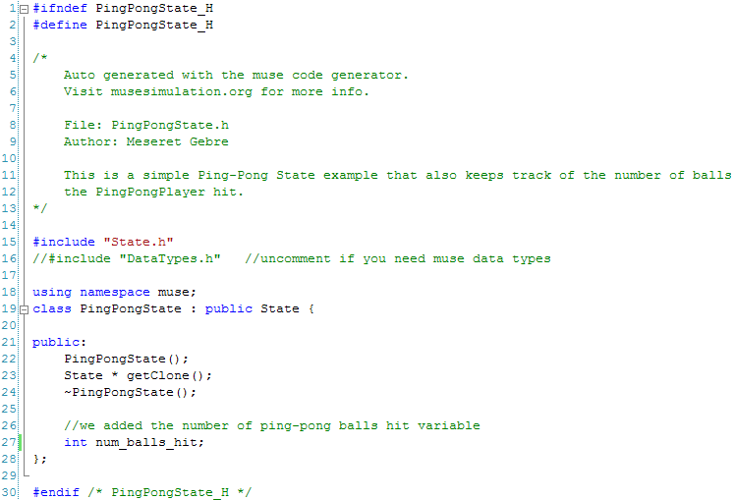

Figure 50 : PingPongState file created with code generator

The only thing added was the variable (shown by the green arrow above) the rest was generated. Moving on to the source file, implement the *PingPongState::getClone()* method and initiate the *num_balls_hit* variable to zero. The resulting figure is what the code looks like.

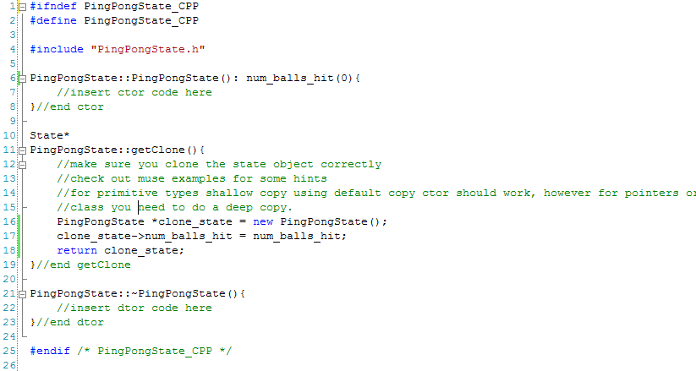

Figure 51 : PingPongState generated header file

With only five lines of code added, the *PingPongState* class is complete. Now there is a way to store the player stats. Next step is to create a ball for the player to hit back and forth. Essentially the ball will be an event in a MUSE simulation. In the simulation players will send each other events and when players receive an event, it can be thought of as a ping-pong ball.

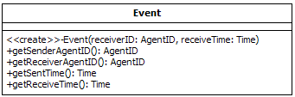

Figure 52: The Event class

The *Event* class has four public methods for the user. The only way to create an *Event* object is to heap allocate it. Once an Event object is created, the user can probe the object for certain types of information. To get the *AgentID* of the agent that sent the event, use the *getSenderAgentID* method. Likewise, figuring out the receiving agent of the event is done by invoking the *getReceiverAgentID* method. The user can also get the sent time or receive time of the event by invoking the *getSentTime* or *getReceiveTime* method. However, one thing that still left unexplained is the custom MUSE defined primitive types. For example, the *getSenderAgentID* and *getReceiverAgentID* methods return an *AgentID* type. The *getSentTime* and *getReceiveTime* methods return a *Time* type. All of MUSE types can be used if the *DataTypes* header file is included.

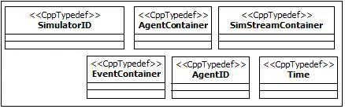

Figure 53 : DataTypes header

Figure 53 above shows the available MUSE defined data types. *SimulatorID* is used to identify kernels in the simulation. When the user initializes the kernel, it automatically assigns itself a *SimulatorID*. *AgentContainer* is used to store agent pointers. The *Simulation and Scheduler* class uses this to contain the registered agents. A discussion on how *Agent* classes can write to any *SimStream* based class was given. The *Agent* class uses the *SimStreamContainer* to store registered *SimStream* based classes. When it is time for an agent to execute its events for any given time, it is passes an *EventContainer*. These are used to store events for processing. It is up to the agent to iterate through the container and process each event accordingly. All the containers are just typedef STL containers and can be used just like the STL containers. As of this writing all the container discussed are of type *std::vector* which hold pointers to the class they contain. *AgentID* are just like *SimulatorID*, but they are used to identify agents. All IDs should be globally unique. This is left for the user to define. *Time* is the last data type, this is used to describe the time in the simulation. Benefits of MUSE defined data types are very clear when you view the code. Parameters are very clear and understandable, for example:

1. void foo(Time t1, AgentID id1, SimulatorID id2);
2. void foo(double t1, int id1, int id2);

Uninformative variable names were chosen intentionally and most of the times this is how naive developers code. However, with the first example one can clear understand what each variable represent, because the data types are themselves informative. The second example leaves a lot to the code reader to try and guess. This is a very simple example. There are methods that take many parameters and these are when the developer truly see the benefits.

In the ping-pong simulation the ball is represented by creating an *Event* class called *Ball*. To create the *Event* based class *Ball*, use the MUSE code generator and execute the following command in our shell prompt.

python ../muse/tools/muse_code_generator/muse.py create event Ball



Figure 54 : Creating Ball event with code generator

For this example, the *Ball* event does not need to carry additional information. When the player agent receives the *Ball* event, the player must create a new *Ball* event and send it back to the opposite player. Also, all events that are in the simulation are automatically cleaned up by the kernel at the end of the simulation. The following two figures show what the source and header file should look like for the *Ball* class.

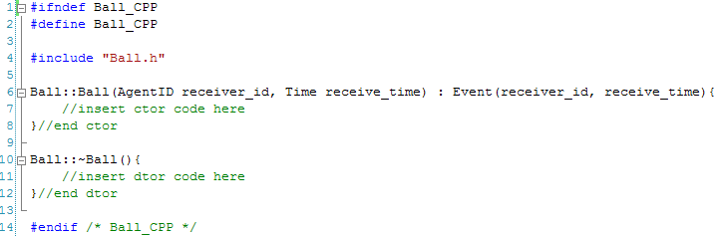

Figure 55: Ball class generated source file

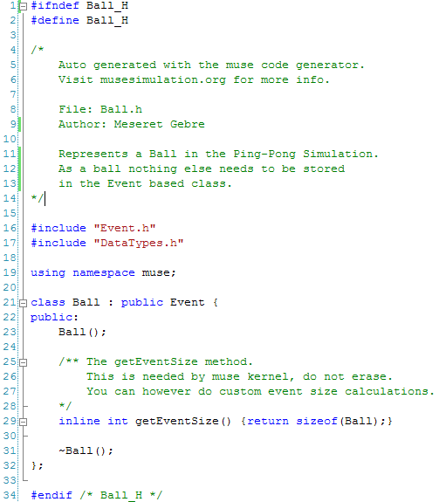

Figure 56: Ball class generated header file

The *Event* based class *Ball* is complete and up to this point (besides commenting code) only five lines of code was added. Next, create the ping-pong player. In term of MUSE, representing a ping-pong player is accomplished with the *Agent* class.

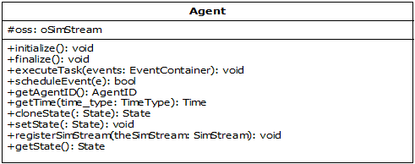

Figure 57 : The Agent class public methods

The *Agent* class is a base class provided to represent agents in the simulation. Agents are autonomous and independent; this *Agent* class handles most of the heavy lifting for the user. There are a couple of important things to understand about the *Agent* class. The first three methods, the destructor, and the *cloneState* from figure 57 above are declared virtual methods and should be implemented by the subclass. The *initialize* method should contain information and procedures to initialize the agent. When the simulation is started, the kernel will invoke all *initialize* methods of all the agents that are registered. Likewise, the *finalize* methods should store information and procedures to finalize and end the agent class. The kernel will call the *finalize* method when it is finalizing. Figure 58 below visually shows this process.



Figure 58 : Sequence of initializing and finalizing an agent

The most important method is the *executeTask(events).* This is the only way you communicate with the agent. In parallel simulation, the developer does not have the luxury of having pointers to the agent with which to communicate. The subclass should handle the event(s) it gets accordingly. The *Scheduler* class will inform the agent when it is time to process its next set of events and these are the event(s) the agent gets. When an agent creates an event, it must use the *scheduleEvent(event)*  to schedule that event. This method handles all the work of determining the receiver agent’s location and how to get it there. To get the identifier of the agent, use the *getAgentID()* method. Agent class also provides the user with time information. The *Agent* class allows the developer to grab three different times, based on what parameter pass into the *getTime(TimeType)* method. *TimeType* is an enumeration which contains *LVT, LGVT, and GVT*. Default parameter is the *LVT* (local virtual time). However, the agent can get the *LGVT* (local global virtual time), this is the least *LVT* of all agents registered to the kernel. *GVT* (global virtual time) is the least *LGVT* throughout all the kernels. Most operation just need to call *getTime()*, because the *LVT* is sufficient. The figure below visual explains the different time types. An option to get a clone of the agent’s state is available through the *cloneState(state).* To get a pointer to your current state, just call the *getState()* method. Another method that is available is the *setState(state)* method.

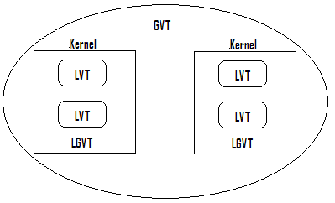

Equals smallest LVT

Agent’s LVT

Equals smallest LGVT

Figure 59 : getTime method time types

Briefly, again, the state of an agent is just a collection of data that can be modified through the life cycle of the simulation. Accordingly, there are cases when all the information is not needed at once. For example, running the simulation and creating a person agent as a baby, there is no need to store information about the person’s school grades or what type of car the person drives, yet. When it comes time to fast forward this persons age to say twenty-one then the information mentioned above become significant. Therefore, there should be many different types of states and should be switched based on the need of the information. The advantage becomes evident with the space savings, which increases performance. The last method publicly available is *registerSimStream(SimStream).* Running simulations is about gathering data. MUSE allows the modeler to extract the data to any stream that has a stream buffer. An explanation on how to properly use the *SimStream* is presented later in this section. That sums up the *Agent* class public API. Now implementation of a ping-pong player as an agent is possible. Using MUSE code generator, the following command generates the header and source file for the *PingPongPlayer* class.

*python ../muse/tools/muse_code_generator/muse.py create agent PingPongPlayer*



Figure 60 : Creating PingPongPlayer agent with code generator

The *PingPongPlayer* class is very simple; hence the default header file generated by MUSE code generator can stay unmodified. The following is what the implementation should look like.

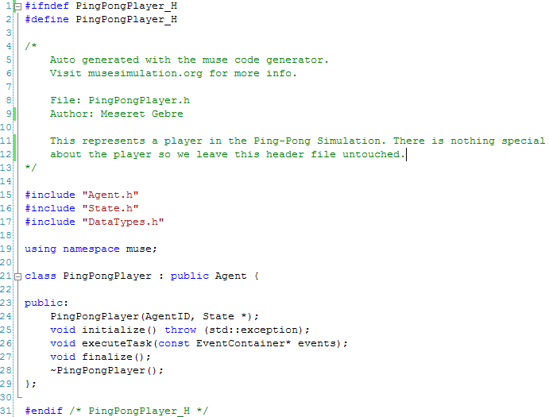

Figure 61 : Generated PingPongPlayer header file

The source file that was generated will have to be modified. In the simulation, there will be two players. The first player will have an *AgentID* assigned to zero, the second player *AgentID* is assigned to one. The *initialize* method in *PingPongPlayer.cpp* will get the simulation started by letting the player with *AgentID* zero start by hitting the ball first. The next method to implement is the *executeTask* method. There are three actions that must be taken care of in the executeTask method. First, grab a hold of the agent’s state to modify the player’s stats. Second, create a new *Ball* event. Lastly, send the ball to the other agent. The *finalize* method will simply print out the player’s stat. This will be the number of time the player hit the ping-pong ball. Since this is a simple example the default implementation of the *cloneState* method in the *Agent* base class should suffice. The following figure is what the implementation should look like.

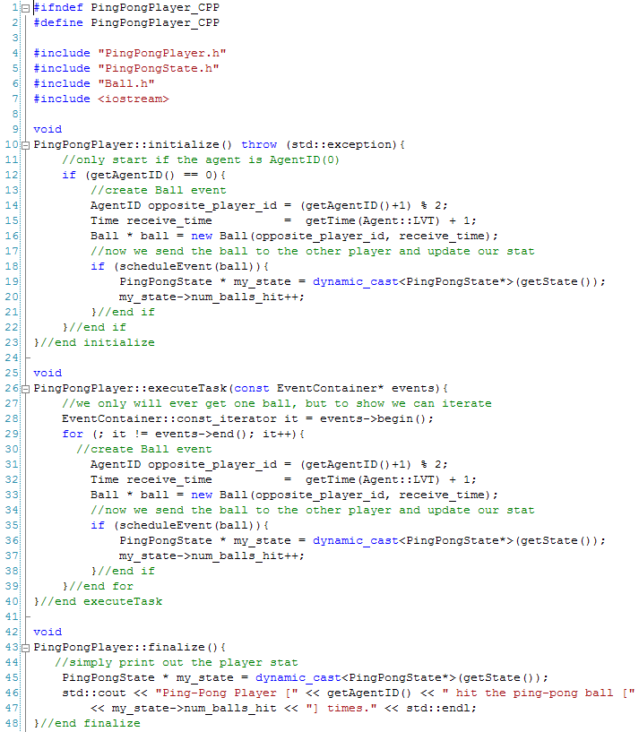

getState returns a pointer to State, cast this to a PingPongState pointer.

Don’t forget to include

Figure 62 : PingPongPlayer source file

The PingPongPlayer class is now complete and with the help of MUSE code generator only sixteen lines of code in the source code were added. The last piece needed to have a MUSE simulation is the main execution code. When creating the *PingPong* project earlier, MUSE code generator also created a main execution file called *PingPong_main.cpp*. To understand what is contained in the main file learning the public methods of the *Simulation* class is necessary.

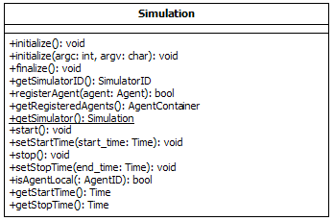

Figure 63 : Simulation Class

Figure 63 above shows all the public available method in the *Simulation* class. When the user runs a simulation with MUSE there is a common order of methods that must be called. First, request an instance of the *Simulation* class. *Simulation* class implements the singleton pattern, so to get an instance use the *getSimulation* method. This will return a pointer to the class. Once an instance is acquired the user should initialize the instance. This can be done with two methods. The first option is the *initialize* method. The second is the *initialize(argc,argv).* This lets the user pass in arguments from the main executable. The arguments are not used in anyway by the kernel, but they are passed in to init MPI. When the simulation kernel is initialized it will attain a valid *SimulatorID*. It is important to note that initialization should only happen once. After initialization is complete, set the start and stop time of the simulation. This can be done with the *setStartTime(Time start)* and *setStopTime(Time stop)* methods. After this point the user should create and register the agents with the simulation kernel. The *registerAgent(Agent * agent)* method is used to let the kernel know of agents that it is responsible for. The simplest step, which gets the entire simulation started, is the *start* method. Lastly, the user needs to make sure that all agents and internal resources are freed. Calling the *finalize* methods releases all of the internal resources and external resources like the agents and events created. The remaining public methods are just getters, which are self explanatory. The following figure 64 is a sequence diagram to visually show what was just described.



Figure 64 : Sequence Diagram of starting a simulation

Keep in mind that the Simulation class calls other classes that were not shown, but more sequence diagrams are presented as needed.

In the example, MUSE code generator already created and called most of the methods. All that is left is to register the two ping-pong players. The players should reside on two different nodes. Hence, use the *SimulatorID* to figure out which kernel to register each ping-pong player. The following is what PingPong_main.cpp should look like.

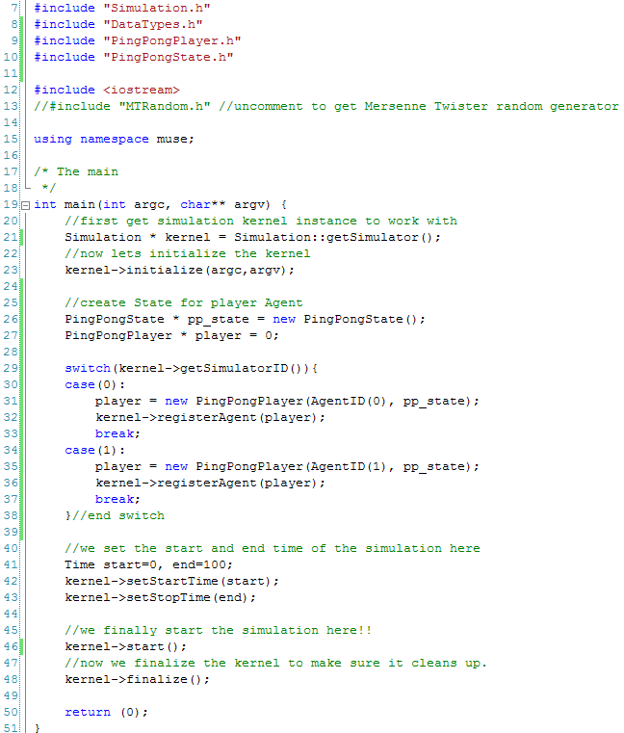

Don’t forget to include

Added Code

Figure 65 : PingPong Main executable file

The main executable source is not complete. Only twelve lines of code were added to the main file. In total only thirty-three lines of code were implemented. Hence, out of the 241 lines of code, 90% was done with MUSE code generator. This is yet another example how simple making models with MUSE. To run the final simulation, recreate the *makefile*, compile with the make command, and run the main execution file.



Figure 66 : Running Ping-Pong example

Using the default stop time for the simulation, the simulation runs for 100 time steps. The simulation shows that each player hits the ball 50 times each. MUSE also prints out some statistics about each *Agent* class. For each agent, it is known that there were a total of 50 events scheduled and 50 events were committed. There were no rollbacks, which makes sense and the total number of MPI messages used is 50. This is because the agents resided on two different nodes.

# Benchmarking

This section will go into empirically testing and benchmarking MUSE. In the next five subsections of this chapter, first a description of the case study for the experiments is given. Second, subsection shows implementation snippets of PHOLD for each framework in used in the tests. These frameworks, beside MUSE, will be MASON and WARPED. In the third subsection, a description about the metrics used is given. Fourth subsection is a talk on the data gathered from empirically testing MUSE. Finally, a talk on the benchmark results is presented.

## Synthetic Simulation PHOLD

Being a distributed framework, there is high interest in the scalability and efficiency of MUSE. For the experiments, implementation and testing is done with PHOLD (Fujimoto). PHOLD is supposed to synthetically test the typical workload of each agent in a simulation. It also allows you to scale and fine tune many variables to observe the impact in the simulation framework. For the tests, PHOLD will be an *X x Y* agent grid, where each agent in the grid will have four neighbors. When the simulation starts, each agent initializes by sending *N* events to itself. The *N* events have a random receive time for the future, with a max receive time defined by the variable *Delay*. During PHOLD simulation, when an agent receives an event, the following takes place.

1. Randomly select which neighbor to send the next event to.
2. Randomly choose a receive time from 1 to *Delay*.
3. Create and send the event.

This process happens for each agent until the simulation is over. The following figure 67 visually shows the PHOLD process. Since MUSE is distributed the different color agents represent the node they reside in. Hence, the figure shows a 3 x 3 grid of agents each color represents a compute node or a different process.

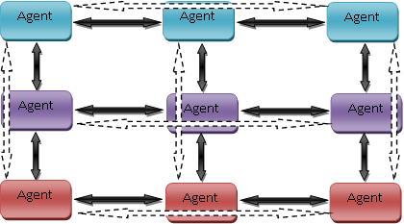

Figure 67 : 3 x 3 PHOLD simulations on three compute nodes

There are different variables that can be adjusted. Depending on the variable adjusted different behaviors are observed. The following are the different variables that can be adjusted:

* *X*, this is the number of columns to have in the PHOLD grid
* *Y*, this is the number of rows to have in the PHOLD grid
* *N*, the number of events each agent sends every time.
* *Delay*, the maximum receive time that an agent can schedule an event for.
* *Nodes*, the number of compute nodes to use for the PHOLD simulation.

The experiments will be held on a cluster which houses 128 compute nodes. The spec of each compute node is shown below.

|  |  |
| --- | --- |
| Component | Details |
| CPU Model | Intel Xeon (x2) |
| CPU/Core Speed | 3.0 GHz (x2) |
| Main Memory (RAM) size | 4 GB |
| Operating system used | Linux 2.6.9-22.ELsmp |
| Interconnect type & speed (if applicable) | Infiniband @ 20Gbps |

## 5.2 Implementation and Code Snippets

This section presents the implementation code for each framework. The first implementation will be for MUSE.

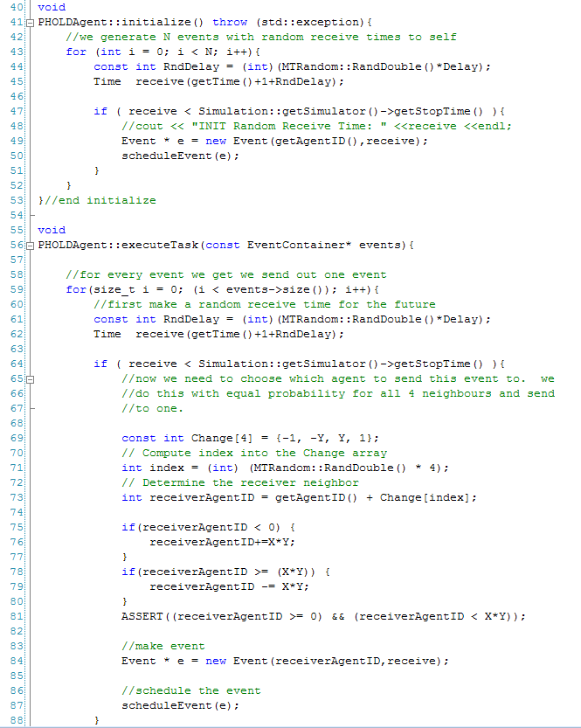

Figure 68 : PHOLD implementation for MUSE

The next implementation is for the WARPED framework. Note that the implementation is almost identical to MUSE. However, the terminology is different. For example, when dealing with Time Warp a Logical Process is similar to an agent. However, WARPED associated a Logical Process with a process or a compute node. This can get very confusing because the terminology that WARPED uses is not common. The following is an implementation of PHOLD in WARPED.

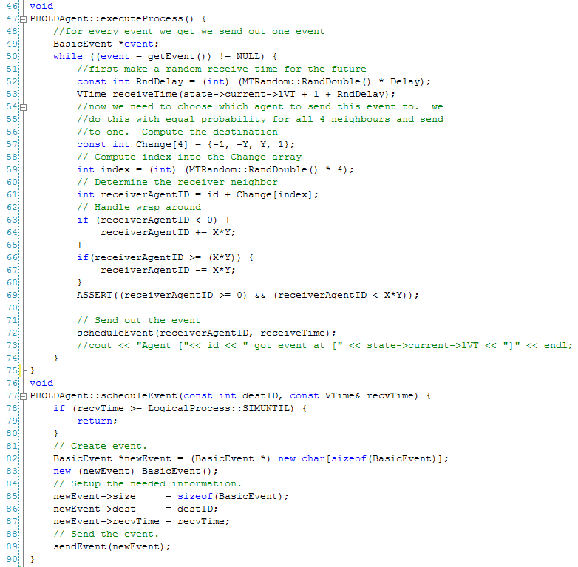

Figure 69 : PHOLD implementation for WARPED

MASON uses Java as a language and is not a distributed framework. MASON works differently. To create a model the user must create a class that extends the *SimState* class and to create an agent the user implement the *Steppable* interface. The following figure is the implementation of the PHOLD class which extends the *SimState* class.

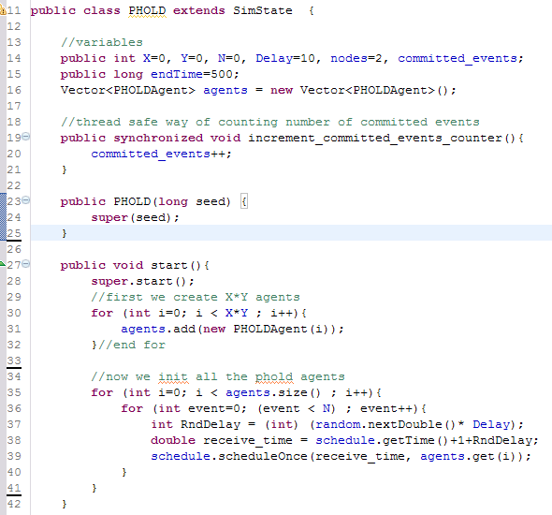

Figure 70 : Section of PHOLD class for MASON

To get the MASON simulation started, the *start* method (figure 2 lines 27-42) must be implemented. The agents in PHOLD simulation are initialized (figure 2 lines 35-41) just like the other two frameworks. Since there is no concept of “events” the agents actually just schedule themselves to be step on at random future times. When an agent is step on it randomly chooses the next agent to step on and schedule that agent for a future random time. This process is repeated until 500 steps are complete. Notice for MASON there will always be at least 500 steps unlike MUSE or WARPED, where the *LVT* affects the number of time steps the framework makes. The following figure is a snippet of the *PHOLDAgent* class.

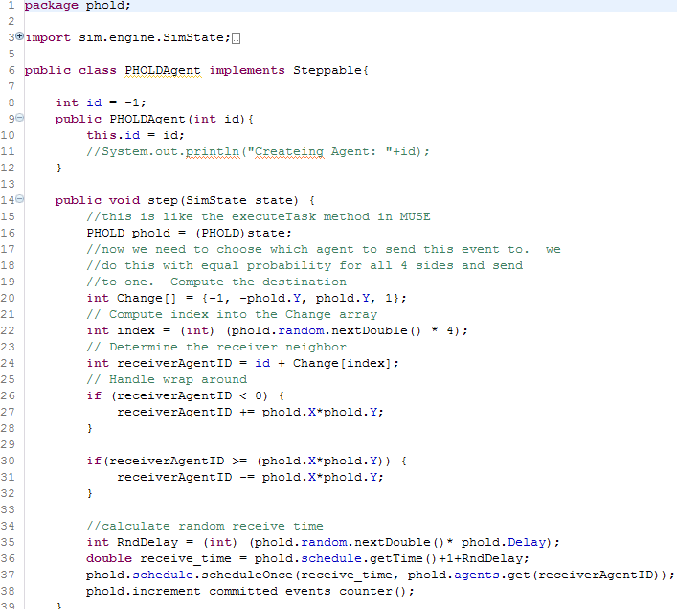

Figure 71 : PHOLDAgent class snippet for MASON

## 5.3 Metrics used for MUSE analysis

The execution time of parallel algorithms depends on, the number of processing elements and the amount of communication between the processing elements. A metric focuses on a single aspect of a given algorithm. A single metric is typically insufficient for complete analysis and comparison of various algorithms. Several metrics are used for comparing and analyzing computational complexity of parallel programs.

Parallel programs typically do not scale linearly. This is mainly due to various overheads in parallel programs. Various possible factors that lead to overheads in parallel programs are:

* Inter process interactions: Processing elements generally interact and communicate data between one another. This form of interaction involves some amount of time being spent when the data communicated is waiting in the buffer to be sent or received (Grama, Gupta and Karypis).
* Idling of processing elements: Processing elements may go to idle state at certain instances due to synchronization. This is mainly due to the fact that it is difficult to predict the size of subtasks assigned to various processing elements (Grama, Gupta and Karypis).
* Excess computation: The difference in computation performed by a parallel program and the best serial program is the excess computation overhead incurred by the parallel program. Parallel program generally has to perform various tasks that in excess when compared to the serial program. This is mainly due to the fact that certain intermediate results cannot be re-used since they have been produced by various processing elements (Grama, Gupta and Karypis).

It is therefore important to study the performance of a parallel program and generate metrics that can be based on the comparison of a parallel program to its serial counterpart. Commonly used metrics for this purpose are as follows:

* Execution Time
* Speed up
* Efficiency
* Scalability

Execution time can be calculated for both the parallel algorithm and its serial counterpart. The serial runtime *(Ts)* is the wall clock time elapsed between the beginning and end of an execution of a sequential program, while the parallel runtime *(Tp)* is the time elapsed from the moment a parallel computation started to the time when the last processing element finished execution. Generally, parallel runtime has to be less than serial runtime for a reasonable size of input for the parallel program to be efficient.

A general interest while running a parallel program is to determine the performance gain that is achieved on parallelizing an application. Speedup is a metric that can be used for this purpose. Speedup is the ratio of time taken to solve a problem on a single processing element to the time required to solve the same problem on a parallel computer with *p* identical processing elements (Grama, Gupta and Karypis). More formally, speedup is defined as the ratio of serial runtime to the parallel runtime.

*S=*

Theoretically, speedup should not exceed the number of processing elements. However, there are cases when speedup exceeds the number of processing elements, in which case it is called super linear speedup (Grama, Gupta and Karypis). This could mainly happen due to:

* Super linearity effects from caches: when program data is large and cannot be cached. In such cases, each individual process executes much faster compared to its serial counterpart (Grama, Gupta and Karypis).
* Super linearity effects due to exploratory decomposition: happens when the problem space is partitioned; once a parallel version identifies a solution, the parallel program terminates (Grama, Gupta and Karypis).

An ideal parallel system containing *p* processing elements can deliver a speedup equal to *p*. An ideal behavior is difficult to achieve since the processing elements are unable to devote 100% of their time to the computation of an algorithm. It is due to this reason a metric such as efficiency is used. Efficiency can be used to determine the percentage of time for which a processing element is useful (Grama, Gupta and Karypis). It is the ratio of speedup to the number of processing elements.

*E=*

In an ideal system, speedup is equal to *p* and efficiency is 1. In practical applications, speedup is generally less than *p* and efficiency is a value between 0 and 1.

An important metric used for evaluating the efficacy of a parallel algorithm is scalability. Scalability is defined as the measure of capacity of parallel program to increase its speedup in proportion to the number of processing elements and the size of the problem (Grama, Gupta and Karypis). A program is said to be scalable if it continues to remain efficient as the number of processing elements increases. Scalability and Efficiency are related metrics. An inefficient program is not a scalable program. In general, scalability focuses on the ability of a parallel program to maintain efficiency when both the problem size and the number of processing elements are simultaneously increased.

A common phenomenon seen in parallel programs is a decrease in efficiency as the number of processing elements is increased. In many cases, the efficiency of a parallel program increases if the problem size is increased while keeping the number processing elements a constant. This is a highly desirable concept that is expected of parallel programs. These metrics will be used to obtain data to help figure scalability and efficiency of MUSE.

## 5.4 Empirical evaluation of MUSE

This section presents an empirical evaluation of MUSE. Specifically, experimental results are presented to illustrate the scalability and efficiency of MUSE. The empirical evaluation has been conducted using the PHOLD benchmark by varying its controllable variables. For benchmarking, experiments were initially conducted using a square grid consisting of 512 x 512 (262,144) agents participating in PHOLD. In subsequent experiments the number of compute nodes was increased in powers of two starting from one compute-node. The tests were run five times to obtain average run times for each configuration. The number of agents was held at a constant value of 512 x 512 for these experiments. The *N* value for each agent was set to three and the *Delay* was set to ten units of simulation time. The simulation was run for 500 time steps. The control variable in the experiments was the number of compute *Nodes* used for parallel simulation. The table below shows the execution times for each check point.

|  |  |  |  |  |  |
| --- | --- | --- | --- | --- | --- |
| Agents | Events | Delay | Nodes | End Time | Execution Time (seconds) |
| 512 x 512 | 3 | 10 | 1 | 500 | 1663 |
| 512 x 512 | 3 | 10 | 2 | 500 | 645 |
| 512 x 512 | 3 | 10 | 4 | 500 | 291 |
| 512 x 512 | 3 | 10 | 8 | 500 | 142 |
| 512 x 512 | 3 | 10 | 16 | 500 | 65 |
| 512 x 512 | 3 | 10 | 32 | 500 | 33 |

Table 5: Execution times with increasing nodes

Figure 72 : PHOLD trend with increasing nodes on MUSE

From the table and figure above calculation of speedup and efficiency is possible. The serial program used is the execution time obtained from running PHOLD on MUSE with one node. Hence, the serial runtime *Ts* = 1663 seconds. The observed speedup and efficiency of PHOLD simulation is shown in the table below.

|  |  |  |  |  |
| --- | --- | --- | --- | --- |
| Agents | Nodes | Execution Time (seconds) | Speedup | Efficiency |
| 512 x 512 | 2 | 645 | 2.578295 | 1.289147 |
| 512 x 512 | 4 | 291 | 5.714777 | 1.428694 |
| 512 x 512 | 8 | 142 | 11.71127 | 1.463908 |
| 512 x 512 | 16 | 65 | 25.58462 | 1.599038 |
| 512 x 512 | 32 | 33 | 50.39394 | 1.574811 |

Table 6 : PHOLD on MUSE with increasing nodes results

Figure 73 : Speedup on MUSE

Figure 74 : Efficiency on MUSE

An ideal speedup is equal to the number of nodes used to run the parallel algorithm. However, there was also a mentioned of special cases were the speedup is greater than the number of nodes used earlier. The PHOLD simulation on MUSE observed super linear speedup. This caused the efficiency to be greater than one. These great results are thanks to the reduction in rollbacks by using the optimization trick WARPED uses. Another is the use of data structure for scheduling. From these results one can conclude that MUSE is very efficient for very large models. Another important detail to notice is that as the number of nodes increased, MUSE efficiency did not drop, but instead increased as well. These results are very desirable as previously mentioned. However, in order to calm MUSE as being scalable, one more experiment has to be performed.

The next experiment is to check if the trend for execution time stays consistent. Here, the idea will be to adjust the number of nodes while trying to maintain the number of agents to compute node ratio roughly consistent. Starting from one node and moving up to 32 nodes in power of twos. Also incrementing our agents such that at any given configuration each compute node works with around 8000 to 10,000 agents. The table below shows the results obtained.

|  |  |  |  |  |  |
| --- | --- | --- | --- | --- | --- |
| Agents | Events | Delay | Nodes | End Time | Execution Time (seconds) |
| 100 x 100 | 3 | 10 | 1 | 500 | 32 |
| 200 x 100 | 3 | 10 | 2 | 500 | 33 |
| 200 x 200 | 3 | 10 | 4 | 500 | 34 |
| 400 x 200 | 3 | 10 | 8 | 500 | 34 |
| 400 x 350 | 3 | 10 | 16 | 500 | 33 |
| 700 x 400 | 3 | 10 | 32 | 500 | 35 |

Table 7 : Execution time with increasing agents and nodes

Figure 75 : PHOLD on MUSE with increasing nodes and agents

The first experiment observed super linear speedup and excellent efficiency with MUSE. The second experiment proved that as the number of agents increased and the number of nodes increased, execution time remained comparatively constant. This nice trend is that last piece of data needed to conclude that indeed MUSE is a very scalable framework.

## 5.5 Benchmarking MUSE

Empirical testing showed that MUSE is very efficient and scalable. This section compares MUSE against WARPED and MASON. MUSE empirical evaluation showed that as the model grew MUSE was still showing super linear speedup. This implies that the true strength of MUSE is exposed even more as the model gets larger. MASON and WARPED use different concepts, when dealing with the simulation as a whole. MASON for example, can only work with one process. All the agents have direct access to all other agents in the simulation. Also there is no concept of an “Event”. MASON uses conservative synchronization; these features make the framework very fast for small models. Lastly, MASON has multi-threaded capabilities. This means that if agents can execute independently, then the different threads can be used to run them concurrently. However, MASON cannot maintain its impressive speed with very large models like MUSE can, this is because as the model grows, the overhead to synchronize becomes very costly. On the other side of the spectrum is WARPED. WARPED has some similarities to MUSE, for example, WARPED uses Time Warp for synchronization. It is also a distributed framework like MUSE. However, it is not an agent-based framework. The first benchmark is MUSE vs. Warped and then MUSE vs. MASON.

Since WAPRED is distributed and uses Time Warp, a direct execution time comparison is used. PHOLD will be the simulation for the benchmark. The following will be the variables used in the benchmark.

* X x Y = 256 x 256
* N = 3
* Delay = 10
* Nodes = {1,2,4,8,16,32}
* End Time = 500

The PHOLD simulation started with one node and increased nodes by powers of two. The following is the table with the results from the simulation.

|  |  |  |  |  |  |  |
| --- | --- | --- | --- | --- | --- | --- |
| Agents | Events | Delay | Nodes | End Time | MUSE Execution Time (seconds) | WARPED Execution Time (seconds) |
| 256 x 256 | 3 | 10 | 1 | 500 | 273 | 156469 |
| 256 x 256 | 3 | 10 | 2 | 500 | 137 | 35390 |
| 256 x 256 | 3 | 10 | 4 | 500 | 62 | 7006 |
| 256 x 256 | 3 | 10 | 8 | 500 | 30 | 1226 |
| 256 x 256 | 3 | 10 | 16 | 500 | 16 | 184 |
| 256 x 256 | 3 | 10 | 32 | 500 | 9 | 61 |

Table 8 : 256x256 PHOLD on MUSE and WARPED

WARPED ~1 min mark.

MUSE ~1 min mark.

Figure 76 : PHOLD Simulation on MUSE and WARPED

Benchmarking MUSE vs. WARPED reveals many interesting facts. First, remember that they are both distributed frameworks. This means that the more nodes added to a steady size model the runtime will increamentally execute faster. Using this point of view, the results show that WARPED needed 32 nodes to reach the approximate one minute mark. In contrast, MUSE only need four nodes. This fact indicates that MUSE is far more scalable and efficient, because MUSE utilizes more of the compute node and thus needs far less nodes. There was also a mention that MUSE true strenght is with very large models. The 256 x 256 PHOLD simulated was a model that consisted of 65,536 agents. From WARPED point of view this turned out to be a very large model and in terms of runtime, MUSE execution time with one node was about 572 times faster. This is more evidence which indicates MUSE data structures are indeed much better with large models.

The next set of experiment will be used to benchmark MUSE vs. MASON. Since MASON uses different concepts as discussed earlier, the experiments are broken into two steps. MASON is a light weight and impressively optimized agent-based simulation framework. Hence, the first experiment will be a direct comparison on one compute node with increasing number of agents. This should show the difference in overhead that a distributed framework has to incur. Comparison will go until a 512 x 512 agent’s grid on PHOLD. MASON best time for PHOLD on a 512 x 512 grid will be used for the second experiment.

|  |  |  |  |  |  |  |
| --- | --- | --- | --- | --- | --- | --- |
| Agents | Events | Delay | Nodes | End Time | MUSE Execution Time (seconds) | MASON Execution Time (seconds) |
| 100 x 100 | 3 | 10 | 1 | 500 | 30 | 5 |
| 150 x 150 | 3 | 10 | 1 | 500 | 78 | 10 |
| 200 x 200 | 3 | 10 | 1 | 500 | 148 | 20 |
| 256 x 256 | 3 | 10 | 1 | 500 | 267 | 34 |
| 300 x 300 | 3 | 10 | 1 | 500 | 379 | 55 |
| 512 x 512 | 3 | 10 | 1 | 500 | 1663 | 171 |

Table 9 : MUSE vs. MASON on one node

Figure 77 : MUSE vs. MASON PHOLD with one node and varying agents

Like any distributed program, MUSE has overhead that is incurred to take care of varying operations. As of this writing MUSE source code has not been optimized and from figure 77 the overhead proved to be costly. However, MUSE is very scalable and efficient. Therefore, for any large model amortizing the overhead cost over more compute nodes can ultimately out performing any serial framework. The second experiment is to see how many nodes it takes to outperform MASON’s runtime of 171 seconds. PHOLD variables used for this experiment are as follow.

* X x Y = 512 x 512
* N = 3
* Delay = 10
* Nodes = {5,6,7,16,32}
* End Time = 500

During the empirical evaluation of MUSE, PHOLD was already simulated with 512 x 512. Therefore, the runtimes for varying compute nodes is known and there has to be at least greater than four compute nodes to beat the best runtime from MASON (171 seconds). PHOLD was simulated and the number of compute nodes used was increased until the least number of compute nodes to outperform MASON’s runtime was observed. The remaining runs are there just to show the trend. The following are the results in table format.

|  |  |  |  |  |  |
| --- | --- | --- | --- | --- | --- |
| Agents | Events | Delay | Nodes | End Time | Execution Time (seconds) |
| 512 x 512 | 3 | 10 | 5 | 500 | 224 |
| 512 x 512 | 3 | 10 | 6 | 500 | 180 |
| 512 x 512 | 3 | 10 | 7 | 500 | 150 |
| 512 x 512 | 3 | 10 | 16 | 500 | 65 |
| 512 x 512 | 3 | 10 | 32 | 500 | 33 |

Table 10 : MUSE on PHOLD increasing nodes

After 7 nodes MUSE out performs MASON

Threshold line, to show MASON best time of 171 seconds on 1 node.

Figure 78 : MUSE outperforming MASON after 7 nodes

This experiment reveals some important details concerning MUSE. One disadvantage that comes to light is when benchmarking with one node. MASON can handle fairly large model with ease. MUSE’s runtime for a 512 x 512 PHOLD simulation was approximately 27 minutes. In contrast, MASON finished in just under three minutes. This is due to many reasons. First, MASON only works with one process; hence all agents can directly communicate. Second, there is no notation of “events”, so the overhead of maintaining “events” and making sure an agent can communicate in a distributed fashion is no longer there. However, there are important points to take from this benchmark. For any size model, MUSE will eventually outperform MASON for the following reasons.

1. The overhead incurred for maintaining “events” and a medium for agent communication is fixed, even as the model grows.
2. MUSE is very efficient and scalable, so as the model gets larger MUSE gets even faster than MASON.

# Conclusion and Future Work

Agent-based simulations are becoming ever more demanding and increasing is size. As of this writing there is no framework that supports parallel agent-based simulations. MUSE is purposed as a scalable and efficient solution. Railsback explored several agent-based simulation frameworks and described criteria for what a great agent-based framework should have at the very least. Among these criteria, documentation and ease of use was noted as being most important. After the development of MUSE the public API section 4 showed just how easy developing with MUSE is, this included the use of the MUSE code generator. Empirical evaluations in section 5.1 showed that MUSE achieved super linear speedup and excellent efficiency. These facts combined demonstrated MUSE as a very scalable framework. MUSE was benchmarked against a non-agent-based parallel framework (WARPED) and against a serial agent-based framework (MASON). Benchmarking against WARPED showed how efficient MUSE was because it needed far fewer nodes to achieve similar runtimes as WARPED, the results can be viewed in section 5.2. The next benchmark against MASON showed some of the limitations a distributed framework and of the Time Warp protocol. The first experiment was a direct comparison of the PHOLD simulation on one compute node. MASON serial implementation of PHOLD proved to outperform MUSE on a single compute node. However, the second experiment showed MUSE scalability and as the model gets larger MUSE will always come out on top because MUSE can effectively and efficiently make use of more compute nodes. Moreover the benchmark showed that for a PHOLD simulation with a size of 512 x 512 it took at least seven compute nodes to outperform MASON best serial time. There are many things that can be considered as future work.

In the MUSE core, there was no real optimization done. Like MASON, if MUSE was to use custom created data structures for the storage of events and states MUSE should be able to increase the performance in the one compute node benchmark. A future work can be to learn all the optimization done in MASON and port those tricks over to MUSE. Making the single node benchmark as close as possible to that runtime of MASON will make MUSE even more scalable and efficient. Another future that is important is to add an API to handle visualization. Ways to visualize 3D and 2D simulations would be a great benefit to the overall framework. Simulations that are very popular with agent-based frameworks are spatial based simulations. Hence, a library to optimize communication between agents by wisely moving frequently communicating agents to the same compute node would be a great library.

# References

Bailey, M. and L. Snyder. A Model for Comparing Synchronization Strategies for Parallel . 1989.

Bonabeau, E. "Agent-based modeling: methods and techniques for simulating human systems." In Proc. National Academy of Sciences. 2001. 7280-7287.

Bryant, R. E. "Simulation on a distributed system." In Proc. Of the 16th Design automation Conference. 1979. 544-552.

Chandy, K.M. and J. Misra. "Distributed simulation: a case study in design and verification of distributed programs." IEEE Transactions on Software Engineering. September 1979. 440-452.

Chen, Gilbert and Boleslaw K. Szymanski. "DSIM: SCALING TIME WARP TO 1,033 PROCESSORS ." Proceedings of the 37th conference on Winter simulation. Orlando, Florida, December 2005. 346-355.

Cleary, John G. and Jya-Jang Tsai. "Conservative Parallel Simulation of ATM Networks." SIGSIM. July 1996. 30-38.

Collier, Nick. RePast: An Extensible Framework for Agent Simulation. Chicago: University of Chicago, n.d.

Das, D., et al. "GTW: A Time Warp system for shared memory multiprocessors." In Proceedings of the 26th Winter Simulation Conference. 1994. 1332-1339.

Das, Samir R. and Richard M. Fujimoto. "Adaptive memory management and optimism control in time warp." ACM Transactions on Modeling and Computer Simulation (TOMACS). April 1997. 239-271.

Fredman, M. L. and R. E. Tarjan. "Fibonacci heaps and their uses in improved network optimization algorithms." ACM (July 1987): 596-615.

Fujimoto, R.M. "Performance of Time Warp under Synthetic ." Proceedings of the SCS Multiconference on distributed Simulation. 1990.

Grama, Ananth, et al. Introduction to Parallel Computing (Second Edition). Addison-Wesley, n.d.

Hao, , Fang and Wilson,, Karen and Fujimoto,, Richard and Zegura,, Ellen. "Logical process size in parallel simulations." Proceedings of the 28th conference on Winter simulation. Washington DC: IEEE Computer Society, 1996. 45--652.

Jefferson, David R. "Virtual Time." ACM Transactions on Programming Languages and Systems. UCLA, July 1985. 404-425.

Kühl, Dietmar. Dietmar Kühl's Homepage. 10 January 2009 <http://www.dietmar-kuehl.de/cxxrt/heaps.tar.gz>.

—. Dietmar Kühl's Homepage. 10 01 2009 <http://www.dietmar-kuehl.de/cxxrt/heaps.tar.gz>.

LIN, YI-BING and EDWARD D. LAZOWSKA. "A study of time warp rollback mechanisms." ACM Transactions on Modeling and Computer Simulation (TOMACS). January 1991. 51-72.

Luke, Sean, et al. "MASON: A New Multi-Agent Simulation Toolkit." In Proceedings of the Eighth Annual Swarm Users/Researchers Conference. 2004.

Macal, C. M. and M. J. North. "Tutorial on agent-based modeling and simulation." In Proceedings of the 37th Conference on Winter Simulation. 2005. 2-15.

Matsumoto, Makoto and Takuji Nishimura. "Mersenne Twister: A 623-dimensionally equidistributed uniform pseudorandom number generator." ACM Transactions on Modeling and Computer Simulations: Special Issue on Uniform Random Number Generation. 1998. 3-30.

Mattern, Friedemann. "Efficient Algorithms for Distributed Snapshots and Global Virtual Time Approximation." Jornal of Parallel and Distributed Computing. 1993.

Minson, R. and G. K. Theodoropoulos. "Distributing RePast Agent-Based Simulations with HLA." European Simulation Interoperability Workshop. 2004.

MPI-2: Extensions to the Message-Passing Interface. 18 October 2008 <http://www.mpi-forum.org/docs/mpi-20-html/mpi2-report.html>.

N., Minar, et al. "The Swarm simulation system: A toolkit for building multi-agent simulations." Santa Fe (NM): Santa Fe Institute, 1996.

R. Bagrodia, R. Meyerr, et al. "PARSEC: A Parallel Simulation Environment for Complex System." Technical report. 1997.

Radhakrishnan, R., Martin, D. E., Chetlur, M., Rao, D. M., and Wilsey, P. A. "An Object-Oriented Time Warp Simulation Kernel." In Proceedings of the Second international Symposium on Computing in Object-Oriented Parallel Environments. 1998. 13-23.

Railsback, Steven F. and Steven L. Lytinen. "Agent-based Simulation Platforms:Review and Development Recommendations." Simulation (A journal from The Society for Modeling and Simnulation International). 2006. 609-623.

Steinrnan, Jeff S. "BREATHING TIME WARP." Proceedings of the seventh workshop on Parallel and distributed simulation. San Diego, 1993. 109-118.

Tisue, Seth and Uri Wilensky. "NetLogo: A Simple Environment for Modeling Complexity." International Conference on Complex Systems . 2004.

Wikipedia. Binary Heaps. 11 April 2009 <http://en.wikipedia.org/wiki/Binary_heap>.

www.wikipedia.org. 3 November 2008 <http://en.wikipedia.org/wiki/Agent_based_modeling>.