
FoodBridge Module 1 Continuous Assessment Report
Only for course Teacher
 |  | Needs Improvement | Developing | Sufficient | Above Average | Total Mark
Allocate mark & Percentage |  | 25% | 50% | 75% | 100% | 15
Content Development | 5
Problem solving | 5
Organization and Formatting | 5
Total obtained mark
Comments

Semester: Fall 2026
Student Name: Raofun Azad Piel
Student ID: 232-35-707
Batch: 41 Section: B1
Course Code: SE 331 Course Name: Software Engineering Design
Capstone Project

Course Teacher Name:
Designation:
Submission Date: ……. /……/…….

1. Student and Project Information
Item | Information
Student Name | Raofun Azad Piel
Student ID | 232-35-707
Group No. | Group-7
Project Title | FoodBridge- Coordinate surplus food collection
Assigned Module Name | Module 1
Assessment | Continuous Assessment 1

2. Features Implemented
No. | Feature Name | Brief Description
1 | User Registration (FR 01) | Allows a new user to create a FoodBridge account by selecting a role and providing the required account information.
2 | User Login (FR 02) | Allows an existing registered user to access FoodBridge by entering valid login credentials.

3. Development Environment and Technologies
Technologies and tools that actually used to implement and test these features.
Category | Technology & Tools
Frontend | React, React Router
Backend | Node.js, Express
Database | MongoDB, Mongoose
Other tools/APIs/libraries | Framer Motion, Lucide React, bcryptjs, jsonwebtoken, google-auth-library
Development/testing tools | Antigravity IDE, Git/GitHub, web browser

4. Feature Implementation Details
This section explains the objective, user flow, frontend, backend, database, validation, evidence, and testing for each feature. The diagrams below show the requirement workflow.

Activity Flow of the Features:
Figure 1: Activity Diagram - User Registration (FR 01)
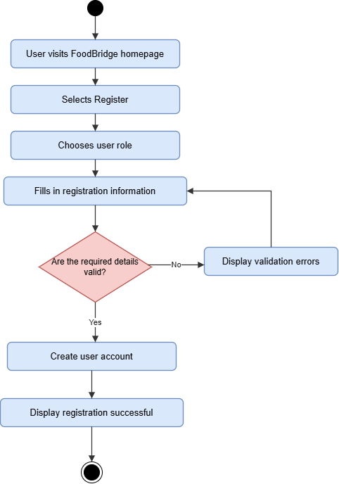

4.1.1 Objective
The objective of User Registration is to allow a new person to create an account on FoodBridge. The user selects a role and provides the information requested by the application. The role-based account structure supports the different types of users who take part in the FoodBridge platform. After successful registration, the user has an account that can be used to access the system.

4.1.2 User Flow / Functionality
- The user opens FoodBridge and chooses Register.
- The user selects one of the available roles: Donor, Receiver, or Volunteer.
- The user enters the information requested by the registration form.
- The user submits the form.
- The system checks the submitted information. If information is missing or invalid, the system should show a message and allow correction.
- If the information is accepted, the system creates the account, returns an authentication session, and takes the user to the requested page or the home feed.

4.1.3 Frontend Implementation
The registration page is implemented in RegisterPage.jsx as a controlled React form. It stores the selected role and the name, email, password, and confirmation fields in component state. The role selector offers Donor, Receiver, and Volunteer. Required fields, email format, a 100-character name limit, a minimum eight-character password, and matching password confirmation are checked in the browser. On submission, the page sends the trimmed name and email, password, and role as JSON to POST /api/auth/register. It shows the request state and any API error. When registration succeeds, AuthContext stores the returned session and the page navigates to the requested route or the home feed.

4.1.4 Backend Implementation
The Express application mounts the authentication router at /api/auth. Its POST /register handler checks that name, email, and password are present; validates the email format and minimum password length; restricts the role to the server allowlist; normalizes the email to lowercase; and rejects an existing email with HTTP 409. It hashes the password with bcryptjs using 12 salt rounds before creating the user. A successful request returns HTTP 201 with a seven-day JSON Web Token and the public user fields. Errors pass to the shared error handler, which also maps MongoDB duplicate-key errors to HTTP 409.

4.1.5 Database Implementation
Registration creates a document in the MongoDB User collection through the Mongoose User model. The schema stores a required, trimmed name (maximum 100 characters), a required unique lowercase email, a passwordHash excluded from normal query results, an optional Google ID, and a role constrained by an enum. Timestamps are enabled. The plaintext password is not stored; the controller saves only its bcrypt hash. The registration screen offers Donor, Receiver, and Volunteer, while the model also supports the system roles member and community.

4.1.6 Validation and Error Handling
The browser requires the name, email, password, and confirmation fields, checks email syntax, limits the name length, and prevents submission when the password is shorter than eight characters or the confirmation differs. The API repeats the required-field, email-format, password-length, and role checks so requests are validated on the server as well. It returns 400 for invalid input and 409 for an email already in use. The page displays API errors and keeps the form available for correction. Passwords are hashed before database storage.

4.1.7 Implementation Evidence
The supplied draft includes Figure 1, the registration activity diagram. It does not include screenshots of the registration interface, a successful registration, or the POST /api/auth/register response. Add genuine application and API/Postman screenshots before submission; the template marks API/Postman evidence as mandatory. A database screenshot may also be added if required by the instructor.

4.1.8 Testing

Test Case | Action | Expected Result | Actual Result
Valid registration | Select a role, enter valid required details, and submit. | The system accepts the information and creates the account. | Registration Successful
Missing required information | Leave a required field empty and submit. | The system prevents submission or shows a validation message. | Registration failed
Existing email (if enforced) | Try to register with an email already in use. | The system rejects the duplicate account and shows a message. | The email is already registered

4.2 Feature 2: User Login (FR 02)
Figure 2: Activity Diagram - User Login (FR 02)
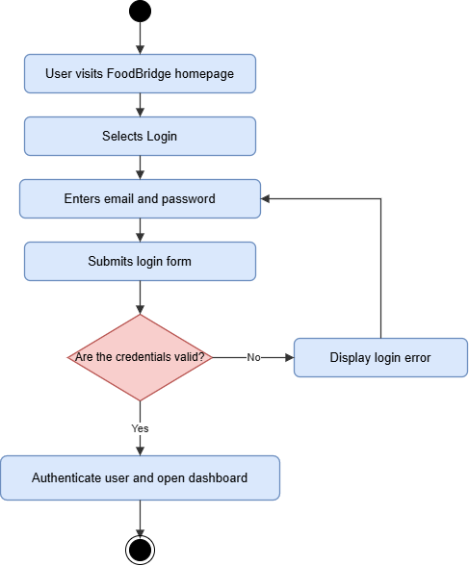

4.2.1 Objective
The objective of User Login is to allow a person who already has a FoodBridge account to access the application. The user provides an email address and password. The system checks the credentials and, when they are valid, allows the user to continue to the application dashboard.

4.2.2 User Flow / Functionality
- The user opens FoodBridge and chooses Login.
- The user enters the registered email address and password.
- The user submits the login form.
- The system checks the supplied credentials.
- If the credentials are incorrect, the system displays an error. If they are correct, it creates an authentication session and takes the user to the requested page or the home feed.

4.2.3 Frontend Implementation
The login page is implemented in LoginPage.jsx as a controlled React form with email and password state, a password visibility control, a busy state, and an error message. The browser requires both fields and checks email syntax. The page sends the credentials as JSON to POST /api/auth/login through the shared apiRequest helper. When the API returns a token and user, the page calls AuthContext.signIn, which stores the token in localStorage and updates the session. The user is then returned to the route they originally requested or to the home feed. On a later page load, AuthProvider uses the saved token with GET /api/auth/me to restore the session.

4.2.4 Backend Implementation
The Express authentication router exposes POST /api/auth/login. The controller checks for an email and password, normalizes the email, retrieves the matching user with passwordHash explicitly selected, and compares the submitted password with the stored bcrypt hash. If the account is missing or the password does not match, it returns the same HTTP 401 message, “Email or password is incorrect.” A valid login returns the same seven-day JWT session structure used by registration. The protected GET /api/auth/me route uses requireAuth to validate the bearer token and return the current user.

4.2.5 Database Implementation
Login reads the existing user document from MongoDB through the Mongoose User model. Because passwordHash is excluded by default, the controller explicitly selects it only for credential verification. bcryptjs compares the submitted password with that hash; the plaintext password is never returned to the client. The response contains the user ID, name, email, role, and signed token, not the stored hash.

4.2.6 Validation and Error Handling
The login form marks email and password as required and uses the email input type for browser-level format checking. The API independently rejects missing credentials with HTTP 400, and returns a generic HTTP 401 response for either an unknown email or an incorrect password so it does not reveal which value failed. The UI displays API errors and allows another attempt. Authenticated routes wait for session restoration and redirect unauthenticated users to the login page.

4.2.7 Implementation Evidence
The supplied draft includes Figure 2, the login activity diagram. It does not include screenshots of the login interface, a successful or rejected login, or the POST /api/auth/login response. Add genuine application and API/Postman screenshots before submission; the template marks API/Postman evidence as mandatory.

4.2.8 Testing
The input actions, expected results, and actual outcomes below are retained from the supplied draft. Confirm each actual outcome against your own test evidence before submission.
Test Case | Input / Action | Expected Result | Actual Result
Valid login | Enter the email and password of an existing test account and submit. | The system accepts the credentials and opens the appropriate dashboard. | Login Successful
Incorrect password | Enter a registered email with an incorrect password. | The system rejects login and displays an appropriate error. | Login Failed
Missing information | Leave the email or password empty and submit. | The system prevents login and displays a validation message. | Login Failed

5. Features Integration
Registration and login use the same MongoDB User model and authentication API. Registration stores the account and returns a JWT; login verifies the saved password hash and returns a JWT for an existing account. Both responses update the shared AuthContext, which stores the token and restores the user through GET /api/auth/me on the next load. Protected routes use that session to decide whether the user can continue. This report describes only the two assigned authentication features.

6. Challenges and Solutions
Challenge -1:
Problem: During registration, a user might try to create an account using an email address that is already registered in the system. This could create duplicate user accounts.
Investigation/Debugging: I checked the registration process and tested it using an email address that had already been used.
Solution: If the email already exists, the system displays an appropriate error message and asks the user to use another email address.

Challenge -2:
Problem: During login, users might enter an incorrect email address or password. The system needs to prevent unauthorized access when the provided credentials are incorrect.
Investigation/Debugging: I tested the login form using valid and invalid email-password combinations to check whether the authentication process worked correctly.
Solution: I implemented credential verification during login. The system checks the user's information and allows access only when the credentials are correct. Otherwise, it displays an error message.

7. Git/GitHub Contribution
Git & GitHub were used to manage the source code and track the development progress of the User Registration & Login features.
During the Development process:
- Worked on the User Registration and User Login features.
- Used Git to track changes in the source code.
- Committed code changes after completing and updating the features.
- Pushed the updated code to the GitHub repository.
- Used the repository to maintain and share the project implementation with other team members.
- GitHub repository link: https://github.com/raofun/foodbridge
- Branch Name: dev/raofun
- Feature work: User Registration & User Login
- Pull request: #7 (merged; recorded by the local merge commit)
- Relevant local commits: 7b52eb3 — backend connected for reg and login; 3d0a260 — feat(auth): complete registration UI and project handoff docs.

8. Final Summary of Individual Contribution
My CA1 contribution in this report covers the two assigned Module 1 features: User Registration (FR 01) and User Login (FR 02). The registration flow collects account details, validates them, and creates a stored account; the login flow verifies credentials and establishes a session for the application. The status table summarizes the completion state recorded in this draft.
Feature | Status | Notes
User Registration (FR 01) | Complete | I implemented the registration form, role selection, client-side validation, and API-connected account creation. The report records this feature as complete.
User Login (FR 02) | Complete | I implemented the login form, credential verification flow, session storage, and authenticated route access. The report records this feature as complete.

