# Exam Preparation – Expenses Tracker

*Expenses Tracker is an application that allows you to create your own profile (name, profile picture, and budget), create, edit, delete expenses and track your budget. You are also able to edit your profile data and delete your profile.*

## Skeleton

You are provided with all the needed **HTML pages**, **images,** and **CSS** for the project.

## Database

You will need **2 models**:

* **Profile**
  + **First name**
    - Character field, required.
    - It should have at least **2 characters** and **maximum -** **15 characters.**
    - The name should consist **only of letters**. Otherwise, raise **ValidationError** with the message: **"Ensure this value contains only letters."**
  + **Last name** 
    - Character field, required.
    - It should have at least **2 characters** and **maximum -** **15 characters.**
    - The name should consist **only of letters**. Otherwise, raise **ValidationError** with the message: **"Ensure this value contains only letters."**
  + **Budget**
    - Float field, required. The budget is **0** **by default**.
    - The budget should **not be below 0**, when created or edited.
  + **Profile Image**
    - Image field, **optional**. The picture is **user.png** (located in the resources) **by** **default**; if no image is uploaded)
    - The max size limit is **5MB** (inclusive). Otherwise, raise **ValidationError** with the message: **"Max file size is 5.00 MB"**
* **Expense**
  + **Title**
    - Character field, required.
    - It should consist of a **maximum** **of 30 characters.**
  + **Expense Image**
    - URL field, required.
  + **Description**
    - Text field, **optional**.
  + **Price**
    - Float field, required.

## Routes

* <http://localhost:8000/> - home page
* <http://localhost:8000/create>/ - create expense page
* [http://localhost:8000/edit/<id](http://localhost:8000/edit/%3cid)>/ - edit expense page
* [http://localhost:8000/delete/<id](http://localhost:8000/delete/%3cid)>/ - delete expense page
* <http://localhost:8000/profile>/ - profile page
* <http://localhost:8000/profile/edit>/ - profile edit page
* <http://localhost:8000/profile/delete>/ - delete profile page

## Pages

### Home Page

**Template files**: **"home-no-profile.html"**; "**home-with-profile.html"**

If there is **no profile** created yet, the home page shows a form for profile creation. It consists of:

* A **"Budget:"**, a **"First Name:"**, a **"Last Name:"**, and a **"Profile Image:"** fields.
  + Only the **"Profile Image:"** field uses a **CSS** style class called **"form-file"**.
* A button **"Submit"**.
  + When you **click** on it, **if** the profile is **successfully created**, you should be redirected to the **home page**, showing a template for a **home page with a profile**.
  + Otherwise, the form should show the **appropriate validation errors**.

There is also a button at the left side of the navigation bar called **"Expenses Tracker"**. It leads to the **home page**.

When you click on the **"Submit"** button, if the profile is **successfully created**, you should be redirected to the **same page**, showing a template for a **home page with a profile.**

In addition to the button **"Expenses Tracker"**, on the right side of the **navigation bar** is a button **"Profile"**  that **leads to the profile page**.

When there are **no expenses created**, you should **only** **see** the headline **"My Expenses"** and the button **"Add Expense"** that leads to the **create expense page**:

If there are a **profile** and **expenses, the page should have the following**:

* A headline **"Summary"**
* A **summary** of **all your expenses** - the first number (in blue) is your **budget**, the following numbers (in red) are the **prices of each product**, the last number (in green) is the **budget left**. All of them should be **formatted** to the **second decimal point**.
* A headline **"My Expensese"**
* A button **"Add Expense"** that leads to the **create expense page**.
* A container for each expense showing the **title**, the **image**, the **description** (if any), and the **price** for the expense. In each container, there should be **two buttons**:
  + **"Edit"** - leading to edit expense page.
  + **"Delete"** - leading to delete expense page.

### Create Expense Page

Template file: **"expense-create.html"**

This page contains an **expense** **creation form**. The page should have the following:

* A navigation bar containing **"Expenses Tracker"** and **"Profile"** buttons.
* A headline **"Create Expense"**.
* A **form** for **creating an expense** with **"Title:"**, **"Description:"**, **"Link to Image:"**, and **"Price:"** fields.
* A button **"Create"**.
  + When you **click** on it, **if** the expense is **successfully created**, you should be redirected to the **home page**, showing a template for a **home page with a profile**.
  + Otherwise, the form should show the **appropriate validation errors**.

### Edit Expense Page

Template file: **"expense-edit.html"**

On the page, the form must be **filled** with the **data** of the **expense** we want **to edit.** When you click on the **"Edit"** button:

* **If** the expense is **successfully edited**,you should be redirected to the **home page**, showing a template for a home page with a profile
* Otherwise, the form should show the **appropriate validation errors**.

### Delete Expense Page

Template file: **"expense-delete.html"**

On the page, the form must be **filled** with the **data** of the **expense,** and the **fields** should be **disabled.** When you click on the **"Delete"**, the expense is **deleted from the database**, and you should be redirected to the **home page**, showing a template for a home page with a profile.

The deleted expense should be **no longer visible in the app**.

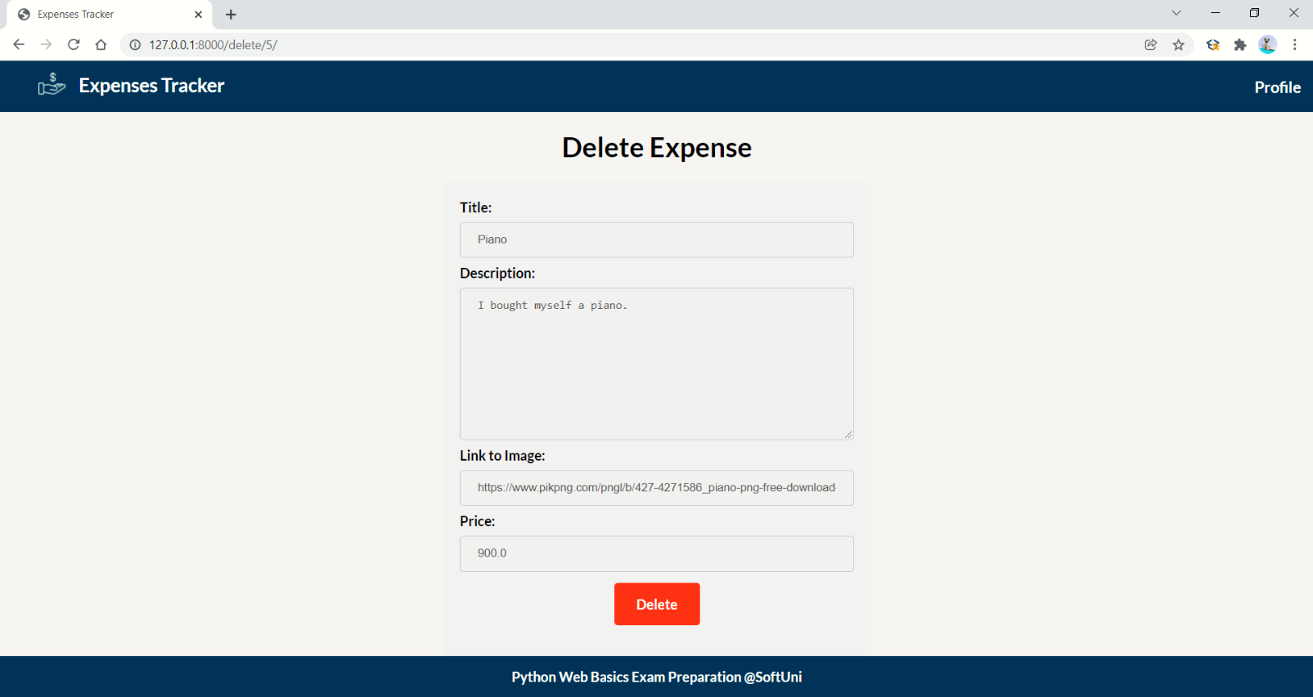

### Profile Page

Template file: **"profile.html"**

This page contains the user data. It should have the following:

* A navigation bar containing **"Expenses Tracker"** and **"Profile"** buttons.
* A headline **"Your Profile"**
* A container consisting of:
  + The user's **full name** (separated by a single space)
  + The profile **image** (if there is one, otherwise, show the default user.png image)
  + A paragraph **"Total Items Bought: {total_number_of_items}"** that shows the total **number of items** existing in the database.
  + A paragraph **"Budget Left: {budget_left}$ "** that shows the **budget left** after deduction of all expenses. It should be formatted to the second decimal point.
  + An **"Edit Profile"** button that leads to the **edit profile page**
  + A **"Delete Profile"** button that leads to the **delete profile page**

### Edit Profile Page

Template file: **"profile-edit.html"**

On the page, the form must be **filled** with the **data** of the **profile** we want **to edit.** When you click on the **"Edit"** button:

* **If** the profile is successfully **edited**, you should be redirected to the **profile page**, showing a template filled with edited profile data
* Otherwise, the form should show the **appropriate validation errors**.

### Delete Profile Page

Template file: **"profile-delete.html"**

Deleting a profile should delete the profile info and **all expenses.** After **deletion**, the user should be redirected to the **home page with no profile**.

