Workshop: Petstagram
We will be creating a complete Django project called "Petstagram" throughout this course. The project will cover the following functionalities: creating a user profile; a user could view all photos of pets, open details, like a photo, edit and delete them.

Final Project

Home Page
When the user hasn't created a profile, only this page and create profile page (below) are available. The button visible is "Create Profile," and it redirects to the create profile page:
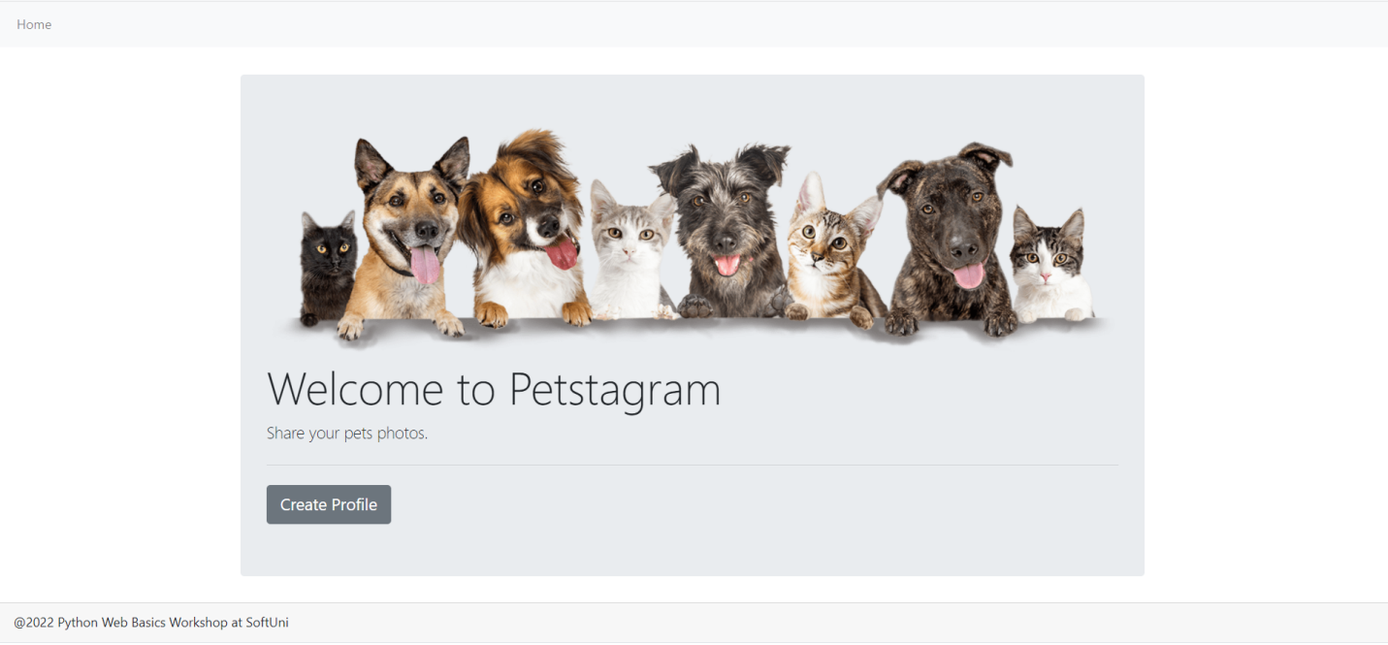
When a profile is created, the button visible is "Enter", and it redirects to the dashboard. Pay attention to the changed navigation bar:
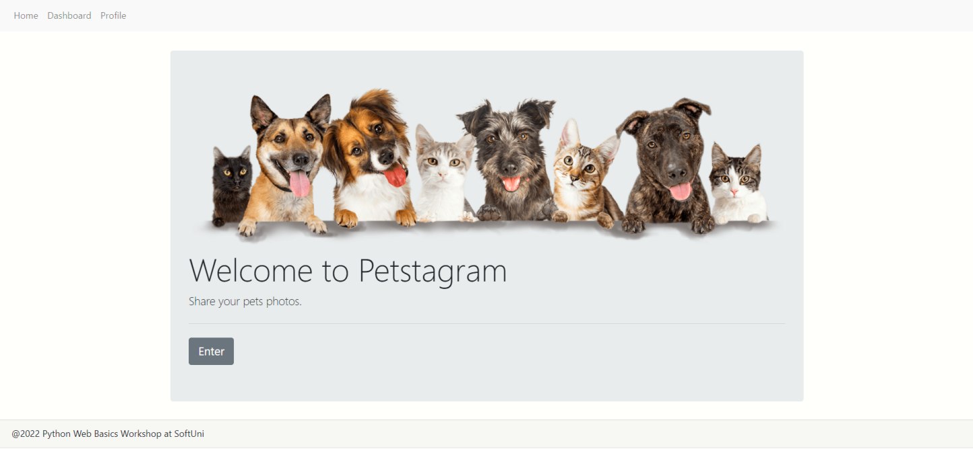

Create Profile Page
The visible fields when creating a profile are "First Name", "Last Name", and "Link to Profile Picture". When the button "Create" is clicked, the profile is created, and it redirects to the Home page:
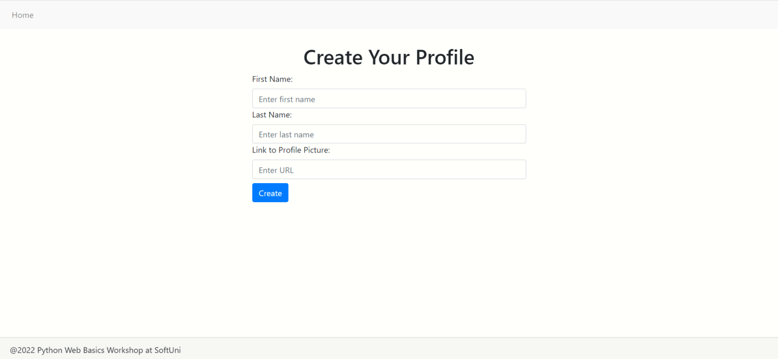

401 Unauthorized
If a user tries to access any other page when he doesn't have a profile:
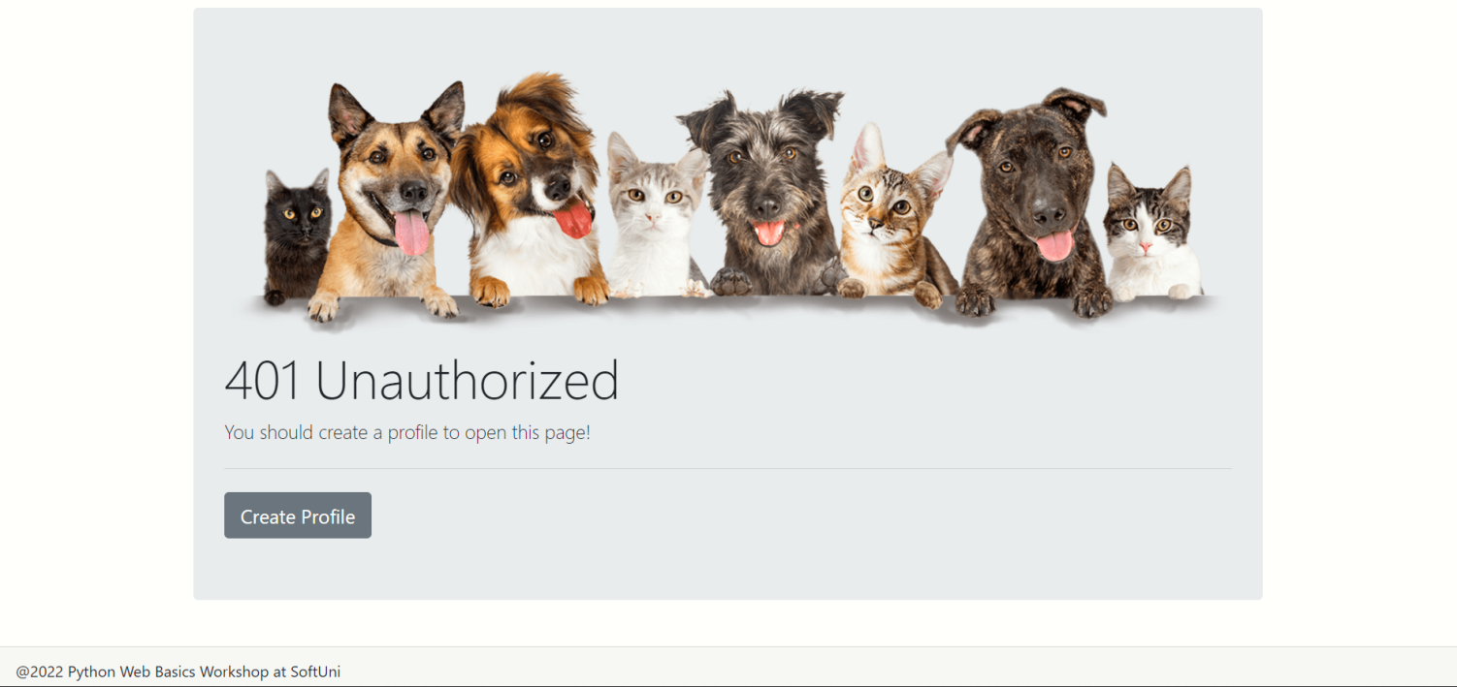

Dashboard
When there are NOT created pet photos yet, the user sees the message "No pet photos yet" and the button "Add Photo". The button redirects to add photo page:
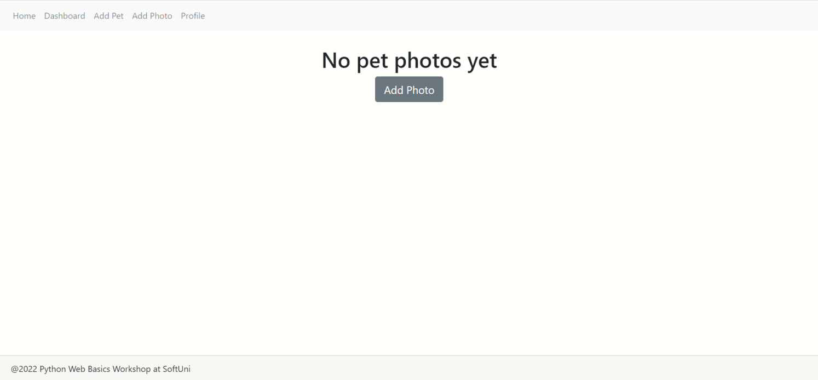

When there are pets' photos, the user sees cards, each consisting of a pet' photo, name, and age, and the "See Details" button, which redirects to the chosen photo detail page:
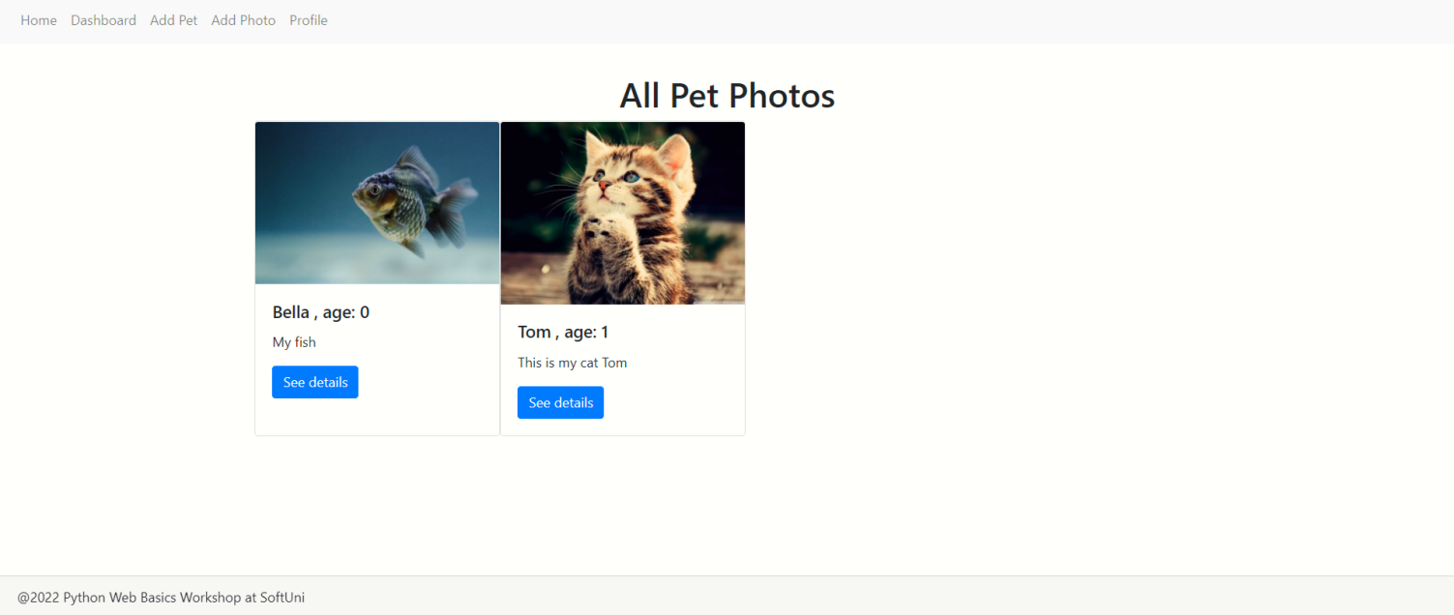

Add Pet Page
The visible fields when creating a pet profile are "Pet Name", "Type", and "Day of Birth". When the user successfully creates a pet, he is redirected to their profile page, where info for all your pets is visible:
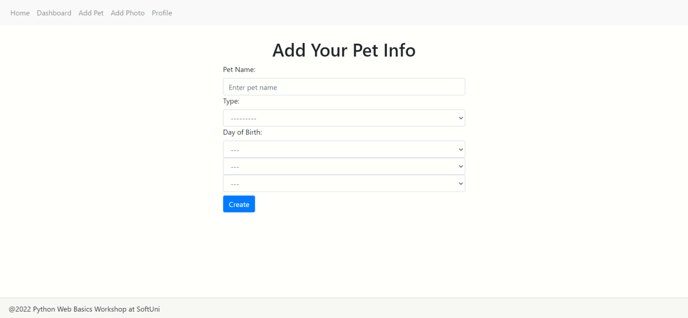

Add Photo Page
The visible fields when adding a new photo are "Pet Image", "Description", and "Tag Pets". When the user successfully adds a photo, they are redirected to the dashboard:
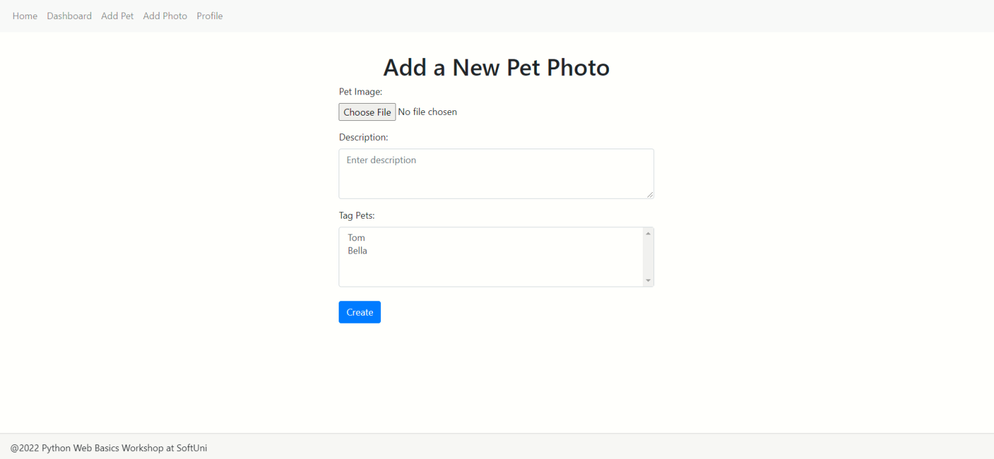

Photo Details Page
On the details page, the user can see the photo on the left and their pet's info: "Name", "Type", "Age". Next, they can see the photo description and publishing date and time. There is a button in the shape of a heart. Each click on a button means one like. When the button is clicked, the page will reload, and the like added will be visible. The "Edit" and "Delete" buttons are also on this page. Use them to edit or delete the current photo:
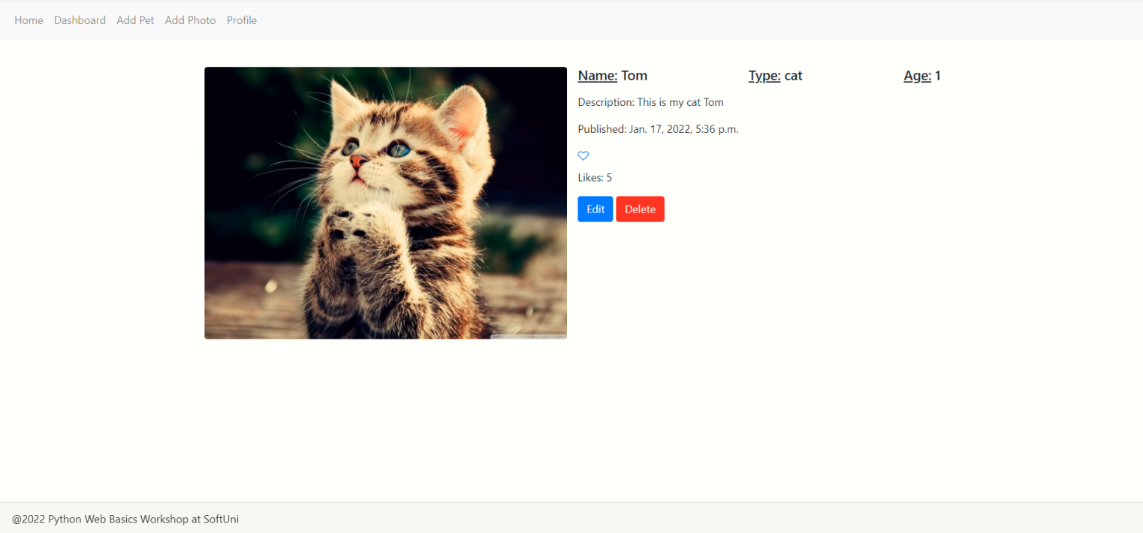

Photo Edit Page
The visible fields when editing a photo are "Description", and "Tag Pets". The photo is not editable! When you click on the "Edit" button, the photo info is updated, and the user is redirected to the details page:
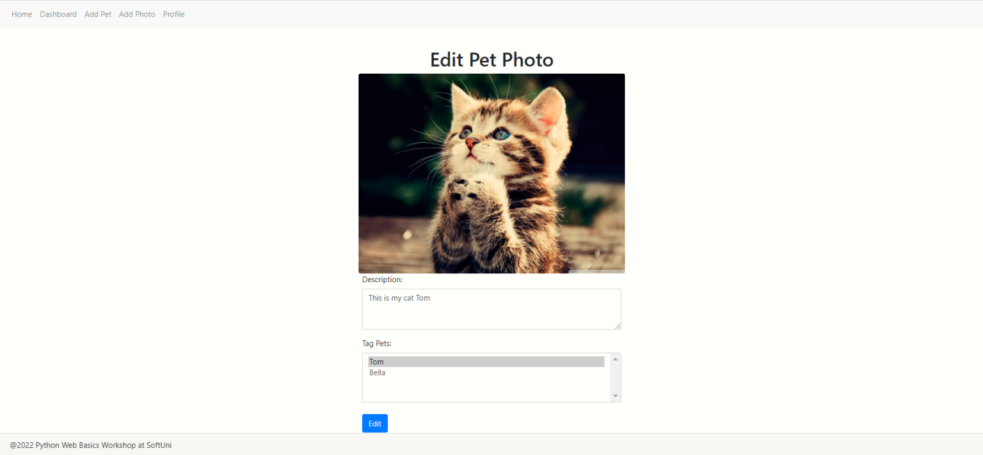

Profile Page
The user can see info about them and their pets on the profile page. At first, they can see their profile picture, the total number of images, and the total number of likes. There are "Edit" and "Delete" buttons to edit or delete the profile.
Next, the user can see all their pets in the "My Pets" field. For each pet, they can see its name and age. Also, there are "Edit" and "Delete" buttons for each pet - to edit or delete the user's pet info.
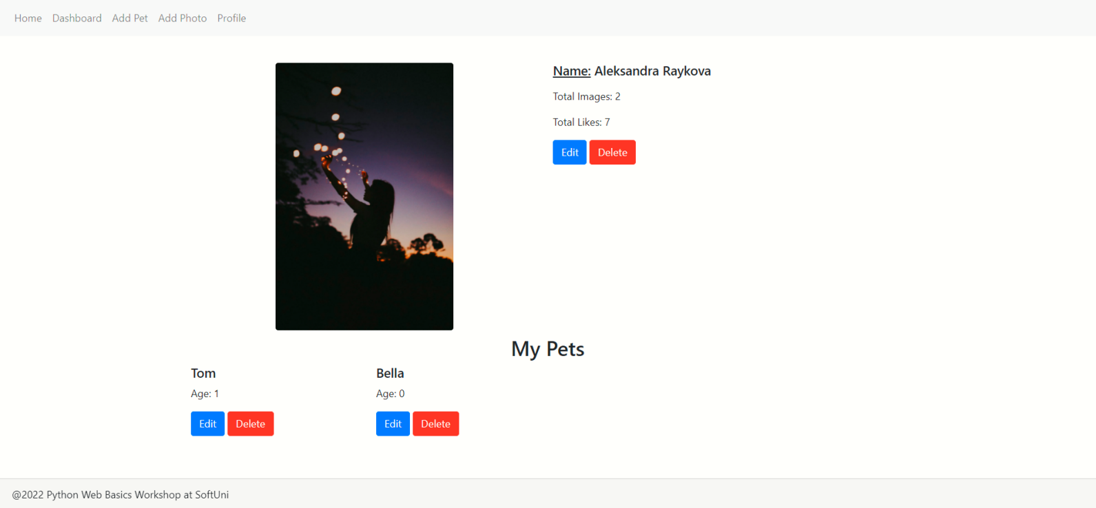

The user can add additional information about themself, and it will be shown on the page:
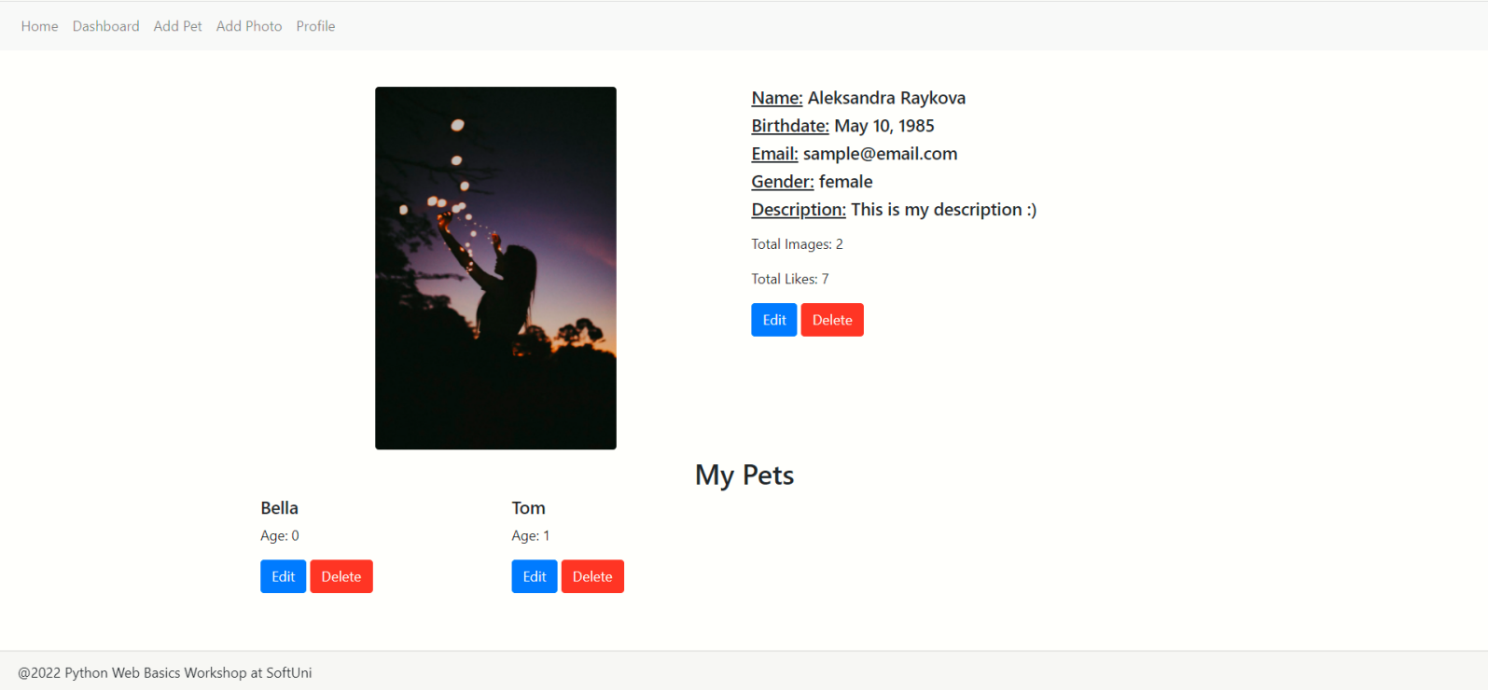

Pet Edit Page
The visible fields when editing a photo are "Pet Name", "Type", and "Day of Birth". When the user clicks on the "Edit" button, the pet info is updated, and they will be redirected to the profile page:
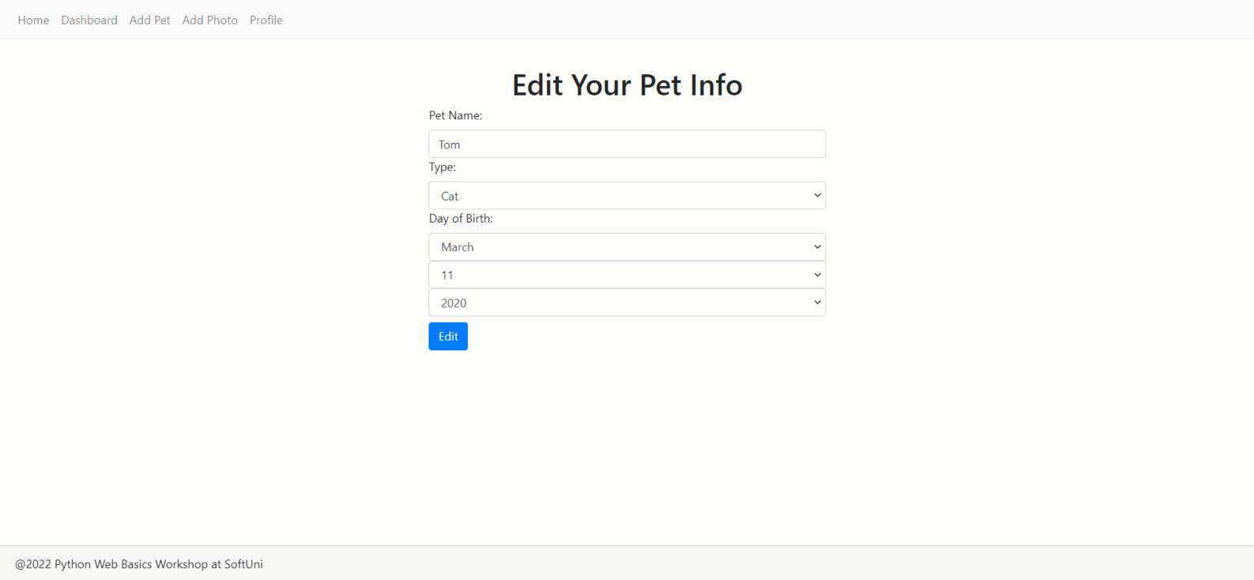

Pet Delete Page
Before the info is permanently deleted, the visible fields are "Pet Name", "Type", and "Day of Birth" - all disabled. When the user clicks on the "Delete" button, the pet is deleted, but the tagged photos are not. After deletion, the user will be redirected to the profile page:
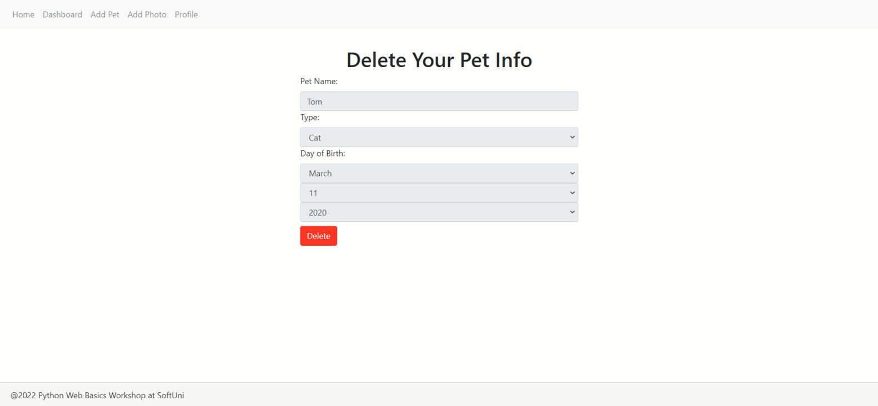

Profile Edit Page
The visible fields when editing the profile are "First Name", "Last Name", "Link to Profile Picture", "Date of Birth", "Email", "Gender", "Description". When you click on the "Edit" button, the photo info is updated, and the user is redirected to the profile details page:
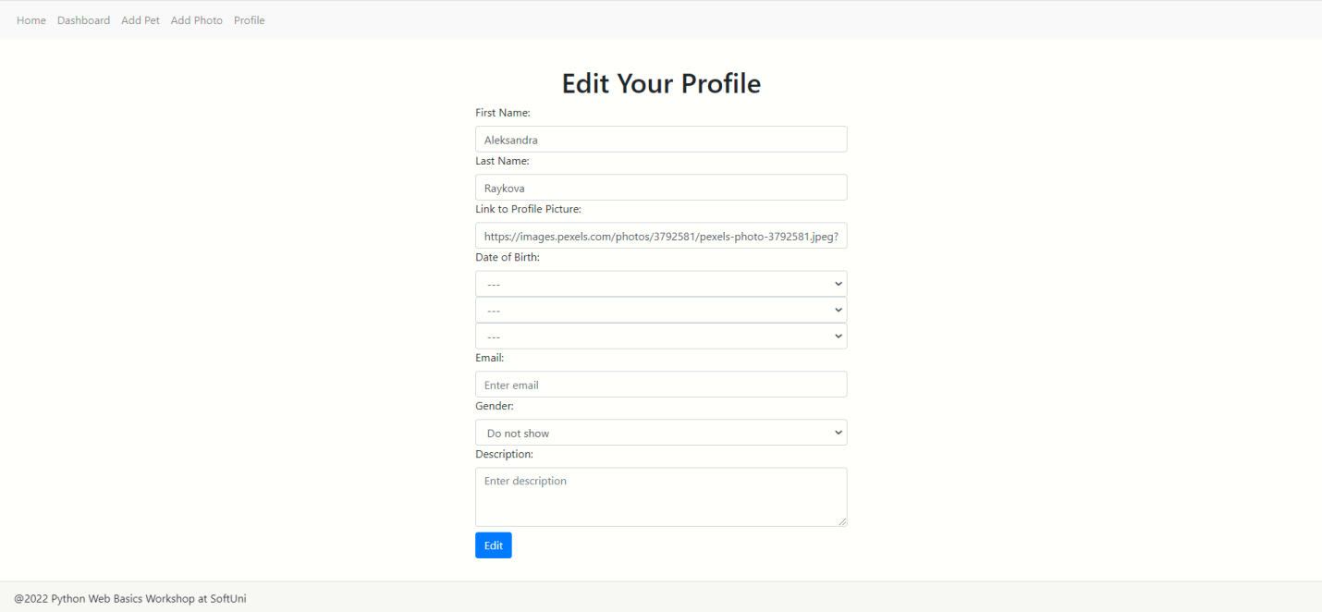

Profile Delete Page
Before the profile is permanently deleted, the user will see the following page. When the user clicks on the "Confirm" button, the profile, all its pets, and all photos are deleted. After deletion, the user will be redirected to the home page:
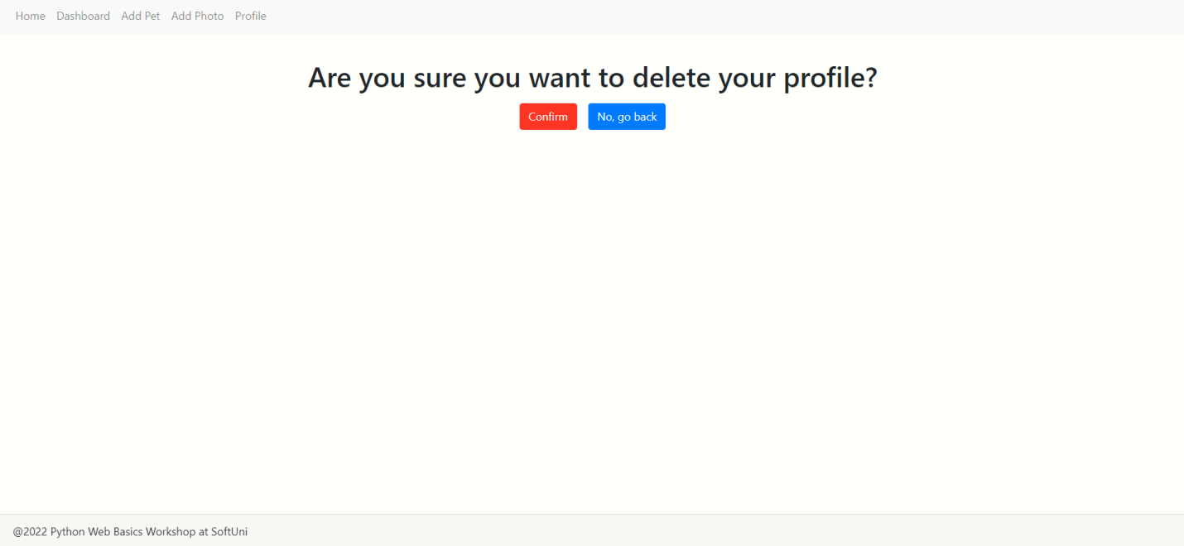

Workshop - Part I

Setup
Let us start by creating the project
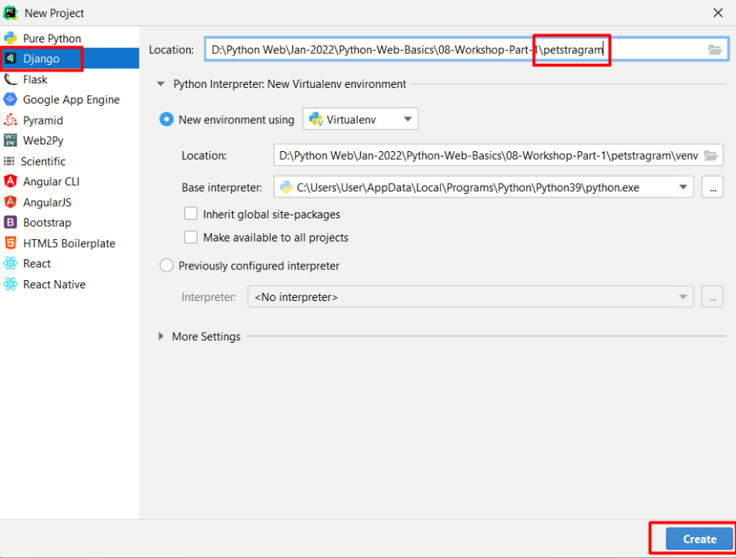
Now, let us create the first app which will be called 'main_app' which will contain all parts of our project:
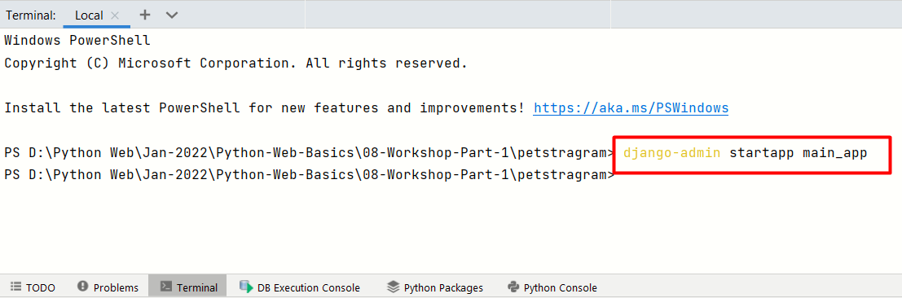
For clarification, move the created app inside the project.

The next step is to create the templates folder inside the app directory and add the given templates in it:
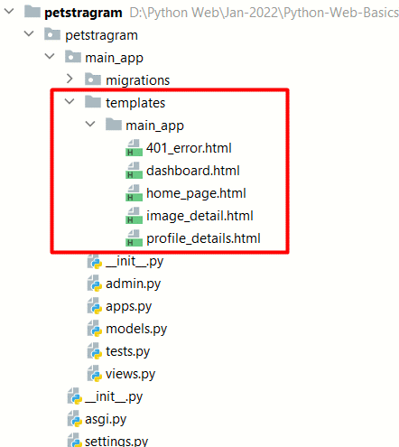

Configurations
We need to add the app we just created in the INSTALLED_APPS:
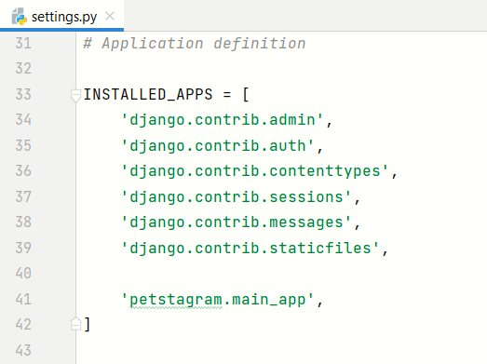

Creating the Models

Profile
The user must provide the following information in their profile:
- The first name - it should have at least 2 chars, max - 30 chars, and should consist only of letters.
- The last name - it should have at least 2 chars, max - 30 chars, and should consist only of letters.
- Profile picture - the user can link their picture using a URL.

The user may provide the following information in their profile:
- Date of birth: day, month, and year of birth.
- Description - a user can write any description about themselves, no limit of words/chars.
- Email - a user can only write a valid email address.
- Gender - the user can choose one of the following: "Male", "Female", and "Do not show".

Pet
The user must provide the following information when adding a pet in their profile:
- Name - it should consist of maximum 30 characters. All pets' names should be unique for that user.
- Type - the user can choose one of the following: "Cat", "Dog", "Bunny", "Parrot", "Fish", or "Other".
The user may provide the following information when adding a pet to their profile:
- Date of birth - pet's day, month, and year of birth.

Pet's Photo
The user must provide the following information when uploading a pet's photo in their profile:
- Photo - the maximum size of the photo can be 5MB
- Tagged pets - the user should tag at least one of their pets. There is no limit in the number of tagged pets
The user may provide the following information when uploading a pet's photo in their profile:
- Description - a user can write any description about the picture, with no limit of words/chars
Other:
- Date and time of publication - when a picture is created (only), the date and time of publication are automatically generated.
- Likes - each picture has 0 likes at the beginning, and no one can change it. The number of likes a picture can collect is unlimited.

Creating the URLs
Home Page: http://127.0.0.1:8000/
Dashboard Page: http://127.0.0.1:8000/dashboard/
Profile Page: http://127.0.0.1:8000/profile/
Photo Details Page: http://127.0.0.1:8000/photo/details/photo_id/
Note: if the user tries to access any other page except the home page, they should get a 401 HTTP response with the 401_error.html template.

Creating the Home Page
Template File: home_page.html
Requirements:
- If the user does not have a profile, they can see only the "Create Profile" button in the HTML container and the "Home" button in the navigation bar on the top left:
  - The "Create Profile" button should lead to the create profile page (Workshop Part 2).
  - The "Home" button should lead to the home page.
- If the user has a profile, they can see only the button "Enter" in the HTML container and the buttons "Home", "Dashboard", and "Profile" on the navigation bar on the top left (in this order):
  - The "Enter" button should lead to the dashboard page.
  - The "Home" button should lead to the home page.
  - The "Dashboard" button should lead to the dashboard page.
  - The "Profile" button should lead to the profile page.

Creating the Dashboard Page
Template File: dashboard.html
Requirements:
- Navigation Bar: "Home", "Dashboard", "Add Pet", "Add Photo", and "Profile" buttons are positioned on the navigation bar on the top left (in the given order).
- When there are NOT created pet photos yet, the user can see the message "No pet photos yet" and the button "Add Photo", which leads to adding a photo page (Workshop Part 2).
- When there are pets' photos, the user sees cards, each consisting of a pet' photo, name, and age for each pet on the photo, description for the photo, and a "See Details" button:
        - The "age: {age}" of a pet is only visible if the user entered the day of birth in the pet's info. The age is represented in years.
        - If the description is too long, the only visible part is the first 30 characters.
        - The button leads to the chosen photo detail page (Workshop Part 2).

Create Profile Page
Template File: profile.html
Requirements:
- Navigation Bar: "Home", "Dashboard", "Add Pet", "Add Photo", and "Profile" buttons are positioned on the navigation bar on the top left (in the given order).
- The user can see info about them and their pets on the profile page:
        - All they can see is their profile picture, "Name" (full name), "Birthdate", "Email", "Gender", "Description", the total number of images, and the total number of likes.
        - There are also "Edit" and "Delete" buttons to edit or delete the profile (Workshop Part 2).
- Next, the user can see all their pets in the "My Pets" field:
        - For each pet, they can see its name and age.
        - "Edit" and "Delete" buttons for each pet - to edit or delete the user's pet info (Workshop Part 2).
Note: if optional information is not given, the optional field is not visible.

Creating the Photo Details Page
Template File: photo_details.html
Requirements:
- Navigation Bar: "Home", "Dashboard", "Add Pet", "Add Photo", and "Profile" buttons are positioned on the navigation bar on the top left (in the given order).
- The photo is on the left and the pet's info is on the right side:
        - "Name", "Type", "Age" (if the day of birth is given) for each pet on the photo (on separate lines).
        - "Description" - the photo description.
        - "Published" - the publishing date and time.
        - A button in the shape of a heart:
          - Each click on a button means one like. When the button is clicked, the page will reload, and the like added will be visible.
        - The "Edit" and "Delete" buttons to edit or delete the current photo (Workshop Part 2).

Creating Template Inheritance
Create a template for all common parts in the templates.

