Workshop: Petstagram
Trought this workshop, we will be creating all the forms in the Django Project called "Petstagram". There are a "create", an "edit", and a "delete" form for a pet. A "create" and an "edit" form for the profile and a photo. The profile is deleted with a confirmation page, and a photo is deleted directly through the button "Delete".

Workshop - Part II

Creating the URLs
Create Profile Page: http://127.0.0.1:8000/profile/create/
Add Pet Page: http://127.0.0.1:8000/pet/add/
Pet Edit Page: http://127.0.0.1:8000/pet/edit/<pet_id>/
Pet Delete Page: http://127.0.0.1:8000/pet/delete/<pet_id>/
Add Photo Page: http://127.0.0.1:8000/photo/add/
Photo Edit Page: http://127.0.0.1:8000/photo/edit/<photo_id>/
Profile Edit Page: http://127.0.0.1:8000/profile/edit/
Profile Delete Page: http://127.0.0.1:8000/profile/delete/
Note: if the user tries to access any other page except the home page, they should get a 401 HTTP response with the 401_error.html template.

Create Profile Page
Template: profile_create.html
The navigation bar consists of only a Home button.
The visible fields when creating a profile are:
- "First Name:"
  - Char field, required,
  - The name should consist of only letters, the minimum length is 2 characters, and the maximum length is 30 characters.
  - There must be a placeholder "Enter first name".
  - The CSS class used to style that field is "form-control".
- "Last Name:"
  - Char field, required
  - The last name should consist of only letters, the minimum length is 2 characters, and the maximum length is 30 characters.
  - There must be a placeholder "Enter last name".
  - The CSS class used to style that field is "form-control".
- "Link to Profile Picture:"
  - URL field, required.
  - There must be a placeholder "Enter URL".
  - The CSS class used to style that field is "form-control".
When the button "Create" is clicked, the profile is created, and it redirects to the Home page.
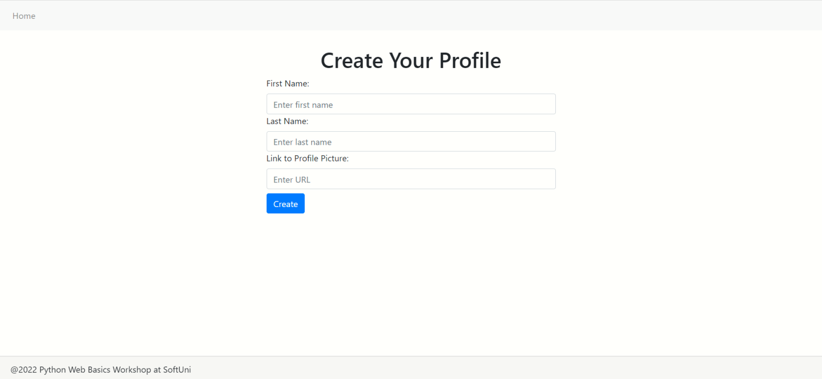

Add Pet Page
Template: pet_create.html
The visible fields when creating a pet profile are:
- "Pet Name:"
  - Char field, required.
  - The maximum length is 30 characters.
  - All pet names for a profile must be unique.
  - There must be a placeholder "Enter pet name".
  - The CSS class used to style that field is "form-control".
- "Type:"
  - Choice field, required.
  - The choices are the same as in the model.
  - The CSS class used to style that field is "form-control".
- "Day of Birth:"
  - Date field, optional.
  - The years are in the range [1920…this year].
  - The CSS class used to style that field is "form-control".
When the user successfully creates a pet, they are redirected to their profile page, where info for all their pets is visible:
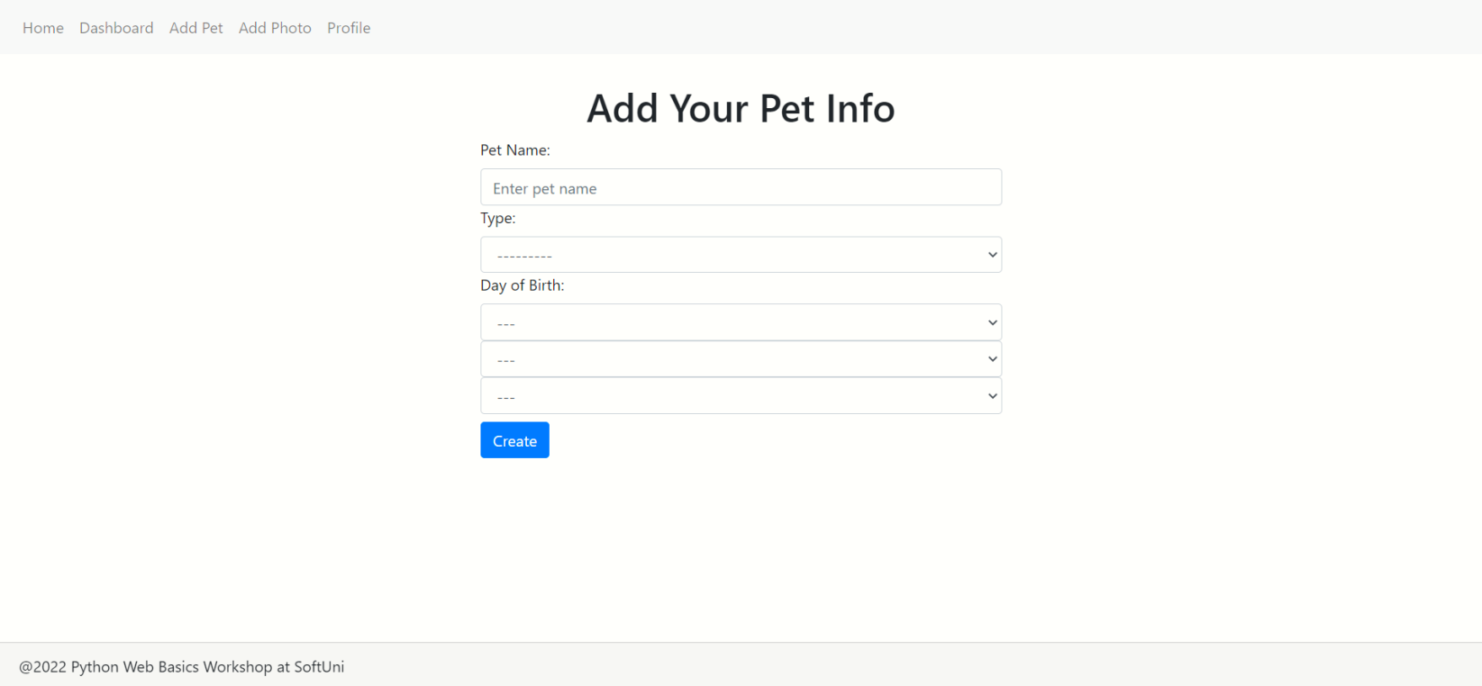

Add Photo Page
Template: photo_create.html
The visible fields when adding a new photo are:
- "Pet Image:"
  - Image field, required.
  - The maximum size of an image is 5MB.
  - The CSS class used to style that field is "form-control-file".
- "Description:"
  - Textarea field, optional.
  - Shows only 3 rows at a time.
  - There must be a placeholder "Enter description".
  - The CSS class used to style that field is "form-control".
- "Tag Pets:"
  - Multiple Select field, required (at least one pet should be tagged).
  - Shows only the names of all created pets in the profile.
  - The CSS class used to style that field is "form-control".
When the user successfully adds a photo, they are redirected to the dashboard:
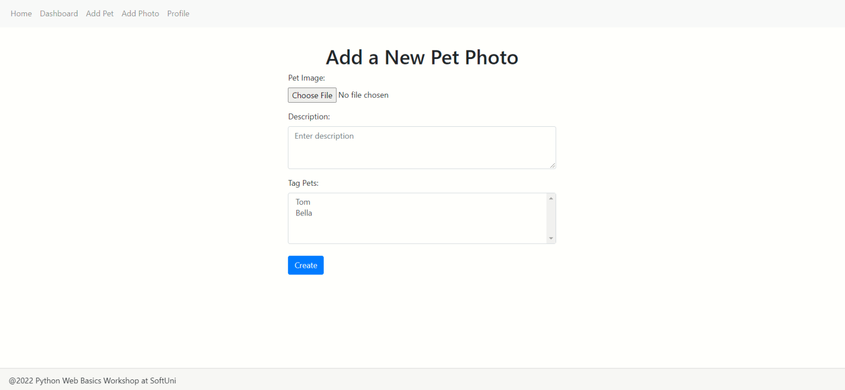

Photo Edit Page
Template: photo_edit.html
The photo is not editable! However, it must be shown in the form as an image.
The editable fields are:
- "Description:"
  - The already created description must be visible and editable in the form.
- "Tag Pets:"
  - The already tagged pets must be visible and editable in the form.
When you click on the "Edit" button, the photo info is updated, and the user is redirected to the details page:
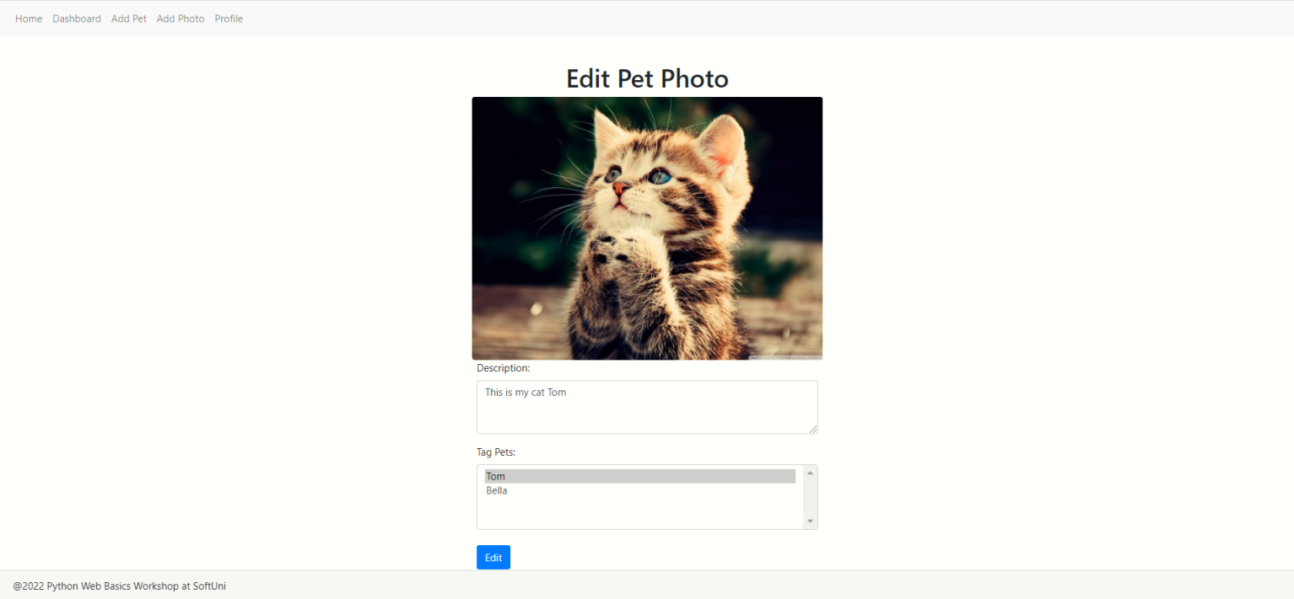

Note: there is no form for deleting a photo. It is deleted directly from the "Delete" button on the photo details page.

Pet Edit Page
Template: pet_edit.html
The editable fields are "Pet Name:", "Type:", "Day of Birth:". All fields that were already created must be visible and editable. When click on the "Edit" button, the pet info is updated, and they will be redirected to the profile page:
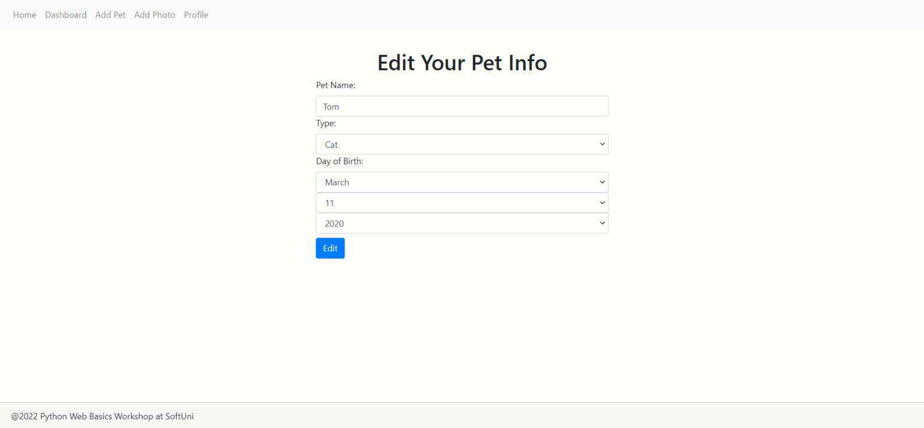

Pet Delete Page
Template: pet_delete.html
Before the info is permanently deleted, the visible fields are "Pet Name:", "Type:", and "Day of Birth:" - all disabled. When the user clicks on the "Delete" button, the pet is deleted, but the tagged photos are not. After deletion, the user will be redirected to the profile page:
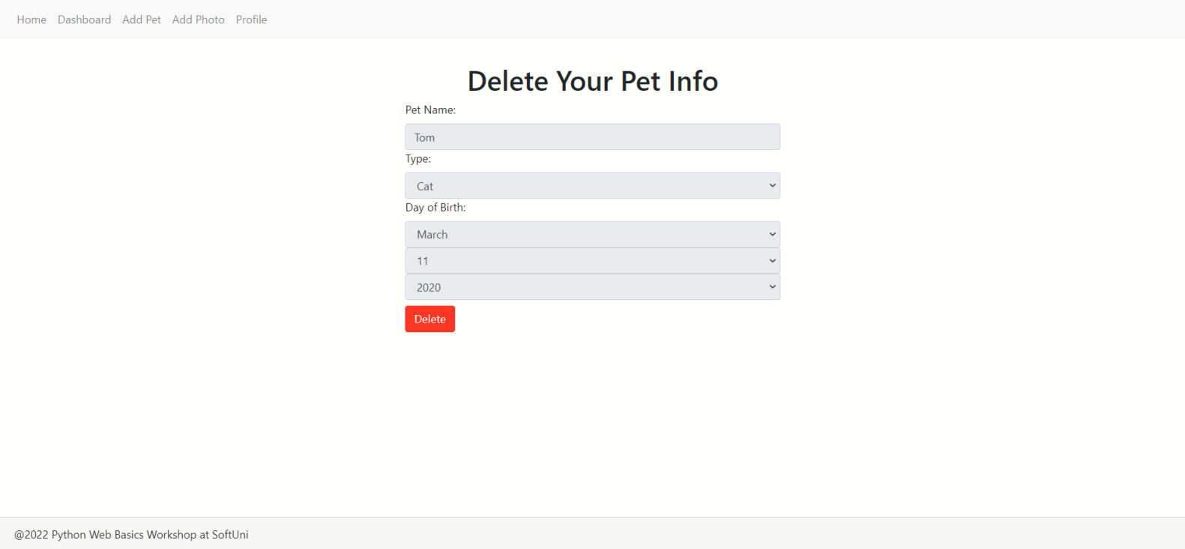

Profile Edit Page
Template: profile_edit.html
The visible fields when editing the profile are:
- "First Name:"
  - The already entered name must be visible and editable in the form.
- "Last Name:"
  - The already entered name must be visible and editable in the form.
- "Link to Profile Picture:"
  - The already entered URL must be visible and editable in the form.
- "Date of Birth:"
  - Date field, optional.
  - The years are in the range [1920…this year].
  - The CSS class used to style that field is "form-control".
- "Email:"
  - Email field, optional.
  - There must be a placeholder "Enter email".
  - The CSS class used to style that field is "form-control".
- "Gender:"
  - Choice field, optional.
  - "Do not show" by default.
  - The choices are the same as in the model.
- "Description:"
  - Textarea field, optional.
  - Shows only 3 rows at a time.
  - There must be a placeholder "Enter description".
  - The CSS class used to style that field is "form-control".
When you click on the "Edit" button, the photo info is updated, and the user is redirected to the profile details page:
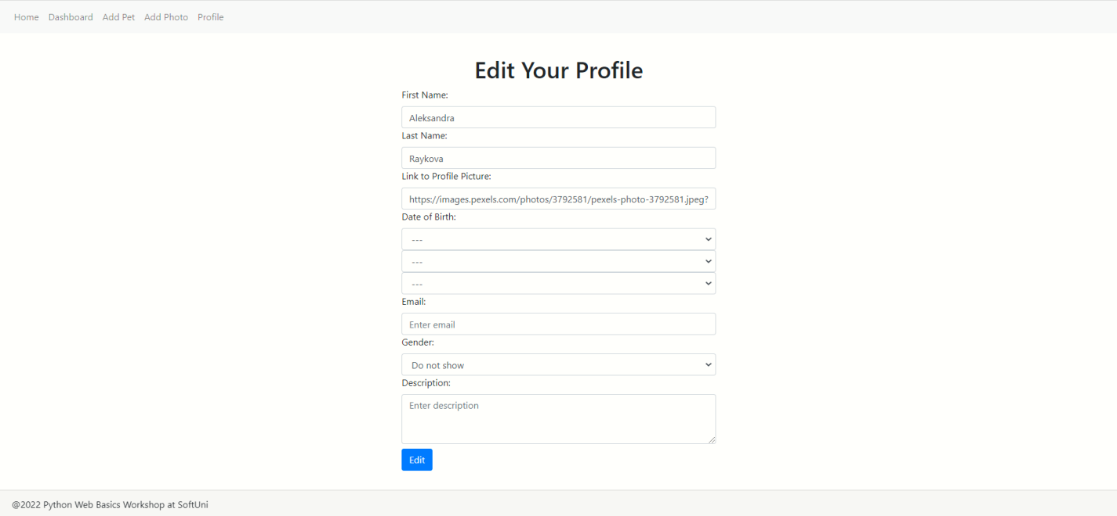

Profile Delete Page
Template: profile_delete.html
Before the profile is permanently deleted, the user will see the following page. When the user clicks on the "Confirm" button, the profile, pets, and photos are deleted. If the user clicks on the "No, no back" button, he is redirected to the profile page.
After deletion, the user will be redirected to the home page (with no profile):
