# Unit Office

# Ref:

“Office politics” in L12 Unit 6 Politcs.docx, C:\Tracy\TW related\English\IETLS\oral topic\2 EF oral topics - Script based on Level\EF L12

# Lexical resource

|  |
| --- |
| ['stæmɪnə] [stæmənə] stamina  n. 毅力(指体力精力)；活力；持久力  physical or mental strength that lets you continue doing something for a long time without getting tired  持久力，耐力，毅力  •You need stamina to be a long-distance runner. 当长跑运动员需要耐力。  •Elaine has the stamina and the determination to succeed. 伊莱恩具有成功所需的毅力和决心。  e.g. Most employees in this industry work full time, and many work over 40 hours a week. Construction workers often work evenings, weekends and holidays to finish a job**. The nature of the work**工作性质 requires **physical stamina['stæmɪnə] [stæmənə]（耐力,体力持久）**, as the body has to be able to cope with **prolonged** standing, bending, **stooping [stuːp]弯腰驼背**and working in small spaces.. |
| [stuːp] stoop V.S. give sb. a piggyback    vi. 弯腰驼背；屈服；堕落 [ condescending manner, condescending way ]  n. 弯腰驼背，屈背；屈服  1.  [V-I](javascript:;)If you stoop, you stand or walk with your shoulders bent forward. 驼背  •  She was taller than he was and stooped slightly.   她比他高，但有点儿驼背。  2.  [N-SING](javascript:;)Stoop is also a noun. 驼背  •  He was a tall, thin fellow with a slight stoop.   他是一个有点儿驼背的瘦高个男子。  3.  [N](javascript:;)a small platform with steps up to it at the entrance to a building 小门廊  4.  [V-I](javascript:;)If you stoop, you bend your body forward and downward. 弯腰  •  He stooped to pick up the carrier bag of groceries.   他弯腰提起装满食品杂货的购物袋。  •  Two men in shirt sleeves stooped over the car.   两个穿衬衫的男人趴在那辆汽车上。  5.  [V-I](javascript:;)If you say that a person stoops to doing something, you are criticizing them because they do something wrong or immoral that they would not normally do. 卑鄙到…  •  He had not, until recently, stooped to personal abuse.   他最近才卑鄙到进行人身攻击。  MEANINGS 义项   1. to bend your body forward and down 俯身，弯腰   •We had to stoop to pass through the low entrance. 我们得弯腰通过那低矮的入口。  •Dave stooped down to tie his shoes. 戴夫俯身系鞋带。  e.g. Most employees in this industry work full time, and many work over 40 hours a week. Construction workers often work evenings, weekends and holidays to finish a job**. The nature of the work**工作性质 requires **physical stamina['stæmɪnə] [stæmənə]（耐力,体力持久）**, as the body has to be able to cope with **prolonged** standing, bending, **stooping [stuːp]弯腰驼背**and working in small spaces.  2. to stand with your back and shoulders bent forwards  弓背站立，弯腰曲背站立  PHRVB 短语动词  stoop to sth: to do something bad or morally wrong, which you do not normally do  堕落[卑鄙]到去做…  stoop to doing sth  •I didn’t expect you to stoop to lying.我没料到你竟然卑劣到会撒谎。  stoop to sb’s/that level  •Don’t stoop to her level.别把自己降低到她的档次。  V.S. piggyback |
| /'ʃæbi,ˋʃæbɪ/ adj. shabby  => comparative: shabbier ; su’perlative [suːˈpəːlətɪv]: shabbiest  => DERIVATIVE 派生词=> shabbily adv; shabbiness n [U]   1. shabby clothes, places, or objects are untidy and in bad condition because they have been used for a long time又脏又破的(衣服，东西，地方); 肮脏破旧的(地方) **[ old and shabby ]** e.g. a **shabby** little hawker小贩中心 in **a run-down community** 一家肮脏的小贩中心 e.g. His clothes are old and shabby.   他的衣服又旧又破。 2. wearing clothes that are old and worn 衣衫褴褛的，衣着寒酸的 a shabby tramp 一个衣衫褴褛的流浪汉 ; a shabby begger 3. unfair and unkind不公平的；不仁慈的 **[卑鄙的花招a shabby trick/maneuver/ruse/artifice]**   肮脏破旧的(地方) a shabby place/ restaurant; a shabby **hawker**: 一家肮脏的小贩中心  V.S.  破旧的，破落的〔建筑物或地区〕**: a run-down area; a run-down building; a run-down community**   1. a building or area that is run-down is in very bad condition 破旧的，破落的〔建筑物或地区〕 2. [not before noun, 不用于名词前] someone who is run-down is tired and not healthy精疲力竭的，衰弱的 e.g. You look a bit run-down. 你看上去有点疲倦。 |

|  |
| --- |
| [ʌndə'teɪk] undertake; 过去式 undertook过去分词 undertaken现在分词 undertaking  vt. 承担，保证；从事；同意；试图   1. to accept that you are responsible for a piece of work, and start to do it 承担；着手做〔某事〕 [ undertake a task/a project/research/a study] etc e.g. Dr Johnson undertook the task of writing a comprehensive English dictionary. 约翰逊博士担负起编写一本综合性英语词典的工作。 2. **[ undertake to do sth ] = promise or agree to do something 承诺做某事，答应做某事** e.g. He **undertook to pay** the money back in six months. 他保证在六个月之内还钱。 e.g. We **understand that** the Villa comes fully equipped for use and that a before and after “maid service(客房清洁服务): is included. We undertake/promise to pay you back a deposit of $250 which will be refundable on arrival home. We also undertake/promise to leave the property in a reasonably clean and tidy order. Please note that if there is excessive cleaning of damage to the Villa part of your deposit may be withheld (withhold: refuse to give). |

|  |
| --- |
| [杯中的水是半空还是半满全取决于你的态度/是一个仁者见仁智者见智的问题: glass half empty, half full ]  e.g. It is a case of "the glass being half full or half empty", depending on your view. 这是一个仁者见仁智者见智的问题  e.g. Stephen Green, head of economic research, said it was a case of "the glass being half full or half empty", depending on your view. 这是一个仁者见仁智者见智的问题,全看你怎样看待  V.S.  **第一次努力是不太可能得到所有想要的: You don’t get full on the first spoonful**  Vice Minister, at South Korea's Unification Ministry, says the talks got off to a positive start this morning and this afternoon negotiators will tackle "more on-the-field, technical matters." He says the delegations will discuss the specific arrangements for the North Korean participation in the Winter Olympics as well as the possibility of family reunions and military talks. "Starting is half the work and...**you don’t get full on the first spoonfu**l," he says. |
| Substance = substantive, substantively ['sʌbst(ə)ntɪv] [səb'stæntɪv]  dealing with things that are important or real 实质的；真实的，实际的 **[ substantive matters/issues; 实质性的商谈: substantive disucssions; 实质性的进展substantive progress ]**  e.g. The State Department reported that substantive discussions had taken place with Beijing. 美国国务院称已经和北京方面进行了实质性的商谈。  e.g. President Moon's proposal for North Korean participation in the Winter Olympics is an incremental step that might eventually lead to further, more **substantive实质性的** interactions between the North and South. |
| [mɪs‚kælkjʊ'leɪʃ ə n,mɪs‚kælkjə'leɪʃ ə n]  miscalculation   1. a mistake made in deciding how long something will take to do, how much money you will need etc 误算，错算 2. a wrong judgment about a situation 〔对局势的〕错误判断   But if the North does participate in the Olympics and manages to keep its lines of communication open this reduces the **likelihood** of **miscalculation /'mis,kælkju'leiʃən/ 〔对局势的〕错误判断** (on both sides) which could escalate into a military conflict. |
| **后门；非法途径; 不正规的途径** [ back door; 走后门: get in through the back door ]   * back door: a secret or underhand means of access (to a place or a position) * get in through the back door: to achieve something by having an unfair secret advantage   e.g. His father works there, so he got in through the back door. 他父亲在那里做事，所以他走了后门。 |
| (会谈，政治对话的) 对话者；谈话者 interlocutor  [,ɪntə'lɒkjʊtə] your interlocutor is the person you are speaking to 对话者，参加谈话者  [词条图片](javascript:;) |
| **[ 有约束力的决定: a binding decision; 一种具有法律约束力的决定: a legally binding decision; 没有约束力的决议: a non-binding decision ]**  e.g.The CHMP's recommendation has now been forwarded to the European Commission for the adoption of a legally binding decision.  以便作为一种具有法律约束力的决定而被采用。  e.g. from the perspective of the North Koreans, they will want **interlocutors** who have the authority to make **a binding decision有约束力的决定**, pending President Moon's approval, about the North's participation.  2. China has already ruled out a joint referral to the tribunal, but del Rosario said it is possible for acountry to go to the panel unilaterally for a non-binding decision.  寻求一个单方的专家组做出没有约束力的决议对一个国家来说还是有可能的。  3. May I remind everyone that this committee has authority to make a binding decision.  有权做 约束性的决定。 |
| 插入一根不谐锲子, **制造分裂,** 种下不和的种子: **drive a hedge; drive a hedge between A and B.**   * + 1. The president accused his hardline rivals of trying to **drive a wedge between him and the man** whosits at the top of Iran's clerical leadership and has final say in all state matters. 对手冀图在他和卡梅尼之间插入一根不谐锲子(**制造分裂**)，离间两人之间的关系。     2. E.g. There is concern in Seoul that Pyongyang's insistence on holding bilateral talks with Washingtoncould drive a wedge between the U.S. and South Korea.  平壤坚持要同华盛顿举行双边会谈，这可能在美国和韩国之间种下不和的种子   They're talking about **appeasement** of the North, of Pyongyang using its potential participation in the Olympics as a way to extract **concessions** on issues of geostrategic concern, and to give voice to a "sky is falling" perspective that Pyongyang is attempting to **drive a wedge制造分裂** in the South Korean-US alliance. |
| [əʊvə'rɔːt] overwrought  adj. 过度紧张的；过度兴奋的；过分劳累的；（文体等）过于考究的  v. 工作过度；把…做过头；使过于激动（overwork的过去式和过去分词: overwork, overwrought, overwrought）  very upset, nervous, and worried  非常烦恼的；神经很紧张的；十分忧虑的  e.g. Clara was tired and overwrought after all the problems of the last few days. 经历了过去几天的重重困难之后，克拉拉既疲惫又紧张。  E.G. The fact that South Korean President Moon Jae-in even proposed the meeting, in response to remarks Kim Jong-un made during his New Year's Day address, has sent some analysts into making overwrought([‚əʊvə'rɔːt◂ over upsetting and nervous) and heavy handed pronouncements. |

|  |  |
| --- | --- |
| **对 <xxx事情的发生>抱有一线希望** | **对 <xxx事情的发生>抱有一线希望 [ on the off-chance that sth will happen ]** if you do something on the off-chance that something will happen, you do it hoping that it will happen although it is unlikely 对 <xxx事情的发生>抱有一线希望  E.G. I just came to see you **on the off-chance that** Pippa might be here. 我来看你只是抱着一丝希望皮帕或许会在这儿。  E.G. After the call ended, officials from the Ministry of Unification -- responsible for "all issues pertaining to inter-Korean relations and unification" -- stayed by the phone, **on the off-chance that** the North would call again. The DMZ village is home to 33 communications lines between South and North Korea, according to the Ministry of Unification. |
| 衰退(貌似也不再有进展/进步) ;  失去了信心，做xxx事情犹豫 | /ˈfɔːltə/  falter   1. [V-I](javascript:;)If something falters, it loses power or strength in an uneven way, or no longer makes much progress. 衰退(貌似也不再有进展/进步)  **[经济正在衰退(貌似也不再有进展/进步): economy is faltering/melting down.]** e.g. Normal life is at a standstill, and **the economy is faltering/melting down**. We’d foresee an **economic recession/meltdown**.  正常生活陷入停滞，经济正在衰退(貌似也不再有进展/进步) 2. [V-I](javascript:;)失去了信心，做xxx事情犹豫/动摇 **[ falter in sth ]** If you falter or falter in sth, you lose your confidence and stop doing something or start making mistakes.   e.g. I have not **faltered in** my **quest/pursuit for** a new future.  我 **对<**崭新未来>的**追求**未曾犹豫过/动摇过。  e.g. I have not **faltered in** my **quest for** new knowledge.  **//对<xxx>的追求 N) my quest for sth (knowledge)**  V.S **pain/stress/pressure abates: become less strong, weaker or decrease V.S. mitigate/alleviate pain/stress/pressure** |
| (风暴, 危机，价格，气势) 减弱 | 减弱 **sth abate /əˈbeɪt/, abatement:** If something bad or undesirable abates, it becomes much less strong, weaker, or severe. 减弱  🡺Derivative word: abatement means a reduction in the strength or power of something or the reduction of it. 减少 **[ 二氧化碳排放的减少 the abatement of carbon dioxide emissions; the abatement of GHG emissions; 噪音的减少: abatement of the noise ]**  e.g. The storms had **abated** by the time they rounded Cape Horn.   暴风 已经减弱了。  e.g. We waited for the storm to **abate**. 我们等风暴减弱。  e.g. Genuine fears that the Trump administration might be on the path to a new conflict on the Korean peninsula. South Korea's President Moon has responded positively, eager to bolster his own **diplomatic hand外交手段**. But given that the North sees its nuclear programme as a permanent **fixture固定设备** and President Donald Trump insists that Pyongyang will not be allowed to have a credible means of striking US territory, it is hard to **see this crisis abating减弱**any time soon.  e.g. Some see commodities in general, and gold in particular, as **a hedge against inflation** (**avert** risk by using sth避险), and so may sell if their fears about rising prices **abate (become weaker, less strong)**.  e.g. Our team morale has **abated** dramatically since the foiled military coup.    V.S.  **mitigate sth/alleviate sth (pain,pressure,sadness):** to make a situation or the effects of something less unpleasant, harmful, or serious 减轻，缓解，缓和(痛苦，压力，伤心) |
| **蒙上了一层阴影** | **[蒙上了一层阴影 by marred by sth ]**  e.g. Their wedding **was marred by** the death of Jenny’s mother a week earlier. 一周之前珍妮母亲的过世使他们的婚礼 **蒙上了一层阴影。**  e.g. After a year **marred by蒙上了一层阴影** mass shootings and deadly terror attacks, many celebrations unfolded amid heightened security. In London, officials **deployed** armed officers as part of a security plan they "developed and reviewed following the tragic incidents that have occurred throughout the year," **Metropolitan** Police Superintendent Nick Aldworth [said](http://news.met.police.uk/news/planning-for-new-years-eve-287712).  After **a spate of** sexual assaults **marred(蒙上了一层阴影)** New Year's Eve events in several German cities in 2015, [officials in Berlin this year set up a special "safe zone"](http://www.cnn.com/2017/12/31/europe/germany-berlin-new-year-safe-zone/index.html) for women who feel harassed. Berlin, Cologne and other German cities also added hundreds of extra police |
|  |  |
|  |  |
|  |  |

# Lexical_officeRelatedDic

|  |
| --- |
| **我的工作主要包括什么? [What does his/her job entail?**] = Job description: use strong action verb to describe a job |
| stipulate /ˈstɪpjʊˌleɪt/      |CET6 TEM8 (stipulatingstipulatedstipulates)  1.  [V-T](javascript:;)If you stipulate a condition or stipulate that something must be done, you say clearly that it must be done. 规定; 明确要求  •  She could have stipulated that she would pay when she collected the computer.   她本可以明确要求取电脑时付款的。   * e.g. The dress code **stipulates/rules 明确规定xxx that** you wear leather shoes.   2.  [N-COUNT](javascript:;)规定; 明确要求  •  Clifford's only stipulation is that his clients obey his advice.   克里弗德惟一的规定是他的客户必须听从自己的建议。 |
| [口头警告 a verbal warning V.S. a written warning ]    e.g. |
|  |

## Lexical_dressRelated (for dress code in a company)

|  |
| --- |
| attire /əˈtaɪə/  **[ business attire 商务着装，正装: suit, tire, and leather shoes]**  [N-UNCOUNT](javascript:;)Your attire is the clothes you are wearing. 服装 •  ...seven women dressed in their finest attire.   ...七位着盛装的女士。 |
| flip-flop  1. [N-PLURAL](javascript:;)Flip-flops are open shoes which are held on your feet by a strap that goes between your toes. 人字拖 = t**hongs** are open shoes which are held on your foot by a V-shaped strap that goes between your big toe and the toe next to it. 人字拖鞋  2. [V-I](javascript:;)If you say that someone, especially a politician, flip-flops on a decision, you are critical of them because they change their decision, so that they do or think the opposite. (尤指政客)改变立场  •  He has been criticized for flip-flopping on several key issues.   他由于在几个关键问题上变卦而备受指责。  •  He seemed so sure of his decision, how could he flip-flop so dramatically now?   他似乎对自己的决定非常肯定，现在怎么会戏剧性地改变立场呢？   1. [N-COUNT](javascript:;)Flip-flop is also a noun. 也可作名词。   •  The president's flip-flops on taxes made him appear indecisive.   总统在税收问题上的决定临场变卦使他看起来有些优柔寡断。  V.S.  thong /θɒŋ/  1. [N-COUNT](javascript:;)A thong is a long thin strip of leather, plastic, or rubber. 皮带; 塑料带; 橡胶带  2. [N-COUNT](javascript:;)Thongs are open shoes which are held on your foot by a V-shaped strap that goes between your big toe and the toe next to it. = flip-flops人字拖鞋  3. [N-COUNT](javascript:;)A thong is a narrow band of cloth that is worn between a person's legs to cover up his or her sexual organs, and that is held up by a piece of string around the waist. 丁字裤; Ｇ弦裤 |
| [ʃɔːts] shorts 男性短裤 V.S. pants  [词条图片](javascript:;)  [N-PLURAL](javascript:;)trousers reaching the top of the thigh or partway to the knee, worn by both sexes for sport, relaxing in summer, etc 男性短裤 |
| Appropriate Office Attire: For men: shirts with collars, short sleeves in summer, suits, jackets, cardigans, leather shoes. Ties  must be worn during business meetings and when with clients.  For women: sleeved shirts, blouses, skirts of appropriate length, pants, cardigans, pantsuits. Ties  are not compulsory. Heels should be no higher than 3 inches.   Inappropriate Office Attire: For men: Sleeveless shirts, sweatshirts, sweat pants, shorts, jeans, sandals, slippers, sportswear For women: Sleeveless shirts, bare midriff, bare shoulders, shorts, miniskirts, jeans, sportswear  Strictly Forbidden: Visible tattoos  Visible body piercings: e.g. ear piercing; tongue piercing Brightly dyed hair: 明亮染色 Flip-flops/thongs: 人字拖鞋  Shorts: 男性短裤 |

# Part 1)Trend of office layout



 //learning the ropes?







 //receptionist













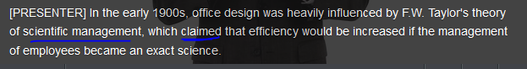







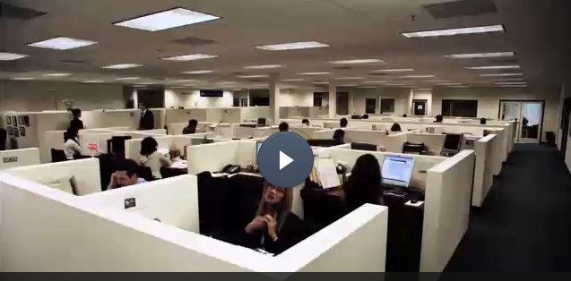









* + To fit the trend of being agile in work



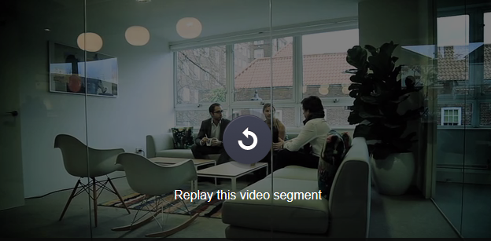





All in all, 

# Part 2)

## Office equipment, supplies, stationery

|  |
| --- |
| ['kɑːtrɪdʒ] cartridge: **弹药筒**，打印机的（墨盒）; [摄影photography] 暗盒； 笔芯；一卷软片   1. a small container or piece of equipment that you put inside something to make it work 〔插进某物里使用的〕盒；卡  * computer game cartridges 电脑游戏卡 * an ink cartridge for a printer 打印机的墨盒 * The printer needs a new **ink cartridge.** * This printer needs a new **toner cartridge.**      1. (Military) a tube containing explosive powder and a bullet that you put in a gun; A cartridge is a metal or cardboard tube containing a bullet and an explosive substance. Cartridges are used in guns. 弹药筒; 弹壳，弹夹 [词条图片](javascript:;) 2. A cartridge is part of a machine or device that can be easily removed and replaced when it is worn out or empty. (机器或装置中可替换的部分) 套筒 e.g.  Change the filter cartridge as often as instructed by the manufacturer.   要按制造商要求的频率更换过滤套筒 |
|  |
| stationery  [下载](javascript:;)[纠错](http://c.youdao.com/ugc/errorreport.html?q=stationery)  英 ['steɪʃ(ə)n(ə)rɪ]    美 ['steʃənɛri]  n. 文具；信纸  [词条图片](javascript:;)  [[pencil sharpener 卷笔刀；marker 记号笔；scissors 剪刀；ruler 尺；stapler 订书机；tack <i>AmE</i>【美】工字钉；ring binder <i>BrE</i>【英】/binder <i>AmE</i>【美】活页夹；highlighter 荧光笔；rubber <i>BrE</i>【英】/eraser <i>AmE</i>【美】橡皮；drawing pin <i>BrE</i>【英】/thumbtack <i>AmE</i>【美】图钉；correction fluid 修正液；paperclips 回形针；folder 文件夹；pen 笔；punch 打孔器；Scotch tape 透明胶带；cap 笔帽；felt-tip pen 毡头笔；pencil 铅笔；fountain pen 钢笔；notebook 笔记簿；staple remover 起钉器；Bulldog clip <i>BrE</i>【英】/binder clip <i>AmE</i>【美】长尾夹；elastic band【英】/rubber band 橡皮筋](javascript:;)](javascript:;)  [STATIONERY 文具](javascript:;)  sta‧tion‧e‧ry   /'steɪʃən ə ri,ˋsteʃən͵ɛrɪ/ n. [U ]  英 ['steɪʃən ə ri]  MEANINGS 义项  1.  paper for writing letters, usually with matching envelopes  〔一般指配有信封的〕信纸，信笺  •a letter on hotel stationery 用酒店信纸写的信  2.  materials that you use for writing, such as paper, pens, pencils etc  文具 |
|  |
|  |
|  |
|  |

officesupply.com

https://cns2.ef-cdn.com/Juno/11/90/44/v/119044/Off2.1.3_sub.jpg

|  |  |  |
| --- | --- | --- |
| https://cns2.ef-cdn.com/Juno/11/90/47/v/119047/Off2.1.3_copy.jpg | https://cns2.ef-cdn.com/Juno/11/90/48/v/119048/Off2.1.3_printer.jpg | https://cns2.ef-cdn.com/Juno/11/90/49/v/119049/Off2.1.3_stapler.jpg |
| **Copy machines**  The Clearcopy 7000 series delivers crisp, colorful photocopies. A must-have addition for the office that’s sinking under a sea of paper. | **Printers**  The new, improved Prestell 2.0 color printer prints 15 pages per minute. If you need an office report printed super fast, look no further than this model. | **Staplers**  A Stanley stapler is the cornerstone of every office. Never jams and is always reliable. |

|  |  |  |
| --- | --- | --- |
| https://cns2.ef-cdn.com/Juno/11/90/46/v/119046/Off2.1.3_toner.jpg | https://cns2.ef-cdn.com/Juno/11/90/54/v/119054/Off2.1.3_envelop.jpg | https://cns2.ef-cdn.com/Juno/11/90/55/v/119055/Off2.1.3_binder.jpg |
| **Toner**  No printer is complete without a top-quality toner. The new Clearcopy 7000 series toner has been engineered to work perfectly with their new model of printer. Clearcopy guarantees a minimum of 1000 prints per toner cartridge. | **Envelopes**  For those important official documents, these envelopes never fail to deliver. | **Binders**  For documents in need of safekeeping. |

|  |  |  |
| --- | --- | --- |
| https://cns2.ef-cdn.com/Juno/11/90/56/v/119056/Off2.1.3_projector.jpg |  | https://cns2.ef-cdn.com/Juno/11/90/58/v/119058/Off2.1.3_post.jpg |
| **Projectors**  PowerPoint presentations are popular with today’s business professionals. That’s why Panther Projectors give you the edge when it comes your time to show and tell. Amaze your superiors with our new selection of Panther Projectors. | **Monitor mounts**  Monitor mounts are rising in popularity amongst office workers who don’t like going home every night with a stiff neck and a bad back.  //mount:  [V-T](javascript:;)If you mount an object on something, you fix it there firmly. 安装  •  Her husband mounts the work on velour paper and makes the frame.   她丈夫把作品装裱到丝绒纸上，又做了框架。  8. [COMB in ADJ](javascript:;)安装在…上的  •  She installed a wall-mounted electric fan.   她装了一台墙壁式电扇。 | **Post-it notes**  Some of us still cling to the old-fashioned way of making notes and scribbling down reminders. Stick one anywhere! |

## People in an office

Fill in the gaps with the words below.

Senior Accountant  -  Personal Assistant  -  receptionist  -  Director  -  Office Manager  -  Head of Sales  -  Chairman

1. The Chairman is the highest-ranking person in a company, who is ultimately responsible for its strategy, decisions and success.   
  
2. A Director is on the board and charged with helping make the big decisions that decide a company's strategy.   
  
3. The Senior Accountant is ultimately responsible for the handling of the money going in and out of a company.   
  
4. The Head of Sales is in charge of selling a company's product.   
  
5. The Office Manager is responsible for the smooth running and organization of the work environment.   
  
6. The Personal Assistant (PA) is tasked with helping a superior with his or her administrative duties.   
  
7. The duties of a receptionist include fielding phone calls and mail and welcoming visitors to the company office.

|  |
| --- |
| [ 销售代表 sales reps]  e.g. As the Assistant Sales Manager, you're **in charge of** two junior sales representatives. These **sales reps** are each responsible for a particular product line but have to cooperate closely. Your main responsibility is to make sure their product lines are selling well. |
| 总经理（General Manager: GM） |
|  |
|  |
|  |

## Company structure: organizational chart (breakdown)

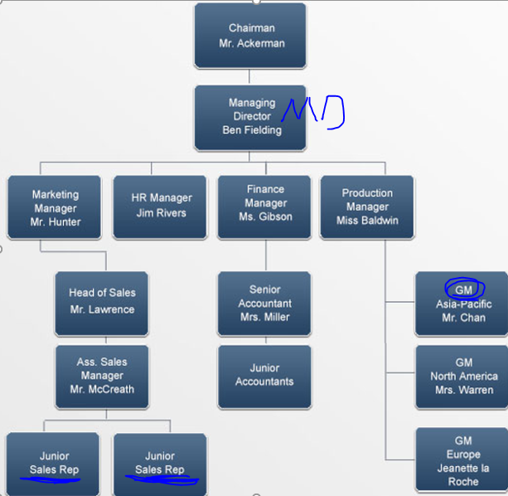

Fill in the gaps with the phrases used in the audio to describe a company's structure. Use the organizational chart to help you.

is responsible for  -  is controlled by  -  Your main responsibility is  -  I report directly to  -  is in charge  -  is held by  -  is structured around  -  is divided into

Mr. Lawrence: So, now that you've had the office tour, let me tell you about the company in a bit more detail.   
  
Gordon: Sure.   
  
Mr. Lawrence: Diamond Sports is controlled by a board of directors. The chairman of the board is a man called Neil Ackerman but, between you and me, the person who really runs the company is Ben Fielding, our managing director.   
  
Gordon: Right. I see.  
  
Mr. Lawrence: The company is structured around four main functional areas: Marketing, Human Resources, Finance and Production.

* Henry Hunter **is in charge of** the Marketing Department and, as the Head of Sales, I report directly to him.
* Jim Rivers **is responsible for** HR and deals with things like recruitment and training.
* The position of Finance Manager **is held by** Belinda Gibson. She has two accountants working under her; Ruth Miller is in the senior role and supervises the junior accountants.
* Wendy Baldwin is Head of Production and **is responsible for** our factories in Europe, Asia and America.

As the Assistant Sales Manager, you're **in charge of** two junior sales representatives. These **sales reps** are each responsible for a particular product line but have to cooperate closely. Your main responsibility is to make sure their product lines are selling well. And as head of sales, I am responsible for making sure you do that effectively.   
  
The Production Department is divided into three main regions.

* Jimmy Chan is **GM** (General Manager) of Asia-Pacific, and **is responsible for** about 100 staff.
* Liz Warren **heads** our North American division. She's based in Chicago.
* Jeanette la Roche **oversees** our operations in Europe, but she's originally from the States.

These **regional managers** run the production facilities, and each **supervises** up to 100 workers.

## Introducing a new employee to the company

You’re the HR manager for a big logistics and shipping company. You’ve just hired a new marketing manager, and you’re **showing her around the office.**

* Name
* Position: who does this new guy directly report to? Who does this new guy might oversee and supervise; or how are his/her peers? 一个员工的上下有游
* **What does his/her job entail? 我的工作主要包括什么?** = Job description: use strong action verb to describe a job

# Part 3)Conduct an interview

## Confirming an appointment over the phone

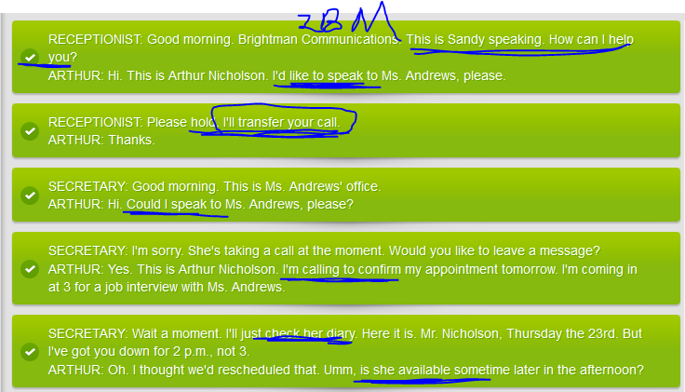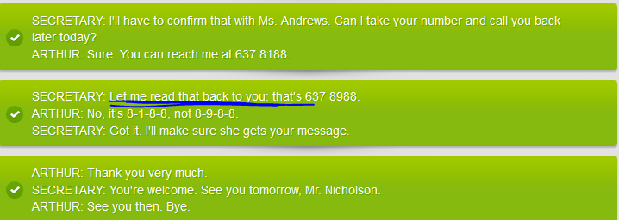

## Language strategies for conducting a job interview

**Very good mp3 as my reference for accepting a job interview:**

Right. Shall we get started?

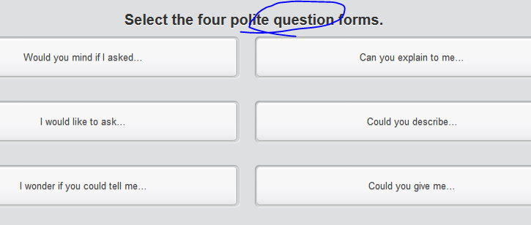

* Can you describe yourself a little bit?
* Why did you leave your previous job?: Would you mind if I asked why you left your previous job? =>

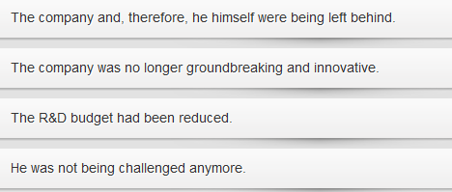

* What’re your strengths and weaknesses: e.g. I'd like you to expand on that. Could you give me a concrete example?  
  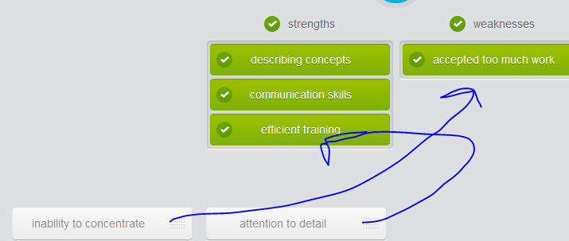
* The future (career path)? One more question. Where do you see yourself five years from now?

## Identifying details from a job interview

Listen to an excerpt from the job interview. Try to pick out the key points regarding Arthur Nicholson’s experience.

## Conducting an interview

You are the HR Manager for a big design company. You are interviewing a candidate for the position of Assistant Head of Design. The successful candidate will have a team of six under him or her. Choose the correct and most appropriate response each time, making sure to ask the candidate to expand if they haven't provided enough detail.

# Part4) Code of business conduct

## Dress code

If you were to dress in any of the following ways at your office, how much trouble would you get into? Rank the dress code violations in their order of seriousness where you work.

Dress Code  
  
1. Purpose   
This is a general overview of appropriate business attire for the Clearview Futures and Derivatives Central Headquarters in Shanghai. Clearview Futures and Derivatives has a standard policy on business attire that generally follows what is known as  'business casual.'  This document outlines in detail Clearview’s understanding and application of that term.   
  
NOTE: The dress code must be strictly adhered to at all times, except in certain extenuating circumstances as outlined below in section 3. Failure to obey the dress code can lead to an informal verbal warning. Failure to heed said warning can lead to further action and even, in extreme cases, dismissal.      
  
2. Rules  
Business casual wear should be neat, clean, ironed and look appropriate for the modern workplace.   
Please avoid tight, baggy or revealing clothing. This kind of clothing is prohibited. If you are unsure   
whether  what you are wearing constitutes business casual attire, please consult your line manager.   
  
Appropriate Office Attire:  
For men: shirts with collars, short sleeves in summer, suits, jackets, cardigans, leather shoes. Ties   
must be worn during business meetings and when with clients.   
For women: sleeved shirts, blouses, skirts of appropriate length, pants, cardigans, pantsuits. Ties   
are not compulsory. Heels should be no higher than 3 inches.   
  
Inappropriate Office Attire:  
For men: Sleeveless shirts, sweatshirts, sweat pants, shorts, jeans, sandals, slippers, sportswear  
For women: Sleeveless shirts, bare midriff, bare shoulders, shorts, miniskirts, jeans, sportswear  
  
Strictly Forbidden:  
Visible tattoos   
Visible body piercings: e.g. ear piercing; tongue piercing  
Brightly dyed hair: 明亮染色  
Flip-flops/thongs: 人字拖鞋   
Shorts: 男性短裤  
  
3. Exceptions  
Casual Friday:  
Casual wear such as jeans, sweaters, T-shirts and sneakers are permitted only on Fridays. However, business meetings and visits from clients or VIPs still require more formal attire.  
Offsite Events:  
Certain offsite activities such as teambuilding events may require specific items of clothing normally prohibited in the office. You will be informed of these items by your line manager prior to any such event.

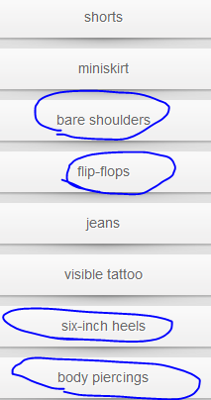 e.g. tongue piece ; ear pierce

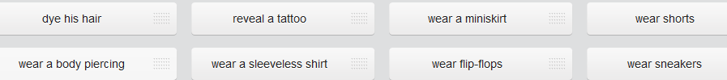

Fill in the gaps with the words below.

normally prohibited  -  must be worn  -  obey  -  strictly adhered to  -  prohibited  -  permitted

1. The dress code must be strictly adhered to at all times, except in certain extenuating circumstances as outlined below in section 3.   
  
2. Failure to obey the dress code can lead to an informal verbal warning. Failure to heed said warning can lead to further action and even, in extreme cases, dismissal.   
  
3. Business casual wear should be neat, clean, ironed and look appropriate for the modern workplace. Please avoid tight, baggy or revealing clothing. This kind of clothing is prohibited .   
  
4. Ties must be worn during business meetings and when with clients.   
  
5. Casual wear such as jeans, sweaters, T-shirts and sneakers are permitted only on Fridays. However, business meetings and visits from clients or VIPs still require more formal attire.   
  
6. Certain offsite activities such as teambuilding events may require specific items of clothing normally prohibited in the office. You will be informed of these items by your line manager prior to any such event.

## Drawing attention to an issue

Jenny Zhang, a manager at Clearview Futures and Derivatives Central Headquarters in Shanghai, has a problem: Kevin, one of her team, has consistently been breaking the dress code. Group the dress code violations according to whether or not Kevin broke them.

* **It's been brought to my attention** (that) you've not been **adhering to/complying with** the dress code.
* Wearing sleeveless shirts in the office is prohibited.
* It's in direct violation of the dress code.
* The dress code **stipulates/rules 明确规定xxx that** you wear leather shoes.
* This absolutely cannot continue. Do you understand me?
* If you don't adhere to/comply with the dress code in the future, I'll have to take this further.

## Verbal warning口头警告

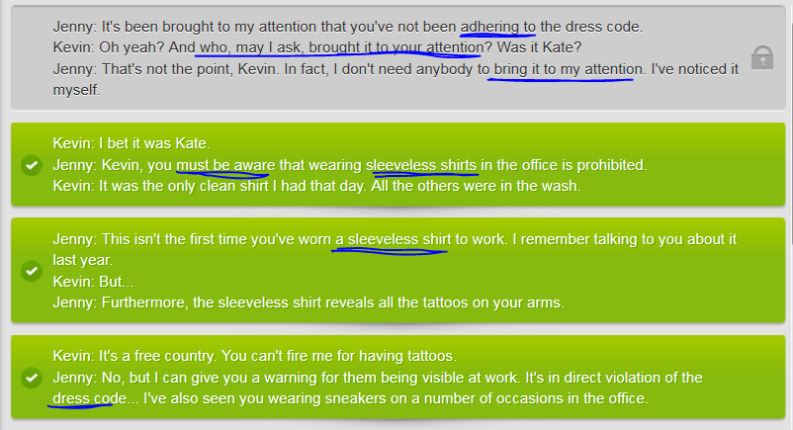

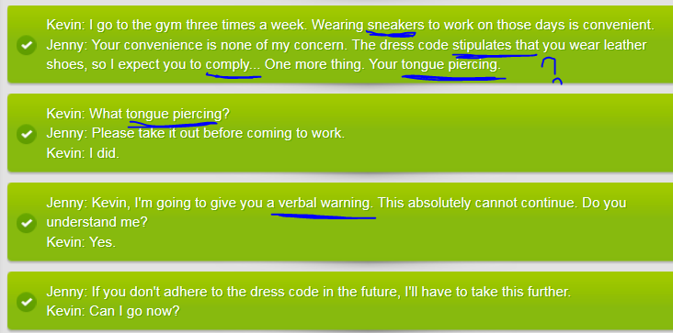

## Writing a warning letter (a written warning)

Kevin has not **complied with/adhered to** the dress code. Put Jenny's final letter of warning to Kevin into the correct sequence. Pay attention to the letter's clear, simple structure.

|  |
| --- |
| Formal letter of warning for dress code violation  From  Jenny Zhang  Dear Kevin,  **It has been brought to my attention** on a number of occasions recently **that**, despite my repeated **verbal warnings,** you are continuing to violate the company’s dress code. Therefore it is with great regret that I am forced to issue you this formal written warning.  I am sure that you recall my previous **verbal warning** one month ago, during which I told you if you didn’t **comply with/adhere to** the dress code I would be forced to take things further. Since then there have been three more complaints regarding your **attire**, including one related to you wearing **flip-flops/thongs人字拖** and another regarding your new color of hair. This has quite simply gone on long enough.  I **would like to** make this clear: **This is your final warning on this matter.** Should you not begin **complying with the** dress code regulations, your contract will be terminated.  Sincerely,  Jenny Zhang Vice President Clearview Futures and Derivatives Shanghai Central HQ China |

## Writing

Imagine you need to write a formal warning letter to Clare, shown in the photo in her office attire. Write her a letter regarding her dress code violations. Ensure that you follow the correct structure and use appropriate formal language.

|  |
| --- |
| https://cns2.ef-cdn.com/Juno/14/75/1/v/14751/14.5.3_tattoos.jpg |