# Unit Oil and Gas industry

# Oil price

Ten-second **trivia**:十秒钟问答：

|  |
| --- |
| Trivia /ˈtrɪviə/  美  n.  [ U ]   1. unimportant matters, details or information 琐事；细枝末节  e.g. We spent the whole evening discussing **domestic trivia.** 我们整个晚上谈论**家庭琐事** 2. ( usually in compounds 通常构成复合词 ) facts about many subjects that are used in a game to test people's knowledge （智力测验比赛用的）各种科目的**知识问答比赛**   e.g. **[ a trivia quiz 知识面宽的问答比赛; ten-second trivia:十秒钟知识问答比赛]** |

**Crude oil**, also known as petroleum, is made up primarily of what element?

**Hydrogen, nitrogen, carbon or o**xygen? 是氢元素，氮元素，碳元素，还是氧元素？

While crude oil contains all of these elements, it’s mostly made up of carbon.

尽管这些元素全都包含在原油之内，不过碳元素才是构成原油的主要元素。

Just a few years ago, the fallen oil prices was so **dramatic**, **tumbling/plummeting/plunging/nosediving** more than 75 percent. 国际油价戏剧性下跌，下跌了超过百分之七十五。

But crude is **staging a comeback,** rising about 20 percent in the past year. 不过原油也经历了回温(**卷土重来；东山再起；再度走红**)，在过去几年上涨了百分之二十。

So, what is driving the rise? 所以到底是什么在调控油价呢？

First, demand is much higher than anticipated, especially from countries like China, India, Japan and South Korea.

World **consumption** is expected to cross 100 million **barrels** per day in the coming months.

And when it does, it will be the first time in history = **unprecedented/all-time** 那这将是历**史上前所未有的**情况。

Second, supply is limited, even though the United States is flooding the market with crude, the most in 40 years, other major players are doing exactly the opposite.

第二点，世界原油的供应量有限，即使美国在国际原油市场大量出售原油，四十年来出售了最多的原油，但在国际市场，其他玩家的做法却与美国截然不同。

The two largest oil exporters, Saudi Arabia and Russia are taking millions of **barrels** off the market to **drive up prices/jack up prices**以抬高油价。

|  |
| --- |
| * jack up prices * jack up my salary   V to increase (prices, salaries, etc) 增加(价钱、工资等) |

And other big suppliers, like Venezuela, Libya and Nigeria are dealing with economic and political crises **at home/domestically**. That’s limiting how much they can produce. 国内的问题限制了他们国家对石油的出口。

Then there’s the unknown. 还有一些无法确定的原因。

Yemeni missile launches into Saudi Arabia, ongoing tensions with regards to the Iran nuclear agreement, U.S. involvement into Syria.

All these forces combined have the market worried and driving up/**jacking up that price** of crude.

这些问题的合力使国际市场十分忧虑，继而使国际原油价格升高

Hitting the road? 要上路吗？

This will likely be the most expensive summer driving season in years. 今年夏天应该是几年来开车费用最高的季节了。**Filling up the tank** will cost 14 percent more than last summer. 加满油箱需要花费的费用比去年上涨了14%。

Summer gas already **tends to** be more expensive, because federal and state laws require cleaner fuel for the busy and hot summer months. 因为联邦和州法律要求在繁忙和炎热的夏季要使用更清洁的燃料。

But **what else goes into the** cost of filling up? 但还**有其他造成<**价格上涨>**的原因吗**？

= How about other **contributing factors** to the **jacking-up** oil prices?

Well, those refining costs and profits are the smallest slice of what you **pay at the pump** 支付油钱.

There’s also the cost of shipping and selling the gas itself and that depends on where you live. 在运输和贩卖汽油时也会有所花费，而这取决于你居住的地方。So do taxes, they make up about a fifth of the cost of your gasoline. 还有税收，大概占了汽油成本的五分之一。

But the biggest factor, it’s the price of **crude oil** and it’s rising. 但最大的因素就是原油价格的上涨。

There’s several reasons for that. 这包括很多原因。

One, the global economy is improving. 一，全球经济水平提升。

When **that’s at good shape,** the demand for oil increases, causing its price to rise. 当经济水平较好时，油的需求量就会增加，这就造成了价格上涨。

Two, political **instability**. 二，政治不稳定性。

Economic trouble in Venezuela, the ongoing civil war in Syria, uncertainty over the Iran nuclear deal, all of these things can cause oil prices to go up.

Three, major exporters of oil are **pumping** less of crude oil. 三，石油的主要出口国正在减少石油的出口。

Some of them like Saudi Arabia want crude prices to be higher. Countries whose economies are dependent on oil sales generally have higher **revenues** when crude prices go up.

A **downside 不利因素** to all of this though is what happens here. 所有的这些不利因素都造成了现在这种状况。

The American Automobile Association says the U.S. national average for **a gallon of gas** is $2.86. 美国**每加仑汽油**的平均价格是2.86美元。

That’s 52 cents higher per gallon than it was a year ago. 比去年每加仑增长了52美分。

And though it’s nowhere near the record of $4.11, hit in 2008, gas prices can eventually hurt the U.S. economy if they climb too high.

# Oil industry -The Iran nuclear deal may be doomed, at least if you believe the global oil market.

[Oil prices have surged](http://money.cnn.com/2018/04/26/news/companies/oil-prices-kyle-bass-markets-now/index.html?iid=EL) partly because of mounting expectations that President Trump will kill the 2015 agreement, which allowed Iran to export more crude. Trump must decide by May 12 whether to re-impose sanctions on the OPEC nation.

Brent crude, the global benchmark, briefly soared above $75 a barrel on Monday after [Israel leveled new nuclear allegations](http://www.cnn.com/2018/04/30/middleeast/netanyahu-iran-nuclear-program/index.html?iid=EL) against Iran.

Bringing back sanctions on Iran could knock out as much as 1 million barrels per day of crude supply, dealing a blow to increasingly fragile energy markets.

"There will be a significant disruption," said Michael Wittner, global head of oil research at Societe Generale.

Content by the UK’s Department for International Trade

Highlights from Mobile World Congress 2018

Smart UK tech pioneers unveiled their brave new ideas at this year's Mobile World Congress. Here are the best and brightest.

"The market is assuming that oil sanctions will snap back onto Iran," he said.

Trump said on Monday that Israeli Prime Minister Benjamin Netanyahu's speech on Iran helps show he's "100% right" about the Iranian nuclear agreement, which was signed by former President Barack Obama.

ADVERTISING

[inRead invented by Teads](http://inread-experience.teads.tv)

"We'll see what happens," Trump said about his decision on the Iran deal. "I'm not telling you what I'm doing, but a lot of people think they know."

[Related: Iran deal: Who loses if Trump brings back sanctions](http://money.cnn.com/2018/04/26/investing/iran-nuclear-deal-trump-macron/index.html?iid=EL)

The oil market certainly thinks it knows. The price of Brent crude has soared 7% this year, and the US benchmark has soared 8% to nearly $69 a barrel for the first time since late 2014. Oil prices have been lifted by concerns about the fate of the Iran deal as well as strong demand and supply cuts by OPEC and Russia.

"The Iranian nuclear deal is dead in the water and a Trump torpedo is fast approaching," Stephen Brennock, oil analyst at brokerage firm PVM Oil Associates, wrote to clients late last week.

[Under the deal,](https://www.cnn.com/2015/07/14/politics/iran-nuclear-deal/index.html?iid=EL) Iran agreed to limits on its nuclear activities, including bans on enrichment at key facilities. In exchange, sanctions were lifted in early 2016, freeing Iran to quickly boost its oil production by about 1 million barrels per day. Iran found eager customers for its crude in Europe, Japan, India and South Korea.

It's "now looking increasingly likely" that Trump will not renew the waiver on Iranian sanctions by May 12, according to energy research firm FGE.

**Up to 1 million barrels at risk**

If the sanctions are restored, FGE estimates that Iran's output could be slashed by 250,000 to 500,000 barrels per day by the end of 2018. That figure would rise to 500,000 to 1 million per day through 2019.

But energy analysts are not certain that all of Iran's oil production growth is at risk. That's because France and other countries are urging Trump not to kill the nuclear deal.

While the European Union put a 100% embargo on Iranian crude oil imports when sanctions were imposed in 2012, Wittner doesn't think the EU will necessarily go along if Trump restores sanctions.

Likewise, China has a voracious appetite for oil and may not wish to do Trump any favors in the midst of its trade spat with the United States, Wittner said.

Other American allies, including India, Japan and South Korea, are expected to cut Iran off.

**Will prices spike?**

Even though imposing sanctions on Iran would disrupt the oil market, the price impact may not be that dramatic considering how far prices have already risen.

"I don't think you should expect an acute spike given the fact that it's already been pretty well telegraphed," said Brian Kessens, a portfolio manager at energy investment firm Tortoise Capital.

Wittner said that about half of the impact from the Iran deal collapsing has been priced in. He anticipates crude oil could jump another $5 per barrel once the news is confirmed.

Of course, that means oil prices could drop sharply if Trump decides to keep the Iranian deal intact.

One thing that could give Trump pause: It's a precarious time to put Iran back into the penalty box.

First, demand for oil is very strong thanks to the healthy world economy. Global oil demand grew during the first three months of 2018 at the fastest pace in nearly eight years, according to Goldman Sachs.

Another problem: OPEC and Russia have teamed up to boost prices by slashing production.

[Trump attacked OPEC last month](http://money.cnn.com/2018/04/20/news/oil-prices-opec-trump/index.html?iid=EL) for higher prices, even though his own threats to the Iran deal have also played a role.

Trump has also threatened to hit Venezuela with oil sanctions that would further slash the OPEC nation's crumbling output.

**Who will step up?**

If no one steps in to fill the void left by Iran, FGE warns that the gap between supply and demand could shrink to the tightest level since 2013, when oil prices were above $100 a barrel.

It's possible the United States could step up by boosting exports. However, US output is already at record highs and it would take time to ramp up further. And pipelines in the Permian Basin, the prolific shale oil field in West Texas, are nearing full capacity.

Analysts said that Saudi Arabia is one of the only major countries that has the flexibility to make up for the loss of Iranian crude. Yet the Saudis have not signaled a desire to disrupt a strategy that has helped lift prices, and oil revenue.

"It's an open question whether or not Saudi Arabia would react," Wittner said.

|  |
| --- |
| Some say Clinton's economic package **is dead in the water** .  有些人说，克林顿的全盘经济方案还没有拿出来，已经**半死不活**了。  blog.sina.com.cn  3.  This pretty much fits with the view that the economy **is dead in the water** – or even weakening, " saidSamuel D. Kahan, chief financial economist for Fuji Securities in Chicago."  芝加哥富士证券公司首席财经专家卡亨说，“这与经济毫无生气，或甚至正在恶化的见解颇为吻合。  dj.iciba.com  "The Iranian nuclear deal **is dead in the wate**r and a Trump torpedo is fast approaching," Stephen Brennock, oil analyst at brokerage firm PVM Oil Associates, wrote to clients late last week. |
| [Under the deal,](https://www.cnn.com/2015/07/14/politics/iran-nuclear-deal/index.html?iid=EL) Iran agreed to limits on its nuclear activities, including bans on enrichment at key facilities. In exchange, **sanctions were lifted** in early 2016, freeing Iran to quickly boost its oil production by about 1 million barrels per day  V.S. sb. be reprieved |
| waiver /ˈweɪvə/      [N-COUNT](javascript:;)A waiver is when a person, government, or organization agrees to give up a right or says that people do not have to obey a particular rule or law. 弃权者  •  ...a waiver of constitutional rights.   …一位放弃宪法权利者。  an official written statement saying that a right, legal process etc can be waived  弃权声明书 |
| f the sanctions are restored, FGE estimates that Iran's output could be slashed by 250,000 to 500,000 barrels per day by the end of 2018. |
| the European Union put a 100% **embargo** on Iranian c**rude oil** imports when **sanctions were imposed** in 2012 |
| **Likewise**, China has a voracious appetite for oil and may not wish to do Trump any favors in the midst of its **trade spat** with the United States, Wittner said. |
| Of course, that means oil prices could drop **sharply/rapidly** if Trump decides to keep the Iranian deal intact. |
| OPEC and Russia have **teamed up to** boost prices by slashing production |

# Lexical resource

|  |  |
| --- | --- |
| 姑息sb (表不满) | [ appease sb. /əˈpiːz/ ] If you try to appease someone, you try to stop them from being angry and try to satisfy or gratify them by giving them what they want even though/whereas that person is wrong  e.g. Gandhi was accused by some of trying to appease both factions of the electorate. 对两派选民都加以姑息  e.g. Although reporters know that the ostrich policy is aimed at appeasing [ə'piːz] the authorities, they still don’t like it. 知道鸵鸟政策是为了迎合/姑息当局者，他们还是不喜欢这样  //ostrich ['ɒstrɪtʃ] An ostrich is a very large, long-necked African bird that cannot fly. 鸵鸟 [ 鸵鸟政策 the ostrich policy; Ostrich Runners 鸵鸟快跑; Ostrich Farming 鸵鸟养殖 ; 鸵鸟养殖; Ostrich Quill 鸵鸟羽毛笔 ; ostrich plumes鸵鸟毛 ］ |
| 1. 评价sb/sth 2. (房产，宝石，钻石） 估价 | **appraise /əˈpreɪz) => appraiser: (房产，宝石，钻石） 鉴定人，评价人；估价官** 1. If you appraise something or someone, you consider them carefully and form an opinion about them, such as how good or bad they are. 评价, appraise = evaluate e.g. This prompted many employers to appraise their selection and recruitment policies. 这促使很多雇主评价其人才选聘政策。 //If you evaluate something or someone, you consider them in order to make a judgment about them, for example about how good or bad they are. 评价; 评估 2. When pros/ experts **appraise something (e.g. house, estate, diamond, gem宝石,** oil field**)** , they decide how much money it is worth, **measure the value of something** (房产，宝石，钻石） 估价  e.g. His estate is now appraised at a figure near $1,000,000 产现在被估价的数额接近$1000000 => appraiser: (房产，宝石，钻石） 鉴定人，评价人；估价官 //praise表扬: lavish praises on sb/sth 对xxx大加赞赏 |

|  |  |
| --- | --- |
| ['kɒntʊə] contour  n. 轮廓；等高线；周线；电路；概要 vt. 画轮廓；画等高线  [词条图片](javascript:;)  contour /ˈkɒntʊə/   1. [N-COUNT](javascript:;)You can refer to the general shape or outline of an object as its contours. (xxx的)轮廓; 轮廓线   e.g....the texture and colour of the skin, the contours of the body. …皮肤的肌理/纹理和颜色，身体的(轮廓)曲线。 2. [N-COUNT](javascript:;)A contour on a map is a line joining points of **equal height** and indicating hills, valleys, and the steepness of slopes. 等高线 •  ...**a contour map** showing two hills and this large mountain in the middle.   …一张显示有两座小山和其间一座大山的等高线图。  |  | | --- | | [测] 等高线图；[数][地物] 等值线图 **[ contour map ]**  [词条图片](javascript:;)  e.g. In our view, it is crucial that a detailed, combined geologic-engineering evaluation be conducted of the oil, gas and coal resources in the area. This would require us to acquire new **seismic data**, compile existing data, produce detailed **structural contour maps  ['kɒntʊə] [测] 等高线图**  for each potential **reservoir ((oil)的大量储备),** model the basic **source rock**生油(oil)岩层 parameters, and calculate petroleum volumetrics for each of the potential rocks | |
| **[经济可行的commercially/economically viable]**  e.g. After conducting these **exploratory/ɪkˈsplɒrətərɪ/ tests**, they must then **drill the “wildcat wells”** to confirm the presence of oil or gas. Once **the “wildcat well” has been drilled**, companies can determine whether the find is **commercially/economically viable经济可行的.** |
| 实质性的（非夸夸其谈，不是装的）；(物质存在的)真实的，实际的substance  ['sʌbst(ə)ns]= substantive, substantively ['sʌbst(ə)ntɪv] [səb'stæntɪv] dealing with things that are important or real  **[实质性问题(指重要的实际存在的问题): substantive matters/issues;**  **实质性的商谈: substantive discussions (not throwing any rhetorical marks口头上的夸夸其谈);**  **实质性的进展substantive progress**  **实质性的互动substantive interactions ]**  e.g. The State Department reported that **substantive discussions** had taken place with Beijing. 美国国务院称已经和北京方面进行了 **实质性的商谈**。  e.g. President Moon's proposal for North Korean participation in the Winter Olympics is an incremental step that might eventually lead to further, more **substantive interactions** between the North and South.  e.g. ..today only three delegations made speeches on two **substantive issues**: 1. how to realize **abatement减少 of GHG emissions** by 5% by 2020 2. How to speed up the R&D of the green-energy automotive. 三个代表团就 实质性问题 做了发言。  =>   |  | | --- | | V 证实(rumor/gossip/news/claim/statement/story)；使实体化[səb**'s**tænʃɪeɪt]  [ substantiate a rumor/gossip/news/claim/statement/story]  **[ substantiate the rumor: 证实了谣言； substantiate the gossip证实了扉文; substantiate this news证实了这个新闻; substantiate sb’s claims证实了某人的说法; substantiate these finding: 证实这些发现]**   过去式 substantiated过去分词 substantiated现在分词 substantiating   * Substantiate sth (rumor/gossip/claim/a piece of news): to prove the truth of something that someone has said, claimed etc; To substantiate a statement or a story means to supply evidence which proves that it is true. 证明，证实 * Authenticate sth: to prove that something is true or real 证明〔某物〕是真的，鉴定〔某物〕之真实性 **[新闻的真实性authenticity of the news; 报道的真实性authenticity of the report]** * Validate sth: to prove that something is true or correct, or to make a document or agreement officially and legally acceptable 证实xxx；使生效使合法化   e.g. He offered little evidence to **substantiate his claims** . 拿不出什么证据来 **证明他的说法**。  e.g. There is little scientific evidence to **substantiate these findings.**  **证实这些发现** | | =>adj)  经证实了的(rumor/gossip/news/claim/statement/story), 被证明了的xxx: substantiated xx  V.S.  未经证实/鉴定的(谣言,新闻,说法)，无事实根据的: [ʌnsəb**'**stænʃɪeɪtɪd] unsubstantiated: not proved to be true == unau’thenticated [ʌnɔː'θentɪkeɪtɪd]:  e.g. **unsubstantiated allegations** of child abuse 未经证实的虐待儿童的指控  e.g. A member of [the popular all-girl group Moranbong](http://www.cnn.com/2018/01/15/asia/north-korea-moranbong-band-olympics-intl/index.html), Hyon was once the subject of **unsubstantiated rumors** that she dated Kim Jong Un. It was also reported that she may have been later executed by him in 2013. | | ʌnɔː'θentɪkeɪtɪd] unauthenticated: 不可靠的；未经鉴定的；未经证实的 = unsubstantiated | |
| [杯中的水是半空还是半满全取决于你的态度/是一个仁者见仁智者见智的问题: glass half empty, half full ]  e.g. It is a case of "the glass being half full or half empty", depending on your view. 这是一个仁者见仁智者见智的问题  e.g. Stephen Green, head of economic research, said it was a case of "the glass being half full or half empty", depending on your view. 这是一个仁者见仁智者见智的问题,全看你怎样看待  V.S.  **第一次努力是不太可能得到所有想要的: You don’t get full on the first spoonful**  Vice Minister, at South Korea's Unification Ministry, says the talks got off to a positive start this morning and this afternoon negotiators will tackle "more on-the-field, technical matters." He says the delegations will discuss the specific arrangements for the North Korean participation in the Winter Olympics as well as the possibility of family reunions and military talks. "Starting is half the work and...**you don’t get full on the first spoonfu**l," he says. | |
| [mɪs‚kælkjʊ'leɪʃ ə n,mɪs‚kælkjə'leɪʃ ə n]  miscalculate; miscalculation   1. a mistake made in deciding how long something will take to do, how much money you will need etc 误算，错算 2. a wrong judgment about a situation 〔对局势的〕错误判断   But if the North does participate in the Olympics and manages to keep its lines of communication open this reduces the **likelihood** of **miscalculation /'mis,kælkju'leiʃən/ 〔对局势的〕错误判断** (on both sides) which could escalate into a military conflict. | |
| **后门；非法途径; 不正规的途径** [ back door; 走后门: get in through the back door ]   * back door: a secret or underhand means of access (to a place or a position) * get in through the back door: to achieve something by having an unfair secret advantage   e.g. His father works there, so he **got in through the back door**, which is classical embodiment of the notorious **nepotism** in CHINA. 他父亲在那里做事，所以他走了后门,　典型的“**裙带关系**”的体现 | |
| (会谈，政治对话的) 对话者；谈话者 interlocutor  [,ɪntə'lɒkjʊtə] your interlocutor is the person you are speaking to 对话者，参加谈话者  [词条图片](javascript:;) | |
| **[ 有约束力的决定: a binding decision; 一种具有法律约束力的决定: a legally binding decision; 没有约束力的决议: a non-binding decision ]**  e.g.The CHMP's recommendation has now been forwarded to the European Commission for the adoption of a legally binding decision.  以便作为一种具有法律约束力的决定而被采用。  e.g. from the perspective of the North Koreans, they will want **interlocutors** who have the authority to make **a binding decision有约束力的决定**, pending President Moon's approval, about the North's participation.  2. China has already ruled out a joint referral to the tribunal, but del Rosario said it is possible for acountry to go to the panel unilaterally for a non-binding decision.  寻求一个单方的专家组做出没有约束力的决议对一个国家来说还是有可能的。  3. May I remind everyone that this committee has authority to make a binding decision.  有权做 约束性的决定。 | |
| 插入一根不谐锲子, **制造分裂,** 种下不和的种子: **drive a hedge; drive a hedge between A and B.**   * + 1. The president accused his hardline rivals of trying to **drive a wedge between him and the man** whosits at the top of Iran's clerical leadership and has final say in all state matters. 对手冀图在他和卡梅尼之间插入一根不谐锲子(**制造分裂**)，离间两人之间的关系。     2. E.g. There is concern in Seoul that Pyongyang's insistence on holding bilateral talks with Washingtoncould drive a wedge between the U.S. and South Korea.  平壤坚持要同华盛顿举行双边会谈，这可能在美国和韩国之间种下不和的种子   They're talking about **appeasement** of the North, of Pyongyang using its potential participation in the Olympics as a way to extract **concessions** on issues of geostrategic concern, and to give voice to a "sky is falling" perspective that Pyongyang is attempting to **drive a wedge制造分裂** in the South Korean-US alliance. | |
| [əʊvə'rɔːt] overwrought  adj. 过度紧张的；过度兴奋的；过分劳累的；（文体等）过于考究的  v. 工作过度；把…做过头；使过于激动（overwork的过去式和过去分词: overwork, overwrought, overwrought）  very upset, nervous, and worried  非常烦恼的；神经很紧张的；十分忧虑的  e.g. Clara was tired and overwrought after all the problems of the last few days. 经历了过去几天的重重困难之后，克拉拉既疲惫又紧张。  E.G. The fact that South Korean President Moon Jae-in even proposed the meeting, in response to remarks Kim Jong-un made during his New Year's Day address, has sent some analysts into making overwrought([‚əʊvə'rɔːt◂ over upsetting and nervous) and heavy handed pronouncements. | |

|  |  |
| --- | --- |
| **对 <xxx事情的发生>抱有一线希望** | **对 <xxx事情的发生>抱有一线希望 [ on the off-chance that sth will happen ]** if you do something on the off-chance that something will happen, you do it hoping that it will happen although it is unlikely 对 <xxx事情的发生>抱有一线希望  E.G. I just came to see you **on the off-chance that** Pippa might be here. 我来看你只是抱着一丝希望皮帕或许会在这儿。  E.G. After the call ended, officials from the Ministry of Unification -- responsible for "all issues pertaining to inter-Korean relations and unification" -- stayed by the phone, **on the off-chance that** the North would call again. The DMZ village is home to 33 communications lines between South and North Korea, according to the Ministry of Unification. |
| 衰退(貌似也不再有进展/进步) ;  失去了信心，做xxx事情犹豫 | /ˈfɔːltə/  falter   1. [V-I](javascript:;)If something falters, it loses power or strength in an uneven way, or no longer makes much progress. 衰退(貌似也不再有进展/进步)  **[经济正在衰退(貌似也不再有进展/进步): economy is faltering/melting down.]** e.g. Normal life is at a standstill, and **the economy is faltering/melting down**. We’d foresee an **economic recession/meltdown**.  正常生活陷入停滞，经济正在衰退(貌似也不再有进展/进步) 2. [V-I](javascript:;)失去了信心，做xxx事情犹豫/动摇 **[ falter in sth ]** If you falter or falter in sth, you lose your confidence and stop doing something or start making mistakes.   e.g. I have not **faltered in** my **quest/pursuit for** a new future.  我 **对<**崭新未来>的**追求**未曾犹豫过/动摇过。  e.g. I have not **faltered in** my **quest for** new knowledge.  **//对<xxx>的追求 N) my quest for sth (knowledge)**  V.S **pain/stress/pressure abates: become less strong, weaker or decrease V.S. mitigate/alleviate pain/stress/pressure** |
| (风暴, 危机，价格，气势) 减弱 | 减弱 **sth abate /əˈbeɪt/, abatement:** If something bad or undesirable abates, it becomes much less strong, weaker, or severe. 减弱  🡺Derivative word: abatement means a reduction in the strength or power of something or the reduction of it. 减少 **[ 二氧化碳排放的减少 the abatement of carbon dioxide emissions; the abatement of GHG emissions; 噪音的减少: abatement of the noise ]**  e.g. The storms had **abated** by the time they rounded Cape Horn.   暴风 已经减弱了。  e.g. We waited for the storm to **abate**. 我们等风暴减弱。  e.g. Genuine fears that the Trump administration might be on the path to a new conflict on the Korean peninsula. South Korea's President Moon has responded positively, eager to bolster his own **diplomatic hand外交手段**. But given that the North sees its nuclear programme as a permanent **fixture固定设备** and President Donald Trump insists that Pyongyang will not be allowed to have a credible means of striking US territory, it is hard to **see this crisis abating减弱**any time soon.  e.g. Some see commodities in general, and gold in particular, as **a hedge against inflation** (**avert** risk by using sth避险), and so may sell if their fears about rising prices **abate (become weaker, less strong)**.  e.g. Our team morale has **abated** dramatically since the foiled military coup.    V.S.  **mitigate sth/alleviate sth (pain,pressure,sadness):** to make a situation or the effects of something less unpleasant, harmful, or serious 减轻，缓解，缓和(痛苦，压力，伤心) |
| **蒙上了一层阴影** | **[蒙上了一层阴影 by marred by sth ]**  e.g. Their wedding **was marred by** the death of Jenny’s mother a week earlier. 一周之前珍妮母亲的过世使他们的婚礼 **蒙上了一层阴影。**  e.g. After a year **marred by蒙上了一层阴影** mass shootings and deadly terror attacks, many celebrations unfolded amid heightened security. In London, officials **deployed** armed officers as part of a security plan they "developed and reviewed following the tragic incidents that have occurred throughout the year," **Metropolitan** Police Superintendent Nick Aldworth [said](http://news.met.police.uk/news/planning-for-new-years-eve-287712).  After **a spate of** sexual assaults **marred(蒙上了一层阴影)** New Year's Eve events in several German cities in 2015, [officials in Berlin this year set up a special "safe zone"](http://www.cnn.com/2017/12/31/europe/germany-berlin-new-year-safe-zone/index.html) for women who feel harassed. Berlin, Cologne and other German cities also added hundreds of extra police |

|  |
| --- |
| extractable  [下载](javascript:;)[纠错](http://c.youdao.com/ugc/errorreport.html?q=extractable)  [ɪk'stræktəbl]  adj. 可抽出的，(原油等)可榨出的；可推断出的  [ oil extraction in the Alberta oil field油田] |
| [油气] 油田oil field, e.g. Alberta oil fields; An oilfield is an area of land or sea under which there is oil. 油田  e.g. If a field is estimated as an oil field, the field contains **all the elements** necessary for major **oil and gas accumulations气藏**:   * source rocks: 生油岩层 * reservoirs: 大量的(石油)储备 * trapping mechanisms: 捕获机理   Commercial deposits of oil have been discovered both within and along the margins of the region. Although the characteristics of the oil field are favorable **for the accumulation of oil and gas气藏**, wildcat (well) density is extremely sparse. Although the exploration [eksplə'reɪʃ(ə)n] risk is high, the monument could contain major **accumulations of oil气藏** based on the production history of the field and geologic evidence.  [词条图片](javascript:;) |

# Lexical: Oil and gas industry

|  |  |
| --- | --- |
| 1. **控制和操纵 (某人)**  2. 控制和操纵 (event) 3. **(熟练有技巧的**)操作（计算机， 设备） 4 .使脱臼复位; 用推拿术治疗 4.为达到个人目的而进行的操作, 窜改 (file/account) | manipulate /məˈnɪpjʊˌleɪt/ , manipulation: [mə,nɪpjʊ'leɪʃ(ə)n]  1. 控制和操纵（某人); 控制/操纵sb做xxx If you say that someone manipulates people to do sth, you disapprove of them because they skilfully force or persuade people to do what they want. e.g. She's always manipulating me to give her vast sums of money. 控制我让我给她大笔的钱。e.g. I'm not a pushover. Don't wanna attempt to manipulate me 控制操纵我. I'm sticking to my principle and I'm a principled person (我是一个有原则的人）  2.控制和操纵(event) If you say that someone manipulates or rigs a (political) event or situation, you disapprove of them because they use or control it for their own benefit, or cause it to develop in the way they want. e.g The president was unable, for once, to control and manipulate/rig events. 她曾一度无法控制和操纵事件。=> N. 对xxx的控制/操纵 manipulation [ ...accusations/indictment of his political manipulation/rigging.…对政治操纵的指控; ... an indictment for his manipulation of the real-estate market 对他对房地产市场操纵的指控] [ manipulation of our minds 对我们思想的控制/操纵; manipulating its currency 操纵货币; a currency manipulator 货币操纵者/货币操纵国) ] e.g. Mr Trump has also criticised Japan for trade barriers (tariff, quota) to American car exports and for manipulating its currency 操纵货币 to gain a competitive advantage. e .g. America's trade deficit with Germany was $67 billion, and with Japan it was $56 billion last year. Director of the White House National Trade Council, criticized Japan and Germany for manipulating their currencies 操作货币 to make their exports cheaper and more competitive against the U.S. e.g. Despite having congratulated Mr Xi on his political ascendency, Mr Trump has been a vocal critic over what he sees as unfair Chinese trade practices. During his presidential campaign, he called Beijing **a currency manipulator(货币操纵国)** and accused it of stealing US jobs.   5. (熟练有技巧的)操作（计算机， 设备） If you manipulate something (such as computer, devices) that requires skill, such as a complicated piece of equipment or a difficult idea, you operate it, manage it, handle it or process it with profession and skills. e.g. The technology uses a pen to manipulate a computer. 这项技术使用笔来 (熟练有技巧的)操作计算机。=> manipulation e.g. ...science that requires only the simplest of mathematical manipulations. …只要求进行最简单数学运算的科学。 7. 使脱臼复位; 用推拿术治疗 If someone manipulates your bones or muscles, they skilfully move and press your bones or muscles with their hands in order to push the dislocated bones into their correct position or make the muscles less stiff. e. g. The way he can manipulate my leg has helped my arthritis[ɑ:'θraitis] so much. 他针对我的腿部做的推拿治疗对我的关节炎大有帮助。 => N. 推拿术 manipulation e.g. A permanent cure will only be effected by acupuncture针灸, chiropractic按摩, or manipulation推拿术. //If you dislocate a bone or joint in your body, or in someone else's body, it moves out of its proper position in relation to other bones, usually in an accident. 使脱臼 my dislocated shoulder/jaw |
| 9. manipulate a file or account= to falsify or fake sth in a fraudulent/deceptive manner 为达到个人目的而进行的操作或欺诈, 窜改 sth [ manipulate/falsify accounts 窜改(帐目等); manipulate files = falsify file 窜改文件； manipulate testimony = falsify testimony 窜改证词 => perjury: 作伪证] [fraud: business fraud/scam/shenanigan; fraudulent = intended to deceive/sucker sb] e.g. Russia's athletes face a nervous wait to see if a blanket ban全面禁止令 will be imposed with the IOC announcing it will retest all of its track and field athletes which competed at the 2014 Winter Olympics in Sochi. That's because an independent report published by Canadian law professor found that urine samples of Russian competitors were manipulated/falsified 窜改 across the winter Olympic sports from 2011 through to August 2015. The IOC has also asked the Canadian lawyer to give all names of those who were implicated牵连卷入 in allegations of manipulating窜改 drug tests. //sucker sb into doing sth = deceive sb. //bogus ['bəʊgəs] acccount = faked account |
| 1. (欺骗性地耍手段的) **幕后操纵** xxx (选举，投票，工作安排，职位升迁，游戏） 2. . 钻塔 , 钻井设备 3. 给(船、桅等)装配帆、锁具等 | rig, rigged, rigged V.S. a rug 小地毯 V.S. rugged terrain 崎岖的地形 rig /rɪɡ/ 1. If someone rigs an election, rig the vote, rig a bidding, rig a job appointment, rig a position promotion, or rig a game (e.g. gamble), they manipulate操纵 that event, dishonestly arrange it to get the result they want or to give someone an unfair advantage. (欺骗性地耍手段的) 幕后操纵 (选举，投票，投标, 工作安排，职位升迁，游戏） e.g. She accused her opponents of rigging this election. 她指责对手幕后操纵了这次选举。=> 非法的竞标: a bid rigging 2. rig = to equip (a vessel, mast, etc) with ( sails帆, rigging, etc) 给(船、桅等)装配帆、锁具等 N) 船具装配 //half-mast 3. A rig is a large structure that is used for looking for oil or gas and for taking it out of the ground or the sea bed. 钻塔 , 钻井设备 e.g：...a supply vessel for oil rigs in the Gulf of Mexico. …石油钻塔的供给船。 eg. He says the "rig count" in the natural gas market – an indicator of production – supports a possible price rise, but warns inventories are high and demand weak. 天然气市场的“钻井设备数量”(一种产量指标).   |  | | --- | | 钻机；凿岩机; 钻井设备 drill rig V.S. oil rig  Transocean, which provided the drill rig, could also be banned in Brazil.  提供 钻井设备 的Transocean公司也在巴西遭禁。  www.forbeschina.com  2.  Large degree of freedom of drilling frame structure can enlarger efficiently operation scope of drill rig.  多自由度钻架结构，有效地扩展了钻机的作业范围 | | 石油钻塔，油井设备oil rig = 'oil ‚platform  [词条图片](javascript:;)  a large structure on the land or in the sea, which has equipment for getting oil from under the ground 〔用于陆上或海底采油的〕石油钻台[塔]；油井设备 |   4. A rig is a truck that is made in two or more sections which are jointed together by metal bars, so that the vehicle can turn more easily. 重型(铰接式)卡车 e.g. An inspection of his rig showed that three of the brakes were faulty. 对他的重型卡车的检查显示有3处刹车存在问题。 5. a rig = a ridge or raised strip of unploughed land in a ploughed field 田埂 |
| adj.rigged 作弊的以不正当手段操纵的 This is **a rigged election,** quiet unfair.  n. rigging 索具，绳索；装备，传动装置; rigger 装配工；索具装配人；保护架 |
| (幕后操纵)非法的竞标 | a bid-rigging. is an illegal, illegitimate/illegal, unethical bidding action. eg Maya's actions in response to the request for proposals make her part of that scheme/consipracy/collusion,which is a form of bid-rigging prohibited by IBM policy and the laws of most countries. all three companies facing bid-rigging and other antitrust charges—and violations of antitrust laws usually result in large fines [collusive, collusion: fraudulent consipiracy] //legitimate right = legal right |

|  |
| --- |
| [bɔː] bore  vi. 钻孔；使烦扰. 过去式 bored过去分词 bored现在分词 boring  n. (钻的) 孔； 令人讨厌的人such a bore = such a nuisance  [词条图片](javascript:;)     1. [V-T](javascript:;)If someone or something bores you, you find them dull and uninteresting. 使厌烦   •  Dickie bored him all through the meal with stories of the navy.   迪基整整一顿饭都在讲海军的故事，让他厌烦。   1. [PHRASE](javascript:;)If someone or something bores you to tears, bores you to death, or bores you stiff, they bore you very much. 使…厌烦至极   •  Monuments and museums bore him to tears.   纪念碑和博物馆让他厌烦透了。   1. [N-COUNT](javascript:;)You describe someone as a bore when you think that they talk in a very uninteresting way. 无聊的家伙   •  There is every reason why I shouldn't enjoy his company – he's a bore and a fool.   我有充分的理由不和他在一起–他是个无聊的家伙，一个傻瓜。   1. [N-SING](javascript:;)You can describe a situation as a bore when you find it annoying. 令人讨厌的事   •  It's a bore to be sick, and the novelty of lying in bed all day wears off quickly.   生病是件无趣的事，整天躺在床上的新鲜感很快就没了。   1. [V-T](javascript:;)If you bore a hole in something, you make a deep round hole in it using a special tool. 钻 (孔)   •  Get the special drill钻头 bit to bore the correct size hole for the job.   找个特殊的钻头，钻个尺寸合适的孔。  6. [N](javascript:;)a high steep-fronted wave moving up a narrow estuary, caused by the tide 涌潮  7. Bore is the past tense of bear. (bear)的过去式 |
| |  |  | | --- | --- | | drill钻头 | Get the special drill钻头 bit to bore a hole钻个孔with the correct size for the job. | | bore  vi. 钻孔；使烦扰  n. (钻的) 孔； 令人讨厌的人 |  | | [机] 钻柱；[机] 钻杆；钻具  drill stem | e.g.Forty-seven **wildcat wells** have been **drilled** within this field. **Petroleum [pə'trəʊlɪəm] shows** have been found in Triassic, Permian, Devonian, and Cambrian **age rocks**. These shows were in the form of petroleum recovered from **drill-stem钻柱**or production tests in wells and live **oil stains油渍；[机] 油斑** in **drilling cuttings钻粉；钻井岩屑.** | | 钻粉；钻井岩屑drill cuttings | e.g. Forty-seven wildcat wells have been drilled within this field. Petroleum [pə'trəʊlɪəm] shows have been found in Triassic, Permian, Devonian, and Cambrian age rocks. These shows were in the form of petroleum recovered from drill-stem钻柱or production tests in wells and live oil stains油渍；[机] 油斑 in drilling cuttings钻粉；钻井岩屑.  e.g. By sampling the **drill cuttings**岩 and using a microcomputer at the well site, the rock drillability can be determined by the energy law measure system.  能量法岩石可钻性测定系统是通过采集钻井井口 岩屑 并利用微机来测定岩石的可钻性。 | |
| **三次采油技术; 强化采油技术[** **tertiary recovery technique****]**  e.g. In summary, we estimate the ultimate recovery from Cotton Valley Field at about **21 million barrels of oil**. With **tertiary recovery techniques(三次/强化采油技术)** and new technological advances in enhanced oil recovery, the Cotton Valley **(Oil) Field** should exceed the estimated amount of oil. However, the evaluation of potential petroleum resources presented in this report is based on a limited amount of information. |
|  |
| **the oil refinery** |
| 初探井(wild cat drilling **第一口探井**); 野猫 wild cat   1. [N-COUNT](javascript:;)A wildcat is a fierce cat that lives especially in mountains and forests. 野猫   •  A giant wildcat is being hunted after 58 lambs were butchered.   正在猎捕一只杀了58只羊羔的大野猫。  2.  [ADJ](javascript:;)A wildcat strike happens suddenly, as a result of a decision by a group of workers, and is not officially approved by a trade union. (罢工)自发的; 未经工会允许的 •  Frustration, anger and desperation have led to a series of wildcat strikes.   挫败感、愤怒和绝望引发了一系列自发性罢工。  e.g.  The prediction model was adapted to predict borehole stability of pre-drilling formation by using the log data of drilled part for the first **wild cat well.**  方法主要解决以**第一口探井**二开有测井数据为前提，预测二开下部待钻地层的井壁稳定性。 |
| [ /əˈk**uːs**tɪk/  acoustic survey ]  1. [ADJ](javascript:;)An acoustic guitar or other instrument is one whose sound is produced without any electrical equipment. 自然声的  2. [N-COUNT](javascript:;)If you refer to the acoustics of a space, you are referring to the structural features which determine how well you can hear music or speech in it. 传声效果        •  In this performance, Rattle had the acoustics of the Symphony Hall on his side.   在这场演出中，拉特尔有着交响音乐厅传声效果的翼助。   1. [N-UNCOUNT](javascript:;)Acoustics is the scientific study of sound. 声学 •  ...his work in acoustics.   …他在声学方面的工作。 |
| [ HIVE : highly immersive visual environment] |
| [ exploration of any available oil field油田]  [eksplə'reɪʃ(ə)n] “p”要发“b”的音 exploration 探测；探究；踏勘  [词条图片](javascript:;)   1. the act of travelling through a place in order to find out about it or find something such as oil or gold in it   探索；探险；勘探；勘查  •oil exploration facilities in the North Sea 北海的石油勘探设施  •You can then use this hut as a base for explorations into the mountains around. 你到时可以把这间小屋当大本营，去周围的山里探险。  [+ of]  •the exploration of space 对宇宙空间的探索   1. when you try to find out more about something by discussing it, thinking about it etc   研究，探究  [+ into/of]  •an exploration into how an abused child becomes an abuser 对受虐待的孩子如何变成施虐者的研究  •the exploration of literary texts 对文学文本的研究  V)   |  | | --- | | [ɪk'splɔː; ek-] explore   1.  [V-T/V-I](javascript:;)If you explore, or explore a place, you travel around it to find out what it is like. 考察  •  I just wanted to explore on my own.   我只是想独自考察一下。  •  After exploring the old part of town there is a guided tour of the cathedral.   考察老城区之后，有到大教堂的导览之旅。  2.  [N-VAR](javascript:;)考察  •  We devote several days to the exploration of the magnificent Maya sites of Copan.   我们投入了几天时间在科潘宏伟的玛雅遗址考察。  3.  [V-T](javascript:;)If you explore an idea or suggestion, you think about it or comment on it in detail, in order to assess it carefully. 探讨  •  The film is eloquent as it explores the relationship between artist and instrument.   这部影片探讨艺术家与乐器之间的关系，意味深长。  4.  [N-VAR](javascript:;)探讨  •  I looked forward to the exploration of their theories.   我期待着对他们的理论进行探讨。  5.  [V-I](javascript:;)If people explore for a substance such as oil or minerals, they study an area and do tests on the land to see whether they can find it. 勘探  •  Central to the operation is a mile-deep well, dug originally to explore for oil.   那次行动的重点是一口原本为勘探石油而挖的一英里深的井。  6.  [N-UNCOUNT](javascript:;)勘探  •  Oryx is a Dallas-based oil and gas exploration and production concern.   奥瑞克斯公司是一家以达拉斯为基地的石油和天然气勘探及生产公司。  7.  [V-T](javascript:;)If you explore something with your hands or fingers, you touch it to find out what it feels like. 摸索  •  He explored the wound with his finger, trying to establish its extent.   他用手指探查伤口，试图确定受伤的程度。 | | /ɪkˈsplɒrətərɪ/ exploratory: [ADJ](javascript:;)Exploratory actions are done in order to discover something or to learn the truth about something. 探索性的; 探查的  •  Exploratory surgery revealed her liver cancer.  探查手术发现了她的肝癌 | |
| [**21 million barrels of oil**] |
| [ oil and gas accumulations]  e.g. If a field is estimated as an oil field, the field contains **all the elements** necessary for major **oil and gas accumulations气藏**:   * source rocks: 生油岩层 * reservoirs: 大量的(石油)储备 * trapping mechanisms: 捕获机理   Commercial deposits of oil have been discovered both within and along the margins of the region. Although the characteristics of the oil field are favorable **for the accumulation of oil and gas气藏**, wildcat (well) density is extremely sparse. Although the exploration [eksplə'reɪʃ(ə)n] risk is high, the monument could contain major **accumulations of oil气藏** based on the production history of the field and geologic evidence.  e.g. Numerous untested structures and other prospects, along with proven **oil and gas accumulations**, provide for many exploration勘探 opportunities.  该地区还有许多未经检查的沉积结构以及其它勘探地区，更多的石油和天然气勘探前景巨大。  e.g. Combining with analysis of structure and sedimentation , oil and gas migration direction is studied to find favorable **oil and gas accumulations** in this area. |
| |  |  | | --- | --- | | **NEWS** The oil industry has a specific kind of language.  Here are some examples. | | | * **explore** search or study carefully * **refine** improve the quality, produce a purer form * **transport** move something from one location to another * **drill** **bore a hole钻一个洞** through something with a drill钻头 //If you **bore a hole** in something, you make a deep round hole in it using a special tool. 钻 (孔) * **acquire, acquisition** get or obtain something | * **construct** build or make * **survey** do a study, make a detailed map **(?contour map?等高图)** * **process** treat or prepare something in a series of steps or actions * **appraise (the diamond/house/oil field) 估价** measure the value of something * **extract** take something out of something else, remove e.g. oil extraction from the Alberta oil field油田. * **market** sell or promote a product, make a product available for customers | |

|  |
| --- |
| 碳氢化合物hydrocarbon /ˌhaɪd**rəʊˈ**kɑːbən/: A hydrocarbon is a chemical compound that is a mixture of hydrogen and carbon.  V.S.  hydration: [haɪ'dreɪʃən] [化学] 水合作用  V.S.  dehydration:  [,diːhaɪ'dreɪʃən] 脱水 |
| thermochemical  [,θɝ**mo**'kɛmɪkl] adj. 热化学的  adj. thermochemistry /,θə:**məu**'kemistri/【医学】热化学  V.S.  thermometer /θəˈmɒmɪtə/: A thermometer is an instrument for measuring temperature. It usually consists of a narrow glass tube containing a thin column of a liquid which rises and falls as the temperature rises and falls. 温度计 |
| ['saɪ**z**mə(ʊ)grɑːf] seismograph 地震仪, a seismograph is an instrument for recording and measuring the strength of earthquakes and seismic activities.  [词条图片](javascript:;)  =>seismic   |  | | --- | | seismic /ˈsaɪzmɪk/  1. Seismic means caused by or relating to an earthquake. 地震的; 地震引起的 **[ the seismic activity; 地震波: seismic waves ]**  e.g. Earthquakes produce two types of **seismic /ˈsaɪzmɪk/ waves**. 地震产生两种类型的 地震波。  e.g. Emiratis frolicked in the snow 嬉戏 over the weekend, as temperatures plummeted/slumped/stumbled across the United Arab Emirates. The UAE's weather service, the National Center of Meteorology/ˌmiːtɪəˈrɒlədʒɪ/ and Seismology /saɪzˈmɒlədʒɪ/ (NCMS), reported that the usually warm and arid['ærɪd]干燥的 region experienced temperatures as low as -5 degrees Celsius (23 Fahrenheit ['færən'haɪt]) on Friday evening.  E.g**. Seismic activity** is also on the rise in certain energy-intensive states after a relatively/comparatively 相对的 stable period of about 30 years.  2. A seismic shift or a seismic change is a very sudden or dramatic change. **突然的戏剧性的(转变，改变）[A seismic shift , a seismic change]**  e.g. I have never seen such a seismic shift in public opinion in such a short period of time. 发生如此突然的戏剧性的转变。 |   => |
|  |
| [ core sampling**地质学】岩芯抽样检查**V.S. seismic testing Seismic testing: 抗震实验]  e.g. Finding oil is a complex process that involves a series of steps. **Before** the company can drill a well, they need to **identify a prospective site (that is ‘oil field’) for oil production and then test the (source) rock**. Companies use a variety of techniques to do this, including **core sampling** and **seismic testing**.  e.g.   |  |  |  |  |  | | --- | --- | --- | --- | --- | | |  |  | | --- | --- | | **Upstream** part of the oil production process **=> towards the “source (e.g. crude oil)”** | * Seismic testing: 抗震实验 * Core sampling: **【地质学】岩芯抽样检查** * Production * Exploration * Identify the drilling site | | **Downstream** part of the oil production process **=> towards the “destination of consumption, like customers”** | * Refining * Marketing * selling | |   After conducting these **exploratory/ɪkˈsplɒrətərɪ/ tests**, they must then drill to confirm the presence of oil or gas. Once **the wildcat well** has been drilled, companies can determine whether the find is **commercially/economically viable经济可行的.** |
| 地下的; 地表下的subterranean [,sʌbtə'reɪnɪən] [usually before noun 一般用于名词前]A subterranean river or tunnel is under the ground; beneath the surface of the earth  **[ subterranean passage 地下通道]**  E.g.  The city has 9 miles of such subterranean passages.  这座城市有9英里这样的地下通道。  V.S.  Mediterranean  [ˌmɛdətəˈreɪniən] n. 地中海 adj. 地中海的 |

## Lexical_estimate whether a field is an “oil field”气田

If a field is estimated as an oil field, the field contains **all the elements** necessary for major **oil and gas accumulations气藏**:

|  |  |  |
| --- | --- | --- |
| source rocks  生油岩层 | [岩] 源岩；生油岩层source rock  [词条图片](javascript:;)  V.S.   |  | | --- | | [ 油砂岩 oil sand ]: a sandstone impregnated with hydrocarbons [,haɪdrə(ʊ)'kɑːb(ə)n]碳氢化合物, esp such deposits in Alberta, Canada 油砂岩  e.g.  [词条图片](javascript:;) | |
| Reservoirs 大量的(石油)储备 | ['rezəvwɑ: (r)] reservoir 水库蓄水池; 大量的(石油)储备    1. A reservoir is a lake that is used for storing water before it is supplied to people. 水库蓄水池  2. **A reservoir of something** is a large quantity of it that is available for use when needed. 大量储备  e.g. the huge **oil reservoir (大量的石油储备)** beneath the Kuwaiti desert.   …科威特沙漠下面 大量的石油储备。  e.g. In our view, it is crucial that a detailed, combined geologic-engineering evaluation be conducted of the oil, gas and coal resources in the area. This would require us to acquire new **seismic data**, compile existing data, produce detailed **structural contour maps  ['kɒntʊə] [测] 等高线图**  for each potential **reservoir ((oil)的大量储备),** model the basic **source rock**生油(oil)岩层 parameters, and calculate petroleum volumetrics for each of the potential rocks |
| trapping mechanisms捕获机理 | e.g. The sucking and trapping mechanism is among the fastest movements in the entire plant kingdom. 吮吸和**诱捕机制**是植物王国里最快的。  e.g. The research work showed that drawbacks in ion trapping mechanism捕获机理 make this theory unsuited for explanation APGD in air.  研究表明离子 捕获机理 存在理论缺陷，不适合作为APGD的理论解释。 |

## Lexical_personnelsInOilGasIndustry

|  |  |
| --- | --- |
|  |  |
|  |  |
|  |  |
|  |  |
|  |  |
|  |  |

## Lexical_OilProduct

Match the oil and gas products to their definitions

|  |  |
| --- | --- |
| **Kerosene** - A combustible hydrocarbon liquid mainly used to power jet-engine aircraft and rockets | ['kerəsiːn] kerosene  煤油，火油Kerosene is a clear, strong-smelling liquid which is used as a fuel, for example in heaters and lamps. 煤油  [词条图片](javascript:;)  kerosene /ˈkɛrəˌsiːn/ |
| **Diesel Fuel** - In general, any liquid fuel used in diesel engines |  |
| Octane – A highly flammable hydrocarbon that is a component of gasoline | ['ɒkteɪn] octane  辛烷Octane is a chemical substance that exists in petrol. Higher octane fuel is of better quality. 辛烷 →see also high-octane  [词条图片](javascript:;)    •  ...high octane fuel for cars.   ...高辛烷汽车燃油。  V.S.  [,eθə'næl] ethanal n. [有化] 乙醛, which is a env-friendly fuel used by automotive, replacing the traditional oil, diesel. |
| Propane - A three-carbon alkane gas commonly used as a fuel for engines, oxy-gas torches, barbecues, portable stoves and residential central heating. | ['prəʊpeɪn] propane propane /ˈprəʊpeɪn/  [N-UNCOUNT](javascript:;)Propane is a gas that is used for cooking and heating. 丙烷  [词条图片](javascript:;)    •  ...a propane gas cylinder.   ...一个丙烷汽缸。 |
|  |  |
| Bitumen - A mixture of organic fluids that are sticky, tar-like form of petroleum. Bitumen must be heated or diluted before it can flow. Mainly used in waterproofing products, paving materials and roofing. | ['bɪtjʊmən] bitumen 美 [bə'tumən]  [词条图片](javascript:;)  Bitumen is a black sticky substance which is obtained from tar or oil and is used in making roads. 沥青; 柏油 |
| **LPG (Liquid Petroleum Gas)** - Used as a fuel in heating appliances and vehicles, and increasingly as an aerosol propellant and refrigerant, replacing chlorofluorocarbons in an effort to reduce damage to the ozone layer. LPG is widely available and can be used for hundreds of commercial and domestic applications. |  |
| **Naphtha** - Used primarily as feedstock for producing high-octane gasoline, and is also used in the petrochemical industry. Common products made with it are lighter fluid, fuel for camp stoves, and cleaning solvents. | ['næfθə] naphtha  n. 石脑油；挥发油；粗汽油  [词条图片](javascript:;)  naphtha /ˈnæfθə, ˈnæp-/  [N](javascript:;)a distillation product from coal tar boiling in the approximate range 80–170°C and containing aromatic hydrocarbons 石脑油 |
| **Lubricants** - A substance (often a liquid) introduced between two moving surfaces to reduce the friction between them, improving efficiency and reducing wear. The largest use of lubricants is for motor oil, to protect internal combustion engines of vehicles. | ['luːbrɪk(ə)nt] lubricant  n. 润滑剂；润滑油  adj. 润滑的  [词条图片](javascript:;)      1.  [N-MASS](javascript:;)A lubricant is a substance which you put on the surfaces or parts of something, especially something mechanical, to make the parts move smoothly. (尤指机械用的)润滑剂; 润滑油  •  Its nozzle was smeared with some kind of lubricant.   它的喷嘴上涂了种润滑油。  •  ...industrial lubricants.   ...工业用润滑剂。  V.S.  grease: a thick oily substance that is put on the moving parts of a car, machine etc to make it run or move smoothly  润滑油  2.  [N-COUNT](javascript:;)If you refer to something as a lubricant in a particular situation, you mean that it helps to make things happen without any problems. (比喻有利于事情顺利进行的)润滑剂  •  I think humour is a great lubricant for life.   我认为幽默是一种上好的人生润滑剂。 |
| **Petroleum** - A naturally occurring, toxic, flammable liquid found in geologic formations beneath the Earth’s surface. Refined and separated into a large number of consumer products such as kerosene and chemical agents. | **/**pəˈtrəʊlɪəm/ petroleum is oil that is found under the surface of the earth or under the sea bed. Petrol and kerosene are obtained from petroleum. 石油 |
| **Wax** - Most industrial waxes are components of fossil fuels or synthesized from petroleum-derived compounds such as naphtha. They are used as adhesives, in foods such as **chewing gum** and cheese, in cosmetics, and as coatings. | wax /wæks/      |CET4 TEM4 (waxingwaxedwaxes)  1.  [N-MASS](javascript:;)Wax is a solid, slightly shiny substance made of fat or oil that is used to make candles and polish. It melts when it is heated. 蜡  •  There were coloured candles which had spread pools of wax on the furniture.   彩色蜡烛在家具上留下了一摊摊的蜡油。  2.  →see also beeswax  3.  [V-T](javascript:;)If you wax a surface, you put a thin layer of wax onto it, especially in order to polish it. 给…上蜡  •  We'd have long talks while she helped me wax the floor.   她帮我给地板上蜡时，我们闲聊了很长时间。  4.  [N-UNCOUNT](javascript:;)Wax is the sticky yellow substance found in your ears. 耳垢  •  Use a cotton bud to remove the wax from your ears.   用棉花棒挖掉你耳朵里的耳垢。  5.  [V-T](javascript:;)If you have a part of your body waxed, for example your legs, you have the hair removed from the area by having wax put on it and then pulled off quickly. (用蜡) 去毛  •  She has just had her legs waxed at the local beauty parlour.   她刚在当地的美容院用蜡去了腿毛。  6. [V](javascript:;)to become larger, more powerful, etc 变更大; 变更强大  7. [N](javascript:;)a fit of rage or temper 发怒; 生气  •  He's in a wax today. |
| 合成原油 synthetic crude (oil) |  |

e.g.

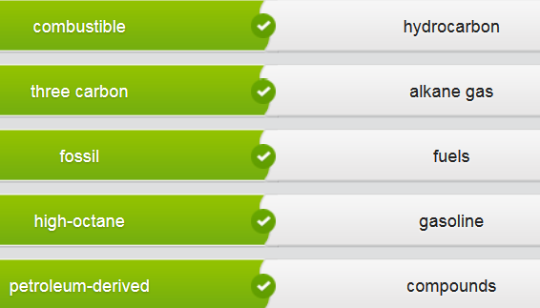



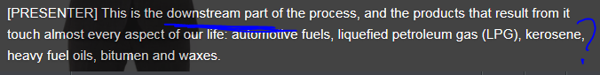





# Part 1)











 // [ə'**kuː**stɪk] adj. 声学的；音响的；听觉的











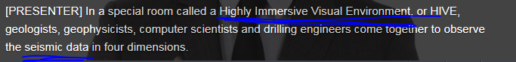

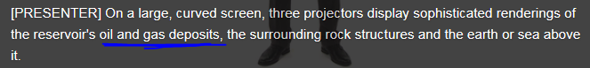



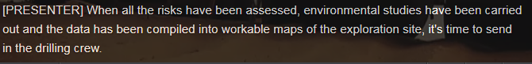

















## Phases of the drilling process: exploration, production, refinery&sales

## Time expressions

Next  -  finally  -  before  -  third  -  then  -  second  -  during  -  after  -  first  -  once

|  |
| --- |
| Oil production is divided into three phases. The first step is exploration, the second is production, and the third is refinery and sales.  These steps fall into two main groups:   * **Upstream activities** take place close to the source, * while **downstream activities**, such as refining, sales and marketing, are closer to the consumer.   (In conclusion) During the upstream phase, there is high capital expenditure, but also great potential for profit.   Finding oil is a complex process that involves a series of steps. **Before** the company can drill a well, they need to **identify a prospective site (that is ‘oil field’) for oil production and then test the (source) rock**. Companies use a variety of techniques to do this, including **core sampling** and **seismic testing**.   After conducting these **exploratory/ɪkˈsplɒrətərɪ/ tests**, they must then drill to confirm the presence of oil or gas. Once **the wildcat well** has been **drilled**, companies can determine whether the find is **commercially/economically viable经济可行的.** After a successful well identifies the presence of oil and/or gas (and maybe coal resources), additional **wells are drilled** to test the production conditions and determine the boundaries of the **reservoir (（石油）的大量储备)**.    Next , production, or development wells are put in place, along with tanks, pipelines and gas processing plants. Finally , the crude oil is refined into usable products, moved to markets and sold. |

|  |  |
| --- | --- |
| Phase of drilling |  |
| 1.Exporation | [ appraise the diamond/house/gem = measure the value of sth 估价 ] |
| 2 Production | Construction: e.g. erect the oil rig. |
| 3.Refinery & sales |  |

## Upstream and downstream part of the drilling process

|  |  |
| --- | --- |
| **Upstream** part of the oil production process **=> towards the “source (e.g. crude oil)”** | * Seismic testing: 抗震实验 * Core sampling: **【地质学】岩芯样品抽样检查** * Production * Exploration * Identify the drilling site |
| **Downstream** part of the oil production process **=> towards the “destination of consumption, like customers”** | * Refining * Marketing * selling |

# Part 2) Describing the drilling process

A local government official is visiting **the oil refinery** where you work. Explain the oil production process to him as you show him around. Use the text to help you.

|  |  |
| --- | --- |
| Phase of drilling |  |
| 1.Exporatio |  |
| 2 Production | Construction: e.g. erect the oil rig. |
| 3.Refinery & sales |  |

# Part 3)

## On a drill rig 钻机；凿岩机; 钻井设备

How much do you know about what’s on a drill rig? Match the words to the definitions.

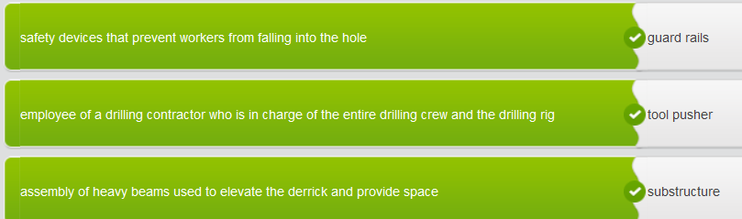

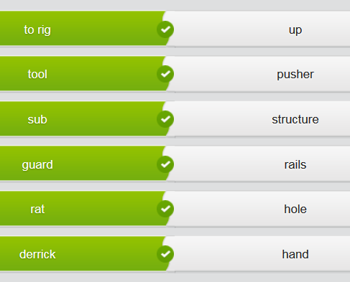

|  |
| --- |
| Oil and Gas Today  https://cns2.ef-cdn.com/Juno/11/71/26/v/117126/Oil2.1.1_header.jpg  **Background**  The oil industry uses a language all its own. Here are just some of the people, machinery, structures and activities on a rig.   * **Rig up:** To prepare the drilling rig * **Substructure:**An assembly of heavy beams used to elevate the derrick and provide space * **Muffler:** A device for reducing the amount of noise emitted by the exhaust on an oil rig * **Tool pusher:** An employee of a drilling contractor who is in charge of the entire drilling crew and the drilling rig * **Floor hands:** The workers who work primarily on the rig floor * **Derrick:** A large load-bearing structure, usually of bolted construction * **Derrick hand:** The crew member who handles the upper end of the drill string as it is being hoisted out of or lowered into the hole * **Rig floor:** The area immediately around the rotary table and extending to each corner of the derrick or mast * **Guard rails:** Safety structures that prevent workers from falling into the hole * **Rat hole:** A hole in the rig floor 30 to 35 feet deep, lined with casing that projects above the floor |

|  |
| --- |
| 1. If there are any problems, please contact the tool pusher .  2. Make sure the floor hands put up the guard rails .   3. Tell the derrick hands to be careful when hoisting the drill.  4. I have told the floor hands to cover the rat hole .  5. If the muffler is too loud, find a way to reduce the noise. |

|  |
| --- |
| Fill in the gaps with the verbs and prepositions below. Use the audio to help you.  depend upon  -  worn out  -  listen up  -  directed away  -  rigging up  -  watch out for  -  make sure  Right everyone, listen up please. We're going to start rigging up tomorrow, and you all know this is a prime time for accidents to occur. I want everyone to pay attention to these safety tips.   Once the substructure is positioned, make sure the engines are arranged so that the mufflers and exhaust can be directed away from the rig floor. Check the direction of the prevailing winds - we don't want to create a breathing hazard.   We can't have guard rails up all the time during rigging up, so keep any open rat holes covered when you're not using them. Make sure there's adequate lighting wherever people will be working on the rig floor and in the derrick.  Inspect all chains, hooks and cables before using them. If the equipment looks worn out or frayed, let the tool pusher know so that they can get it repaired or replaced. At all times, avoid working beneath a suspended load.   Most importantly, the supervisors and seasoned hands need to watch out for the inexperienced floorhands. These guys are new to the oil patch and will depend upon other members of the crew for guidance, so please give them a hand. |

## Giving instructions on a rig

## Rigging up safety rules

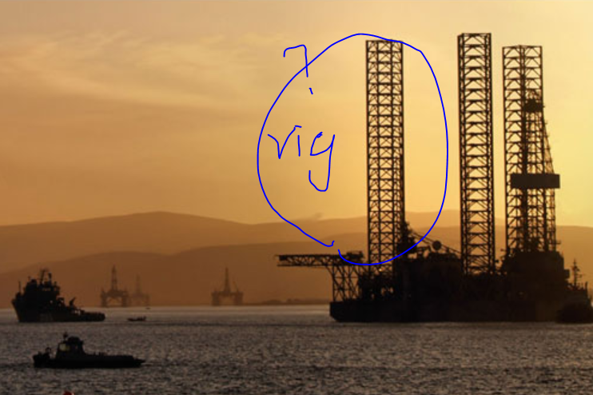

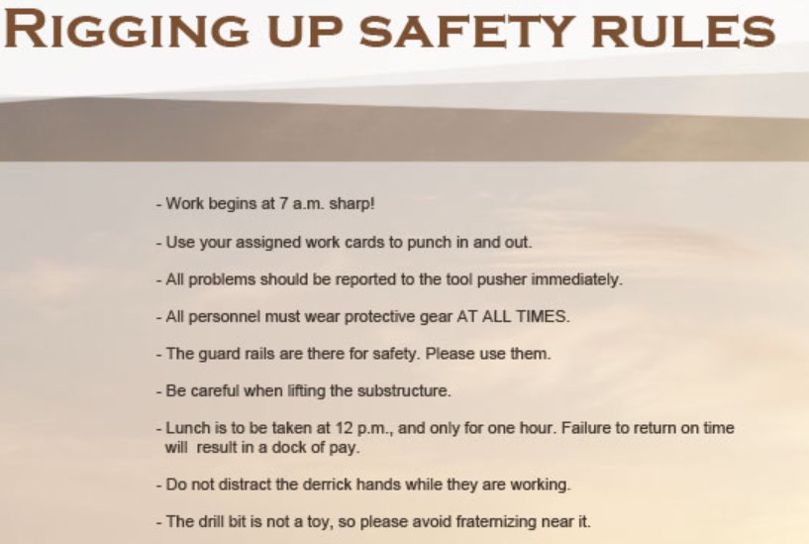

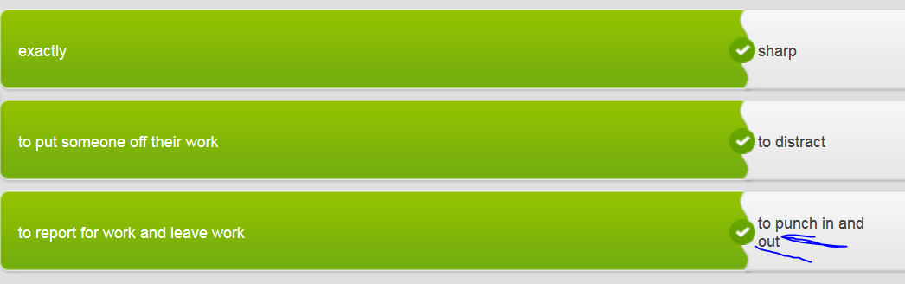

## Giving instructions to new staff on a rig

You're in charge of a new oil rig that’s just about ready to start rigging up. Read the email from your superior and make notes about the issues he wants you to make the staff aware of.

Hi, there.  
  
We have been given the green light to begin rigging up on the new rig Oilcat 10. However, as there were a few problems with safety and employee injuries on our last new rig, I thought it important to make sure you understood the gravity of this issue. We cannot - I repeat, cannot - have the same amount of accidents and injuries as last time. Below are the important points I need you to get across to the employees:  
  
-    The substructure is in position, but the engines need to be aimed away from the rig floor so the exhaust   
has a chance to vent.  
-    Workers on the rig must wear protective gear at all times.  
-    Derrick hands must not get distracted while operating the drill bit.  
-    Be careful of wind direction.   
-    Cover up rat holes.  
-    Make sure there is adequate lighting.       
-    Report any damaged equipment to the tool pusher.  
-    Experienced staff must watch out for new hires.   
  
I look forward to good news on the rigging up process. Don’t let me down.   
  
Best rgds…

|  |
| --- |
| It’s the morning of the first day of rigging up, and your crew has just punched in for work. You gather them around you to give them a speech about safety. Use your notes to help you make the speech.  -    We have been given green light to rig up. -    Safety is a priority.    -    The substructure is in position, but the engines need to be aimed away from  the rig floor so the exhaust has a chance to vent. -    Workers on the rig must wear protective gear at all times. -    Derrick hands must not get distracted while operating the drill bit. -    Be careful of wind direction.  -    Cover up rat holes. -    Make sure there is adequate lighting.      -    Report any damaged equipment to the tool pusher. -    Experienced staff must watch out for new hires. -    Let’s make sure there are no mistakes. |

# Part4) Write a formal report

## Making predictions

What do you think lies ahead in the future of the oil and gas industry? Rank the products below as to whether you think they will increase or decrease in quantity and revenue in the future.

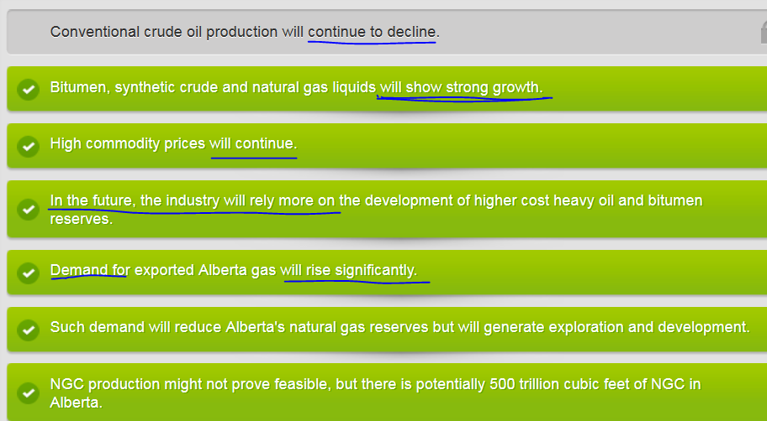

## Writing a formal report

|  |
| --- |
| A report normally consists of five sections:   * Title * Introduction: purpose of this report; the summary/conclusion is xxx * Findings: list all results of an investigation or search by providing data and evidence to support your findings (Someone's findings are the information they get or the conclusions they come to as the result of an investigation or some research. 调查结果; 研究结论) * 1.xxx * 2. Xxx * 3. xxx * Conclusion: * Recommendations: * 1.xx * 2…. |

Write your own version of the report, using the section headings and summaries as a basis. Compare your text with the model.

|  |
| --- |
| **Hi, there.**  This report is to provide a preliminary assessment of the oil and gas resources in Carlos Fields.    **Findings**  Petroleum has been found, but more testing needs to be done on different ages of rock.   Surveys suggest the field does contain major oil and gas accumulations.    **Conclusion**  Based on limited information, the estimate is about 21 million barrels of oil.   **Recommendations**   More data needs to be acquired and analyzed |

## Report of “Assessment of Oil and Gas Resources in a potential oil field”

**Title**A Preliminary Assessment of Oil and Gas Resources in the Cotton Valley Field.  
   
**Introduction**   
**The purpose of this report is to** provide a preliminary assessment of the oil and gas resources in the newly opened Carlos Fields. **The summary information (aka the “Conclusion” section) in this report gives** what we believe is a reasonable initial overview of each of the different commodities present, although the amount and quality of data for each commodity varies.   
  
**Findings**  
Forty-seven **wildcat wells** have been **drilled** within this field. **Petroleum [pə'trəʊlɪəm] shows** have been found in Triassic, Permian, Devonian, and Cambrian **age rocks**. These shows were in the form of petroleum recovered from **drill-stem** or production tests in wells and live **oil stains油渍；[机] 油斑** in **drilling cuttings钻粉；钻井岩屑.**

Sixty-three percent of the wells drilled in the plateau tested only the Permian section. Just five wells tested the Mississippian and Devonian sections, and only three **penetrated** the Precambrian.  
   
Our survey indicates that the field contains **all the elements**( necessary for major **oil and gas accumulations气藏**):

* source rocks: 生油(oil)岩层
* reservoirs: 大量的(石油)储备
* trapping mechanisms: 捕获机理

**Commercial deposits of oil** have been discovered both within and along the margins of the region. Although the characteristics of the oil field are favorable for **the accumulation of oil and gas气藏**, wildcat density is extremely sparse. Although the exploration [eksplə'reɪʃ(ə)n] risk is high, **the monument???** could contain major **accumulations of oil气藏** based on the production history of the field and geologic evidence.   
  
**Conclusion**   
**In summary/In conclusion/To sum up,** we estimate the ultimate recovery from Cotton Valley Field at about **21 million barrels of oil**. With **tertiary recovery techniques(三次开采；强化采油)** and new technological advances in enhanced oil recovery, the Cotton Valley **(Oil) Field** should exceed the estimated amount of oil. However, the evaluation of potential petroleum resources presented in this report is based on a limited amount of information.   
  
**Recommendations**   
In our view, it is crucial that a detailed, combined geologic-engineering evaluation be conducted of the oil, gas and coal resources in the area. This would require us to acquire new **seismic data**, compile existing data, produce detailed **structural contour maps  ['kɒntʊə] [测] 等高线图**  for each potential **reservoir ((oil)的大量储备),** model the basic **source rock**生油(oil)岩层 parameters, and calculate petroleum volumetrics for each of the potential rocks.

## Estimate whether a field is an “oil field”油田

If a field is estimated as an oil field, the field contains **all the elements** necessary for major **oil and gas accumulations气藏**:

* source rocks: 生油岩层
* reservoirs: 大量的(石油)储备
* trapping mechanisms: 捕获机理

Commercial deposits of oil have been discovered both within and along the margins of the region. Although the characteristics of the oil field are favorable for **the accumulation of oil and gas气藏**, wildcat (well) density is extremely sparse. Although the exploration [eksplə'reɪʃ(ə)n] risk is high, the monument could contain major **accumulations of oil气藏** based on the production history of the field and geologic evidence.

## Writing a report on the Alberta **oil fields油田**

Your company has asked you to write a report on the Alberta oil fields, which you recently visited. While there, you made some notes. Put the notes in the correct sequence in preparation for writing the formal report.

|  |
| --- |
| A report normally consists of five sections:   * Title * Introduction: purpose of this report; the summary/conclusion is xxx * Findings: list all results of an investigation or search by providing data and evidence to support your findings (Someone's findings are the information they get or the conclusions they come to as the result of an investigation or some research. 调查结果; 研究结论) * 1.xxx * 2. Xxx * 3. xxx * Conclusion: * Recommendations: * 1.xx * 2…. |

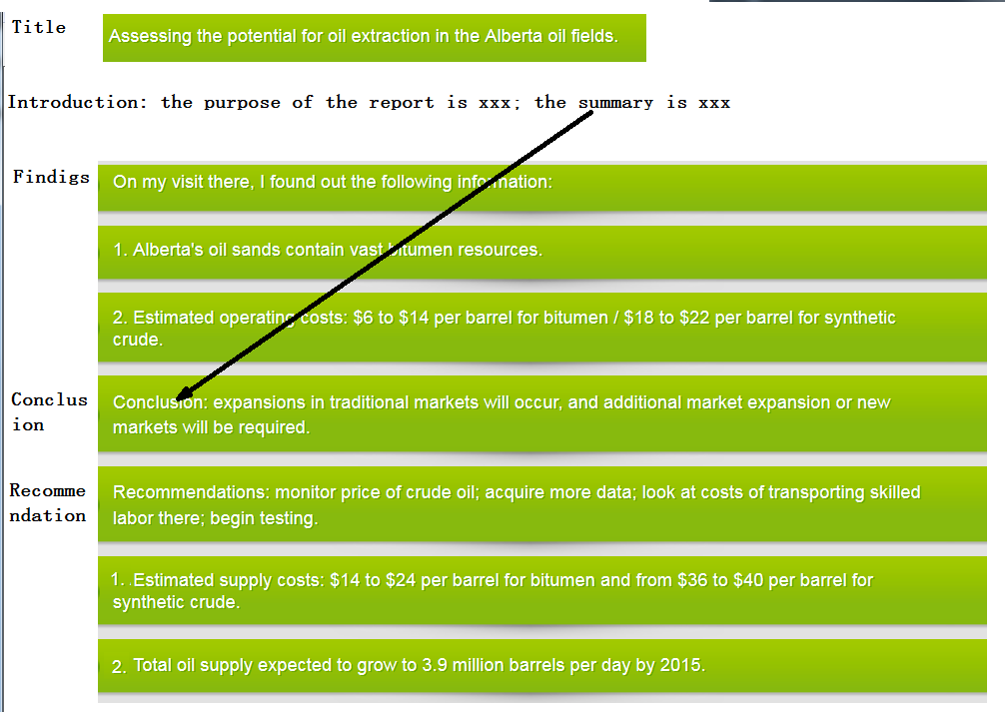

|  |  |
| --- | --- |
| Sections of a formal report |  |
| Title |  |
| Intro: purpose of this report; the summary/conclusion is xxx |  |
| Finding: list all results of an investigation or search by providing data and evidence to support your findings (Someone's findings are the information they get or the conclusions they come to as the result of an investigation or some research. 调查结果; 研究结论) | 1．  2．  3． |
| Conclusion |  |
| Recommendations |  |