# ==L7, Unit 3, Interview

# Lexical resource

|  |  |
| --- | --- |
| 极地的 | /ˈpəʊlə/ polar bears  [ADJ](javascript:;)Polar means near the North or South Poles. 极地的 |
|  | 杆，柱，竿 : pole a long stick or post usually made of wood or metal, often set upright in the ground to support something; e.g. a wooden pole |
|  | 柱子，墩: pillar: a tall upright round post used as a support for a roof or bridge;  a tall upright round post, usually made of stone, put up to remind people of an important person or event 〔通常为石质的〕纪念柱  e.g. Eight massive stone pillars supported the roof. 八根巨大的石柱支撑起房顶。 |

|  |
| --- |
| **[ 背后说别人的坏话: back-mouth someone**  **V.S. 暗箭伤(人)，背后中伤，背后说人坏话或出卖别人: backstab somebody**  //stab:(用knife, dagger〕刺/戳/捅  **(literal meaning:在黑暗中刺/戳) Figurative meaning瞎猜/瞎蒙 [ a stab in the dark ]**  e.g. I totally have no idea about it, but just **have a stab in the dark**.  e.g. Guess, quickly guess… Come on, the time is **running out**, just **have a stab in the dark**.  e.g. Some celebrities realize that their dream and becoming famous just wasn’t as amazing as they thought it would be. However, some other celebrities **get so carried away(too complacent/big-headed/cocky得意忘形)**, they begin to believe their own **hype炒作**, thinking they are really superhuman. Well, I don’t wanna **back-mouth someone背后说别人的坏话**, but I’d like to give them a piece of my mins , blar bar. Additionally, I think she **needs taking down a peg or two**, which is **an idiomatic expression [,ɪdɪə'mætɪk]** 地道的惯用表达 to indicate that she has become too **big-headed/arrogant/cocky/complacent**. |
| [ saw V.S. seesaw ]  # 锯;锯子; 电锯 **saw**  * [N-COUNT](javascript:;)A saw is a tool for cutting wood, which has a blade with sharp or **barbed** teeth along one edge. Some **saws** are pushed backward and forward by hand, and others are **powered by electricity**. 锯;锯子; 电锯 **[ electric saw]**  * [N-COUNT](javascript:;)a wise saying, maxim, or proverb 格言  * [V-T/V-I](javascript:;)If you **[ saw something],** you cut it with a saw. **锯xxx东西**  •  He escaped by **sawing through the bars** of his cell. 锯断牢房的铁栅逃跑了。  ## 跷跷板 **seesaw /ˈsiːˌsɔː/**  [N-COUNT](javascript:;)A seesaw is a long board which is balanced in the middle. To play on it, a child sits on each end, and when one end goes up, the other goes down. |
| **[ (保险等sales的)推销辞令; 销售辞令/说辞: sales pitch ]**  [N-COUNT](javascript:;)A salesperson's sales pitch is what they say in order to persuade someone to buy something from them.  e.g. His **sales pitch** is smooth, impressive, compelling, and convincing.  他的推销辞令流畅且令人信服  //compelling: **a compelling argument, reason, evidence** is one that strongly and powerfully convinces you that something is true or that something should be done, **compelling=strongly persuasive and convincing 令人信服的(论据，理由，证据)** |
| **['tʌtʃi] touchy = very sensitive; touchiness n [U]**  **[ be touchy about sth = very sensitive to sth ]**  1.easily becoming offended or annoyed, and angry过分敏感的；易动怒的[SYN](javascript:;) SENSITIVE [+ about]  •She **is very touchy about** her past. 她对她的过去 **十分敏感**。  **[ a touchy subject/question/topic ]:**a subject etc that needs to be dealt with very carefully, especially because it may offend people敏感的话题/问题等  e.g. Asking about a reporter’s sources can be **a touchy question**. 询问一名记者的消息来源有时是个**敏感问题**。  e.g. Asking her about her marriage..hmm, is such **a touchy topic**. |
| To whom it may concern  e.g. To whom it may concern:  I am writing **in response to** your online ad for a store manager. I have a lot of **hands-on experience** in the business and am very interested in the position. I am very **motivated积极主动的,** proactive, hardworking, and **organized思路有条例的**. I have attached my resume to this email.  Sincerely, Mike Briggs |
| In an interview, **there is nothing like** <hands-on experience> **没什么能比的上<实战经验>**  **= Nothing beats** <your hands-on experience.> |
| organized /ˈɔːɡəˌnaɪzd/  1.[ADJ](javascript:;)An organized activity or group involves a number of people doing something together in a structured way, rather than doing it by themselves. 有组织的 **[ well/badly/carefully etc organized**组织良好的/很糟的/周密的等**]**  •  ...organized groups of art thieves.  …有组织的艺术品盗窃团伙。  •  ...organized religion.  …有组织的宗教。  •a carefully organized campaign 精心筹划的宣传活动  •a highly organized (= well-organized ) social system 高度组织化的社会体系  e.g. I want to work with a **well-organized team**. 我想和有良好组织性的团队一起工作  2.[ADJ](javascript:;)Someone who is organized plans their work and activities efficiently; **organized = well-planned (计划安排好的)有条理的(人, 团队)**  e.g. What’s your strength? Well, I’m a highly **organized** person. I mean I like to plan my work, life, and even activities in an efficient and clear way. Placing everything well-planned makes me feel comfortable and safe. Additionally, I have good **communication skill,** well, especially in my work. I’m good at expressing and concluding my idea and opinion in a concise and coherent way简洁,有调理.  e.g. Well, one of my biggest **strengths** is I'm very hardworking, **motivated积极主动的**, and **organized思路清晰／有条理的.** I’d like to make my everything **well-planne**d. What is more, I’m a quick learner. **On the other hand,** for my weaknesses, well, sometimes I get a little too excited - I don't like to wait. In other words, I’d like to finish tasks asap, which might give other colleagues some extra stress **in some capacity在某些方面.**  e.g. These people are very efficient, very **organized**, and excellent time managers.  这些人效率很高、很有条理.  3.achieving your aims in a way that is effective, ordered, and sensible 〔思路〕清晰的，有条理的 **[ 把思路理清, 然后把事情清理了get organized and then straighten up everything ]**  e.g. I just joined DP project/IoTOperation team last week. Well, I just feel totally messy, frankly speaking. It will take me a few days to **get organized;** and then **straighte[n u]p everything** . 我要花几天时间 **来理清思路**, 然后 **把事情清理**。  **//让我把这个搞清楚/理清楚: Let me get this straight. //straighten up something: 把事情清理** |
| * You get me wrong!  你冤枉了我, 你误解/误会了我 * Don’t get me wrong! 别冤枉我, 别误会我的意思, 别误会我 |
| 疲惫烦躁的 ['fræz ə ld] frazzled: feeling **tired/weary, exhausted, and anxious**, for example after a journey or because you are very busy  **[ I’m so tired/weary ['wɪərɪ]/exhausted.**  **筋疲力尽：I’m totally burnt out/totally frazzled.**  **我压力山大: I’m beyond stressed out ]**  e.g. The meeting left me feeling completely frazzled. 这会开得我精疲力竭、烦躁不安。  V.S. weary**['wɪərɪ]** = tired  1.[ADJ](javascript:;)If you are weary, you are very tired. 疲惫的 •  Rachel looked pale and weary. 看起来苍白而疲惫。  2.[ADJ](javascript:;)If you are weary of something, you have become tired of it and have lost your enthusiasm for it. 对…感到厌倦  **[ be tired/weary ['wɪərɪ]** **of sth = be sick of sth = get fed up with sth ]**  •  They're getting awfully weary of this silly war.  他们对这场愚蠢的战争感到极其厌倦 |
| I think it's important to have clear **career goals**, and always be active to chase further **professional development职业发展.**  We hired him because he's **hardworking, motivated积极主动的.** And he’s an **organized/well-planned思路有条例的** and creative person.  e.g. I am writing **in response to** your online ad for a store manager. I have a lot of **hands-on experience** in the business and am very interested in the position. I am very **motivated积极主动的**, hardworking, and **organized(well-planned)思路有条例的**. I have attached my resume to this email.  In an interview, **there is nothing like** hands-on experience **没什么能比的上<实战经验>. = Nothing beats your hands-on experience.**  The boss has very **high expectations** of the staff. |
| **[难伺候 : high maintenance]**  e.g. My boss, well, he’s **a difficult man**, sort of a **high maintenance**. //[******难以相处的人/不好相处的人 : a difficult man ]**  e.g. My girl friend is **too picky,** sort of **a high maintenance**. Frankly, she’s **a difficult person**. //Someone who is **picky** is difficult to please and only likes a small range of things. 爱挑剔的; 过分讲究的 •  Some people are very picky about who they choose to share their lives with. |
| [******难以相处的人/不好相处的人 : a difficult man ]**  e.g. My boss, well, he’s **a difficult man**, sort of high maintenance. //**[难伺候 : high maintenance]**  e.g. My girl friend is **too picky,** sort of **a high maintenance**. Frankly, she’s **a difficult person**. //Someone who is **picky** is difficult to please and only likes a small range of things. 爱挑剔的; 过分讲究的 •  Some people are very picky about who they choose to share their lives with. |
| **[加油. 放手去做吧,. Good luck! Go for it! ]**  e.g. Just think where you wanna be **in five years,** and **go for it 放手去做吧. It doesn’t hurt to try any new things.**  e.g. Well, don’t hesitate any more. Just **go for it**. **It doesn’t hurt to** try a new world.  **//做xxx事情也没什么坏处/无伤大雅/也不会少快肉: It doesn’t hurt to do sth.** |
| **[ night classes夜校]**  e.g. Generally, your employee review was very positive. You have strong **communication skills**, and you're extremely **organized** . You work very well with the team. One thing: I **wish** that you **had** a stronger technical background . I think you should take some **night classes**夜校. Everyone needs to think about **professional development** . The company will pay. It won't be easy, but you can definitely do it. We believe that you have a lot of **potential** and we will do all we can to help you succeed. |
| /**ˈtæmpə/ [tamper with sth]**  1.[V-I](javascript:;)If someone tampers with something, they interfere with it or try to change it when they have no right to do so. 干涉; 篡改; **tamper with sth = falsify sth**  •  I don't want to be accused of **tampering with** the evidence.  我不想被指控篡改证据。  2. **[ tamper with sth (file, doc) ]** to touch something or make changes to it without permission, especially in order to deliberately damage it 胡乱摆弄；擅自改动〔尤指为了故意损坏〕  •He noticed that the instruments had been **tampered with.** 他注意到仪器被人动过了。  •I don’t see the point in **tampering with** a system that’s worked fine so far. 我不明白一个系统运行得好好的，改它干吗。  3.[N](javascript:;)a person or thing that tamps, esp an instrument for packing down tobacco in a pipe 拍压的人; 工具(尤指装填烟草)  V.S. lose sb’s temper |
| **[强烈/刺眼的阳光: bright sunlight]**  e.g  The **bright sunlight** made me **squint**.  强烈/刺眼的阳光 使我 眯起了眼  //squint verb) 眯着眼看xxx If you **[squint at]** something, you look at it with your eyes partly closed normally because of your **low vision/shortsightness低视力** or because of **bright sunlight强烈/刺眼的阳光 ; Noun)** If someone **[ have a squint ],** their eyes look in different directions from each other. 斜视 |
| Slang:   * **貌似灾祸实使人得福之事**；塞翁失马，焉知非福: **a blessing in disguise[dɪs'gaɪz]** * **[ 不切实际的想法; 不能保证实现的诺言；渺茫的希望: a pie in the sky]** * **[不要以貌取人: Don’t judge a book by its cover. ]** * 不可信的人; 不道德的人，不真诚的；坏人，坏蛋；流氓；失足的人**An wrong'un /'rɔŋən; 'rɔ:ŋ-/:** the person you cannot trust normally because there’s sth wrong with his/her morality or ethics. In other words, he’s not an honest person to trust and always telling ties. * **[ 话就在我嘴边，我一时想不起来 It's on the tip of my tongue. ]** E.G. “Her name”…Just a moment. It's **on the tip of my tongue**. e.g. Let me think. Well, his name is just **on the tip of my tongue**. 他的名字就在我嘴边. * **Slang**: **(literal meaning:在黑暗中刺/戳) Figurative meaning瞎猜/瞎懵 [ a stab in the dark ]**   e.g. I totally have no idea about it, but just **have a stab in the dark**.  e.g. Guess, quickly guess… Come on, the time is **running out**, just **have a stab in the dark**.  [stab => **backstab sb.: 暗箭伤(人)，背后中伤，背后说人坏话或出卖别人 = back-mouth sb**: 在背后说别人的坏话 ]   * **难以相处的人/不好相处的人 : a difficult man V.S. [难伺候 : high maintenance]** * You get me wrong!  你冤枉了我, 你误解/误会了我 * Don’t get me wrong! 别冤枉我, 别误会我的意思, 别误会我 |
| [ dream of sth; dream of doing sth]   |  | | --- | | A: **你给自己未来<5/10年>的定位是什么**？**Where do you see yourself** **in five or 10 years**? = **Where do you wanna be** in five or ten years? |   => I’d like to **see myself in** an mgmt. position in five year; and I also dream of running my own business in 10 years. |
| ## An interview will commonly include questions about your **career goals.**   |  | | --- | | A: What are your **career goals**? / Do you have clear **career goals清晰的职业目标**?B: **I'd like to** start my own business in 5 years. **//would like to do sth:想要做 xxx** | | |  | | --- | | A: Please tell me a little bit more about your **short-term and your long-term career goals.** | | B: Short term, **I'd like to** improve my technical skills, like Linux and JavaScript API, additionally, enhance my **English proficiency熟练能力**. **On the other hand**, for my **long-term** career goals, I'd like to **see myself in** a management position in 5 years and then run my own business in 10 years.  // Proficiency: a good standard of ability and skill 熟练；精通（在行）; proficient: able to do something well or **skilfully**熟练的，精通/在行的  **[ 对 (英语/电脑/数学/编程/化妆) 很精通/在行/熟练: be proficient with/in sth; 对xxx很精通/在行/熟练: proficiency in/with/at sth, ]** | | | 你给自己未来<5/10年>的定位是什么？   |  | | --- | | A: **Where do you see yourself** **in five or 10 years**? = **Where do you wanna be** in five or ten years? | | B: **I'd like to** get into management and run my own company. /I’d like to **see myself in** project management. | | |
| **['pʌŋktʃuəl] be punctual; punctually adv;**  arriving, happening, or being done at exactly the time that has been arranged 准时的，守时的，如期的  e.g. She’s always very **punctual** for appointments. 她一向准时赴约。  e.g. the **punctual** payment of invoices 准时结清费用清单  **punctuality /ˌpʌŋktʃʊˈælɪtɪ/ :** [N-UNCOUNT](javascript:;)  Punctuality is the quality of being punctual. 准时性,准点性  e.g. This **budget airline廉价航空** hopes to **improve its punctuality** next year.  在准点上做出改善。 |
| 小口地喝，抿，呷 **sip sth:** to drink something slowly, taking very small mouthfuls  •She was sitting at the table, **sipping** her coffee. 她坐在桌边 呷/啜/抿着咖啡。  •He **sipped at** his wine with pleasure. 他愉快地 呷/抿着酒。  Noun: a very small amount of a drink抿一小口（饮料），一啜之量 **[抿了一小口/一啜: take a sip; take a sip of sth ]**  •She poured more wine **and took a sip** . 她又倒了些酒，**抿了一小口**。  •**take a sip of her coffee** 一小口咖啡  e.g. I’m allergic to tropic fruits, like durian, passion fruit百香果, mangtosteen山竹, so I was just **taking a sip of** her mango juice. |
| **[ stay in touch = keep in touch ]**    e.g. Let’s keep in touch/stay in touch. |
|  |
| [I'm **a good fit** for this position.]  e.g. After hearing your responses to my questions, I'd really like to work here. I think that I'm **a good fit** for this position. |
| * Would you be available for **a follow-up interview** next Wed.? * Sure, I’m available any time next Wed. * OK**, I’ve got you scheduled for** next Wed. afternoon at 3 * Great, thanks. |
| [**试试吧; 试一试** **Give it a Shot****= Try it out.]**  e.g. I'll give it a shot 我会试试看的 |
| [dʒɪ'vɑŋ**ʃɪ**] Givenchy n. 纪梵希（品牌名称） |
| brush over sth  1. 彻底地刷(或扫)，刷遍：to brush the floor over将地板彻底打扫干净  2.轻轻地涂漆(或油彩)，给…抹上一层涂料，上色：The painter brushed over the canvas to bring out a more vivid effect.画家给油画涂上一层色彩使画面更加生动。  3. **忽略xxx/不鸟xxx,** 轻率地对待，随随便便地处理，轻描淡写地说，不重视： brush over sth= ignore sth bz you think it’s not important = downplay sth  He brushed over the details of policy. 他对政策的细节不重视。 |
| **[ (一次一个脚步) 一步一步地；扎扎实实地: one step at a time ]**  **V.S. [ keep your feet on the ground 脚踏实地]**  E,g, .And each person completed it the same way: **one step at a time**.  E,g, But we said, 'We're going to get out of here, we just have to take it **one step at a time.** | |
| Carbon: n. [化学] 碳；复写纸  [ email’s CC = carbon copy ]  1.a copy, especially of something that has been typed using **carbon paper**复写本，副本 //thin paper with a blue or black substance on one side, that you put between sheets of paper when **typing** on a typewriter in order to make a copy onto the second sheet of paper复写纸  **2.someone or something that is very similar to another person or thing极为相似的人[事物]; 如出一辙**  [+ of]  •The robbery is **a carbon copy of** one that took place in Paris last year. 这宗抢劫案与去年发生的一宗 **如出一辙** |
| ['θrɒtl] throttle  1. **[ throttle sb]** to kill or injure someone by holding their throat very tightly so that they cannot breathe, almost be **suffocated** to death掐，勒〔某人的脖子〕；掐死 //suffocate sb: make someone die by preventing them from breathing（使）窒息而死，（使）闷  •He grabbed her by the throat and began **throttling her**. 他掐住她的咽喉，使劲勒紧。  2.to make it difficult or impossible for something to succeed阻挡xxx走向成功(压制；扼杀)  e.g. The U.S. established lots of **insensitive不讲道理**的 policies and **slapped sanctions against** Asian countries, which are **throttling many Asian economies** 抑制许多亚洲国家经济发展的政策  3. **throttle back: to reduce the amount of fuel flowing into an engine, in order to reduce its speed 调节油门减速**  e.g. A[nti-DDoS Basic](https://www.alibabacloud.com/help/doc-detail/28399.htm) is a free Distributed Denial of Service (DDoS) protection service that safeguards data and application on your ECS instance. As a global service from Alibaba Cloud Security, Anti-DDoS Basic functions with **5 Gbit/s capacity of DDoS mitigation** (//a limit, threshold) against common DDoS attacks. When the inbound traffic to an ECS instance exceeds its limits, which is determined by the ECS instance type, Alibaba Cloud Security enables **throttling (一个基于threshold来调节inbound traffic的机制)** to keep the ECS instance stable. **//throttle: to reduce the amount of fuel/traffic flowing into a server/node 调节油门减少inbound traffic** |
| **分词participle /ˈpɑːtɪsɪpəl/**  V.S. **particle  颗粒；[物] 质点；极小量**  In grammar, a participle is a form of a verb that can be used in compound tenses of the verb. There are two participles in English:   |  |  | | --- | --- | | **Type of participles** | **Definition of the participle** | | **过去分词the past participle** | the past participle, which usually ends in "-ed,"  e.g. 过去完成式 “past perfect”: the form of a verb that shows that the action described by the verb was completed before a particular time in the past, formed in English with ‘had’ and **a past participle**过去分词. | | **现在分词the present participle** | the present participle, which ends in "-ing." 分词  e.g. I just **got caught up with my work** 被工作给捆住了 and cannot leave. I’m checking the codes now. | | |
| **That's for sure****那是肯定的; 那是当然的** | |
| 我帮你安排在周四下午3点  A: OK. I've **got you scheduled for** Thursday afternoon at 3:00 for **a follow-up interview.**  B: Yes, thank you  e.g.:   * Would you be available for **a follow-up interview** next Wed.? * Sure, I’m available any time next Wed. * OK, **I’ve got you scheduled for** next Wed. afternoon at, let’s say 3:00? * Great, thanks. | |
| 还有其他什么事情我可以效劳吗？Is there anything else I can help you **with**? | |
| **[加班协议 overtime policy ]** | |
| LINDA: **Would you be available to start on** <April 23rd>, **let’s say**?  FRED: Why, yes, I think so.  e.g.:   * Would you be available for **a follow-up interview** next Wed.? * Sure, I’m available any time next Wed. * OK, **I’ve got you scheduled for** next Wed. afternoon at 3 * Great, thanks. | |
| Use this expression to schedule an interview over the phone.  B. I'm calling to schedule an interview.  A: When **would you like to** come in?  B: How about Thursday afternoon?  A: I can see you Thursday afternoon at 3. Is that good for you?  B: Yes, that works for me.  A: OK**. I've got you scheduled for** Thursday afternoon at 3.  B: Yes, that's correct.  : Great. We'll see you on Thursday. | |
| ##  果馅饼 **/flæn, flɑːn/ flan**   1. [N-VAR](javascript:;)A flan is a **custard/'kʌstəd]** dessert with a **caramel sauce**. 带有**焦糖汁**的蛋奶甜点 **// Custard is a baked dessert made of milk, eggs, and sugar. 蛋奶 //caramel latte焦糖拿铁** 2. [N-VAR](javascript:;)A flan is a food that has a base and sides of **pastry油酥面团**or sponge cake. The base is filled with fruit or savoury food. 果馅饼 **//油酥面团:pastry**is a food made from flour, fat, butter, eggs and water that is mixed together, rolled flat, and baked in the oven. It’s oily and **crispy〔食物的外皮〕松脆的**. It is used, for example, for making pies or used as a base for some desserts, like the base of egg tarts蛋塔的油酥底盘or the base of a flan 果馅饼的油酥底盘      ##小松饼 **muffin /ˈmʌfɪn/  [ chocolate muffin V.S. strawberry muffin]**  Muffins are small, round, sweet cakes, usually with fruit or bran inside. They are often eaten for breakfast.  ## **donut 炸面圈**  ## **scone /ˈskəʊn, skɒn/** 司康饼; 通常和黄油一起食用  [N-COUNT](javascript:;)A scone is a small cake made from flour and fat, usually eaten with butter.  ## 美）**粗玉米粉 grits //grit, gritty: determination and courage坚毅，勇气perseverance**  e.g. I like yogurt with **grits粗玉米粉**as my breakfast. | |

|  |  |
| --- | --- |
| stingy / sting刺, 螫 | 1) 吝啬的小气的 (cheapskate)：非常不情愿地给予或花费的 Giving or spending reluctantly and unwillingly; stingy=cheap= **begrudge** any penny spent  [ sb is **stingy and cheap** = a **cheapskate** ]  Noun) [美俚] 小气鬼，守财奴，吝啬鬼〔含贬义〕： a **cheapskate**: someone who spends as little money as possible, very **stingy and cheap**. In other words, a **cheapskate** is used to **begrudging any money spent for anyone吝惜为sb.花出的钱**  e.g. GouFucheng, is reported to be very **stingy and cheap吝啬的小气的** that he even **begrudged the money吝惜花出的钱spent for** his girlfriend; we just call him "**cheapskate**/cheap mit"  2**) stingy有刺的 V.S. stingless**[昆虫学】无螫针的，无螫刺的;【植物学】无刺毛的  eg The honeybee is **stingy**, but the **drone (male bee)** is **stingless**.  🡺sting, stung, stung: e.g. He was stung by a bee. 他被蜜蜂蜇了 |
| [bɪ'grʌdʒ]  begrudge | [bɪ'grʌdʒ] begrudge  1. 羡慕：嫉妒拥有…或享受 **begrudge sth**= To envy the possession of or enjoyment of:  eg羡慕嫉妒他的青春 Frankly, I **begrudged her youth and beauty** = I'm **envious['envɪəs] /jealous** of her youth and beauty  eg Why do you **begrudge her success**? 你为什么 **嫉妒她的成功**? |
| 2. [**吝惜为sb.花出的钱: begrudge the money spent for sb ]** unwilling or reluctant to spend money for sb, normally to describe a **cheapskate小气鬼，守财奴.** In other words, this person is very **stingy and cheap**  eg 吝惜花出的每一分钱: begrudge every penny spent.  e.g.她对用在孩子们教育上的费用从不吝啬: She never **begrudge any money** spent on her children's education.  e.g.我对父母花钱从不吝啬: I never **begrudge any money** spent for my parents.  e.g. GouFuchenfs, is reported to be very **stingy and cheap吝啬的小气的** that he even **begrudged the money吝惜花出的钱spent for** his girlfriend; we just call him "**cheapskate**/cheap mit” |
| **[美俚] 小气鬼，守财奴，吝啬鬼〔含贬义〕： a cheapskate**  someone who spends as little money as possible, very stingy – used to show disapproval  e.g. The **cheapskate** didn’t even pay for the cab. 这个小气鬼甚至没有付出租车费。  e.g. GouFuchenfs, is reported to be very **stingy and cheap吝啬的小气的** that he even **begrudged the money吝惜花出的钱spent for** his girlfriend; we just call him "**cheapskate**/cheap mit” |

|  |  |
| --- | --- |
| 1. 向sb.行军礼 (表示尊敬 ) 2. 向sb.打招呼 3。对sb以及某人的成就表示敬意 4. 鸣礼炮二十一响 行礼致敬 | salute /səˈluːt/  1 向sb.行军礼 (表示尊敬) **[ 向sb.行军礼 salute somebody; 行注目礼 salute with eyes; 行持枪礼 salute with rifles ; 行举手礼salute with the hand ]** If you salute a person, you greet them or show your **respect/reverence['rev(ə)r(ə)ns]** with a formal sign. Soldiers usually **salute officers** by raising their right hand so that their fingers touch their forehead or hat .  e.g. One of the company stepped out and **saluted the General.** 向那位将军行军礼。  eg As the Brazilian team lined up整队 for the **national anthem['ænθəm],** all Brazail spectators who were draped in yellow roses stand up and **saluted with eyes 行注目礼** for their entire homeland.  2. **[ salute sb. for their achievements对sb以及某人的成就表示敬意]** means to publicly show or state your reverence**['rev(ə)r(ə)ns]** and admiration **[ædmə'reɪʃ(ə)n]** for them.  e.g. I salute the governor for the **charismatic有魅力的/有感召力的 leadership** role that he is taking. 我对州长的领导风范表示敬意 //[rɪ'vɪə] revere sb. =respect sb.; reverence['rev(ə)r(ə)ns] |
| **向sb.打招呼**  => N-COUNT Salute is also a noun. 招呼 e.g.He gave his salute and left. 他打了招呼然后离开了. // 观众(指比赛或表演) spectator |
| 4. **鸣礼炮**salute is a formal military display of honor, respect, or greeting, such as the firing of cannon ['kænən]大炮 or fireworks. **[ fire a 21-gun salute 鸣礼炮二十一响, 行礼致敬 ; The Royal Gun Salute 皇家礼炮; Eleven-gun salute十一响礼炮 ]**  e.g. On Monday two simultaneous 21-gun salutes will be fired in Cuba to pay tribute to Castro, who ruled Cuba for nearly five decades, according to Cuba's state--run news agency. On Wednesday Castro's ashes (after cremation) will begin a ceremonial /ˌsɛrɪˈməʊnɪəl/ journey and finally reach the Cuba cemetery. Castro took to seize power from the dictator/autocrat Fulgencio in 1959. On Sunday, Castro's ashes will be interred/buried in the same cemetery where Marti is buried. At 9 a.m. that day, another 21-gun salute will be fired simultaneously in Havana and Santiago de Cuba.  e.g. After the inauguration ceremony in front of the white house, Obama will get a 21-gun salute that is fired following the national anthem. All people applauded with a standing ovation, showing theire reverence to the new president.  // pay tribute to sb, esp. dead //起立鼓掌；起立致敬 a standing ovation // a dictator = an autocrat /an authoritarian, is a person in authority who has complete power, specially power which was obtained by force and is used unfairly or cruelly 独裁统治者 or a person who behaves in a tyrannical manner; => authoritarian system(独裁体制) //cremate sb.火化; cremation //cemetery 英 ['semɪtrɪ] 美 ['sɛmə'tɛri] 墓地公墓 //埋；葬 inter = bury |
| 1. (枪炮的)齐射; (尤指)礼炮齐鸣 (gun salute) 2. | salvo 1 ['sælvəu]  1.N A salvo is the firing of several guns or missiles at the same time in a battle or ceremony (in ceremony, like “gun salute” to show respect to sb.). **(枪炮的)齐射; (尤指)礼炮齐鸣** (gun salute)  e.g. They were to fire a salvo of blanks, after the national anthem. 齐射一阵空包弹。  //**鸣礼炮**salute is a formal military display of honor, respect, or greeting, such as the firing of cannon ['kænən]大炮 or fireworks. **[ fire a 21-gun salute 鸣礼炮二十一响, 行礼致敬 ; The Royal Gun Salute 皇家礼炮; Eleven-gun salute十一响礼炮 ]**  2.N **A salvo of (angry words, applause)** is a lot of them spoken or written at the same time. 猛烈抨击; (抨击, 掌声、欢呼声等的)突然爆发：如炸弹齐投或武器齐射一样的东西， e.g. His testimony [法] 证词，证言, however, was only one in **a salvo of new attacks**. 一轮猛烈抨击的 e.g. The ongoing war of words between the United States and North Korea saw several new fiery/ˈfaɪərɪ/ **salvos(猛烈抨击) S**aturday, a day on which the US military, in a show of force, flew bombers in international airspace over waters east of North Korea. |
| （军队）敬礼 V.S. 礼毕 | Present… arms = Salute V.S. Order …arm 礼毕 |

|  |  |
| --- | --- |
| 自鸣得意的；自以为是的； n. 自以为是/自命不凡的家伙 ；　[英国俚语] 不喜活动死用功的学生 | a) 自鸣得意的；自以为是的 smug = complacent, If you say that someone is **smug**, you are criticizing the fact they seem very pleased or **arrogant** with how good, clever, or lucky they are. 自鸣得意的(表不满)  **[ smug V.S. mug sb. V.S. smuggle ]**  e.g. Thomas and his wife looked at each other in **smug** satisfaction. 托马斯和他妻子互相看着对方，面带着自鸣得意的满足  e.g. but don't be smug until you xxxx 不要太自以为是    n) **a smugness 一个 自命不凡的家伙; 自以为是的家伙** , [英国俚语] 不喜活动死用功的学生(书呆子), a smugness/bookworm/nerd　smug: marked by excessive complacency ( 自满；自鸣得意), who is big-headed, arrogant, cocky, or self-satisfaction.  e.g. **She needs taking down a peg or two.** => which is an **idiomatic expression地道的惯用表**达，indicates she has become too arrogant or big-headed/arrogant/cocky/complacent or sb is a smugness.  **[ smug V.S. mug sb. V.S. smuggle ]** //mug (a mug of sparkling coffee 马克杯, she's a mugger/robber行凶抢劫者 V.S. smuggle, smuggler |
| 自满的; 盲目乐观的(表不满) | [kəm'pleɪs(ə)nt] complacent, complacency [kəm'pleisənsi]:  A complacent [kəm'pleisənt] person is very pleased or satisfied with themselves or feels that they do not need to do anything about a situation, even though the situation may be uncertain or dangerous. 自满的; 盲目乐观的(表不满) = arrogant, cocky, big-headed,[kəm'pleisənt] , smug.    e.g. She **needs taking down a peg or two**. => which is an **idiomatic expression地道的惯用表达**，indicates she has become too big-headed/arrogant/cocky/complacent.  e.g. Australia has refused to apologize after an Olympic swimmer **sparked national outrage/fury暴怒** by **accusing China's Sun Yang of** being a "drug cheat." Speaking to the media after beating Sun by a mere , Horton said Sun, who served a three-month ban for testing positive for a banned Sports **doping兴奋剂** in 2014, was a "drug cheat." , this rude words **sparked international outrage/fury** among CHINA **netizens**. Horton's Facebook and Instagram posts were **flooded/deluged** with comments attacking him and demanding he apologize to Sun. "You are too **complacent[kəm'pleɪs(ə)nt] 自满的/big-headed/cocky**”.  e.g. Some celebrities realize that their dream and becoming famous just wasn’t as amazing as they thought it would be. However, some other celebrities **get so carried away(too complacent/big-headed/cocky得意忘形)**, they begin to believe their own **hype炒作** and become totally arrogant/big-headed/cocky/complacent, thinking they are really superhuman. Well, I don’t wanna **back-mouth someone背后说别人的坏话**, but I’d like to give them a piece of my mind , blar bar. Additionally, I think she **needs taking down a peg or two**, which is **an idiomatic expression [,ɪdɪə'mætɪk]** 地道的惯用表达 to indicate that she has become too **big-headed/arrogant/cocky/complacent**.  e.g. "If you see a little bit of success. You can get **cocky/arrogant/big-headed or complacent/smug(自鸣得意的，沾沾自喜的〔含贬义〕)** and I think it's when people get the head rush and lose that clinical or rational assessment, that's when people make mistakes."  [ 激起国际社会的愤怒 spark/trigger international/national outrage; spark international/national fury ] [freestyle, breaststroke蛙式, butterfly蝶泳; backstroke:仰泳; medley混合泳; Men's 4x200m freestyle relay 接力] |
| 大头症/自满的/自以为是，骄傲自打的 | **[get so carried away得意忘形)]**  e.g. Some celebrities realize that their dream and becoming famous just wasn’t as amazing as they thought it would be. However, some other celebrities **get so carried away (too complacent/big-headed/cocky得意忘形)**, they begin to believe their own **hype炒作** and become totally arrogant/big-headed/cocky/complacent, thinking they are really superhuman. Well, I don’t wanna **back-mouth someone背后说别人的坏话**, but I’d like to give them a piece of my mind , blar bar. Additionally, I think she **needs taking down a peg or two**, which is **an idiomatic expression [,ɪdɪə'mætɪk]** 地道的惯用表达 to indicate that she has become too **big-headed/arrogant/cocky/complacent**. |
| 骄傲自大的，趾高气扬的 | cocky; cockily; cockiness n [U] too confident about yourself and your abilities, especially in a way that annoys other people 骄傲自大的，趾高气扬的 e.g. He’s a cocky little man and I don’t like him. 他是个傲慢自大的小子，我不喜欢他  e.g. Some celebrities realize that their dream and becoming famous just wasn’t as amazing as they thought it would be. However, some other celebrities **get so carried away (too complacent/big-headed/cocky得意忘形)**, they begin to believe their own **hype炒作** and become totally arrogant/big-headed/cocky/complacent, thinking they are really superhuman. Well, I don’t wanna **back-mouth someone背后说别人的坏话**, but I’d like to give them a piece of my mind , blar bar. Additionally, I think she **needs taking down a peg or two**, which is **an idiomatic expression [,ɪdɪə'mætɪk]** 地道的惯用表达 to indicate that she has become too **big-headed/arrogant/cocky/complacent**. |
| 自大的，自负的〔含贬义〕 | big-headed: someone who is big-headed thinks they are very important, clever etc – used to show disapproval 自大的，自负的〔含贬义〕  •  ...an arrogant, **big-headed/cocky** man.  ...一个傲慢自负的男人。 |
| 自负的，骄傲自满的，自高自大的〔含贬义〕 ；狂想的；逞能的 | [kən'siːtɪd] conceited adj. 自负的，骄傲自满的，自高自大的〔含贬义〕 ；狂想的；逞能的 someone who is conceited thinks they are very clever, skilful, beautiful etc – used to show disapproval •You’re the most conceited/big-headed/cocky, selfish person I’ve ever known. 你是我认识的人当中最自负、最自私的。 |
| 粗鲁傲慢的; 张狂无礼的(的凝视,的语气) | Adj) insolent, insolently ['ɪns(ə)l(ə)nt] : ADJ insolent: If you say that someone is being insolent, you mean they are being rude to someone they ought to be respectful to; be rude without respect and reverence to sb. 粗鲁傲慢的; 张狂无礼的(的凝视,的语气)  [ her insolent stare.她那傲慢无礼的凝视; an insolent tone of voice 傲慢无礼的语气; You insolent child! 你这个没礼貌的孩子 insolence (N) ['ɪns(ə)l(ə)ns] n. 傲慢；傲慢无礼的行为 |

# Part 1) Respond to a job advertisement

I’m so tired/weary/exhausted. **I’m totally burnt out/totally frazzled**.



 









Hi Jack, welcome, 





**//So maybe you could start by telling me a little bit about yourself.**





Yes, bodyshop









 e.g. My boss, well, he’s **a difficult man难以相处的人**, sort of **high maintenance** /ˈmeɪntɪnəns/**.(难伺候 )**

**…**

Can we talk about your work experience?



So, what’re your **career goals**? Any clear **career goals**?

Career goals?







**//** **That's for sure****那是肯定的; 那是当然的**

OK. 



 

…

. Well, I mean, she’s **a difficult person难以相处的人**.

.. And Kate.





**…**

 











 **//overtime policy: 加班协议**

 

**…**





 **//stay in touch**



**Thanks**







## Job advertisements

|  |  |
| --- | --- |
| Jobs advertisements can be found online, in the classified section of newspapers and in professional  journals. A typical advertisement usually has the following information. | |
| **## Job title (Job title)** | |
| office manager |  |
| **## JD, Job description** | |
| Manage office operations and supervise staff of 20. |  |
|  | |
| **## Job duties/responsibilities** | |
| Maintain office staff by hiring and training employees. Assign and monitor tasks among office staff. |  |
|  | |

|  |  |  |  |
| --- | --- | --- | --- |
| **## Education and experience不可数** | | | |
|  | Business degree or equivalent. | |
|  | Knowledge of management practices and procedures. | |
|  | Knowledge of human resources practices and procedures. | |
|  | Computer skills and knowledge of office software. | |
|  | | | |
| **## English proficiency**  a good standard of ability and skill 熟练；精通（在行） [ 对xxx很精通/在行/熟练: proficiency in/with/at sth, 对xxx很精通/在行/熟练: be proficient with/in sth ]  •a high level of **proficiency in English** 精通英语  •Nick’s **proficiency with** computers is well known. 尼克对(电脑)很在行是出了名  **## Computer proficiency**  **## Compensation: Salary and benefits (e.g. dental plan, pension plan)** | | | |
| $65K annually | |  | |

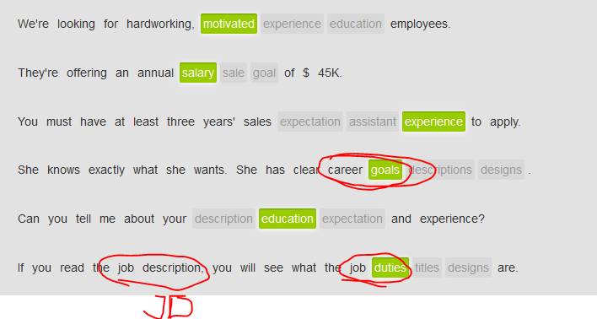

I think it's important to have clear **career goals**, and always be active to chase further **professional development职业发展.**

We hired him because he's **hardworking** and **motivated积极主动的**, and creative.

Only people with sales experience should apply.

In an interview, **there is nothing like** hands-on experience 没什么能比的上实战经验.

The boss has very **high expectations** of the staff.

## 'Resume' and 'CV'

|  |  |  |
| --- | --- | --- |
| In American English, a **resume** is an outline of work experience and qualifications used for job applications; a **CV (curriculum vitae)** is a more thorough, lengthy outline used mostly for academic or scientific applications.  Could you email me your resume? | | |
|  |  |  |

|  |  |  |
| --- | --- | --- |
|  |  |  |
|  |  |  |
| In British English, **CV** is the term used more broadly for **resume**, though **resume** is also used. | | |
|  |  |  |

|  |  |  |
| --- | --- | --- |
|  | I've had a look at your **CV**, and I'm impressed. |  |
|  |  |  |

|  |  |  |
| --- | --- | --- |
|  | **Would you mind** sending me your **resume**? |  |

|  |
| --- |
| jobfind.org  **Opportunity for hardworking, motivated person, interested in fashion**  **Job title:** sales assistant  **Hours**: Mon-Sat, 6-8 hours per day. **Flexibility** important.  **Pay**: $15 per hour  **Job description, JD**: Sales assistant in a small women's clothing shop. Work closely with boss/owner.  **Duties and responsibilities**: Opening and/or closing shop. Helping customers. Organizing clothing. Customer sales.  **Education/experience:** High school **diploma** or equivalent. 1-2 years' sales experience.\  **English proficiency:** Good oral speaking.  Please email your resume to: nina@fashionstop.com |

## Responding to job advertisements

|  |  |  |
| --- | --- | --- |
| One way to reply to a job advertisement is to send an email with your resume or CV attached.  Begin your email with a formal salutation.  If you don't know the person's name, use the following expression: | | |
| **To whom it may concern:** |  | |
|  | | |
| Next, reference the job you are applying for, and where you saw it advertised. | | |
| I am writing **in response to** your online ad for an office manager. |  | |
|  |  | |
| Then briefly say something positive about yourself. | | |
| I **am very interested in** the position. |  | |
| I am hardworking, proactive and **motivated积极主动的**. Additionally, **I’m also an organized** person, who like to make everything **well-planned.** |  | |
| You can mention if you have included your resume or CV. | | |
| **I have attached** my resume. | |  |
|  | |  |
| Don't forget to state your availability for a phone call or interview. | |  |
|  | |  |
| **I am available for an interview** anytime in the next few weeks. **You can reach** **me at** 760-320-4246. | |  |
| End the email with a positive statement. | | |
| I **look forward to** hearing from you. | |  |

## Job application email + Cover letter

See 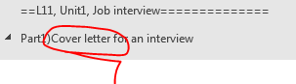

|  |
| --- |
| From:  mike.briggs@fastshop.net  To:  hr@superbuy.com  To whom it may concern:  I am writing **in response to** your online ad for a store manager. I have a lot of **hands-on experience** in the business and am very interested in the position. I am very **motivated积极主动的,** proactive, hardworking, and **organized思路有条例的**. I have **attached** my resume to this email.  **I am available for an interview anytime**. You can reach me on my cellphone at 615-734-8923.  Thank you very much, and I **look forward to** **hearing from you.**  Sincerely,  Mike Briggs |

## Apply for a job by email

|  |
| --- |
| jobfind.org  **Opportunity for motivated, flexible, hardworking computer programmer**  Job title: computer programmer  Hours: Mon-Fri, 6-8 hours per day  Pay: $20 per hour  Job description: Computer programmer in a large software company. Work closely with other programmers and software developers.  Duties and responsibilities: Programming company computers. Helping developers. Organizing databases.  Education/experience: Computer programming certificate or equivalent. 3-4 years' experience.  Please email your resume to: [josh.barnes@IXWcorporation.com](mailto:josh.barnes@IXWcorporation.com) |

Pretend you are an expert in computer programming. Apply for a position as a manager.

Type in the input box

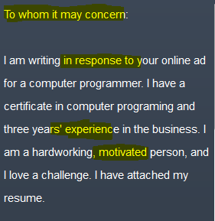 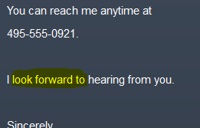

# Part 2) Arrange an interview time

**Job details**

|  |
| --- |
| LINDA: Hi, Fred. This is Linda Jenkins calling from World Tea.  FRED: Oh, hello. I'm happy to **hear from you.** LINDA: Good. Listen: We looked at your resume , and we think that you should come in for an interview . But first, **I'd just like to** ask you a couple of questions.  FRED: OK.  LINDA: **Would you be available to start on, let’s say,**  April 23rd?  FRED: Why, yes, I think so.  LINDA: Great. And are you more interested in a full-time or part-time position?  FRED: Um, well, does the part-time position include benefits ?  LINDA: No, I'm sorry.  FRED: Well, I would only be interested in a full-time position .  LINDA: OK, then. Let's talk about a good day to have you come in for an interview. |

|  |  |  |
| --- | --- | --- |
| After you respond to a job advertisement, the company might call you to ask some questions before an interview is scheduled. You might also ask a few questions to make sure an interview is worth your while. Some topics that might be covered in this preliminary conversation include: | | |
|  |  |  |

|  |  |  |
| --- | --- | --- |
|  | your availability or the start date |  |
|  |  |  |

|  |  |  |
| --- | --- | --- |
|  | a full-time or part-time position |  |
|  |  |  |

|  |  |  |
| --- | --- | --- |
|  | working hours |  |
|  |  |  |

|  |  |  |
| --- | --- | --- |
|  | compensation and benefits |  |
|  |  |  |

|  |  |  |
| --- | --- | --- |
|  | **overtime policy加班协议** |  |
|  |  |  |

|  |  |  |
| --- | --- | --- |
|  | job responsibilities |  |

## Telephone language

|  |
| --- |
| RECEPTIONIST: Good morning. Citizen Bank. **How can I help you**?  MS. SMITH: Yes, **I'd like to speak with** Jack, the ID manager.  RECEPTIONIST: **Can I ask who's calling , please?**  MS. SMITH: It's Sandy Smith from Delight Restaurant.  RECEPTIONIST: **Hold on a moment**, please. I'm sorry, Ms. Smith, but Mr. Crosby **is not available** . **Would you like to leave a message** ?  MS. SMITH: Yes. Please tell him that I received the papers he sent me.  RECEPTIONIST: Certainly. **Is there anything else I can help you with?** MS. SMITH: No, that's it. Thank you. RECEPTIONIST: You're very welcome. Have a good day. |

|  |  |  |
| --- | --- | --- |
| When you call a business, a receptionist answering the phone will usually say the name of the company.  People answering the phone might also say their names. | | |
|  |  |  |
|  | Good morning. Marklex Company. How can I help you? |  |
|  |  |  |

|  |  |  |
| --- | --- | --- |
|  | Hello. Tracy’s speaking. |  |
| The caller would then ask to speak with someone or greet the person they're calling. | | |
|  |  |  |

|  |  |  |
| --- | --- | --- |
|  | Yes, **I'd like to speak with** <Peter Cass in Human Resources>. |  |
|  |  |  |

|  |  |  |
| --- | --- | --- |
|  | Oh, hello, Peter. It's Jerry Adamson. |  |

|  |  |  |
| --- | --- | --- |
| The **receptionist** will probably ask who you are. | | |
|  |  |  |

|  |  |  |
| --- | --- | --- |
|  | Can I ask who's calling, please? |  |
| The **receptionist** might ask you to hold or ask you if you'd like to leave a message. | | |
|  |  |  |

|  |  |  |
| --- | --- | --- |
|  | **Hold on a moment.** |  |
|  |  |  |

|  |  |  |
| --- | --- | --- |
|  | I'm sorry. Mr. Cass is not available. **Would you like to** leave a message? |  |
|  |  | |
| After your business is complete, the receptionist might ask if you need anything else. | | |
|  |  |  |

|  |  |  |
| --- | --- | --- |
|  | Is there anything else I can help you with? |  |

## Schedule an interview by phone

|  |  |  |
| --- | --- | --- |
| Use this expression to schedule an interview over the phone. | |  |
|  |  |  |
|  | I'm calling to schedule an interview. |  |
| Use these expressions to negotiate a time for an interview. | |  |
|  |  |  |
|  |  |

|  |  |  |
| --- | --- | --- |
|  | A: When would you like to come in? |  |
| B: How about Thursday afternoon? |  |
| A: I can see you Thursday afternoon at 3. Is that good for you? |  |
| B: Yes, that works for me. |  |

|  |  |  |
| --- | --- | --- |
| Once the appointment has been made, one or both people might confirm the time. | | |
|  |  |  |
|  |  |

|  |  |  |
| --- | --- | --- |
|  | A: OK. I've **got you scheduled** for Thursday afternoon at 3. |  |
| B: Yes, that's correct. |  |
| A: Great. We'll see you on Thursday. |  |
| B: Thank you very much. |  |

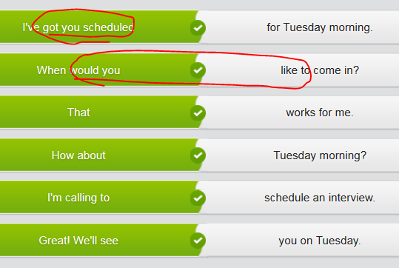

# Part 3) Interview for a job

I was so nervous.









 and they asked tons of questions.















**[ (一次一个脚步) 一步一步地；扎扎实实地: one step at a time ]**

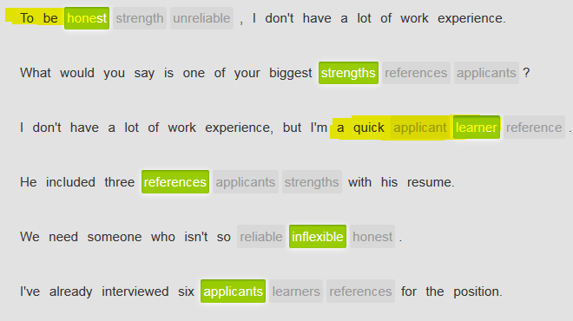

## Grammar: Past perfect

**过去完成式 “past perfect”:** the form of a verb that shows that the action described by the verb was completed before a particular time **in the past**, formed in English with the word ‘had’ and **a past participle**过去分词. 🡺 **past perfect = had + a past participle**

|  |  |  |
| --- | --- | --- |
| Use the **past perfect** to say which of two past events happened first. The **past perfect** is formed with **had +** **past participle** 过去分词of the verb. **Had** is contracted缩写 as **'d**. Pay attention to the order of events in the following examples. | | |
|  |  |  |

|  |  |  |
| --- | --- | --- |
|  | When he **arrived** at the interview, Mr. Jones **had gone.** |  |
|  |  |  |

|  |  |  |
| --- | --- | --- |
|  | **I'd sent** my resume before I **went** to the interview. |  |
|  |  |  |

|  |  |  |
| --- | --- | --- |
|  | **She'd** already **applied** for the job when she **saw** the terrible salary. |  |
| When a sentence contains **a time conjunction时间连词** like **before** or **after**, the **past perfect** is optional, as the time relationship is already clearly indicated by the time conjunction**时间连词**. In these cases, you can use **the simple past一般过去时**. | | |
|  |  |  |

|  |  |  |
| --- | --- | --- |
|  | He sent his resume **before** he went to the interview. |  |
|  |  |  |

|  |  |  |
| --- | --- | --- |
|  | He flew to New York **after** he got the job. |  |

e.g. After he **had sent** out more than 20 resumes, he finally got an interview. Before he was interviewed in person, he had two interviews on the phone. After he **had been interviewed** three times, by different managers, he was finally hired . After he **had worked** at the company for six months, he quit .

## Grammar: participle /ˈpɑːtɪsɪpəl/分词  V.S. particle  颗粒；[物] 质点；极小量

In grammar, a participle is a form of a verb that can be used in compound tenses of the verb. There are two types of participles in English: **the past participle**, which usually ends in "-ed," and **the present participle**, which ends in "-ing." 分词

|  |  |
| --- | --- |
| **Type of participles** | **Definition of the participle** |
| **过去分词the past participle** | the past participle, which usually ends in "-ed,"  e.g. 过去完成式 “past perfect”: the form of a verb that shows that the action described by the verb was completed before a particular time in the past, formed in English with ‘had’ and **a past participle**过去分词. |
| **现在分词the present participle** | the present participle, which ends in "-ing." 分词  e.g. I just **got caught up with my work** 被工作给捆住了 and cannot leave. I’m checking the codes now. |

## Grammar : Time conjunction时间连词

|  |
| --- |
| /kənˈdʒʌŋkʃən/ conjunction V.S. traffic congestion  [kən'dʒestʃ(ə)n]  1.[N-COUNT](javascript:;)[(几件事情的)同时发生; (几件事情的)同地发生 : a conjunction of two or more things] is the occurrence of them **at the same time or the same place.**  e.g.  ...the conjunction of two events.  …两事件的同时发生。 e.g. I **have a conjunction of several happy things** today 几件事情令人高兴的巧合  2.[N-COUNT](javascript:;)In grammar, a conjunction is a word or group of words that joins together words, groups, or clauses. In English, there are coordinating conjunctions such as "and" and "but," and subordinating conjunctions such as "although," "because," and "when." 连词  e.g. When a sentence contains **a time conjunction时间连词** like **before** or **after**, the **past perfect** is optional, as the time relationship is already clearly indicated by the time conjunction**时间连词**. In these cases, you can use **the simple past一般过去时**  3.[**PHRASE [与…一起结合使用; 和xxx 一起配合使用/配套使用: in conjunction with sth ]**](javascript:;)  If one thing is done **in conjunction with** another, the two things are done or used together.  e.g.  Textbooks are designed to be used **in conjunction with** classroom teaching.  教科书被设计成 **与<课堂教学>配合使用。**  e.g Well, there are some other alternatives that you can use either on their own, or **in conjunction with** the service gateway to provide other forms of standardization.  还有一些其他的替代选择，您可以单独使用它们或者**结合**服务网关来提供其他形式的标准化  e.g. The worksheets are designed to be used **in conjunction** with the new course books. **这些活页练习题专门用来与<新课本>配套使用** |

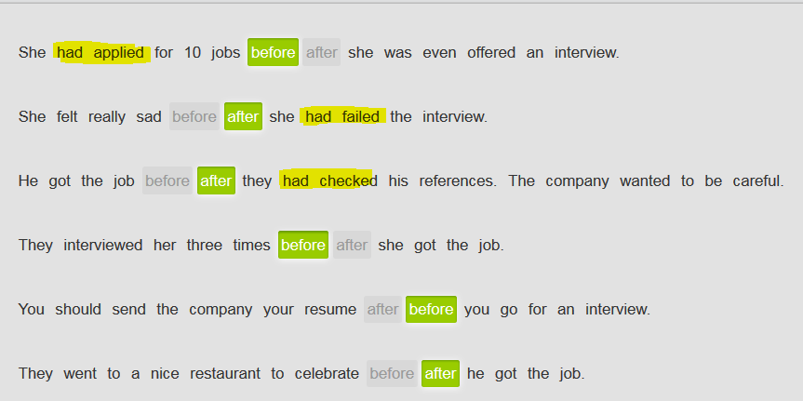

## Interviewing dos and don'ts

**Job interviews are stressful**. You want to present yourself in the best possible way. Here is some advice about what to do and what not to do.

Dos:

* Be on time/**punctual** for the interview – arrive 10 minutes early. **//**ˌpʌŋktʃʊˈælɪtɪ/**punctuality:  is the quality of being punctual. 准时性**
* Dress professionally.
* Answer all questions slowly, calmly, **coherently** and clearly.
* Look your interviewer in the eye.
* Ask for **clarification** if you need to.
* Write a thank-you (**heartfelt gratitude)** email after the interview.
* Mute or turn off your phones.

Don'ts

* Don't chew gum or smell like smoke.
* Don't allow your cellphone to ring.
* Don't say bad things about old jobs.
* Don't be **dishonest**.
* Don't ask about money right away.
* Don't act nervous, like **stutter/stammer结巴，口吃　//speech impediment:语言障碍**

## Interview questions

Even though there are some questions that will probably surprise you in an interview, there are many standard ones that you can prepare for. Here are a few of them.

Culture note: When asked to describe a weakness, try to explain your weakness in a positive light.

An interview will commonly include questions about your **career goals.**

|  |
| --- |
| A: Could you tell me a little more about your work experience? / OK, can we start by telling me something about your work experience? B: I've been working in the fashion industry for three years. |
|  |
| A: Why are you interested in this position? B: I'm interested because it offers a chance to work in an exciting company, with charming/attractive characters, like diversity and multi-culture. |
|  |
| A: What are some of your **strengths and weaknesses**? B: Well, one of my biggest strengths is I'm very hardworking, **motivated积极主动的**, and **organized思路清晰／有条理的**. I like to make my everything well-planned.  What is more, I’m a quick learner.  **On the other hand,** for my weaknesses, well, sometimes I get a little too excited - I don't like to wait. In other words, I’d like to finish tasks asap, which might give other colleagues some extra stress **in some capacity在某些方面.** |

## An interview will commonly include questions about your **career goals.**

|  |
| --- |
| A: What are your **career goals**? / Do you have clear **career goals**?B: **I'd like to** start my own business in 5 years. **//would like to do sth:想要做 xxx** |
| |  | | --- | | A: Please tell me a little bit more about your **short-term and your long-term goals.** | | B: Short term, **I'd like to** improve my technical skills and enhance my **English proficiency熟练能力**. Long term, I'd like to **get into management** and run my own business. | |
| |  | | --- | | A: **Where do you see yourself** **<in five or 10 years>**? = **Where do you wanna be** <**in five or ten years>?** | | B: **I'd like to** **get into management** and run my own company./ I’d like to **see my myself in** project management. | |

|  |
| --- |
| INTERVIEWER: What do you think are some of your **strengths and weaknesses** ? APPLICANT: Well, one of my biggest strengths is my ability to work with others. I'm a great team player . INTERVIEWER: And **weaknesses**? APPLICANT: Well, sometimes I just get too excited about things. I want everything to happen quickly. INTERVIEWER: I see. And why do you want to work for this company? APPLICANT: Because you're number one. You have no real competition that I can see. INTERVIEWER: And **what are your career goals/Where do you see yourself/Where do you wanna be** - say, in two or three years? APPLICANT: **I’d like to see myself in** a management position. |

# Part 4 ) End an interview

Interview tips

**Ending an interview**

How you end an interview leaves an important impression on your interviewer. Here are some tips for how to leave a strong, positive impression.

**Ask your own questions.**

This shows that you **are interested, prepared, well-planned and curious**. What you ask, of course, will depend on the position and the interview. For example, you can ask about the office environment/working condition, team members, the compensation or salary range, the benefits package and even how decisions are made in the company.

**Summarize why you're a good fit.**

Briefly **restate** why you **are suitable for the position** and why you would like to work there. When you summarize your strengths and show your **enthusiasm** for the position, you show confidence and leave a good impression.

**Ask about next steps in the hiring process.**

For example, you can ask when they expect to make a decision. Ask if they need any additional information from you, such as **personal references**.

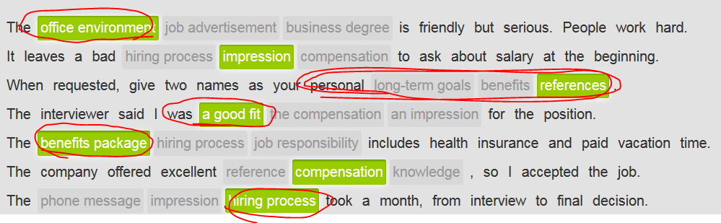

## Ask questions at the end of an interview

|  |  |  |
| --- | --- | --- |
|  | | |
|  |  |  |
| During an interview, make sure you ask some questions. This shows you are interested and curious about the position. Indirect questions are usually more polite than direct questions. Look at these examples. | | |
|  |  |  |
| Direct: | | |
|  |  |  |
|  |  |  |

|  |  |  |
| --- | --- | --- |
|  | What is the salary? |  |
|  |  |  |
| Indirect: | | |
|  |  |  |

|  |  |  |
| --- | --- | --- |
|  | Can you tell me what the salary is? |  |
|  |  |  |
| Here are some more examples of indirect questions. | | |
|  |  |  |

|  |  |  |
| --- | --- | --- |
|  | Could you tell me what the office environment is like? |  |
|  |  |  |

|  |  |  |
| --- | --- | --- |
|  | Could you explain how decisions are made? |  |
|  |  |  |

|  |  |  |
| --- | --- | --- |
|  | Can you tell me who the team members are? |  |

|  |  |  |
| --- | --- | --- |
| You can also ask indirect questions with these expressions. | |  |
|  | | |
|  |  |  |

|  |  |  |
| --- | --- | --- |
|  | **Could you tell me a little more about** the benefits package? |  |
|  |  |  |
|  |  |  |

|  |  |  |
| --- | --- | --- |
|  | **I was wondering about** the salary range. |  |
|  |  |  |
|  |  |  |

|  |  |  |
| --- | --- | --- |
|  | **Would you mind telling me more about** your overtime policy? |  |

## Close the interview

|  |  |  |
| --- | --- | --- |
| At the end of the interview, it is customary to stand up and shake hands. Here are some useful ways to take your leave. First, thank your interviewer. | | |
| First, thank your interviewer. | | |
|  |  |  |

|  |  |  |
| --- | --- | --- |
|  | *It was very nice to meet you.* | It was very nice to meet you. |
|  |  |  |

|  |  |  |
| --- | --- | --- |
|  | *Thank you for the opportunity to interview with your company.* | Thank you for the opportunity to interview with your company. |
|  |  |  |
| Express your interest in the position, offer to provide more information, and say goodbye. | | |
|  |  |  |

|  |  |  |
| --- | --- | --- |
|  | *I enjoyed talking with you about the position.* | I enjoyed talking with you about the position. |
|  |  |  |

|  |  |  |
| --- | --- | --- |
|  | *Please let me know if there's any other information I can provide.* | Please let me know if there's any other information I can provide. |
|  |  |  |

|  |  |  |
| --- | --- | --- |
|  | *I look forward to hearing from you soon.* | I look forward to hearing from you soon. |

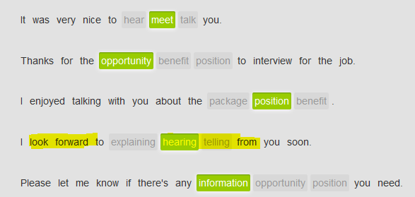

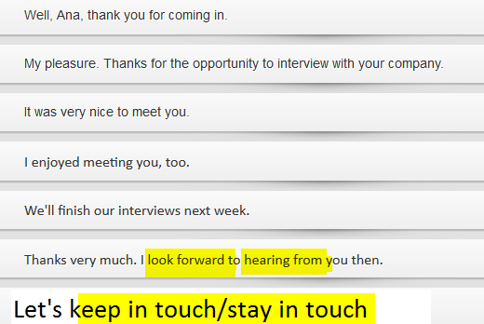

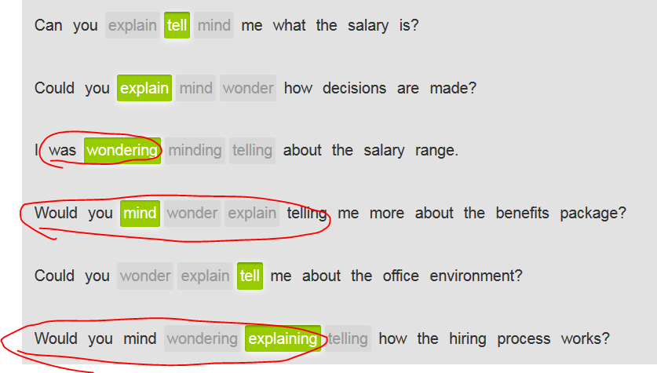

# ==L11, Unit1, Job interview==============

# Part1)Cover letter for an interview

## Hire an accountant



I know right.



JOhn





 //accounting firms会计师事务所; law firm



 //extensive experience 丰富的经验; 广泛经验

solid background; a keeper

keeper **/ˈkiːpə/**

|TEM4

* 1.

[N-COUNT](javascript:;)In American football, a keeper is a play in which the quarterback keeps the ball. (足球运动中) 守球

* 2.

[N-COUNT](javascript:;)A keeper at a zoo is a person who takes care of the animals. (动物园) 饲养员

* 3.

[N-COUNT](javascript:;)A keeper is something or someone that you value and that you feel is worth keeping. 值得保留的东西; 值得保留的人

•  The show's a keeper–daring, imaginative and provocative.   
 这部电影值得收藏–大胆、富于想像力和煽动性。

•  His sweet nature and kindness made him a keeper, she said.   
 她说他的可爱和善良使他成为值得珍视的人



Good. That works for me. Let me call him to book time.







|  |  |  |
| --- | --- | --- |
| Sequence words | | |
| Use the sequence words **afterward** or **subsequently** to say what came next in a series of events or points in time. | | |
|  | |  |
|  |  |  |

|  |  |  |
| --- | --- | --- |
|  | I got my engineering degree from Delft. **Afterward,** I began working for Smoot. |  |
|  |  |  |

|  |  |  |
| --- | --- | --- |
|  | I graduated from high school in 2004. **Subsequently,** I moved to England to study at Oxford. | . |
|  |  |  |
| Use **following** with an object to say what came next in a series of events or points in time. | | |
|  | |  |
|  |  |  |

|  |  |  |
| --- | --- | --- |
|  | **Following my promotion,** I designed the Northside Professional Center. |  |
|  |  |  |

|  |  |  |
| --- | --- | --- |
|  | **Following that,** I **was recognized as** Architect of the Year. |  |

|  |  |  |
| --- | --- | --- |
| Use **previously** to say what came before another event. | | |
|  | |  |
|  |  |  |

|  |  |  |
| --- | --- | --- |
|  | I started here in May. **Previously,** I was working for a competitor. |  |
|  |  |  |
| Use **prior to +** object to say what preceded another event or time. | | |
|  | |  |
|  |  |  |

|  |  |  |
| --- | --- | --- |
|  | **Prior to my time managing HR,** I wrote training courses. |  |
|  |  |  |
| Use the word **currently** to tell someone where you are working now. | | |
|  |  |  |
|  |  |  |

|  |  |  |
| --- | --- | --- |
|  | I'm **currently** working at IBM |  |

**Prior to** graduation, I got an internship at SWG.

I graduated in 2005. **Subsequently** , I moved to France and stayed until 2010.

**Following** my promotion, I was sent to the factory in Paris.

I was just hired at the bank. **Previously** , I worked at IXW.

**Currently** , I am working as a product manager.

## Career vocabulary

|  |  |  |
| --- | --- | --- |
| When you talk about your career, you will often need to mention positions you've held. **Head** is a general title that can mean **director** or **manager**. The word **head** can be used as a noun, verb or adjective. When it's a noun, it's followed by the word **of**. | | |
| Noun | | |
|  |  |  |

|  |  |  |
| --- | --- | --- |
|  | He's the **head** of quality assurance. |  |
| Verb | | |
|  |  |  |

|  |  |  |
| --- | --- | --- |
|  | She **heads** the sales department. = in charge of = take the helm of |  |
| Adjective | | |
|  |  |  |

|  |  |  |  |  |  |
| --- | --- | --- | --- | --- | --- |
|  | He's the **head** teacher. | | | |  |
| Lower in an organization are the people who help **managers** and **directors**, such as **assistants** and **associates**. An **associate** is generally a higher rank than an **assistant**. | | | |
|  | |  |  |

|  |  |  |
| --- | --- | --- |
|  | **associate** managing editor |  |
|  |  |  |

|  |  |  |
| --- | --- | --- |
|  | **assistant** sales director |  |

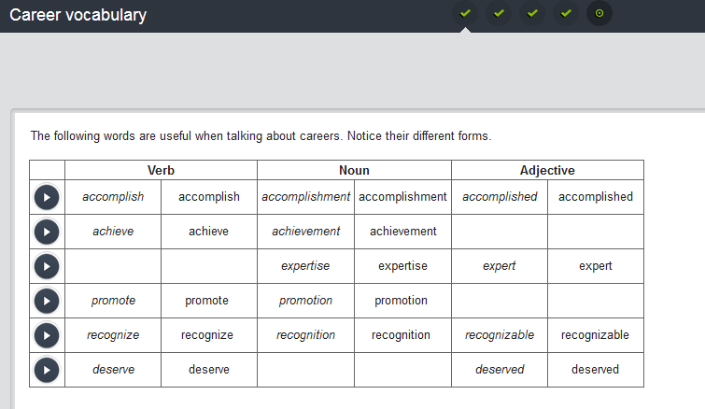

recognizable **/ˌrɛkəɡˈnaɪzəbəl/**

|TEM4

* + [ADJ](javascript:;)If something can be easily recognized or identified, you can say that it is easily recognizable. 可辨认的; 可认出的

•  The vault was opened and the body found to be well preserved, his features easily recognizable.   
 地窖被打开了, 尸体被发现保存完好, 他的面容很容易辨认。

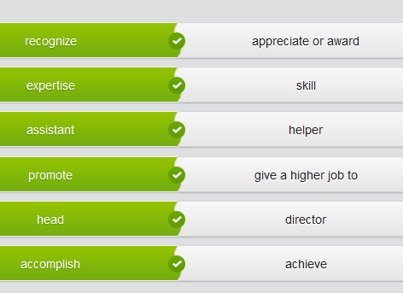 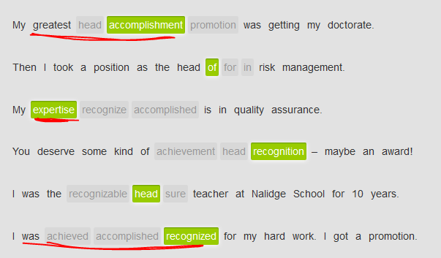

## Education and experience

|  |  |  |
| --- | --- | --- |
| **Describing your education** | | |
| You can use the following expressions to write about your college education. Notice the prepositions that go with each expression. | | |
|  | |  |
|  |  |  |

|  |  |  |
| --- | --- | --- |
|  | I **graduated from** Edinburgh University **in** 2010. |  |
|  |  |  |

|  |  |  |
| --- | --- | --- |
|  | I **have** a master's degree **in** business **from** Beijing University. |  |
|  |  |  |

|  |  |  |
| --- | --- | --- |
|  | I'm currently **working on** an MBA. |  |
|  |  |  |

|  |  |  |
| --- | --- | --- |
|  | I **majored** **in** chemistry. major in  * + **[美国口语]主修；专修；攻读：**   He majored in history.  他主修历史。  Are you majoring in English Literature? 你主修的是英国文学吗? |  |

|  |  |  |
| --- | --- | --- |
| Describing your experience | | |
| Use expressions like these to write about your work experience: | | |
|  | |  |
|  |  |  |

|  |  |  |
| --- | --- | --- |
|  | I have a **solid background in** product development. |  |
|  |  |  |

|  |  |  |
| --- | --- | --- |
|  | I have **extensive experience in** managing big projects. |  |
|  |  |  |

|  |  |  |
| --- | --- | --- |
|  | I was **promoted to** director of sales in 2010. |  |

## Cover letters- **Writing a cover letter for a job interview**

|  |  |
| --- | --- |
|  | |
| When you are applying for a job, send a short **cover letter** (cover letter) with your **resume** (resume). | |
|  |  |
| **Paragraph 1** | |
| After the salutation, tell the person what position you are applying for, and make a positive statement about your education and experience. | |
|  | |
| I am applying for the director of sales position posted on your company website. I believe my education, solid background, and extensive experience make me a strongly competitive candidate. | |
|  |  |
| **Paragraph 2** | |
| Next, summarize your education and experience. | |
|  |  |
| I have a BS in marketing from the University of Bologna and seven years of experience in sales. | |
| I worked for three years at Martinique Systems. Afterward, I worked at Hall and Smith for two years. I am currently working at Beijing Accounting Inc. | |

|  |  |
| --- | --- |
| **Paragraph 3** | |
| Finally, refer to your resume, thank the person for **considering** (considering) you and close the letter. | |
|  |  |
| Details about my education and experience are in the attached resume. Thank you for considering me for this position. I look forward to hearing from you. | |

## Cover letter-example

Director's position

From:

efstudent@efcourse.com

To:

bmcclain@smoot.com

Dear Mr. McClain:

I am writing to **apply for** the director's position at Smoot Inc. I believe my **solid background**, **extensive experience and education** make me a strong candidate.

I graduated with a master's degree in business from the University of Paris. I subsequently worked for three years at Cristo Systems. I am currently working at Bordeaux Consulting Inc.

e.g. 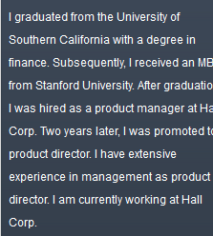

Details about my education and experience are in the attached resume. Thank you for considering my application. I hope to hear from you soon.

Sincerely,

EF student

## Write a cover letter

You are applying for a position as a Senior TW/Content Strategy at a major company. Read the example cover letter. Pretend you have extensive business qualifications and experience and write your cover letter

# Part2)Job titles and posistions

## Titles and positions

|  |  |  |
| --- | --- | --- |
|  | | |
| Although companies have different job titles, the person in authority generally starts with the **manager**. After that, the titles rise from director to **CEO** or **president**. Notice that the word **senior** raises the importance of a position. | | |
|  | |  |
|  |  |  |

|  |  |  |
| --- | --- | --- |
|  | John is a **senior project manager**. |  |
|  |  |  |

|  |  |  |
| --- | --- | --- |
|  | She's the **production manager.** |  |
|  |  |  |

|  |  |  |
| --- | --- | --- |
|  | He's the **director of design**. |  |
|  |  |  |

|  |  |  |
| --- | --- | --- |
|  | Martina is the **vice president of engineering**. |  |

|  |  |  |
| --- | --- | --- |
| here are many titles that have a **c** in it. The **c** stands for **chief**. The **CEO** is the highest rank in a company. The other C-titles report to the **CEO**, but are generally above the **vice presidents**. Here are the most common titles. | | |
|  | |  |
|  |  |  |

|  |  |  |
| --- | --- | --- |
|  | **chief executive officer (CEO)** |  |
|  |  |  |

|  |  |  |
| --- | --- | --- |
|  | **chief operations officer (COO)** |  |
|  |  |  |

|  |  |  |
| --- | --- | --- |
|  | **chief financial officer (CFO)** |  |
|  |  |  |

|  |  |  |
| --- | --- | --- |
|  | **chief technology officer (CTO)** |  |

## Begin the interview –salutation [,sæljʊ'teɪʃ(ə)n] 招呼；寒喧 = greeting



yes

 //you’re right on time

 would you mind doing thst



 



 



 

Yes, lovely







Yeah, will do that

 







## Beginning the interview

|  |  |  |
| --- | --- | --- |
| **Finding the interviewer** | | |
| The first step is finding the person who is going to interview you. In a large company, you may have to ask an **administrative assistant** (administrative assistant) or **receptionist** (receptionist). Be sure to state who you are and why you're there. | | |
|  | |  |
|  |  |  |
|  |  |

|  |  |  |
| --- | --- | --- |
|  | A: Good afternoon. I'm Rob Taylor. I have an appointment with the HR director, Ms. Rifkin. | . |
| B: Oh, yes. She's expecting you. |  |
|  |  |  |
| **Greeting the interviewer** | | |
| Greet the **interviewer** (interviewer) formally, and thank the person for giving you their time. Listen for clues about how the interviewer prefers to be addressed. | | |
|  | |  |
|  |  |  |
|  |  |

|  |  |  |
| --- | --- | --- |
|  | A: Good afternoon, Ms. Rifkin. |  |
| B: Oh, please – call me Mary. |  |
|  |  |  |
|  |  |  |
|  |  |

|  |  |  |
| --- | --- | --- |
|  | A: Thank you for the opportunity to interview for design manager. |  |
| B: It's my pleasure. You're a strong candidate. |  |

## Making small talk - salutation [,s**æ**ljʊ'teɪʃ(ə)n] 招呼；寒喧

|  |  |  |
| --- | --- | --- |
| // salutation **/ˌsæljʊˈteɪʃən/**  * [N-COUNT](javascript:;)Salutation or a salutation is a greeting to someone. 打招呼; 致意l 招呼；寒喧   •  Jackson nodded a salutation.   杰克逊点头打了个招呼。  •  The old man moved away, raising his hand in salutation.   这位老者离开，举起他的手致意   [‚sæljʊ'teɪʃ ə n,‚sæljə'teɪʃ ə n]  formal 【正式】 MEANINGS 义项  * 1.   [C] a word or phrase used at the beginning of a letter or speech, such as ‘Dear Mr Smith’  〔信函、演讲开头的〕称呼语   * 2.   [C,U] something you say or do when greeting someone  问候，致意 | | |
| Expect a short period of small talk. If you came from another city, you may be asked about your trip or what you think about the city. | | |
|  | |  |
|  |  |  |
|  |  |

|  |  |  |
| --- | --- | --- |
|  | A: So how do you like Chicago? | So how do you like Chicago? |
| B: I love it! Everyone's so friendly! | I love it! Everyone's so friendly! |
|  |  |  |
| The interviewer will signal when it's time to begin the interview. | | |
|  | |  |
|  |  |  |
|  |  |

|  |  |  |
| --- | --- | --- |
|  | A: Well, we only have an hour. Shall we begin? | Well, we only have an hour. Shall we begin? |
| B: Sounds good. | Sounds good. |

# Part3)Interview questions

**Adjectives for strengths and weaknesses**  
**Ref: see Level10, Unit “Solve a problem” > use “SWOT Analysis”**

|  |  |  |
| --- | --- | --- |
| Adjectives are an important part of expressing **strengths** and **weaknesses**. Use positive adjectives like these to describe someone you think is **smart**. Notice that they are synonyms. | | |
|  |  |  |

|  |  |  |
| --- | --- | --- |
|  | clever | clever |
|  |  |  |

|  |  |  |
| --- | --- | --- |
|  | bright | bright |
|  |  |  |

|  |  |  |
| --- | --- | --- |
|  | sharp | sharp |
| The following adjectives also generally have a positive meaning. They describe people who are keen to do well. | | |
|  |  |  |

|  |  |  |
| --- | --- | --- |
|  | ambitious | ambitious |
|  |  |  |

|  |  |  |
| --- | --- | --- |
|  | determined | determined |

 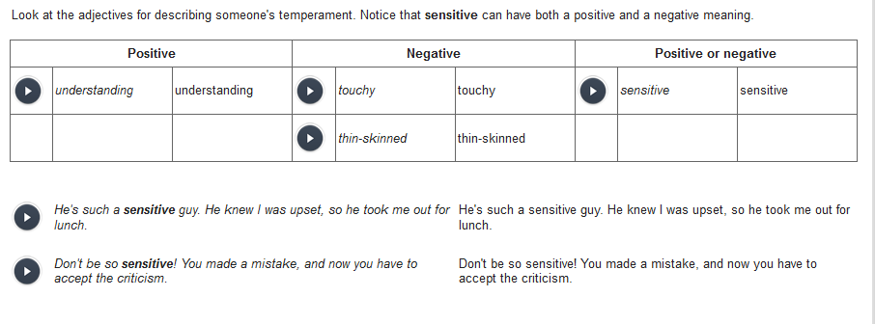

|  |
| --- |
| Look at the adjectives for describing someone's temperament. Notice that **sensitive** can have both a positive and a negative meaning. |

|  |  |  |  |  |  |  |  |  |
| --- | --- | --- | --- | --- | --- | --- | --- | --- |
| **Positive** | | | **Negative** | | | **Positive or negative** | | |
|  |  |  |  |  |  |  |  |  |

|  |  |  |  |
| --- | --- | --- | --- |
|  | understanding | understanding |  |

|  |  |  |  |
| --- | --- | --- | --- |
|  | touchy | touchy |  |

|  |  |  |
| --- | --- | --- |
|  | sensitive | sensitive |
|  |  |  |  |

|  |  |  |  |  |  |
| --- | --- | --- | --- | --- | --- |
|  | thin-skinned | thin-skinned |  |  |  |

|  |  |  |
| --- | --- | --- |
|  |  |  |
|  |  |  |
|  |  |  |

|  |  |  |
| --- | --- | --- |
|  | He's such a **sensitive** guy. He knew I was upset, so he took me out for lunch. | He's such a sensitive guy. He knew I was upset, so he took me out for lunch. |
|  |  |  |
|  |  |  |

|  |  |  |
| --- | --- | --- |
|  | Don't be so **sensitive**! You made a mistake, and now you have to accept the criticism. | Don't be so sensitive! You made a mistake, and now you have to accept the criticism. |

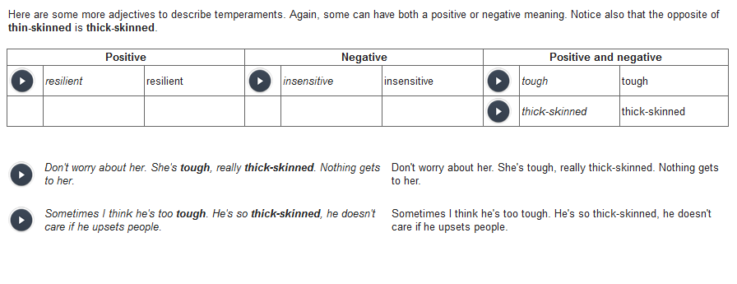

|  |
| --- |
| Here are some more adjectives to describe temperaments. Again, some can have both a positive or negative meaning. Notice also that the opposite of **thin-skinned** is **thick-skinned**. |

|  |  |  |  |  |  |  |  |  |
| --- | --- | --- | --- | --- | --- | --- | --- | --- |
| **Positive** | | | **Negative** | | | **Positive and negative** | | |
|  |  |  |  |  |  |  |  |  |

|  |  |  |  |
| --- | --- | --- | --- |
|  | resilient | resilient |  |

|  |  |  |  |
| --- | --- | --- | --- |
|  | insensitive | insensitive |  |

|  |  |  |
| --- | --- | --- |
|  | tough | tough |
|  |  |  |  |  |  |  |

|  |  |  |
| --- | --- | --- |
|  | thick-skinned | thick-skinned |

|  |  |  |
| --- | --- | --- |
|  |  |  |
|  |  |  |
|  |  |  |

|  |  |  |
| --- | --- | --- |
|  | Don't worry about her. She's **tough**, really **thick-skinned**. Nothing gets to her. |  |
|  |  |  |
|  |  |  |

|  |  |  |
| --- | --- | --- |
|  | Sometimes I think he's too **tough**. He's so **thick-skinned**, he doesn't care if he upsets people. |  |

## 骄傲自满的; 自满的, 自大的

|  |  |  |  |  |
| --- | --- | --- | --- | --- |
| The following synonyms always have a negative meaning. Use them to describe overly confident people. Use them carefully since they are considered quite insulting.  **[ cocky = complacent [kəm'pleɪs ə nt] = big-headed, arrogant ]** | | | | |
|  | |  |  | |
|  |  | | |  |

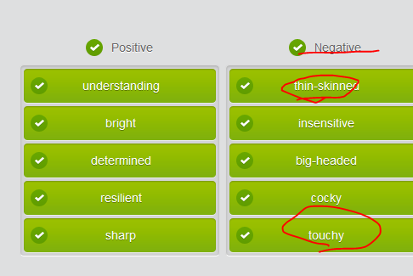

## Interview questions

|  |
| --- |
| • Tell me a little bit about yourself.  • • Why do you want to leave?  • • What are some of your **strengths**?  • • What is your greatest **weakness**?  • Tell me about a **challenge** you had. |





Tell me a little about yourself.

 



 => strong curiosity , a fast learner

//extensive experience and solid background









## Some common interview questions

|  |  |  |
| --- | --- | --- |
|  | | |
| Many interviewers will start with a general question about you. Use this as an opportunity to sell yourself. | | |
|  | |  |
|  |  |  |

|  |  |  |
| --- | --- | --- |
|  | Could you tell me something about yourself? |  |
|  |  |  |

|  |  |  |  |
| --- | --- | --- | --- |
|  | Well, I've been in the clothing design industry for seven years. I'm my company's lead designer. |  | |
|  |  |  | |
| Interviewers generally want to know why you want to leave your current job. Try not to be negative. Emphasize the benefits of the position that you are interviewing for. | | | | |
|  | | |  | |
|  |  |  | |

|  |  |  |
| --- | --- | --- |
|  | Why do you want to leave BTL?  I've increased sales there by 15% in the last two years. I love it there, but I'm ready now for another challenge |  |
|  |  |  |

|  |  |  |
| --- | --- | --- |
|  | . |  |
| Some interviewers want specific examples of challenges you have faced. | | |
|  | |  |
|  |  |  |

|  |  |  |
| --- | --- | --- |
|  | Tell me about a difficult situation that you faced at work and what you did about it. |  |
|  |  |  |

|  |  |  |
| --- | --- | --- |
|  | A junior colleague was making mistakes in his data. It made our team look bad. I taught him how to use spreadsheets effectively. |  |

Interviewing for a job

• You are interviewing to be a director.

## Part4) End the interview

## End the interview











Yeah, go ahead.





















Well, that’s great.















OK, we’ll come back to you soon. Thank you once again for coming in.

 and Thank you for tak**ing** the time to interview me.

## At the end of interview, ask the interviewer questions

|  |  |  |
| --- | --- | --- |
|  | | |
| Have some questions ready for the end of the interview. This is your opportunity to show your interest in the company and to get more information about it. | | |
|  | |  |
|  |  |  |

|  |  |  |
| --- | --- | --- |
|  | What is the biggest challenge for your staff? |  |
|  |  |  |

|  |  |  |
| --- | --- | --- |
|  | What would I need to do to be successful at this position? |  |
|  |  |  |

|  |  |  |
| --- | --- | --- |
|  | Do you have any reservations about my qualifications? |  |
|  |  |  |
| You might want to connect on a personal level with your interviewer. Don't push too hard, but find out how your interviewer feels about the company . | | |
|  | |  |
|  |  |  |

|  |  |  |
| --- | --- | --- |
|  | How do you feel about working at IBX? Closing a job interview |  |

|  |  |  |
| --- | --- | --- |
|  | | |
| You have asked the interviewer a lot of questions. Now you have a question to ask yourself: Are you still interested in the job? If you are, you should communicate that to the interviewer. | | |
|  | |  |
|  |  |  |

|  |  |  |
| --- | --- | --- |
|  | After hearing your responses to my questions, I'd really like to work here. I think that I'm **a good fit** for this position. |  |
|  |  |  |
| Before you leave, you need to find out what the next steps are. Thank the interviewer and ask for a business card so you can write a short thank-you email with an accurately spelled name and job title. | | |
|  | |  |
|  |  |  |
|  |  |

|  |  |  |
| --- | --- | --- |
|  | A: So, what are the next steps in the hiring process? |  |
| B: Well, I need to interview one more candidate. I should be able to tell you my decision by next Monday. |  |
|  |  |  |
|  |  |  |

|  |  |  |
| --- | --- | --- |
|  | Thank you for taking the time to interview me. I hope to talk to you again soon. |  |
|  |  |  |
|  |  |  |

|  |  |  |
| --- | --- | --- |
|  | Oh, and could I have one of your business cards? |  |

What is the biggest challenge for your staff?

What would I need to do to be successful at this position?

Do you have any reservations about my qualifications?

How do you feel about working at Smoot?

What are the next steps in the hiring process?

I think that I'm **a good fit** for this position.

# SMART

|  |  |  |  |
| --- | --- | --- | --- |
| |  |  |  | | --- | --- | --- | | |  | | --- | | Get SMART with wellness goals | |  | | |
|  |
| |  |  |  |  |  |  |  |  |  |  |  |  |  |  | | --- | --- | --- | --- | --- | --- | --- | --- | --- | --- | --- | --- | --- | --- | | |  |  |  |  |  |  |  |  |  |  |  |  |  | | --- | --- | --- | --- | --- | --- | --- | --- | --- | --- | --- | --- | --- | | |  |  |  |  |  |  |  |  |  |  |  |  | | --- | --- | --- | --- | --- | --- | --- | --- | --- | --- | --- | --- | | |  |  |  |  |  |  |  |  |  |  |  | | --- | --- | --- | --- | --- | --- | --- | --- | --- | --- | --- | | |  |  |  |  |  |  |  |  |  |  | | --- | --- | --- | --- | --- | --- | --- | --- | --- | --- | | |  |  |  |  |  |  |  |  |  | | --- | --- | --- | --- | --- | --- | --- | --- | --- | | |  |  |  |  |  |  |  |  | | --- | --- | --- | --- | --- | --- | --- | --- | | |  |  |  |  |  |  |  | | --- | --- | --- | --- | --- | --- | --- | | |  |  |  |  |  |  | | --- | --- | --- | --- | --- | --- | | |  |  |  |  |  | | --- | --- | --- | --- | --- | | |  |  |  |  | | --- | --- | --- | --- | | |  |  |  | | --- | --- | --- | | |  |  | | --- | --- | | |  | | --- | | Are you ready to improve your health and fitness, but not sure where to start? Set goals! Goals give you something to work toward, and improve your chances of success. An effective way to set a wellness goal is to apply the same technique you use in setting your HP performance goals – make your goals **SMART**: **s**pecific,**m**easurable,**a**ttainable, **r**elevant, and **t**ime-bound.  For example, let’s say you want to be more physically active. Rather than stating your goal as “I want to walk more,” try a SMART goal, such as “I want to walk for at least 30 minutes per day, three days per week.” This goal is SMART because it’s:  smart goals Specific—you’ll walk a certain number of minutes per week rather than “walk more.”  Smart Goals Measurable—you can track the amount of time and number of days you walk.  Smart Goals Attainable—realistic and attainable, walking three times a week is a goal most of us can meet.  Smart Goals Relevant—walking is an appropriate, suitable goal for people who want to be more active.  Smart Goals Time-bound—you can set a deadline of one week to meet your walking goal.  **Setting yourself up for success**  Here are a few tips to keep in mind as you’re setting your goals, so you’ve got the best chance at success:  **- Start small**. It’s easier to achieve small goals than large ones, and you can always build on your success later. **- Put it in writing**. Daily reminders help you stay committed, so be sure to post your written goals in a prominent place. **- Keep it manageable**. It’s easier to meet your goals if you take it one step at a time. **- Build on your progress**. When you reach your goal, set a new one. Keep raising the bar! | | | | | | | | | | | | | | |