# Music

# Lexical resource

|  |
| --- |
| couch potato  * + [N-COUNT](javascript:;)A couch potato is someone who spends most of their time watching television and does not exercise or have any interesting hobbies. 电视迷; 大部分时间都在家看电视、不运动或没有其它兴趣爱好的人   •  ...couch potatoes flicking through endless satellite TV channels.   ...在无数个卫星电视频道之间来回换台的电视迷。 |
| Night out夜生活/晚上出去玩 |
| [səb'skraɪb]  subscribe /səbˈskraɪb/      |CET6 TEM4 (subscribingsubscribedsubscribes)  1.  [V-I](javascript:;)If you subscribe to an opinion or belief, you are one of a number of people who have this opinion or belief. 持有 (意见或信仰)  •  I've personally never subscribed to the view that either sex is superior to the other.   我个人从未持有过一种性别比另一种性别优越的观点。  2.  [V-I](javascript:;)If you subscribe to a magazine or a newspaper, you pay to receive copies of it regularly. 订阅  •  My main reason for subscribing to New Scientist is to keep abreast of advances in science.   我订阅《新科学家》的主要原因是要跟上科学的进步。  3.  [V-I](javascript:;)If you subscribe to an online newsgroup or service, you send a message saying that you wish to receive it or belong to it. 申请加入 (在线新闻组); 申请 (在线服务)  •  Usenet is a collection of discussion groups, known as newsgroups, to which anybody can subscribe.   新闻组网络是由称为新闻组的讨论组组成，任何人都能申请加入。  4.  [V-I](javascript:;)If you subscribe for shares in a company, you apply to buy shares in that company. 申购 (股份)  •  Employees subscribed for far more shares than were available.   雇员们申购了远比实际数额还多的股份。  MEANINGS 义项  1.  [I] to pay money, usually once a year, to have copies of a newspaper or magazine sent to you, or to have some other service  订阅〔报纸或杂志〕，订购〔服务〕  [+ to]  •You can subscribe to the magazine for as little as 32 a year. 一年只需 32 美元就可以订阅这份杂志。  2.  [I] to pay money regularly to be a member of an organization or to help its work  定期缴纳会员费；定期捐款  [+ to]  •She subscribes to an environmental action group. 她定期捐款给一个环境行动组织。  3.  [I] to agree to buy or pay for share s  认购股份  [+ for]  •Each employee may subscribe for up to £2,000 worth of shares. 每位员工最高可以认购价值 2,000 英镑的股份。  PHRVB 短语动词  subscribe to sthphr v  if you subscribe to an idea, you agree with it or support it  同意，赞同；支持  subscribe to the view/belief/theory etc  •I have never subscribed to the view that schooldays are the happiest days of your life.我从未赞同过这样的看法，以为学生时代是一生中最快乐的日子 |
| [səb'skrɪpʃ ə n]  MEANINGS 义项  1.  [C,U] an amount of money you pay, usually once a year, to receive copies of a newspaper or magazine, or receive a service, or the act of paying money for this  订阅（费）；用户费（的缴纳）  •You may cancel your subscription at any time. 你随时可以取消订阅。  •I’ve decided not to renew my subscription . 我决定不再续订了。  [+ to]  •Are you interested in taking out a subscription to ‘Newsweek’ (= arranging to buy it on a regular basis ) ? 你有兴趣订阅《新闻周刊》吗？  2.  [C,U] an amount of money you pay regularly to be a member of an organization or to help its work, or the act of paying money for this  会（员）费；会（员）费的缴纳  [+ to]  •a subscription to Amnesty International 向大赦国际缴纳的会费  3.  [U] when people in a country or place give money in order to pay for something to be done  认捐；捐助；捐款  •The church’s 120-foot Gothic spire was paid for by public subscription in 1939. 这座教堂 120 英尺高的哥特式尖塔是 1939 年由公众捐资建成的。  以上来源于《朗文当代高级英语辞典》  1.  [N-COUNT](javascript:;)A subscription is an amount of money that you pay regularly in order to belong to an organization, to help a charity or campaign, or to receive copies of a magazine or newspaper. 会员费; 捐赠款; 征订费  •  You can become a member by paying the yearly subscription.   你通过支付年度会员费可以成为一名会员。  2.  [ADJ](javascript:;)Subscription television is television that you can watch only if you pay a subscription. Asubscription channel is a channel that you can watch only if you pay a subscription. (电视或频道) 付费的  •  Premiere, a subscription channel which began in 1991, shows live football covering the top two divisions.   始于1991年的一个付费频道实况转播两大顶级足球赛。 |
| hear me out  听我说完呀 |
| ## [做xxx又不会少快肉: It wouldn't hurt to do sth]  e.g. **It wouldn't hurt to try** and You'd like it. So, **give it a shot/a try/try it out/check it out 试试吧; 试一试呗**. |
| ## 试试吧; 试一试呗 Give it a try = Give it a shot = Try it out = Check it out  e.g. It wouldn't hurt to try and You'd like it. So, **give it a shot/a try/try it out/check it out 试试吧; 试一试呗**. |
| ## piggyback /ˈpɪɡɪˌbæk/ [ give sb. a piggyback; piggyback on/onto sth]  1. N-COUNT 可数名词 If you [**give someone a piggyback**], you carry them high on your back, supporting them under their knees. 把sb.背在背上/驮在背上  3. V-I If you [**piggyback on/onto something**], you take advantage of it that has been done or achieved by other people. 利用(别人已经取得成果/技术/知识) / 站在巨人的肩膀上  • I was just **piggybacking onto** Jill's idea. 我只是 利用/借用<Jill>的想法而已。  • They are **piggybacking onto** developed technology. 他们 利用/借用已发展的科技。  4. **[盗用sb's的网络连接: piggyback onto sb's internet connection]**: to use someone else’s wi-fi connection to the Internet, without their knowledge or permission. |
| /ˈseɪlaɪn/  美 ['selin] saline: [ADJ](javascript:;)A saline substance or liquid contains salt. 含盐的(溶液,饮料, 液体)  •  ...a saline solution.   ...一种含盐溶液; … a saline cocktail 一种含盐鸡尾酒  V.S.  salty /ˈsɔːltɪ/ [ADJ](javascript:;)Something that is salty contains salt or tastes of salt. 含盐的; 咸的  •  ...salty foods such as ham and bacon.  …例如火腿和熏肉这样的咸味食品  e.g. The eggs taste **a little/wee bit** salty. |
| * Be used to do. * Used to do sth过去常常做xxx  🡺 **Did** sb use to do sth? * Be used to sth/doing 习惯了xxx; **be accustomed to****sth/doing sth习惯于, 适应于** |
| 说到这儿**On that note = Speaking of which,**  说到xxx: **Speaking of sth, xx** |
| ['muːdi] **moody, moodily, moodiness n [U]**  1.annoyed or unhappy情绪不好的，郁郁寡欢的; 闷闷不乐的  •Keith had seemed moody all morning. 基思好像整个早上都不高兴。  2. [ADJ](javascript:;)If you describe someone as moody, you mean that their feelings, mood, and behaviour change frequently, often changing quickly from being in a good temper to being in a bad temper; and in particular that they often become depressed, sad, or angry without any warning. 喜怒无常的，情绪多变的  •  my mother was **unstable and moody.**  戴维的母亲情绪不稳定，喜怒无常。  • a moody teenager 情绪多变的少年  •Lewis was moody and brilliantly clever. 刘易斯喜怒无常，但是非常聪明  3. [ADJ](javascript:;)If you describe a picture, film, places, or piece of music as **moody**, you mean that it suggests particular emotions, especially sadness or **sorrow (noun悲伤,伤心事**); **moody places, films, pictures, and music** make you feel slightly sad, lonely, or perhaps frightened〔地方、影片、照片和音乐〕令人忧郁悲伤的；令人感伤的  V.S.  **[gripping movie/film/story] is very exciting and interesting 〔电影、故事等〕扣人心弦的，引人入胜的**  e.g.  ...**moody** black and white photographs.  …令人感伤的黑白照片。  e.g. This music feels **a little/wee bit** moody.  DERIVATIVE 派生词  moodily adv  e.g. She was staring **moodily** into the fire. 她闷闷不乐地注视着炉火。  e.g. He sat and stared **moodily** out the window.  他坐在那里，闷闷不乐地盯着窗外。  moodiness n [U] |
| [**a little/wee bit**]  e.g. This music feels **a little/wee bit** moody. // If you describe a picture, film, places, or piece of music as **moody**, you mean that it suggests particular emotions, especially sad ones; **moody places, films, pictures, and music** make you feel slightly sad, lonely, or perhaps frightened〔地方、影片、照片和音乐〕令人忧郁的；令人悲伤的；令人感伤的 |
| **[消磨时间, 打发时间; 随便玩玩: goof around  [guːf] ]**  E.g. I don’t wanna **goof around随便玩玩;** instead, I’d like to have a serious relationship with you. I mean, I wanna be your BF. Seriously.  e.g. We spent the whole afternoon just **goofing around** on our bikes around HanGang river in Seoul, which is so relaxing. When you’re riding the bike and circulating the Han river, you can nicely enjoy **the panoramic view** 全景 of the whole river. **//panorama [pænə'rɑːmə]; panoramic [,pænə'ræmɪk] adj. [摄] 全景的**  V.S.  **[混日子，逃避工作: goof off]:** to waste and kill time or avoid doing any work  e.g. He’s been goofing off at school. 他在学校里一直混日子。  e.g. From my point, he’s just goofing off at company |

# Music-related dic

|  |
| --- |
| If you describe a picture, film, places, or piece of music as **moody**, you mean that it suggests particular emotions, especially sadness or sorrow (noun悲伤,伤心事); **moody places, films, pictures, and music** make you feel slightly sad, lonely, or perhaps frightened〔地方、影片、照片和音乐〕  V.S.  **[gripping movie/film/story] is very exciting and interesting 〔电影、故事等〕扣人心弦的，引人入胜的**  e.g.  ...**moody** black and white photographs.  …令人感伤的黑白照片。  e.g. This music feels **a little/wee bit** moody.  **[扣人心弦的/引人入胜的〔电影、故事等〕: gripping movie/film/story;**  **令人感到忧郁悲伤的；令人感伤的〔地方、影片、照片和音乐〕: moody place/film/photos/music]** |
| melody /ˈmɛlədɪ/      |CET6 TEM4  [N-COUNT](javascript:;)A melody is a tune. 旋律  •  I whistle melodies from Beethoven and Vivaldi and the more popular classical composers.   我用口哨吹贝多芬、维瓦尔迪和更大众化一些的古典作曲家的曲子。  ['melədi]  pl: melodies  MEANINGS 义项  1.  [C] a song or tune  歌曲；曲调  [THESAURUS](javascript:;)  MUSIC  •They played some lovely melodies. 他们演奏了一些动听的曲子。  •a haunting melody 难以忘怀的曲调  2.  [U] the arrangement of musical notes in a way that is pleasant  悦耳的音调，美妙的旋律 |
| 唱片 LPs |
| **DJ: a disc jockey, 流行音乐节目主持人**  e.g. I always wanted to be a disc jockey (DJ). DJs are cool.  e.g. He got into the station manager's office and told him he wanted to be a disc jockey.  他走进经理办公室，说他想成为一名流行音乐节目主持人  **V.S. jockey club:** [N](javascript:;)the governing body that regulates and controls horse-racing both on the flat and over jumps 赛马俱乐部; 规范和控制无障碍和有障碍马赛的理事机构 |
| I'm not a big fan of country music. **I'm into** rock. |
| 贝多芬（德国作曲家）Beethoven  ['b**e**i,**t**əuvən] |
| * **[ə'kʊstɪk**] acoustic:   1. relating to sound and the way people hear things 声音的；听觉的  2. [**an acoustic guitar or other musical instrument]** is one whose sound is produced without any electrical equipment. 自然声;〔乐器〕原声的，自然声的; 不用电传音的乐器  E.g. I don't like “electric guitar”, instead, **I’m into** “acoustic music”.  e.g. The electricity went out, so the band played **acoustic**.  3. [N-COUNT](javascript:;)复**数**If you refer to **[ the acoustics of a space ],** you are referring to the structural features which determine how well you can hear music or speech in it. **一个地方的传声效果**  •  In this performance, Rattle **had the acoustics of the Symphony Hall** on his side.  有着交响音乐厅的 传声效果 的翼助。  3. [N-UNCOUNT](javascript:;)**Acoustics** is the scientific study of sound. 声学  •  ...his work in **acoustics**. …他在声学方面的工作。 |
| * /ɪnˈθjuːzɪˌæst/ enthusiast: [N-COUNT](javascript:;)An enthusiast is a person who is very interested in a particular activity or subject and who spends a lot of time on it. (充满热情的)爱好者 [**music enthusiast; sports enthusiast**] * /ɪnˌθjuːzɪˈæstɪk/ enthusiastic: [ADJ](javascript:;)If **you [ are enthusiastic about]** something, you show how much you like or enjoy it by the way that you behave and talk. 热衷的; 热烈的 * /ɪnˈθjuːzɪˌæzəm/ enthusiasm: [N-VAR](javascript:;)Enthusiasm is great eagerness to be involved in a particular activity that you like and enjoy or that you think is important. 热情   e.g. For **music enthusiasts**, the HP DreamScreen, a music app, allows users to **stream music** directly from the Internet using Pandora. |
| Creepy: making you feel nervous and slightly frightened 使人紧张的；令人毛骨悚然的  e.g. There’s something **creepy** about the way he looks at me. 他看着我的样子让人有点毛骨悚然。  e.g. This ghost movie makes me feel so **creepy**感到毛骨悚然, even though the **plot is very gripping〔电影、故事等〕扣人心弦的.**  e.g. The whole place **feels creepy.** 整个地方让人感到毛骨悚然  e.g. The lyrics of this music **feels creepy.** |
| “How to choose a music”…uh, you know, I just don’t care whether the music’s cool or not**. If it’s right for the mood I’m in, then it’s right for me.** |
| Here are a few that describe aspects of an app.   * A new app;  e.g. I found a great new app for **streaming music (downloading from internet).** * **Streaming service: 在线的下载服务/在线的需要有网络(online)流媒体服务 🡺antonym: offline 离线的(can stream music from internet; stream movie from internet) e.g. (Music app) Have u ever tried streaming?** e.g. I found a great new app for **streaming music (downloading from internet). e.g.** e.g. I fail to **stream music (download from internet)**. See that the “**streaming service”** doesn’t work bz there’s no internet in the forest. e.g. OMG, someone is **piggybacking onto our internet**; and we lost our internet…see, the **“streaming service”** doesn’t work. //**盗用的网络连接: piggyback onto sb’s internet** e.g. I found a great new app in iTune for **streaming music from internet (downloading from internet).** E.G. More and more people are buying digital music (through **streaming service** rendered by **music apps, like QQ音乐**), but companies are still getting less and less profit. That's because music is often illegally downloaded from the internet. Songs are shared for free between people's computers or shared storage – no one **pays for** them. To help stop illegal downloading, companies like myTurn are offering **music subscriptions for customers to stream music (download from internet)**. The companies believe that if an inexpensive subscription is offered, people will be less interested in illegal downloading * Monthly/quarterly/yearly subscription; e.g. The monthly subscription has unlimited content * Offline mode:  e.g. I listen **in offline mode** where there's no service. * Unlimited content/service/downloading times e.g. The **monthly subscription** has unlimited content. * **Ad-supported,** **ad-supported software****; ad-supported app 广告支持的软件 e.g.** It has great sound quality, but it's ad-supported. * No service * Great sound quality e.g. It has great sound quality, but it's **ad-supported**. * **Free trial e.g.** If you're interested, you can try the free trial. |
| **[ad-supported,** **ad-supported software****; ad-supported app 广告支持的软件]**  e.g. Only in 2009 did Google introduce a free**, ad-supported music service** in China, in conjunction with music labels.  在2009年谷歌在中国引入了免费的、**广告支持的音乐服务**，同时与唱片公司关联。  e.g. The cost of harnessing the capabilities of your cloud may be based on **a monthly subscription**每月订费 or it may be metered, or it may be **ad-supported.**  利用你的云的这个能力的成本建立在每月订费的基础上，或者它可能是按实际使用量计费，或者它可能是**广告支持的**。 |
| **[ streaming service; 流媒体服务(upload/download from the internet;**  **verb) stream music** directly from the internet ]  e.g. (Music app) Have u ever tried streaming (the stream service of the music app) ?  e.g. "ITunes will let you **stream the music**, but that comes with a few downsides, like Apple trying to get you to buy the music"  e.g. For **music enthusiasts**, the HP DreamScreen, a music app, allows users to **stream music** directly from the Internet using Pandora. |

# Types of music

|  |  |
| --- | --- |
| [soft pop music] | You know, I often listen to … Beethoven ['bei,təuvən]. If I’m sad or moody情绪不好的，郁郁寡欢的, if I feel like I need to relax, I’ll put on some soft pop music, like Celine Dion. |
| [techno] | techno /ˈtɛknəʊ/: a type of fast, electronic dance music, typically with little or no singing  ***[techno music; techno club]***  [N-UNCOUNT](javascript:;)Techno is a form of modern electronic music with a very fast beat; a type of popular electronic dance music with a fast strong beat 高科技舞曲〔一种节奏快而强劲的电子舞蹈音乐〕  e.g. e.g. She ***used to*** listen to ***techno music***. |
| [hip-pop] |  |
|  | [ADJ](javascript:;)Folk art and customs are traditional or typical of a particular community or nation. 民间的  •  ...South American folk art.   …南美民间艺术。  5.  [ADJ](javascript:;)Folk music is music which is traditional or typical of a particular community or nation. 民间的 (音乐)  6.  [N-UNCOUNT](javascript:;)Folk is also a noun. 民间 (音乐) /foʊk/  music in the traditional style of a country or community  a folk festival/concert  •  ...a variety of music including classical and folk.   …包括古典音乐和民间音乐在内的各种音乐。 |
|  | classical  /ˈklæsɪkl/  written in a Western musical tradition, usually using an established form (for example a symphony) and not played on electronic instruments. Classical music is generally considered to be serious and to have a lasting value  He plays classical music, as well as pop and jazz. |
|  | jazz  /dʒæz/  a type of music with strong rhythms, in which the players often improvise(= make up the music as they are playing), originally created by African American musicians  a jazz band/club |
|  | punk  /pʌŋk/  a type of loud and aggressive rock music popular in the late 1970s and early 1980s  a punk band |
|  | rock  /rɑːk/  a type of loud popular music, developed in the 1960s, with a strong beat played on electric guitars and drums  punk rock |
|  | pop  /pɑːp/  popular music of the sort that has been popular since the 1950s, usually with a strong rhythm and simple tunes, often contrasted with rock, soul and other forms of popular music  rock, pop and soul |
|  | country  /ˈkʌntri/  popular music which is based on a type of traditional music from the western and southern US  pop, folk and country |
|  | hip-hop  /hɪphɑːp/  a type of popular music with spoken words and a steady beat played on electronic instruments, originally played by young African Americans  Hip-hop music has had a big influence on urban fashion. |
|  | symphony /ˈsɪmfənɪ/      |CET6 TEM4  [N-COUNT/N-IN-NAMES](javascript:;)A symphony is a piece of music written to be played by an orchestra. Symphonies are usually made up of four separate sections called movements. 交响乐  •  ...Beethoven's Ninth Symphony.   …贝多芬的第九交响曲。  1.  a long piece of music usually in four parts, written for an orchestra  交响乐，交响曲  •Bruckner’s Fifth Symphony 布鲁克纳的《第五交响曲》  2.  a large group of classical musicians led by a conductor  交响乐团 |
|  | ['ɔːkɪstrə,'ɔːkəstrə]  MEANINGS 义项  1.  [N-COUNT](javascript:;)An orchestra is a large group of musicians who play a variety of different instruments together. Orchestras usually play classical music. 管弦乐队  •  ...the Los Angeles Philharmonic Orchestra.   …洛杉矶爱乐乐团。  [C also + plural verb BrE,英国英语中亦用复数动词] a large group of musicians playing many different kinds of instruments and led by a conductor  〔大型的〕管弦乐队  •the Berlin Symphony Orchestra 柏林交响乐团  •the school orchestra 校管弦乐队  2.  [N-SING](javascript:;)Theorchestra or the orchestra seats in a theatre or concert hall are the seats on the first floor directly in front of the stage. 舞台前方一楼座位  •  With the balcony blocked off, patrons filled most of the orchestra seats.   楼厅包厢被封闭了，赞助人几乎坐满了舞台前方的一楼座位  orchestra section/seats  the area of seats in a theatre close to and on the same level as the stage  〔剧院的〕正厅前排座位 |

# Part 1) Talk about music you like













## Grammar: ‘used to do’, ‘be used to do’

* Be used to do.
* Used to do sth过去常常做xxx
* Be used to sth/doing 习惯了xxx; **be accustomed to****sth/doing sth习惯于, 适应于**

|  |  |  |
| --- | --- | --- |
| **Used to' and 'be used to'** | |  |
| Use **used to +** verb to talk about past habits or preferences. | | |
|  |  |  |

|  |  |  |
| --- | --- | --- |
|  | *Kayla* ***used to like*** *punk music.* |  |
|  |  |  |

|  |  |  |
| --- | --- | --- |
|  | *Ted* ***used to watch*** *cartoons, but now he listens to music.* |  |
| Use **be used to +** noun to talk about something you're accustomed to. | | |
|  |  |  |

|  |  |  |
| --- | --- | --- |
|  | *Mark* ***is used to******loud music****. He was in a rock band.* |  |
|  |  |  |

|  |  |  |
| --- | --- | --- |
|  | *She has a headache. She's* ***not used to******punk rock concerts****.* |  |
| In questions and negatives, the **d** in **used to** is dropped when talking about something **you did in the past.** | | |
|  |  |  |
|  |  |

|  |  |  |
| --- | --- | --- |
|  | A: *Did you* ***use to like*** *folk music?* |  |
| B: *No, I* ***did not use to like*** *folk music.* |  |

 e.g. ***Did*** you use to watch cartoons?

Yes, I ***used to*** watch cartoons, esp..

e.g. She ***used to*** listen to techno music.

e.g. He ***didn't*** use to listen to music online.

# STOP mp3

## Talk about music you like

I'm not a big fan of country music. **I'm into** rock.

City Music Hall is a great **venue** for a concert.

It's a classical **orchestra**; 85 musicians play in it.

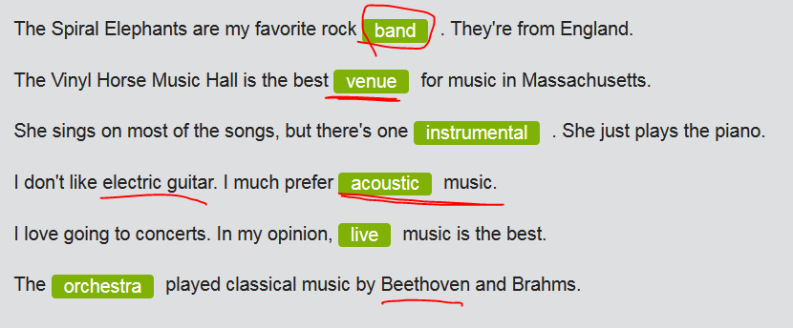

FEMALE: What are you listening to?  
MALE: Clunk.  
FEMALE: Oh, Clunk. The **punk** singer?  
MALE: Yeah. I mean, he **used to** play punk music …  
FEMALE: Used to ?  
MALE: Now he's **a folk singer.**  
FEMALE: A folk singer? Weird! So, now you like folk?  
MALE: Yeah, I do. I mean, I like Clunk's folk. He uses a lot of piano now.  
FEMALE: But I thought you liked **punk music**.  
MALE: Oh, I still like punk. But I **used to** enjoy only punk. Now, I'm enjoying different music styles.  
FEMALE: What happened?  
MALE: Well, **I'm used to** loud music, but now I seem to like quiet music, too. Surprising, huh?  
FEMALE: Wow. That's a big change! I guess I shouldn't be surprised. You like change.  
MALE: Yeah. I guess I do.

## ‘Fillers ['fɪlɚ]’: You know; I mean; like, you now

|  |  |  |
| --- | --- | --- |
|  | | |
|  | | |
| People use expressions such as `**you know`, `I mean`,** and `**like, you know`** to fill the silence while they're thinking about what to say next. Generally, fillers['fɪlɚ] have no real meaning, but it's important to be able to recognize them, if only so you can focus on what the person is really saying. | | |
| Here are some examples of fillers['fɪlɚ]: | | |
|  |  |  |

|  |  |  |
| --- | --- | --- |
|  | *Ben's got tickets for that techno band -* ***you know****, Rokmo.* |  |
|  |  |  |

|  |  |  |
| --- | --- | --- |
|  | *Jazz is the best.* ***I mean****, the music is so complex and unpredictable.* |  |
|  |  |  |

|  |  |  |
| --- | --- | --- |
|  | *This music is,* ***like****, way too loud.* |  |
|  |  |  |

|  |  |  |
| --- | --- | --- |
|  | *He was,* ***uh****, a DJ in high school*  I thought we were, **_like, you know_,** a rock band.  *e*.g. I don’t wanna **goof around随便玩玩;** instead, I’d like to have a serious relationship with you. ***I mean***, I wanna be your BF. Seriously. |  |
| Language note: **You can use fillers in conversation/oral speaking to make your speech sound more natural; however, overuse of fillers can sound annoying and repetitive [rɪ'pɛtətɪv].** | | |

# Part 2)Online services for “streaming music/movie”

## Online music/movie services

|  |  |  |
| --- | --- | --- |
|  | | |
| There are many ways to talk about **music software and services**.  Here are a few that describe aspects of an app.   * A new app;  e.g. I found a great new app for **streaming music (downloading from internet).** * **streaming service: 在线的下载服务/在线的需要有网络(online)流媒体服务/ 🡺 antonym: offline 离线的 e.g. (Music app) Have u ever tried streaming?** e.g. I found a great new app for **streaming music (downloading from internet).** e.g. I fail to **stream music**. See the “**streaming service”** doesn’t work if there’s no internet in the forest. e.g. OMG, someone is **piggybacking onto our internet盗用的网络连接**; and we lost our internet…see, the **“streaming service”** doesn’t work now * Offline mode:  e.g. I listen **in offline mode** where there's no service. * Monthly subscription; e.g. The monthly subscription has unlimited content * Unlimited content/service/downloading times e.g. The **monthly subscription** has unlimited content. * **Ad-supported e.g.** It has great sound quality, but it's ad-supported. * No service * Great sound quality e.g. It has great sound quality, but it's **ad-supported**. * **Free trial e.g.** If you're interested, you can try the free trial. | | | |
|  |  |  |

## Discuss online services for music/movie

Use expressions like these to ask about or describe online services

|  |  |  |
| --- | --- | --- |
|  | *A:* ***What kind of service*** *is it?*  *B: It's a* ***music-streaming/movie-streaming*** *app. //stream music/movie: to download from internet* |  |
|  |  |  |

|  |  |  |
| --- | --- | --- |
|  | *A: Do you* ***have to pay?***  *B: Yes,* ***it's a monthly/quarterly/yearly subscription.***  *C: That's the problem.* ***You don't own the product.*** | . |
|  |  |  |

|  |  |  |
| --- | --- | --- |
|  | *A:* ***I guess it's a*** *subscription?*  *B: Yes, but* ***you can get a 30-day free trial.*** |  |
|  |  |  |

|  |  |  |
| --- | --- | --- |
|  | *A: Does it work* ***offline****?*  *B: Ah, no.* ***It's streaming (在线的下载服务) only****. But* ***it's unlimited content****.* | . |

## Quality of the “streaming service” ***在线的下载服务***

|  |  |  |
| --- | --- | --- |
| You might also be interested in the quality of the service. | | |
|  |  |  |

|  |  |  |
| --- | --- | --- |
|  | *A:* ***What about the quality?***  *B: It's great on my tablet. That's* ***all I need it for****.* |  |
|  |  |  |

|  |  |  |
| --- | --- | --- |
|  | *A:* ***How's the sound?***  *B: The sound quality is pretty* ***fine with headphones.*** |  |
|  |  |  |

|  |  |  |
| --- | --- | --- |
|  | *A: Is it* ***any good****?*  *B: Yeah, it'll* ***recommend new music for you****.* |  |

## [试试吧](javascript:;);[试一试](javascript:;) **Encouraging someone**

|  |  |  |
| --- | --- | --- |
|  |  |  |
| You can encourage someone to try a service with expressions like these. | | |
|  |  |  |

|  |  |  |  |  |
| --- | --- | --- | --- | --- |
|  | [**试试吧**](javascript:;)**;**[**试一试**](javascript:;)***Give it a try = Give it a shot = Try it out = Check it out  e.g. You should check it out***  ***It wouldn't hurt to try and You'd like it. //It wouldn’t hurt to do sth.做xxx又不会少快肉*** | | | . |
|  |  | | |  |
|  | |  |  | |

|  |  |  |
| --- | --- | --- |
|  |  |  |

## Music industry

|  |
| --- |
| **Predicting before reading** |
| You will understand a text better if you can predict what's in it before you read. Use the headline, or title, as well as any pictures to work out what the text is about. Then try to predict the kind of vocabulary you might encounter. |

## Illegal music



More and more people are buying digital music (through **streaming service rendered by music apps, like QQ music app**), but companies are still getting less and less profit. That's because music is often illegally downloaded from the internet. Songs are shared for free between people's computers or shared storage – no one **pays for** them. "It's a serious problem for the music business," said Dan Coates, CEO at myTurn, an online music service.

In the 1990s, sales were supported by CDs. "But no one buys CDs anymore," says Coates.

To help stop illegal downloading, companies like myTurn are offering **music subscriptions for customers to stream music (download from internet)**. The companies believe that if an inexpensive subscription is offered, people will be less interested in illegal downloading. Subscriptions are from $10 to $20 a month, and they're getting cheaper and cheaper.

# Part 3) Night out夜生活/晚上出去玩

 **// a couch potato 电视虫**









 **//I’m totally frazzled/burnt out 疲惫/筋疲力尽**







No, thanks.





.. Leave me alone plz.





I’m gonna **grab a coffee. //grab a bite: 吃点东西； grab a coffee: 喝点咖啡; grab a taxi**



## DJ: a disc jockey, 流行音乐节目主持人

e.g. I always wanted to be **a disc jockey (DJ).** DJs are cool.

e.g. He got into the station manager's office and told him he wanted to be **a disc jockey**.  他走进经理办公室，说他想成为一名 流行音乐节目主持人

## Music events in calendar

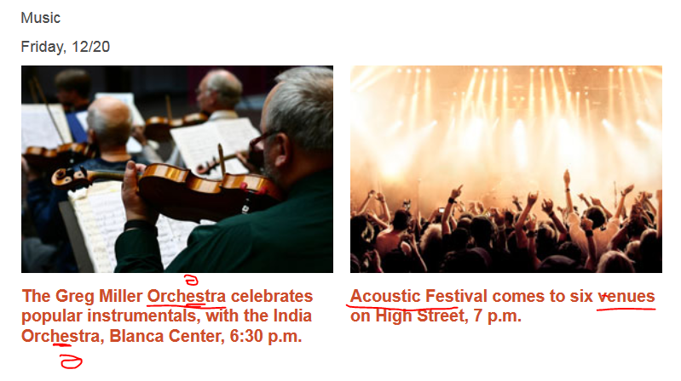

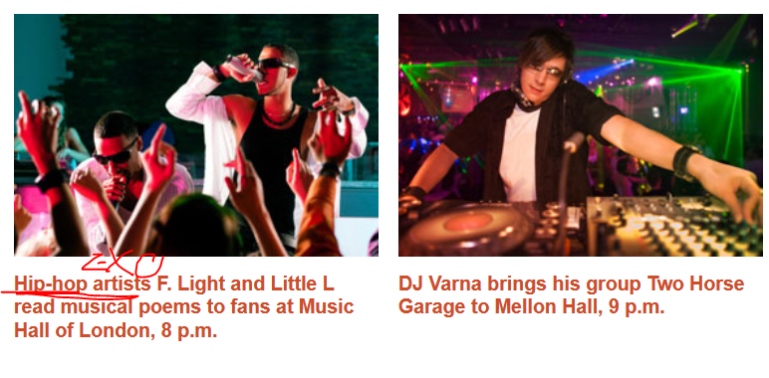

## Persuading

|  |  |  |
| --- | --- | --- |
|  | | |
| There are several ways to persuade someone to do something. You can use expressions like these to directly persuade or convince: | | |
|  |  |  |

|  |  |  |
| --- | --- | --- |
|  | *Come on!* | Come on! |
|  |  |  |

|  |  |  |
| --- | --- | --- |
|  | *Please!* | Please! |
|  |  |  |

|  |  |  |
| --- | --- | --- |
|  | *You'll have a great time.* | You'll have a great time. |
|  |  |  |

|  |  |  |
| --- | --- | --- |
|  | *It'll be good for you to get out.* | It'll be good for you to get out. |
| You can give details that make the proposal seem more attractive. | | |
|  |  |  |

|  |  |  |
| --- | --- | --- |
|  | *Tonight he's playing acoustic guitar at a small club.* | Tonight he's playing acoustic guitar at a small club. |

|  |  |  |  |
| --- | --- | --- | --- |
| You can offer something that makes the proposal more attractive. | | | |
|  | | | |
|  |  |  |  |

|  |  |  |  |
| --- | --- | --- | --- |
|  | *I'll buy the tickets.* | I'll buy the tickets. | |
|  |  |  |  |

|  |  |  |  |
| --- | --- | --- | --- |
|  | *Look, I'll pay, and I'll drive.* | Look. I'll pay, and I'll drive. | |
|  |  |  | |
| You can criticize the person. However, this approach can be somewhat negative unless delivered lightheartedly. | | | |
|  | | | |
|  |  |  |  |

|  |  |  |
| --- | --- | --- |
|  | *You're such a couch potato.* | You're such a couch potato. |
|  |  |  |

|  |  |  |
| --- | --- | --- |
|  | *Don't be lazy. You need to get out of the house.* | Don't be lazy. You need to get out of the house. |
|  |  |  |
| Use expressions like these to respond when someone tries to persuade you: | | | |
|  | | | |
|  |  |  |  |

|  |  |  |
| --- | --- | --- |
|  | *Fine. You've convinced me.* | Fine. You've convinced me. |
|  |  |  |

|  |  |  |
| --- | --- | --- |
|  | *No, but thanks for inviting me.* | No, but thanks for inviting me. |

 OK, you've convinced me. Let's get out of here.

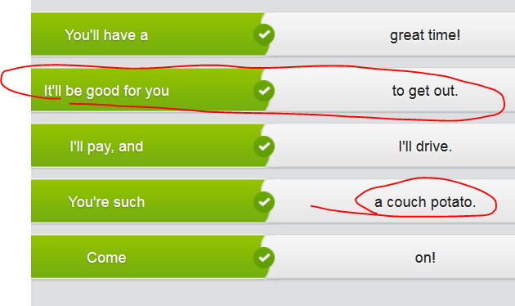

# Part 4 ) Compose a song





 // ] the arrangement of musical notes in a way that is pleasant 悦耳的音调，美妙的旋律





### melody **/ˈmɛlədɪ/**

### 

### 

|CET6 TEM4

* + [N-COUNT](javascript:;)A melody is a tune. 旋律

•  I whistle melodies from Beethoven and Vivaldi and the more popular classical composers.   
 我用口哨吹贝多芬、维瓦尔迪和更大众化一些的古典作曲家的曲子。

['melədi]

pl: melodies

#### MEANINGS 义项

* 1.

[C] a song or tune

歌曲；曲调

##### [**THESAURUS**](javascript:;)

MUSIC

•They played some lovely melodies. 他们演奏了一些动听的曲子。

•a haunting melody 难以忘怀的曲调

* 2.

[U] the arrangement of musical notes in a way that is pleasant

悦耳的音调，美妙的旋律