# Unit: Production and Innovation

## Stop) Lexical resource

|  |
| --- |
| polyester /ˌpɒlɪˈɛstə/ : Polyester is a type of synthetic cloth used especially to make clothes; an artificial material used to make cloth 聚酯纤维，涤 •  ...a green polyester shirt.   …一件绿色的涤纶衬衫。 |
| [rip off; you’re ripped off ]  [PHRASAL VERB 动词词组](javascript:;)If someone rips you off, they cheat you by charging you too much money for something or by selling you something that is broken or damaged. 宰人; 坑人  e.g. The bigger, more reputable online casinos are not going to rip you off.  不会宰你e.g. 500 bucks? Hmm, you’re **ripped off**. It’s not **a good value for money.** //**不值那么多钱; 花这个价不值得: not a good value for money** |
| glue => ['ɡlu**tə**nəs] glutinous: Something that is glutinous is very sticky. 粘性的, 粘的, 粘稠的; 糯米的, 胶质的  **[** **glutinous flour****糯米粉 ]**  •  The sauce was glutinous and tasted artificial.  这种粘酱尝起来感觉不自然。  •  ...soft and glutinous mud.  ...柔软粘稠的泥巴 |
| Clam   1. Clam is a shellfish you can eat that has a shell in two parts that open up蛤；蛤蜊；蚬 [ clam chowder ['tʃaʊdɚ] 蛤蜊海鲜杂烩浓汤] 2. as happy as a clam, informal very happy非常高兴的，相当满足的 3. **informal) a clam is someone who does not say what they are thinking or feeling 沉默寡言的人 e.g. when I was young, I was pretty quiet and I was a clam.**  * phrasal verb) clam up: 〔尤指因紧张、害羞而〕突然闭口，突然沉默不语 v to suddenly stop talking, especially when you are nervous or shy 🡺 [拒不开口](javascript:;); [守口如瓶](javascript:;); [沉默不语](javascript:;)   e.g. A sensitive child is likely just to clam up. 敏感的孩子可能就会闭口不言。 |
| When asking about a product in a store, we might first want to ask about its **level of quality**.   * 质量最好的商品：the top of the range e.g. Can you show me some shoes from **the top of the range**? e.g. Can you show me one camera from **the top of the range**? * 质量在中等水平的商品: middle of the range e.g. This mobile phone is **middle of the range.** e.g. I want a **middle-of-the-range** model – not too expensive, not too cheap. * **a budget** option**: 指的是相对廉价的实惠的选择**V.S. **[ budget airline: 廉价航空 ]** e.g. Well, those are from **the top of the range质量最好的商品**, so they’re pretty expensive. Hmm I'd like to see **a budget option.** e.g. This one's too expensive. Do you have **a budget option**? |
| * **不值那么多钱; 花这个价不值得: not a good value for money** e.g. 500 bucks? Hmm, you’re **ripped off**. It’s not **a good value for money.** //rip off: If someone rips you off, they cheat you by charging you too much money for something or by selling you something that is broken or damaged. 宰人; 坑人 * **a budget option: 指的是相对廉价的实惠的选择**V.S. **[ budget airline: 廉价航空 ]** e.g. Well, those are from **the top of the range质量最好的商品**, so they’re pretty expensive. Hmm I'd like to see a budget option. |
| * **它(这个产品)还有其他颜色吗? Does it come in other colors**? **Is it available in <**blue or green>? * **Is it available with** a keyboard? * **它（这个产品卖的时候）包括/赙赠其他产品附件吗？** A) Does it **come with** all the accessories, like the camera case, strap, cables, and chargers?  B) Sorry, no. All the accessories are extra.   What accessories does it **come with**? |
|  |
|  |
| Strap: is a narrow band of strong material that is used to fasten, hang, or hold onto something  带子  e.g. shoulder strap: 背背加的肩膀的带子  e.g. a bra strap 胸罩肩带 e.g. OMG my bra strap is broken.  e.g. The strap of my bag is broken. 我包上的带子断了  e.g. She pulled the strap of her pyjama onto her shoulder.  她把睡衣的带子拉到她的肩上。  strap 2: pp: strapped   pt: strapped   pres part: strapping  1. [always + adv/prep] to fasten something or someone in place with one or more straps 用带子束住，捆绑  e.g. Strap the harness around your body closely for security when you’re playing extreme sports, like zip lining, bungee ['bʌndʒi]  e.g. soldiers with grenades strapped to their belts 腰带上绑着手榴弹的士兵  e.g. She strapped the baby seat into the car.  她把婴儿座椅用带子绑在那辆汽车上  strap sth on/down etc  e.g. He was only ten when he strapped on a guitar for the first time. 他第一次背上吉他时才十岁。  **[ be strapped in (=have a belt fastened around you in a car)〔在汽车里〕系好安全带 ]**  **e.g. Are the kids strapped in? 孩子们系好安全带了吗**？  2.[often passive,常用被动态] strap: to tie bandages firmly round a part of your body that has been hurt〔用绷带〕包扎〔伤口〕 |
| Cashier /kæˈʃɪr/ a person whose job is to receive and pay out money in a bank, shop/store, hotel, etc. |
| **收银机: cash register**[N-COUNT](javascript:;)A cash register is a machine in a shop, bar, or restaurant that is used by cashier to add up and record how much money people pay, and in which the money is kept. |
| credit card V.S. debit card |
| **slide your card** /slaɪd jʊr kɑːrd/ move your key card or credit card through or by an electronic device so that its data can be read   1. Please slide your card. 2. You have to slide your card to unlock the door. |
| **Receipt** /rɪˈsiːt/ a piece of paper that shows that goods or services have been paid for   1. Can I have a receipt, please? |
| invoice /ˈɪnvɔɪs/   1.[N-COUNT](javascript:;)费用清单; 发票 An invoice is a document that lists goods that have been supplied or services that have been done, and says how much money you owe for them, which is used for **reimbursement(报销)**  •  We will then send you an invoice for the total course fees.  [V-T](javascript:;)If you **invoice someone**, you send them a bill for goods or services you have provided them with. 给…开具发票  •  The agency **invoices the client** who then pays the full amount to the agency.  那个代销处给客户开具发票 |
| reimbursement n [C,U]  to pay money back to someone when their money has been spent or lost  付还；偿还  reimburse sb for sth  •The company will reimburse you for travel expenses. 你的旅费可向公司报销。  DERIVATIVE 派生词  reimbursement n [C,U]  to pay money back to someone when their money has been spent or lost  付还；偿还  reimburse sb for sth  •The company will reimburse you for travel expenses. 你的旅费可向公司报销。  DERIVATIVE 派生词 |
| ['riːfʌnd] refund     1.[N-COUNT 可数名词](javascript:;)A refund is a sum of money that is returned to you, for example because you have paid too much or because you have returned goods to a shop. 退款; an amount of money that is given back to you if you are not satisfied with the goods or services that you have paid for 退款  •They refused to **give me a refund** . 给我退款。  •You should go down there and **demand a refund**. 要求退款  •  Face it – you'll just have to take those cowboy boots back and **ask for a refund 要求退款**。    2.[V-T](javascript:;)If someone refunds your money, they return it to you, for example because you have paid too much or because you have returned goods to a shop; to give someone their money back, especially because they are not satisfied with the goods or services they have paid for 退还〔钱款，尤因买家对所购货物或服务不满意〕  e.g. I took the radio back, and they **refunded my money** . 他们给我退了款  e.g.  A.  We guarantee to **refund your money** if you're not delighted with your purchase.  B. OK, so what’s your `return policy`?  A. **Return your purchase within 14 days for `a full refund`. 14 天之内退货可以全额退款**  **[退税 tax refund]**  money that you get back from the government when it has taken too much money in taxes from your salary |

# Part 1) Product features

## Product: level of quality （连读）

|  |
| --- |
| When asking about a product in a store, we might first want to ask about its **level of quality**.   * 质量最好的商品：the top of the range e.g. Can you show me some shoes from **the top of the range**? e.g. Can you show me one camera from **the top of the range**? * 质量在中等水平的商品: middle of the range （连读） e.g. This mobile phone is **middle of the range.** e.g. I want a **middle-of-the-range** model – not too expensive, not too cheap. * **a budget option: 指的是相对廉价的实惠的选择**V.S. **[ budget airline: 廉价航空 ]** e.g. Well, those are from **the top of the range质量最好的商品**, so they’re pretty expensive. Hmm I'd like to see **a budget option.** e.g. This one's too expensive. Do you have **a budget option**? |

🡺 **物有所值: a good value for money**e.g. This laptop is **a good value for money**.

不值那么多钱; 花这个价不值得: not a good value for money  
e.g. 500 bucks? Hmm, you’re ripped off. It’s not a good value for money at all.  
//rip off: If someone rips you off, they cheat you by charging you too much money for something or by selling you something that is broken or damaged. 宰人; 坑人

## Accessories that **come with** the product

We might also want to ask about the things/accessories that come with the product.

E.g. Hmm these accessories, like cables, case, and charger don’t **come with the** camera.

|  |  |  |
| --- | --- | --- |
|  | accessories |  |
|  |  |  |

|  |  |  |
| --- | --- | --- |
|  | a strap |  |
|  |  |  |

|  |  |  |
| --- | --- | --- |
|  | cables |  |
|  |  |  |

|  |  |  |
| --- | --- | --- |
|  | instructions |  |
|  |  |  |

|  |  |  |
| --- | --- | --- |
|  | a case |  |
|  |  |  |

|  |  |  |
| --- | --- | --- |
|  | a charger |  |

## **Inquire about a product**

|  |  |  |
| --- | --- | --- |
| Before you ask about a product, use an expression like this to get the sales assistant's attention. | | |
|  |  |  |
|  |  |  |

|  |  |  |
| --- | --- | --- |
|  | **Excuse me. Can I just ask you something** about this tablet? |  |
|  |  |  |
| You then might need to confirm what it is you're looking at. | | |
|  |  |  |
|  |  |  |

|  |  |  |
| --- | --- | --- |
|  | **This is a** Jupiter, **is that right**? |  |
|  |  |  |
| You might also want to know if the product is **top of the range, middle of the range, a budget option,** or not. | | |
|  |  |  |
|  |  |  |

|  |  |  |
| --- | --- | --- |
|  | 1. And **how does this compare with** other tablets? 2. Hmm, it’s not from **the top of range 质量最好的商品** and it’s **a budget option是相对廉价的实惠的选择.** | |
|  | |

Finally, you might want to ask about the color, accessories and other extras.

* **它(这个产品)还有其他颜色吗?   
  Does it come in other colors**? **Is it available in <**blue or green> = Does it **come in** <blue/green>?
* **Is it available with** a keyboard? = Does it **come with** a keyword? **包括/赙赠键盘吗**
* **它（这个产品卖的时候）包括/赙赠其他产品附件吗？**A) Does it **come with** all the accessories, like the camera case, strap, cables, and chargers?   
  B) Sorry, no. **All the accessories are extra**. / Yes, **it comes with all the accessories you need to get started.**

What accessories does it **come with**?

Does it **come with** instructions, so I know how to use it?

# Part 2) Purchase a product

|  |
| --- |
| Cashier /kæˈʃɪr/ a person whose job is to receive and pay out money in a bank, shop/store, hotel, etc. |
| **收银机: cash register**[N-COUNT](javascript:;)A cash register is a machine in a shop, bar, or restaurant that is used by **cashier** to add up and record how much money people pay, and in which the money is kept. |
| credit card V.S. debit card |
| **slide your card** /slaɪd jʊr kɑːrd/ move your key card or credit card through or by an electronic device so that its data can be read   1. Please slide your card. 2. You have to slide your card to unlock the door. |
| **Receipt** /rɪˈsiːt/ a piece of paper that shows that goods or services have been paid for   1. Can I have a receipt, please? |
| invoice /ˈɪnvɔɪs/     1.[N-COUNT](javascript:;)费用清单; 发票 An invoice is a document that lists goods that have been supplied or services that have been done, and says how much money you owe for them, which is used for **reimbursement(报销)**  •  We will then send you an invoice for the total course fees.  [V-T](javascript:;)If you **invoice someone**, you send them a bill for goods or services you have provided them with. 给sb开具发票  •  The agency **invoices the client** who then pays the full amount to the agency.  那个代销处给客户开具发票 |
| ['riːfʌnd] refund     1.[N-COUNT 可数名词](javascript:;)A refund is a sum of money that is returned to you, for example because you have paid too much or because you have returned goods to a shop. 退款; an amount of money that is given back to you if you are not satisfied with the goods or services that you have paid for 退款  •They refused to **give me a refund** . 给我退款。  •You should go down there and **demand a refund**. 要求退款  •  Face it – you'll just have to take those cowboy boots back and **ask for a refund 要求退款**。    2.[V-T](javascript:;)If someone refunds your money, they return it to you, for example because you have paid too much or because you have returned goods to a shop; to give someone their money back, especially because they are not satisfied with the goods or services they have paid for 退还〔钱款，尤因买家对所购货物或服务不满意〕  e.g. I took the radio back, and they **refunded my money** . 他们给我退了款  e.g.  A.  We guarantee to **refund your money** if you're not delighted with your purchase.  B. OK, so what’s your `return policy`?  A. **Return your purchase within 14 days for `a full refund`. 14 天之内退货可以全额退款**  **[退税 tax refund]**  money that you get back from the government when it has taken too much money in taxes from your salary |
| reimbursement n [C,U]  to pay money back to someone when their money has been spent or lost  付还；偿还  reimburse sb for sth  •The company will reimburse you for travel expenses. 你的旅费可向公司报销。  DERIVATIVE 派生词  reimbursement n [C,U]  to pay money back to someone when their money has been spent or lost  付还；偿还  reimburse sb for sth  •The company will reimburse you for travel expenses. 你的旅费可向公司报销。  DERIVATIVE 派生词 |

## Make a purchase

**Making a purchase**  
  
The process of paying for a product can differ from country to country. Here are some things to be aware of when buying something in the US.  
  
**Paying for the purchase**

* Cash
* Check
* Credit card V.S. debit card
* Digital money in Alipay, zhifubao, apply pay

Nowadays, few people write **checks** for their purchases. **Cards** and **cash** are quick and convenient. It's important to understand that **debit cards** and **credit cards** are very different. When you use a **debit card**, the money is taken directly from a bank account. When you use a **credit card**, you are borrowing the money from a financial company and have to pay the money back in the future.  
  
  
**Taxes**  
  
Most states in the United States have a **sales tax**, money collected for the government. The sales tax is a percentage of the purchase price.  
  
**Returning an item**  
  
When you buy something, ask about the store's **return policy**, the rules for bringing back something that you don't want. There is usually a time limit for returns – for example, 60 days – and some items may not be returnable. To return an item, you must have the **receipt**, the piece of paper that shows the price and that you bought the item at that store. The store will usually give you a **refund**, the money you paid for the item.

e.g.

MAX: Good morning.  
CASHIER: Good morning. So, just this belt?  
MAX: Yes, thanks, just the belt.  
CASHIER: OK. With tax , that's $67.93. **How would you like to pay**?  
MAX: I'll use my card.  
CASHIER: Credit or debit?  
MAX: Uh, credit card .  
CASHIER: OK. Just **slide your car**d.  
MAX: OK.  
CASHIER: Please sign here .  
MAX: Here you go.  
CASHIER: And here's your receipt . Have a wonderful day.  
MAX: You, too. Oh, by the way, **what's your return policy** ?  
CASHIER: You can return anything before 90 days **for a full refund** . But keep your receipt.  
MAX: Great. Thanks.

## Numbers at the cash register**收银机**

|  |  |  |
| --- | --- | --- |
| Listen for numbers when you make a purchase in a store. In the US, **dollars** (written as **$**) and **cents** indicate the amount you owe. | | |
|  |  |  |

|  |  |  |
| --- | --- | --- |
|  | *That comes to $7.64.* |  |
| They may also shorten the amount to just the numbers. | | |
|  |  |  |

|  |  |  |
| --- | --- | --- |
|  | ***With tax,*** *your total is $459.75.* |  |
| In the UK, listen for **pounds** (written as **£**) and **pence**. | | |
|  |  |  |

|  |  |  |
| --- | --- | --- |
|  | *That's £78.22.* |  |
|  |  |  |

|  |  |  |
| --- | --- | --- |
|  | *£321.28, please.* |  |
| You may also hear **pence** said in the same way as the letter **p**. | | |
|  |  |  |

|  |  |  |
| --- | --- | --- |
|  | *That's 58p, please.* |  |











//team xxx with // polyester /ˌpɒlɪˈɛstə/ : Polyester is a type of synthetic cloth used especially to make clothes; an artificial material used to make cloth 聚酯纤维，涤 •  ...a green polyester shirt.   
 …一件绿色的涤纶衬衫。



 //buying trip





## Return policy

|  |  |  |
| --- | --- | --- |
| Before you make your purchase at a store, remember to talk about the return policy. | | |
|  |  |  |
|  |  |

|  |  |  |
| --- | --- | --- |
|  | A: *What's your `****return policy****`?* |  |
| B: *You can return any item for `****a full refund****` within seven days. Remember to bring your receipt.*  **Return your purchase within 14 days for `a full refund`. 14 天之内退货可以全额退款** |  |
| After totaling up your items, the cashier will tell you the how much you owe. | | |
|  |  |  |

|  |  |  |
| --- | --- | --- |
|  | *Your total with tax will be $477.25.* |  |
|  |  |  |

|  |  |  |
| --- | --- | --- |
|  | *That comes to $17.99.* |  |

## How would you like to pay?

|  |  |  |
| --- | --- | --- |
| The cashier may ask you what form of payment you want to use. | | |
|  |  |  |
|  |  |

|  |  |  |
| --- | --- | --- |
|  | A: *How* ***would you like to pay****?* |  |
| B: *I'll use my debit card.* |  |
|  |  |  |
|  |  |  |
|  |  |

|  |  |  |
| --- | --- | --- |
|  | A: *Will that be credit or debit?* |  |
| B: *Debit, please.* |  |
| If you're paying with a card, the cashier will either ask for your card and slide it for you, or ask you to slide it. | | |
|  |  |  |

|  |  |  |
| --- | --- | --- |
|  | *May I see your card, please?* |  |
|  |  |  |

|  |  |  |
| --- | --- | --- |
|  | *Go ahead and slide your card. Then press 'OK.'* | ' |

|  |
| --- |
| When you use a credit or debit card, sometimes you sign your name on paper or a machine, and the cashier gives you a copy of the receipt. Sometimes you have to type in your card's personal identification number **(PIN)**. When people hand you something in the transaction, they will often use the word **here**. |

|  |  |  |
| --- | --- | --- |
|  | A: *Could you sign here, please?* |  |
| B: *Sure.* |  |
| A: *OK. Here's your receipt. Have a nice day!* |  |

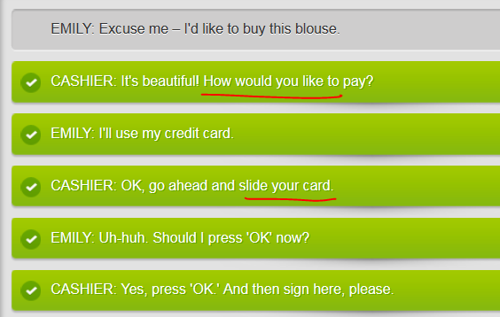

# MP3 not here

# Part 3) Revolution in technology, invention



YESE, I KNOW











Yes. 











The competition is catching up to us.

Can you describe how the new touch screen works?

The smartphone was an amazing development.

Texting revolutionized the way we communication.

We had a heated discussion about production

His latest invention is a tiny phone worn like a ring

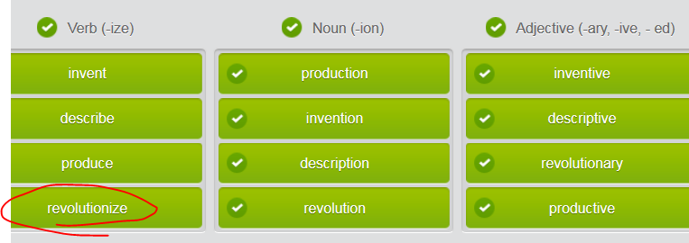

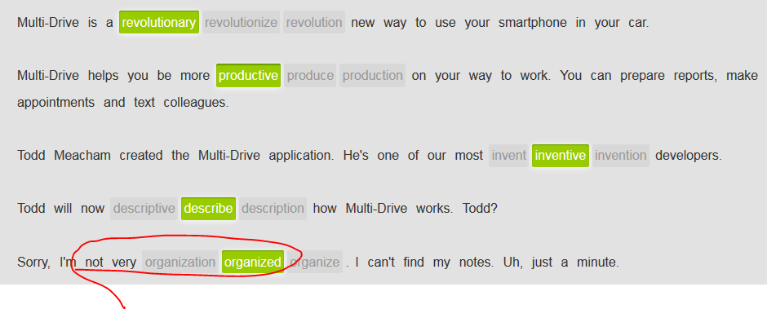

Multi-Drive

Plan your day.

Get your email.

Send texts.

Get organized while you're in your car.

Stop wasting time in your car. Multi-Drive, our latest invention, will revolutionize the way you work – and get to work. Use any smartphone with the Multi-Drive system. Now you can work safely and successfully outside your office. Want to organize your schedule? Tell Multi-Drive. Need that important email from your boss? Let Multi-Drive read it to you. Text messages? Speak and send them with Multi-Drive.

Be more productive. Go to work before you get to work!

Multi-Drive.

Warning: Driving while using a mobile device is against the law. Use Multi-Drive responsibly.

## **Future continuous**

|  |  |  |
| --- | --- | --- |
| Use the future continuous tense to talk about an event that will last for a period of time in the future. Form the future continuous tense with **will be** and a verb **+ ing**. Use it for talking about things you expect to happen. | | |
|  |  |  |

|  |  |  |
| --- | --- | --- |
|  | *People* ***will be using*** *their smartphones for everything.* |  |
|  |  |  |

|  |  |  |
| --- | --- | --- |
|  | *They****'ll******be producing*** *smartphones that you can wear like a ring.* |  |
|  |  |  |
|  |  |

|  |  |  |
| --- | --- | --- |
|  | A: ***Will*** *you**still* ***be******working*** *here in 20 years?* |  |
| B: *Yes, but I'****ll be running*** *the company.* |  |

INVENTOR: Everything is changing. Technology is revolutionizing our work and entertainment.  
JUDY: What's she talking about?  
MAC: I'm not really sure. Something about how they'll soon be producing notebooks that are as thin as a piece of paper?  
JUDY: I'm not interested. I'm happy with my old desktop computer.  
MAC: Shhh! Let's listen to what she's saying.  
INVENTOR: No more monitors. We'll be using our hands, the wall, a desk – anything flat – as a touch screen .  
JUDY: Huh?  
MAC: Wow. I think that she means we'll be taking anything flat and using it as a computer monitor. Like, we could see a video game and a keyboard on a wall and press the keys to play the game.  
JUDY: Scary! I don't want to play a video game or call somebody on my hand.  
MAC: But you will. Everyone will be doing it someday.  
INVENTOR: Yes, ladies and gentlemen! This is the future.

# Part 4 )