1. On vSphere (web)client, server (perhaps <https://ast-55esxvc-01.tidalsoft.local:9443/vsphere-client/> ), there is an option under Actions to Deploy OVF Template.

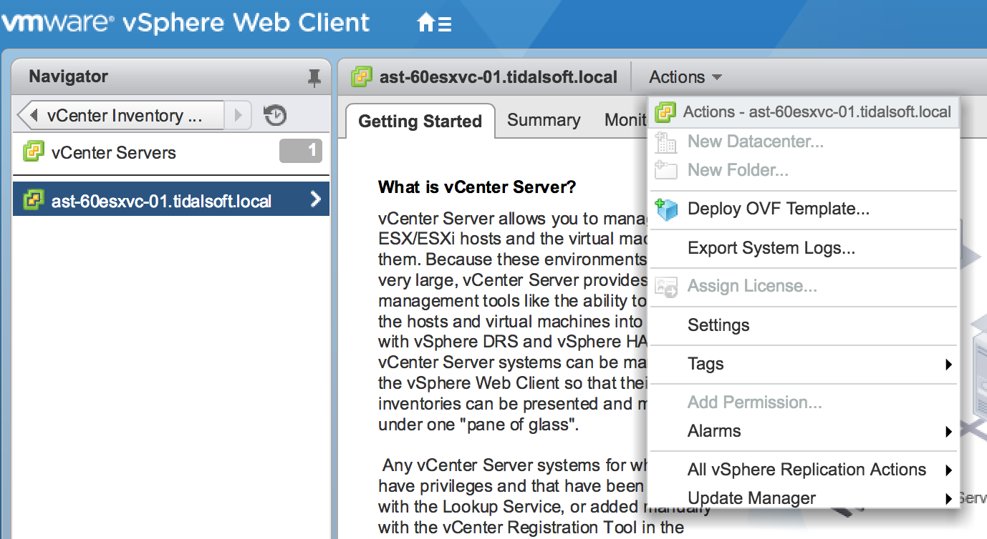

1. Point the latest appliance OVA file as Source

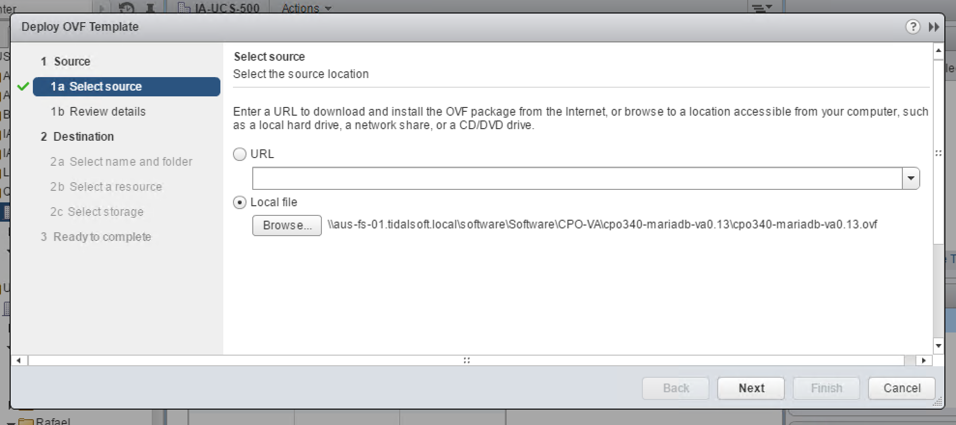

*In this directory, you can find the latest versions of the appliance:*

[*\\aus-fs-01.tidalsoft.local\Software\Software\CPO-VA*](file:///aus-fs-01.tidalsoft.local/Software/Software/CPO-VA)

1. After choosing name, folder and resource(s), setup a Thin Provision disk format. 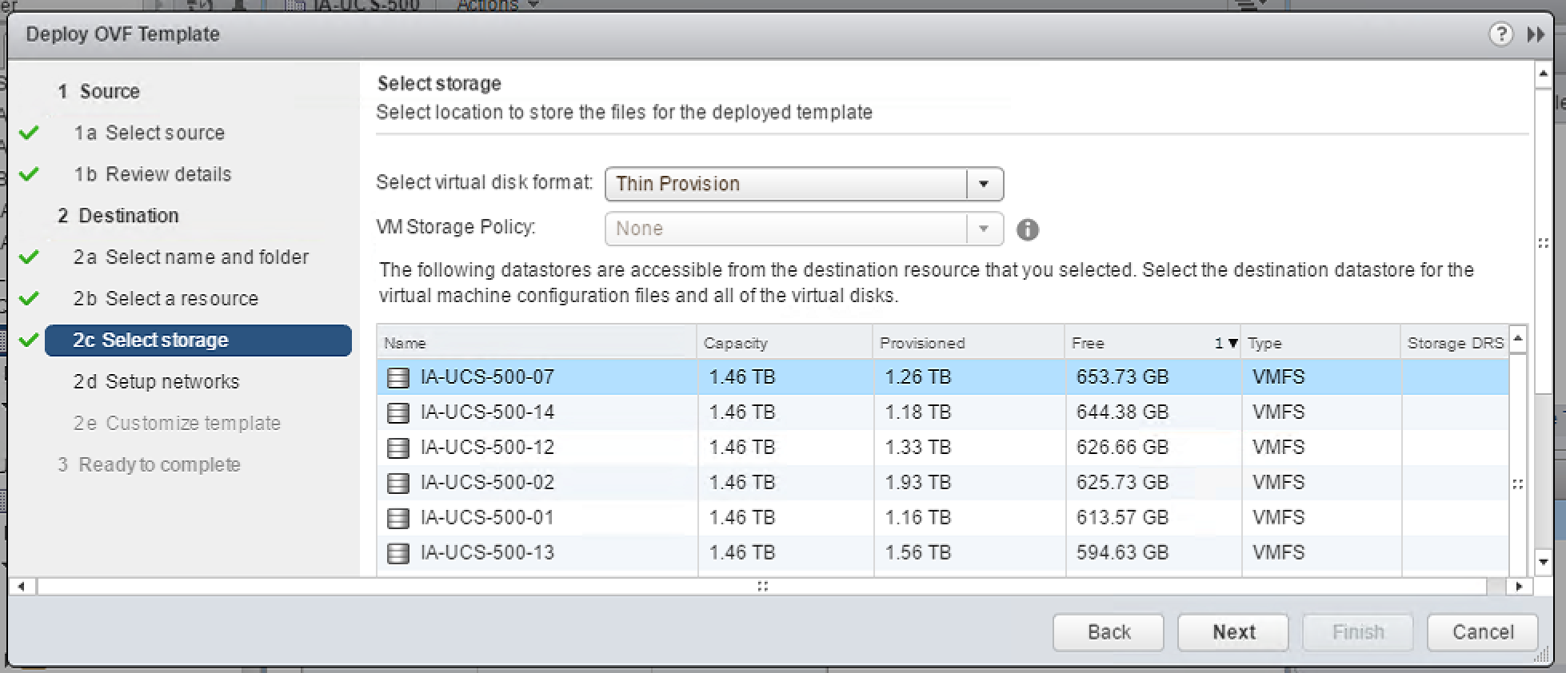
2. Choose a Computer Name and local administrator account password.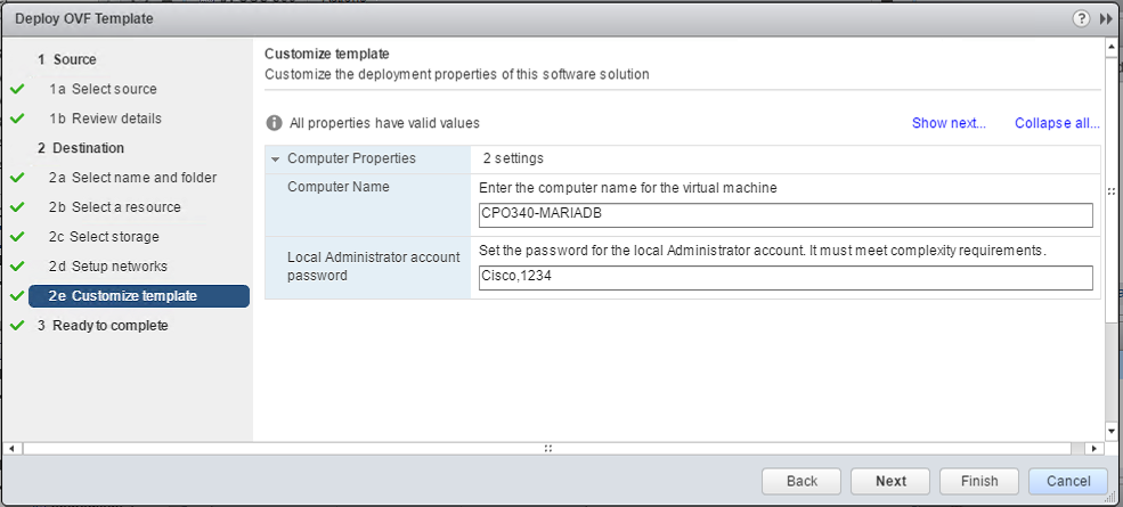
3. After deployment is done, power on the VM and wait for the second boot before login. The appliance takes about 15 minutes to be ready:
   * The VM will reboot some minutes after the first boot, it’s necessary in order to update hostname and local Administrator password.
   * In the next boot, PO will be silently installed and the common automation packs will be imported.

PO Web console URL: https://<hostname>/OrchestratorWebConsole

PO client access: http://<hostname>:61525/CiscoProcessOrchestrator