

  - 14614_202010 - Introduction to Mobile App Dev
  - CSIS-3175-001

  - Instructor: Padmapriya Arasanipalai Kandhadai

  - Group Number #1

App Name - Booking Hotels

Group Members

Denis Antoniazzi - 300300426
Reynaldo Luiz Martins Junior - 300311277
Ronaldo Aparecido de Oliveira - 300305192

App Description

Booking Mobile was conceived and implemented to be the online room booking application for a Hotel company called DRD Hotel Chain, which will interact directly with its customers without any middle application such as Trivago. The application is aimed to provide suitable and easy ways of doing booking allowing customers to select available Hotel Rooms for specific period of times, check the Hotels and Rooms characteristics, pay for the reservation using a Credit Card and verify his/her history as a DRD customer.

Motivation of the app: This application is useful because it allows customers of the DRD hotel chain to make their reservations without having to use another third party application, such as Trivago, ensuring that they will have access to all hotels and room options, with all the information to choose better and always at the best price. Furthermore, for RDR, having its own app, means that the company can have reservations done, without paying fees for a third party.

List of App main functionalities

Customer Login

It is possible to login informing email as UserId and password. It is possible also to create a new user if the customer is not yet signed-up. Another option is to navigate in the Add for doing searches as an anonymous user and perform the login just when the customer wants to confirm the booking.

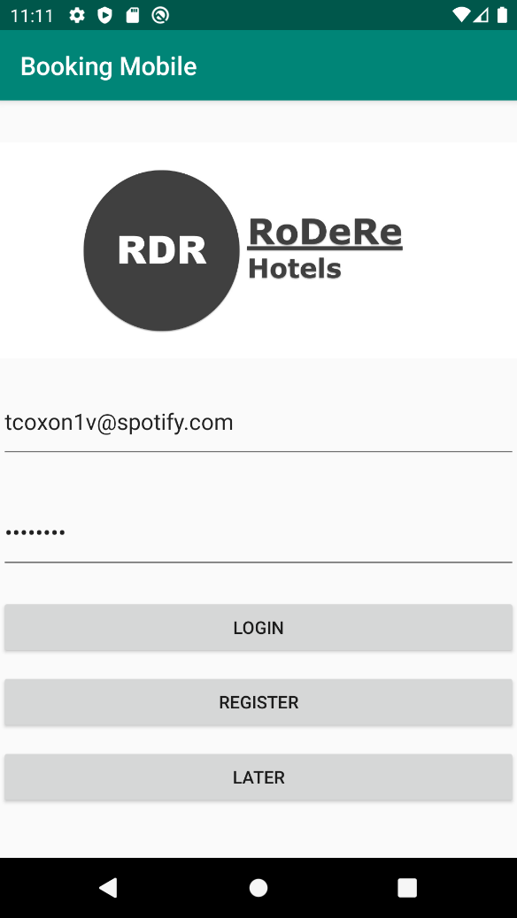

Booking Hotel/Room Search

The Hotel/Room searching can be done by informing the desired city, number of hosts and staying date period. The App will make a search in the DB to verify if there are available rooms that fulfill these criteria. The App will show all Hotels that have rooms according to the search inputs, informing the minimum daily rate for that dates, for each Hotel listed. By clicking in each (i) icon of each Hotel the customer can verify the common Hotel amenities and characteristics and also been informed about distances from the Hotel to some points of interest.

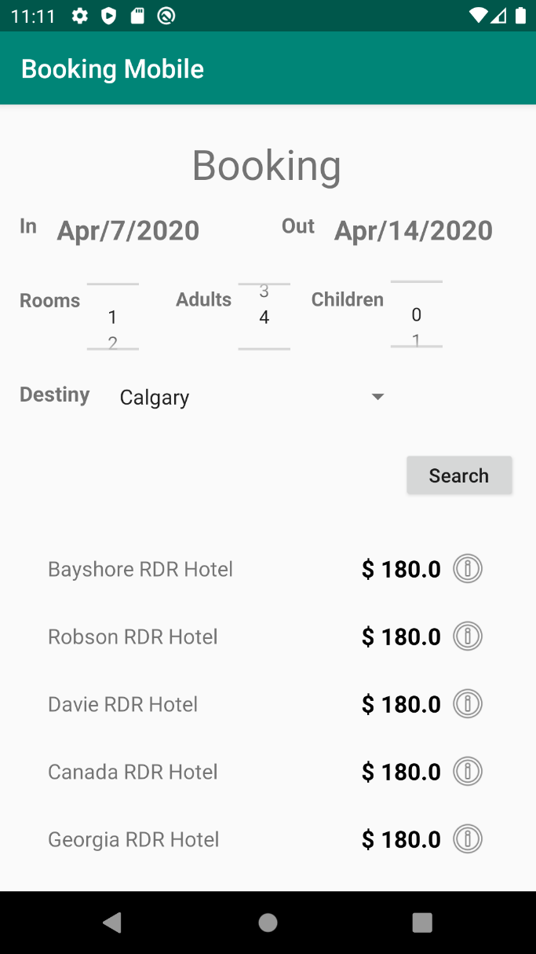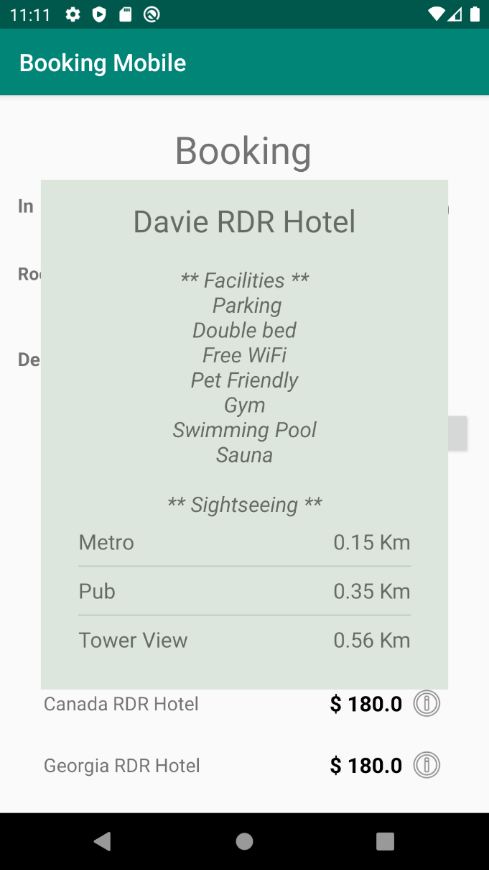

Room Selection

Once the Hotel was selected, the Customer can select the most convenient Room for him/her from the selected Hotel for the staying period, verifying the available categories of Rooms, their prices and their amenities / characteristics.

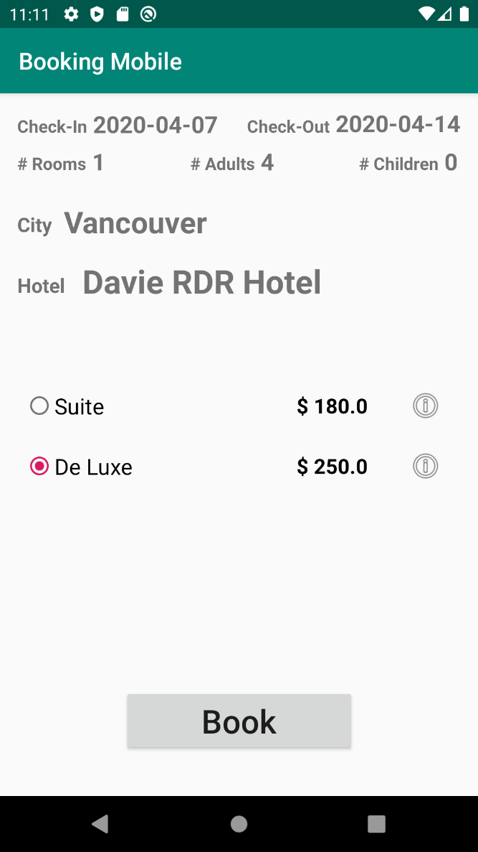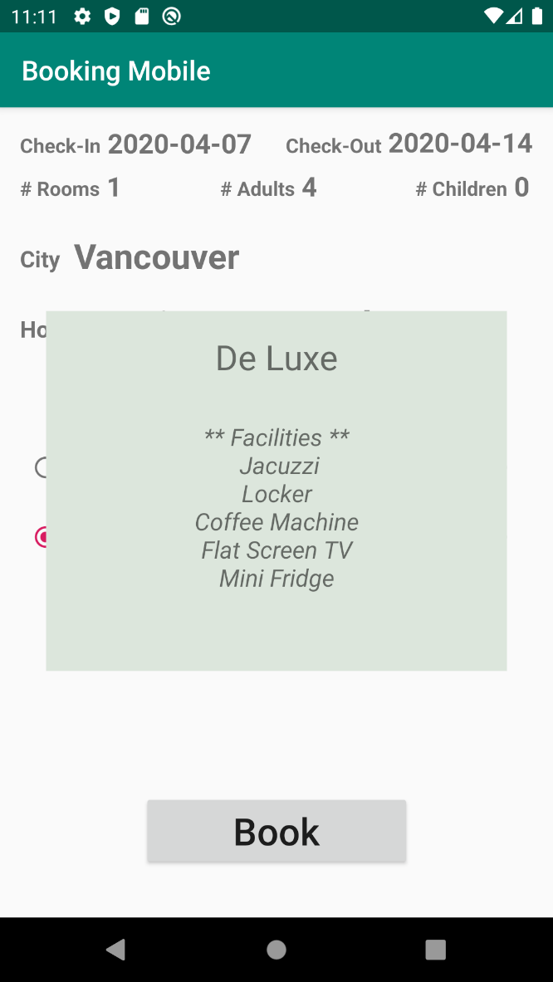

Booking Confirmation

Once the Room was chosen, the customer will verify the Booking information and provide Credit Card information to confirm the Booking. After the Confirming a Book command is done the customer has a screen which will show him/her once again information about the Booking, so the customers will know that his/her request went through.

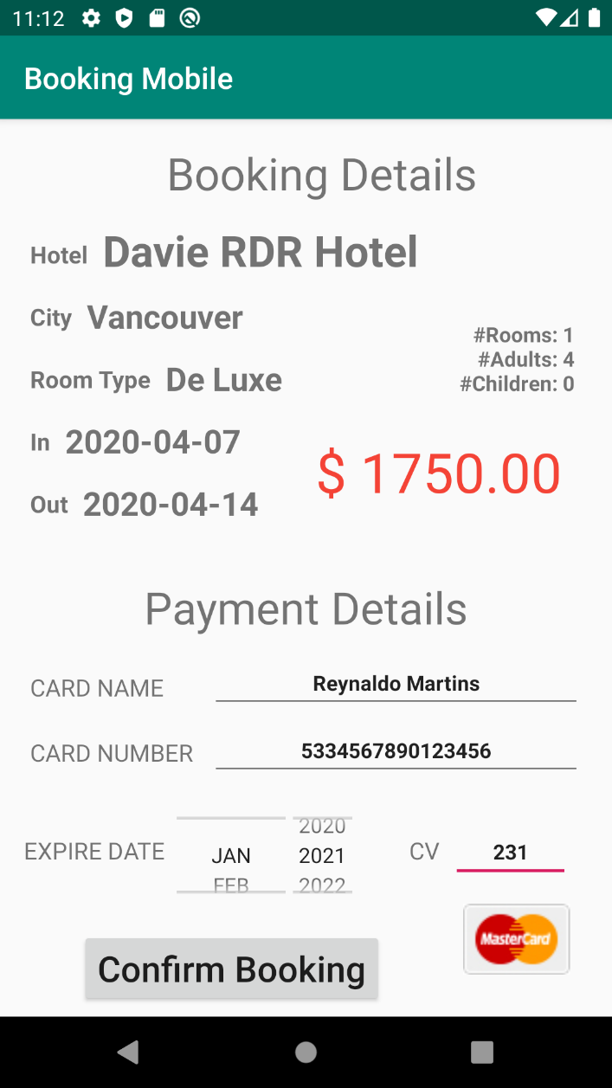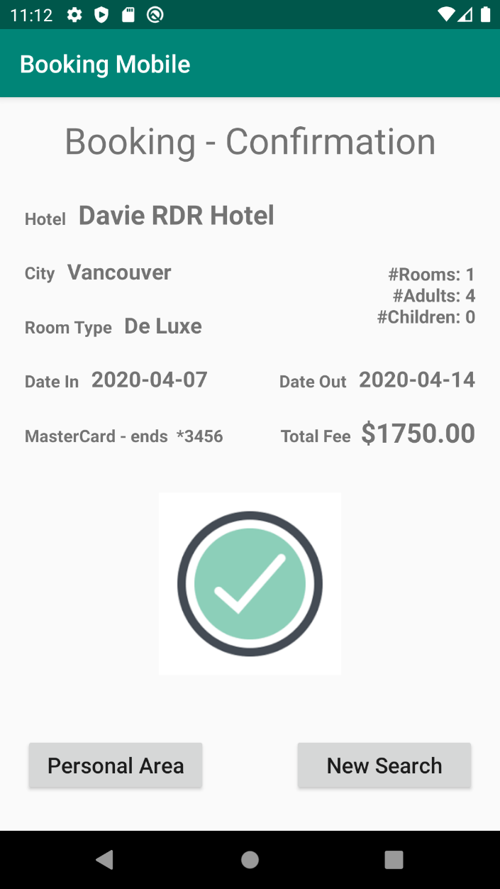

Personal Area

In this screen the Customer can verify all his/her Booking done with DRD Hotel chains, scrolling down all of them if the complete book list does not fit in the device screen.
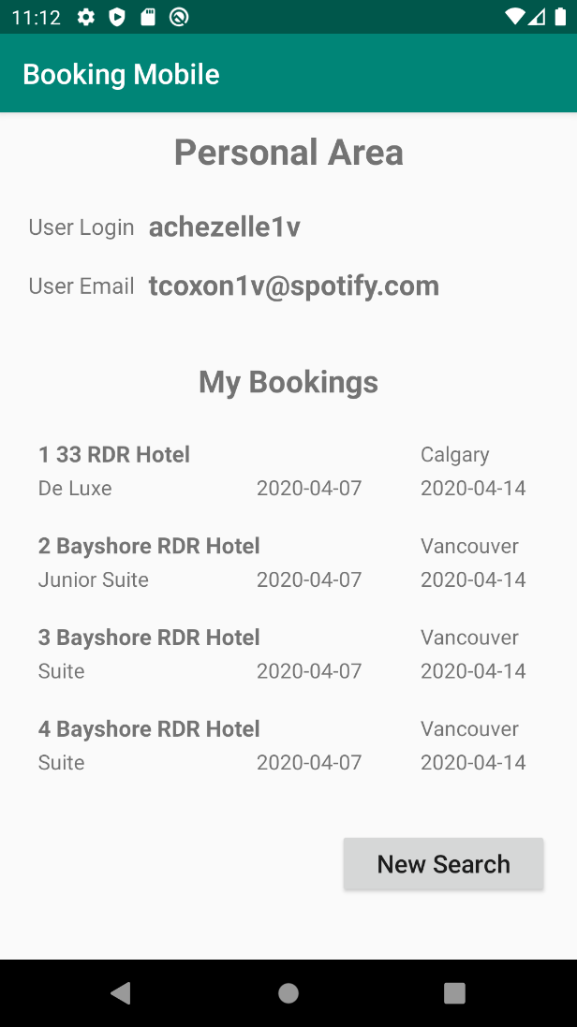

Application Video Presentation

https://collegedouglas-my.sharepoint.com/:f:/r/personal/antoniazzid_student_douglascollege_ca/Documents/00_Winter_2020/01_3175_001_Tue_6107/Project?csf=1&web=1

Group Members Task Division

Task | Denis Antoniazzi | Reynaldo Martins | Ronaldo  Oliveira
Database Modeling | 25 | 25 | 50
Database Creation | 0 | 0 | 100
Data Generation (Mockaroo) | 75 | 0 | 25
Classes to connect to DB | 0 | 0 | 100
SQLite DBHelper (development) | 0 | 0 | 100
SharedPreferences (definitions) | 20 | 20 | 60
DatePicker (definitions) | 20 | 80 | 0
NumberPicker (definitions) | 20 | 80 | 0
RecyclerView (definitions) | 10 | 10 | 80
Pop-up (definitions) | 0 | 0 | 100
Interface Definitions | 25 | 25 | 50
Parcelable | 0 | 25 | 75
Activity “Login” | 80 | 0 | 20
Activity “Select Hotel” | 0 | 60 | 40
Activity “Select Room” | 0 | 70 | 30
Activity “Payment” | 80 | 20 | 0
Activity “Confirmation” | 40 | 40 | 20
Activity “Personal Area” | 30 | 40 | 30
Layout “Login” | 100 | 0 | 0
Layout “Select Hotel” | 0 | 80 | 20
Layout “Select Room” | 0 | 80 | 20
Layout “Payment” | 50 | 50 | 0
Layout “Confirmation” | 80 | 20 | 0
Layout “Personal Area” | 50 | 50 | 0
RecyclerView “Select Hotel” | 0 | 0 | 100
RecyclerView “Select Room” | 0 | 0 | 100
RecyclerView “Personal Area” | 0 | 0 | 100
General Review of Exceptions and Messages | 60 | 30 | 10
Report | 35 | 45 | 20
Overall | 26 | 33 | 43
* all values are in percent

Technical concepts implemented

- Pass value among activities;
- Using intent to call other activities;
- Creating layout and using this layout in inflater elements;
- Listening events from onClick;
- Checking radio button selected and validation;
- Getting and setting information from/to database;
- Data formatting and validation;
- Using drawable image;

Technical Extensions (beyond what is done in class)

Feature | Use
DatePicker | It was used to allow the user to select the date and guarantee the format.  Use: MainActivity and ActivityConfirmBooking. DatePicker is quite useful, cause it is not necessary to parse the dates formats since they can be loaded directly on Calendar objects. The only date validations that were necessary was to validate the dates (In and Out) between them and against the current date.
NumPicker | It was used to allow the user to select a valid number (or even a String)  Use: MainActivity and ActivityConfirmBooking  NumPicker is quite useful because with it is not necessary to parse the Integer number formats, since it returns already Integer numbers within a valid range configured in the control. NumPicker can be use also to show Strings that will be translated to the String position in the control list.
RecyclerView | An interesting update in relation to ListView and ImageView presented in classes, because, with this component it was possible to create a list of values (like other options) but with a “magic” vertical scrollbar to allow to navigate to many options.  Use: MyRecyclerViewAdapterHotels, MyRecyclerViewAdapterRooms, MyRecyclerViewAdapterBookings (definitions in these xml files: recyclerview_hotel, recyclerview_row, recyclerview_bookings, row, layout_row_hotel and layout_row_sightseeing).
DBHelper – SQLite | Allow to query, insert and update any information in/from database, with an implementation much more complex than a presented in class. The database was previously created using MySQL and SQLite databases.  Use: all occurrences when it was necessary to read or query or insert information into database
SharedPreferences | Feature used to pass a set of values between activities and keep live the actual values during the execution of the app. For instance, the User logged in is shared by all activities.  Use: almost all Activities
Pop-up | This kind of feature was interesting because allowed to insert a new “activity” over another to show a set of details without to lose the focus on the primay activity.
Parcelable | It was used to allow to transfer complex objects to other activities. As example, in many cases was necessary to pass the Hotel class, class that contain all rooms, facilities and sightseeing inside it. So with just one command it was possible to transfer the whole object.  Use: all database interface classes (classes responsible to store the information from/to database – practically all java classes starting with “C”)

New concepts or insights learned (beyond what was done in class)

- Pass value using Parcelable, when it was possible to send and receive a whole object with its properties and sub objects inside.
- Creating a “live” dataset list using recycler view using the most modern component with many resources already done to be used.
- Get an event from a specific click where it is possible to have many options; this occurred when it was necessary to identify if the user was click on the information icon or on the hotel name or room type.
- Created the DB using SQLite workbench, without been necessary to create it inside the application
- Used Mock’ron to populate the DB with meaningful data for testing the application
- Github utilization was essential to keep all team members working together in the same codes

